LAB 5: CONFIGURATION OF STATIC ROUTES AND
DEFAULT ROUTES

OBJECTIVES:
- To study and understand the working of Static Routing and Default Routing for manual selection of packet paths in a computer network.
- To design and configure a network topology in Cisco Packet Tracer using static and default routes and analyze packet flow between multiple networks.
SOFTWARE AND HARDWARE REQUIREMENTS :
1. Cisco Packet Tracer
2. Windows PC/Laptop

THEORY:
Routing is the process of selecting the best path for data packets to travel from a source network to a destination network. Routers maintain a routing table that contains information about different networks and the paths used to reach them. Static routing and default routing are two important routing techniques used for manual control of packet forwarding in a network.

Static Routing
Static routing is a method in which routes are manually configured by a network administrator in a router’s routing table. In this technique, the administrator specifies the destination network, subnet mask, and the next-hop address through which the packet should be forwarded.
Static routes are configured using the command:
ip route <destination_network> <subnet_mask> <next_hop_address>
Once configured, the router uses this route to forward packets to the specified destination. Static routing does not change automatically; if the network topology changes or a link fails, the route must be updated manually.
Static routing is suitable for small and stable networks where the topology does not change frequently. It provides better security and full control over routing decisions, as routes are not advertised to other routers.

Default Routing:

Default routing is a special type of static routing that is used when no specific route to a destination network exists in the routing table. It acts as a “gateway of last resort” for the router.
The default route is configured using the command:
ip route 0.0.0.0 0.0.0.0 <next_hop_address>
This configuration instructs the router to forward all packets with unknown destinations to the specified next-hop router. Default routing is commonly used in stub networks, where there is only one path to external networks such as the Internet.
Default routing helps reduce the size of the routing table and simplifies network configuration while ensuring connectivity to external networks.
NETWORK TOPOLOGY
A topology was created using two routers: "Sudip" and "Router1". These routers are connected via a serial link. Switch0 connects PC0 and PC1 to the "Sudip" router,forming the first network. Switch1 connects PC2 and PC3 to "Router1", forming the second network.
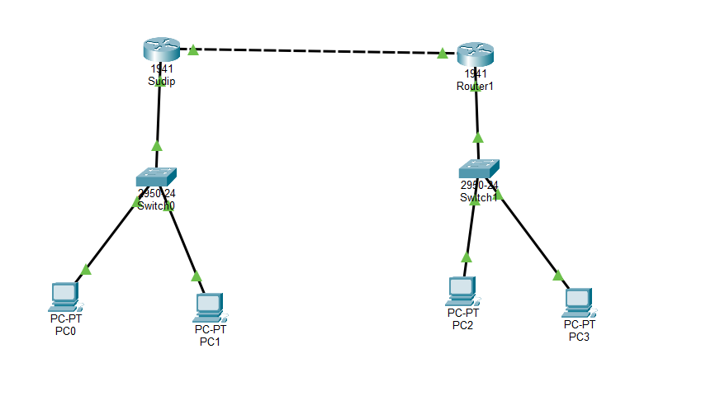
CONFIGURATION TABLE:
Device | Interface | IPv4 Address | Subnet Mask | Default  Gateway
Router  Sudip | GigabitEthernet0/0 | 10.0.0.1 | 255.0.0.0 | N/A
Router  Sudip | GigabitEthernet0/1 | 192.168.1.1 | 255.255.255.0 | N/A
Router1 | GigabitEthernet0/0 | 10.0.0.2 | 255.0.0.0 | N/A
Router1 | GigabitEthernet0/1 | 192.168.2.1 | 255.255.255.0 | N/A
PC0 | FastEthernet0 | 192.168.1.2 | 255.255.255.0 | 192.168.1.1
PC1 | FastEthernet0 | 192.168.1.3 | 255.255.255.0 | 192.168.1.1
PC2 | FastEthernet0 | 192.168.2.2 | 255.255.255.0 | 192.168.2.1
PC3 | FastEthernet0 | 192.168.2.3 | 255.255.255.0 | 192.168.2.1

Routing Configuration:
Device | Routing Type | Command / Route
Router Sudip | Static Route | ip route 192.168.2.0  255.255.255.0 10.0.0.2
Router1 | Static Route | ip route 192.168.1.0  255.255.255.0 10.0.0.1
Router Sudip | Default Route | ip route 0.0.0.0 0.0.0.0  10.0.0.2
Router1 | Default Route | ip route 0.0.0.0 0.0.0.0  10.0.0.1

RESULT
The network was successfully configured. To verify the connectivity, a ping request was sent from PC1 (192.168.1.3) in the first network to PC2 (192.168.2.3) in the second network. The packets were sent and received successfully which validates that the static route is correct and similar was done for default route connection testing.
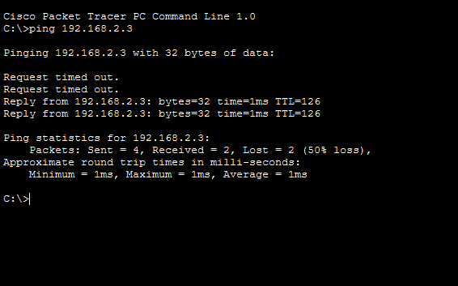
Fig:Ping request(Static routing)

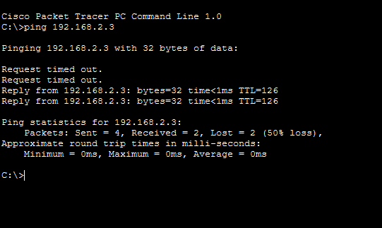
Fig: Fig:Ping request(Default routing)
DISCUSSION AND CONCLUSION :
In this experiment, static and default routing techniques were implemented to understand how routers direct traffic between different networks. Static routing provided complete control over routing paths, while default routing simplified the routing process in a stub network environment. The successful ping results confirmed correct configuration and understanding of routing concepts.
Thus, the experiment was carried out successfully, and the objectives of configuring and verifying static and default routes using Cisco Packet Tracer were achieved.

