mkdir C:\db1\db
mkdir C:\db1\log
mkdir C:\db2\db
mkdir C:\db2\log
dir C:\db1
dir C:\db2

Output:
Directory of C:\db1
db
log
Directory of C:\db2
db
log

"C:\Program Files\MongoDB\Server\8.0\bin\mongod.exe" --dbpath "C:\Program Files\MongoDB\Server\8.0\data" --logpath "C:\Program Files\MongoDB\Server\8.0\log\mongod.log" --port 27017 --replSet prodrep
No Output here this is running mongodb
mongosh --port 27017

Output:
Connecting to: mongodb://127.0.0.1:27017/
Using MongoDB: 8.0.6

rs.status()

Output:
MongoServerError[NotYetInitialized]: no replset config has been received

rs.initiate(
{
_id: "prodrep",
members: [
{ _id: 0, host: "localhost:27017" }
]
}
)

Output:
{ ok: 1 }

rs.status()

Output:
stateStr : "PRIMARY"

"C:\Program Files\MongoDB\Server\8.0\bin\mongod.exe" --dbpath "C:\db1\db" --logpath "C:\db1\log\mongod.log" --port 27020 --replSet prodrep
No output
"C:\Program Files\MongoDB\Server\8.0\bin\mongod.exe" --dbpath "C:\db2\db" --logpath "C:\db2\log\mongod.log" --port 27030 --replSet prodrep
No output

rs.add("localhost:27020")

Output:
{ ok: 1 }

rs.add("localhost:27030")

Output:
{ ok: 1 }

res.status()

Output:
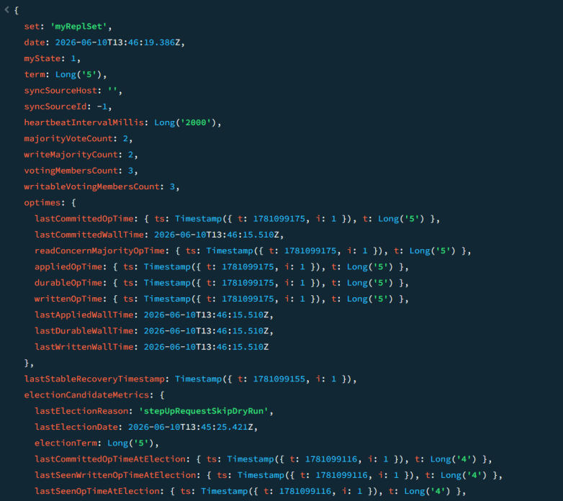
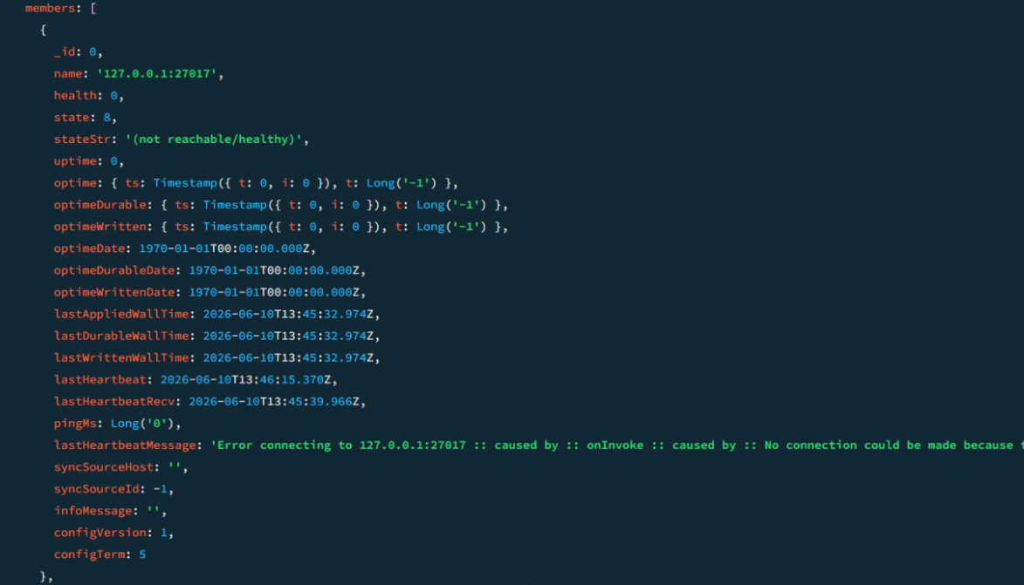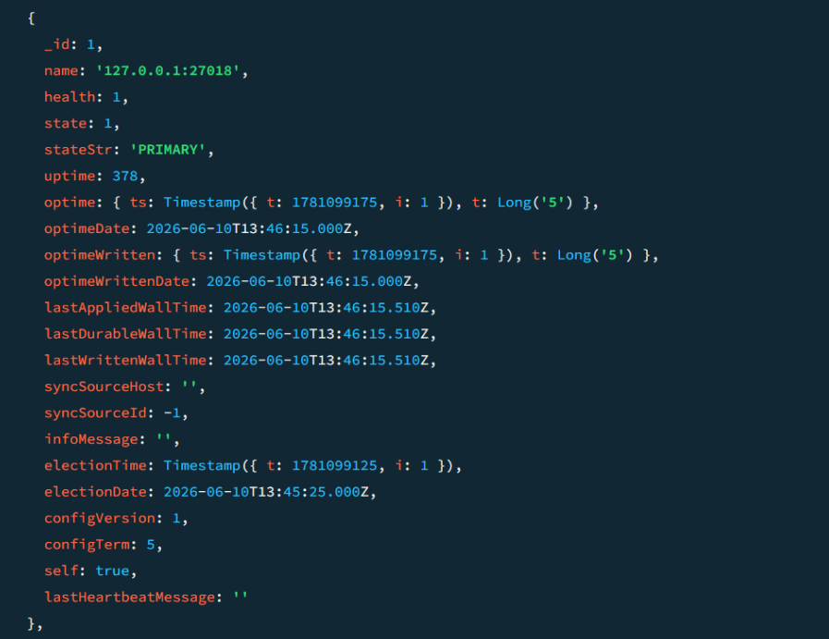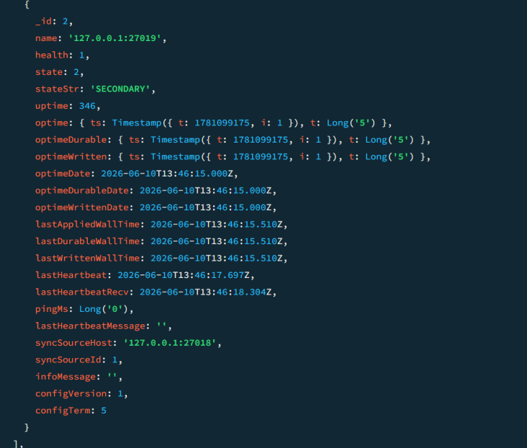
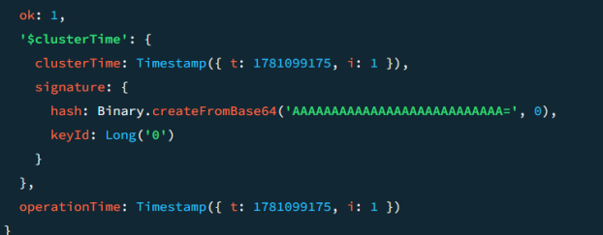 ok: 1,

"C:\Program Files\MongoDB\Server\8.0\bin\mongod.exe" --configsvr --replSet configReplSet --dbpath C:\config\db --port 27019

Output:
Waiting for connections on port 27019

rs.initiate({
_id: "configReplSet",
configsvr: true,
members: [
{ _id: 0, host: "localhost:27019" }
]
})

Output:
{ ok: 1, operationTime: Timestamp(...) }

rs.status()

Output:
{
set: "configReplSet",
members: [
{
name: "localhost:27019",
stateStr: "PRIMARY"
}
],
ok: 1
}

"C:\Program Files\MongoDB\Server\8.0\bin\mongod.exe" --shardsvr --replSet shard1ReplSet --dbpath C:\shard1\db --port 27011

rs.initiate({
_id: "shard1ReplSet",
members: [
{ _id: 0, host: "localhost:27011" }
]
})

Output:
{ ok: 1 }

rs.status()

Output:
{
set: "shard1ReplSet",
members: [
{
name: "localhost:27011",
stateStr: "PRIMARY"
}
],
ok: 1
}

"C:\Program Files\MongoDB\Server\8.0\bin\mongod.exe" --shardsvr --replSet shard2ReplSet --dbpath C:\shard2\db --port 27012

Output:
Waiting for connections on port 27012

rs.initiate({
_id: "shard2ReplSet",
members: [
{ _id: 0, host: "localhost:27012" }
]
})
Output:
{ ok: 1 }

rs.status()

Output:
{
set: "shard2ReplSet",
members: [
{
name: "localhost:27012",
stateStr: "PRIMARY"
}
],
ok: 1
}

"C:\Program Files\MongoDB\Server\8.0\bin\mongos.exe" --configdb configReplSet/localhost:27019 --port 27017

Output:
mongos startup complete
Listening on 127.0.0.1:27017
Waiting for connections
mongosh --port 27017
sh.addShard("shard1ReplSet/localhost:27011")

Output:
{ shardAdded: "shard1ReplSet", ok: 1 }

sh.addShard("shard2ReplSet/localhost:27012")

Output:
{ shardAdded: "shard2ReplSet", ok: 1 }

sh.enableSharding("eCommerceDB")

Output:
{ ok: 1 }

sh.shardCollection(
"eCommerceDB.orders",
{ customer_id: "hashed" }
)

Output:
{ collectionsharded: "eCommerceDB.orders", ok: 1 }

use eCommerceDB
for (let i = 0; i < 1000; i++) {
db.orders.insertOne({
customer_id: "cust_" + i,
amount: Math.random() * 100
});
}

Output:
{
acknowledged: true,
insertedId: ObjectId("68583c5d9f4d2a1b7c8e9f01")
}

sh.status()
shards
[
{
_id: 'shard1ReplSet',
host: 'shard1ReplSet/localhost:27011'
},
{
_id: 'shard2ReplSet',
host: 'shard2ReplSet/localhost:27012'
}
]

databases
[
{
database: 'eCommerceDB',
partitioned: true
}
]

use eCommerceDB
db.orders.countDocuments()
Output:
471

mongosh --port 27012
use eCommerceDB
db.orders.countDocuments()
Output:
529

db.orders.getShardDistribution()
Shard shard1ReplSet at shard1ReplSet/localhost:27011
data : 47.1%
docs : 471

Shard shard2ReplSet at shard2ReplSet/localhost:27012
data : 52.9%
docs : 529

