📬 Submit this assignment by Monday, October 5th at 2:59AM EDT using the Submit button 👉

Unit 3: Project 3 - Virtual Community Space

Overview
In this project, you'll create a virtual community space with an interactive interface that allows users to explore events by location. The user should be able to click on one of at least four locations and view events that have occurred or will occur there. Your virtual community can be real or imagined, but your site should help your target user find interesting stuff to do. Here are some examples:
- Music events
- Dungeon crawling expeditions
- Support groups for different communities
- Protests
- Geocaching spots
- Dromedary herders association meetups
Use AI to brainstorm ideas for your code

🎯 Goals
By the end of this assignment you will be able to...
- Build a backend that is accessible via an API
- Access the logic and data within the server on the frontend

Required Features
- The web app uses React to display data from the API
- The web app is connected to a PostgreSQL database
  - The web app is connected to a Render PostgreSQL database
  - The database contains an appropriately structured events table

- Front page of web app is functional and appropriately styled
  - The web app displays a title
  - Website includes a visual interface that allows users to select a location they would like to view
    - Note: A non-visual list of links to different locations is insufficient.

- Each location has a corresponding page
  - Each location has a detail page with its own unique URL
  - Clicking on a location navigates to its corresponding detail page and displays a list of all events from the events table associated with that location

View an exemplar of the project here!
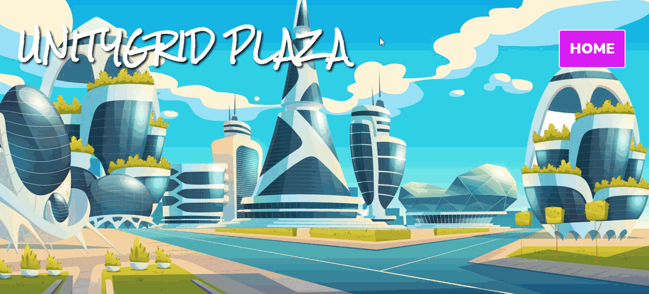

Stretch Features
- The app includes an additional Events page
  - An additional page shows all possible events
  - Users can sort or filter events by location

- Each Event includes a countdown to when the Event will occur
  - Events display a countdown showing the time remaining before that event
  - Events appear with different formatting when the event has passed
    - e.g., negative time, indication the event has passed, crossed out, etc.

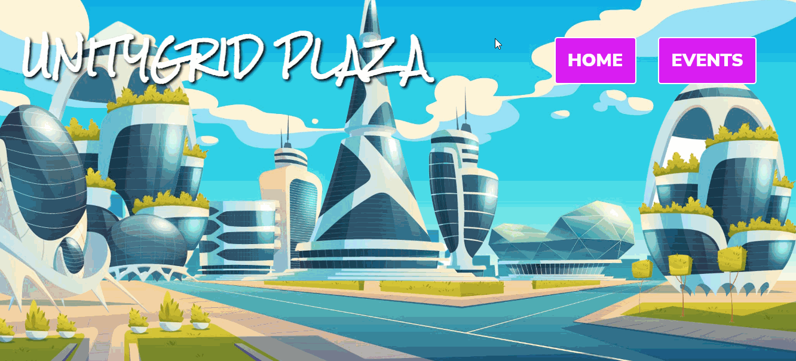

Resources
- Express Routing
- Express Tutorial: Routes and controllers
- Build a REST API with Node.js: Routes and Controllers
- React Reference: useState
- React Reference: useEffect
- MDN Web Docs: async

Step 0: Getting Started
- Access and fork the starter code.
- In your terminal, run npm install to install dependencies, then npm run dev to run the web app.
- Take a look at the starter code so you understand its structure and functionality.
Use AI to understand provided code → Codebase navigation

Step 1: Setup a database on Render
Before proceeding, you'll need to suspend any active Postgres databases. Render's free tier only allows for one active database at a time.Want to confirm the suspension procedure? Check it out here ⤵️
- 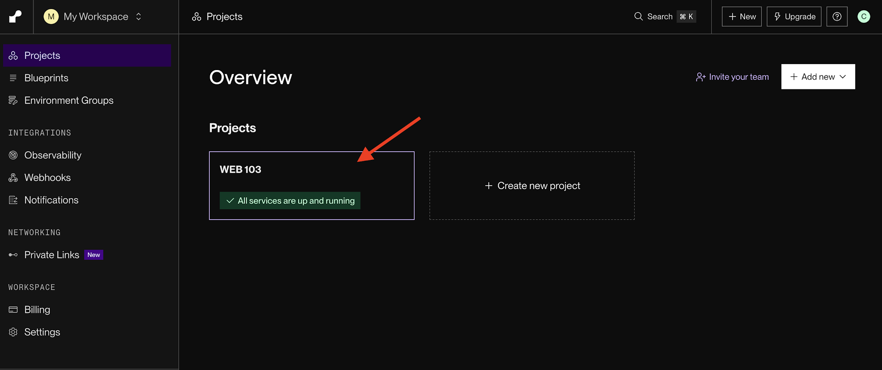
- 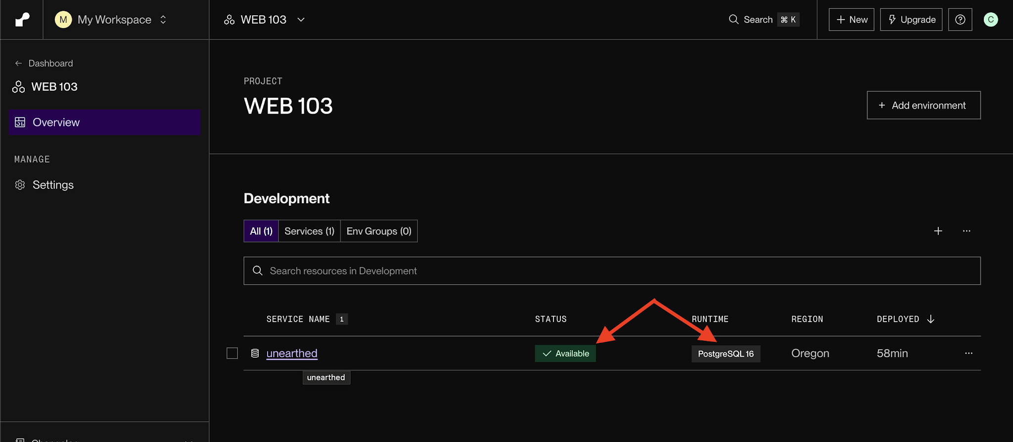
- 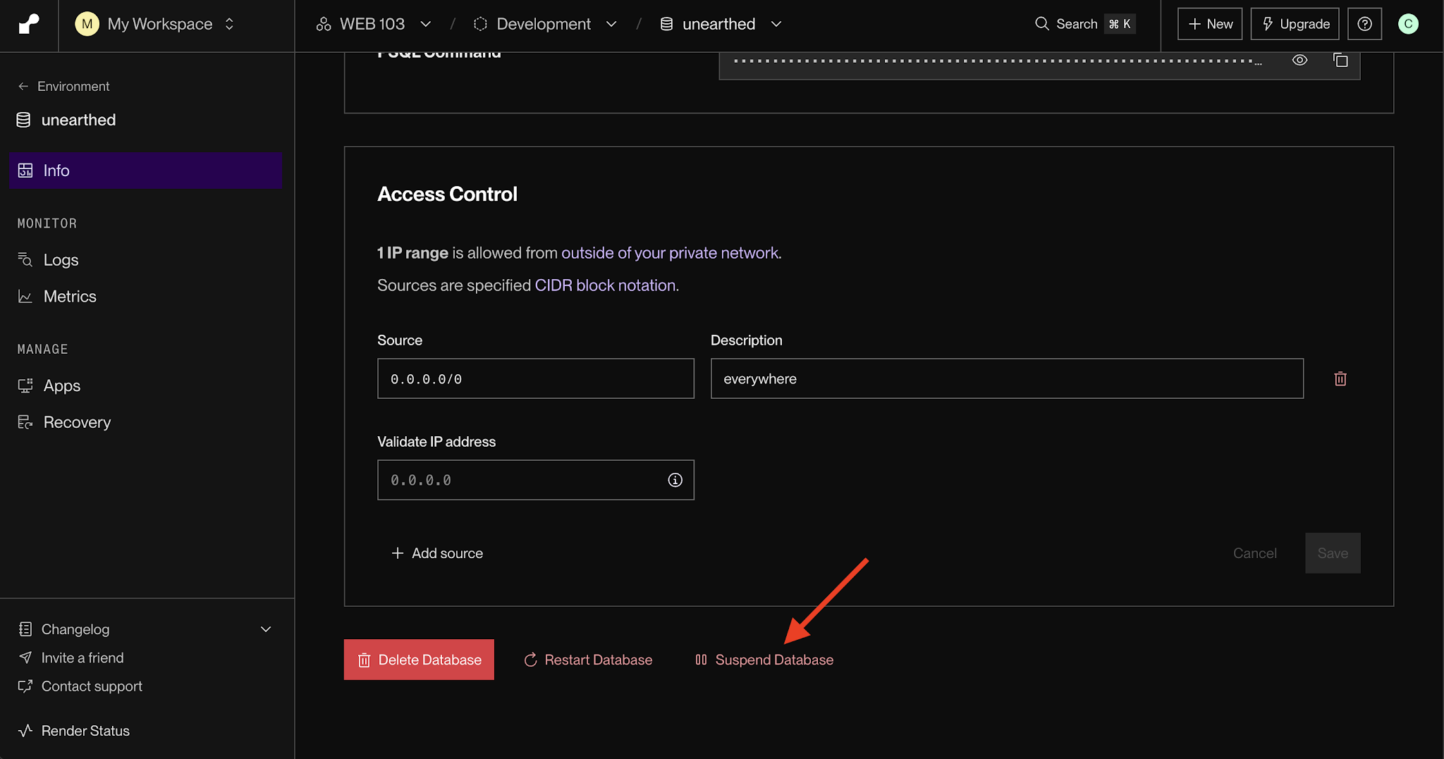
- 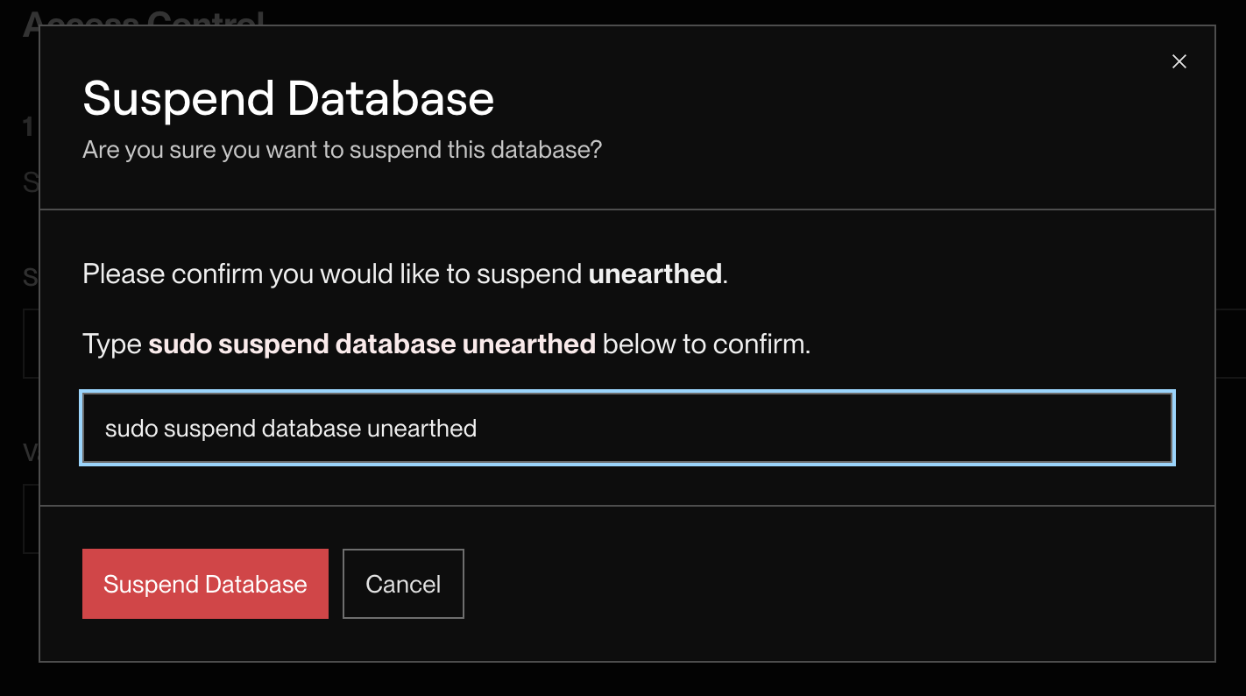
You'll need to create a database on Render for your web app to connect to.
- Choose +New in the header, and select Postgres from the dropdown menu.
- Select a name for your database, choose the free tier, and click Create Database.
This will create an empty PostgreSQL database.

Step 2: Connect to the database
Now that we have a database on Render, connect your Virtual Community Space project to it.
- In the server directory, create a folder called config.
- Inside the config folder, create a file called database.js.
- Add the following code to your database.js file:
import pg from 'pg'

const config = {
user: process.env.PGUSER,
password: process.env.PGPASSWORD,
host: process.env.PGHOST,
port: process.env.PGPORT,
database: process.env.PGDATABASE,
ssl: {
rejectUnauthorized: false
}
}

export const pool = new pg.Pool(config)

- In the server directory, create a new file called .env and add the following variables:
PGUSER=""
PGPASSWORD=""
PGHOST=""
PGPORT=
PGDATABASE=""

- In Render, click on the database you created. Insert the values from the Connections subheader into your .env file as shown below:
PGDATABASE="{Database}"
PGHOST="{Hostname}.oregon-postgres.render.com"
PGPASSWORD="{Password}"
PGPORT={Port}
PGUSER="{Username}"

- In the config directory, create a new file called reset.js to create the tables you will need to store the events and locations data that your web app will need to work with.

Step 3: Setup controllers
So now your Virtual Community Space project can talk to the database, but next it needs the ability to get the events and locations from your tables.
- In the server directory, create a folder called controllers.
- In the controllers folder, create files for your events and locations tables.
- In these files, import the pool from your database.js file.
- Add your functions to get events from your events table and locations from your locations table.
- Export the functions you create.

Step 4: Define routes
Great! Now your project can connect to the database and access the events and locations tables. Next, let's set up routes that call these functions when accessed.
- In the server directory, create a new directory called routes.
- In the routes folder, create files for the routes you'll need for your events and locations.
- Add the following code to each file:
import express from 'express'
// import controllers for events and locations

const router = express.Router()

// define routes to get events and locations

export default Router

- Import your controllers for your events and locations.
- Define routes to get events and locations that use the appropriate function from your controllers.
Use AI to brainstorm ideas for your code → Getting unstuck

Step 5: Update the server
We have our database, tables, controller, and routes. The last thing we need to do on the backend is tell the server that these routes exist.
- In the server.js file in the server directory, import your routers from your routes files.
- Specify the API path for each router for the server to use, for example:
app.use('/api', router)

Step 6: Connect the frontend to the API
Phew! Your Virtual Community Space is all set up ✅ Let's build its frontend to get the data from the database so the user can get events and locations.
- In the client directory, create a folder called services in the src folder.
- In the services folder, create files for your API calls, such as EventsAPI.jsx and LocationsAPI.jsx.
- In this file, define functions to get events and locations by calling the API. For example, getAllEvents, getEventById, etc.
- Export the functions.

Step 7: Complete the frontend
The starter code has pages viewing all locations and events for each location, but they're currently blank! Build these pages to pull the data needed from the database and implement the features.
- Complete the pages to allow the user to view the events for each location.
- Import the files from the services folder as needed in these pages.

💡 Hints
- Help! I don't know where to start!
  - Look at this week's lab for examples on how to implement similar applications. What code will be similar? What do you need to change?
- I'm stuck on something!
  - Don't just skip the Resources section.
  - Review the AI debugging tips in the box below!
  - Still need a little extra help getting started or running into an error? Try posting in the Class Slack Channel.
Use AI to understand why your code isn't working
📣 Submission Guidelines: For more details on submission instructions, follow the guidelines on the Submitting Coursework page.
- Make sure you are adding and committing files in git as you complete features and milestones.
- Be sure to include a README containing a GIF walkthrough of your project.
- Use this README TEMPLATE.
  - It is important that you follow the same layout as the README template so that we can easily access your work.
  - Be sure to check off each feature that is implemented in your submission by changing [ ] to [x]. We won't be able to assign points if a feature is unchecked.
Note: We highly encourage you submit your project in any state (even if it is not done) by Monday, October 5th at 2:59AM EDT. You can continue to work on your project with our 48-hour extension* in which your project will be graded once more once the extension deadline has passed (see "Coursework Submissions" in Syllabus for details). Don't forget to resubmit through the course portal with your updated GIF recording!

Project 3: Virtual Community Space
Total Points: 16pts + 4pts bonus
Required Features | Points
The web app uses React to display data from an API | 1
The web app is connected to a PostgreSQL database | 5
Front page of web app is functional and appropriately styled | 5
Each list item has a corresponding page | 5
Total | 16

Stretch Features | Points
The app includes an additional Events page | 2
Each event includes a countdown to when the event will occur | 2
Total | 4

