

**Software development with C**

**QUIZGAME: Developer guide**

**SUBMITTED TO: SUBMITTED BY:**

**Prof. Cristina Ruiz Parth Patel- 101135782**

**Pavan Patel - 101123965**

**Vimil Rathod-101128083**

**Hitul Shah- 101163945**

**QUIZ GAME**

The quiz is launched, the user will have only 30 seconds to answer each question, or else it will skip to the next question. The users will be prompted with their respective scores and the total points earned at the end of the quiz with the highest score of the quiz. The user can reset the Highest score of the quiz on his/ her device to start again from scratch or even request for help to know additional information about the quiz in the main menu of the quiz.

**Software Design**

**Flow-chart:**

Our Flowchart is divided into two main sections according to the 2 releases of our software. Release-1 is highlighted with a blue colour and Release-2 is highlighted with a green colour. As we can see through the flowchart, after the user launches our application, he will be asked to input his/her name. Further, the user will start the quiz, which will in-turn lead to data extraction from an excel file and then the application will enter a for loop, where any random question will be selected from the extracted data using random function library and will be fed to the user.

Meanwhile, a timer will be initiated which gives the user 30 seconds to answer the question. If the timer overflows before the user’s attempt, then the loop will be incremented, and the application will skip to the next question. Else the answer obtained from the user will be evaluated and accordingly the user’s score will be updated. Once the application reaches the end of the loop after going through all the questions, the user will submit his/her quiz and thereafter the application will print the user’s score and the Highest score ever achieved in the quiz by any user.

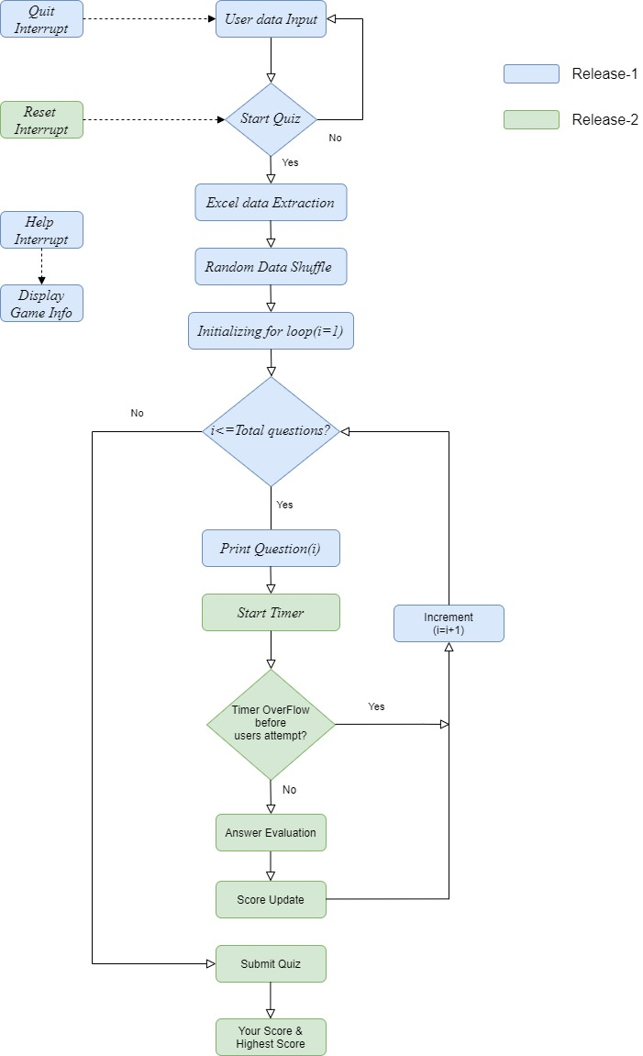

Figure 1: Flow chart of QUIZGAME.

**Following functions implemented as per flowchart process:**

1: User data Input:

* char* getuserdata( )

2: Start Quiz:

* void startquiz()

3: Data extraction and use of random function:

* struct readexcel( )
* void randomize(int arr[], int n)
* void swap(int *a, int *b)

4: Time constraint (start timer):

* void timer()

5: Answer Evaluation and Score update:

* int calculatescore(char userinput[])

6: Display Score:

* void displayscore()

7: Highest score :

* bool compare_score()
* void updatetxtfile(int user_score, char* user_name)

8: Help:

* void help( )

9: Reset:

* void reset_score( )

10: Quit:

* void quit( )

**File and Folder Structure Organization**

1. **bin:** This folder has executable and data file for the quiz game:
2. main.exe
3. test.exe

1. **database:** This folder has the database.
2. Book.csv
3. **doc:** It contains all the documents for the project.
4. html: The html folder generated by Doxigen for our project.
5. latex: The latex folder generated by Doxigen for our project.
6. user_manual.docs
7. developerguide.docs
8. **build:** This folder has all the object files generated using make file.
9. main.o
10. readexcel.o
11. startquiz.o
12. calculatescore.o
13. displayquiz.o
14. swap.o
15. randomize.o
16. reset_score.o
17. help.o
18. compare_score.o
19. updatetextfile.o
20. display_score.o
21. quit.o
22. test.o
23. **include:** It contains all the header files included in the project.
24. readexcel.h
25. startquiz.h
26. calculatescore.h
27. displayquiz.h
28. swap.h
29. randomize.h
30. reset_score.h
31. help.h
32. compare_score.h
33. updatetextfile.h
34. display_score.h
35. quit.h
36. **src:** It has following .c files:
37. main.c
38. readexcel.c
39. startquiz.c
40. calculatescore.c
41. displayquiz.c
42. swap.c
43. randomize.c
44. reset_score.c
45. help.c
46. compare_score.c
47. updatetextfile.c
48. display_score.c
49. quit.c
50. **test:** It has the following files:

test.c

**GitHub Link:** <https://github.com/parth4719/Group_J_QUIZGAME>