

**Software development with C**

**QUIZGAME: User guide**

**SUBMITTED TO: SUBMITTED BY:**

**Prof. Cristina Ruiz Parth Patel- 101135782**

**Pavan Patel - 101123965**

**Vimil Rathod – 101128083**

**Hitul Shah- 101163945**

**Installing Dev-C++**

**For Windows 10– Installation**

1) Visit <https://sourceforge.net/projects/orwelldevcpp/>.

2) Look for the section "Download" and start downloading Dev-C++ setup.

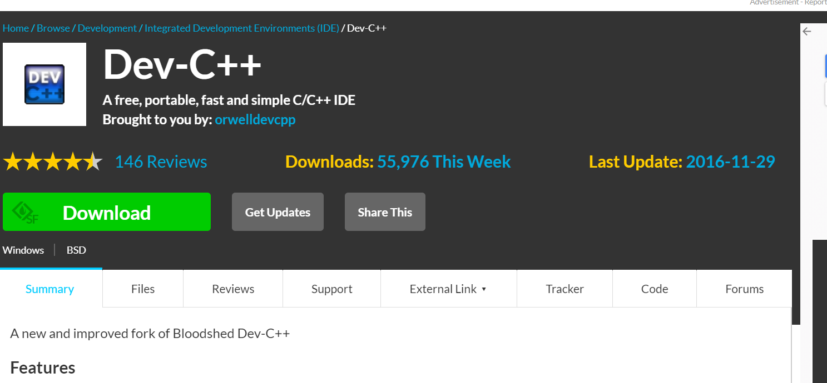

Figure 1: Dev-C++ download.

3) After completing download, go to download folder and install the Dev-C++ exe.

4) The installation will start, and it will ask you to select the language. Please select “English” and click “OK”.

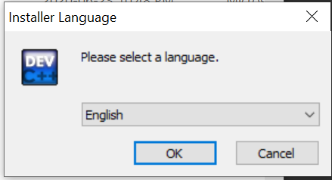

Figure 2: Language selection.

5) The next step is license agreement. Please select “I Agree”.

6) After license agreement, it will ask you to select component agreement. Please select component as default. Then click on to next button.

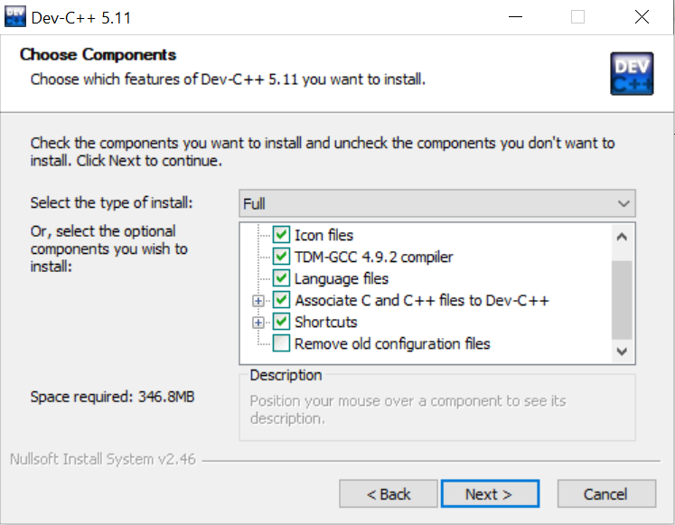

Figure 3: Components selection.

7) The next step is to select location for installation. After selection appropriate location, click on Install button.

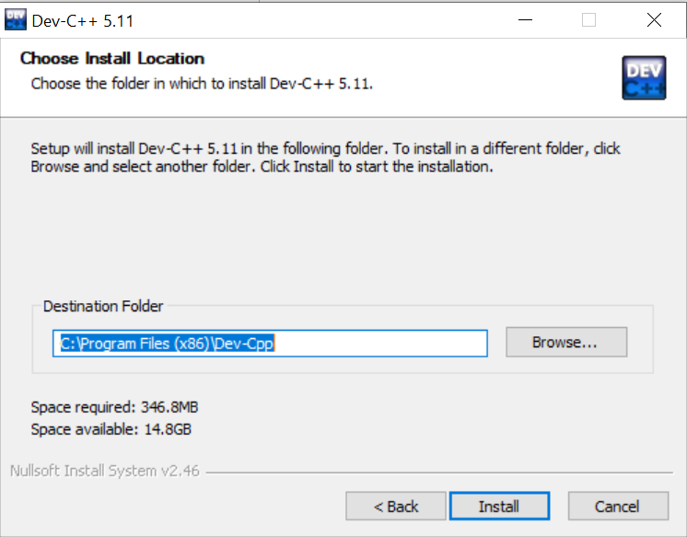

Figure 4: Location for installation.

8) It will start installing Dev-C++ in your PC.

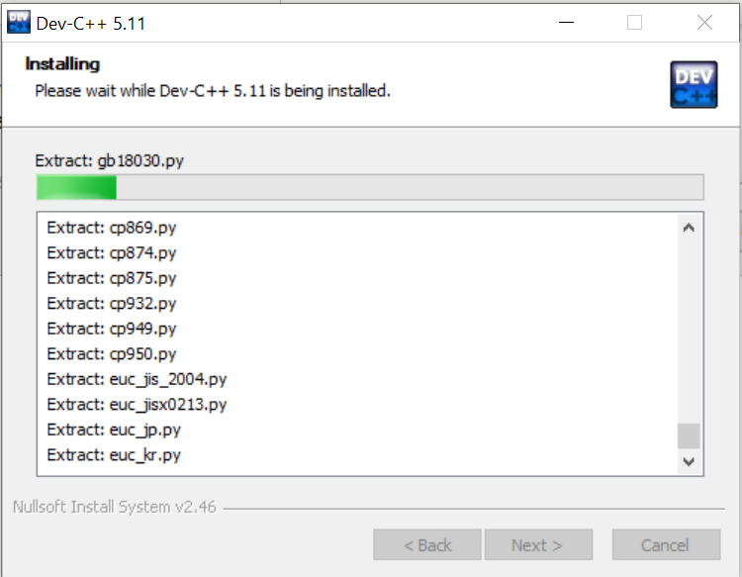

Figure 5: Installing Dev-C++.

9) It will take few seconds to install and then just select the Finish button.

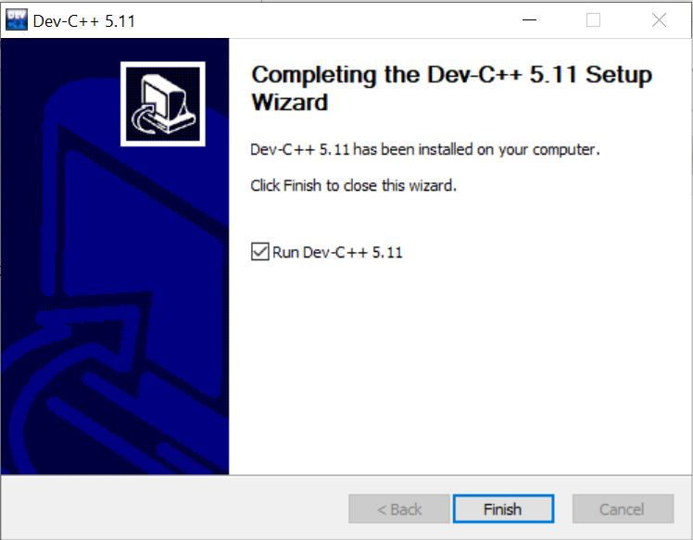

Figure 6: Dev-C++ installation for version 5.11 finish.

10) It will open Dev-C++ window as shown below:

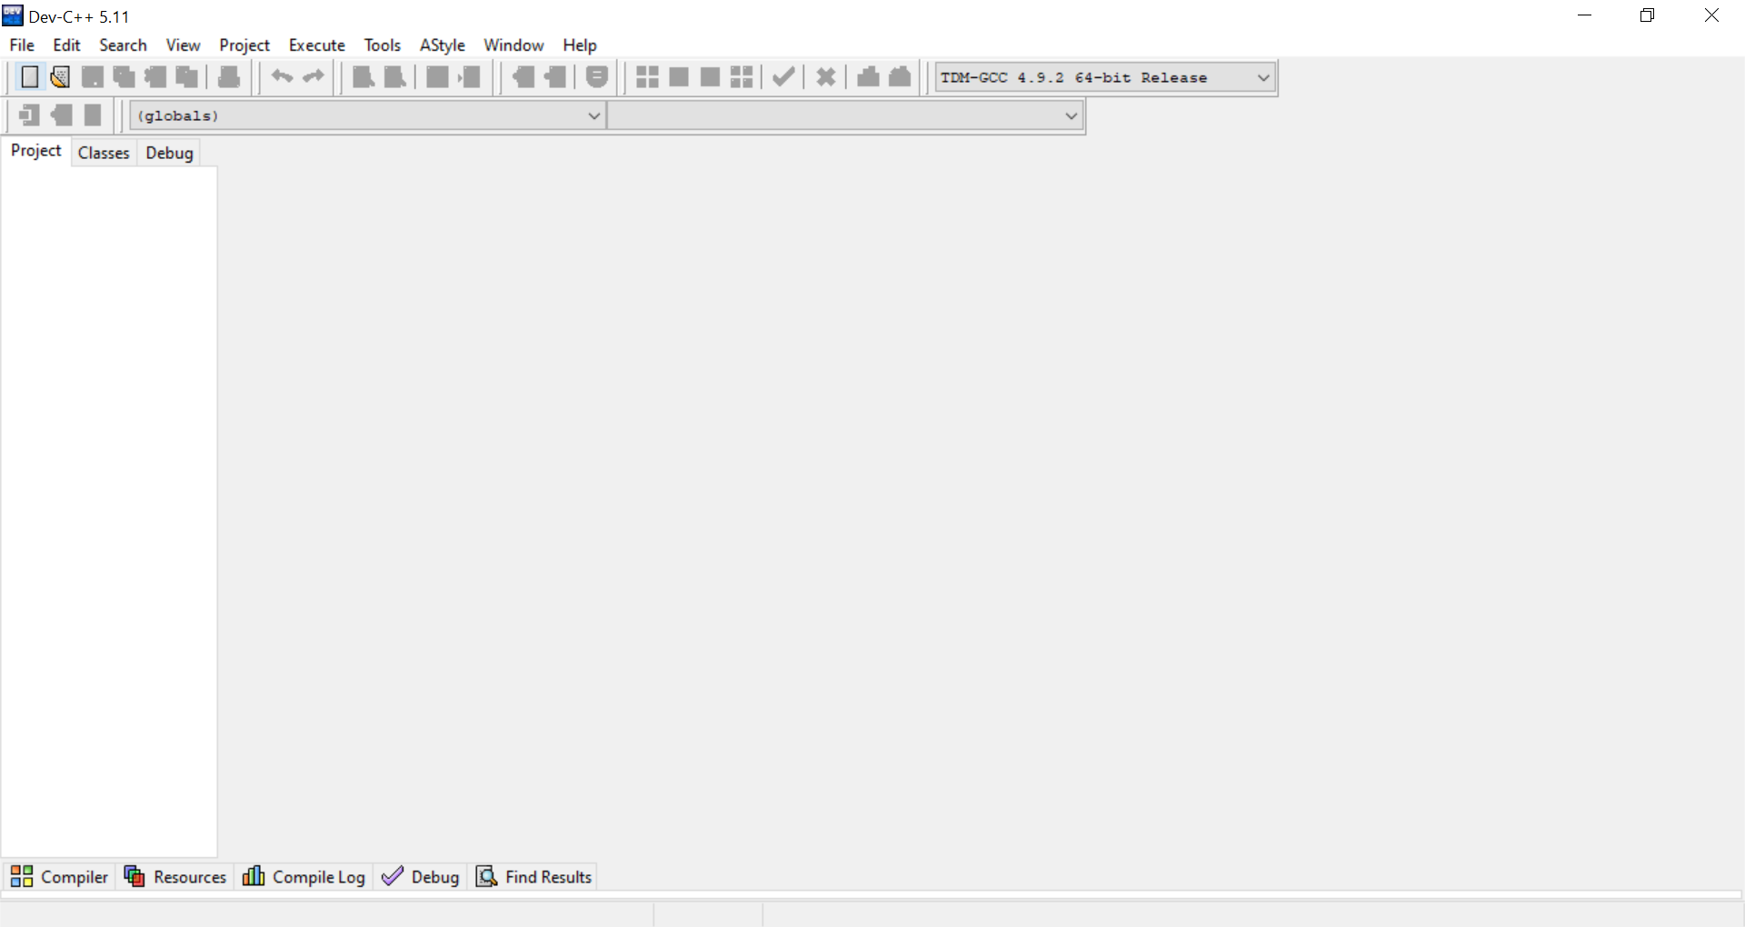

Figure 7: Dev-C++ window.

**Downloading Quizgame**

1) Install Git (User can use GitHub Desktop or Git bash or any other software of your choice to clone the project).

2) Create a new folder for the project. Right Click inside the folder and open a git bash here. Right Click +” Git Bash here”.

3) Type the following command in the git terminal:

Git clone https://github.com/parth4719/Group_J_QUIZGAME

OR

Go to the link https://github.com/parth4719/Group_J_QUIZGAME and click on Clone or Download

and download the zip folder of the software.

**Running Quizgame software**

1) Compiling the project.

a) Open the downloaded (cloned) folder, open ..\ Group_J_QUIZGAME.

b) Under this, open main.exe file, which will run our application.

c) Else you can open main.c in Dev-C++ and then compile and run this code by using F11 shortcut of Dev-C++.

2) After you compile the code, you will see welcome to quiz game screen.

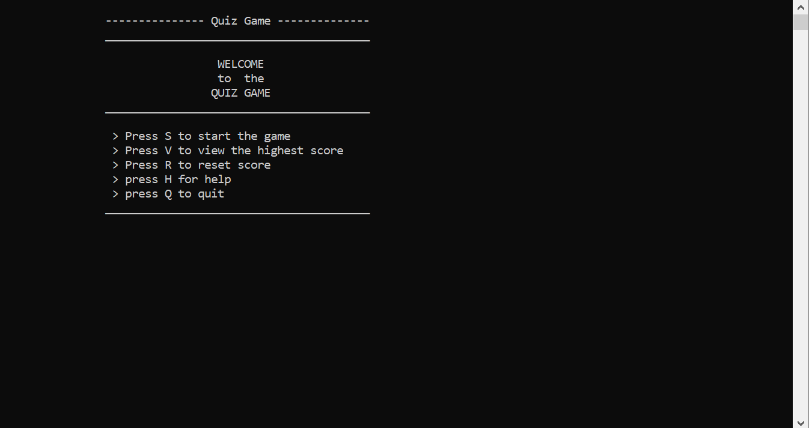

Figure 2: Welcome to Quiz Game.

The welcome screen has the following options.

1. To “start” the quiz, press “s”.
2. To view the “highest score” press “v”.
3. To “reset score” press “r”.
4. For “help” press “h”.
5. To “quit” press “q”.

If you press the wrong key then it will tell you that you have entered a wrong key and please re-enter the correct option.

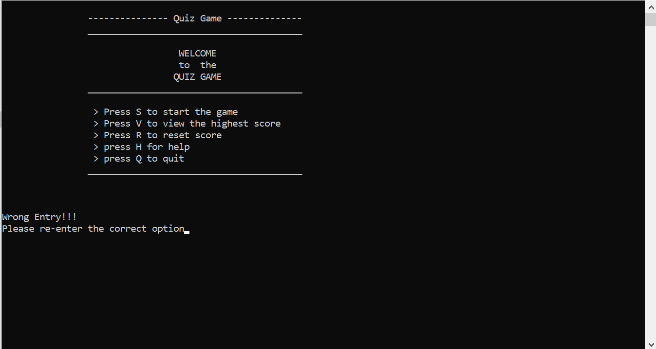

Figure 3: Wrong entry!

Now, let’s start the quiz by pressing S. It will show you the following window.

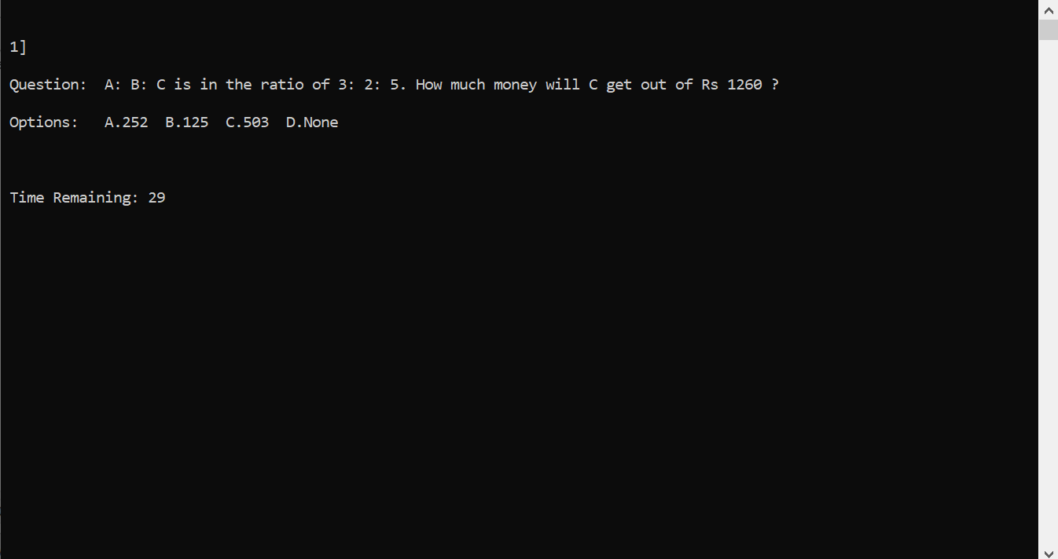

Figure 4: start the quiz.

It will show the following window after completing the quiz.

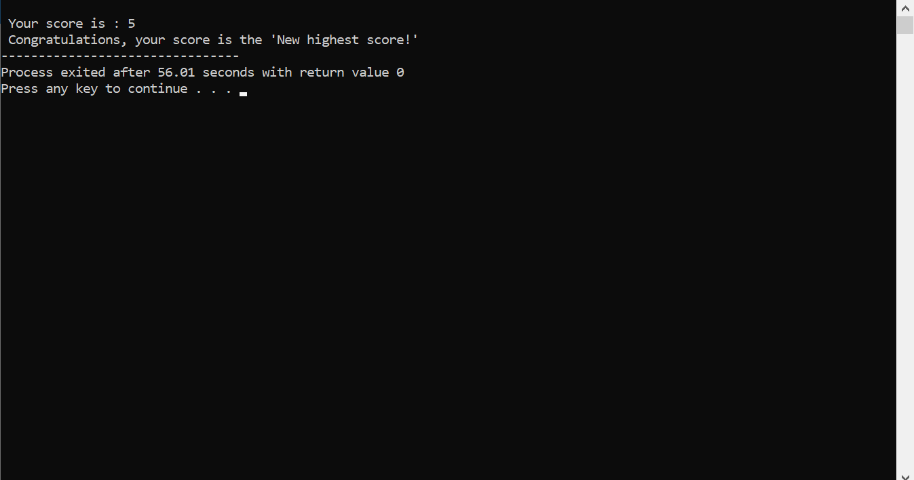

Figure 5: Quiz result.

If you want to check the highest score recorded in the system. Press “v” and it will show you the following window. And it will ask you to press any key to return to the main menu.

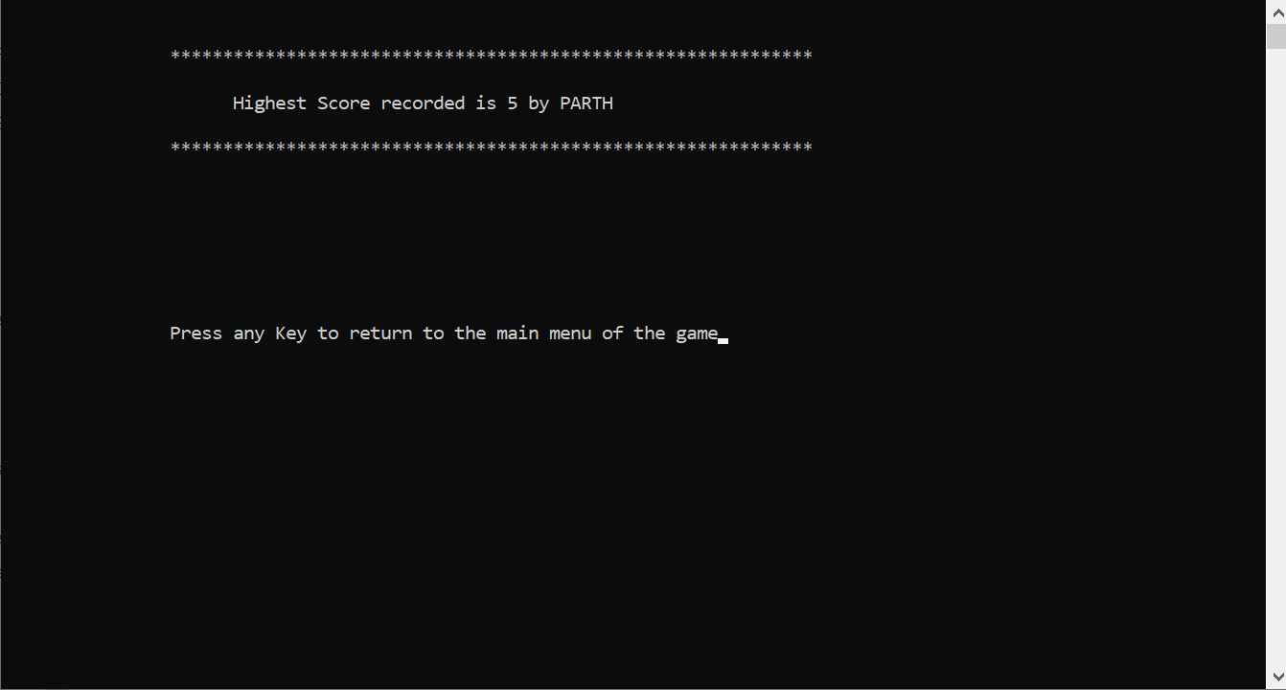

Figure 6: Highest score recorded in the system.

If you want to reset the highest score, press “R”. It will be reinitialized the highest score to ‘zero’. And it will ask you to press any key to return to the main menu.

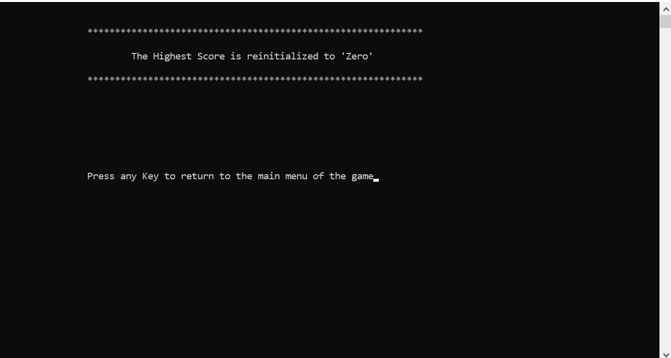

Figure 7: Reset highest score.

If you need general information about the quiz and its rules, press “H”. It will bring you to the following window. And it will ask you to press any key to return to the main menu.

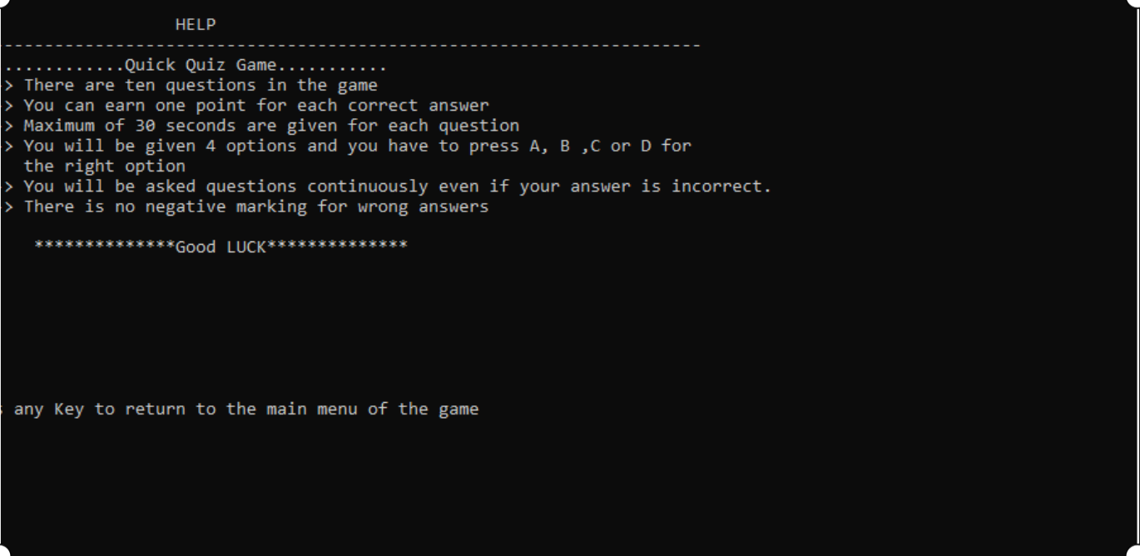

Figure 8: Help window.

If you want to quit the Quiz game, then Press “Q”. It will close our application (main.exe) file.