**Parthkumar Patel Javascript Assignment**

1. **What is JavaScript?**

* JavaScript is a scripting language which can help us to make website stylish and dynamic. It makes attractive website.

1. **What is the use of isNaN function?**

* It is global function which converts NaN value to number and it checks value whether it is number or not. If it is number, it gives false. If it is not a number, it gives true.
* Here is syntax : isNaN(value)
* NaN full form is not a number.
* E.g

 <script>

        let a = isNaN("123")

        console.log(a); // Ans is false.

        let b = isNaN("Kriva86")

        console.log(b); // Ans is true.

    </script>

1. What is negative Infinity?

* A negative infinity is a special numeric value which will be return when output value is in negative and greater than representable value of JavaScript while operating arithmetic or mathematical operation.

e.g –Number.MAX_VALUE

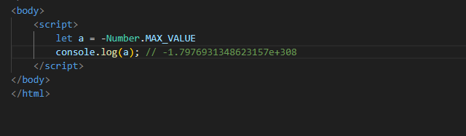

1. Which company developed JavaScript?

* JavaScript was created at Netscape Communications by Brendan Eich in 1995.

1. What are undeclared and undefined variables?

* Undefined: When we declare variable but not assign any value. Then output comes as an undefined.

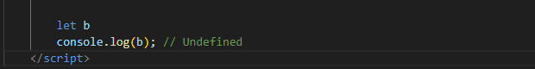

* Undeclared: It occurs when we access variable before it initialization by using var or const variable.



1. Write the code for adding new elements dynamically?

* Here is a syntax for that
* Syntax: document.createElement(“tag_name”)

document.createElement("h1")

1. What is the difference between ViewState and SessionState?

* A ViewState is a state of a page within a browser wherein the values of controls persist when post back operation is done.

When another page is loaded, the previous page data is no longer available.

* SessionState is the data of a user session and is maintained on the server side. This data available until user closes the browser or session time-outs.

1. What is === operator?

* It is a comparison operator which compare values of variable and also compare datatype of variables and returns output in Boolean values like true or flase.

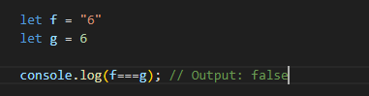

1. How can the style/class of an element be changed?

* JavaScript has in-built property which called .classList.add(“class_name”).



1. How to read and write a file using JavaScript?

* We have in-built method for read and write an external file.
* To read a file: fs.readFile( file_name, encoding, callback_function )
* To write a file: fs.writeFile( file_name, data, options, callback )

1. What are all the looping structures in JavaScript?

* We have many looping structure.
  + - 1. for
      2. for/in
      3. for/of
      4. while
      5. do/while
      6. foreach

<https://github.com/parth5493/Front-End-Developer/tree/main/Loop>

1. How can you convert the string of any base to an integer in JavaScript?

* JavaScript has in-built method called parseInt().



1. What is the function of the delete operator?

* We can use the delete operator to delete an element from array, object and property from object.
* Sometimes we give same property to many objects but sometime we require to delete property from one or some objects. At that time we use delete property.
* Syntax: delete()

1. What are all the types of Pop up boxes available in JavaScript?

* JavaScript has mainly three types of popup boxes.

1. alert()
2. prompt()
3. confirm()
4. What is the use of Void (0)?

* JavaScript void 0 means returning undefined (void) as a primitive value. You might come across the term “JavaScript:void(0)” while going through HTML documents. It is used to prevent any side effects caused while inserting an expression in a web page.
* We write JavaScript:void(0) in anchor tag in href attribute.

1. How can a page be forced to load another page in JavaScript?

* JavaScript has in-built method to load another page.
* Syntax: window.location.href = “url”

1. What are the disadvantages of using innerHTML in JavaScript?

* Event handlers attached to any DOM element are preserved.
* Replacement is done everywhere.
* It is not possible to append innerHTML.
* Breaks the document.
* Used for Cross-site Scripting.

1. Create password field with show hide functionalities

* <https://github.com/parth5493/Front-End-Developer/blob/main/JavaScript/JavaScript_Assignment/Create%20Password/password.html>

1. Create basic math operation in JS

* <https://github.com/parth5493/Front-End-Developer/tree/main/JavaScript/JavaScript_Assignment/Basic%20Math>

1. Create result

* <https://github.com/parth5493/Front-End-Developer/tree/main/JavaScript/JavaScript_Assignment/Create%20Result>