**Down Loading of Drone Data**

***Objective:*** To understand the different types of files and formats of the Drone data and the files to be downloaded for further processing like Geo tagging.

Input required: 1) Fly logs from on board UAV(Trintiy)-.bin,kml, csv formats

2) Images from Pay load of UAV(.jpg format)

3)Rinex file from I-Base which is mounted on reference

GNSS station. (.22r, .nav and .obs formats)

Software/applicaton required: 1) Q Base 3D---- For Quantum system Drones

2) Blue fire map assist-- For Idea forge drones

**Procedure:** Firstly , the Flylogs will be downloaded from Drone body by connecting it to the Laptop/PC which is having Q base 3D software.

Then the Images which are stored in the SD card of the Payload camera will be down loaded.

Then Rinex file which is stored in the micro SD card of the I base instrument is downladed**.**

**Exercise 1. Downloading of Fly logs and log files.**

**Objective***: Downloading the Flylogs and log files and identifying the flylog which is pertaining to your drone fly /mission for further processing***.**

FlyLogs are generated during the flight and saved on board of the UAV. KML and tagging files can be generated from the FlyLog.

**Fly log** Contains all the coordinates of the pictures that are recorded during the flight. During the geotagging process , these coordinate tags are correlated with the corresponding pictures. For every flight there is a new FlyLog written.

**LogFile:** Includes all the sensor data of the flight and might be needed by reseller for troubleshooting. For troubleshooting, the FlyLog and the corresponding Log File is required.

Step 1: Disconnect the battery from the drone.

Step2: Connect the main body of the UAV to your computer, laptop or tablet via magnetic USB. Plug in yellow tagged magnetic USB cable in top side pin of Trinity’s main body and in Qbase running s/w Tablet. Do not connect the battery. The power supply is guaranteed by the USB connection

Make sure the LED on the top of the Trinity turns green.

**Note:** In case the the LED of trinity shows red colour, then remove the magnetic USB cable and reconnect it. Even after this if the problem exists, then reload the drivers of Q base 3D software.

Step3: Open Q base. Go to setting and select Flylog debrief. The UAV will be mounted as a local drive.

Step4: Open the local drive and select the corresponding LOG.bin and/or Fly.bin files from the Log folder.

For Ex:

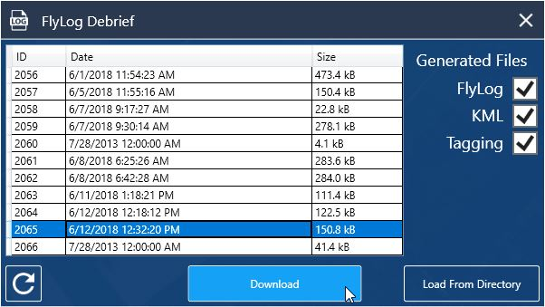

Step5: Create Fly log folder in a particular drive and store the Fly logs in the format of bin, kml and csv files.

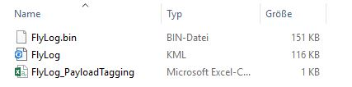

Create Log folder and store the log.bin files in this folder.

**Note:** 1.only the last twenty FlyLogs and LogFiles are saved on the autopilot board. In order to prevent loss of data, please download the FlyLogs and LogFiles regularly.

2. a) Only bin file generated from FlyLog is used for Geotagging purpose.

b)With the KML file you can display the data in Google Maps or Google Earth

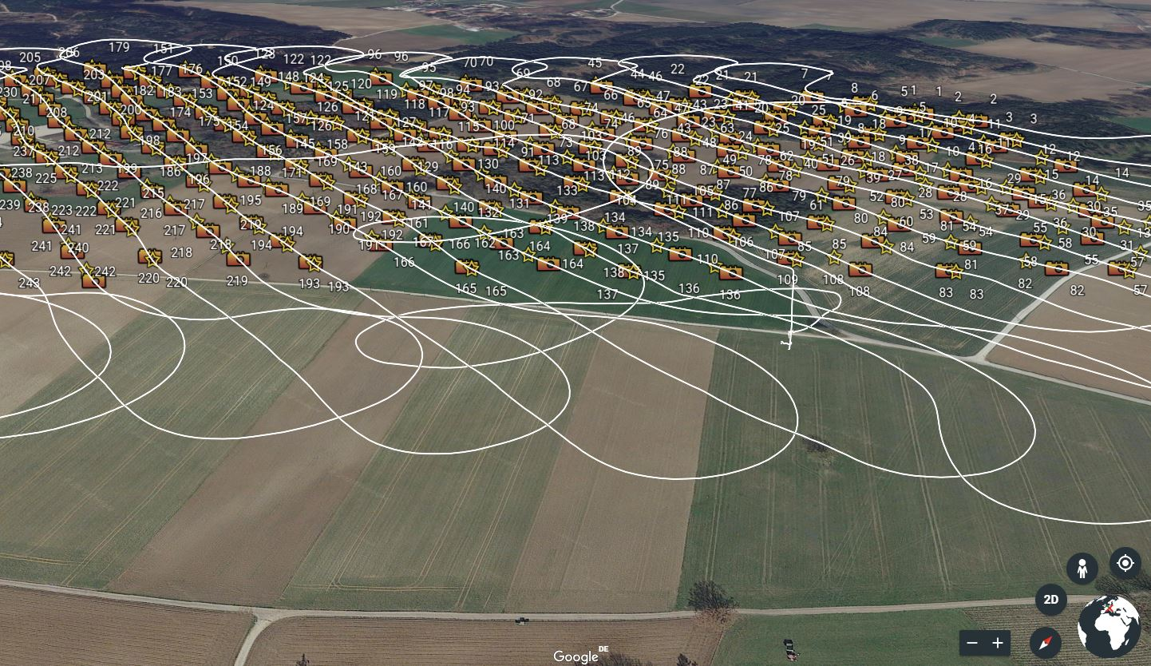

c)The PayloadTagging file allows visual checking of the most important recording parameters

Remaining files i.e., kml and csv are used for trouble shooting.

**Exercise 2: Down loading of Rinex file from i-Base.**

***Objective*:** *To down load the Rinex file corresponding to your flight for the purpose of PPK processing and geotagging.*

**i-Base –Ground reference station.**

i-Base is an entry level GNSS reference station. It automatically logs GNSS reference measurements on the ground to a file on the micro SD card. This file enables Q Base 3D to do PPK processing of the data collected in flight. It enables the geotagging relative precision down to 2-5cm in respect to the antenna placement point.

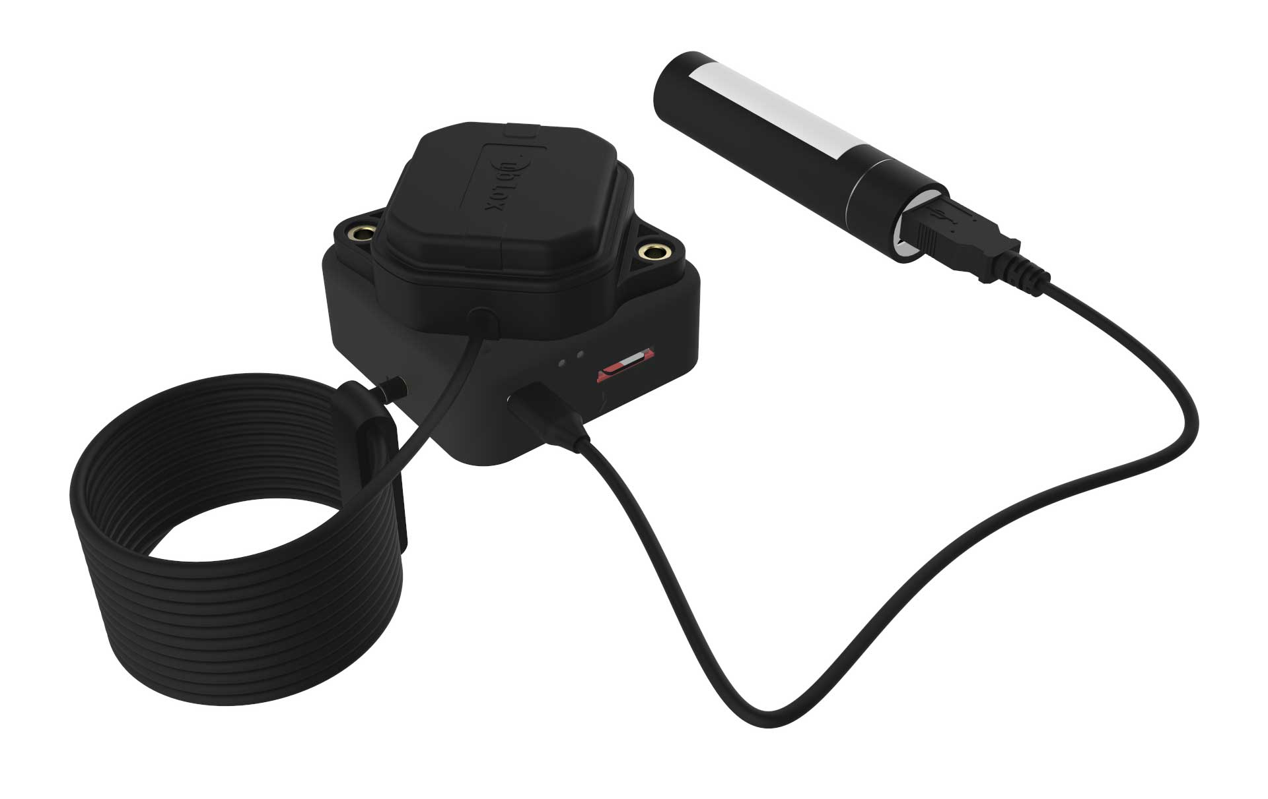

Step1. Remove Micro SD card from I-base and insert in the Card reader if required and connect the card reader to computer.

Step2. Copy the iBase Log file corresponding to your flight on your computer (the latest file on the SD card e.g. QS341B00.22R)

Here QS stands for Quantum system.

341 corresponds to the day which is calculated from January 1 as day 1.

B-represents 01:00 hrs the UTC time ( A corresponds to 00: 00 hrs and X corresponds to 23 hrs of UTC time.) gives the time of flight.

00—represents the counter of logs within the hour.

22--- Represents the year 2022.

R---- Represents the file format( Rinex stands for Receiver idependent Exchange format)

**Exercise 3: Down loading of Images from the pay load (camera)**

**Objective :** *To down load the Images which is stored in the SD card of the payload, for the purpose of Geo tagging and further data processing*

Step1:Remove from the SD card from payload compartment of main body.

Step2: Then insert the SD card in the Tablet /laptop using card reader.

Download the jpg format photos from the SD card and store in a folder namely **Raw photos** in a specified directory in the Tablet/laptop.

This file contains all photographs i.e., ground flashes (during pre flight check test) and flight exposures as per the mission.

Reference videos: <https://www.youtube.com/watch?v=Gs5ETJnMDNE>