* Git stores metadata of a repository with the help of some hidden files. The filenames of these types usually starts with a period, eg .git
* To create a git repository go to the folder which you want to make a repository and type the command: git init
* You should be able to find a .git file in that folder after that.
* To list all the files (including hidden files) use the command: ls -a
* After creating a git repository to find the status of the repository use the command: git status
* Git allows the user to choose which files he want to commit. After creating the repository the user may move the two files into the staging area using the command: git add <filename>
* Now the two files which were added to the staging area will be tracked and will be added when a git commit is done. However the third file will still remain untracked.
* 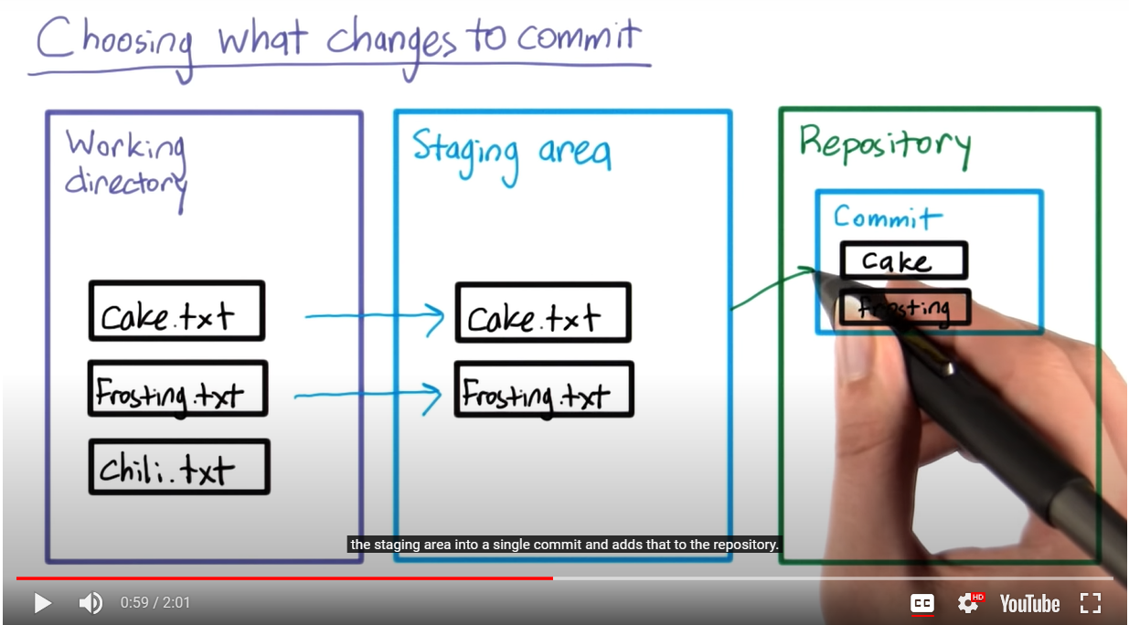
* If you added some files accidentally to the staging area then you can revert it using the command git reset
* To commit the files in the staging area use the command: git commit
* The default editor will appear after this command and you’ll have to type the commit message.
* In case you want to type the message in the command line, use the command: git commit -m “commit message”