**Set up Password Caching**

Every time you send changes to GitHub via the command line, you'll need to type your password to prove that you have permission to modify the repository. This can get annoying quickly, so many people like to set up password caching, which will let you type your password once and have it auto-filled on that computer in the future. To do this, follow the instructions [here](https://help.github.com/articles/caching-your-github-password-in-git). If you're using Windows and you followed our Git installation instructions earlier, you're using msysgit, so you can follow the instructions for msysgit.

* Now we will learn about Github. Github is the remote repository which stores a remote version of the repository we created in our local. We can push data into remote and pull data from remote.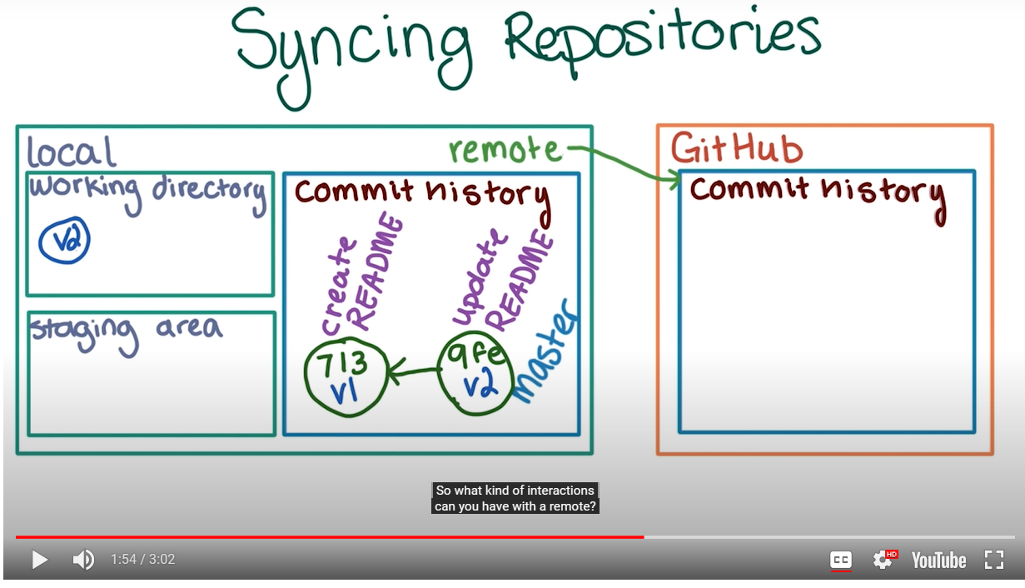
* Now create a repository in github for your reflections directory. To find what are the current remote repos linked to the directory run the command **git remote**
* To add a remote repo link for the current directory use the command: **git remote add <name for the remote by which it will be referred in the local > <URL of the remote repo>**
* Now to get more information on the remote repo use the code git remote -v . Here -v command means verbose.
* Now to push all the changes from the local to remote use the command: git push <name of the remote repo> <name of the local branch which I want to push>
* Now the remote branch with all its commit history will be pushed to the remote. By default the name of the remote branch will be same as the local branch.