* Git is the version control system and Github is the online repository of projects.
* To find out difference between old version of a file and a new version various methods are available.
* First one is to compare both files manually. However this is not an efficient method in anyway.
* The second method is to use inbuilt functions in windows, mac or linux.
* In case of Windows use the function in the command line called FC ( file compare). Command format : FC <space> <old filename><space>><new filename>
* In case of linux and mac use the command : diff -u <old filename> <new filename>.
* Different version control methods and their features.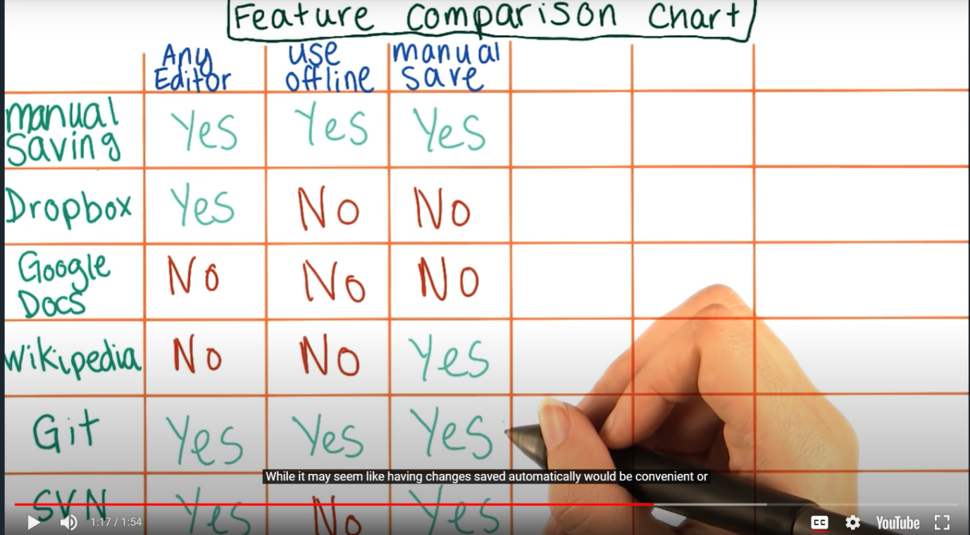
* Different concepts leant till now: 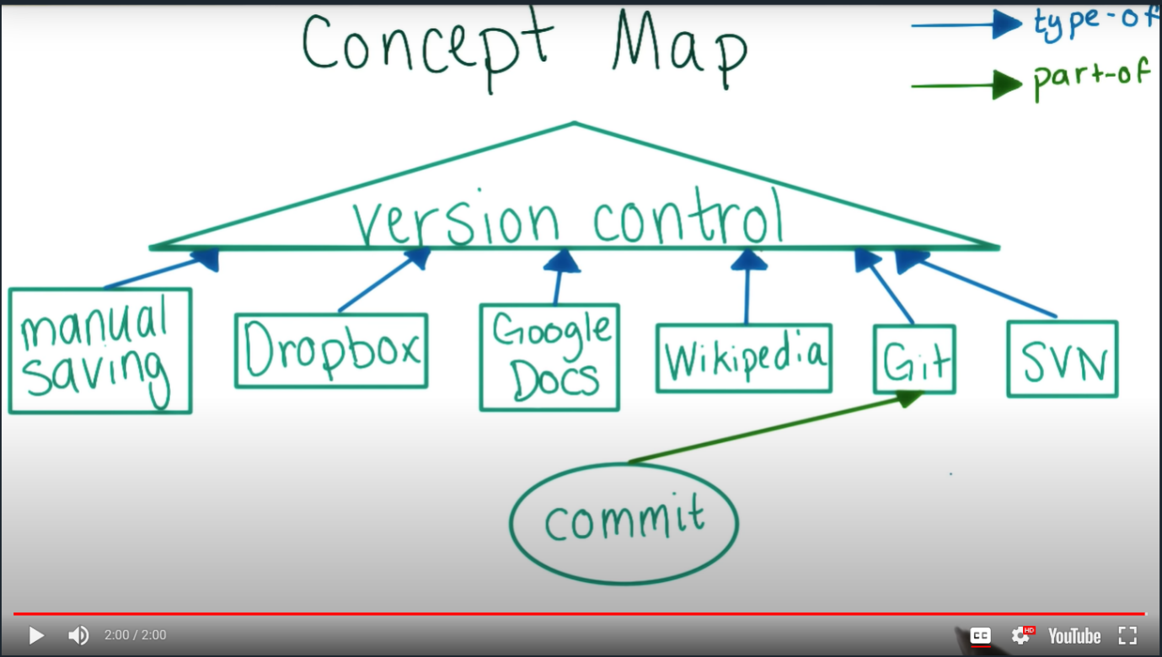
* Git commits usually contains an id, an author, date and the changes made in the commit.
* To find the differences between two commits use the following command: git diff <id of the first commit> <id of the second commit>
* Git commits shouldn’t be too small or too large. It is good to make a git commit after a logical change. For example, if you fixed a typo, then fixed a bug in a separate part of the file, you should use one commit for each change since they are logically separate.
* Collection of files in git is called a repository. When a commit is made, git saves a copy of all the files in the repository.
* In order to download a repository into your computer use the command: git clone <url of the repository>. Git clone downloads all the previous versions of the repository along with its current one.
* To get coloured output for git differences use the command : git config –global color.ui auto
* In git log commits are listed from newest to the oldest one.
* In the command line every red line that appears is a deleted line. Every green line is an added line.
* Git can throw many unusual errors. The course will teach you how to interpret those errors.
* To go to any previous version of a code use the command: git checkout <commit id>
* In git HEAD is the current version of the code you are working on. In case you use the command git checkout to switch to a previous commit, git will show an error of ‘detached HEAD’. No need to worry, lesson 2 will teach how to deal with these errors.