**Design of Form1**

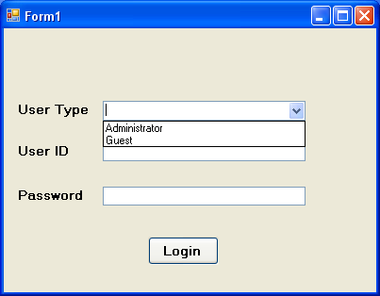

**Button1**

**Code of Form1**

using System;

using System.Collections.Generic;

using System.ComponentModel;

using System.Data;

using System.Drawing;

using System.Linq;

using System.Text;

using System.Windows.Forms;

using System.Data.OleDb;

namespace library_management

{

public partial class Form1 : Form

{

OleDbConnection con = new OleDbConnection();

OleDbCommand com;

OleDbDataAdapter da;

DataSet ds;

public Form1()

{

InitializeComponent();

}

private void Form1_Load(object sender, EventArgs e)

{

this.comboBox1.Select();

}

private void button1_Click(object sender, EventArgs e)

{

if (this.comboBox1.Text == "" && this.textBox1.Text == "" && this.textBox2.Text == "")

{

MessageBox.Show("Please fill the info");

}

else if (this.comboBox1.Text == "" && this.textBox1.Text == "")

{

MessageBox.Show("You must select user type and enter user id");

}

else if (this.comboBox1.Text == "" && this.textBox2.Text == "")

{

MessageBox.Show("You must select user type and enter password");

}

else if (this.textBox1.Text == "" && this.textBox2.Text == "")

{

MessageBox.Show("You must enter user id and password");

}

else

{

con.ConnectionString = "Provider=Microsoft.Jet.OLEDB.4.0; Data Source=library.mdb";

con.Open();

com = new OleDbCommand("select * from logdata where user_type='" + this.comboBox1.Text + "' and user_id='" + this.textBox1.Text + "' and user_password='" + this.textBox2.Text + "'", con);

da = new OleDbDataAdapter(com);

ds = new DataSet();

da.Fill(ds);

if (ds.Tables[0].Rows.Count > 0)

{

if (ds.Tables[0].Rows[0][0].ToString() == "Administrator")

{

this.Hide();

main1 mn1 = new main1();

mn1.Show();

}

else if (ds.Tables[0].Rows[0][0].ToString() == "Guest")

{

this.Hide();

main2 mn2 = new main2();

mn2.Show();

}

}

else

{

MessageBox.Show("Please select correct user type and enter valid user id and password");

this.comboBox1.Text = "";

this.textBox1.Text = "";

this.textBox2.Text = "";

}

con.Close();

}

}

}

}

**Design of main1**

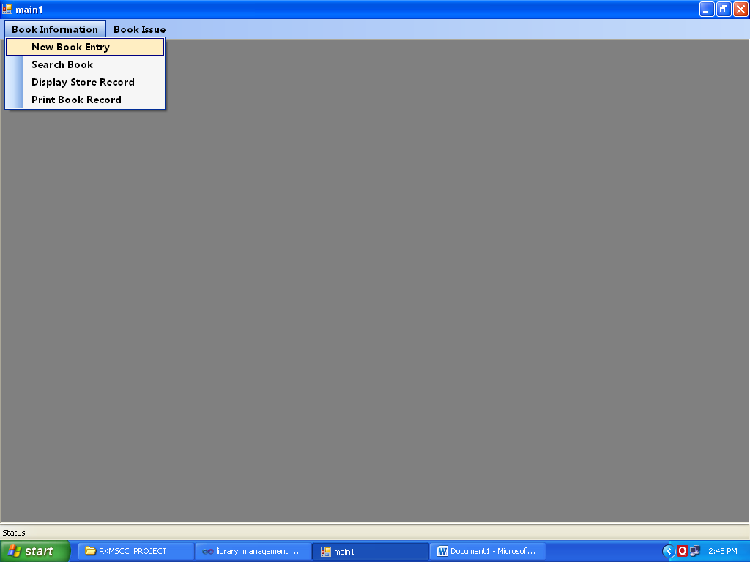

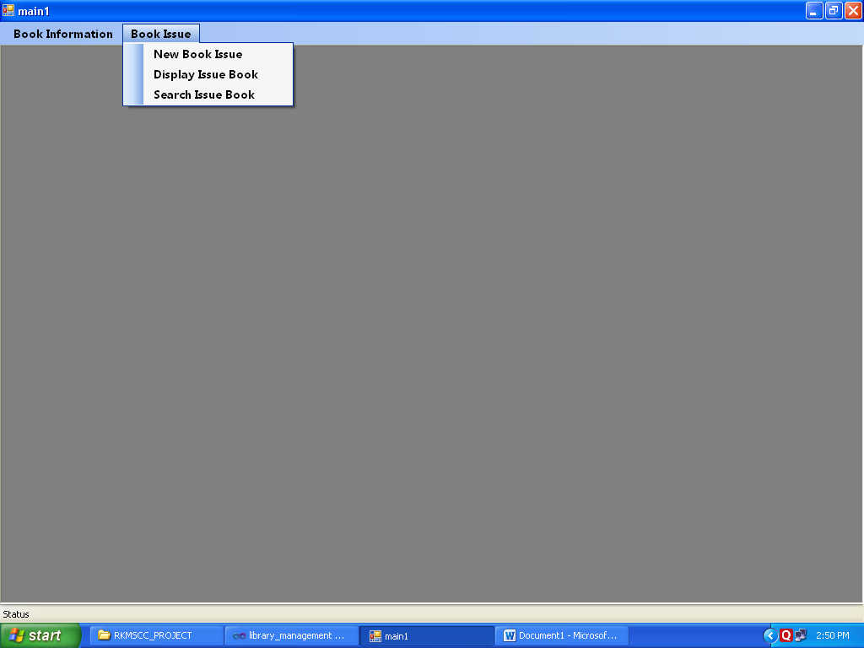

**Code of main1**

using System;

using System.Collections.Generic;

using System.ComponentModel;

using System.Data;

using System.Drawing;

using System.Linq;

using System.Text;

using System.Windows.Forms;

using System.Data.OleDb;

namespace library_management

{

public partial class main1 : Form

{

OleDbConnection con = new OleDbConnection();

OleDbCommand com;

OleDbCommand com1;

OleDbDataAdapter da;

OleDbDataAdapter da1;

DataSet ds;

DataSet ds1;

private int childFormNumber = 0;

public main1()

{

InitializeComponent();

}

private void ShowNewForm(object sender, EventArgs e)

{

}

private void OpenFile(object sender, EventArgs e)

{

}

private void SaveAsToolStripMenuItem_Click(object sender, EventArgs e)

{

}

private void ExitToolsStripMenuItem_Click(object sender, EventArgs e)

{

}

private void CutToolStripMenuItem_Click(object sender, EventArgs e)

{

}

private void CopyToolStripMenuItem_Click(object sender, EventArgs e)

{

}

private void PasteToolStripMenuItem_Click(object sender, EventArgs e)

{

}

private void ToolBarToolStripMenuItem_Click(object sender, EventArgs e)

{

}

private void StatusBarToolStripMenuItem_Click(object sender, EventArgs e)

{

}

private void CascadeToolStripMenuItem_Click(object sender, EventArgs e)

{

}

private void TileVerticalToolStripMenuItem_Click(object sender, EventArgs e)

{

}

private void TileHorizontalToolStripMenuItem_Click(object sender, EventArgs e)

{

}

private void ArrangeIconsToolStripMenuItem_Click(object sender, EventArgs e)

{

}

private void CloseAllToolStripMenuItem_Click(object sender, EventArgs e)

{

}

private void newBookEntryToolStripMenuItem_Click(object sender, EventArgs e)

{

Form2 frm2 = new Form2();

frm2.MdiParent = this;

frm2.Show();

con.ConnectionString = "Provider=Microsoft.Jet.OLEDB.4.0; Data Source=library.mdb";

con.Open();

com1 = new OleDbCommand("select max(book_id) from book", con);

da1 = new OleDbDataAdapter(com1);

ds = new DataSet();

da1.Fill(ds, "book");

if (ds.Tables["book"].Rows.Count > 0)

{

string stringtoint = ds.Tables["book"].Rows[0][0].ToString().Substring(3);

int num = Convert.ToInt16(stringtoint) + 1;

string inttostring = "BPR" + num.ToString();

frm2.textBox1.Text = inttostring.ToString();

}

com = new OleDbCommand("select * from book order by book_id", con);

da = new OleDbDataAdapter(com);

ds = new DataSet();

da.Fill(ds);

if (ds.Tables[0].Rows.Count > 0)

{

frm2.dataGridView1.DataSource = ds.Tables[0];

}

con.Close();

}

private void linkLabel1_LinkClicked(object sender, LinkLabelLinkClickedEventArgs e)

{

this.Hide();

Form1 frm1 = new Form1();

frm1.Show();

}

private void searchBookToolStripMenuItem_Click(object sender, EventArgs e)

{

Form3 frm3 = new Form3();

frm3.MdiParent = this;

frm3.Show();

}

private void newBookIssueToolStripMenuItem_Click(object sender, EventArgs e)

{

Form4 frm4 = new Form4();

frm4.MdiParent = this;

frm4.Show();

con.ConnectionString = "Provider=Microsoft.Jet.OLEDB.4.0; Data Source=library.mdb";

con.Open();

com = new OleDbCommand("select * from issue", con);

da = new OleDbDataAdapter(com);

ds = new DataSet();

da.Fill(ds);

if (ds.Tables[0].Rows.Count > 0)

{

frm4.dataGridView1.DataSource = ds.Tables[0];

}

com1 = new OleDbCommand("select * from book", con);

da1 = new OleDbDataAdapter(com1);

ds = new DataSet();

da1.Fill(ds,"1");

if (ds.Tables[0].Rows.Count > 0)

{

frm4.dataGridView2.DataSource = ds.Tables[0];

}

OleDbDataReader dr=new OleDbCommand("select book_name from book order by book_name",con).ExecuteReader();

while(dr.Read())

{

frm4.comboBox1.Items.Add(dr.GetValue(0).ToString());

}

dr.Close();

OleDbDataReader dr1=new OleDbCommand("select user_id from logdata order by user_id",con).ExecuteReader();

while(dr1.Read())

{

frm4.comboBox2.Items.Add(dr1.GetValue(0).ToString());

}

dr1.Close();

con.Close();

}

private void searchIssueBookToolStripMenuItem_Click(object sender, EventArgs e)

{

Form6 frm6 = new Form6();

frm6.MdiParent = this;

frm6.Show();

con.ConnectionString = "Provider=Microsoft.Jet.OLEDB.4.0; Data Source=library.mdb";

con.Open();

com = new OleDbCommand("select * from issue", con);

da = new OleDbDataAdapter(com);

ds = new DataSet();

da.Fill(ds);

if (ds.Tables[0].Rows.Count > 0)

{

frm6.dataGridView1.DataSource = ds.Tables[0];

}

con.Close();

}

private void displayStoreRecordToolStripMenuItem_Click(object sender, EventArgs e)

{

Form5 frm5 = new Form5();

frm5.MdiParent = this;

frm5.Show();

con.ConnectionString = "Provider=Microsoft.Jet.OLEDB.4.0; Data Source=library.mdb";

con.Open();

com = new OleDbCommand("select * from book", con);

da = new OleDbDataAdapter(com);

ds = new DataSet();

da.Fill(ds);

if (ds.Tables[0].Rows.Count > 0)

{

frm5.dataGridView1.DataSource = ds.Tables[0];

}

con.Close();

}

private void printBookRecordToolStripMenuItem_Click(object sender, EventArgs e)

{

Form7 frm7 = new Form7();

frm7.MdiParent = this;

frm7.Show();

}

private void searchIssueBookToolStripMenuItem1_Click(object sender, EventArgs e)

{

Form8 frm8 = new Form8();

frm8.MdiParent = this;

frm8.Show();

con.ConnectionString = "Provider=Microsoft.Jet.OLEDB.4.0; Data Source=library.mdb";

con.Open();

OleDbDataReader dr = new OleDbCommand("select book_name from book order by book_name", con).ExecuteReader();

while (dr.Read())

{

frm8.comboBox1.Items.Add(dr.GetValue(0).ToString());

}

dr.Close();

con.Close();

}

}

}

**Design of Form2**

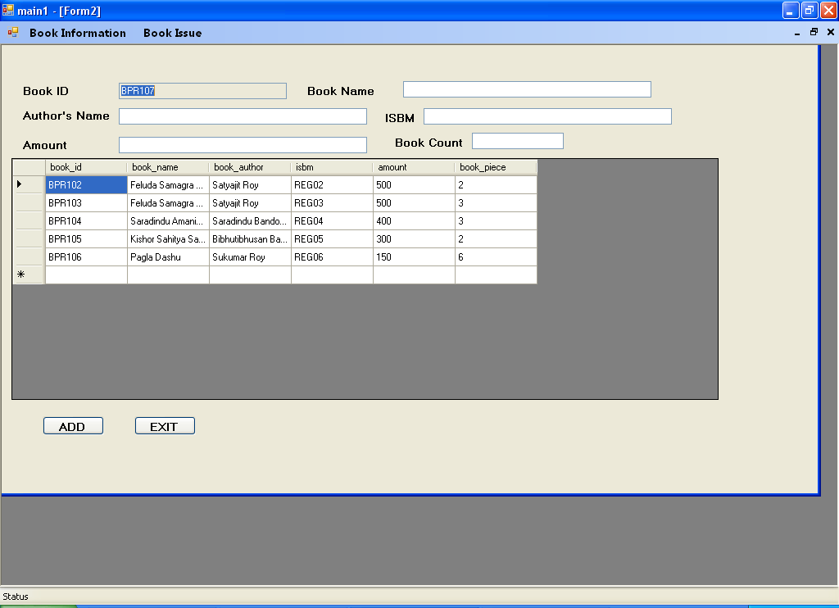

**Button1**

**Button2**

**Code of Form2**

using System;

using System.Collections.Generic;

using System.ComponentModel;

using System.Data;

using System.Drawing;

using System.Linq;

using System.Text;

using System.Windows.Forms;

using System.Data.OleDb;

namespace library_management

{

public partial class Form2 : Form

{

OleDbConnection con = new OleDbConnection();

OleDbCommand com;

OleDbCommand com1;

OleDbCommand com2;

OleDbDataAdapter da;

OleDbDataAdapter da1;

DataSet ds;

public Form2()

{

InitializeComponent();

}

private void textBox4_TextChanged(object sender, EventArgs e)

{

}

private void button1_Click(object sender, EventArgs e)

{

DialogResult dialog = MessageBox.Show("Do you want to add?", "Add", MessageBoxButtons.YesNo);

if (dialog == DialogResult.Yes)

{

con.ConnectionString = "Provider=Microsoft.Jet.OLEDB.4.0; Data Source=library.mdb";

con.Open();

string sql;

sql = "insert into book values('" + this.textBox1.Text + "','" + this.textBox2.Text + "','" + this.textBox3.Text + "','" + this.textBox4.Text + "'," + this.textBox5.Text + "," + this.textBox7.Text + ")";

com = new OleDbCommand(sql, con);

com.ExecuteNonQuery();

MessageBox.Show("New book added in the record");

com1 = new OleDbCommand("select * from book order by book_id", con);

da = new OleDbDataAdapter(com1);

ds = new DataSet();

da.Fill(ds);

if (ds.Tables[0].Rows.Count > 0)

{

this.dataGridView1.DataSource = ds.Tables[0];

this.textBox2.Text = "";

this.textBox3.Text = "";

this.textBox4.Text = "";

this.textBox5.Text = "";

this.textBox7.Text = "";

}

com2 = new OleDbCommand("select max(book_id) from book", con);

da1 = new OleDbDataAdapter(com2);

ds = new DataSet();

da1.Fill(ds, "note");

if (ds.Tables["note"].Rows.Count > 0)

{

string stringtoint = ds.Tables["note"].Rows[0][0].ToString().Substring(3);

int num = Convert.ToInt16(stringtoint) + 1;

string inttostring = "BPR" + num.ToString();

this.textBox1.Text = inttostring.ToString();

}

con.Close();

}

else if (dialog == DialogResult.No)

{

}

}

private void button2_Click(object sender, EventArgs e)

{

this.textBox1.Text = "";

this.textBox2.Text = "";

this.textBox3.Text = "";

this.textBox4.Text = "";

this.textBox5.Text = "";

this.textBox7.Text = "";

this.Hide();

main1 mn1=new main1();

mn1.Show();

}

}

}

**Design of Form3**

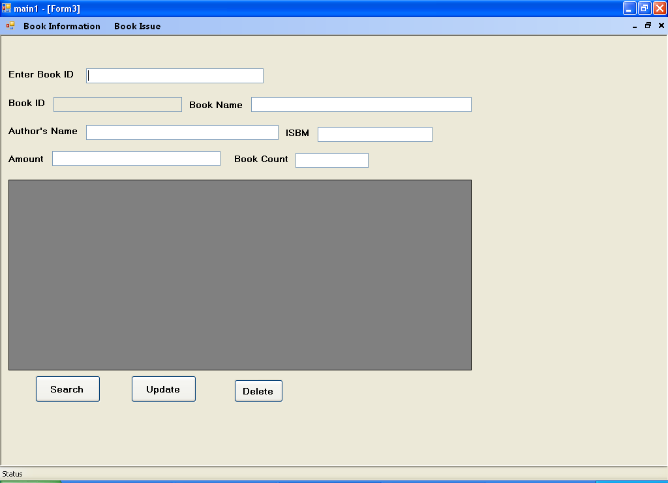

**Button3**

**Button2**

**Button1**

**Code of Form3**

using System;

using System.Collections.Generic;

using System.ComponentModel;

using System.Data;

using System.Drawing;

using System.Linq;

using System.Text;

using System.Windows.Forms;

using System.Data.OleDb;

namespace library_management

{

public partial class Form3 : Form

{

OleDbConnection con = new OleDbConnection();

OleDbCommand com;

OleDbCommand com1;

OleDbDataAdapter da;

DataSet ds;

public Form3()

{

InitializeComponent();

}

private void button1_Click(object sender, EventArgs e)

{

con.ConnectionString = "Provider=Microsoft.Jet.OLEDB.4.0; Data Source=library.mdb";

con.Open();

com = new OleDbCommand("select * from book where book_id='" +this.textBox1.Text+ "'", con);

da = new OleDbDataAdapter(com);

ds = new DataSet();

da.Fill(ds);

if (ds.Tables[0].Rows.Count > 0)

{

this.textBox1.Text = ds.Tables[0].Rows[0][0].ToString();

this.textBox6.Text = ds.Tables[0].Rows[0][0].ToString();

this.textBox2.Text = ds.Tables[0].Rows[0][1].ToString();

this.textBox3.Text = ds.Tables[0].Rows[0][2].ToString();

this.textBox4.Text = ds.Tables[0].Rows[0][3].ToString();

this.textBox5.Text = ds.Tables[0].Rows[0][4].ToString();

this.textBox7.Text = ds.Tables[0].Rows[0][5].ToString();

this.dataGridView1.DataSource = ds.Tables[0];

}

con.Close();

}

private void textBox1_KeyDown(object sender, KeyEventArgs e)

{

if (e.KeyCode == Keys.Enter)

{

con.ConnectionString = "Provider=Microsoft.Jet.OLEDB.4.0; Data Source=library.mdb";

con.Open();

com = new OleDbCommand("select * from book where book_id='" + this.textBox1.Text + "'", con);

da = new OleDbDataAdapter(com);

ds = new DataSet();

da.Fill(ds);

if (ds.Tables[0].Rows.Count > 0)

{

this.textBox1.Text = ds.Tables[0].Rows[0][0].ToString();

this.textBox6.Text = ds.Tables[0].Rows[0][0].ToString();

this.textBox2.Text = ds.Tables[0].Rows[0][1].ToString();

this.textBox3.Text = ds.Tables[0].Rows[0][2].ToString();

this.textBox4.Text = ds.Tables[0].Rows[0][3].ToString();

this.textBox5.Text = ds.Tables[0].Rows[0][4].ToString();

this.textBox7.Text = ds.Tables[0].Rows[0][5].ToString();

this.dataGridView1.DataSource = ds.Tables[0];

}

con.Close();

}

}

private void button2_Click(object sender, EventArgs e)

{

DialogResult dialog = MessageBox.Show("Do you want to update?", "Update", MessageBoxButtons.YesNo);

if (dialog == DialogResult.Yes)

{

con.ConnectionString = "Provider=Microsoft.Jet.OLEDB.4.0; Data Source=library.mdb";

con.Open();

string sql;

sql = "update book set book_name='" + this.textBox2.Text + "',book_author='" + this.textBox3.Text + "',isbm='" + this.textBox4.Text + "',amount=" + this.textBox5.Text + ", book_piece=" + this.textBox7.Text + " where book_id='" + this.textBox6.Text + "'";

com = new OleDbCommand(sql, con);

com.ExecuteNonQuery();

MessageBox.Show("Record updated successfully");

com1 = new OleDbCommand("select * from book where book_id='" + this.textBox6.Text + "'", con);

da = new OleDbDataAdapter(com1);

ds = new DataSet();

da.Fill(ds);

if (ds.Tables[0].Rows.Count > 0)

{

this.textBox1.Text = ds.Tables[0].Rows[0][0].ToString();

this.textBox6.Text = ds.Tables[0].Rows[0][0].ToString();

this.textBox2.Text = ds.Tables[0].Rows[0][1].ToString();

this.textBox3.Text = ds.Tables[0].Rows[0][2].ToString();

this.textBox4.Text = ds.Tables[0].Rows[0][3].ToString();

this.textBox5.Text = ds.Tables[0].Rows[0][4].ToString();

this.textBox7.Text = ds.Tables[0].Rows[0][5].ToString();

this.dataGridView1.DataSource = ds.Tables[0];

}

con.Close();

}

else if (dialog == DialogResult.No)

{

}

}

private void dataGridView1_CellContentClick(object sender, DataGridViewCellEventArgs e)

{

}

private void label5_Click(object sender, EventArgs e)

{

}

private void textBox3_TextChanged(object sender, EventArgs e)

{

}

private void label4_Click(object sender, EventArgs e)

{

}

private void textBox4_TextChanged(object sender, EventArgs e)

{

}

private void label3_Click(object sender, EventArgs e)

{

}

private void textBox5_TextChanged(object sender, EventArgs e)

{

}

private void textBox6_TextChanged(object sender, EventArgs e)

{

}

private void button3_Click(object sender, EventArgs e)

{

con.ConnectionString = "Provider=Microsoft.Jet.OLEDB.4.0; Data Source=library.mdb";

con.Open();

string sql;

sql = "delete * from book where book_id='" + this.textBox6.Text + "'";

com = new OleDbCommand(sql, con);

com.ExecuteNonQuery();

this.textBox1.Text = "";

this.textBox6.Text = "";

this.textBox2.Text = "";

this.textBox3.Text = "";

this.textBox4.Text = "";

this.textBox5.Text = "";

this.textBox7.Text = "";

this.dataGridView1.DataSource = "";

con.Close();

}

}

}

**Design of Form4**

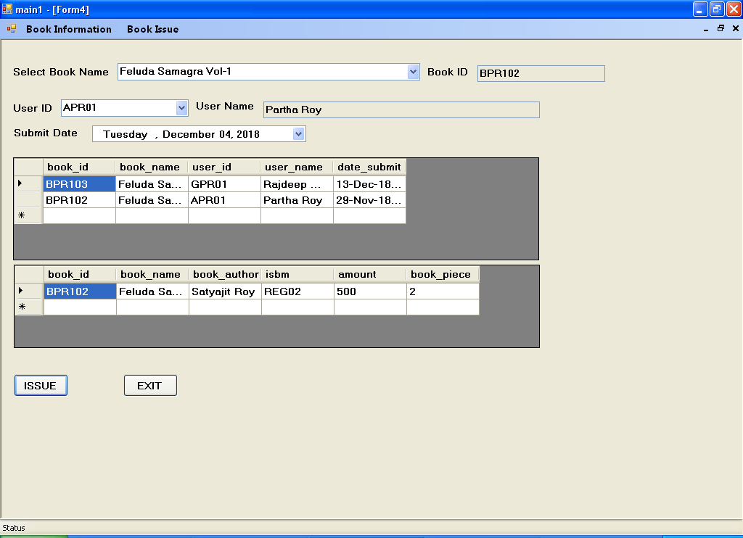

**Button2**

**Button1**

**Code of Form4**

using System;

using System.Collections.Generic;

using System.ComponentModel;

using System.Data;

using System.Drawing;

using System.Linq;

using System.Text;

using System.Windows.Forms;

using System.Data.OleDb;

namespace library_management

{

public partial class Form4 : Form

{

OleDbConnection con = new OleDbConnection();

OleDbCommand com;

OleDbCommand com1;

OleDbCommand com2;

OleDbCommand com3;

OleDbCommand com4;

OleDbCommand com5;

OleDbCommand com6;

OleDbDataAdapter da;

OleDbDataAdapter da1;

OleDbDataAdapter da2;

OleDbDataAdapter da3;

OleDbDataAdapter da4;

OleDbDataAdapter da5;

DataSet ds;

public Form4()

{

InitializeComponent();

}

private void dataGridView1_CellContentClick(object sender, DataGridViewCellEventArgs e)

{

}

private void button1_Click(object sender, EventArgs e)

{

DialogResult dialog = MessageBox.Show("Do you want to issue?", "Issue", MessageBoxButtons.YesNo);

if (dialog == DialogResult.Yes)

{

con.ConnectionString = "Provider=Microsoft.Jet.OLEDB.4.0; Data Source=library.mdb";

con.Open();

com5 = new OleDbCommand("select issue_status from logdata where user_id='" + this.comboBox2.Text + "'", con);

da4 = new OleDbDataAdapter(com5);

ds = new DataSet();

da4.Fill(ds, "yesno");

if (ds.Tables["yesno"].Rows.Count > 0)

{

string yesno = ds.Tables["yesno"].Rows[0][0].ToString();

if (yesno == "Yes")

{

MessageBox.Show("A book is already issue against this userid");

}

/* com4 = new OleDbCommand("select book_piece from book where book_name='" + this.comboBox1.Text + "'", con);

da2 = new OleDbDataAdapter(com4);

ds = new DataSet();

da2.Fill(ds, "2"); */

else

{

string sql;

sql = "insert into issue values('" + this.textBox2.Text + "','" + this.comboBox1.Text + "','" + this.comboBox2.Text + "','" + this.textBox4.Text + "','" + this.dateTimePicker1.Value + "')";

com = new OleDbCommand(sql, con);

com.ExecuteNonQuery();

com1 = new OleDbCommand("select * from issue where user_id='" + this.comboBox2.Text + "' order by date_submit", con);

da = new OleDbDataAdapter(com1);

ds = new DataSet();

da.Fill(ds);

if (ds.Tables[0].Rows.Count > 0)

{

this.dataGridView1.DataSource = ds.Tables[0];

}

string sqlx;

sqlx = "update book set book_piece=book_piece-1 where book_id='" + this.textBox2.Text + "'";

com2 = new OleDbCommand(sqlx, con);

com2.ExecuteNonQuery();

com3 = new OleDbCommand("select * from book where book_id='" + this.textBox2.Text + "'", con);

da1 = new OleDbDataAdapter(com3);

ds = new DataSet();

da1.Fill(ds, "1");

if (ds.Tables[0].Rows.Count > 0)

{

this.dataGridView2.DataSource = ds.Tables[0];

}

string sqlp = "update logdata set issue_status='Yes' where user_id='" + this.comboBox2.Text + "'";

com6 = new OleDbCommand(sqlp, con);

com6.ExecuteNonQuery();

this.comboBox1.Text = "";

this.textBox2.Text = "";

this.comboBox2.Text = "";

this.textBox4.Text = "";

}

}

con.Close();

}

else if (dialog == DialogResult.No)

{

}

}

private void button2_Click(object sender, EventArgs e)

{

this.comboBox1.Text = "";

this.textBox2.Text = "";

this.comboBox2.Text = "";

this.textBox4.Text = "";

this.Hide();

main1 mn1 = new main1();

mn1.Show();

}

private void comboBox1_SelectedIndexChanged(object sender, EventArgs e)

{

con.ConnectionString = "Provider=Microsoft.Jet.OLEDB.4.0; Data Source=library.mdb";

con.Open();

com = new OleDbCommand("select book_id from book where book_name='" + this.comboBox1.Text + "'", con);

da = new OleDbDataAdapter(com);

ds = new DataSet();

da.Fill(ds);

if (ds.Tables[0].Rows.Count > 0)

{

this.textBox2.Text = ds.Tables[0].Rows[0][0].ToString();

}

com1 = new OleDbCommand("select * from book where book_name='" + this.comboBox1.Text + "'", con);

da1 = new OleDbDataAdapter(com1);

ds = new DataSet();

da1.Fill(ds,"1");

if (ds.Tables[0].Rows.Count > 0)

{

this.dataGridView2.DataSource = ds.Tables[0];

}

con.Close();

}

private void comboBox2_SelectedIndexChanged(object sender, EventArgs e)

{

con.ConnectionString = "Provider=Microsoft.Jet.OLEDB.4.0; Data Source=library.mdb";

con.Open();

com = new OleDbCommand("select user_name from logdata where user_id='" + this.comboBox2.Text + "'", con);

da = new OleDbDataAdapter(com);

ds = new DataSet();

da.Fill(ds);

if (ds.Tables[0].Rows.Count > 0)

{

this.textBox4.Text = ds.Tables[0].Rows[0][0].ToString();

}

con.Close();

}

}

}

**Design of Form5**

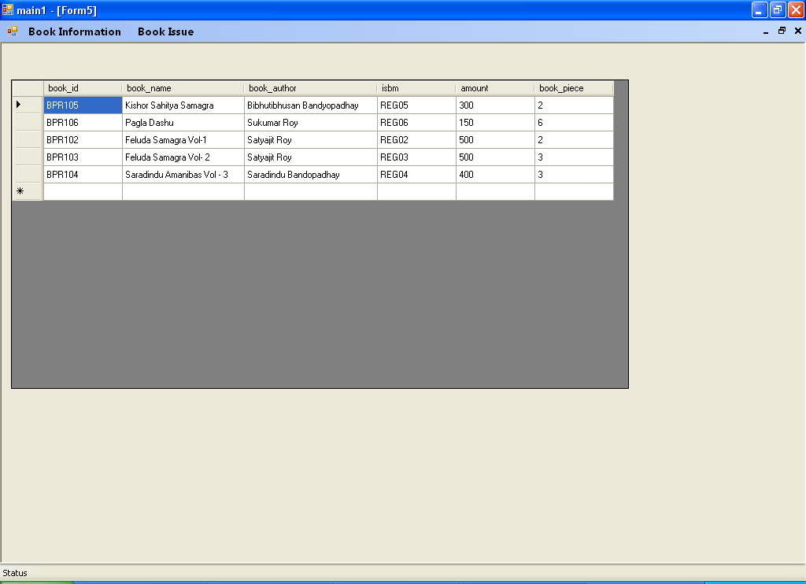

**Design of Form6**

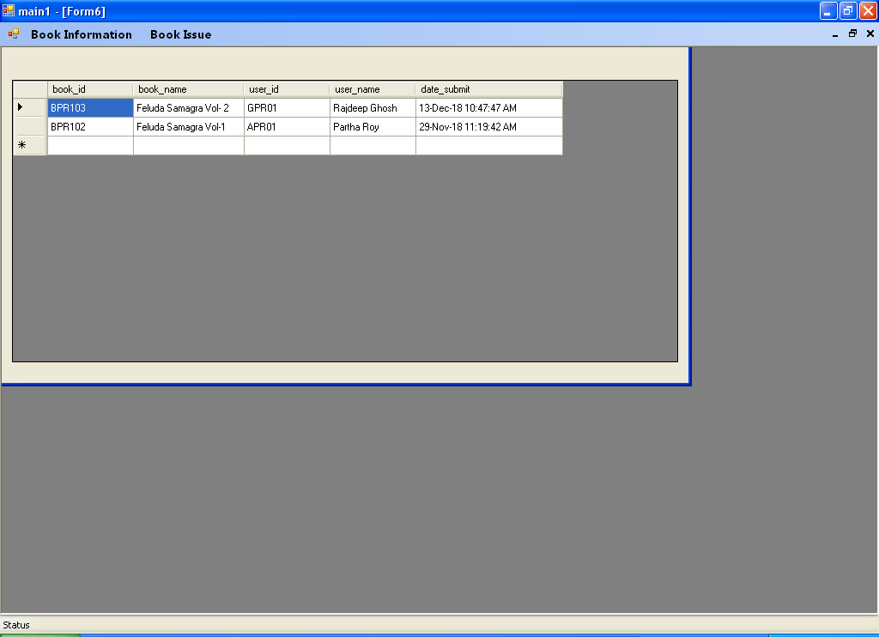

**Design of Form8**

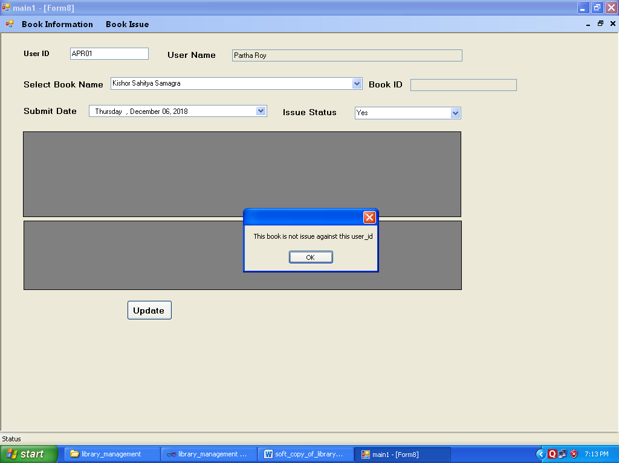

**Button1**

**Code of Form8**

using System;

using System.Collections.Generic;

using System.ComponentModel;

using System.Data;

using System.Drawing;

using System.Linq;

using System.Text;

using System.Windows.Forms;

using System.Data.OleDb;

namespace library_management

{

public partial class Form8 : Form

{

OleDbConnection con = new OleDbConnection();

OleDbCommand com;

OleDbCommand com1;

OleDbCommand com2;

OleDbCommand com3;

OleDbCommand com4;

OleDbCommand com5;

OleDbCommand com6;

OleDbDataAdapter da;

OleDbDataAdapter da1;

OleDbDataAdapter da2;

OleDbDataAdapter da3;

OleDbDataAdapter da4;

OleDbDataAdapter da5;

DataSet ds;

public Form8()

{

InitializeComponent();

}

private void label4_Click(object sender, EventArgs e)

{

}

private void button1_Click(object sender, EventArgs e)

{

}

private void button2_Click(object sender, EventArgs e)

{

con.ConnectionString = "Provider=Microsoft.Jet.OLEDB.4.0; Data Source=library.mdb";

con.Open();

string sqlx;

sqlx = "update logdata set issue_status='" + this.comboBox2.Text + "' where user_id='" + this.textBox1.Text + "'";

com2 = new OleDbCommand(sqlx, con);

com2.ExecuteNonQuery();

MessageBox.Show("Book received");

con.Close();

}

private void textBox1_KeyDown(object sender, KeyEventArgs e)

{

if (e.KeyCode == Keys.Enter)

{

con.ConnectionString = "Provider=Microsoft.Jet.OLEDB.4.0; Data Source=library.mdb";

con.Open();

com = new OleDbCommand("select user_name from issue where user_id='" + this.textBox1.Text + "'", con);

da = new OleDbDataAdapter(com);

ds = new DataSet();

da.Fill(ds);

if (ds.Tables[0].Rows.Count > 0)

{

this.textBox4.Text = ds.Tables[0].Rows[0][0].ToString();

}

com1 = new OleDbCommand("select issue_status from logdata where user_id='" + this.textBox1.Text + "'", con);

da1 = new OleDbDataAdapter(com1);

ds = new DataSet();

da1.Fill(ds, "noyes");

if (ds.Tables["noyes"].Rows.Count > 0)

{

this.comboBox2.Text = ds.Tables["noyes"].Rows[0][0].ToString();

}

con.Close();

}

}

private void button3_Click(object sender, EventArgs e)

{

}

private void comboBox1_SelectedIndexChanged(object sender, EventArgs e)

{

con.ConnectionString = "Provider=Microsoft.Jet.OLEDB.4.0; Data Source=library.mdb";

con.Open();

com = new OleDbCommand("select book_id,date_submit from issue where user_id='" + this.textBox1.Text + "' and book_name='" +this.comboBox1.Text+ "'", con);

da = new OleDbDataAdapter(com);

ds = new DataSet();

da.Fill(ds);

if (ds.Tables[0].Rows.Count > 0)

{

this.textBox2.Text = ds.Tables[0].Rows[0][0].ToString();

this.dateTimePicker1.Text = ds.Tables[0].Rows[0][1].ToString();

}

else

{

MessageBox.Show("This book is not issue against this user_id");

}

con.Close();

}

}

}

**Design of Form7**

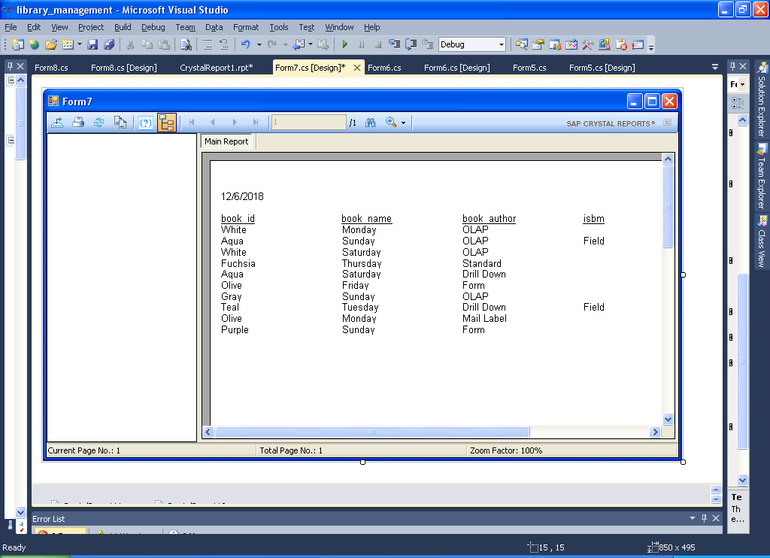

**Design of CrystalReport1**

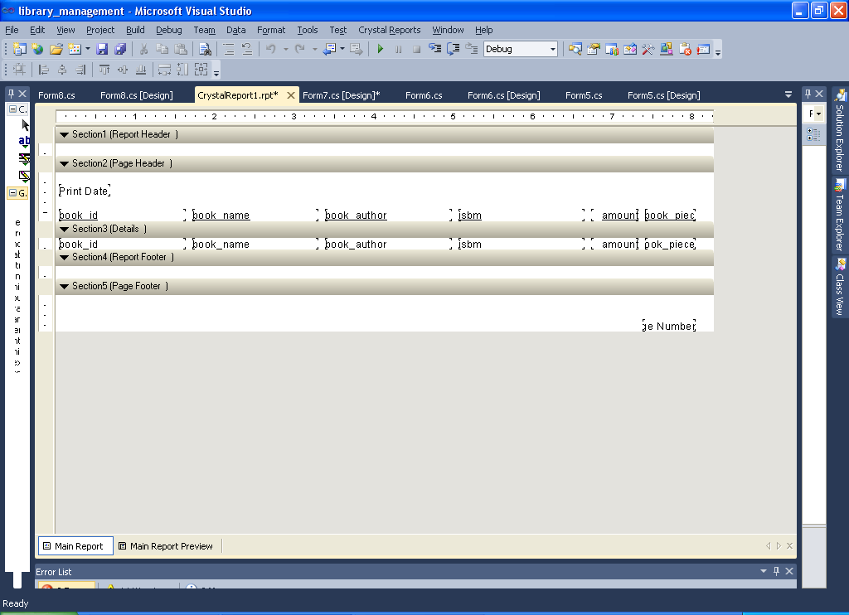

**DATABASE NAME :- library.mdb**

**TABLE NAME :- book**

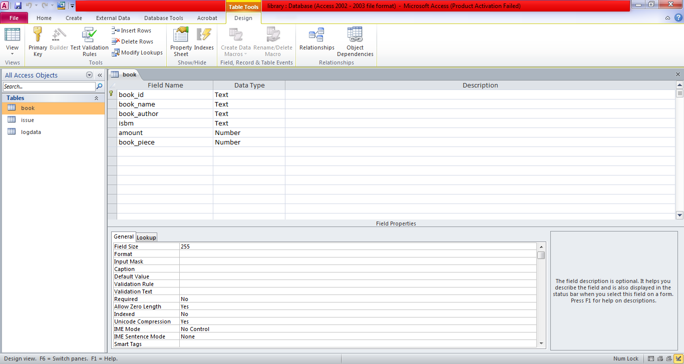

**DATABASE NAME :- library**

**TABLE NAME :- issue**

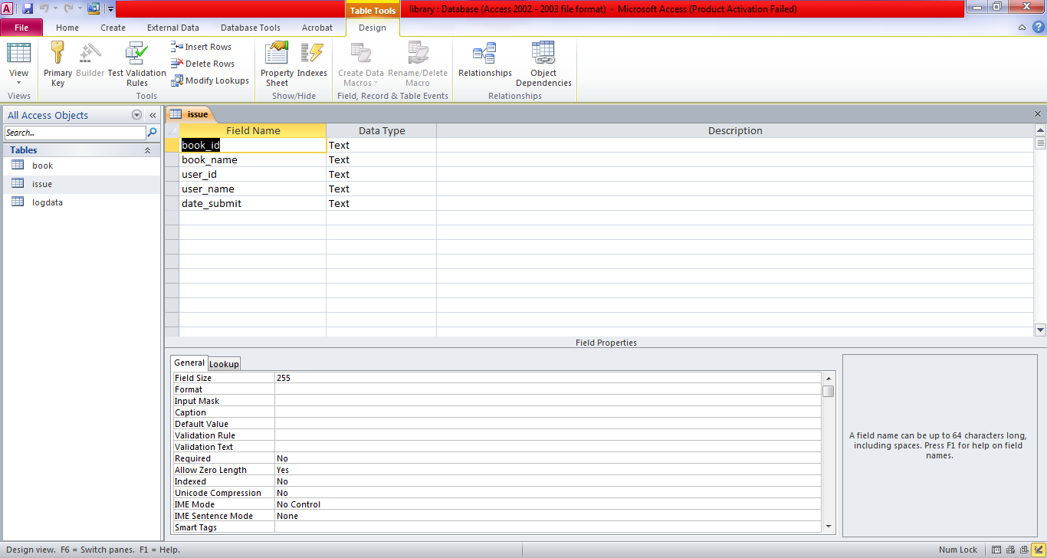

**DATABASE NAME :- library**

**TABLE NAME :- logdata**

