**Design of Default4.aspx**

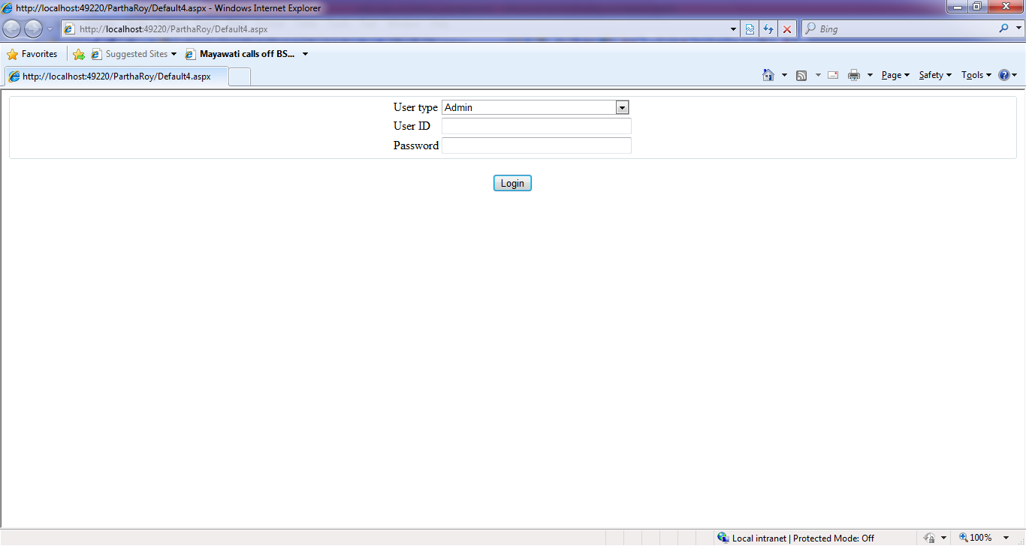

**Code of Default4.aspx.cs**

using System;

using System.Collections.Generic;

using System.Linq;

using System.Web;

using System.Web.UI;

using System.Web.UI.WebControls;

using System.Data;

using System.Data.Odbc;

public partial class Default4 : System.Web.UI.Page

{

OdbcConnection con = new OdbcConnection();

OdbcCommand com;

OdbcDataAdapter da;

DataSet ds;

protected void Page_Load(object sender, EventArgs e)

{

}

protected void Button1_Click(object sender, EventArgs e)

{

con = new OdbcConnection(@"DRIVER={Microsoft Access Driver (*.mdb)}; DBQ=E:\CHEMISTRY\MY COMPUTER\my_project\RKMSCC_PROJECT\ParthaRoy\school.mdb");

con.Open();

string sql = "select * from login where usertype='" + this.DropDownList1.Text + "' and userid='" + this.TextBox1.Text + "' and password='" + this.TextBox2.Text + "'";

OdbcDataAdapter da= new OdbcDataAdapter(sql, con);

ds = new DataSet();

da.Fill(ds);

if (ds.Tables[0].Rows.Count > 0)

{

Response.Redirect("Default.aspx");

}

else

{

Response.Write("<script>alert('Pleasae select correct usertype and enter valid user id and password');</script>");

this.DropDownList1.Text = "";

this.TextBox1.Text = "";

this.TextBox2.Text = "";

}

con.Close();

}

}

**Design of Default.aspx**

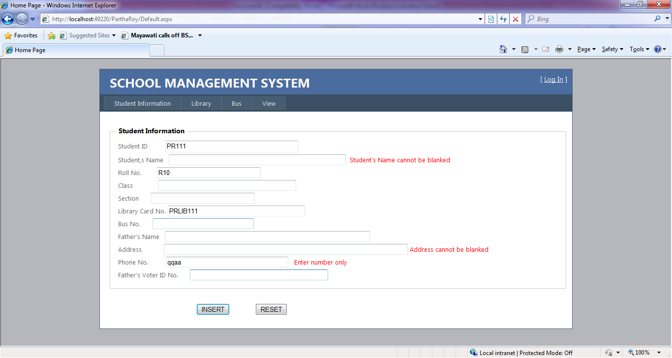

Button1

Compare Validator

Required Field Validator

Required Field Validator

**Code of Default.aspx.cs**

using System;

using System.Collections.Generic;

using System.Linq;

using System.Web;

using System.Web.UI;

using System.Web.UI.WebControls;

using System.Data;

using System.Data.Odbc;

public partial class _Default : System.Web.UI.Page

{

OdbcConnection con = new OdbcConnection();

OdbcCommand com;

OdbcDataAdapter da;

DataSet ds;

protected void Page_Load(object sender, EventArgs e)

{

con = new OdbcConnection(@"DRIVER={Microsoft Access Driver (*.mdb)}; DBQ=E:\CHEMISTRY\MY COMPUTER\my_project\RKMSCC_PROJECT\ParthaRoy\school.mdb");

con.Open();

try

{

string sql = "select max(student_id), max(roll_no), max(library_card_no) from student";

da = new OdbcDataAdapter(sql, con);

ds = new DataSet();

da.Fill(ds);

if (ds.Tables[0].Rows.Count > 0)

{

string stringtoint = ds.Tables[0].Rows[0][0].ToString().Substring(2);

string stringtoint2 = ds.Tables[0].Rows[0][1].ToString().Substring(1);

string stringtoint3 = ds.Tables[0].Rows[0][2].ToString().Substring(5);

int num = Convert.ToInt16(stringtoint) + 1;

int num2 = Convert.ToInt16(stringtoint2) + 1;

int num3 = Convert.ToInt16(stringtoint3) + 1;

string inttostring = "PR" + num.ToString();

string inttostring2 = "R" + num2.ToString();

string inttostring3 = "PRLIB" + num3.ToString();

TextBox1.Text = inttostring.ToString();

TextBox3.Text = inttostring2.ToString();

TextBox6.Text = inttostring3.ToString();

}

}

catch

{

TextBox1.Text = "PR101";

TextBox3.Text = "R101";

TextBox6.Text = "PRLIB101";

}

finally

{

con.Close();

}

}

protected void Button1_Click(object sender, EventArgs e)

{

con = new OdbcConnection(@"DRIVER={Microsoft Access Driver (*.mdb)}; DBQ=E:\CHEMISTRY\MY COMPUTER\my_project\RKMSCC_PROJECT\ParthaRoy\school.mdb");

con.Open();

string sql = "insert into student values('" + this.TextBox1.Text + "','" + this.TextBox2.Text + "','" + this.TextBox3.Text + "','" + this.TextBox4.Text + "','" + this.TextBox5.Text + "','" + this.TextBox6.Text + "','" + this.TextBox7.Text + "','" + this.TextBox8.Text + "','" + this.TextBox10.Text + "','" + this.TextBox11.Text + "','" + this.TextBox12.Text + "')";

com = new OdbcCommand(sql, con);

com.ExecuteNonQuery();

try

{

string sqlx = "select max(student_id), max(roll_no), max(library_card_no) from student";

da = new OdbcDataAdapter(sqlx, con);

ds = new DataSet();

da.Fill(ds);

if (ds.Tables[0].Rows.Count > 0)

{

string stringtoint = ds.Tables[0].Rows[0][0].ToString().Substring(2);

string stringtoint2 = ds.Tables[0].Rows[0][1].ToString().Substring(1);

string stringtoint3 = ds.Tables[0].Rows[0][2].ToString().Substring(5);

int num = Convert.ToInt16(stringtoint) + 1;

int num2 = Convert.ToInt16(stringtoint2) + 1;

int num3 = Convert.ToInt16(stringtoint3) + 1;

string inttostring = "PR" + num.ToString();

string inttostring2 = "R" + num2.ToString();

string inttostring3 = "PRLIB" + num3.ToString();

TextBox1.Text = inttostring.ToString();

TextBox3.Text = inttostring2.ToString();

TextBox6.Text = inttostring3.ToString();

}

}

catch

{

TextBox1.Text = "PR101";

TextBox3.Text = "R101";

TextBox6.Text = "PRLIB101";

}

finally

{

con.Close();

}

clear();

}

public void clear()

{

this.TextBox2.Text = "";

this.TextBox4.Text = "";

this.TextBox5.Text = "";

this.TextBox7.Text = "";

this.TextBox8.Text = "";

this.TextBox10.Text = "";

this.TextBox11.Text = "";

this.TextBox12.Text = "";

}

protected void Button2_Click(object sender, EventArgs e)

{

clear();

}

}

**Design of Defaul2.aspx**

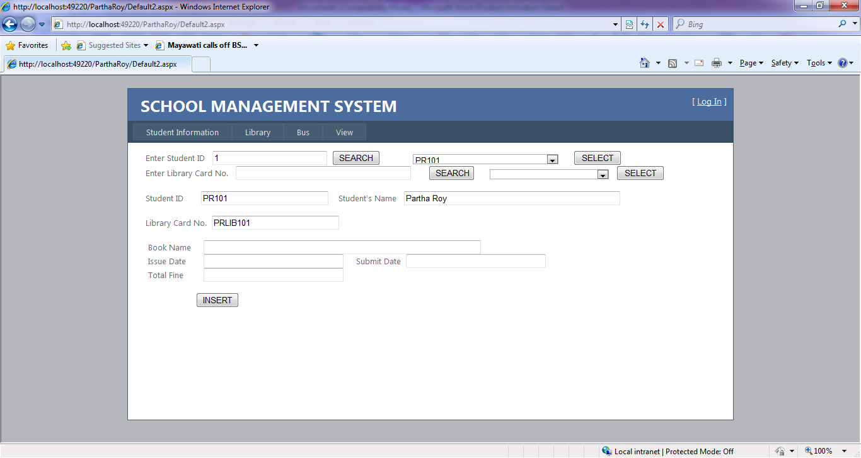

**Code of Default2.aspx.cs**

using System;

using System.Collections.Generic;

using System.Linq;

using System.Web;

using System.Web.UI;

using System.Web.UI.WebControls;

using System.Data;

using System.Data.Odbc;

public partial class Default2 : System.Web.UI.Page

{

OdbcConnection con = new OdbcConnection();

OdbcCommand com;

OdbcDataAdapter da;

DataSet ds;

protected void Page_Load(object sender, EventArgs e)

{

}

protected void GridView1_SelectedIndexChanged(object sender, EventArgs e)

{

}

protected void TextBox1_TextChanged(object sender, EventArgs e)

{

}

protected void TextBox2_TextChanged(object sender, EventArgs e)

{

}

protected void Button1_Click(object sender, EventArgs e)

{

con = new OdbcConnection(@"DRIVER={Microsoft Access Driver (*.mdb)}; DBQ=E:\CHEMISTRY\MY COMPUTER\my_project\RKMSCC_PROJECT\ParthaRoy\school.mdb");

con.Open();

string sql = "select student_id from student where student_id like '%" + this.TextBox1.Text + "%' order by student_id ";

OdbcDataReader dr = new OdbcCommand(sql, con).ExecuteReader();

while(dr.Read())

{

this.DropDownList1.Items.Add(dr.GetValue(0).ToString());

}

con.Close();

}

protected void Button2_Click(object sender, EventArgs e)

{

con = new OdbcConnection(@"DRIVER={Microsoft Access Driver (*.mdb)}; DBQ=E:\CHEMISTRY\MY COMPUTER\my_project\RKMSCC_PROJECT\ParthaRoy\school.mdb");

con.Open();

string sql = "select library_card_no from student where library_card_no like '%" + this.TextBox2.Text + "%' order by library_card_no ";

OdbcDataReader dr = new OdbcCommand(sql, con).ExecuteReader();

while(dr.Read())

{

this.DropDownList2.Items.Add(dr.GetValue(0).ToString());

}

con.Close();

}

protected void Button3_Click(object sender, EventArgs e)

{

this.DropDownList2.Text = "";

con = new OdbcConnection(@"DRIVER={Microsoft Access Driver (*.mdb)}; DBQ=E:\CHEMISTRY\MY COMPUTER\my_project\RKMSCC_PROJECT\ParthaRoy\school.mdb");

con.Open();

string sql = "select student_id,student_name,library_card_no from student where student_id='" + this.DropDownList1.Text + "'";

da = new OdbcDataAdapter(sql, con);

ds = new DataSet();

da.Fill(ds);

if (ds.Tables[0].Rows.Count > 0)

{

this.TextBox3.Text = ds.Tables[0].Rows[0][0].ToString();

this.TextBox4.Text = ds.Tables[0].Rows[0][1].ToString();

this.TextBox5.Text = ds.Tables[0].Rows[0][2].ToString();

}

con.Close();

}

protected void Button4_Click(object sender, EventArgs e)

{

this.DropDownList1.Text = "";

con = new OdbcConnection(@"DRIVER={Microsoft Access Driver (*.mdb)}; E:\CHEMISTRY\MY COMPUTER\my_project\RKMSCC_PROJECT\ParthaRoy\school.mdb");

con.Open();

string sql = "select student_id,student_name,library_card_no from student where library_card_no='" + this.DropDownList2.Text + "'";

da = new OdbcDataAdapter(sql, con);

ds = new DataSet();

da.Fill(ds);

if (ds.Tables[0].Rows.Count > 0)

{

this.TextBox3.Text = ds.Tables[0].Rows[0][0].ToString();

this.TextBox4.Text = ds.Tables[0].Rows[0][1].ToString();

this.TextBox5.Text = ds.Tables[0].Rows[0][2].ToString();

}

con.Close();

}

protected void Button5_Click(object sender, EventArgs e)

{

con = new OdbcConnection(@"DRIVER={Microsoft Access Driver (*.mdb)}; DBQ=E:\CHEMISTRY\MY COMPUTER\my_project\RKMSCC_PROJECT\ParthaRoy\school.mdb");

con.Open();

string sql = "insert into library values('" + this.TextBox3.Text + "','" + this.TextBox5.Text + "','" + this.TextBox6.Text + "','" + this.TextBox7.Text + "','" + this.TextBox8.Text + "','" + this.TextBox9.Text + "')";

com = new OdbcCommand(sql, con);

com.ExecuteNonQuery();

con.Close();

this.TextBox6.Text = "";

this.TextBox7.Text = "";

this.TextBox8.Text = "";

this.TextBox9.Text = "";

}

}

**Design of About.aspx**

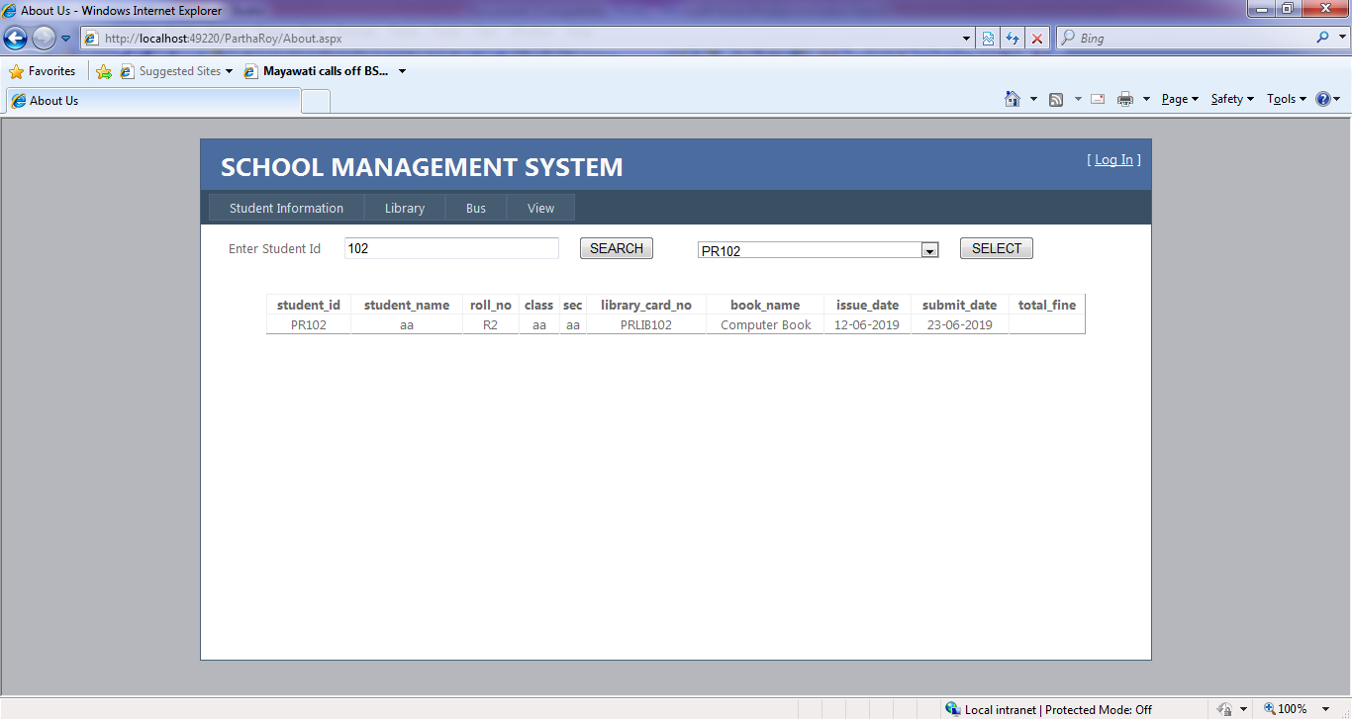

**Code of About.aspx.cs**

using System;

using System.Collections.Generic;

using System.Linq;

using System.Web;

using System.Web.UI;

using System.Web.UI.WebControls;

using System.Data;

using System.Data.Odbc;

public partial class About : System.Web.UI.Page

{

OdbcConnection con = new OdbcConnection();

OdbcCommand com;

OdbcDataAdapter da;

DataSet ds;

protected void Page_Load(object sender, EventArgs e)

{

}

protected void Button1_Click(object sender, EventArgs e)

{

con = new OdbcConnection(@"DRIVER={Microsoft Access Driver (*.mdb)}; DBQ=E:\CHEMISTRY\MY COMPUTER\my_project\RKMSCC_PROJECT\ParthaRoy\school.mdb");

con.Open();

string sql = "select student_id from student where student_id like '%" + this.TextBox1.Text + "%' order by student_id ";

OdbcDataReader dr = new OdbcCommand(sql, con).ExecuteReader();

while (dr.Read())

{

this.DropDownList1.Items.Add(dr.GetValue(0).ToString());

}

con.Close();

}

protected void Button3_Click(object sender, EventArgs e)

{

con = new OdbcConnection(@"DRIVER={Microsoft Access Driver (*.mdb)}; DBQ=E:\CHEMISTRY\MY COMPUTER\my_project\RKMSCC_PROJECT\ParthaRoy\school.mdb");

con.Open();

string sql = "select s.student_id,s.student_name,s.roll_no,s.class,s.sec,l.library_card_no,l.book_name,l.issue_date,l.submit_date,l.total_fine from student s, library l where s.student_id=l.student_id and s.student_id='" + this.DropDownList1.Text + "'";

da = new OdbcDataAdapter(sql, con);

ds = new DataSet();

da.Fill(ds);

if (ds.Tables[0].Rows.Count > 0)

{

this.GridView1.DataSource = ds.Tables[0];

this.GridView1.DataBind();

}

else

{

Response.Write("<script>alert('Record not found');</script>");

}

con.Close();

}

}

**Design of Default3.aspx**

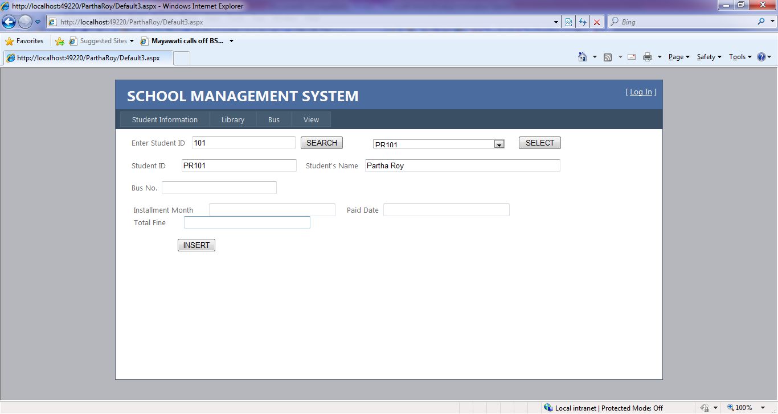

**Code of Default3.aspx.cs**

using System;

using System.Collections.Generic;

using System.Linq;

using System.Web;

using System.Web.UI;

using System.Web.UI.WebControls;

using System.Data;

using System.Data.Odbc;

public partial class Default3 : System.Web.UI.Page

{

OdbcConnection con = new OdbcConnection();

OdbcCommand com;

OdbcDataAdapter da;

DataSet ds;

protected void Page_Load(object sender, EventArgs e)

{

}

protected void Button1_Click(object sender, EventArgs e)

{

con = new OdbcConnection(@"DRIVER={Microsoft Access Driver (*.mdb)}; DBQ=E:\CHEMISTRY\MY COMPUTER\my_project\RKMSCC_PROJECT\ParthaRoy\school.mdb");

con.Open();

string sql = "select student_id from student where student_id like '%" + this.TextBox1.Text + "%' order by student_id ";

OdbcDataReader dr = new OdbcCommand(sql, con).ExecuteReader();

while (dr.Read())

{

this.DropDownList1.Items.Add(dr.GetValue(0).ToString());

}

con.Close();

}

protected void Button2_Click(object sender, EventArgs e)

{

}

protected void Button3_Click(object sender, EventArgs e)

{

con = new OdbcConnection(@"DRIVER={Microsoft Access Driver (*.mdb)}; DBQ=E:\CHEMISTRY\MY COMPUTER\my_project\RKMSCC_PROJECT\ParthaRoy\school.mdb");

con.Open();

string sql = "select student_id,student_name,bus_no from student where student_id='" + this.DropDownList1.Text + "'";

da = new OdbcDataAdapter(sql, con);

ds = new DataSet();

da.Fill(ds);

if (ds.Tables[0].Rows.Count > 0)

{

this.TextBox3.Text = ds.Tables[0].Rows[0][0].ToString();

this.TextBox4.Text = ds.Tables[0].Rows[0][1].ToString();

this.TextBox5.Text = ds.Tables[0].Rows[0][2].ToString();

}

con.Close();

}

protected void Button4_Click(object sender, EventArgs e)

{

}

protected void Button5_Click(object sender, EventArgs e)

{

if (this.TextBox5.Text == "")

{

Response.Write("<script>alert('This student does not select bus service yet');</script>");

}

else

{

con = new OdbcConnection(@"DRIVER={Microsoft Access Driver (*.mdb)}; DBQ=E:\CHEMISTRY\MY COMPUTER\my_project\RKMSCC_PROJECT\ParthaRoy\school.mdb");

con.Open();

string sql = "insert into bus values('" + this.TextBox3.Text + "','" + this.TextBox5.Text + "','" + this.TextBox7.Text + "','" + this.TextBox8.Text + "','" + this.TextBox9.Text + "')";

com = new OdbcCommand(sql, con);

com.ExecuteNonQuery();

con.Close();

Response.Write("<script>alert('Data inserted successfully');</script>");

this.TextBox7.Text = "";

this.TextBox8.Text = "";

this.TextBox9.Text = "";

}

}

}

**Design of Default5.aspx**

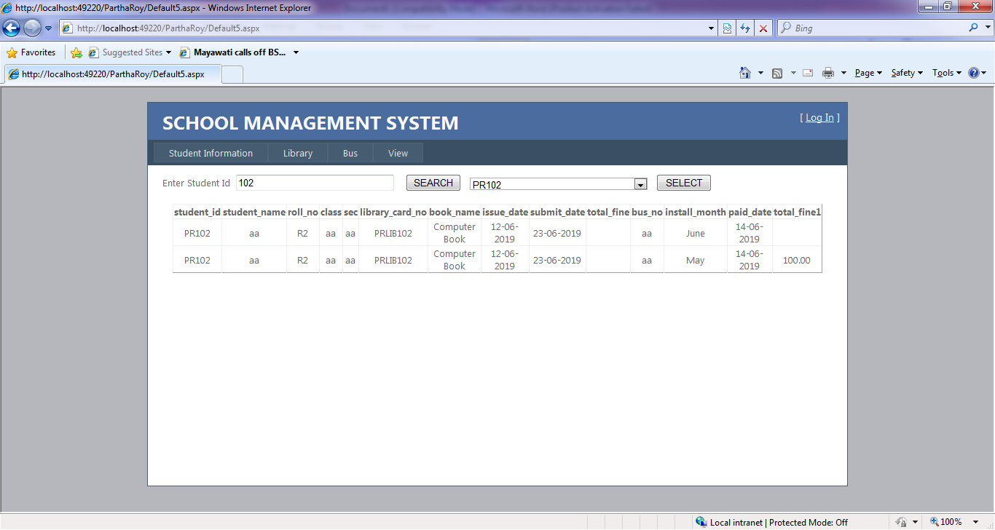

**Code of Default5.aspx.cs**

using System;

using System.Collections.Generic;

using System.Linq;

using System.Web;

using System.Web.UI;

using System.Web.UI.WebControls;

using System.Data;

using System.Data.Odbc;

public partial class Default5 : System.Web.UI.Page

{

OdbcConnection con = new OdbcConnection();

OdbcCommand com;

OdbcDataAdapter da;

DataSet ds;

protected void Page_Load(object sender, EventArgs e)

{

}

protected void Button1_Click(object sender, EventArgs e)

{

con = new OdbcConnection(@"DRIVER={Microsoft Access Driver (*.mdb)}; DBQ=E:\CHEMISTRY\MY COMPUTER\my_project\RKMSCC_PROJECT\ParthaRoy\school.mdb");

con.Open();

string sql = "select student_id from student where student_id like '%" + this.TextBox1.Text + "%' order by student_id ";

OdbcDataReader dr = new OdbcCommand(sql, con).ExecuteReader();

while (dr.Read())

{

this.DropDownList1.Items.Add(dr.GetValue(0).ToString());

}

con.Close();

}

protected void Button3_Click(object sender, EventArgs e)

{

con = new OdbcConnection(@"DRIVER={Microsoft Access Driver (*.mdb)}; DBQ=E:\CHEMISTRY\MY COMPUTER\my_project\RKMSCC_PROJECT\ParthaRoy\school.mdb");

con.Open();

string sql = "select s.student_id,s.student_name,s.roll_no,s.class,s.sec,l.library_card_no,l.book_name,l.issue_date,l.submit_date,l.total_fine,b.bus_no,b.install_month,b.paid_date,b.total_fine from student s, library l, bus b where s.student_id=l.student_id and s.student_id=b.student_id and s.student_id='" + this.DropDownList1.Text + "'";

da = new OdbcDataAdapter(sql, con);

ds = new DataSet();

da.Fill(ds);

if (ds.Tables[0].Rows.Count > 0)

{

this.GridView1.DataSource = ds.Tables[0];

this.GridView1.DataBind();

}

else

{

Response.Write("<script>alert('Record not found');</script>");

}

con.Close();

}

}