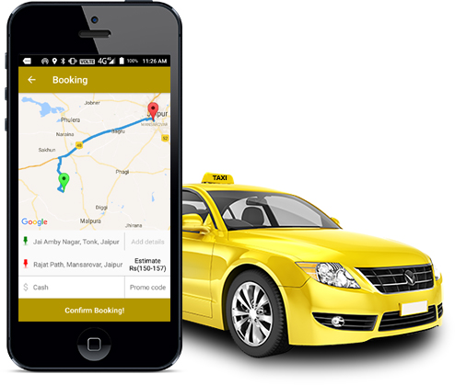

**JSP**

**PROJECT ON**

**ONLINE TAXI BOOKING**

**ACKNOWLEDGEMENT :-**

I am highly grateful to my teachers for their valuable guidance to complete this project in time.I am also thankful to my class teacher who has learnt me the use of netbeans java software and importance of that software and also encouraged me to fulfill the project.

**NAME :- PARTHA ROY**

**ROLL :- C04201811**

**BATCH :- CACPA04/2018**

**PROJECT NAME :- ONLINE TAXI BOOKING WITH JSP**

**COURSE- CACPA**

**EQUIPMENT USED:-**

**1. HARDWARE EQUIPMENT-**

1. INPUT DEVICE- KEYBOARD, MOUSE
2. PROCESSING UNIT- INTEL CORE I5 PROCESSOR
3. MEMORY- RAM (CAPACITY 8 GB)
4. STORAGE DEVICE- HARD DISK, COMPACT DISK
5. OUTPUT DEVICE- MONITOR

**2. SOFTWARE EQUIPMENT-**

1. SYSTEM SOFTWARE-MICROSOFT WINDOWS 10 PRO
2. APPLICATION SOFTWARE- a) Netbeans Java

b) Wamp Server for mysql database software

**INDEX**

**Subject**  **Page No.**

Design & Code of index.html______________________________________________1-2

Design & Code of custinsert.jsp ____________________________________________3-7

Design & Code of custdisplay.jsp ___________________________________________8-14

Design & Code of newcss.css______________________________________________15-16