**Design of index.html**

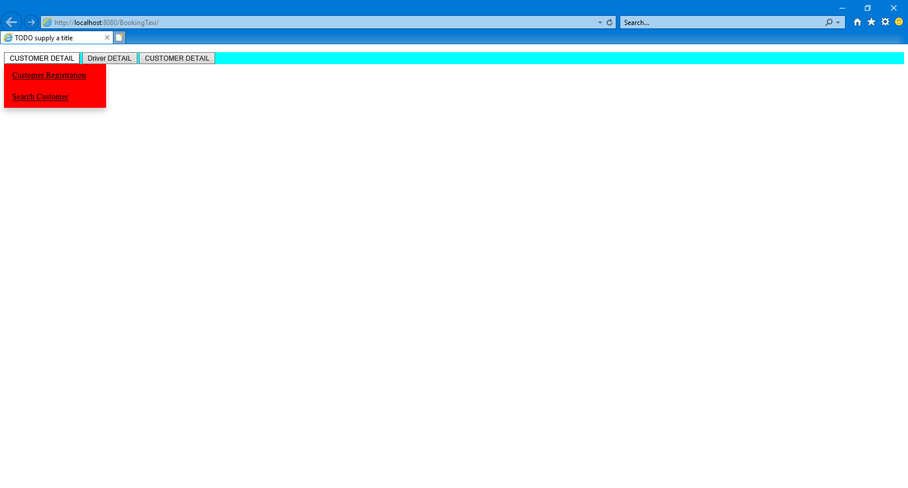

**Code of index.html**

<!DOCTYPE html>

<!--

To change this license header, choose License Headers in Project Properties.

To change this template file, choose Tools | Templates

and open the template in the editor.

-->

<html>

<head>

<title>TODO supply a title</title>

<meta charset="UTF-8">

<meta name="viewport" content="width=device-width, initial-scale=1.0">

<link href="newcss.css" rel="stylesheet" type="text/css"/>

</head>

<body>

<div style="background-color: cyan;">

<p>

<div class="dropdown">

<button class="dropbtn">CUSTOMER DETAIL</button>

<div class="dropdown-content">

<a href="custinsert.jsp">Customer Registration</a>

<a href="custdisplay.jsp">Search Customer</a>

</div>

</div>

<div class="dropdown">

<button class="dropbtn">Driver DETAIL</button>

<div class="dropdown-content">

<a href="">Driver Registration</a>

<a href="">Search Driver</a>

</div>

</div>

<div class="dropdown">

<button class="dropbtn">BOOKING</button>

<div class="dropdown-content">

<a href=""></a>

<a href=""></a>

</div>

</div>

</p>

</div>

</body>

</html>

**Design of custinsert.jsp**

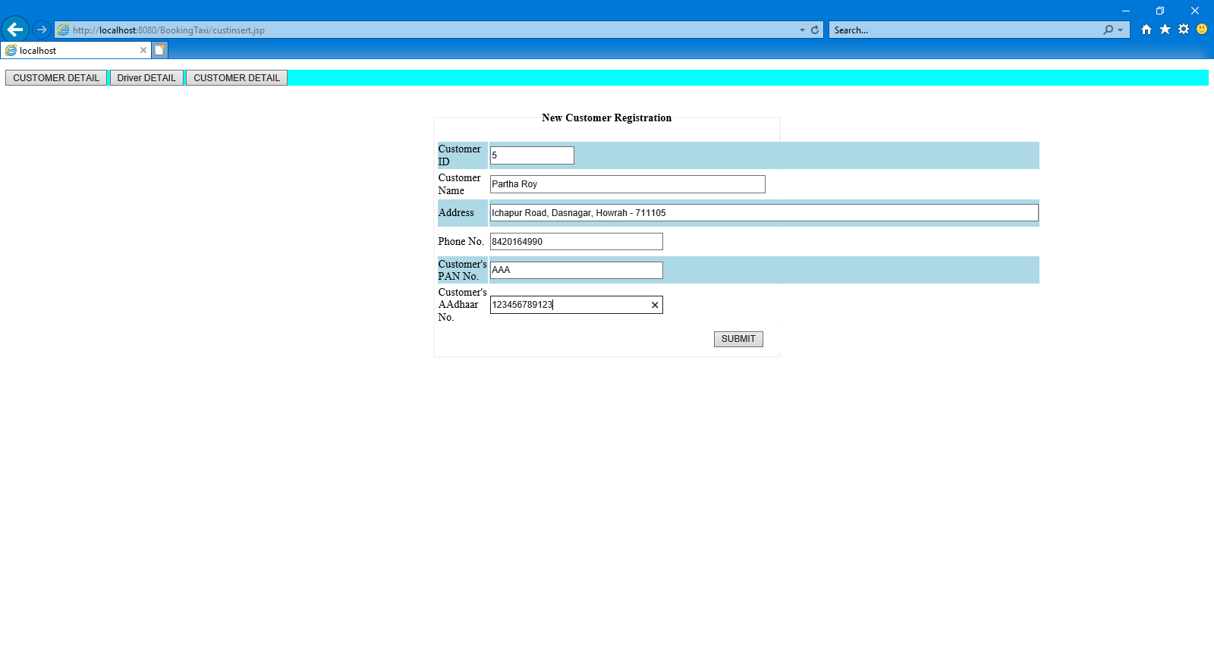

**Code of custinsert.jsp**

<%--

Document : custinsert

Created on : Jun 26, 2019, 10:53:37 AM

Author : Admin

--%>

<%@page contentType="text/html" pageEncoding="UTF-8"%>

<%@page language="java" import="java.sql.*"%>

<%

Connection con=null;

String url="jdbc:mysql://localhost:3306/";

String db="prtaxi";

String driver="com.mysql.jdbc.Driver";

String username="root";

Statement st;

Class.forName(driver).newInstance();

con=DriverManager.getConnection(url+db,username,"");

st=con.createStatement();

String cust_id=request.getParameter("cid");

String cust_name=request.getParameter("cnm");

String cust_address=request.getParameter("cads");

String cust_ph=request.getParameter("cph");

String cust_pan=request.getParameter("cpan");

String cust_adhar=request.getParameter("cadhar");

if(cust_id!=null)

st.executeUpdate("insert into customer(cust_id,cust_name,cust_address,cust_ph,cust_pan,cust_adhar) values('" +cust_id+ "','" +cust_name+ "','" +cust_address+ "','" +cust_ph+ "','" +cust_pan+ "','" +cust_adhar+ "')");

%>

<%--

Connection conx=null;

String urlx="jdbc:mysql://localhost:3306/";

String dbx="prtaxi";

String driverx="com.mysql.jdbc.Driver";

String usernm="root";

Statement stat;

Class.forName(driverx).newInstance();

conx=DriverManager.getConnection(urlx+dbx,usernm,"");

stat=conx.createStatement();

String sqlx="select max(cust_id)+1 from customer";

ResultSet res=stat.executeQuery(sqlx);

--%>

<!DOCTYPE html>

<html>

<head>

<meta http-equiv="Content-Type" content="text/html; charset=UTF-8">

<link href="newcss.css" rel="stylesheet" type="text/css"/>

<script>

function validate(){

var z=document.forms["myform"]["cph"];

if(!/^[0-9]+$/.test(z)){

alert("Please enter number only");

}

}

</script>

</head>

<body>

<div style="background-color: cyan;">

<p>

<div class="dropdown">

<button class="dropbtn">CUSTOMER DETAIL</button>

<div class="dropdown-content">

<a href="custinsert.jsp">Customer Registration</a>

<a href="custdisplay.jsp">Search Customer</a>

</div>

</div>

<div class="dropdown">

<button class="dropbtn">Driver DETAIL</button>

<div class="dropdown-content">

<a href="">Driver Registration</a>

<a href="">Search Driver</a>

</div>

</div>

<div class="dropdown">

<button class="dropbtn">CUSTOMER DETAIL</button>

<div class="dropdown-content">

<a href="">Customer Registration</a>

<a href="">Search Registration</a>

</div>

</div>

</p>

</div>

<center><fieldset style="width:500px;">

<legend><h4><b>New Customer Registration</b></h4></legend>

<form method="post" action="custinsert.jsp" name="myform">

<table width="70%">

<tr bgcolor="lightblue" height="40px">

<td align="left" width="15%">Customer ID</td><td><input type="text" name="cid" style="width:120px; height:20px;" /></td>

</tr>

<tr bgcolor="white" height="40px">

<td align="left" width="15%">Customer Name</td><td><input type="text" name="cnm" style="width:400px; height:20px;"></td>

</tr>

<tr bgcolor="lightblue" height="40px">

<td align="left" width="15%">Address</td><td><input type="text" name="cads" style="width:800px; height:20px;"></td>

</tr>

<tr bgcolor="white" height="40px">

<td align="left" width="15%">Phone No.</td><td><input type="text" name="cph" style="width:250px; height:20px;" onkeypress="if (isNaN(this.value + String.fromCharCode(event.keyCode)))return false;"></td>

</tr>

<tr bgcolor="lightblue" height="40px">

<td align="left" width="15%">Customer's PAN No.</td><td><input type="text" name="cpan" style="width:250px; height:20px;"></td>

</tr>

<tr bgcolor="white" height="40px">

<td align="left" width="15%">Customer's AAdhaar No.</td><td><input type="text" name="cadhar" style="width:250px; height:20px;" onkeypress="if (isNaN(this.value + String.fromCharCode(event.keyCode)))return false;"></td>

</tr>

<tr bgcolor="white" height="40px">

<td colspan="2" align="center"><input type="submit" name="insert" value="SUBMIT" />

</tr>

</table>

</form>

</fieldset></center>

</body>

</html>

**Design of custdisplay.jsp**

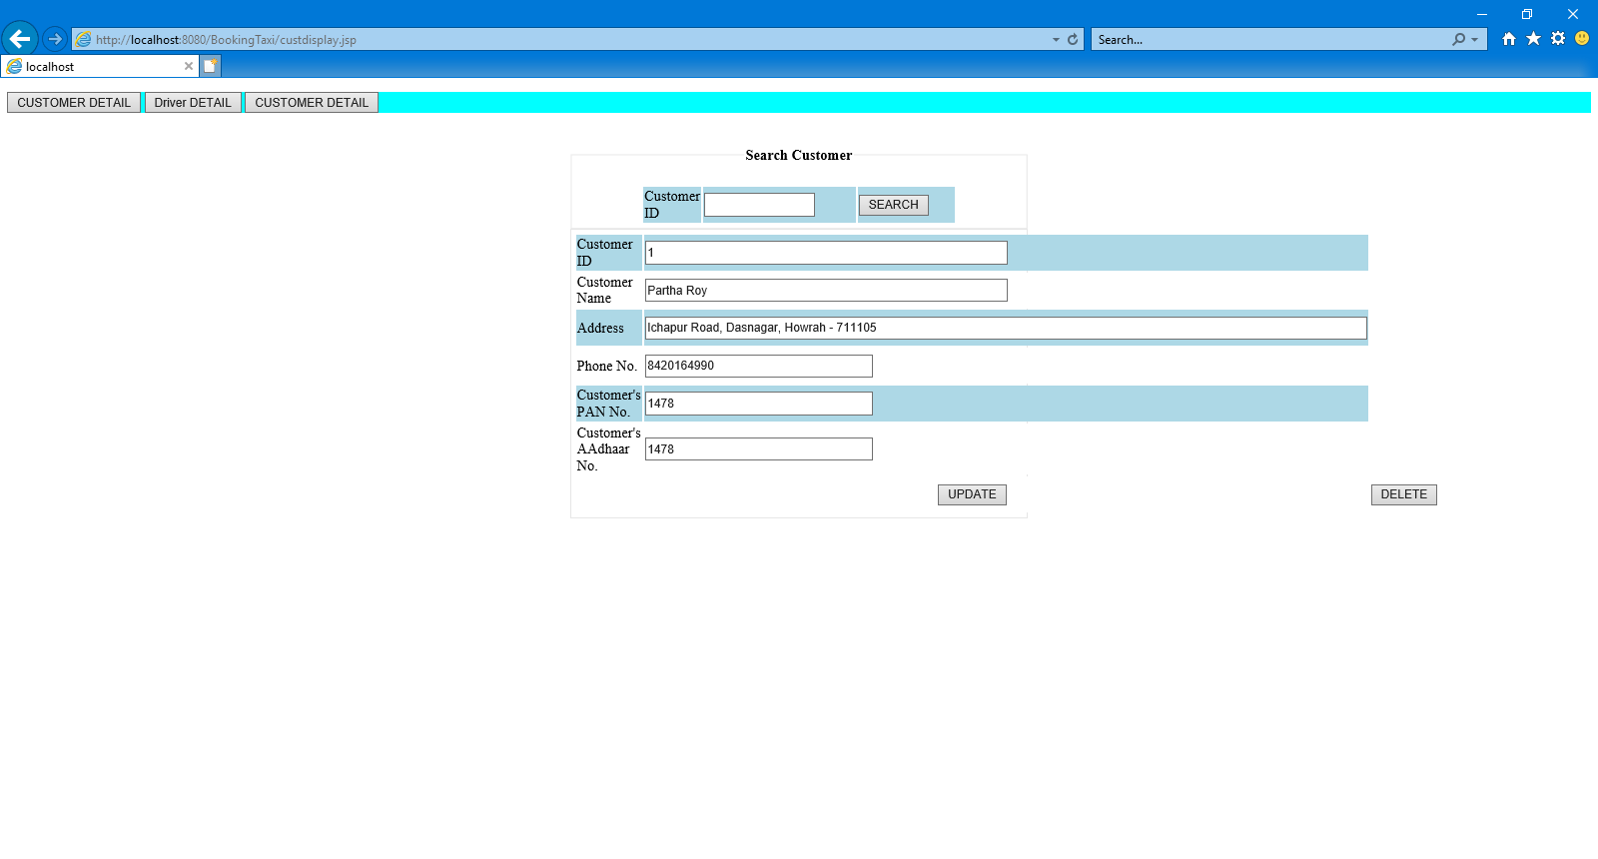

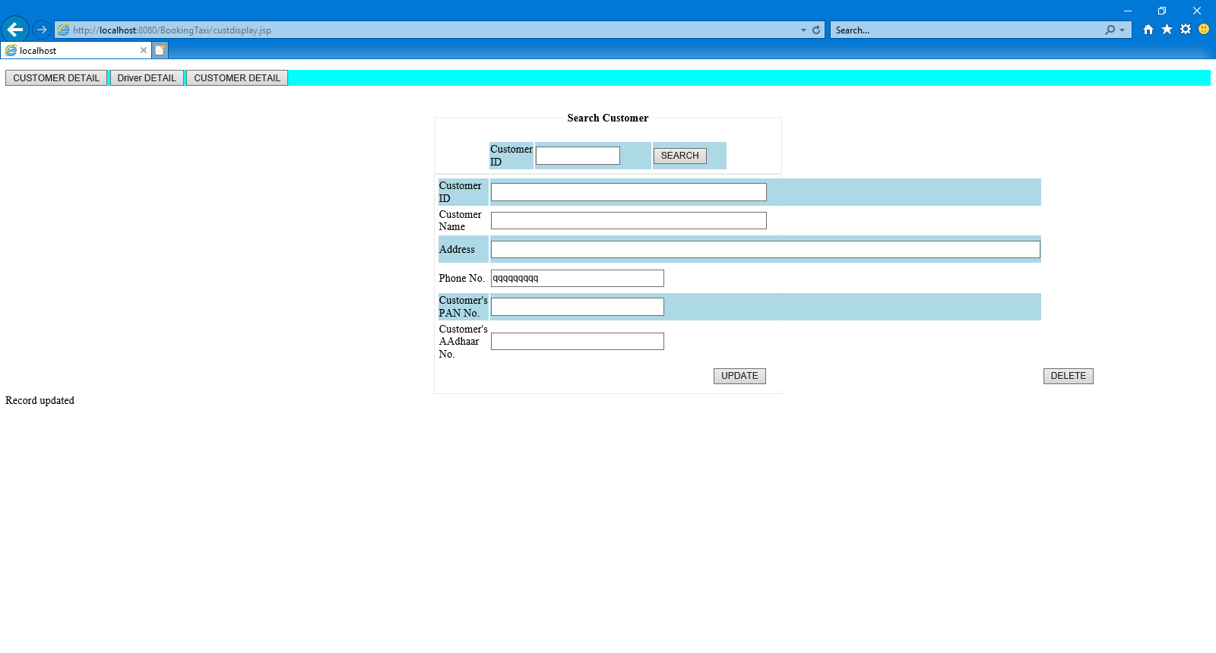

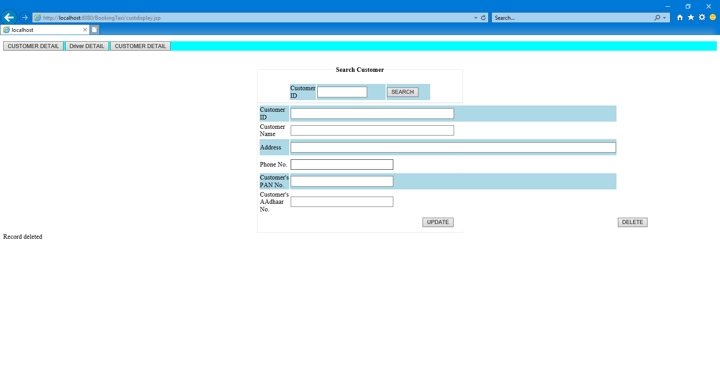

**Code of custdisplay.jsp**

<%--

Document : custdisplay

Created on : Jun 26, 2019, 10:56:45 AM

Author : Admin

--%>

<%@page contentType="text/html" pageEncoding="UTF-8"%>

<%@page language="java" import="java.sql.*"%>

<!DOCTYPE html>

<html>

<head>

<meta http-equiv="Content-Type" content="text/html; charset=UTF-8">

<link href="newcss.css" rel="stylesheet" type="text/css"/>

</head>

<body>

<div style="background-color: cyan;">

<p>

<div class="dropdown">

<button class="dropbtn">CUSTOMER DETAIL</button>

<div class="dropdown-content">

<a href="custinsert.jsp">Customer Registration</a>

<a href="custdisplay.jsp">Search Customer</a>

</div>

</div>

<div class="dropdown">

<button class="dropbtn">Driver DETAIL</button>

<div class="dropdown-content">

<a href="">Driver Registration</a>

<a href="">Search Driver</a>

</div>

</div>

<div class="dropdown">

<button class="dropbtn">CUSTOMER DETAIL</button>

<div class="dropdown-content">

<a href="">Customer Registration</a>

<a href="">Search Registration</a>

</div>

</div>

</p>

</div>

<center><fieldset style="width:500px;">

<legend><h4><b>Search Customer</b></h4></legend>

<form method="post" action="custdisplay.jsp">

<table width="70%">

<tr bgcolor="lightblue" height="40px">

<td align="left" width="15%">Customer ID</td>

<td><input type="text" name="cid" style="width:120px; height:20px;"></td>

<td><input type="submit" name="search" value="SEARCH" /></td>

</tr>

</table>

</fieldset></center>

<%

Connection con=null;

String url="jdbc:mysql://localhost:3306/";

String db="prtaxi";

String driver="com.mysql.jdbc.Driver";

String username="root";

Statement st;

Class.forName(driver).newInstance();

con=DriverManager.getConnection(url+db,username,"");

st=con.createStatement();

String cust_id=request.getParameter("cid");

String sql="select * from customer where cust_id='"+cust_id+ "'";

ResultSet rs=st.executeQuery(sql);

if(rs.next())

{ %>

<center><fieldset style="width:500px;">

<table width="70%">

<tr bgcolor="lightblue" height="40px">

<td align="left" width="15%">Customer ID</td><td><input type="text" name="custid" style="width:400px; height:20px;" value='<%=rs.getString(1)%>' readonly></td>

</tr>

<tr bgcolor="white" height="40px">

<td align="left" width="15%">Customer Name</td><td><input type="text" name="cnm" style="width:400px; height:20px;" value='<%=rs.getString(2)%>'></td>

</tr>

<tr bgcolor="lightblue" height="40px">

<td align="left" width="15%">Address</td><td><input type="text" name="cads" style="width:800px; height:20px;" value='<%=rs.getString(3)%>'></td>

</tr>

<tr bgcolor="white" height="40px">

<td align="left" width="15%">Phone No.</td><td><input type="text" name="cph" style="width:250px; height:20px;" value='<%=rs.getString(4)%>'></td>

</tr>

<tr bgcolor="lightblue" height="40px">

<td align="left" width="15%">Customer's PAN No.</td><td><input type="text" name="cpan" style="width:250px; height:20px;" value='<%=rs.getString(5)%>'></td>

</tr>

<tr bgcolor="white" height="40px">

<td align="left" width="15%">Customer's AAdhaar No.</td><td><input type="text" name="cadhar" style="width:250px; height:20px;" value='<%=rs.getString(6)%>'></td>

</tr>

<tr bgcolor="white" height="40px">

<td colspan="2" align="center"><input type="submit" name="update" value="UPDATE" />

<td colspan="2" align="center"><input type="submit" name="delete" value="DELETE" />

</tr>

</table>

<% }%>

</form>

</fieldset></center>

</body>

</html>

<%

if(request.getParameter("update")!=null)

{

Connection conx=null;

String urlx="jdbc:mysql://localhost:3306/";

String dbx="prtaxi";

String driverx="com.mysql.jdbc.Driver";

String usernm="root";

Statement stat;

Class.forName(driverx).newInstance();

conx=DriverManager.getConnection(urlx+dbx,usernm,"");

stat=conx.createStatement();

String cst_id=request.getParameter("custid");

String cust_name=request.getParameter("cnm");

String cust_address=request.getParameter("cads");

String cust_ph=request.getParameter("cph");

String cust_pan=request.getParameter("cpan");

String cust_adhar=request.getParameter("cadhar");

if(cst_id!=null)

{

stat.executeUpdate("update customer set cust_name='" +cust_name+ "',cust_address='" +cust_address+ "',cust_ph='" +cust_ph+ "',cust_pan='" +cust_pan+ "',cust_adhar='" +cust_adhar+ "' where cust_id='" +cst_id+ "'");

out.println("Record updated");

}

}

else if(request.getParameter("delete")!=null){

Connection cond=null;

String urld="jdbc:mysql://localhost:3306/";

String dbd="prtaxi";

String driverd="com.mysql.jdbc.Driver";

String usernmd="root";

Statement statd;

Class.forName(driverd).newInstance();

cond=DriverManager.getConnection(urld+dbd,usernmd,"");

statd=cond.createStatement();

String cs_id=request.getParameter("custid");

if(cs_id!=null)

{

statd.executeUpdate("delete from customer where cust_id='" +cs_id+ "'");

out.println("Record deleted");

}

}

**%>**

**Code of newcss.css**

/*

To change this license header, choose License Headers in Project Properties.

To change this template file, choose Tools | Templates

and open the template in the editor.

*/

/*

Created on : Jun 24, 2019, 10:28:29 AM

Author : Admin

*/

.drpbtn{

background-color: seagreen;

color: white;

padding:20px 30px;

border: none;

cursor: pointer;

}

.dropdown{

position: relative;

display: inline-block;

}

.dropdown-content{

display: none;

position: absolute;

background-color: red;

min-width: 200px;

box-shadow: 0px 8px 16px 0px rgba(0,0,0,0.2);

z-index: 1;

}

.dropdown-content a{

color: black;

padding: 12px 16px;

display: block;

}

.dropdown-content a:hover{

background-color: silver;

}

.dropdown:hover .dropdown-content{

display: block;

}

.dropdown:hover .dropbtn{

background-color: white;

}