VALUE ADDED COURSE
PROJECT REPORT
AI Data Cleaning Assistant
with Python
Submitted by
Periyannan Ratish N
B.Tech – Artificial Intelligence and Data Science (III Year)
Dhanalakshmi College of Engineering
Register No.: ______________________
Faculty Guide: ______________________
October 2026

Abstract
Real-world datasets are rarely ready for analysis. They contain missing values, duplicate rows, inconsistent spellings, wrong data types, impossible values and outliers, and data scientists commonly spend the majority of their time fixing these problems by hand. This project presents the AI Data Cleaning Assistant, a Python application that automates the process end to end.
The assistant accepts a CSV or Excel file, profiles it, produces data-driven recommendations, and then runs a configurable 15-step cleaning pipeline built on pandas, NumPy and scikit-learn. Machine-learning techniques are used where simple rules fall short: fuzzy string matching merges near-duplicate category labels ("Chenai" → "Chennai"), automatic type inference recovers numbers, dates and booleans hidden in text ("Rs. 31,499", "15 Oct 2019", "Y/N"), Isolation Forest detects multivariate anomalies, and K-Nearest-Neighbour imputation fills numeric gaps from similar rows. Every action is written to an audit log so that the user can see exactly what changed.
The tool is delivered as a Streamlit web application, a command-line utility and a tested Python library (15 automated tests). On a deliberately messy 428-row sample dataset it raised the data-quality score from 81.3 to 99.6 out of 100, reduced missing/placeholder cells from 995 to 28, removed 27 duplicate rows and collapsed 25 inconsistent city spellings into 7.
Keywords: data cleaning, data preprocessing, fuzzy matching, outlier detection, KNN imputation, Isolation Forest, Streamlit, pandas.

Table of Contents

1. Introduction

1.1 Background
Data preparation is the least glamorous but most time-consuming stage of any data-science or machine-learning project. Surveys of practitioners repeatedly report that cleaning and organising data takes a large share of project time. Models trained on dirty data give unreliable results – the well-known principle of "garbage in, garbage out".
Typical problems include blank or placeholder entries ("N/A", "null", "-"), numbers stored as text with currency symbols, dates written in several formats, the same city spelled five different ways, duplicated records, and values that are physically impossible such as an age of 250.

1.2 Problem Statement
Manual cleaning in spreadsheets or ad-hoc scripts is slow, error-prone, inconsistent between analysts, and leaves no record of what was changed. There is a need for a tool that detects these problems automatically, applies safe and explainable fixes, and lets a non-programmer review and control the process.

1.3 Objectives
- Build a Python engine that profiles a dataset and detects common data-quality problems automatically.
- Apply AI / machine-learning techniques – fuzzy matching, Isolation Forest, KNN imputation, type inference – for problems that rigid rules cannot solve.
- Give the user control through a simple web interface with configurable options.
- Record every change in an audit log and measure improvement with a data-quality score.
- Validate correctness with automated tests on a realistic messy dataset.

1.4 Scope
The system handles tabular data in CSV and Excel formats held in memory. It targets structured business-type data (customers, employees, sales). It does not perform domain-specific semantic checks beyond simple range rules, and it does not call external APIs, so data never leaves the user's machine.

2. Literature Review and Existing Systems
Several tools address data cleaning. OpenRefine offers powerful clustering-based cleaning but requires manual interaction column by column. Trifacta and similar commercial platforms are costly and cloud-based. In Python, libraries such as pandas provide the primitives (dropna, fillna, drop_duplicates) but the analyst must write and sequence the code. scikit-learn provides KNNImputer and IsolationForest, while the standard-library module difflib implements the Ratcliff/Obershelp sequence-matching algorithm used for similarity scoring.
Tool | Strength | Limitation
Excel / Sheets | Familiar, visual | Manual; no audit trail; poor at scale
OpenRefine | Strong clustering | Manual, column by column; no ML imputation
Pandas scripts | Flexible | Needs coding every time; not reusable by non-programmers
This project | Automatic, explainable, ML-assisted, free | In-memory; English-language heuristics

2.1 Proposed System
The proposed assistant combines the flexibility of a Python library with the usability of a point-and-click dashboard. It inspects the data first, tells the user what is wrong, then applies a pipeline whose every step can be switched on or off. The outcome is a cleaned file plus a complete log.

3. System Requirements
Category | Specification
Hardware | Any laptop/desktop, 4 GB RAM minimum (8 GB recommended), no GPU required
Operating system | Windows 10/11, Linux or macOS
Language | Python 3.10 or later
Libraries | pandas, NumPy, scikit-learn, Streamlit, openpyxl, pytest
Browser | Any modern browser (Chrome, Edge, Firefox) for the Streamlit interface

4. System Design

4.1 Architecture
The application follows a layered design. The core engine (cleaning.py) contains pure functions that take a DataFrame and return the new DataFrame together with log entries. Two thin front-ends – the Streamlit web app (app.py) and a command-line tool (clean_cli.py) – call the same engine, so behaviour is identical everywhere.
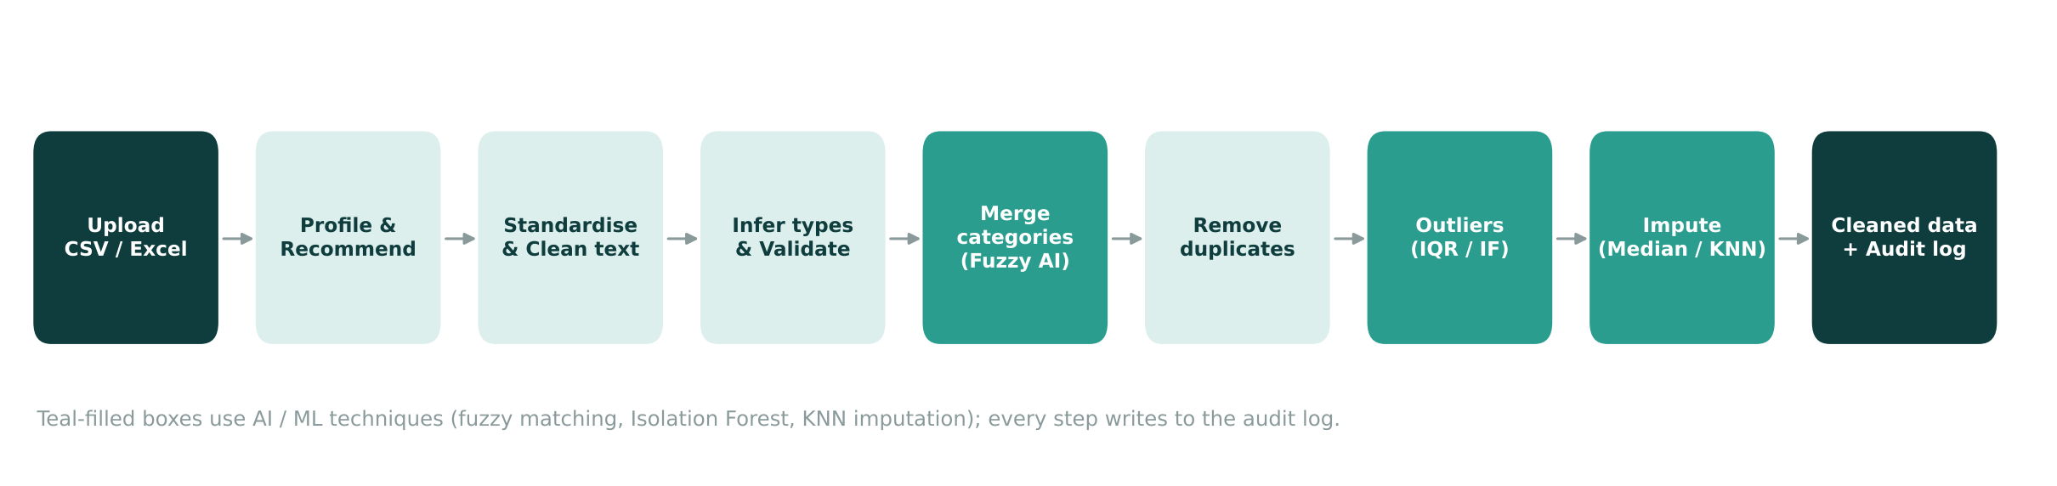
Figure 4.1 – Cleaning pipeline. Teal boxes use AI / ML techniques.

4.2 Modules
Module | Responsibility
Profiler | Counts rows, columns, missing cells, duplicates; per-column dtype, missing % and unique values
Recommender | Reads the profile and suggests steps (e.g. "Column 'Age' is stored as text but looks like numeric")
Cleaning pipeline | Fifteen small, individually testable functions chained by clean_dataframe()
Quality scorer | Single 0–100 score to quantify improvement
Audit logger | Records step name, description and number of values affected
Streamlit UI | Upload, options sidebar, before/after metrics, charts, downloads
CLI | Batch cleaning from the terminal

4.3 Data-quality score
To make improvement measurable, the assistant computes a score out of 100 as a weighted sum: 50% completeness (share of non-missing cells), 30% uniqueness (share of non-duplicate rows) and 20% consistency (share of text columns that really contain text rather than numbers, dates or booleans stored as strings).

5. Implementation

5.1 Cleaning steps
The pipeline runs the steps below in a fixed order chosen so that each step benefits from the previous one – for example, placeholders are converted to real missing values before type inference, and outliers are handled before imputation so that extreme values do not distort medians.
# | Step | Technique / behaviour
1 | Standardise column names | Convert to snake_case, make duplicates unique ("E mail" → e_mail)
2 | Text clean-up | Trim and collapse repeated whitespace
3 | Placeholders | "N/A", "null", "-", "?", "unknown" … → real missing values
4 | Drop empty rows / sparse columns | Remove all-blank rows; drop columns more than 60 % empty (adjustable)
5 | Type inference (AI) | Detect numeric (currency symbols, commas, %), datetime (mixed formats) and boolean (Yes/No/Y/N) hidden in text
6 | E-mail validation | Lower-case, regex check, invalid addresses set to missing
7 | Category merge (AI) | Fuzzy matching with difflib; rare spellings mapped to the most frequent similar label
8 | Manual mappings | User-defined synonyms (Bengaluru = Bangalore)
9 | Duplicate removal | Exact duplicates, run again after normalisation
10 | Range rules | Age 0–100, scores 0–100, no negative salary/price – impossible values become missing
11 | Outlier handling (AI) | IQR per column, or Isolation Forest (multivariate); action = cap, remove or flag
12 | Numeric imputation (AI) | Median, mean or KNN (5 nearest rows)
13 | Categorical imputation | Most frequent value or "Unknown"; skipped for ID-like columns
14 | Integer restoration | Whole-number columns (age) converted back to integers
15 | Final duplicate pass | Normalisation can expose new duplicates

5.2 Key design decisions
- Explainability first. Each function returns a log entry, so nothing changes silently.
- Safe defaults. Identifier-like columns (IDs, names, e-mails, phone numbers) are never fuzzy-merged or imputed, because guessing would corrupt them.
- Date handling. Year-first dates (2022/05/12) are read as Y/M/D, others day-first (18-05-2022), matching Indian usage. An early version misread 2022/05/12 as 5 December; a regression test now prevents this.
- Fuzzy threshold. A similarity of 0.82 merges "Chenai" with "Chennai" but keeps "Male" and "Female" (similarity 0.80) apart; the threshold is adjustable in the UI.

5.3 Selected code
Date parsing (handles mixed formats correctly):
def _parse_dates(series: pd.Series) -> pd.Series:
"""Parse mixed date strings. Year-first dates (2022/05/12) are read as Y/M/D,
everything else (18-05-2022) is read day-first, as is usual in India."""
s = series.astype("object")
iso = s.map(lambda v: isinstance(v, str) and bool(_ISO_RE.match(v)))
a = pd.to_datetime(s.where(iso), errors="coerce", format="mixed", dayfirst=False)
b = pd.to_datetime(s.where(~iso), errors="coerce", format="mixed", dayfirst=True)
return a.fillna(b)

Fuzzy category matching:
def _find_variants(series: pd.Series, threshold: float) -> dict:
"""Map each rare spelling to the most frequent spelling it closely resembles."""
vals = series.dropna().astype(str)
counts = vals.value_counts()
# Group case/space-insensitive first, then fuzzy-match remaining labels
canon_of: dict[str, str] = {}
ordered = list(counts.index) # most frequent first
reps: list[str] = []
for label in ordered:
key = label.strip().lower()
placed = False
for rep in reps:
if key == rep.strip().lower() or SequenceMatcher(None, key, rep.strip().lower()).ratio() >= threshold:
canon_of[label] = rep
placed = True
break
if not placed:
reps.append(label)
canon_of[label] = label
return {k: v for k, v in canon_of.items() if k != v}

Quality score:
def quality_score(df: pd.DataFrame) -> float:
"""0-100 score: completeness, uniqueness and type-consistency combined."""
if df.empty:
return 0.0
cells = df.shape[0] * df.shape[1]
completeness = 1 - df.isna().sum().sum() / cells
uniqueness = 1 - df.duplicated().sum() / len(df)
text_cols = [c for c in df.columns if _is_text(df[c])]
if text_cols:
consistent = np.mean([
1.0 if _infer_kind(df[c]) == "text" else 0.0 for c in text_cols
])
else:
consistent = 1.0
return round(100 * (0.5 * completeness + 0.3 * uniqueness + 0.2 * consistent), 1)

5.4 User interface
The Streamlit dashboard has three tabs. Overview shows dataset metrics, the quality score, AI recommendations and a column profile. Clean runs the pipeline and displays before/after metrics, missing-value charts, the cleaned table and download buttons (CSV, Excel with a log sheet, log CSV). Cleaning log lists every change in order. The sidebar exposes all options.
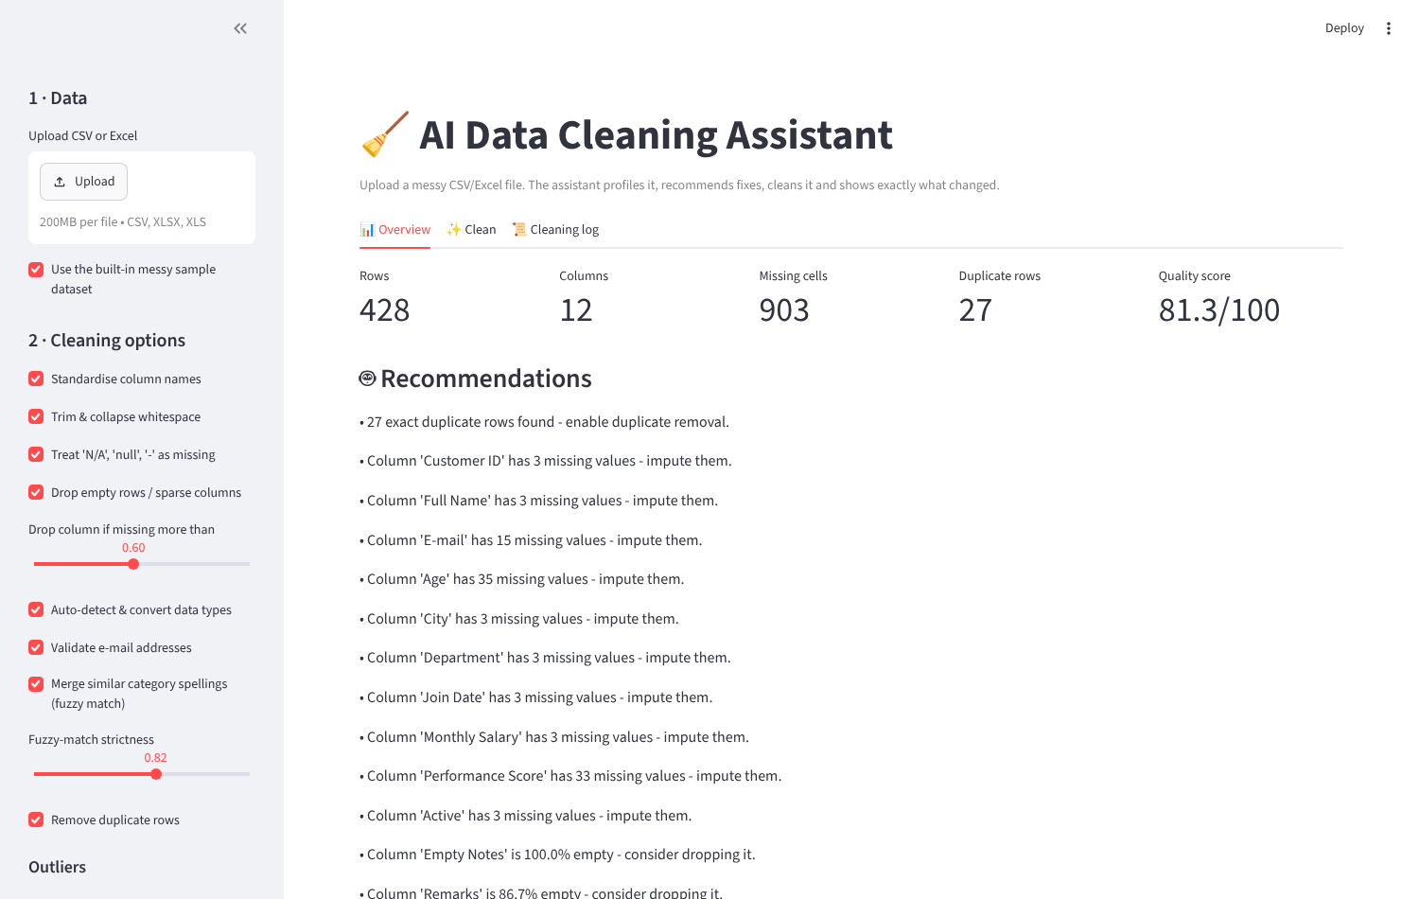
Figure 5.1 – Overview tab with metrics and recommendations.
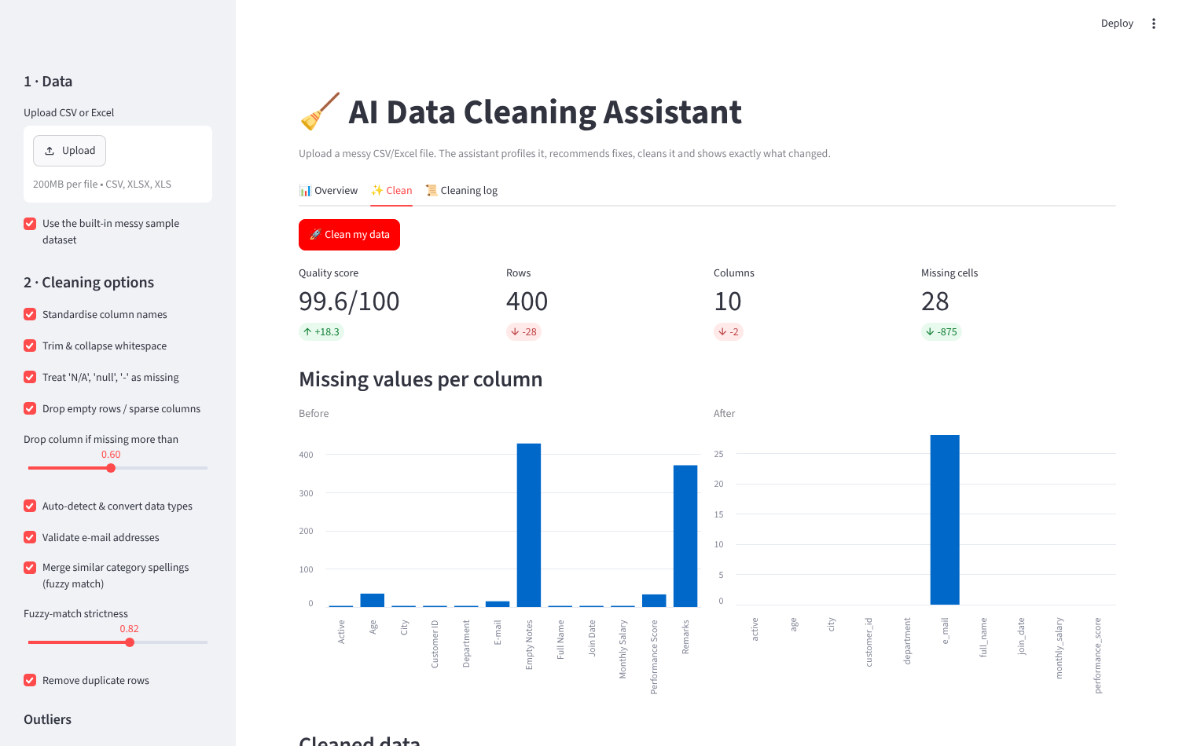
Figure 5.2 – Clean tab after running the pipeline: quality score +18.3, missing cells 903 → 28.

6. Testing and Results

6.1 Test dataset
A generator script (generate_sample.py) creates 428 rows × 12 columns of customer/employee data with deliberately injected faults:
Problem injected | Details
Duplicates | 25 repeated records (27 duplicate rows including blank rows)
Blank rows / empty columns | 3 fully blank rows; 'Empty Notes' (100 % empty) and 'Remarks' (≈87 % empty)
Placeholders | "N/A", "null", "-", "?" scattered across Age, City, Department, Salary
Wrong types | Age and Salary as text, "Rs. 31,499"; Active as Yes/No/Y/N/TRUE/false; dates in 3 formats
Category noise | 25 spellings of 6 cities (chennai, CHENNAI, Chenai, Maduari …)
Invalid e-mails | Entries such as "not_an_email"
Impossible values / outliers | Ages 180, 250, 999, -5; scores 950, 1200, -40; salaries 5,000,000+
Whitespace | Leading, trailing and repeated spaces in names and cities

6.2 Automated testing
The pytest suite contains 15 tests: column naming, placeholder handling, currency-to-number conversion, correct date parsing, boolean detection, fuzzy category merge (including a test that Male and Female are not merged), e-mail validation, range rules, duplicate removal, a full-pipeline test on the sample file, a test that all 36 combinations of outlier method, action and imputation method run without error, the recommender, and a headless test of the Streamlit app. All 15 tests pass.

6.3 Results
Metric | Before | After
Rows | 428 | 400
Columns | 12 | 10
Missing / placeholder cells | 995 | 28
Duplicate rows | 27 | 0
Distinct city spellings | 25 | 7
Data-quality score | 81.3 / 100 | 99.6 / 100

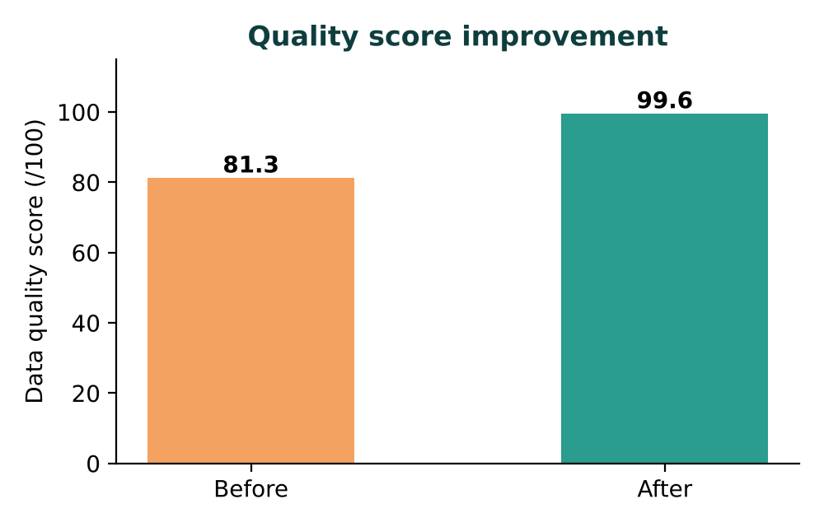
Figure 6.1 – Data-quality score before and after cleaning.
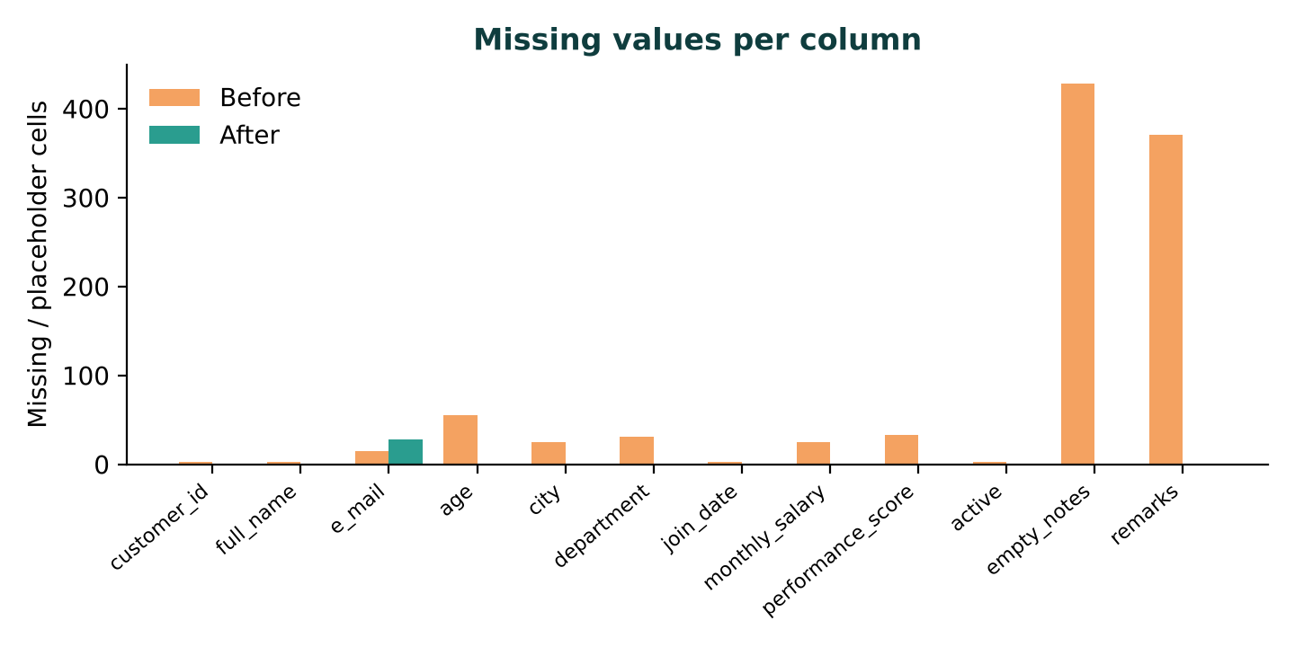
Figure 6.2 – Missing and placeholder cells per column. The 28 remaining gaps are e-mail addresses: invalid or absent e-mails cannot be guessed, so they are intentionally left missing.
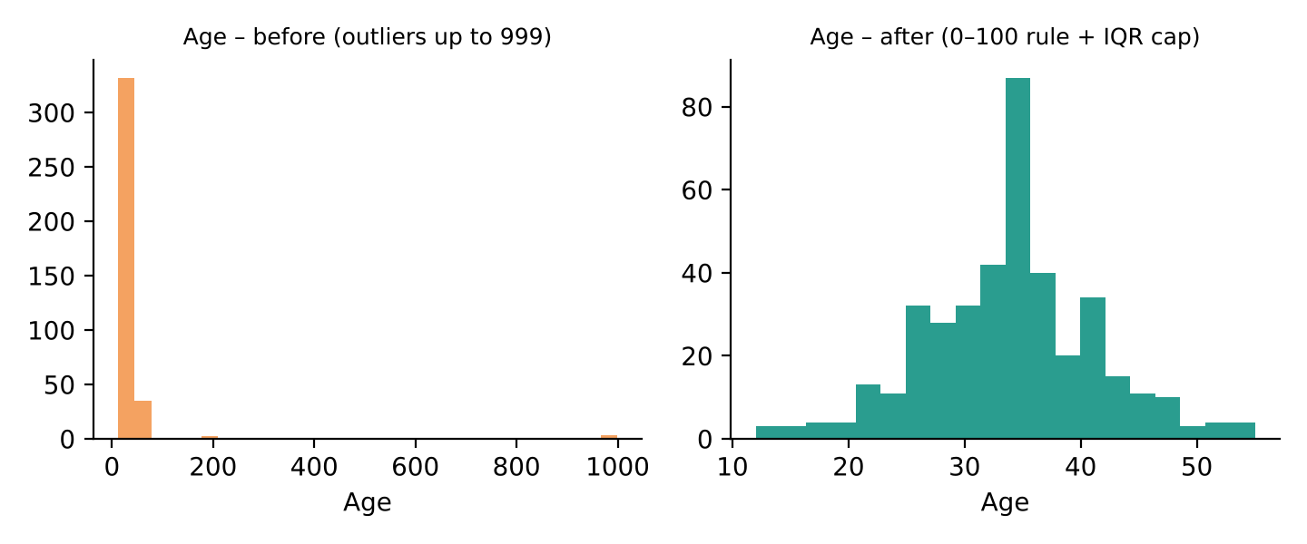
Figure 6.3 – Age distribution before and after range rules and IQR capping.

6.4 Before / after examples
ID | Name | City | Age | Join date | Salary | Active
C1356 (raw) | Anitha Reddy | null | 27.0 | 2022/05/12 | Rs. 31,499 | N
C1356 (clean) | Anitha Reddy | Chennai | 27 | 2022-05-12 | 31,499 | False
C1107 (raw) | Suresh Menon | Coimbatore | 43.0 | 15-10-2019 | Rs. 47,664 | TRUE
C1107 (clean) | Suresh Menon | Coimbatore | 43 | 2019-10-15 | 47,664 | True
C1122 (raw) | Ashwin Menon | Madurai | 29.0 | 18-05-2022 | ? | Yes
C1122 (clean) | Ashwin Menon | Madurai | 29 | 2022-05-18 | 50,922 | True
C1146 (raw) | Pooja Iyer | null | 16.0 | 2019/02/01 | 59407 | yes
C1146 (clean) | Pooja Iyer | Chennai | 16 | 2019-02-01 | 59,407 | True

6.5 Audit log of the run
Step | Detail | Count
Column names | Converted to snake_case | 12
Text cleanup | Trimmed and collapsed extra whitespace | 82
Placeholders | Converted 'N/A', 'null', '-', '?' etc. to real missing values | 92
Empty rows | Removed rows with no data | 3
Sparse columns | Dropped (> 60% missing): empty_notes, remarks | 2
Type conversion | 'age' text -> numeric (0 unparseable values set to missing) | 373
Type conversion | 'join_date' text -> datetime (0 unparseable values set to missing) | 425
Type conversion | 'monthly_salary' text -> numeric (0 unparseable values set to missing) | 403
Type conversion | 'active' text -> boolean | 425
Email validation | 'e_mail': set 16 invalid addresses to missing | 16
Category merge | 'city': merged 14 variant spellings (CHENNAI, Maduari, SALEM, salem...) | 14
Duplicates | Removed exact duplicate rows | 25
Range rule | 'age': 6 impossible values outside 0 to 100 set to missing | 6
Range rule | 'performance_score': 5 impossible values outside 0 to 100 set to missing | 5
Outliers (IQR) | 'age': 2 values outside [11.5, 55.5] - cap | 2
Outliers (IQR) | 'monthly_salary': 9 values outside [21942.1, 80759.1] - cap | 9
Imputation (median) | Filled 107 numeric gaps: age=54, monthly_salary=20, performance_score=33 | 107
Imputation (categorical) | Filled 44 text gaps using most frequent value | 44

6.6 Observations
- Ordering matters: handling outliers before imputation keeps medians representative.
- KNN imputation and Isolation Forest produced the same quality score here (99.6) as the simpler options, but KNN preserves relationships between columns and is preferable on correlated data.
- Fuzzy matching cannot know synonyms: "Bengaluru" stayed separate from "Bangalore" (7 rows) until a manual mapping was supplied. This is a documented limitation.

7. Limitations and Future Scope

7.1 Limitations
- Data is processed in memory; files beyond a few million rows need chunking.
- Ambiguous dates such as 04/05/2024 are read day-first.
- Range rules are guessed from column names and may need review for unusual datasets.
- Mode imputation of categorical columns can bias distributions; users can choose "Unknown" or leave gaps.

7.2 Future scope
- Optional large-language-model assistant: describe a column in plain English and get suggested rules and synonym maps.
- Semantic matching with embeddings to merge synonyms such as Bengaluru/Bangalore automatically.
- Support for databases, JSON and very large files via chunked or Dask processing.
- Save and re-apply cleaning recipes; schedule recurring cleaning jobs.
- Further validators: phone numbers, postal codes, PAN/Aadhaar-style formats.

8. Conclusion
The AI Data Cleaning Assistant demonstrates that most routine data-preparation work can be automated safely and transparently. By combining deterministic rules with machine-learning techniques – fuzzy matching, Isolation Forest and KNN imputation – the system raised the quality score of a messy 428-row dataset from 81.3 to 99.6, removed all duplicates and impossible values, and produced a full audit trail. Because it is built as a tested library with both a web interface and a command-line front end, it can be reused in future data-science and machine-learning projects, saving analysts considerable time while making cleaning decisions visible and repeatable.

9. References
- McKinney, W. (2022). Python for Data Analysis, 3rd ed. O'Reilly Media.
- Pedregosa, F. et al. (2011). Scikit-learn: Machine Learning in Python. Journal of Machine Learning Research, 12, 2825–2830.
- Liu, F. T., Ting, K. M., & Zhou, Z.-H. (2008). Isolation Forest. Proceedings of the IEEE International Conference on Data Mining (ICDM).
- Troyanskaya, O. et al. (2001). Missing value estimation methods for DNA microarrays. Bioinformatics, 17(6), 520–525. (basis of KNN imputation)
- Ratcliff, J. W. & Metzener, D. (1988). Pattern Matching: The Gestalt Approach. Dr. Dobb's Journal. (algorithm behind Python's difflib)
- pandas documentation – https://pandas.pydata.org/docs/
- Streamlit documentation – https://docs.streamlit.io/
- Python difflib documentation – https://docs.python.org/3/library/difflib.html

Appendix A – How to Run
pip install -r requirements.txt
streamlit run app.py # web application
python clean_cli.py sample_data.csv # command line
python -m pytest -q tests # run the 15 tests

Project files
File | Purpose
cleaning.py | Core engine: profiler, 15 cleaning steps, recommender, quality score
app.py | Streamlit web interface
clean_cli.py | Command-line interface
generate_sample.py / sample_data.csv | Messy demo dataset
tests/ | pytest unit and application tests
requirements.txt, README.md | Dependencies and instructions

