INTRODUCTION

Waste management has become a growing concern in both urban and rural areas due to increasing population, consumption patterns, and lack of awareness about sustainable disposal methods. Among the different sources of waste, household waste contributes a significant share. From food scraps and packaging to plastics and paper, households generate a wide variety of waste materials daily. Proper management of this waste at the source — the home — is essential for promoting environmental sustainability, preventing health hazards, and maintaining hygienic living conditions.
Traditional dustbins require physical contact to open and dispose of waste, which can lead to the spread of germs and foul odors, especially in kitchens and bathrooms. During times of pandemics or outbreaks, such as COVID-19, the risk of surface-based transmission highlights the need for contactless alternatives. Manual bins also lack smart features to indicate fill level, leading to overflows or unnecessary checks. With advancements in microcontrollers and sensor technologies, the concept of smart home devices has gained popularity. In this context, smart dustbins offer an intelligent solution to handle waste more efficiently. These bins can automatically open their lids when they detect motion near them, or when the user touches a specific sensor area, eliminating the need for physical contact. They can be designed to be affordable, compact, and energy-efficient for home use.

Affecting Economic Growth
Waste management plays a critical role in the economic development of a country. Poor handling of household waste not only affects the environment but also imposes a significant economic burden on governments and communities. Improper disposal leads to clogged drainage systems, water contamination, air pollution, and increased health risks—all of which demand substantial public spending on healthcare, cleaning, and infrastructure repair. These recurring expenses slow down national economic progress by diverting funds that could be used for development projects such as education, transportation, or digital infrastructure.
In contrast, efficient waste management can contribute positively to the economy. By adopting smart waste practices at the household level such as the use of smart dustbins waste can be better sorted, managed, and even recycled. This reduces the load on municipal waste services and lowers the operational cost of waste collection and disposal. It also creates opportunities in the recycling sector and encourages the development of waste-to-energy technologies, opening doors to green jobs and sustainable industries.
Smart home technologies may seem small in scale but can have a cumulative impact on economic efficiency. They promote automation and reduce dependency on manual labor for basic tasks. In the long term, they also influence consumer behavior by encouraging responsible waste disposal and cleanliness, which contributes to a healthier society and workforce essential factors for sustained economic productivity.

Waste in India Economy
India, with a population exceeding 1.4 billion, generates a vast amount of solid waste daily. According to the Central Pollution Control Board (CPCB), India produces over 160,000 metric tonnes of municipal solid waste every day, with urban areas contributing more than 90% of it. However, only about 75-80% of this waste is collected, and less than 25% is scientifically processed. The remainder ends up in open landfills or illegal dumping sites, which not only pollute the environment but also represent a significant loss to the economy.
Waste mismanagement in India results in several economic challenges. It increases municipal expenses for cleanup operations, health care (due to disease outbreaks from unhygienic surroundings), and land degradation. The World Bank estimates that poorly managed waste costs developing countries like India up to 0.5% to 1% of their GDP annually. This is a major drain on public resources, especially in growing cities where urbanization is rapid but infrastructure remains inadequate.
On the other hand, if properly managed, waste can be a valuable resource. Recyclable waste such as paper, plastic, glass, and metal has the potential to generate income and create employment. India's informal waste sector already supports around 1.5 to 4 million people, who collect and sell recyclables. With better technology and support, this sector can be integrated into formal systems, increasing efficiency and economic returns.
Furthermore, waste-to-energy technologies and composting of organic waste can help reduce landfill loads and generate electricity or manure, contributing to energy security and agricultural productivity. Cities like Pune and Indore have already started benefiting from decentralized waste management systems, which not only reduce costs but also improve public health and quality of life.
The adoption of smart waste systems starting from households can further reduce manual handling and improve source-level segregation. Innovations like smart dustbins can contribute to this transformation by encouraging clean, contactless, and efficient waste disposal practices. As India moves toward its Swachh Bharat and Smart Cities goals, managing waste at the source through technology is not just a need but an economic opportunity.

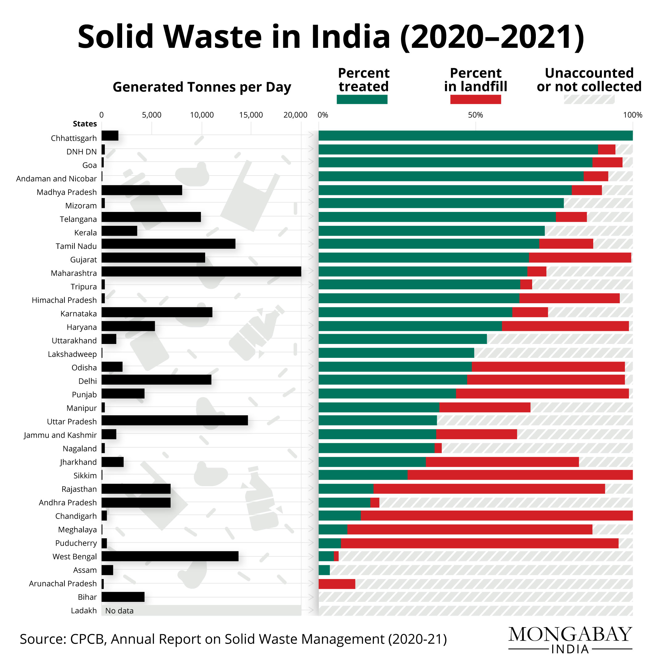

World Economy Spins Fortunes from Waste: A Multi-Trillion Dollar Industry Poised for Growth
The global waste management industry has evolved into a significant pillar of the modern economy. No longer viewed solely as a public health or environmental concern, waste is increasingly recognized as a resource with economic potential. According to market research, the sector was valued between USD 1.29 trillion and USD 1.36 trillion in 2022–2024 and is projected to grow to USD 1.96–2.65 trillion by 2030–2035, driven by a compound annual growth rate (CAGR) of 5.4% to 6.2%.

Economic Structure of the Waste Industry
The industry spans across collection, transportation, treatment, disposal (e.g., landfilling, incineration), recycling, composting, and waste-to-energy (WtE) technologies. Among these, waste collection holds the largest market share globally, while disposal and recycling sectors are expected to experience the fastest growth, especially due to increasing emphasis on sustainable practices. While industrial waste accounts for the largest volume, electronic waste (e-waste) is the fastest-growing category due to rapid technological obsolescence.

Key Economic Practices and Their Impacts
- Recycling: Recycling provides direct and indirect economic benefits by conserving resources, creating employment, reducing landfill use, and lowering raw material costs. The global recycling market supports millions of jobs and contributes billions of dollars annually.
- Waste-to-Energy (WtE): With a valuation of USD 34.5–35.8 billion in 2023–2024, the WtE segment is projected to reach USD 50.92 billion by 2032. It helps mitigate landfill overflow and contributes to energy production, offering both ecological and economic advantages.
- Landfilling: Although still common, landfilling incurs high environmental and economic costs. However, modern landfills increasingly incorporate biogas recovery systems, which offer some revenue by generating power from methane capture.

Technological Innovations Driving Economic Gains
- Smart Waste Systems: IoT-enabled bins using sensors to detect fill levels improve route optimization, reducing fuel and labor costs.
- AI and Robotics: These enhance sorting efficiency in recycling plants, minimizing contamination and improving recovery rates.
- Advanced Recycling Methods: Techniques like chemical recycling make it possible to recover materials from previously non-recyclable plastics.
- Waste Management Software: Digital platforms streamline operations, monitor compliance, and improve transparency and reporting.

Plastic Waste: Dual Challenge and Opportunity
Plastic waste presents both a pressing global challenge and a significant economic opportunity:
- Challenges: Marine pollution, microplastic contamination, and cleanup costs burden governments and industries, especially tourism and fisheries.
- Opportunities: The market for recycled plastics and biodegradable alternatives is booming. As of 2024, the plastic waste management industry is valued at USD 35.81 billion, with projections of reaching USD 44.45 billion by 2030.

Circular Economy: The Emerging Paradigm
The circular economy aims to minimize waste and extract maximum value from resources by promoting reuse, repair, and recycling. Adopting this model could generate enormous economic value. A UNEP report estimates potential net global gains of USD 108.5 billion annually through circular practices in waste management.

Investments and Developing Economies
Waste management in developing countries is gaining attention due to rapid urbanization and inadequate infrastructure. The World Bank alone invested USD 5.13 billion in global solid waste projects between 2003–2021. Investments focus on:
- Infrastructure (landfills, MRFs, WtE plants)
- Capacity building and training
- Public-private partnerships (PPPs)
- Results-based financing mechanisms
- Plastic credits and recycling incentives

Driving Forces of Growth
- Urbanization & Population Growth: Rising waste volumes demand scalable and efficient systems.
- Industrialization: Especially in Asia, this leads to increased industrial waste generation.
- Regulations & EPR Policies: Extended Producer Responsibility (EPR), landfill bans, and recycling targets are driving market growth.
- Consumer Awareness: Public pressure pushes corporations to adopt sustainable waste practices.
- Raw Material Scarcity: Resource recovery becomes increasingly attractive as virgin materials become scarce.
- Technology Adoption: Innovations are making waste processing more profitable and efficient.

Regional Outlook
- Asia-Pacific: Leading growth due to urban expansion and government initiatives like India’s Swachh Bharat Abhiyan. Expected to grow fastest and dominate the market share.
- Europe: A global leader in circular economy policies and green technology.
- North America: Mature market with significant technology adoption in the U.S. and Canada.
- Middle East, Africa, and Latin America: Experiencing steady growth but require infrastructure investment.

Future Outlook
The future of the global waste economy will be shaped by smart technologies, policy reforms, and the circular economy model. Failure to manage waste sustainably could escalate global economic losses to USD 640.3 billion per year by 2050, according to UNEP, while effective measures could result in net gains.
Improper medical waste management can lead to significant health and environmental risks, including disease outbreaks, due to the hazardous nature of biomedical waste. Below, I outline key points regarding medical "outbursts" (interpreted as outbreaks or significant incidents) caused by improper waste management, supported by sources.

Health Risks and Disease Outbreaks
Improper disposal of medical waste, such as infectious waste, sharps, and pharmaceutical residues, can facilitate the spread of pathogens, leading to outbreaks of infectious diseases. Specific risks include:
Infectious Diseases: Exposure to improperly handled biohazardous waste can transmit diseases like HIV, Hepatitis B, and Hepatitis C. For instance, discarded needles can cause needlestick injuries, with a single injury from a contaminated needle carrying a 30% risk of Hepatitis B, 1.8% risk of Hepatitis C, and 0.3% risk of HIV infection.
Historical Context: In the 1980s, medical waste washing up on East Coast beaches in the U.S. raised public health concerns, prompting the Medical Waste Tracking Act of 1988. This was partly due to fears of disease transmissionfrom improperly disposed waste.
Antimicrobial Resistance (AMR): Improper disposal of pharmaceutical waste, especially antibiotics, contributes to the proliferation of antibiotic-resistant bacteria. Hospitals and healthcare facilities are critical hotspots for AMR, where poor waste management can lead to resistant pathogens spreading into communities, potentially causing outbreaks of multidrug-resistant infections.
Parasitic and Vector-Borne Diseases: Improperly managed waste can attract insects, rodents, and other vectors, spreading diseases like rabies or parasitic infections. For example, laboratory waste not properly segregated can harbor parasites transmissible through skin contact or respiration.
Environmental Impact
Improper medical waste disposal also contaminates soil, water, and air, indirectly contributing to health risks:
Water Contamination: Pharmaceuticals and toxic chemicals from medical waste can leach into groundwater or surface water, contaminating drinking water supplies. This can lead to chronic health issues or facilitate disease spread if water sources are compromised.
Air Pollution: Open burning or improper incineration of medical waste releases toxic pollutants, including dioxins and mercury, which can cause respiratory illnesses and increase infection risks in nearby communities.
Case Studies and Incidents
Mandera County, Kenya (2024): A private healthcare facility in Eltul, Mandera South, was reported to have turned a local area into a dumping site for medical waste, including used syringes and soiled dressings. This raised concerns about potential disease transmission among residents due to improper segregation and disposal.
Isiolo General Hospital, Kenya (2025): Residents near the hospital complained about improper incineration of pharmaceutical waste, producing thick smoke that posed health risks, particularly to children. This highlights how mismanaged waste treatment can lead to community health hazards.
Nepal Hospital Study (2013): A study at the Government of Nepal Civil Service Hospital found that poor healthcare waste management practices increased risks of transmitting Hepatitis B, Staphylococcus aureus, and Pseudomonas aeruginosa, emphasizing the need for better segregation and disposal protocols to prevent outbreaks.
Sources of Improper Waste Management
The primary sources contributing to these risks include:
Lack of Segregation: Hazardous waste (15-25% of total healthcare waste) is often mixed with non-hazardous waste due to inadequate training or resources, increasing contamination risks.
Inadequate Infrastructure: In developing countries, healthcare facilities may lack proper waste treatment facilities, leading to open dumping or burning. For example, not all hospitals are connected to efficient sewage treatment plants, allowing untreated waste to enter the environment.
Non-Compliance with Regulations: Failure to follow guidelines from agencies like the EPA, OSHA, or WHO can result in improper disposal. For instance, sharps containers often contain non-sharp items like plastic or paper due to poor understanding of waste categories, increasing handling risks.
Insufficient Training: Healthcare staff and waste handlers may lack education on proper waste handling, leading to errors in segregation and disposal.
Mitigation Strategies
To prevent outbreaks and mitigate risks:
Proper Segregation: Use color-coded containers to separate hazardous and non-hazardous waste at the source.
Staff Training: Regular training on waste handling and compliance with regulations reduces errors.
Advanced Treatment: Technologies like autoclaving, chemical disinfection, or proper incineration can neutralize hazardous waste.
Regulatory Compliance: Adhering to EPA, WHO, and local guidelines ensures safe disposal and minimizes risks.
Community Awareness: Educating communities about safe disposal practices, especially for home-based care waste, prevents environmental contamination.

