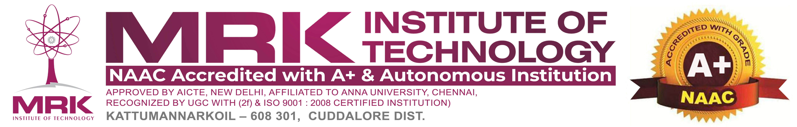

**DESIGNING A COST-EFFECTIVE, COMPACT SOLUTION FOR HOUSEHOLD WASTE SEGREGATION**

|  |  |  |
| --- | --- | --- |
| 1. MAJOR AREA | : | Robotics |
| 2. PROBLEM STATEMENT | : | Design a compact, cost-effective household waste segregation system that automates sorting using sensors and a microcontroller. This solution reduces manual effort, improves recycling efficiency, and minimizes landfill waste. |
| 3. TOTAL COST | : | The estimated cost for the project is ₹ 12,000. This includes expenses for hardware, Research user testing, Software and project document. |
| 4. COLLEGE CODE - NAME | : | 8224 – MRK INSTITUTE OF TECHNOLOGY |
| 5. GUIDE NAME | : |  |
| DESIGNATION | : |  |
| MOBILE NO | : |  |
| EMAIL ID | : |  |
|  |  |  |

**6. STUDENT TEAM DETAILS :**

|  |  |  |  |  |  |
| --- | --- | --- | --- | --- | --- |
| S.NO | Student Reg. No | Name of the student | Branch | Mobile No. | Email ID |
|  |  |  |  |  |  |
|  |  |  |  |  |  |
|  |  |  |  |  |  |

**7. PROJECT SUMMARY / ABSTRACT :**

This project proposes a cost-effective and compact automated waste segregation system for household use. It utilizes sensors (moisture, conductive) to identify waste types and a microcontroller ESP32 is used for processing. A mechanical sorting mechanism directs waste into biodegradable, recyclable, or non-recyclable bins. The system reduces manual effort, promotes efficient waste management, and minimizes landfill waste. It is designed to be affordable, easy to implement, and scalable. Future improvements may include IoT integration and AI-based waste classification.

**8. PROPOSED SOLUTION WITH METHODOLOGY:**

The proposed solution is a compact, automated waste segregation system using an ESP32 microcontroller and sensors to classify waste into biodegradable, recyclable, and non-recyclable categories. The system employs moisture, conductivity, and IR sensors to analyze waste properties, with servo motors directing sorted waste into designated bins. A user-friendly interface, optional IoT connectivity for monitoring, and a cost-effective design make it suitable for household use. The methodology involves sensor-based waste detection, microcontroller processing, mechanical sorting, and potential future enhancements like AI-based classification and mobile app integration for better waste management efficiency.

**9. BLOCK DIAGRAM FOR PROTOTYPE MODEL:**

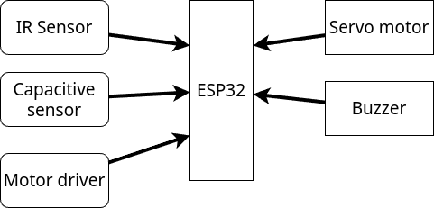

**10. WORK PLAN / TIME SCHEDULE :**

The project is scheduled to commence on March 2025, and conclude on April

2025. The Timeline is structured as follows:

|  |  |  |
| --- | --- | --- |
| Milestone | Work Done | Deadline |
| 1 | Designing hardware system | March |
| 2 | Hardware final result | April |

**11. LIST OF FACILITIES AVAILABLE IN THE COLLEGE:**

Our college provides state-of-the-art facilities crucial for the successful development

of the "Mechatronics and IoT" platform:

**Mechatronics & IoT Lab:**

Equipped with the latest software and hardware required for development.

**Research & Development Cell:**

Innovative meeting rooms where the project team can collaborate with ease and engage in brainstorming sessions.

**Extensive Library Resources:**

Access to an extensive collection of academic literature and resources related to education technology and inclusive learning.

**12. NATURE OF INDUSTRY SUPPORT:**

MS Equipment can assist in promoting the IoT platform . Industry support is seen not only as a source of guidance but as a means to ensure the scalability and sustainability of the "Robotics".

**13. DETAILS OF FINANCIAL ASSISTANCE REQUIRED:**

The estimated financial assistance required is broken down as follows:

Software Licenses: ₹. 1000

Hardware : ₹ 6000

User Testing: ₹.1000

Miscellaneous Expenses: ₹ 4000

Total : ₹12000

**14. EXPECTED OUTCOMES / RESULTS:**

The Robotics system project anticipates the following outcomes:

The automated waste segregation system successfully classifies household waste into biodegradable, recyclable, and non-recyclable categories using sensor-based detection and microcontroller processing. The system reduces manual sorting efforts, enhances recycling efficiency, and minimizes landfill waste. Its compact and cost-effective design makes it suitable for domestic use. Future enhancements like AI-based classification and IoT integration can further improve accuracy and user experience.

**UNDERTAKING**

1. The college will provide the basic infrastructure and other required facilities to the students for timely completion of their projects.

2. The college assumes to undertake the financial and other management responsibilities of the project.

3. The college will ensure that the funds provided are utilized only for the purpose provided and any remaining amount will be returned back to the University after the time of completion of the project.

**Signature of the Faculty Guide**

**Signature of the principasl**