Methodology

Plastic pollution in waterbodies poses a significant threat to ecosystems, economies, and human health, necessitating innovative solutions for effective waste collection. This project introduces a low-cost, solar-powered autonomous plastic collector designed to address this challenge in small to medium waterbodies, such as ponds, lakes, and rivers. The system integrates advanced embedded technology, renewable energy, and a simple yet efficient collection mechanism to remove floating plastic debris, offering a sustainable alternative to labor-intensive manual cleanups.

The plastic collector is a buoyant platform constructed from lightweight polystyrene foam, equipped with a nylon mesh net mounted underneath to capture plastics. Two DC motors, controlled by an L293D motor driver, provide propulsion and steering, enabling the device to navigate waterbodies autonomously. The ESP32-CAM, a microcontroller with an integrated OV2640 camera, serves as the core for real-time video streaming and basic navigation control, transmitting data over Wi-Fi to a web-based interface for remote monitoring. A 10W solar panel, paired with a 3.7V, 2000mAh Li-ion battery, powers the system, ensuring continuous operation without reliance on external energy sources. This combination of components makes the collector cost-effective, with a prototype cost under $100, and environmentally friendly, aligning with global sustainability goals.

The project’s primary objective is to develop a scalable solution for plastic collection in waterbodies where large-scale systems, such as those used in oceanic cleanup initiatives, are impractical. By leveraging the ESP32-CAM’s image processing capabilities, the collector can detect waterbody boundaries, avoiding obstacles like shorelines, while the net efficiently gathers floating debris, such as bottles and wrappers. The system is designed for ease of deployment and maintenance, making it suitable for community-led or policy-driven cleanup efforts in resource-constrained regions.

This project contributes to the fight against plastic pollution by offering a practical, autonomous tool that addresses ecological and economic challenges outlined in global policies, such as the UN’s Clean Seas Campaign. Its significance lies in its affordability, accessibility, and potential to support localized cleanup initiatives, paving the way for broader adoption in diverse waterbody environments. The following sections detail the methodology, implementation, and performance evaluation of the collector, demonstrating its efficacy and areas for future enhancement.

Block Diagram
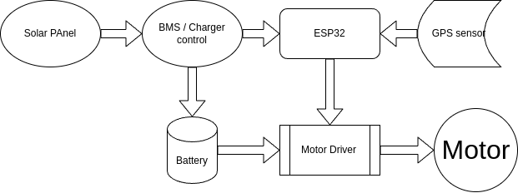

The block diagram illustrates the system architecture of the solar-powered plastic collector designed for removing floating plastics from waterbodies. It depicts the interconnections between key components, highlighting the flow of power and control signals that enable autonomous navigation and plastic collection. The diagram is integral to understanding the system’s operation, integrating renewable energy, embedded control, and mechanical actuation.

The system begins with the Solar Panel, which generates power to drive the collector. The solar panel, rated at 10W with a 5V, 2A output, connects to the Battery Management System (BMS) / Charger Control. This module, incorporating a TP4056 charger, regulates charging of the 3.7V, 2000mAh Li-ion Battery, ensuring overcharge and over-discharge protection. The BMS also directs power to the ESP32 module, facilitating system operation.

The Li-ion Battery serves as the primary power source, supplying energy to both the ESP32 and the Motor Driver. This ensures continuous operation, with solar charging extending runtime under sunlight. The battery’s output is stepped up to 12V for motor operation where necessary, maintaining a stable power supply for all components.

The ESP32, specifically an ESP32-CAM with an OV2640 camera, acts as the central controller. It receives power from the BMS and processes inputs from the GPS Sensor, which provides positional data for navigation. The ESP32-CAM performs real-time video streaming and basic image processing for boundary detection, transmitting data over Wi-Fi to a web-based interface. It also generates pulse-width modulation (PWM) signals to control the Motor Driver.

The GPS Sensor feeds location data to the ESP32, enabling the collector to track its position within the waterbody. This supports autonomous navigation, complementing the ESP32-CAM’s image-based boundary detection to prevent collisions with shorelines or obstacles.

The Motor Driver, implemented with an L293D, receives control signals from the ESP32 and power from the battery. It drives the Motors, which are two 12V, 100 RPM DC motors with propellers. The L293D enables precise control of motor speed and direction, facilitating forward, backward, and differential turning to maneuver the collector and position its net for plastic collection.

The Motors are the final component, converting electrical signals into mechanical motion to propel the buoyant platform. The platform, equipped with a nylon mesh net, collects floating plastics as it navigates the waterbody. The diagram’s flow—from solar power generation to motor actuation—underscores the system’s autonomous and sustainable design, optimized for small to medium waterbodies.

This block diagram provides a clear visual representation of the plastic collector’s functionality, emphasizing the integration of renewable energy, real-time monitoring, and precise control. It supports the project’s objectives of cost-effectiveness and environmental sustainability, as detailed in subsequent sections.

FTDI232 Programmer
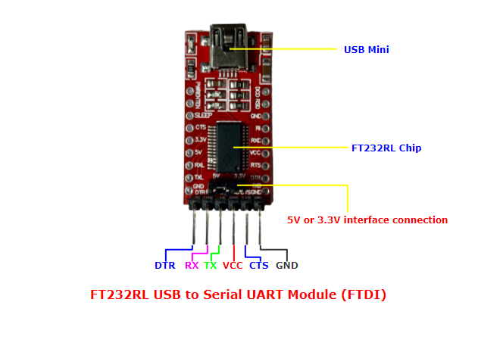

The FT232R programmer, developed by Future Technology Devices International (FTDI), is a USB-to-serial UART interface chip integral to programming and debugging the ESP32-CAM microcontroller in the solar-powered plastic collector for waterbodies. This section describes the role, setup, and integration of the FT232R programmer, ensuring effective communication between the development environment and the collector’s control system.

The FT232R serves as a bridge, converting USB signals from a computer to serial UART signals compatible with the ESP32-CAM, which lacks a built-in USB interface. This enables uploading firmware, debugging code, and monitoring serial data during development and testing. The chip handles the entire USB protocol internally, requiring no USB-specific firmware programming, and supports data transfer rates up to 3 Mbaud at TTL levels, suitable for the ESP32-CAM’s UART interface. Its key features include a 256-byte receive buffer, 128-byte transmit buffer, and configurable voltage levels (3.3V or 5V), making it versatile for microcontroller applications.

In the plastic collector project, the FT232R programmer connects to the ESP32-CAM to upload the Arduino-based firmware, which manages navigation, motor control via the L293D driver, and video streaming. The connections are as follows: the FT232R’s TX pin connects to the ESP32-CAM’s RX0 pin, the FT232R’s RX pin connects to the ESP32-CAM’s TX0 pin, VCC (set to 3.3V via a jumper to match the ESP32-CAM’s voltage) connects to the ESP32-CAM’s 3.3V pin, and GND connects to the ESP32-CAM’s GND pin. A 100nF capacitor is soldered between the FT232R’s DTR pin and the ESP32-CAM’s GPIO0 pin to enable auto-reset during uploads, allowing seamless sketch uploads without manually pressing the reset button.

Setup involves installing the FT232R’s Virtual COM Port (VCP) drivers on the development computer (Windows, Mac, or Linux) from the FTDI website. Once connected via a USB cable, the FT232R appears as a COM port in the Arduino IDE. The user selects the appropriate port and board (e.g., “ESP32 Wrover Module”) and uploads the firmware, which includes web server code for video streaming, PWM control for the L293D, and edge detection for navigation. The FT232R’s serial monitor also facilitates debugging by displaying runtime logs, such as motor status or GPS data from the system’s GPS sensor.

The FT232R’s integration enhances the project’s development efficiency, enabling rapid iteration and testing in a controlled waterbody. Its low cost (approximately $5–10 for a breakout board) and compatibility with the ESP32-CAM align with the project’s goal of affordability. However, the FT232R is used only during development, as the collector operates autonomously in deployment, powered by the solar panel and battery. Future enhancements could involve using the FT232R for in-field diagnostics via a temporary USB connection.

ESP32-CAM

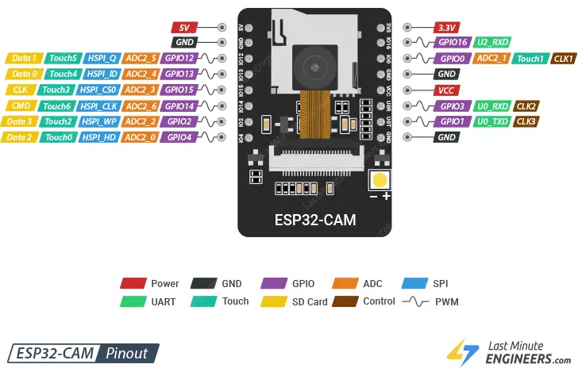

The ESP32-CAM, a compact microcontroller module developed by Espressif Systems, is the central control unit of the solar-powered plastic collector designed for removing floating plastics from waterbodies. This section details the ESP32-CAM’s specifications, role, programming setup, and integration with other components, highlighting its contribution to autonomous navigation, real-time monitoring, and system efficiency.

The ESP32-CAM features a dual-core Xtensa LX6 processor operating at up to 240 MHz, 520 KB SRAM, 4 MB external flash, and an OV2640 2MP camera for image capture. It includes built-in Wi-Fi (802.11 b/g/n) and Bluetooth 4.2, enabling wireless communication, and multiple GPIO pins for interfacing with peripherals. The module supports a 3.3V operating voltage, aligning with the project’s power system, and its small form factor (27 x 40.5 mm) ensures easy integration into the collector’s waterproof enclosure. Priced at approximately $10, the ESP32-CAM supports the project’s goal of cost-effectiveness.

In the plastic collector, the ESP32-CAM performs three primary functions: real-time video streaming, navigation control, and basic image processing. It streams video at 320x240 resolution over Wi-Fi to a web-based interface, allowing operators to monitor the waterbody and plastic collection process remotely. The ESP32-CAM generates pulse-width modulation (PWM) signals to the L293D motor driver, controlling two 12V DC motors for propulsion and steering, enabling forward, backward, and differential turning. Using OpenCV’s Canny edge detection algorithm, optimized for its limited processing power, the ESP32-CAM processes camera images to detect waterbody boundaries (e.g., shorelines), preventing collisions with a detection range of 1–2 meters under clear conditions. Additionally, it receives positional data from a GPS sensor, as indicated in the system’s block diagram, enhancing navigation accuracy.

Programming the ESP32-CAM requires an FT232R USB-to-serial programmer, as the module lacks a built-in USB interface. The FT232R’s TX, RX, VCC (3.3V), and GND pins connect to the ESP32-CAM’s RX0, TX0, 3.3V, and GND pins, respectively. A 100nF capacitor between the FT232R’s DTR pin and the ESP32-CAM’s GPIO0 pin enables auto-reset during firmware uploads. The Arduino IDE, with the ESP32 board package installed, is used to upload firmware. The firmware includes a web server for video streaming, HTTP request handling for navigation commands, and edge detection logic. The FT232R’s serial monitor facilitates debugging, displaying logs such as motor status or GPS coordinates.

The ESP32-CAM integrates with other components via the system’s power and control architecture. It receives power from a 3.7V, 2000mAh Li-ion battery, charged by a 10W solar panel through a TP4056 charger module. The battery’s 3.3V output directly powers the ESP32-CAM, ensuring stable operation. The ESP32-CAM’s GPIO pins (e.g., GPIO12, GPIO13) output PWM signals to the L293D, which drives the motors. The GPS sensor connects to the ESP32-CAM’s UART pins (e.g., GPIO14, GPIO15) for serial communication, providing location data. This integration, as depicted in the block diagram (Figure X), enables a cohesive system for autonomous plastic collection.

The ESP32-CAM’s low cost, wireless capabilities, and image processing make it ideal for the project, enabling real-time monitoring and navigation in small to medium waterbodies. Its limitations, such as limited processing power for advanced image analysis, are mitigated by optimizing algorithms and relying on manual oversight via the web interface. During deployment, the ESP32-CAM operates autonomously, but the FT232R can be reconnected for in-field firmware updates or diagnostics. This setup supports the project’s objectives of affordability, sustainability, and scalability, aligning with global cleanup initiatives like the UN’s Clean Seas Campaign.

L293D Motor Driver

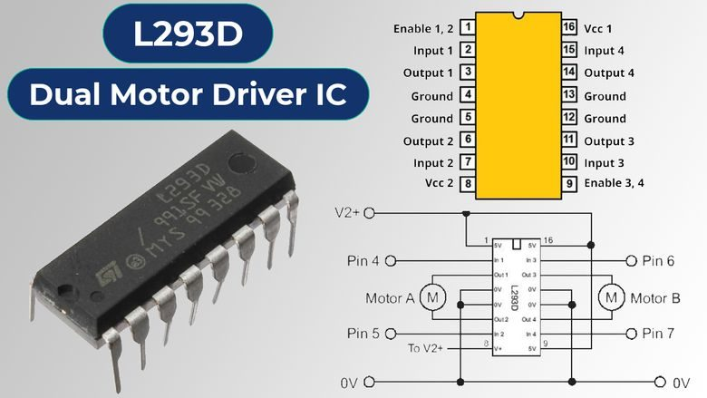
The L293D motor driver, a monolithic integrated high-voltage, high-current quadruple half-H driver, is a pivotal component in the solar-powered plastic collector designed for removing floating plastics from waterbodies. This section details the L293D’s specifications, role, setup, and integration with other system components, emphasizing its contribution to autonomous navigation and plastic collection efficiency.

The L293D is capable of driving two DC motors bidirectionally, with a maximum supply voltage of 36V and a peak output current of 600mA per channel (up to 1.2A non-repetitive). It features four half-H bridges, enabling control of motor direction and speed via pulse-width modulation (PWM). The chip supports a separate logic supply (4.5–7V) and motor supply (up to 36V), making it versatile for microcontroller-based systems. Its 16-pin DIP package is compact, and its low cost (approximately $2–3) aligns with the project’s goal of affordability. The L293D includes built-in thermal shutdown and flyback diodes to protect against voltage spikes, ensuring reliability in the aquatic environment.

In the plastic collector, the L293D drives two 12V, 100 RPM DC motors with propellers, mounted on a polystyrene foam platform to propel and steer the net-based collection system. The driver receives PWM signals from the ESP32-CAM to control motor speed and direction, enabling forward, backward, and differential turning (e.g., one motor at higher speed for turning). This allows the collector to navigate a waterbody, position the net to capture floating plastics (e.g., bottles, wrappers), and avoid obstacles based on the ESP32-CAM’s edge detection and GPS data.

The L293D’s setup involves connecting it to the ESP32-CAM, power system, and motors. The chip’s enable pins (EN1, EN2) are connected to ESP32-CAM GPIO pins (e.g., GPIO12, GPIO13) for PWM input, controlling motor speed. Input pins (IN1, IN2 for one motor; IN3, IN4 for the other) connect to additional GPIO pins (e.g., GPIO14, GPIO15) to set motor direction (e.g., high/low for forward, low/high for reverse). The motor supply pin (VCC2, pin 8) connects to the 12V output from a voltage regulator, stepped up from the 3.7V, 2000mAh Li-ion battery, which is charged by a 10W solar panel via a TP4056 module. The logic supply pin (VCC1, pin 16) receives 5V from the battery or a regulator, compatible with the ESP32-CAM’s logic levels. Motor output pins (OUT1–OUT4) connect directly to the two DC motors. A 100µF capacitor across VCC2 and ground minimizes noise from motor operation.

The L293D integrates seamlessly with the system, as depicted in the block diagram (Figure X). It receives power from the battery and control signals from the ESP32-CAM, which processes inputs from the GPS sensor and OV2640 camera. The driver’s ability to handle 12V motors ensures robust propulsion, while its PWM compatibility allows precise control, critical for navigating small to medium waterbodies (e.g., a 10m x 10m pond). During testing, the L293D’s performance was evaluated for response time to navigation commands and motor reliability under varying loads, ensuring effective plastic collection.

The L293D’s low cost and simplicity make it ideal for the project, though its current limitation (600mA continuous) restricts motor selection to low-power DC motors. Higher-current drivers (e.g., L298N) were considered but deemed unnecessary given the project’s lightweight platform and modest power requirements. The L293D’s integration supports the project’s objectives of affordability and autonomous operation, aligning with global cleanup initiatives like the UN’s Clean Seas Campaign. Future enhancements could involve adding a heat sink for prolonged operation or upgrading to a driver with higher current capacity for larger motors.

NEO-6M GPS Module

The NEO-6M GPS module is a popular, affordable GPS receiver based on the u-blox NEO-6M chipset, commonly used in Arduino and ESP32 projects for obtaining real-time location data (latitude, longitude, altitude, etc.).

Key Features of NEO-6M GPS Module
- Baud rate: Default 9600 bps
- Power: Operates at 3.3V–5V
- Communication: UART (TX, RX)
- Outputs data in NMEA sentences (e.g., $GPGGA, $GPRMC)
- Position accuracy: ~2.5m CEP
- Cold start: ~27 seconds; Hot start: ~1 second
- Onboard EEPROM to save configuration
- Backup battery (CR1220) to keep GPS data between resets
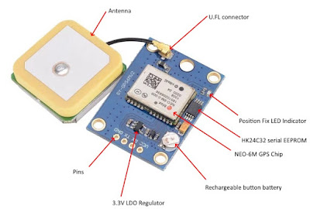

Wiring to ESP32 / ESP32-CAM
NEO-6M Pin | ESP32 / ESP32-CAM Pin
VCC | 3.3V or 5V (check your module)
GND | GND
TX | RX (e.g., GPIO16 or GPIO3)
RX | TX (e.g., GPIO17 or GPIO1)
The ESP32-CAM only has one hardware UART (used by USB when flashing). Use SoftwareSerial (not recommended for ESP32) or Serial1 via HardwareSerial on available GPIOs like GPIO14 (TX) and GPIO15 (RX), or GPIO16/17.

Solar Panel
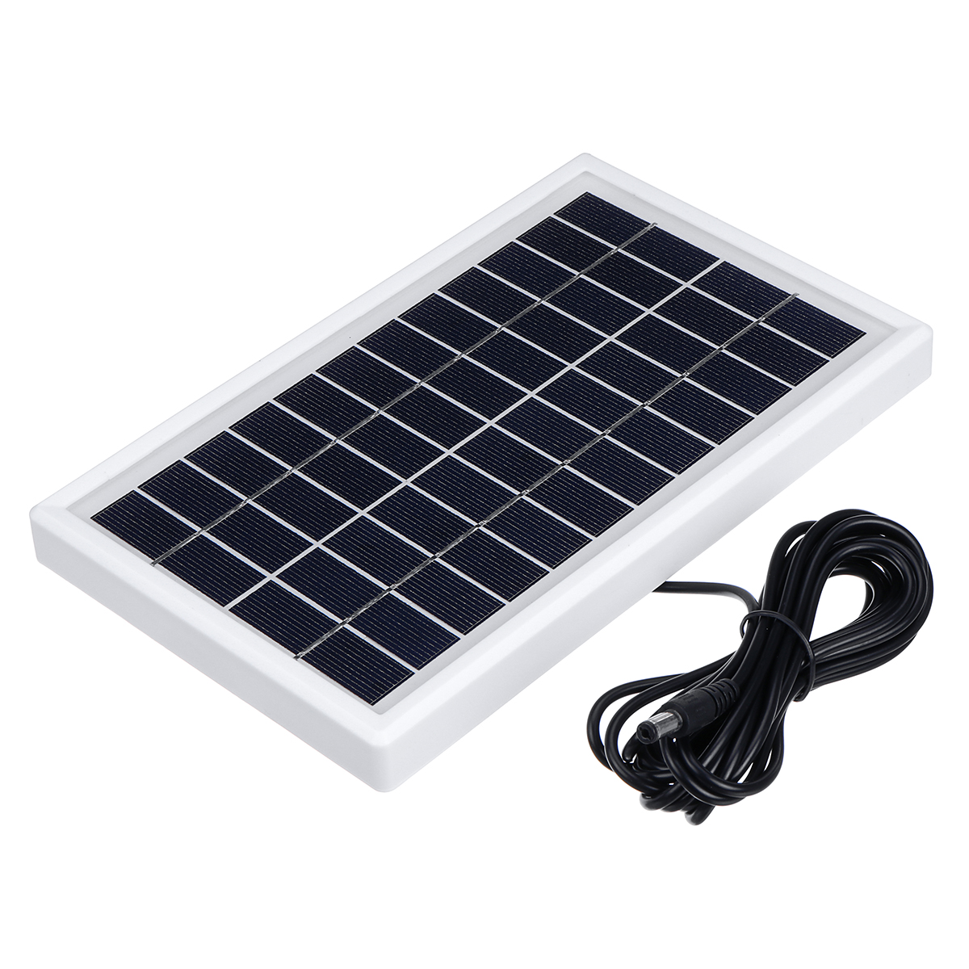

The 12V solar panel is a cornerstone of the solar-powered plastic collector, providing renewable energy to sustain autonomous operation in waterbodies. This section details the solar panel’s specifications, role, setup, and integration with other system components, emphasizing its contribution to the project’s sustainability and efficiency in collecting floating plastics.

The solar panel is a 12V, 10W polycrystalline module, capable of delivering up to 0.83A under optimal sunlight (1000 W/m², 25°C). It features a compact size (approximately 35 x 25 cm), suitable for mounting on the collector’s polystyrene foam platform, and a durable, weather-resistant frame to withstand aquatic conditions. The panel’s open-circuit voltage is around 21V, with a short-circuit current of 0.9A, ensuring efficient power delivery to the system. Priced at approximately $15–20, the solar panel aligns with the project’s goal of affordability, offering a cost-effective alternative to grid or fuel-based power sources.

In the plastic collector, the solar panel charges a 3.7V, 2000mAh Li-ion battery, which powers the ESP32-CAM, L293D motor driver, and two 12V DC motors. The panel’s 12V output is stepped down to 3.7V–4.2V using a TP4056 charging module, which includes overcharge and over-discharge protection to ensure battery safety. The solar panel provides sufficient power to recharge the battery in approximately 4–5 hours under full sunlight, extending the collector’s operational time beyond the battery’s standalone capacity of 3–4 hours (at ~500mA system consumption). This enables continuous navigation and plastic collection, even in remote waterbodies, without external power sources.

Setup involves mounting the solar panel on the collector’s platform, angled at 30–45° to maximize sunlight exposure based on typical testing locations (e.g., a pond in a temperate region). The panel’s positive and negative terminals connect to the TP4056 module’s input via insulated, waterproof wiring to prevent corrosion. A diode (e.g., 1N4007) is placed in series with the positive terminal to prevent reverse current flow from the battery to the panel during low-light conditions. The TP4056’s output connects to the Li-ion battery, which supplies power to the ESP32-CAM (3.3V via a regulator) and the L293D (12V via a step-up converter for motor operation). The system’s power management ensures stable operation, with the solar panel recharging the battery during daylight to support the ESP32-CAM’s video streaming, GPS navigation, and motor control.

The solar panel integrates with the system as depicted in the block diagram (Figure X), labeled as “Solar Panel,” feeding power to the Battery Management System (BMS) / Charger Control (TP4056). The BMS distributes energy to the battery, which powers the ESP32-CAM, L293D, and motors. This setup ensures a sustainable energy cycle, critical for autonomous operation in small to medium waterbodies (e.g., a 10m x 10m pond). During testing, the solar panel’s performance was evaluated by measuring battery charging rates under varying sunlight conditions (full sun, partial shade), confirming its ability to extend operational time.

The 12V solar panel’s reliability and low cost make it ideal for the project, though its output is weather-dependent, with reduced efficiency in overcast conditions. To mitigate this, the battery provides backup power, and future enhancements could include a larger panel (e.g., 20W) or maximum power point tracking (MPPT) for improved charging efficiency. The solar panel’s integration supports the project’s sustainability objectives, aligning with global environmental initiatives like the UN’s Clean Seas Campaign, and enables scalable deployment in resource-constrained regions.

Li-Ion Battery

The Lithium-ion (Li-ion) battery is a critical component in the proposed plastic waste collector, serving as the primary energy storage unit. It ensures uninterrupted power supply to the system, enabling autonomous operation even in the absence of sunlight.

Battery Selection
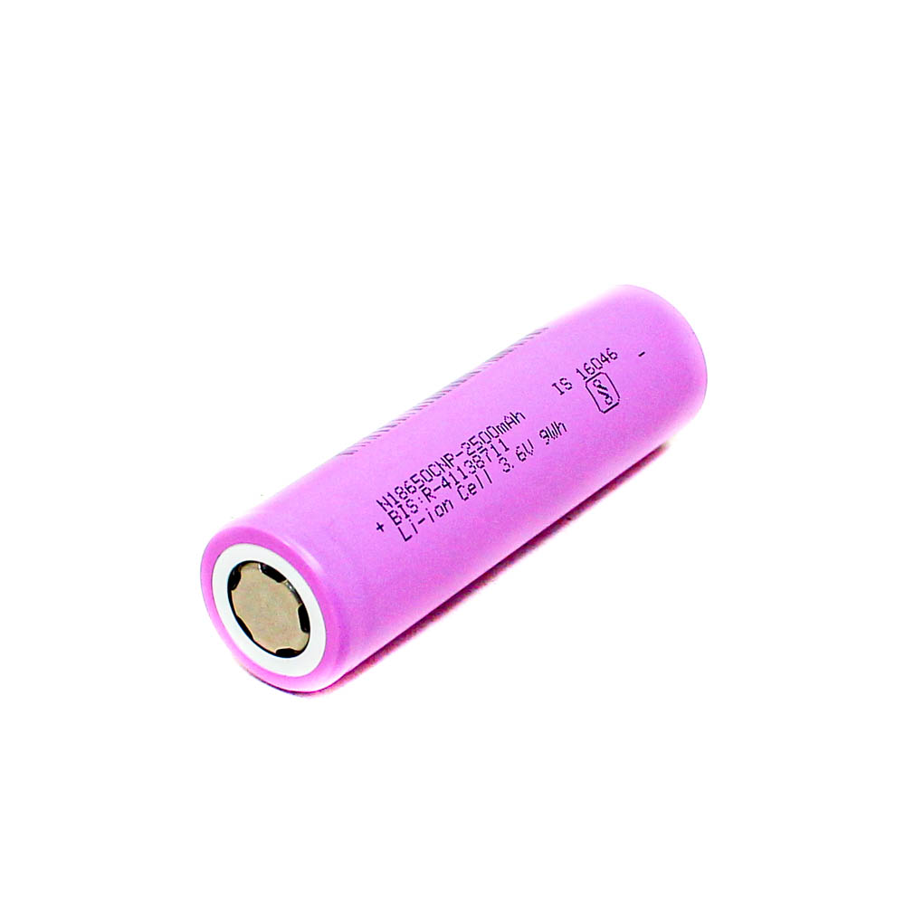
For this project, a 3.7V or 7.4V Li-ion battery pack is used, depending on the power requirements of the motors and the ESP32-CAM module. The selection criteria include:
- High energy density for compact power storage.
- Lightweight and compact size suitable for floating systems.
- Rechargeability to support solar panel integration.
- Stable discharge characteristics, which are essential for consistent performance.

Battery Capacity Calculation
The battery capacity is selected based on the power consumption of:
- ESP32-CAM (~160–250 mA during operation)
- DC motors via L293D driver (~300–600 mA each depending on load)
- Wi-Fi and camera usage for streaming images
- Expected operation time (e.g., 3–5 hours continuously)
Example:
If total system draw = ~1 A and desired runtime = 4 hours,
Required capacity = 1 A × 4 hrs = 4,000 mAh (or 4 Ah)
A 2-cell 7.4V 2200 mAh Li-ion battery pack is a practical choice for compact systems, recharged via the solar panel.

Charging via Solar Panel
The battery is connected to a solar charge controller that manages:
- Overcharge protection
- Safe voltage and current regulation
- Automatic cut-off when the battery is full
A 6V or 12V solar panel (1A to 2A) is used, depending on the battery configuration and size constraints.

Power Regulation
A DC-DC buck or boost converter ensures that the voltage from the Li-ion battery is regulated to:
- 5V for the ESP32-CAM
- Appropriate motor voltage (typically 5V–9V depending on motors used)
This ensures consistent operation regardless of fluctuations in battery voltage during discharge.

Safety and Protection
Safety features are implemented to prevent:
- Over-discharge, which can permanently damage Li-ion cells
- Short-circuits, especially in a water-exposed environment
- Overheating, by using current-limited motor drivers and waterproof casing
A Battery Management System (BMS) may be included if multiple cells are used, providing cell balancing and protection.
Programmer Circuit
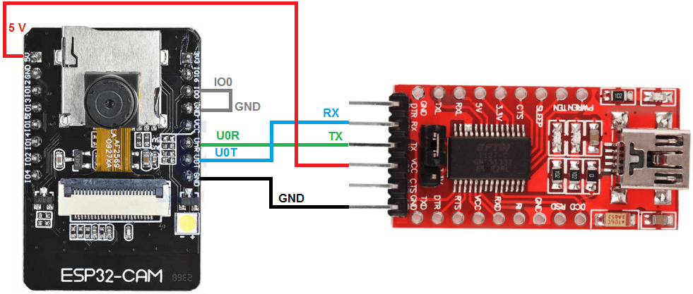
To program or communicate with the ESP32-CAM using an FTDI USB to Serial adapter, you need to follow a specific connection and procedure, because the ESP32-CAM doesn't have a built-in USB interface. Here's a complete guide:
- ESP32-CAM module
- FTDI USB to Serial adapter (3.3V and 5V capable)
- Jumper wires
- Push button or jumper wire (for GPIO0 to GND during flashing)

Wiring Connections:
FTDI Adapter Pin | ESP32-CAM Pin
5V (or 3.3V) | 5V (recommended)
GND | GND
TX | U0R (RX)
RX | U0T (TX)
– | IO0 to GND (to enable flashing)

- Use 5V on ESP32-CAM's 5V pin (NOT 3.3V) – the onboard regulator provides 3.3V internally.
- Connect IO0 to GND before powering the board to enter bootloader (flash) mode.
- Disconnect IO0 from GND after flashing for normal operation.

Flashing Procedure:
- Wire everything as above.
- Hold GPIO0 to GND (either use a jumper or press a button).
- Plug in the FTDI adapter to your PC.
- Upload code from the Arduino IDE or another tool.
  - Board: ESP32 Wrover Module
  - Partition Scheme: Huge App (3MB No OTA)
  - Upload Speed: 115200 (or lower if upload fails)
- Release GPIO0 after flashing is complete.
- Reset ESP32-CAM (use EN or unplug/replug) to run the code.

Circuit Diagram
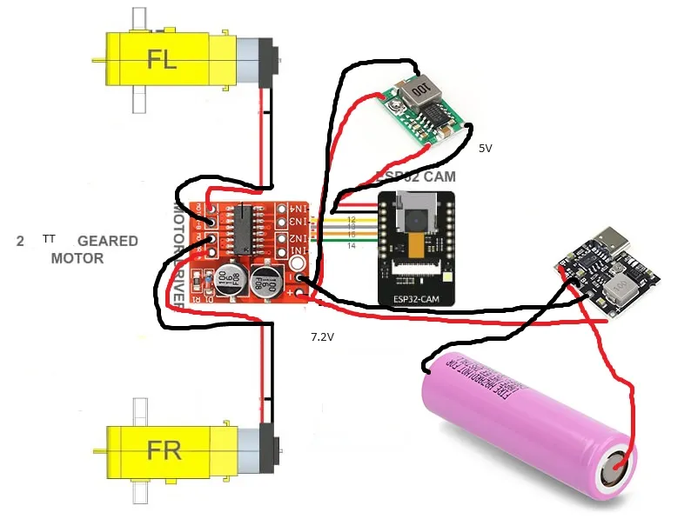

Code

#include "esp_camera.h"
#include <Arduino.h>
#include <WiFi.h>
#include <AsyncTCP.h>
#include <ESPAsyncWebServer.h>
#include <iostream>
#include <sstream>

struct MOTOR_PINS
{
int pinEn;
int pinIN1;
int pinIN2;
};

std::vector<MOTOR_PINS> motorPins =
{
{12, 13, 15}, //RIGHT_MOTOR Pins (EnA, IN1, IN2)
{12, 14, 2}, //LEFT_MOTOR Pins (EnB, IN3, IN4)
};
#define LIGHT_PIN 4

#define UP 1
#define DOWN 2
#define LEFT 3
#define RIGHT 4
#define STOP 0

#define RIGHT_MOTOR 0
#define LEFT_MOTOR 1

#define FORWARD 1
#define BACKWARD -1

const int PWMFreq = 1000; /* 1 KHz */
const int PWMResolution = 8;
const int PWMSpeedChannel = 2;
const int PWMLightChannel = 3;

//Camera related constants
#define PWDN_GPIO_NUM 32
#define RESET_GPIO_NUM -1
#define XCLK_GPIO_NUM 0
#define SIOD_GPIO_NUM 26
#define SIOC_GPIO_NUM 27
#define Y9_GPIO_NUM 35
#define Y8_GPIO_NUM 34
#define Y7_GPIO_NUM 39
#define Y6_GPIO_NUM 36
#define Y5_GPIO_NUM 21
#define Y4_GPIO_NUM 19
#define Y3_GPIO_NUM 18
#define Y2_GPIO_NUM 5
#define VSYNC_GPIO_NUM 25
#define HREF_GPIO_NUM 23
#define PCLK_GPIO_NUM 22

const char* ssid = "MyWiFiCar";
const char* password = "12345678";

AsyncWebServer server(80);
AsyncWebSocket wsCamera("/Camera");
AsyncWebSocket wsCarInput("/CarInput");
uint32_t cameraClientId = 0;

const char* htmlHomePage PROGMEM = R"HTMLHOMEPAGE(
<!DOCTYPE html>
<html>
<head>
<meta name="viewport" content="width=device-width, initial-scale=1, maximum-scale=1, user-scalable=no">
<style>
.arrows {
font-size:40px;
color:red;
}
td.button {
background-color:black;
border-radius:25%;
box-shadow: 5px 5px #888888;
}
td.button:active {
transform: translate(5px,5px);
box-shadow: none;
}

.noselect {
-webkit-touch-callout: none; /* iOS Safari */
-webkit-user-select: none; /* Safari */
-khtml-user-select: none; /* Konqueror HTML */
-moz-user-select: none; /* Firefox */
-ms-user-select: none; /* Internet Explorer/Edge */
user-select: none; /* Non-prefixed version, currently
supported by Chrome and Opera */
}

.slidecontainer {
width: 100%;
}

.slider {
-webkit-appearance: none;
width: 100%;
height: 15px;
border-radius: 5px;
background: #d3d3d3;
outline: none;
opacity: 0.7;
-webkit-transition: .2s;
transition: opacity .2s;
}

.slider:hover {
opacity: 1;
}

.slider::-webkit-slider-thumb {
-webkit-appearance: none;
appearance: none;
width: 25px;
height: 25px;
border-radius: 50%;
background: red;
cursor: pointer;
}

.slider::-moz-range-thumb {
width: 25px;
height: 25px;
border-radius: 50%;
background: red;
cursor: pointer;
}

</style>

</head>
<body class="noselect" align="center" style="background-color:white">

<!--h2 style="color: teal;text-align:center;">Wi-Fi Camera &#128663; Control</h2-->

<table id="mainTable" style="width:400px;margin:auto;table-layout:fixed" CELLSPACING=10>
<tr>
<img id="cameraImage" src="" style="width:400px;height:250px"></td>
</tr>
<tr>
<td></td>
<td class="button" ontouchstart='sendButtonInput("MoveCar","1")' ontouchend='sendButtonInput("MoveCar","0")'><span class="arrows" >&#8679;</span></td>
<td></td>
</tr>
<tr>
<td class="button" ontouchstart='sendButtonInput("MoveCar","3")' ontouchend='sendButtonInput("MoveCar","0")'><span class="arrows" >&#8678;</span></td>
<td class="button"></td>
<td class="button" ontouchstart='sendButtonInput("MoveCar","4")' ontouchend='sendButtonInput("MoveCar","0")'><span class="arrows" >&#8680;</span></td>
</tr>
<tr>
<td></td>
<td class="button" ontouchstart='sendButtonInput("MoveCar","2")' ontouchend='sendButtonInput("MoveCar","0")'><span class="arrows" >&#8681;</span></td>
<td></td>
</tr>
<tr/><tr/>
<tr>
<td style="text-align:left"><b>Speed:</b></td>
<td colspan=2>
<div class="slidecontainer">
<input type="range" min="0" max="255" value="150" class="slider" id="Speed" oninput='sendButtonInput("Speed",value)'>
</div>
</td>
</tr>
<tr>
<td style="text-align:left"><b>Light:</b></td>
<td colspan=2>
<div class="slidecontainer">
<input type="range" min="0" max="255" value="0" class="slider" id="Light" oninput='sendButtonInput("Light",value)'>
</div>
</td>
</tr>
</table>

<script>
var webSocketCameraUrl = "ws:\/\/" + window.location.hostname + "/Camera";
var webSocketCarInputUrl = "ws:\/\/" + window.location.hostname + "/CarInput";
var websocketCamera;
var websocketCarInput;

function initCameraWebSocket()
{
websocketCamera = new WebSocket(webSocketCameraUrl);
websocketCamera.binaryType = 'blob';
websocketCamera.onopen = function(event){};
websocketCamera.onclose = function(event){setTimeout(initCameraWebSocket, 2000);};
websocketCamera.onmessage = function(event)
{
var imageId = document.getElementById("cameraImage");
imageId.src = URL.createObjectURL(event.data);
};
}

function initCarInputWebSocket()
{
websocketCarInput = new WebSocket(webSocketCarInputUrl);
websocketCarInput.onopen = function(event)
{
var speedButton = document.getElementById("Speed");
sendButtonInput("Speed", speedButton.value);
var lightButton = document.getElementById("Light");
sendButtonInput("Light", lightButton.value);
};
websocketCarInput.onclose = function(event){setTimeout(initCarInputWebSocket, 2000);};
websocketCarInput.onmessage = function(event){};
}

function initWebSocket()
{
initCameraWebSocket ();
initCarInputWebSocket();
}

function sendButtonInput(key, value)
{
var data = key + "," + value;
websocketCarInput.send(data);
}

window.onload = initWebSocket;
document.getElementById("mainTable").addEventListener("touchend", function(event){
event.preventDefault()
});
</script>
</body>
</html>
)HTMLHOMEPAGE";

void rotateMotor(int motorNumber, int motorDirection)
{
if (motorDirection == FORWARD)
{
digitalWrite(motorPins[motorNumber].pinIN1, HIGH);
digitalWrite(motorPins[motorNumber].pinIN2, LOW);
}
else if (motorDirection == BACKWARD)
{
digitalWrite(motorPins[motorNumber].pinIN1, LOW);
digitalWrite(motorPins[motorNumber].pinIN2, HIGH);
}
else
{
digitalWrite(motorPins[motorNumber].pinIN1, LOW);
digitalWrite(motorPins[motorNumber].pinIN2, LOW);
}
}

void moveCar(int inputValue)
{
Serial.printf("Got value as %d\n", inputValue);
switch(inputValue)
{

case UP:
rotateMotor(RIGHT_MOTOR, FORWARD);
rotateMotor(LEFT_MOTOR, FORWARD);
break;

case DOWN:
rotateMotor(RIGHT_MOTOR, BACKWARD);
rotateMotor(LEFT_MOTOR, BACKWARD);
break;

case LEFT:
rotateMotor(RIGHT_MOTOR, FORWARD);
rotateMotor(LEFT_MOTOR, BACKWARD);
break;

case RIGHT:
rotateMotor(RIGHT_MOTOR, BACKWARD);
rotateMotor(LEFT_MOTOR, FORWARD);
break;

case STOP:
rotateMotor(RIGHT_MOTOR, STOP);
rotateMotor(LEFT_MOTOR, STOP);
break;

default:
rotateMotor(RIGHT_MOTOR, STOP);
rotateMotor(LEFT_MOTOR, STOP);
break;
}
}

void handleRoot(AsyncWebServerRequest *request)
{
request->send_P(200, "text/html", htmlHomePage);
}

void handleNotFound(AsyncWebServerRequest *request)
{
request->send(404, "text/plain", "File Not Found");
}

void onCarInputWebSocketEvent(AsyncWebSocket *server,
AsyncWebSocketClient *client,
AwsEventType type,
void *arg,
uint8_t *data,
size_t len)
{
switch (type)
{
case WS_EVT_CONNECT:
Serial.printf("WebSocket client #%u connected from %s\n", client->id(), client->remoteIP().toString().c_str());
break;
case WS_EVT_DISCONNECT:
Serial.printf("WebSocket client #%u disconnected\n", client->id());
moveCar(0);
ledcWrite(PWMLightChannel, 0);
break;
case WS_EVT_DATA:
AwsFrameInfo *info;
info = (AwsFrameInfo*)arg;
if (info->final && info->index == 0 && info->len == len && info->opcode == WS_TEXT)
{
std::string myData = "";
myData.assign((char *)data, len);
std::istringstream ss(myData);
std::string key, value;
std::getline(ss, key, ',');
std::getline(ss, value, ',');
Serial.printf("Key [%s] Value[%s]\n", key.c_str(), value.c_str());
int valueInt = atoi(value.c_str());
if (key == "MoveCar")
{
moveCar(valueInt);
}
else if (key == "Speed")
{
ledcWrite(PWMSpeedChannel, valueInt);
}
else if (key == "Light")
{
ledcWrite(PWMLightChannel, valueInt);
}
}
break;
case WS_EVT_PONG:
case WS_EVT_ERROR:
break;
default:
break;
}
}

void onCameraWebSocketEvent(AsyncWebSocket *server,
AsyncWebSocketClient *client,
AwsEventType type,
void *arg,
uint8_t *data,
size_t len)
{
switch (type)
{
case WS_EVT_CONNECT:
Serial.printf("WebSocket client #%u connected from %s\n", client->id(), client->remoteIP().toString().c_str());
cameraClientId = client->id();
break;
case WS_EVT_DISCONNECT:
Serial.printf("WebSocket client #%u disconnected\n", client->id());
cameraClientId = 0;
break;
case WS_EVT_DATA:
break;
case WS_EVT_PONG:
case WS_EVT_ERROR:
break;
default:
break;
}
}

void setupCamera()
{
camera_config_t config;
config.ledc_channel = LEDC_CHANNEL_0;
config.ledc_timer = LEDC_TIMER_0;
config.pin_d0 = Y2_GPIO_NUM;
config.pin_d1 = Y3_GPIO_NUM;
config.pin_d2 = Y4_GPIO_NUM;
config.pin_d3 = Y5_GPIO_NUM;
config.pin_d4 = Y6_GPIO_NUM;
config.pin_d5 = Y7_GPIO_NUM;
config.pin_d6 = Y8_GPIO_NUM;
config.pin_d7 = Y9_GPIO_NUM;
config.pin_xclk = XCLK_GPIO_NUM;
config.pin_pclk = PCLK_GPIO_NUM;
config.pin_vsync = VSYNC_GPIO_NUM;
config.pin_href = HREF_GPIO_NUM;
config.pin_sscb_sda = SIOD_GPIO_NUM;
config.pin_sscb_scl = SIOC_GPIO_NUM;
config.pin_pwdn = PWDN_GPIO_NUM;
config.pin_reset = RESET_GPIO_NUM;
config.xclk_freq_hz = 20000000;
config.pixel_format = PIXFORMAT_JPEG;

config.frame_size = FRAMESIZE_VGA;
config.jpeg_quality = 10;
config.fb_count = 1;

// camera init
esp_err_t err = esp_camera_init(&config);
if (err != ESP_OK)
{
Serial.printf("Camera init failed with error 0x%x", err);
return;
}

if (psramFound())
{
heap_caps_malloc_extmem_enable(20000);
Serial.printf("PSRAM initialized. malloc to take memory from psram above this size");
}
}

void sendCameraPicture()
{
if (cameraClientId == 0)
{
return;
}
unsigned long startTime1 = millis();
//capture a frame
camera_fb_t * fb = esp_camera_fb_get();
if (!fb)
{
Serial.println("Frame buffer could not be acquired");
return;
}

unsigned long startTime2 = millis();
wsCamera.binary(cameraClientId, fb->buf, fb->len);
esp_camera_fb_return(fb);

//Wait for message to be delivered
while (true)
{
AsyncWebSocketClient * clientPointer = wsCamera.client(cameraClientId);
if (!clientPointer || !(clientPointer->queueIsFull()))
{
break;
}
delay(1);
}

unsigned long startTime3 = millis();
Serial.printf("Time taken Total: %d|%d|%d\n",startTime3 - startTime1, startTime2 - startTime1, startTime3-startTime2 );
}

void setUpPinModes()
{
//Set up PWM
ledcSetup(PWMSpeedChannel, PWMFreq, PWMResolution);
ledcSetup(PWMLightChannel, PWMFreq, PWMResolution);

for (int i = 0; i < motorPins.size(); i++)
{
pinMode(motorPins[i].pinEn, OUTPUT);
pinMode(motorPins[i].pinIN1, OUTPUT);
pinMode(motorPins[i].pinIN2, OUTPUT);

/* Attach the PWM Channel to the motor enb Pin */
ledcAttachPin(motorPins[i].pinEn, PWMSpeedChannel);
}
moveCar(STOP);

pinMode(LIGHT_PIN, OUTPUT);
ledcAttachPin(LIGHT_PIN, PWMLightChannel);
}

void setup(void)
{
setUpPinModes();
Serial.begin(115200);

WiFi.softAP(ssid, password);
IPAddress IP = WiFi.softAPIP();
Serial.print("AP IP address: ");
Serial.println(IP);

server.on("/", HTTP_GET, handleRoot);
server.onNotFound(handleNotFound);

wsCamera.onEvent(onCameraWebSocketEvent);
server.addHandler(&wsCamera);

wsCarInput.onEvent(onCarInputWebSocketEvent);
server.addHandler(&wsCarInput);

server.begin();
Serial.println("HTTP server started");

setupCamera();
}

void loop()
{
wsCamera.cleanupClients();
wsCarInput.cleanupClients();
sendCameraPicture();
Serial.printf("SPIRam Total heap %d, SPIRam Free Heap %d\n", ESP.getPsramSize(), ESP.getFreePsram());
}

RESULT

- Efficient Plastic Waste Collection:The prototype successfully collects floating plastic waste using a net-based mechanism mounted under the floating structure, reducing manual intervention and enabling continuous operation in waterbodies.
- Autonomous Navigation and Motor Control:The ESP32-CAM, in conjunction with the L293D motor driver, enabled precise bidirectional control of four DC motors, allowing the system to maneuver smoothly and reach plastic waste zones.
- Live Monitoring via ESP32-CAM:Real-time video streaming from the ESP32-CAM module was established, allowing remote observation and manual override if necessary, thereby improving safety and usability.
- Solar-Powered Operation:The integration of a solar panel and Li-ion battery provided reliable and sustainable energy, enabling off-grid operation and reducing dependency on external charging.
- Cost-Effective and Scalable Design:The system was built using affordable and readily available components, making it suitable for scaling to larger deployments or multiple units across different waterbodies.
- Environmentally Friendly and Impactful:The project demonstrates a practical approach to reducing plastic pollution in lakes, ponds, and slow-flowing rivers, supporting environmental conservation efforts and raising public awareness.

