Introduction

Plastic pollution in waterbodies, including rivers, lakes, and oceans, has emerged as one of the most pressing environmental challenges of the 21st century. An estimated 8 million metric tons of plastic enter the oceans annually, threatening aquatic ecosystems, wildlife, and human health (1). Plastics, due to their durability and resistance to degradation, persist in water environments for decades, breaking down into microplastics that infil-trate food chains and disrupt biodiversity. Floating debris, such as bottles, bags, and packaging, not only poses immediate hazards to marine life through ingestion and en-tanglement but also contributes to the formation of vast garbage patches, like the Great Pacific Garbage Patch, which spans millions of square kilometers (2). The sources of plastic pollution are diverse, ranging from urban runoff and improper waste management to industrial discharges and maritime activities. Developing nations, where waste infrastructure is often inadequate, contribute significantly to the problem, though global consumption patterns exacerbate the issue universally (1). Once in waterbodies, plastics are transported by currents, accumulating in areas of high ecological significance, such as coral reefs and coastal wetlands. This accumulation disrupts habitats, reduces water quality, and impacts industries like fishing and tourism, which rely on healthy aquatic ecosystems. Addressing plastic pollution requires urgent action, as its consequences extend beyond environmental degradation to socioeconomic and public health concerns. Microplastics have been detected in drinking water and seafood, raising alarms about potential human health risks (3). Moreover, the aesthetic degradation of waterbodies diminishes their recreational and cultural value, affecting communities worldwide. While international initiatives, such as the UN’s Clean Seas campaign, aim to raise awareness and promote policy changes, the scale of the problem demands innovative, scalable solutions to pre-vent further accumulation and mitigate existing damage. Understanding the scope and impact of plastic pollution in waterbodies is critical to developing effective strategies for a sustainable future.

Plastic pollution in aquatic environments has emerged as a critical environmental challenge in the 21st century. With the rapid growth of plastic production and inadequate waste management systems, an alarming quantity of plastic waste finds its way into rivers, lakes, and oceans each year. This pollution not only degrades the aesthetic value of natural waterbodies but also poses severe threats to aquatic ecosystems, biodiversity, and human health.
One of the most troubling aspects of plastic waste is its durability. Plastics do not biodegrade easily; instead, they persist in the environment for hundreds of years, breaking down into smaller fragments known as microplastics. These microplastics are often ingested by marine and freshwater organisms, leading to internal injuries, blockages, and even death. Over time, they bioaccumulate through the food chain, eventually reaching humans and potentially causing adverse health effects.
Marine animals such as fish, turtles, and birds are particularly vulnerable to plastic pollution. Many mistake floating plastic bags and other debris for food, while others become entangled in larger plastic items such as fishing nets or packaging materials, often resulting in injury or suffocation. Entire aquatic habitats are affected as plastic waste alters water chemistry, blocks sunlight needed for photosynthesis in aquatic plants, and clogs water flow in rivers and estuaries.
The impact of plastic pollution extends beyond the environment. It also affects local economies, particularly those reliant on tourism, fishing, and clean water sources. Floating plastic debris can damage fishing equipment, reduce fish populations, and deter tourists, leading to economic losses in many coastal and riverine communities. Moreover, the cost of cleaning up plastic waste from waterbodies is significant and often falls on local governments that are already burdened with limited resources.
In light of these issues, addressing plastic pollution in waterbodies is an urgent global priority. Solutions require a multifaceted approach that includes reducing plastic use, improving waste collection and recycling infrastructure, raising public awareness, and developing innovative technologies to remove existing plastic waste from aquatic environments.
Effects of Plastic Pollution on Aquatic Animals
Plastic pollution in waterbodies poses a significant threat to aquatic animals, affecting their physiology, behavior, and ecosystems. With an estimated 8 million metric tons of plastic entering oceans annually (1), marine and freshwater species face increasing risks from macroplastics, microplastics, and associated chemical pollutants. These im-pacts manifest through physical, toxicological, and ecological disruptions, endangering biodiversity and ecosystem stability. One of the primary effects is physical harm through ingestion and entanglement. Aquatic animals, including fish, seabirds, turtles, and marine mammals, often mistake plastic debris for food. Ingestion of plastics, such as bags or bottle caps, can lead to intestinal blockages, starvation, and death. For example, studies have documented sea turtles consuming plastic bags, mistaking them for jellyfish, resulting in mortality rates as high as 22% in affected populations (2). Entanglement in discarded fishing nets, ropes, and other debris restricts movement, causing injuries, drowning, or reduced foraging ability. Cetaceans, such as dolphins and whales, are particularly vulnerable, with entanglement incidents reported in over 60% of species (3). Microplastics, particles smaller than 5mm, exacerbate these issues by infiltrating food chains. Zooplankton, fish, and shellfish ingest microplastics, which accumulate in their tis-sues and transfer to predators, including humans. This bioaccumulation introduces toxic chemicals, such as polychlorinated biphenyls (PCBs) and bisphenol A (BPA), leached from plastics. These pollutants disrupt endocrine systems, impair reproduction, and weaken immune responses in aquatic species (4). For instance, studies on fish exposed to microplastics show reduced fertility and altered behavior, affecting population dynamics.
Ecologically, plastic pollution alters habitats and food webs. Accumulated debris on riverbeds and ocean floors smothers benthic organisms, while floating plastics disrupt light penetration, affecting photosynthesis in aquatic plants and algae. Coral reefs, critical habitats for marine biodiversity, suffer from plastic entanglement and abrasion, with up to 90% of corals in some regions showing signs of plastic-related damage (5). These changes cascade through ecosystems, reducing prey availability and destabilizing predator-prey
relationships.
The cumulative impact of plastic pollution threatens the survival of aquatic species and the health of waterbody ecosystems. Addressing these effects requires urgent action to reduce plastic inputs and mitigate existing damage, ensuring the protection of aquatic animals and their habitats for future generations.

Effects of Plastic Pollution on Aquatic Plants
Plastic pollution in waterbodies, contributing an estimated 8 million metric tons annually to oceans (1), poses a severe threat to aquatic plants, including phytoplankton, macroalgae, and submerged or floating vegetation. These plants are critical to aquatic ecosystems, supporting primary production, oxygen generation, and habitat formation. Plastic debris, ranging from macroplastics to microplastics, disrupts their physiological processes, growth, and ecological functions, with cascading effects on waterbody health. Physical interference is a primary impact. Floating plastics, such as bags and bottles, block sunlight, reducing photosynthesis in aquatic plants like seagrasses and algae. Studies indicate that plastic shading can decrease photosynthetic rates in seagrass beds by up to 50% (2), impairing growth and survival. Submerged plastics, including discarded nets and packaging, settle on riverbeds or lake floors, smothering benthic plants and preventing nutrient uptake. This physical barrier also traps sediments, altering water clarity and further limiting light availability, which is critical for species like Zostera marina (eelgrass).
Microplastics, particles smaller than 5mm, introduce chemical and toxicological threats. These particles adsorb pollutants like heavy metals and persistent organic pollutants (POPs), which are then transferred to aquatic plants through direct contact or water absorption. For instance, phytoplankton exposed to microplastics exhibit reduced chlorophyll content and inhibited growth rates (3). Toxic additives in plastics, such as phthalates, disrupt hormonal pathways in macroalgae, affecting reproduction and development. These chemical stressors weaken plant resilience, making them more susceptible to disease and environmental changes.
Ecologically, plastic pollution alters plant-dependent ecosystems. Seagrass meadows and algal beds, which serve as nurseries for fish and carbon sinks, suffer from plastic entanglement and abrasion, with up to 80% of some seagrass habitats showing plastic-related damage (4). This degradation reduces biodiversity and destabilizes food webs, as herbivorous species lose food sources. Furthermore, microplastics ingested by zooplankton can indirectly affect phytoplankton populations by disrupting predator-prey dynamics, altering nutrient cycling. The cumulative impact of plastic pollution threatens the survival of aquatic plants and their ecosystem services, including carbon sequestration and habitat provision. Mitigating these effects requires reducing plastic inputs and restoring affected habitats to safeguard aquatic plant communities and their vital contributions to global ecosystems.

Economic Effects of Plastic Pollution in Waterbodies
Plastic pollution in waterbodies poses significant economic challenges across multiple sectors, particularly for countries and communities that depend heavily on marine and freshwater resources. The widespread contamination of rivers, lakes, and oceans with plastic waste not only threatens ecosystems but also imposes a substantial financial burden on public institutions, private businesses, and local livelihoods.
One of the most direct economic impacts is seen in the fisheries and aquaculture industries. Plastic debris can damage fishing gear, entangle marine life, and reduce fish stocks due to habitat disruption and ingestion of plastics by aquatic species. This leads to reduced catches, lower incomes for fishermen, and increased operational costs for repair and gear replacement. In aquaculture, floating plastic waste can clog intake systems, contaminate water quality, and harm farmed fish, affecting both yield and market value.
The tourism industry also suffers considerable losses due to polluted beaches, rivers, and lakes. Littered shorelines discourage tourists, affecting hotels, restaurants, and recreation-based businesses. Coastal communities that rely on tourism for employment and income face declining visitor numbers, leading to economic instability. Clean-up efforts to restore natural beauty can be extremely costly for local governments and often require continuous financial input.
Shipping and marine transport are affected as well. Plastic waste can obstruct shipping routes and damage vessel engines or propellers if entangled, resulting in delays, repair costs, and safety hazards. Port operations may also experience increased costs for maintaining clean waterways and ensuring safe navigation.
Moreover, public health systems face indirect economic strain. Plastics in water can leach harmful chemicals and contribute to the spread of microplastics, which have been linked to potential health risks. Addressing these issues—through research, monitoring, and healthcare—adds to national healthcare expenditures.
Municipalities and governments must also allocate substantial budgets to waste management and environmental clean-up operations. The cost of manual or mechanized plastic removal from waterbodies and the disposal or recycling of collected waste is high, especially in densely populated or heavily polluted areas.

Difficulties in Collecting Plastic Waste from Waterbodies
Collecting plastic waste from waterbodies presents several practical, environmental, and technological challenges. Despite growing awareness of the environmental hazards posed by plastic pollution, effective removal of plastic debris from aquatic environments remains a complex task due to the dynamic nature of water systems and the diversity of plastic waste.
One of the primary difficulties is the wide distribution and mobility of plastic waste. Plastic items, especially smaller and lightweight materials, can drift across vast areas due to water currents, wind, and tides. This makes it challenging to locate and collect them efficiently. Floating plastics often get trapped in inaccessible areas like riverbanks, under vegetation, or between rocks, where manual collection becomes labor-intensive and time-consuming.
Another major challenge is differentiating between plastic and organic materials in water. Plastic items, especially when discolored or biofouled (covered with algae or organisms), can closely resemble natural debris such as leaves or wood. This complicates automated sorting and requires advanced sensors or manual intervention, which increases operational complexity and costs.
Environmental sensitivity also plays a role. Many waterbodies are surrounded by or support delicate ecosystems. Using large mechanical collectors or boats may disturb aquatic life, stir up sediments, or damage submerged vegetation. Ensuring minimal environmental impact while collecting waste requires careful design and operation of waste collection systems.
The issue of microplastics adds another layer of complexity. Microplastics are tiny plastic particles (less than 5 mm) that originate from broken-down larger items or industrial sources like microbeads in cosmetics. These particles are nearly impossible to remove using conventional collection methods. They are often suspended in the water column or settle into sediments, making them difficult to detect and extract without advanced filtration systems.
Weather conditions and seasonal variations also affect waste collection. Rainfall, floods, and high winds can increase the flow of plastics into waterbodies and make cleanup operations more dangerous and unpredictable. Moreover, waste collection in open water during bad weather is risky and may require specialized equipment and trained personnel.
Lastly, limited resources and technology in many regions hinder consistent waste collection efforts. Small communities and developing countries may lack the funding, equipment, or technical expertise needed to implement effective plastic cleanup operations, leaving local waterbodies vulnerable to long-term plastic accumulation.

The United Nations has undertaken several significant initiatives to combat plastic pollution in waterbodies. These efforts aim to address the environmental and economic impacts of plastic waste on aquatic ecosystems.

1. United Nations Environment Assembly (UNEA) Resolution
In March 2022, during the fifth session of the United Nations Environment Assembly (UNEA-5.2), a historic resolution was adopted to develop an international legally binding instrument on plastic pollution, including in the marine environment. This resolution set in motion a process to negotiate a global treaty addressing the full life cycle of plastics, from production to disposal.

2. Intergovernmental Negotiating Committee (INC) on Plastic Pollution
Following the UNEA resolution, the Intergovernmental Negotiating Committee (INC) was established to develop the legally binding instrument. The fifth session of the INC (INC-5) took place in Busan, South Korea, in November 2024. However, countries were unable to reach an agreement on key issues, such as capping plastic production and managing hazardous chemicals in plastics. As a result, the negotiations were postponed, with plans to resume in a subsequent session (INC-5.2).

3. UNEP Plastics Initiative
The United Nations Environment Programme (UNEP) has launched the Plastics Initiative, aiming to end global plastic pollution. This initiative promotes a shift from the traditional "take-make-dispose" model to a circular economy where plastic products are designed for reuse, recycling, and repurposing. The initiative encompasses various projects and resources to support this transformative vision.

4. Community Action against Plastic Waste (CAPWs)
The United Nations has also supported community-level actions through the Community Action against Plastic Waste (CAPWs) program. This initiative has facilitated clean-up efforts in multiple areas, including oceans, beaches, rivers, and lakes, engaging local communities in the fight against plastic pollution.

5. Sustainable Development Goal 14: Life Below Water
Addressing plastic pollution aligns with Sustainable Development Goal 14, which aims to "conserve and sustainably use the oceans, seas, and marine resources for sustainable development." One of the targets under this goal focuses on preventing and significantly reducing marine pollution of all kinds, particularly from land-based activities, including marine debris and nutrient pollution.
Policy and Regulatory Frameworks for Plastic Pollution
The global crisis of plastic pollution, with approximately 8 million metric tons entering oceans annually (Jambeck et al., 2015), has prompted a range of international and regional policies aimed at reducing plastic waste and mitigating its environmental impact. These frameworks provide critical guidance for developing and scaling solutions like autonomous plastic collectors. This section outlines key global and regional policies, evaluates their effectiveness, identifies implementation gaps, and explores their relevance to a solar-powered plastic collector for waterbodies.
Global Policies
The United Nations Environment Programme’s (UNEP) Clean Seas Campaign, launched in 2017, is a prominent global initiative to combat plastic pollution. It engages governments, businesses, and citizens to reduce single-use plastics and marine litter, with 69 member states, including the European Commission, committed as of 2022 (UNEP, 2022). The campaign supports the UN Environment Assembly (UNEA) Resolution 5.14, which initiated negotiations for a legally binding global treaty on plastic pollution by 2024, addressing the entire plastic lifecycle from production to disposal (UNEP, 2022). While the Clean Seas Campaign has raised awareness and spurred national pledges, its voluntary nature limits enforcement, and progress varies widely among signatories, with many developing nations lacking resources for implementation.
The Basel Convention’s 2019 Plastic Waste Amendments further regulate transboundary plastic waste shipments, requiring exporting countries to ensure sustainable disposal in receiving nations. This policy aims to curb illegal dumping but faces challenges due to inconsistent compliance and limited monitoring in low-income countries (Elliott et al., 2020). These global frameworks set a foundation for coordinated action but often lack binding mechanisms to ensure universal adoption.
Regional Policies: EU Single-Use Plastics Directive
The European Union’s Directive (EU) 2019/904, known as the Single-Use Plastics (SUP) Directive, adopted in 2019, is a flagship regional policy targeting the top 10 single-use plastic items and fishing gear, which constitute 70% of EU marine litter (EU, 2019). Effective from July 2021, it bans products like plastic cutlery, straws, and cotton buds, mandates 90% recycling of plastic bottles by 2029, and introduces Extended Producer Responsibility (EPR) schemes, requiring producers to cover cleanup and awareness costs (EU, 2019). The directive also sets recycled content targets, such as 25% recycled plastic in PET bottles by 2025 (EU, 2019).
The SUP Directive has achieved notable successes. Citizen science data indicates that single-use plastics constitute 44–68% of litter, and the directive’s bans could reduce litter by up to 40% in a best-case scenario (Hinzmann & Mederake, 2023). Countries like France, Greece, and Sweden have exceeded minimum requirements by restricting additional plastics and promoting reusable alternatives (Seas At Risk, 2021). However, implementation gaps persist. A 2024 evaluation by the Rethink Plastic alliance highlighted uneven enforcement, with countries like Bulgaria and Poland lagging due to delayed transposition and weak EPR schemes (Rethink Plastic Alliance, 2024). Producers often resist EPR costs, and the directive’s focus on specific items overlooks broader plastic types, such as microplastics, limiting its scope (Rethink Plastic Alliance, 2024).
Effectiveness and Implementation Gaps
Global and regional policies have driven progress in reducing plastic pollution. The Clean Seas Campaign has mobilized public and private sectors, while the SUP Directive has reduced single-use plastic consumption in leading EU nations. However, effectiveness is hampered by several gaps. Voluntary global initiatives lack enforceable targets, and resource constraints in developing countries hinder compliance. Regionally, the SUP Directive’s inconsistent implementation across EU member states undermines its potential, with only 13–25% litter reduction achieved under partial enforcement scenarios (Hinzmann & Mederake, 2023). Additionally, both frameworks underaddress microplastics and upstream production, focusing primarily on downstream waste management.
Relevance to the Plastic Collector Project
The solar-powered plastic collector, utilizing an ESP32-CAM for navigation and a net-based mechanism, aligns with these policy frameworks by offering a practical tool for localized cleanup. The Clean Seas Campaign’s emphasis on innovative solutions supports the deployment of autonomous collectors in small waterbodies, where manual efforts are often infeasible. The SUP Directive’s EPR schemes could fund the scaling of such technologies, as producers are incentivized to support cleanup initiatives. The collector’s real-time monitoring via ESP32-CAM’s web interface enables data collection on plastic distribution, aiding compliance with the directive’s reporting requirements. However, gaps in microplastic regulation highlight a limitation, as the net-based system primarily targets macroplastics. Integrating the collector into policy-driven programs, such as EU-funded coastal cleanups or UNEP’s pilot projects, could enhance its impact and scalability.

Global and regional policies like the Clean Seas Campaign and the SUP Directive provide essential frameworks for combating plastic pollution, yet their effectiveness is limited by voluntary commitments, uneven enforcement, and a focus on specific plastic types. The proposed plastic collector aligns with these policies by addressing cleanup needs and supporting data-driven waste management. Strengthening policy enforcement and expanding their scope to include microplastics and production controls are critical to maximizing the impact of innovative solutions like the collector.

Literature review

This literature review provides the contextual framework for the research
interest by identifying theoretical and empirical incentives to explore the issue, as well as points to the gaps in knowledge which the thesis aims to fulfill. First, it sets a broader picture of the plastic pollution problem globally, including discussion on the effectiveness of measures to mitigate plastic pollution. Then it moves to the analysis of the current trends in plastic waste management, particularly in the countries of the Global South. It also includes the justification for the specific interest of this thesis to single-use plastic bags issue and policy regulation in Kenya and the Philippines. The next part presents an overview of the existing policies to reduce single-use plastic bags pollution globally and regionally, including the analysis of international patterns of this norm emergence, and its implications in countries of the Global South. It ends up with a review of the role of agenda-setting in the public policy-making process at the national level.

Plastic as a global environmental problem
1.1.1. Plastic production and consumption
Mass production of plastic started in the 1950s (Beall 2009), and it has
increased 200-fold since that time. Currently, the global annual production of plastic is estimated at 300 million tonnes (Napper et al. 2015), while its global cumulative production has reached 8.3 billion metric tonnes (Geyer et al. 2018). Over 50% of plastic is used for single-use disposable applications, mainly for packaging (Nkwachukwu 2013; Xanthos and Walker 2017). Around 5 trillion plastic bags are produced annually (UNEP 2018). Consumption of plastic in Western Europe and North America has reached 100 kg per capita, while in Asia, it is just around 20 kg per personCEU eTD Collection but with expecting rapid growth (Verma 2016). Plastic production is also shifting to Asia mainly in China (38%), followed by Europe (16%), North America (21%), the Middle East and Africa (18%) (Gourmelon 2015; Worm et al. 2017; UNEP 2018). Most of the plastic waste is generated in Asia, with America, Japan, and the European Union being the world’s largest producers of plastic packaging waste per capita (UNEP 2018).
There are main global trends of plastic industry identified by the different
authors: extremely rapid increase of plastic production and proliferation in every economic sector due to increase of consumption and relatively low price that leads to displacement of more sustainable materials, global shift from production of durable plastic to single-use plastic that increase the amount of plastic wastes, inability of wastes management systems at the national level to deal with increasing amount of plastic wastes, high level of hazardous chemicals use in plastic production that constrains closing the manufacturing loop, plastic waste becomes globally-traded commodity (Barnes et al. 2009; Nkwachukwu 2013; UNEP 2014; Jambeck et al. 2015;
Geyer et al. 2018; Thompson 2017; UNEP 2018).

According to 2010 estimates, 275 million metric tons of plastic waste was
generated in 192 coastal countries with 4.8 to 12.7 million metric tons entering the ocean. According to 2015 estimates, 16 of the top 20 countries contributing to marine plastic litter are middle-income countries, where waste management infrastructure does not fit the pace of economic growth. China, Indonesia, the Philippines, Thailand, and Vietnam are the main polluters with up to 83% of mismanaged waste (McKinsey 2015; Jambeck et al. 2015; Worm et al. 2017). 1.1.2. Plastic waste management Nowadays, there are several approaches to manage plastic waste: recycling, disposal at landfills, incineration with or without energy recovery. Different scholarsCEU eTD Collection underline the advantages and disadvantages of these approaches. While being the least expensive, landfill requires large areas of land, and may lead to the release of hazardous chemicals contained in leachate (Ritch et al. 2009), greenhouse gas emissions, health threats and irrecoverable loss of resources. Incineration allows reducing waste volume and demand for landfills, and energy generation, but it is also associated with the resources loss, intensive air pollution, and greenhouse gas emissions, as well as need to dispose of toxic ash and slag. Currently, more countries begin considering the incineration approach despite the claimed drawbacks (Nkwachukwu 2013).
Recycling requires a developed system of waste segregation and the market for recycled materials. Although it is developed in Europe and America, their recyclables are mainly shipped to the developing countries with lower environmental standards and lack of formal recycling systems (McKinsey 2015). The largest plastic waste exporters are the United States, followed by Japan, Germany, and the United Kingdom. China was the leading importer of plastic scraps from the western countries until 2018 when the country had implemented a national ban for import of the recyclables (Gourmelon 2015). The use of recycled plastic is still quite marginal compared to virgin plastics because of the low price of virgin material and the quality of the recycled resin. Moreover, recycled plastics are not commonly used for food packaging due to food safety concerns and hygiene standards, and low-weight volume rate makes plastic bags less economically viable for collection, and more likely to leak into the environment consequently (Nkwachukwu 2013; Barnes et al. 2009; Hopewell et al. 2009; McKinsey 2015).
There are also some other options aiming to reduce plastic waste generation,
but questioned by a range of the studies: downgauging (reducing the amount ofCEU eTD Collection packaging used per item) which is disadvantaged against aesthetics, convenience and marketing benefits, and the effect of investment in tooling and production process; reuse of plastic packaging which is limited logistically and by marketing purposes; use of biodegradable plastics which requires appropriate technical attributes for disposal, consumer education, and could become a significant issue in sourcing sufficient biomass to replace all the plastic currently consumed (Hopewell et al. 2009; Ritch et al. 2009; Nkwachukwu 2013). Moreover, Ritch et al. (2009) argue that improvements in the environmental performance of packaging materials are used by retailers and manufacturers to improve their sustainability performance without changing the process itself. Based on the recent UNEP (2018) report 79% of the plastic waste ends in landfills, dumps or the environment, while about 12% has been incinerated and only 9% has been recycled. Up to 80% of the waste that accumulates on land, shorelines, the ocean surface, or seabed is plastic, mainly plastic bags which are easily wind-
blown (Barnes et al. 2009). If the trends in consumption and waste management keep going, around 12 billion tonnes of plastic litter will end up in landfills and the environment by 2050 (UNEP 2018). Many studies claim that global “peak waste” will not be achieved before 2100 mainly because of population growth, urbanization and increase of consumption on the developing countries (Walker et al. 2006; Jambeck et al. 2015; McKinsey 2015; Surhoff and Scholz-Bottcher 2016; Wang et al. 2016; Barnes et al. 2009; UNEP 2018). However, Worm et al. (2017) underline such trends as a
decoupling of waste generation with economic growth, stagnation of plastic production and use in Europe, improved waste management in some countries, and growing concerns around plastic pollution.CEU eTD.

Threats of plastic pollution

Plastic presents a range of challenges for the environment, economic, and
social development at every stage of its lifecycle. The production of plastic from the fossil resources is associated with consumption of 8% of the world petroleum and the release of 400 million tonnes of CO2 per year (Gourmelon 2015; European Commission 2017), with an expected increase by 20% by 2050 (UNEP 2018). Plastic can pose a threat to human health through dietary exposure because of a range of hazardous chemicals (phthalates, Bisphenol-A, PFC and BFR, etc) contained in plastic production, and its endocrine-disrupting functions associated with the development of such diseases as obesity, cancer, diabetes and behavioural disorders (GESAMP 2015; Bakir et al. 2016; Keswani et al. 2016; Ritch et al. 2009; Forrest and Hindell 2018; UNEP 2018). There is a substantial range of the studies on endocrine-disrupting chemicals and its growing threat to human-beings and wildlife, led by World Health Organization (WHO 2012) and some national environmental
agencies especially in the EU (KEMI 2013).

Plastic debris can also affect a variety of species through entanglement, ingestion and chemical contamination resulting in harm or death and biodiversity loss (Gall and Thompson 2015; Browne et al. 2015; UNEP 2016; Werner et al. 2016; Wilcox et al. 2016; Worm et al. 2017; Forrest and Hindell 2018). There is a wide range of research made in the different parts of the world to illustrate the scale of the plastic pollution problem. Studies estimate that around 10-20 million metric tonnes of plastic wastes reach the ocean annually, affecting 700-1500 species, including seabirds, turtles, marine mammals and vertebrates, 17% of which are IUCN red-listed (Ritch et al. 2009; Nkwachukwu 2013; Vegter et al. 2014; Gourmelon 2015; Worm et al. 2017; Xanthos and Walker 2017; Jambeck et al. 2018; Forrest and Hindell 2018).According to UNEP (2018), plastic waste causes the death of up to 1 million seabirds and 100 000 marine mammals annually. Plastic bag poses one of the most significant impacts on seabirds, turtles, and marine mammals at population and taxa level because it can be easily mixed up with jellyfish. For example, green turtle mortality due to plastic ingestion was recorded in the Philippines (Abreo et al. 2016; Wilcox et al. 2016; Worm et al. 2017). Ingestion of plastic can affect fertility in female fish, marine ecosystem sustainability and the global fishing industry, which provides 15% of the world’s dietary protein (McKinsey 2015)
Contamination of the environment with plastic debris can have adverse
economic effects. Stranded plastic along shorelines impacts tourism due to aesthetic issues reducing tourism revenue, and recreational activities, and leads to economic losses associated with vessel damage, threats to public health, invasive species transport, negatively impact shipping, energy production, fishing, and aquaculture resources. Moreover, plastic bags can block the sewage system causing the flooding during the rainfalls (e.g., Ghana, Bangladesh, Philippines), act as breeding grounds for malaria-carrying mosquitoes, increasing the risk of diseases spreading, damageagriculture because of soil pollution and livestock decrease due to plastic litter digestion (e.g., Kenya) (Clap and Swanston 2009; Cole et al. 2011; Sivan 2011; Jang et al. 2014; Nkwachukwu 2013; Vegter et al. 2014; Newman et al. 2015; Xanthos and Walker 2017; Jambeck et al. 2018). A preliminary estimate of the overall economic impact of plastic on marine ecosystem is around $13 billion per year (UNEP 2014; Xanthos and Walker 2017), and $1,26 billion just in the countries of Asia-Pacific
Economic Cooperation, with the tourism sector bearing the largest share of the cost there $622 million (Mcilgorm et al. 2011).However, despite increased scientific and public awareness there are still many gaps in knowledge of the sources and the amount of plastic that leaks into the environment, the impact of plastic pollution, particularly the link between plastic ingestion by marine animals and human health, the carbon and toxin footprint of single-
use plastics, social and economic aspects of plastic pollution at the national andregional levels, consequences for ecosystem services.
Mitigation measures to address plastic pollutionCurrently, three main approaches to deal with the plastic pollution problem are
identified: governmental regulation (ban, levies, etc.), market instruments (extendedproducer responsibility, alternative materials promotion, etc.) and change of consumers behavior (raise public awareness, etc.). Vegter at al. (2014) argue that the cost and benefits of these options depend on the distance to point source, population size, a wealth of populations. Market-based governance approaches to address plastic marine litter are implemented in two ways: the direct economic cost of the pollution and its removal, and corporate social responsibility through the taxes, charges, fees, fines, and permits (Mcilgorm et al. 2011; Newman et al. 2015; Vince and Hardesty 2017).
UNEP (2018) specifically focuses on the importance of stakeholders
engagement, evidence-based studies to promote alternatives, economic incentives to encourage the uptake of eco-friendly alternatives (e.g., tax rebates, research and development funds, technology incubation, public private partnerships), revenues use for the public good, jobs creation in the plastic recycling. Nowadays, 127 countries have adopted some form of legislation to regulate plastic bags (UNEP 2019). Vegter et al. (2014) claim that regulatory approaches are widely used due to low transaction costs. Moreover, for the last ten years, 1700 NGOs and activists established anti-plastic movement Break Free From Plastic and a range of national and local campaigns advocating for the reduction of plastic consumption and production through the policy development as well. Many NGOs conduct monitoring research on marine debris to increase awareness: The 5 Gyres
Institute, Joint Group of Experts on the Scientific Aspects of Marine Environmental Protection, the Ocean Conservancy controls the International Coastal Cleanup (Pettipas et al. 2016; Xanthos and Walker 2017). In 2011 plastic industry associations developed a global Declaration for Solutions on Marine Litter (Vince and Hardesty 2017). In 2018 the world’s leading fast-moving consumer goods companies (e.g., Nestlé, Pepsico, Unilever, The Coca-Cola Company, L’Oréal, and Mars, Incorporated), plastic packaging producers (e.g. Amcor, Sealed Air Corporation, ALPLA Group, Aptargroup Inc., Berry Global, RPC Group and Bemis), global retailers (e.g., Walmart Inc., Schwarz Group, Carrefour, Target, and Ahold Delhaize) and environmental services companies released ‘New Plastics Economy Global Commitment’ to ensure that 100% of plastic packaging can be reused, recycled or composted by 2025 that also means elimination of problematic and unnecessary plastic, reducing the need for single-use plastic, rid off hazardous chemicals from plastic and reducing the use of virgin plastic. By June 2019, over 400 companies joined the commitment (Ellen
MacArthur Foundation 2019). Vince and Hardesty (2017) argue that the social license for acceptable behavior regarding plastic use and disposal has been changing dramatically in recent decades However, the effectiveness of the public campaigns, economic incentives, and introduced regulations is rarely evaluated due to lack of data (Vegter et al. 2014; Worm et al. 2017; UNEP 2019). Since the focus of this study is plastic bag policy regulation in the developing countries of the Global South, it is essential to understand the regional context in order to find the similarities and differences which can impact the policy outcome. Therefore, the part below presents a review of the plastic pollution issue in the Global South context, and justification of choice on case-countries. 1.2. Plastic pollution issue in the Global South
There is a range of specific reasons for anti-plastic bag sentiment in developing countries identified by the different authors: poorly developed system of waste management caused by weak economic development and institutional scarcity, which makes the plastic pollution problem more essential especially in the situation of outpacing tends of plastic production and consumption; need to shoulder not only the burden of their own consumption waste but also the externalities of the developed countries; short and clear cause-effect chain with the consequences resulting in body
harm or economy damage (Clap and Swanston 2009; McKinsey 2015; Horvath 2018). For example, in Ghana plastic bags accumulated in waterways clogged drains during heavy rains in 2005 causing significant flooding resulted in the death of 150 people and millions of dollars damage (Jambeck et al. 2018), while in India it resulted in at least 1 000 deaths. Similar floodings happened in Bangladesh in 1988 and 1998, which led to the banning of plastic bags in 2002 (Nkwachukwu 2013), and almost annually in
the Philippines (Wachira 2014). In Western Kenya, veterinarians claimed that in their lifetime cows ingest an average of 2.5 plastic bags, among other plastics (UNEP 2018). Field (1997) underlines that environmental damage in developing countries, more than in the developed ones, affects economic productivity. Moreover, the countries with the largest coastal borders discharge plastic into the oceans with the most considerable quantities. Based on the analysis of mismanaged wastes China, Indonesia, the Philippines, Thailand, and Vietnam are considered as the main contributors to marine plastic debris (Jambeck 2015).
Based on McKinsey (2015) assessment, these countries are at a stage of economic growth in which consumer demand for disposable products is growing much more rapidly than local waste-management infrastructure. The following triggers of consumption growth in these countries are identified: rapid urbanization (around 40%) which increases per capita waste generation and level of plastic within the waste stre am; trends in the consumer-packaged-goods industry where plastic packaging is promoted as a solution for food safety provision, and support low-income consumers with shrinking product- distribution sizes (sachet); lightweighting of packaging to increase resource efficiency and reduce transportation emissions which makes the packaging less valuable to recycling system (McKinsey 2015). All of these countries have introduced different types of plastic regulation. In the Philippines, while there is no national law or regulation on single-use plastics, 59 citiesnd municipalities have enacted local ordinances that ban or charge a levy on plastic bags, and another bill suggesting the national ban has been filed in Congress in 2019. In 2008 China introduced a national ban on non-biodegradable plastic bags <25 μ and levy on the consumer for thicker ones. Indonesia has a range of locals bans on single- use plastic bags and levy on plastic bags imposed on customers at selected retailers in 23 cities. Since 2012 non-biodegradable plastic bags are taxed by weight in Vietnam.
Also, this year, Thailand has approved a roadmap to eliminate single-use plastic, including plastic bags by 2030 (UNEP 2018, 2019).
For this research, Kenya and the Philippines were selected as focus-countries
because of easy access to information and importance for a broader region. The relevant legislation on plastic bags has been introduced in these countries just recently or is at the stage of development that provides an update and rich data for the analysis. Moreover, all information about the cases, including legislation, media publications, and local NGOs reports is available in English, which is also a working language for the target-stakeholders. Both countries are quite significant for the wider sub-region; therefore, understanding the plastic bag policy-making process in these countries could be generalized for a bigger area. Besides, the Philippines was named as one of the main contributors to plastic marine debris, while UNEP headquarters is located in Kenya, that provides additional context to explore using Policy Narrative Framework. Since this study is focused on plastic bag regulation in the developing countries, it is important to analyze the global trends in order to locate the experience of Kenya and the Philippines there. Thus, in the next part, an overview of the current policies inthe field of plastic pollution at the global, sub-regional, and national levels is presented.

Policy regulation of plastic pollution

Currently, there is a number of international frameworks addressing the plastic pollution problem, i.e. the Convention on the Prevention of Marine Pollution by Dumping of Wastes and other Matter (1972), the International Convention for the Prevention of Pollution from Ships (1973), the United Nations Convention on the Law of the Sea (1994), and the Basel Convention on the Control of Transboundary Movements of Hazardous Wastes and their Disposal (1992). It mainly focuses on market-based instruments to minimize wastes and policy development to reduce marine debris in general (Xanthos and Walker 2017; Worm et al. 2017). In May 2019 the 14th Meeting of the Conference of the Parties to the Basel Convention agreed on an amendment prohibiting plastic waste exports to developing countries. Moreover,
there is a range of non-binding commitments such as G7 Action Plan to Combat Marine Litter, Honolulu Strategy, Global Partnership on Marine Litter, UNEP Clean Seas Campaign and recently introduced G20 framework on marine plastic waste (Reuters 2019). Palasis (2011) underlines that soft law dominates global efforts on marine plastic pollution, which leads to an increase of discussions around the need to have a global convention to address the plastic pollution problem. A range of studies claims that the current legislation is ineffective due to its fragmentation and non-binding nature, lacks implementation and stringent rules and does not address land-based sources of plastic litter (Chen 2015; Simon and Schulte 2017; Vince and Hardesty 2017). However, some studies argue more for the integrated policy approaches (Rayner and Howlett 2009; Hu 2012) and bottom-up community-based approaches (Vince and Hardesty 2017) rather than a global treatment, which can be actively opposed by coastal countries
Nevertheless, many countries take national approaches addressing the issue
through legislation and policies. Such initiatives have been started since the 2000s in the developing countries (e.g., Bangladesh, India, etc.) and driven mainly by the adverse environmental impact of plastic bags and as a way to prevent floods and disease spreading (Ritch et al. 2009). Moreover, some studies underline such reasons for the enactment of the plastic bags regulation as visibility gained by governments that introduce bans on the importation, production, and use of single-use plastics (Clap and Swanston 2009; UNEP 20190.
Currently, 127 out of 192 countries reviewed by UNEP (2019) have adopted
some form of legislation to regulate plastic bags. Analysis of the national legislation shows that the most common form of regulation is the ban of the free retail distribution (43%), and manufacturing and import (32%), while around 30% of the countries have instituted economic levies - taxes on the manufacturers or consumers fees for plastic bags. Levies range in cost, frequency and plastic bag quality (Asmuni et al. 2012;ikgang et al. 2012), while bans - in thickness making environmentally informed
decisions for consumers and retailers are difficult (Xanthos and Walker 2017). 22% of the countries have included elements of extended producer responsibility and 27% - legislative requirements to implement recycling targets. In many developing countries
without national legislation, sub-national governments (states, cities, and
municipalities) enacted state or local-level legislation to reduce plastic bag use (e.g., India, the Philippines, the US, etc). Clap and Swanston (2009) confirm that in the case of absence of international treaty to codify new norm, policy responses may vary. Europe leads the way with 44 countries have enacted some form of legislation to regulate plastic bags, followed by African nations with 37 countries regulating plastic bags, and 27 countries in the Asia Pacific region (UNEP 2019). Since 2002, countries in Africa and Asia have introduced bans (Dikgang et al. 2012) on plastic bags, while in
the rest of Europe, mainly levies (Poortinga et al. 2013). Across North and South America, interventions for plastic bags are made mainly at the level of the cities, municipalities, and states rather than national one (Xanthos and Walker 2017). However, the effectiveness of these regulations is still questioned due to lack of information about their impact because of the recent adoption or inadequate monitoring (Vegter et al. 2014; Worm et al. 2017; Vince and Hardesty 2017). Based on recent UNEP (2019) research, in 30% of the countries which have data, a rapid decrease in plastic bags consumption was registered within the first year, while 20% of countries
have reported little to no change. Among the main reasons for that, there is a lack of enforcement and affordable alternatives (UNEP 2019). However, Nkwachukwu et al. (2013) argue that ineffectiveness of regulatory instruments can also be associated with its disparity with trends in production, use, and disposal.CEU eTD Collection

Methodology

Plastic pollution in waterbodies poses a significant threat to ecosystems, economies, and human health, necessitating innovative solutions for effective waste collection. This project introduces a low-cost, solar-powered autonomous plastic collector designed to address this challenge in small to medium waterbodies, such as ponds, lakes, and rivers. The system integrates advanced embedded technology, renewable energy, and a simple yet efficient collection mechanism to remove floating plastic debris, offering a sustainable alternative to labor-intensive manual cleanups.

The plastic collector is a buoyant platform constructed from lightweight polystyrene foam, equipped with a nylon mesh net mounted underneath to capture plastics. Two DC motors, controlled by an L293D motor driver, provide propulsion and steering, enabling the device to navigate waterbodies autonomously. The ESP32-CAM, a microcontroller with an integrated OV2640 camera, serves as the core for real-time video streaming and basic navigation control, transmitting data over Wi-Fi to a web-based interface for remote monitoring. A 10W solar panel, paired with a 3.7V, 2000mAh Li-ion battery, powers the system, ensuring continuous operation without reliance on external energy sources. This combination of components makes the collector cost-effective, with a prototype cost under $100, and environmentally friendly, aligning with global sustainability goals.

The project’s primary objective is to develop a scalable solution for plastic collection in waterbodies where large-scale systems, such as those used in oceanic cleanup initiatives, are impractical. By leveraging the ESP32-CAM’s image processing capabilities, the collector can detect waterbody boundaries, avoiding obstacles like shorelines, while the net efficiently gathers floating debris, such as bottles and wrappers. The system is designed for ease of deployment and maintenance, making it suitable for community-led or policy-driven cleanup efforts in resource-constrained regions.

This project contributes to the fight against plastic pollution by offering a practical, autonomous tool that addresses ecological and economic challenges outlined in global policies, such as the UN’s Clean Seas Campaign. Its significance lies in its affordability, accessibility, and potential to support localized cleanup initiatives, paving the way for broader adoption in diverse waterbody environments. The following sections detail the methodology, implementation, and performance evaluation of the collector, demonstrating its efficacy and areas for future enhancement.

Block Diagram
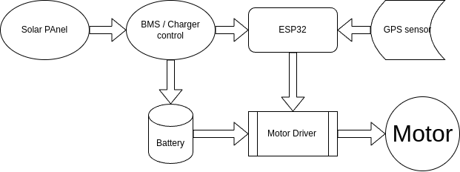

The block diagram illustrates the system architecture of the solar-powered plastic collector designed for removing floating plastics from waterbodies. It depicts the interconnections between key components, highlighting the flow of power and control signals that enable autonomous navigation and plastic collection. The diagram is integral to understanding the system’s operation, integrating renewable energy, embedded control, and mechanical actuation.

The system begins with the Solar Panel, which generates power to drive the collector. The solar panel, rated at 10W with a 5V, 2A output, connects to the Battery Management System (BMS) / Charger Control. This module, incorporating a TP4056 charger, regulates charging of the 3.7V, 2000mAh Li-ion Battery, ensuring overcharge and over-discharge protection. The BMS also directs power to the ESP32 module, facilitating system operation.

The Li-ion Battery serves as the primary power source, supplying energy to both the ESP32 and the Motor Driver. This ensures continuous operation, with solar charging extending runtime under sunlight. The battery’s output is stepped up to 12V for motor operation where necessary, maintaining a stable power supply for all components.

The ESP32, specifically an ESP32-CAM with an OV2640 camera, acts as the central controller. It receives power from the BMS and processes inputs from the GPS Sensor, which provides positional data for navigation. The ESP32-CAM performs real-time video streaming and basic image processing for boundary detection, transmitting data over Wi-Fi to a web-based interface. It also generates pulse-width modulation (PWM) signals to control the Motor Driver.

The GPS Sensor feeds location data to the ESP32, enabling the collector to track its position within the waterbody. This supports autonomous navigation, complementing the ESP32-CAM’s image-based boundary detection to prevent collisions with shorelines or obstacles.

The Motor Driver, implemented with an L293D, receives control signals from the ESP32 and power from the battery. It drives the Motors, which are two 12V, 100 RPM DC motors with propellers. The L293D enables precise control of motor speed and direction, facilitating forward, backward, and differential turning to maneuver the collector and position its net for plastic collection.

The Motors are the final component, converting electrical signals into mechanical motion to propel the buoyant platform. The platform, equipped with a nylon mesh net, collects floating plastics as it navigates the waterbody. The diagram’s flow—from solar power generation to motor actuation—underscores the system’s autonomous and sustainable design, optimized for small to medium waterbodies.

This block diagram provides a clear visual representation of the plastic collector’s functionality, emphasizing the integration of renewable energy, real-time monitoring, and precise control. It supports the project’s objectives of cost-effectiveness and environmental sustainability, as detailed in subsequent sections.

FTDI232 Programmer
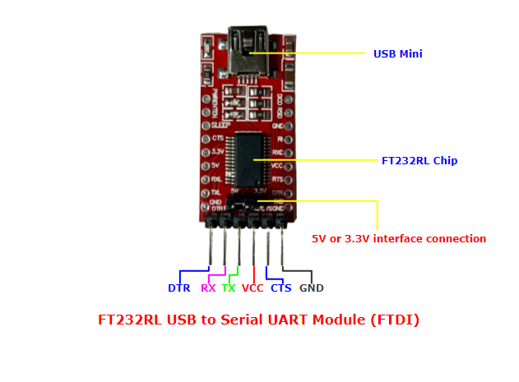

The FT232R programmer, developed by Future Technology Devices International (FTDI), is a USB-to-serial UART interface chip integral to programming and debugging the ESP32-CAM microcontroller in the solar-powered plastic collector for waterbodies. This section describes the role, setup, and integration of the FT232R programmer, ensuring effective communication between the development environment and the collector’s control system.

The FT232R serves as a bridge, converting USB signals from a computer to serial UART signals compatible with the ESP32-CAM, which lacks a built-in USB interface. This enables uploading firmware, debugging code, and monitoring serial data during development and testing. The chip handles the entire USB protocol internally, requiring no USB-specific firmware programming, and supports data transfer rates up to 3 Mbaud at TTL levels, suitable for the ESP32-CAM’s UART interface. Its key features include a 256-byte receive buffer, 128-byte transmit buffer, and configurable voltage levels (3.3V or 5V), making it versatile for microcontroller applications.

In the plastic collector project, the FT232R programmer connects to the ESP32-CAM to upload the Arduino-based firmware, which manages navigation, motor control via the L293D driver, and video streaming. The connections are as follows: the FT232R’s TX pin connects to the ESP32-CAM’s RX0 pin, the FT232R’s RX pin connects to the ESP32-CAM’s TX0 pin, VCC (set to 3.3V via a jumper to match the ESP32-CAM’s voltage) connects to the ESP32-CAM’s 3.3V pin, and GND connects to the ESP32-CAM’s GND pin. A 100nF capacitor is soldered between the FT232R’s DTR pin and the ESP32-CAM’s GPIO0 pin to enable auto-reset during uploads, allowing seamless sketch uploads without manually pressing the reset button.

Setup involves installing the FT232R’s Virtual COM Port (VCP) drivers on the development computer (Windows, Mac, or Linux) from the FTDI website. Once connected via a USB cable, the FT232R appears as a COM port in the Arduino IDE. The user selects the appropriate port and board (e.g., “ESP32 Wrover Module”) and uploads the firmware, which includes web server code for video streaming, PWM control for the L293D, and edge detection for navigation. The FT232R’s serial monitor also facilitates debugging by displaying runtime logs, such as motor status or GPS data from the system’s GPS sensor.

The FT232R’s integration enhances the project’s development efficiency, enabling rapid iteration and testing in a controlled waterbody. Its low cost (approximately $5–10 for a breakout board) and compatibility with the ESP32-CAM align with the project’s goal of affordability. However, the FT232R is used only during development, as the collector operates autonomously in deployment, powered by the solar panel and battery. Future enhancements could involve using the FT232R for in-field diagnostics via a temporary USB connection.

ESP32-CAM

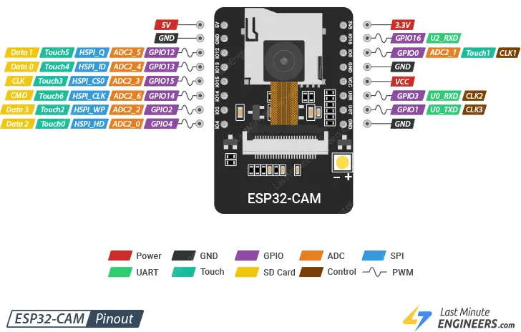

The ESP32-CAM, a compact microcontroller module developed by Espressif Systems, is the central control unit of the solar-powered plastic collector designed for removing floating plastics from waterbodies. This section details the ESP32-CAM’s specifications, role, programming setup, and integration with other components, highlighting its contribution to autonomous navigation, real-time monitoring, and system efficiency.

The ESP32-CAM features a dual-core Xtensa LX6 processor operating at up to 240 MHz, 520 KB SRAM, 4 MB external flash, and an OV2640 2MP camera for image capture. It includes built-in Wi-Fi (802.11 b/g/n) and Bluetooth 4.2, enabling wireless communication, and multiple GPIO pins for interfacing with peripherals. The module supports a 3.3V operating voltage, aligning with the project’s power system, and its small form factor (27 x 40.5 mm) ensures easy integration into the collector’s waterproof enclosure. Priced at approximately $10, the ESP32-CAM supports the project’s goal of cost-effectiveness.

In the plastic collector, the ESP32-CAM performs three primary functions: real-time video streaming, navigation control, and basic image processing. It streams video at 320x240 resolution over Wi-Fi to a web-based interface, allowing operators to monitor the waterbody and plastic collection process remotely. The ESP32-CAM generates pulse-width modulation (PWM) signals to the L293D motor driver, controlling two 12V DC motors for propulsion and steering, enabling forward, backward, and differential turning. Using OpenCV’s Canny edge detection algorithm, optimized for its limited processing power, the ESP32-CAM processes camera images to detect waterbody boundaries (e.g., shorelines), preventing collisions with a detection range of 1–2 meters under clear conditions. Additionally, it receives positional data from a GPS sensor, as indicated in the system’s block diagram, enhancing navigation accuracy.

Programming the ESP32-CAM requires an FT232R USB-to-serial programmer, as the module lacks a built-in USB interface. The FT232R’s TX, RX, VCC (3.3V), and GND pins connect to the ESP32-CAM’s RX0, TX0, 3.3V, and GND pins, respectively. A 100nF capacitor between the FT232R’s DTR pin and the ESP32-CAM’s GPIO0 pin enables auto-reset during firmware uploads. The Arduino IDE, with the ESP32 board package installed, is used to upload firmware. The firmware includes a web server for video streaming, HTTP request handling for navigation commands, and edge detection logic. The FT232R’s serial monitor facilitates debugging, displaying logs such as motor status or GPS coordinates.

The ESP32-CAM integrates with other components via the system’s power and control architecture. It receives power from a 3.7V, 2000mAh Li-ion battery, charged by a 10W solar panel through a TP4056 charger module. The battery’s 3.3V output directly powers the ESP32-CAM, ensuring stable operation. The ESP32-CAM’s GPIO pins (e.g., GPIO12, GPIO13) output PWM signals to the L293D, which drives the motors. The GPS sensor connects to the ESP32-CAM’s UART pins (e.g., GPIO14, GPIO15) for serial communication, providing location data. This integration, as depicted in the block diagram (Figure X), enables a cohesive system for autonomous plastic collection.

The ESP32-CAM’s low cost, wireless capabilities, and image processing make it ideal for the project, enabling real-time monitoring and navigation in small to medium waterbodies. Its limitations, such as limited processing power for advanced image analysis, are mitigated by optimizing algorithms and relying on manual oversight via the web interface. During deployment, the ESP32-CAM operates autonomously, but the FT232R can be reconnected for in-field firmware updates or diagnostics. This setup supports the project’s objectives of affordability, sustainability, and scalability, aligning with global cleanup initiatives like the UN’s Clean Seas Campaign.

L293D Motor Driver

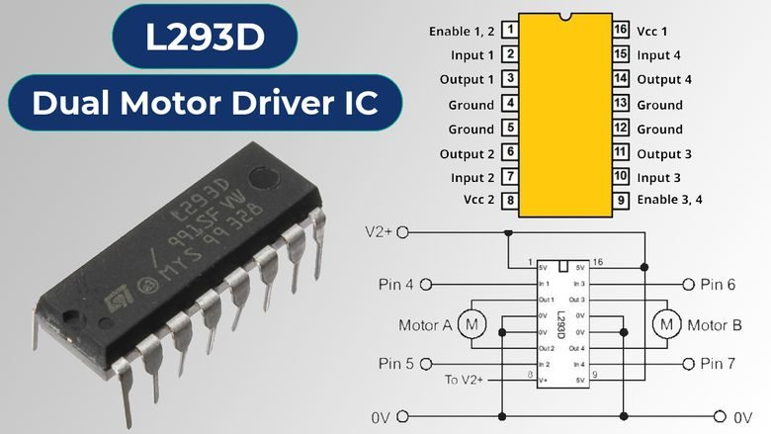
The L293D motor driver, a monolithic integrated high-voltage, high-current quadruple half-H driver, is a pivotal component in the solar-powered plastic collector designed for removing floating plastics from waterbodies. This section details the L293D’s specifications, role, setup, and integration with other system components, emphasizing its contribution to autonomous navigation and plastic collection efficiency.

The L293D is capable of driving two DC motors bidirectionally, with a maximum supply voltage of 36V and a peak output current of 600mA per channel (up to 1.2A non-repetitive). It features four half-H bridges, enabling control of motor direction and speed via pulse-width modulation (PWM). The chip supports a separate logic supply (4.5–7V) and motor supply (up to 36V), making it versatile for microcontroller-based systems. Its 16-pin DIP package is compact, and its low cost (approximately $2–3) aligns with the project’s goal of affordability. The L293D includes built-in thermal shutdown and flyback diodes to protect against voltage spikes, ensuring reliability in the aquatic environment.

In the plastic collector, the L293D drives two 12V, 100 RPM DC motors with propellers, mounted on a polystyrene foam platform to propel and steer the net-based collection system. The driver receives PWM signals from the ESP32-CAM to control motor speed and direction, enabling forward, backward, and differential turning (e.g., one motor at higher speed for turning). This allows the collector to navigate a waterbody, position the net to capture floating plastics (e.g., bottles, wrappers), and avoid obstacles based on the ESP32-CAM’s edge detection and GPS data.

The L293D’s setup involves connecting it to the ESP32-CAM, power system, and motors. The chip’s enable pins (EN1, EN2) are connected to ESP32-CAM GPIO pins (e.g., GPIO12, GPIO13) for PWM input, controlling motor speed. Input pins (IN1, IN2 for one motor; IN3, IN4 for the other) connect to additional GPIO pins (e.g., GPIO14, GPIO15) to set motor direction (e.g., high/low for forward, low/high for reverse). The motor supply pin (VCC2, pin 8) connects to the 12V output from a voltage regulator, stepped up from the 3.7V, 2000mAh Li-ion battery, which is charged by a 10W solar panel via a TP4056 module. The logic supply pin (VCC1, pin 16) receives 5V from the battery or a regulator, compatible with the ESP32-CAM’s logic levels. Motor output pins (OUT1–OUT4) connect directly to the two DC motors. A 100µF capacitor across VCC2 and ground minimizes noise from motor operation.

The L293D integrates seamlessly with the system, as depicted in the block diagram (Figure X). It receives power from the battery and control signals from the ESP32-CAM, which processes inputs from the GPS sensor and OV2640 camera. The driver’s ability to handle 12V motors ensures robust propulsion, while its PWM compatibility allows precise control, critical for navigating small to medium waterbodies (e.g., a 10m x 10m pond). During testing, the L293D’s performance was evaluated for response time to navigation commands and motor reliability under varying loads, ensuring effective plastic collection.

The L293D’s low cost and simplicity make it ideal for the project, though its current limitation (600mA continuous) restricts motor selection to low-power DC motors. Higher-current drivers (e.g., L298N) were considered but deemed unnecessary given the project’s lightweight platform and modest power requirements. The L293D’s integration supports the project’s objectives of affordability and autonomous operation, aligning with global cleanup initiatives like the UN’s Clean Seas Campaign. Future enhancements could involve adding a heat sink for prolonged operation or upgrading to a driver with higher current capacity for larger motors.

NEO-6M GPS Module

The NEO-6M GPS module is a popular, affordable GPS receiver based on the u-blox NEO-6M chipset, commonly used in Arduino and ESP32 projects for obtaining real-time location data (latitude, longitude, altitude, etc.).

Key Features of NEO-6M GPS Module
- Baud rate: Default 9600 bps
- Power: Operates at 3.3V–5V
- Communication: UART (TX, RX)
- Outputs data in NMEA sentences (e.g., $GPGGA, $GPRMC)
- Position accuracy: ~2.5m CEP
- Cold start: ~27 seconds; Hot start: ~1 second
- Onboard EEPROM to save configuration
- Backup battery (CR1220) to keep GPS data between resets
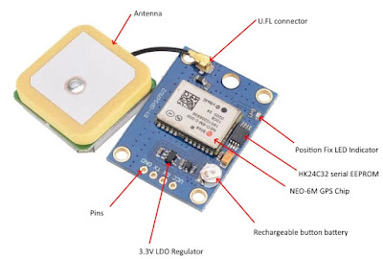

Wiring to ESP32 / ESP32-CAM
NEO-6M Pin | ESP32 / ESP32-CAM Pin
VCC | 3.3V or 5V (check your module)
GND | GND
TX | RX (e.g., GPIO16 or GPIO3)
RX | TX (e.g., GPIO17 or GPIO1)
The ESP32-CAM only has one hardware UART (used by USB when flashing). Use SoftwareSerial (not recommended for ESP32) or Serial1 via HardwareSerial on available GPIOs like GPIO14 (TX) and GPIO15 (RX), or GPIO16/17.

Solar Panel
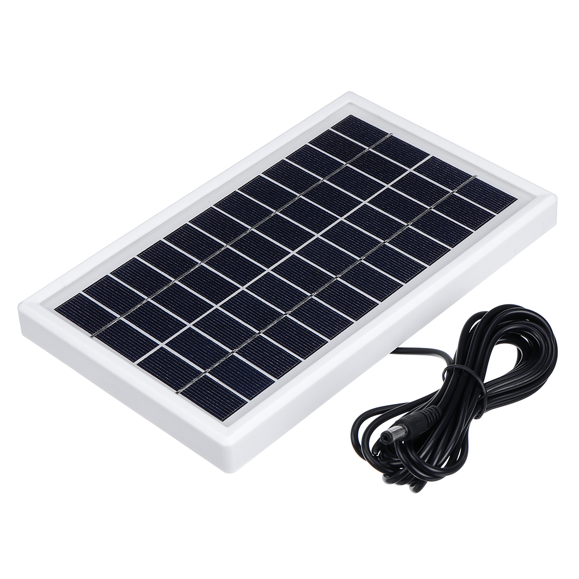

The 12V solar panel is a cornerstone of the solar-powered plastic collector, providing renewable energy to sustain autonomous operation in waterbodies. This section details the solar panel’s specifications, role, setup, and integration with other system components, emphasizing its contribution to the project’s sustainability and efficiency in collecting floating plastics.

The solar panel is a 12V, 10W polycrystalline module, capable of delivering up to 0.83A under optimal sunlight (1000 W/m², 25°C). It features a compact size (approximately 35 x 25 cm), suitable for mounting on the collector’s polystyrene foam platform, and a durable, weather-resistant frame to withstand aquatic conditions. The panel’s open-circuit voltage is around 21V, with a short-circuit current of 0.9A, ensuring efficient power delivery to the system. Priced at approximately $15–20, the solar panel aligns with the project’s goal of affordability, offering a cost-effective alternative to grid or fuel-based power sources.

In the plastic collector, the solar panel charges a 3.7V, 2000mAh Li-ion battery, which powers the ESP32-CAM, L293D motor driver, and two 12V DC motors. The panel’s 12V output is stepped down to 3.7V–4.2V using a TP4056 charging module, which includes overcharge and over-discharge protection to ensure battery safety. The solar panel provides sufficient power to recharge the battery in approximately 4–5 hours under full sunlight, extending the collector’s operational time beyond the battery’s standalone capacity of 3–4 hours (at ~500mA system consumption). This enables continuous navigation and plastic collection, even in remote waterbodies, without external power sources.

Setup involves mounting the solar panel on the collector’s platform, angled at 30–45° to maximize sunlight exposure based on typical testing locations (e.g., a pond in a temperate region). The panel’s positive and negative terminals connect to the TP4056 module’s input via insulated, waterproof wiring to prevent corrosion. A diode (e.g., 1N4007) is placed in series with the positive terminal to prevent reverse current flow from the battery to the panel during low-light conditions. The TP4056’s output connects to the Li-ion battery, which supplies power to the ESP32-CAM (3.3V via a regulator) and the L293D (12V via a step-up converter for motor operation). The system’s power management ensures stable operation, with the solar panel recharging the battery during daylight to support the ESP32-CAM’s video streaming, GPS navigation, and motor control.

The solar panel integrates with the system as depicted in the block diagram (Figure X), labeled as “Solar Panel,” feeding power to the Battery Management System (BMS) / Charger Control (TP4056). The BMS distributes energy to the battery, which powers the ESP32-CAM, L293D, and motors. This setup ensures a sustainable energy cycle, critical for autonomous operation in small to medium waterbodies (e.g., a 10m x 10m pond). During testing, the solar panel’s performance was evaluated by measuring battery charging rates under varying sunlight conditions (full sun, partial shade), confirming its ability to extend operational time.

The 12V solar panel’s reliability and low cost make it ideal for the project, though its output is weather-dependent, with reduced efficiency in overcast conditions. To mitigate this, the battery provides backup power, and future enhancements could include a larger panel (e.g., 20W) or maximum power point tracking (MPPT) for improved charging efficiency. The solar panel’s integration supports the project’s sustainability objectives, aligning with global environmental initiatives like the UN’s Clean Seas Campaign, and enables scalable deployment in resource-constrained regions.

Li-Ion Battery

The Lithium-ion (Li-ion) battery is a critical component in the proposed plastic waste collector, serving as the primary energy storage unit. It ensures uninterrupted power supply to the system, enabling autonomous operation even in the absence of sunlight.

Battery Selection
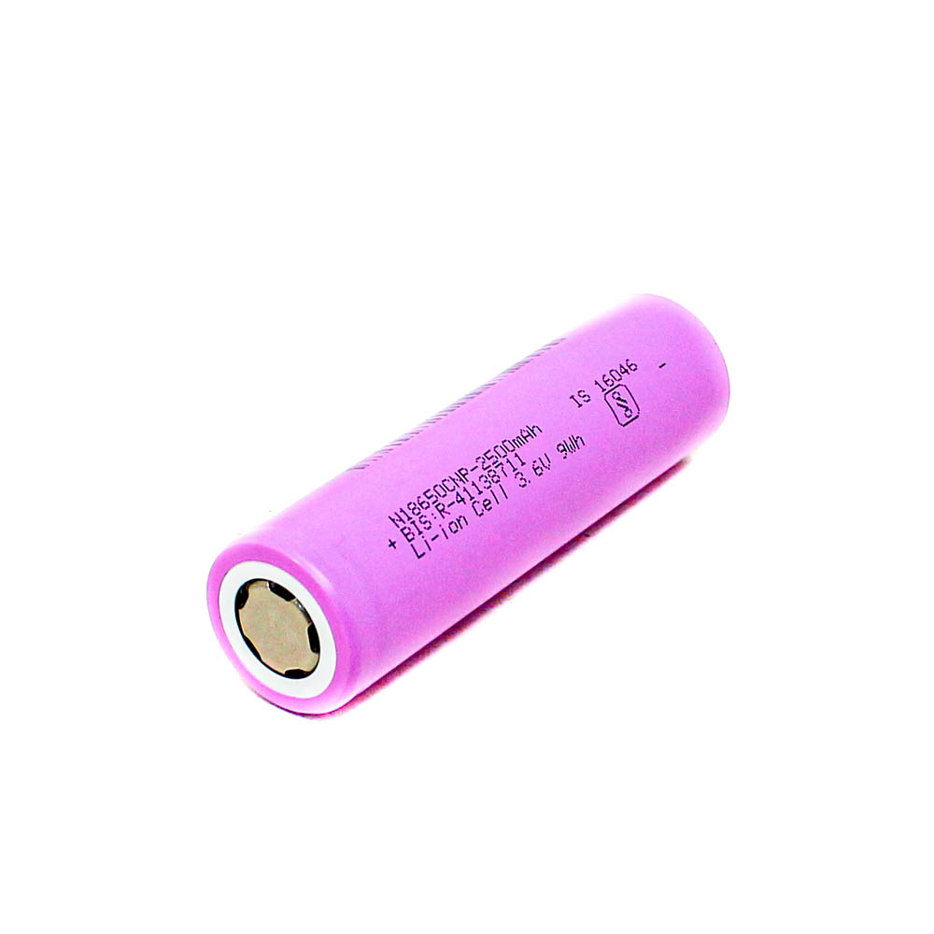
For this project, a 3.7V or 7.4V Li-ion battery pack is used, depending on the power requirements of the motors and the ESP32-CAM module. The selection criteria include:
- High energy density for compact power storage.
- Lightweight and compact size suitable for floating systems.
- Rechargeability to support solar panel integration.
- Stable discharge characteristics, which are essential for consistent performance.

Battery Capacity Calculation
The battery capacity is selected based on the power consumption of:
- ESP32-CAM (~160–250 mA during operation)
- DC motors via L293D driver (~300–600 mA each depending on load)
- Wi-Fi and camera usage for streaming images
- Expected operation time (e.g., 3–5 hours continuously)
Example:
If total system draw = ~1 A and desired runtime = 4 hours,
Required capacity = 1 A × 4 hrs = 4,000 mAh (or 4 Ah)
A 2-cell 7.4V 2200 mAh Li-ion battery pack is a practical choice for compact systems, recharged via the solar panel.

Charging via Solar Panel
The battery is connected to a solar charge controller that manages:
- Overcharge protection
- Safe voltage and current regulation
- Automatic cut-off when the battery is full
A 6V or 12V solar panel (1A to 2A) is used, depending on the battery configuration and size constraints.

Power Regulation
A DC-DC buck or boost converter ensures that the voltage from the Li-ion battery is regulated to:
- 5V for the ESP32-CAM
- Appropriate motor voltage (typically 5V–9V depending on motors used)
This ensures consistent operation regardless of fluctuations in battery voltage during discharge.

Safety and Protection
Safety features are implemented to prevent:
- Over-discharge, which can permanently damage Li-ion cells
- Short-circuits, especially in a water-exposed environment
- Overheating, by using current-limited motor drivers and waterproof casing
A Battery Management System (BMS) may be included if multiple cells are used, providing cell balancing and protection.
Programmer Circuit
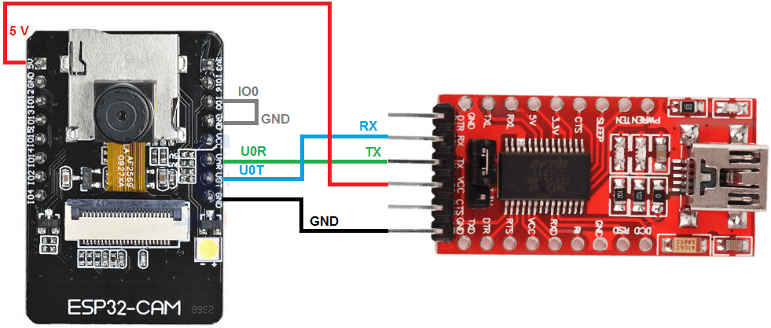
To program or communicate with the ESP32-CAM using an FTDI USB to Serial adapter, you need to follow a specific connection and procedure, because the ESP32-CAM doesn't have a built-in USB interface. Here's a complete guide:
- ESP32-CAM module
- FTDI USB to Serial adapter (3.3V and 5V capable)
- Jumper wires
- Push button or jumper wire (for GPIO0 to GND during flashing)

Wiring Connections:
FTDI Adapter Pin | ESP32-CAM Pin
5V (or 3.3V) | 5V (recommended)
GND | GND
TX | U0R (RX)
RX | U0T (TX)
– | IO0 to GND (to enable flashing)

- Use 5V on ESP32-CAM's 5V pin (NOT 3.3V) – the onboard regulator provides 3.3V internally.
- Connect IO0 to GND before powering the board to enter bootloader (flash) mode.
- Disconnect IO0 from GND after flashing for normal operation.

Flashing Procedure:
- Wire everything as above.
- Hold GPIO0 to GND (either use a jumper or press a button).
- Plug in the FTDI adapter to your PC.
- Upload code from the Arduino IDE or another tool.
  - Board: ESP32 Wrover Module
  - Partition Scheme: Huge App (3MB No OTA)
  - Upload Speed: 115200 (or lower if upload fails)
- Release GPIO0 after flashing is complete.
- Reset ESP32-CAM (use EN or unplug/replug) to run the code.

Circuit Diagram
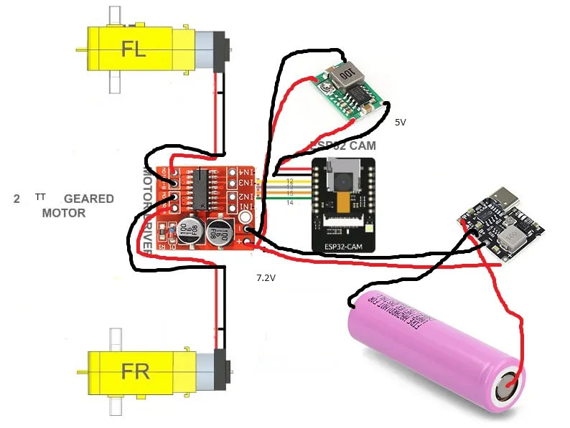

Code

#include "esp_camera.h"
#include <Arduino.h>
#include <WiFi.h>
#include <AsyncTCP.h>
#include <ESPAsyncWebServer.h>
#include <iostream>
#include <sstream>

struct MOTOR_PINS
{
int pinEn;
int pinIN1;
int pinIN2;
};

std::vector<MOTOR_PINS> motorPins =
{
{12, 13, 15}, //RIGHT_MOTOR Pins (EnA, IN1, IN2)
{12, 14, 2}, //LEFT_MOTOR Pins (EnB, IN3, IN4)
};
#define LIGHT_PIN 4

#define UP 1
#define DOWN 2
#define LEFT 3
#define RIGHT 4
#define STOP 0

#define RIGHT_MOTOR 0
#define LEFT_MOTOR 1

#define FORWARD 1
#define BACKWARD -1

const int PWMFreq = 1000; /* 1 KHz */
const int PWMResolution = 8;
const int PWMSpeedChannel = 2;
const int PWMLightChannel = 3;

//Camera related constants
#define PWDN_GPIO_NUM 32
#define RESET_GPIO_NUM -1
#define XCLK_GPIO_NUM 0
#define SIOD_GPIO_NUM 26
#define SIOC_GPIO_NUM 27
#define Y9_GPIO_NUM 35
#define Y8_GPIO_NUM 34
#define Y7_GPIO_NUM 39
#define Y6_GPIO_NUM 36
#define Y5_GPIO_NUM 21
#define Y4_GPIO_NUM 19
#define Y3_GPIO_NUM 18
#define Y2_GPIO_NUM 5
#define VSYNC_GPIO_NUM 25
#define HREF_GPIO_NUM 23
#define PCLK_GPIO_NUM 22

const char* ssid = "MyWiFiCar";
const char* password = "12345678";

AsyncWebServer server(80);
AsyncWebSocket wsCamera("/Camera");
AsyncWebSocket wsCarInput("/CarInput");
uint32_t cameraClientId = 0;

const char* htmlHomePage PROGMEM = R"HTMLHOMEPAGE(
<!DOCTYPE html>
<html>
<head>
<meta name="viewport" content="width=device-width, initial-scale=1, maximum-scale=1, user-scalable=no">
<style>
.arrows {
font-size:40px;
color:red;
}
td.button {
background-color:black;
border-radius:25%;
box-shadow: 5px 5px #888888;
}
td.button:active {
transform: translate(5px,5px);
box-shadow: none;
}

.noselect {
-webkit-touch-callout: none; /* iOS Safari */
-webkit-user-select: none; /* Safari */
-khtml-user-select: none; /* Konqueror HTML */
-moz-user-select: none; /* Firefox */
-ms-user-select: none; /* Internet Explorer/Edge */
user-select: none; /* Non-prefixed version, currently
supported by Chrome and Opera */
}

.slidecontainer {
width: 100%;
}

.slider {
-webkit-appearance: none;
width: 100%;
height: 15px;
border-radius: 5px;
background: #d3d3d3;
outline: none;
opacity: 0.7;
-webkit-transition: .2s;
transition: opacity .2s;
}

.slider:hover {
opacity: 1;
}

.slider::-webkit-slider-thumb {
-webkit-appearance: none;
appearance: none;
width: 25px;
height: 25px;
border-radius: 50%;
background: red;
cursor: pointer;
}

.slider::-moz-range-thumb {
width: 25px;
height: 25px;
border-radius: 50%;
background: red;
cursor: pointer;
}

</style>

</head>
<body class="noselect" align="center" style="background-color:white">

<!--h2 style="color: teal;text-align:center;">Wi-Fi Camera &#128663; Control</h2-->

<table id="mainTable" style="width:400px;margin:auto;table-layout:fixed" CELLSPACING=10>
<tr>
<img id="cameraImage" src="" style="width:400px;height:250px"></td>
</tr>
<tr>
<td></td>
<td class="button" ontouchstart='sendButtonInput("MoveCar","1")' ontouchend='sendButtonInput("MoveCar","0")'><span class="arrows" >&#8679;</span></td>
<td></td>
</tr>
<tr>
<td class="button" ontouchstart='sendButtonInput("MoveCar","3")' ontouchend='sendButtonInput("MoveCar","0")'><span class="arrows" >&#8678;</span></td>
<td class="button"></td>
<td class="button" ontouchstart='sendButtonInput("MoveCar","4")' ontouchend='sendButtonInput("MoveCar","0")'><span class="arrows" >&#8680;</span></td>
</tr>
<tr>
<td></td>
<td class="button" ontouchstart='sendButtonInput("MoveCar","2")' ontouchend='sendButtonInput("MoveCar","0")'><span class="arrows" >&#8681;</span></td>
<td></td>
</tr>
<tr/><tr/>
<tr>
<td style="text-align:left"><b>Speed:</b></td>
<td colspan=2>
<div class="slidecontainer">
<input type="range" min="0" max="255" value="150" class="slider" id="Speed" oninput='sendButtonInput("Speed",value)'>
</div>
</td>
</tr>
<tr>
<td style="text-align:left"><b>Light:</b></td>
<td colspan=2>
<div class="slidecontainer">
<input type="range" min="0" max="255" value="0" class="slider" id="Light" oninput='sendButtonInput("Light",value)'>
</div>
</td>
</tr>
</table>

<script>
var webSocketCameraUrl = "ws:\/\/" + window.location.hostname + "/Camera";
var webSocketCarInputUrl = "ws:\/\/" + window.location.hostname + "/CarInput";
var websocketCamera;
var websocketCarInput;

function initCameraWebSocket()
{
websocketCamera = new WebSocket(webSocketCameraUrl);
websocketCamera.binaryType = 'blob';
websocketCamera.onopen = function(event){};
websocketCamera.onclose = function(event){setTimeout(initCameraWebSocket, 2000);};
websocketCamera.onmessage = function(event)
{
var imageId = document.getElementById("cameraImage");
imageId.src = URL.createObjectURL(event.data);
};
}

function initCarInputWebSocket()
{
websocketCarInput = new WebSocket(webSocketCarInputUrl);
websocketCarInput.onopen = function(event)
{
var speedButton = document.getElementById("Speed");
sendButtonInput("Speed", speedButton.value);
var lightButton = document.getElementById("Light");
sendButtonInput("Light", lightButton.value);
};
websocketCarInput.onclose = function(event){setTimeout(initCarInputWebSocket, 2000);};
websocketCarInput.onmessage = function(event){};
}

function initWebSocket()
{
initCameraWebSocket ();
initCarInputWebSocket();
}

function sendButtonInput(key, value)
{
var data = key + "," + value;
websocketCarInput.send(data);
}

window.onload = initWebSocket;
document.getElementById("mainTable").addEventListener("touchend", function(event){
event.preventDefault()
});
</script>
</body>
</html>
)HTMLHOMEPAGE";

void rotateMotor(int motorNumber, int motorDirection)
{
if (motorDirection == FORWARD)
{
digitalWrite(motorPins[motorNumber].pinIN1, HIGH);
digitalWrite(motorPins[motorNumber].pinIN2, LOW);
}
else if (motorDirection == BACKWARD)
{
digitalWrite(motorPins[motorNumber].pinIN1, LOW);
digitalWrite(motorPins[motorNumber].pinIN2, HIGH);
}
else
{
digitalWrite(motorPins[motorNumber].pinIN1, LOW);
digitalWrite(motorPins[motorNumber].pinIN2, LOW);
}
}

void moveCar(int inputValue)
{
Serial.printf("Got value as %d\n", inputValue);
switch(inputValue)
{

case UP:
rotateMotor(RIGHT_MOTOR, FORWARD);
rotateMotor(LEFT_MOTOR, FORWARD);
break;

case DOWN:
rotateMotor(RIGHT_MOTOR, BACKWARD);
rotateMotor(LEFT_MOTOR, BACKWARD);
break;

case LEFT:
rotateMotor(RIGHT_MOTOR, FORWARD);
rotateMotor(LEFT_MOTOR, BACKWARD);
break;

case RIGHT:
rotateMotor(RIGHT_MOTOR, BACKWARD);
rotateMotor(LEFT_MOTOR, FORWARD);
break;

case STOP:
rotateMotor(RIGHT_MOTOR, STOP);
rotateMotor(LEFT_MOTOR, STOP);
break;

default:
rotateMotor(RIGHT_MOTOR, STOP);
rotateMotor(LEFT_MOTOR, STOP);
break;
}
}

void handleRoot(AsyncWebServerRequest *request)
{
request->send_P(200, "text/html", htmlHomePage);
}

void handleNotFound(AsyncWebServerRequest *request)
{
request->send(404, "text/plain", "File Not Found");
}

void onCarInputWebSocketEvent(AsyncWebSocket *server,
AsyncWebSocketClient *client,
AwsEventType type,
void *arg,
uint8_t *data,
size_t len)
{
switch (type)
{
case WS_EVT_CONNECT:
Serial.printf("WebSocket client #%u connected from %s\n", client->id(), client->remoteIP().toString().c_str());
break;
case WS_EVT_DISCONNECT:
Serial.printf("WebSocket client #%u disconnected\n", client->id());
moveCar(0);
ledcWrite(PWMLightChannel, 0);
break;
case WS_EVT_DATA:
AwsFrameInfo *info;
info = (AwsFrameInfo*)arg;
if (info->final && info->index == 0 && info->len == len && info->opcode == WS_TEXT)
{
std::string myData = "";
myData.assign((char *)data, len);
std::istringstream ss(myData);
std::string key, value;
std::getline(ss, key, ',');
std::getline(ss, value, ',');
Serial.printf("Key [%s] Value[%s]\n", key.c_str(), value.c_str());
int valueInt = atoi(value.c_str());
if (key == "MoveCar")
{
moveCar(valueInt);
}
else if (key == "Speed")
{
ledcWrite(PWMSpeedChannel, valueInt);
}
else if (key == "Light")
{
ledcWrite(PWMLightChannel, valueInt);
}
}
break;
case WS_EVT_PONG:
case WS_EVT_ERROR:
break;
default:
break;
}
}

void onCameraWebSocketEvent(AsyncWebSocket *server,
AsyncWebSocketClient *client,
AwsEventType type,
void *arg,
uint8_t *data,
size_t len)
{
switch (type)
{
case WS_EVT_CONNECT:
Serial.printf("WebSocket client #%u connected from %s\n", client->id(), client->remoteIP().toString().c_str());
cameraClientId = client->id();
break;
case WS_EVT_DISCONNECT:
Serial.printf("WebSocket client #%u disconnected\n", client->id());
cameraClientId = 0;
break;
case WS_EVT_DATA:
break;
case WS_EVT_PONG:
case WS_EVT_ERROR:
break;
default:
break;
}
}

void setupCamera()
{
camera_config_t config;
config.ledc_channel = LEDC_CHANNEL_0;
config.ledc_timer = LEDC_TIMER_0;
config.pin_d0 = Y2_GPIO_NUM;
config.pin_d1 = Y3_GPIO_NUM;
config.pin_d2 = Y4_GPIO_NUM;
config.pin_d3 = Y5_GPIO_NUM;
config.pin_d4 = Y6_GPIO_NUM;
config.pin_d5 = Y7_GPIO_NUM;
config.pin_d6 = Y8_GPIO_NUM;
config.pin_d7 = Y9_GPIO_NUM;
config.pin_xclk = XCLK_GPIO_NUM;
config.pin_pclk = PCLK_GPIO_NUM;
config.pin_vsync = VSYNC_GPIO_NUM;
config.pin_href = HREF_GPIO_NUM;
config.pin_sscb_sda = SIOD_GPIO_NUM;
config.pin_sscb_scl = SIOC_GPIO_NUM;
config.pin_pwdn = PWDN_GPIO_NUM;
config.pin_reset = RESET_GPIO_NUM;
config.xclk_freq_hz = 20000000;
config.pixel_format = PIXFORMAT_JPEG;

config.frame_size = FRAMESIZE_VGA;
config.jpeg_quality = 10;
config.fb_count = 1;

// camera init
esp_err_t err = esp_camera_init(&config);
if (err != ESP_OK)
{
Serial.printf("Camera init failed with error 0x%x", err);
return;
}

if (psramFound())
{
heap_caps_malloc_extmem_enable(20000);
Serial.printf("PSRAM initialized. malloc to take memory from psram above this size");
}
}

void sendCameraPicture()
{
if (cameraClientId == 0)
{
return;
}
unsigned long startTime1 = millis();
//capture a frame
camera_fb_t * fb = esp_camera_fb_get();
if (!fb)
{
Serial.println("Frame buffer could not be acquired");
return;
}

unsigned long startTime2 = millis();
wsCamera.binary(cameraClientId, fb->buf, fb->len);
esp_camera_fb_return(fb);

//Wait for message to be delivered
while (true)
{
AsyncWebSocketClient * clientPointer = wsCamera.client(cameraClientId);
if (!clientPointer || !(clientPointer->queueIsFull()))
{
break;
}
delay(1);
}

unsigned long startTime3 = millis();
Serial.printf("Time taken Total: %d|%d|%d\n",startTime3 - startTime1, startTime2 - startTime1, startTime3-startTime2 );
}

void setUpPinModes()
{
//Set up PWM
ledcSetup(PWMSpeedChannel, PWMFreq, PWMResolution);
ledcSetup(PWMLightChannel, PWMFreq, PWMResolution);

for (int i = 0; i < motorPins.size(); i++)
{
pinMode(motorPins[i].pinEn, OUTPUT);
pinMode(motorPins[i].pinIN1, OUTPUT);
pinMode(motorPins[i].pinIN2, OUTPUT);

/* Attach the PWM Channel to the motor enb Pin */
ledcAttachPin(motorPins[i].pinEn, PWMSpeedChannel);
}
moveCar(STOP);

pinMode(LIGHT_PIN, OUTPUT);
ledcAttachPin(LIGHT_PIN, PWMLightChannel);
}

void setup(void)
{
setUpPinModes();
Serial.begin(115200);

WiFi.softAP(ssid, password);
IPAddress IP = WiFi.softAPIP();
Serial.print("AP IP address: ");
Serial.println(IP);

server.on("/", HTTP_GET, handleRoot);
server.onNotFound(handleNotFound);

wsCamera.onEvent(onCameraWebSocketEvent);
server.addHandler(&wsCamera);

wsCarInput.onEvent(onCarInputWebSocketEvent);
server.addHandler(&wsCarInput);

server.begin();
Serial.println("HTTP server started");

setupCamera();
}

void loop()
{
wsCamera.cleanupClients();
wsCarInput.cleanupClients();
sendCameraPicture();
Serial.printf("SPIRam Total heap %d, SPIRam Free Heap %d\n", ESP.getPsramSize(), ESP.getFreePsram());
}

RESULT

- Efficient Plastic Waste Collection:The prototype successfully collects floating plastic waste using a net-based mechanism mounted under the floating structure, reducing manual intervention and enabling continuous operation in waterbodies.
- Autonomous Navigation and Motor Control:The ESP32-CAM, in conjunction with the L293D motor driver, enabled precise bidirectional control of four DC motors, allowing the system to maneuver smoothly and reach plastic waste zones.
- Live Monitoring via ESP32-CAM:Real-time video streaming from the ESP32-CAM module was established, allowing remote observation and manual override if necessary, thereby improving safety and usability.
- Solar-Powered Operation:The integration of a solar panel and Li-ion battery provided reliable and sustainable energy, enabling off-grid operation and reducing dependency on external charging.
- Cost-Effective and Scalable Design:The system was built using affordable and readily available components, making it suitable for scaling to larger deployments or multiple units across different waterbodies.
- Environmentally Friendly and Impactful:The project demonstrates a practical approach to reducing plastic pollution in lakes, ponds, and slow-flowing rivers, supporting environmental conservation efforts and raising public awareness.

REFERENCES
- Asmuni, A., Hussin, N., Khalili, J. M., & Zain, Z. M. (2012). Public participation and effectiveness of the no plastic bag day program in Malaysia. Procedia - Social and Behavioral Sciences, 42, 422–430.
- Beaumont, N. J., Aanesen, M., Austen, M. C., Börger, T., Clark, J. R., Cole, M., ... & Wyles, K. J. (2019). Global ecological, social and economic impacts of marine plastic. Marine Pollution Bulletin, 142, 189–195.
- Chen, C. L. (2015). Regulation and management of marine litter. In M. Bergmann, L. Gutow, & M. Klages (Eds.), Marine anthropogenic litter (pp. 395–428). Springer.
- Clap, M., & Swanston, L. (2009). Plastics and their impacts. UNEP Discussion Paper.
- Dikgang, J., Leiman, A., & Visser, M. (2012). Analysis of the plastic-bag levy in South Africa. Resources, Conservation and Recycling, 66, 59–65.
- Elliott, T., Curtis, C., & Lim, L. (2020). Plastic waste management and the Basel Convention. Waste Management, 108, 1–10.
- EU. (2019). Directive (EU) 2019/904 of the European Parliament and of the Council of 5 June 2019 on the reduction of the impact of certain plastic products on the environment.
- Gall, S. C., & Thompson, R. C. (2015). The impact of debris on marine life. Marine Pollution Bulletin, 92(1-2), 170–179.
- Hinzmann, M., & Mederake, L. (2023). What potential does the EU Single-Use Plastics Directive have for reducing plastic pollution at coastlines and riversides? Waste Management.
- Hu, F. (2012). Integrated policies for marine litter: A governance perspective. Marine Policy, 36(3), 614–619.
- Jambeck, J. R., Geyer, R., Wilcox, C., Siegler, T. R., Perryman, M., Andrady, A., ... & Law, K. L. (2015). Plastic waste inputs from land into the ocean. Science, 347(6223), 768–771.
- Lamb, J. B., Willis, B. L., Fiorenza, E. A., Couch, C. S., Howard, R., Rader, D. N., ... & Harvell, C. D. (2018). Plastic waste associated with disease on coral reefs. Science, 359(6374), 460–462.
- Macinnis-Ng, C., & Ralph, P. J. (2018). Implications of plastic debris on seagrass ecosystems. Marine Pollution Bulletin, 135, 112–119.
- McIlgorm, A., Campbell, H. F., & Rule, M. J. (2020). The cost of marine litter to the Asia-Pacific tourism and fisheries sectors. Marine Pollution Bulletin, 150, 110615.
- Nkwachukwu, O. I., Chima, C. H., Ikenna, A. O., & Albert, L. (2013). Focus on potential environmental issues on plastic world towards a sustainable plastic recycling in developing countries. International Journal of Industrial Chemistry, 4(1), 34.
- Palasis, D. (2011). The regulation of marine plastic pollution: What future for international law? Ocean Development & International Law, 42(3), 309–331.
- Poortinga, W., Whitmarsh, L., & Suffolk, C. (2013). The introduction of a single-use carrier bag charge in Wales: Attitude change and behavioral spillover effects. Journal of Environmental Psychology, 36, 240–247.
- Rayner, J., & Howlett, M. (2009). Implementing integrated land management in Western Canada: Policy reform and the resilience of clientelism. Journal of Natural Resources Policy Research, 1(4), 321–334.
- Rethink Plastic Alliance. (2024). Assessing Single-Use Plastics Directive implementation ahead of Commission evaluation. Seas At Risk Report.
- Ritch, E., Brennan, C., & MacLeod, C. (2009). Plastic bag politics: Modifying consumer behavior for sustainable development. International Journal of Consumer Studies, 33(2), 168–174.
- Rochman, C. M., Hoh, E., Kurobe, T., & Teh, S. J. (2013). Ingested plastic transfers hazardous chemicals to fish and induces hepatic stress. Scientific Reports, 3, 3263.
- Seas At Risk. (2021). Single-use plastics pollution: Where does Europe stand? Seas At Risk Report.
- Simon, N., & Schulte, M. L. (2017). Stopping global plastic pollution: The case for an international convention. Heinrich Böll Foundation and Break Free From Plastic.
- Spalding, M., Burke, L., Wood, S. A., Ashpole, J., Hutchison, J., & zu Ermgassen, P. (2017). Mapping the global value and distribution of coral reef tourism. Marine Policy, 82, 104–113.
- UNEP. (2016). Marine plastic debris and microplastics: Global lessons and research to inspire action. United Nations Environment Programme.
- UNEP. (2019). Legal limits on single-use plastics and microplastics: A global review of national laws and regulations. United Nations Environment Programme.
- UNEP. (2022). Committing to end plastic pollution: U.S. and European Commission join Clean Seas Campaign. UNEP Report.
- Vegter, A. C., Barletta, M., Beck, C., Borrero, J., Burton, H., Campbell, M. L., ... & Hardesty, B. D. (2014). Global research priorities to mitigate plastic pollution impacts on marine wildlife. Endangered Species Research, 25(3), 225–247.
- Vince, J., & Hardesty, B. D. (2017). Plastic pollution challenges in marine and coastal environments: From local to global governance. Restoration Ecology, 25(1), 123–128.
- Wilcox, C., Van Sebille, E., & Hardesty, B. D. (2016). Threat of plastic pollution to seabirds is global, pervasive, and increasing. Proceedings of the National Academy of Sciences, 113(38), 11899–11904.
- Worm, B., Lotze, H. K., Jubinville, I., Wilcox, C., & Jambeck, J. (2017). Plastic as a persistent marine pollutant. Annual Review of Environment and Resources, 42, 1–26.
- Xanthos, D., & Walker, T. R. (2017). International policies to reduce plastic marine pollution from single-use plastics (plastic bags and microbeads): A review. Marine Pollution Bulletin, 118(1-2), 17–26.
- Zhang, C., Chen, X., Wang, J., & Tan, L. (2017). Toxic effects of microplastics on marine phytoplankton. Environmental Pollution, 224, 1–8.

