3: Methodology

3.1 Introduction
This project presents the design and development of an automated wire harness diagnostic system aimed at improving the accuracy, speed, and reliability of wire testing. Conventional testing methods are often manual, time-consuming, and limited in detecting advanced faults such as signal delay, high resistance connections, and thermal issues. To address these limitations, the proposed system integrates embedded technologies to perform a comprehensive analysis of wire harness conditions.
The system is designed using two functional modules, each dedicated to a specific type of testing. The first module utilizes an ESP32 microcontroller programmed in MicroPython to perform signal integrity and continuity testing. It verifies proper connections between wires and measures propagation delay using high-resolution timing, enabling the detection of faults such as open circuits, incorrect wiring, and abnormal delays.
The second module is developed using an Arduino Nano, focusing on electrical load and thermal analysis. In this module, a controlled load is applied to the wire through a MOSFET switching circuit and a power resistor. The current flowing through the wire is measured using an ACS712 current sensor, while the temperature is monitored using a DS18B20 digital temperature sensor. This setup allows evaluation of the wire’s performance under load conditions and helps identify overheating and excessive current flow.
Both modules operate independently while contributing to a unified diagnostic process. Real-time feedback is provided through display units, where an OLED display presents signal testing results and an LCD shows current and temperature values. The system is capable of identifying various faults, including open circuits, short circuits, high resistance paths, and thermal abnormalities, ensuring a reliable and efficient testing mechanism.

3.2 Overview of the Proposed System
The proposed system is an automated diagnostic setup designed to assess both the electrical and physical performance of wire harnesses. It combines signal-based testing with load-based analysis to provide a complete evaluation of wire integrity and operational reliability.
The signal testing subsystem, based on the ESP32, transmits electrical signals through individual wires in the harness and monitors corresponding inputs to verify correct connections. It also measures signal propagation delay, which helps in identifying issues such as discontinuities, गलत connections, and degraded signal paths. The results are displayed on an OLED screen for immediate interpretation.
The load testing subsystem, implemented using the Arduino Nano, evaluates the behavior of the wire under practical operating conditions. A controlled load is applied using a MOSFET and a power resistor, while the ACS712 sensor measures current flow and the DS18B20 sensor records temperature variations. This enables analysis of current-carrying capacity and thermal performance, which are critical indicators of wire quality.

3.3 Block Diagram
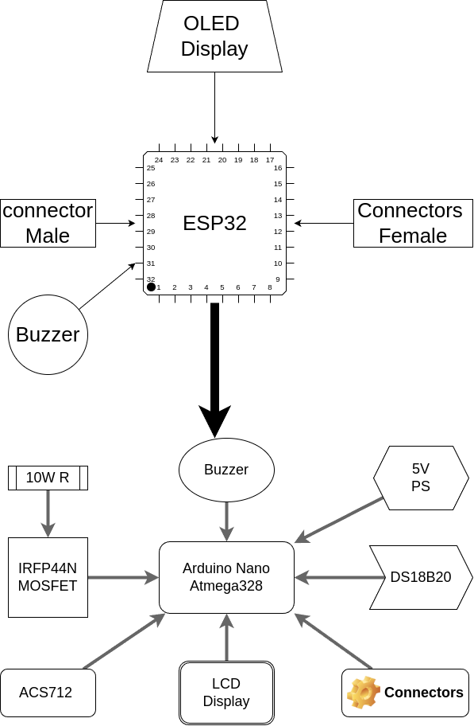
The block diagram represents the overall architecture of the proposed wire harness diagnostic system. It is divided into two main sections: the signal testing unit (ESP32-based) and the load and thermal testing unit (Arduino Nano-based). Each component in the diagram plays a specific role in ensuring accurate and reliable wire harness analysis.
At the top of the system, the OLED display is connected to the ESP32 microcontroller. This display provides real-time feedback for signal integrity testing, showing results such as connection status, propagation delay, and fault indications. The ESP32 is interfaced with both male and female connectors, through which the wire harness under test is connected. The ESP32 sends signals through the output pins and receives them through corresponding input pins to verify correct wiring.
A buzzer is also connected to the ESP32 section to provide audible alerts during testing. It indicates conditions such as pass, fail, or warning, improving user interaction without requiring constant visual monitoring.
The lower section of the block diagram represents the load testing unit, centered around the Arduino Nano (ATmega328). This unit is responsible for analyzing the electrical and thermal performance of the wire. A 5V power supply provides the necessary operating voltage for the Arduino and associated components.
A MOSFET (IRFP150N) is used as a switching device to control the application of load across the wire harness. The load is provided by a 10W power resistor, which simulates real operating conditions by drawing current through the wire. The ACS712 current sensor is connected in series to measure the current flowing through the circuit.
For temperature monitoring, a DS18B20 sensor is used to measure the heat generated in the wire during load testing. This helps in identifying overheating conditions and evaluating the current-carrying capability of the wire.
The Arduino Nano processes the current and temperature data and displays the results on a 16x2 LCD display. A second buzzer is also included in this section to provide alerts for abnormal conditions such as excessive current or high temperature.
Connectors are used in both sections to interface the wire harness with the system, ensuring proper and flexible connections during testing.

3.4 Workflow of the System
The workflow of the proposed wire harness diagnostic system describes the sequence of operations carried out to evaluate the condition of the wire harness. The process is divided into two main stages: signal testing and load/thermal testing. Each stage operates systematically to detect different types of faults and provide accurate results.
The process begins with the initialization of both controllers. The ESP32 initializes the OLED display and configures the input and output pins for signal testing. At the same time, the Arduino Nano initializes the LCD display, current sensor (ACS712), temperature sensor (DS18B20), and the MOSFET-based load circuit.

In the first stage, the ESP32 performs signal integrity testing. It sends a digital signal through each output pin connected to the wire harness. The corresponding input pin is monitored to verify whether the signal is correctly received. The time taken for the signal to travel from output to input is measured using a high-resolution timer. Based on this measurement, the system determines whether the connection is correct, absent, or experiencing high delay. The results are displayed on the OLED screen, and an alert is generated if any fault is detected.
Once signal testing is completed, the system proceeds to the second stage, which is load and thermal testing. The Arduino Nano activates the MOSFET to apply a controlled load across the wire using a power resistor. As current flows through the wire, the ACS712 sensor continuously measures the current, while the DS18B20 sensor monitors the temperature of the wire.
The Arduino processes these sensor readings and displays the current and temperature values on the LCD screen in real time. If the temperature exceeds a predefined threshold or if abnormal current conditions are detected, the system triggers a buzzer alert to indicate a potential issue such as overheating or excessive load.
Throughout the operation, both stages provide continuous feedback, allowing the user to monitor the condition of the wire harness effectively. The combination of signal testing and load testing ensures that both electrical connectivity and physical performance are evaluated.
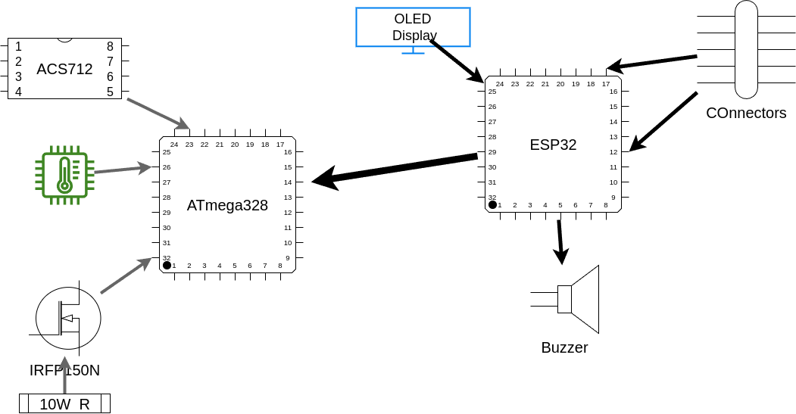

3.5 Software and Explanation
The software of the proposed system is divided into two parts based on the hardware modules used: the ESP32 (MicroPython-based) for signal testing and the Arduino Nano (Embedded C/C++) for load and thermal analysis. Each software module is designed to perform specific tasks efficiently while providing real-time feedback through display units.

ESP32 Software (Signal Testing Module)
The ESP32 is programmed using MicroPython and is responsible for signal integrity and continuity testing. The software begins by initializing the GPIO pins as input and output, along with setting up the OLED display using the I2C protocol. A mapping between output pins and expected input pins is defined to verify correct wiring.
During execution, the ESP32 sends a digital HIGH signal through each output pin one at a time. The corresponding input pin is continuously monitored to detect the signal. A high-resolution timer is used to measure the time taken for the signal to propagate from the output to the input. This propagation delay is calculated in microseconds.
Based on the measured delay and signal detection, the system classifies the result into three categories:
- PASS: Signal received within acceptable delay
- FAIL: No signal detected (open circuit or wrong connection)
- WARNING: Signal detected but with high delay (possible high resistance or poor connection)
The results are displayed on the OLED screen for each wire under test. The software also includes timeout conditions to prevent indefinite waiting in case of signal failure. This module ensures fast and accurate detection of wiring faults.

Arduino Nano Software (Load and Thermal Module)
The Arduino Nano is programmed using Embedded C in the Arduino IDE and is responsible for analyzing the wire under load conditions. The software initializes the ACS712 current sensor, DS18B20 temperature sensor, LCD display, and MOSFET control pin.
During operation, the Arduino activates the MOSFET to apply a load through a power resistor across the wire. The ACS712 sensor reads the current flowing through the wire by converting analog voltage into current values. The DS18B20 sensor measures the temperature of the wire digitally.
The software continuously reads and processes these sensor values. Current is calculated using calibration parameters such as sensitivity and offset voltage, while temperature is obtained directly from the sensor. The readings are displayed on the LCD in real time, showing time, current, and temperature.
The system also includes condition checks:
- If temperature exceeds a predefined threshold, it indicates overheating
- If current exceeds safe limits, it indicates overcurrent condition
In such cases, a buzzer alert is triggered to notify the user. The software ensures stable readings by incorporating small delays and proper sensor handling techniques.

3.6 Hardware Explanation

ESP32-WROOM Module
The ESP32-WROOM is a powerful and versatile microcontroller module used in the proposed system for signal integrity and continuity testing. It is based on a dual-core processor with integrated Wi-Fi and Bluetooth capabilities, making it suitable for high-speed and real-time applications. In this project, the ESP32-WROOM is primarily utilized for its fast processing speed and precise timing features, which are essential for measuring signal propagation delay.
The ESP32 operates at a clock frequency of up to 240 MHz and includes multiple General Purpose Input/Output (GPIO) pins. These GPIO pins are used to interface with the wire harness under test. In the system, selected GPIO pins are configured as output pins to send signals, while others are configured as input pins to receive signals. This configuration allows the ESP32 to verify the continuity and correctness of each wire connection.
One of the key advantages of the ESP32-WROOM module is its ability to perform high-resolution timing operations. Using internal timers, the system measures the time taken for a signal to travel from an output pin to the corresponding input pin. This enables detection of propagation delays, which can indicate issues such as high resistance, poor connections, or degraded wiring.
The ESP32 is also interfaced with an OLED display using the I2C communication protocol. The display provides real-time output of test results, including connection status and delay measurements. This improves user interaction by offering clear and immediate feedback during testing.
Additionally, the ESP32 supports MicroPython programming, which simplifies code development and debugging. The use of MicroPython allows for rapid implementation of logic, easy handling of GPIO operations, and efficient control of peripherals.

Arduino Nano (ATmega328)
The Arduino Nano is a compact and efficient microcontroller board based on the ATmega328 microcontroller. In the proposed system, it is used for load and thermal analysis of the wire harness. The Arduino Nano is well-suited for this application due to its stable analog-to-digital conversion, ease of interfacing with sensors, and reliable performance in embedded systems.
The ATmega328 microcontroller operates at a clock frequency of 16 MHz and provides multiple input/output pins, including analog input pins. These analog pins are particularly important in this system, as they are used to read the output from the ACS712 current sensor. The built-in Analog-to-Digital Converter (ADC) converts the analog voltage from the sensor into digital values, which are then processed to calculate the current flowing through the wire.
The Arduino Nano is also interfaced with the DS18B20 temperature sensor, which provides digital temperature readings. This sensor communicates using a one-wire protocol, allowing accurate measurement of the wire’s temperature during load testing. The Arduino processes this data to monitor thermal conditions and detect overheating.
A MOSFET switching circuit is controlled by the Arduino Nano to apply a load across the wire harness. By turning the MOSFET on and off, the system can control the flow of current through a power resistor, simulating real operating conditions. This enables evaluation of the wire’s current-carrying capacity and thermal performance.
The processed data, including current and temperature values, is displayed on a 16x2 LCD using I2C communication. This provides real-time monitoring for the user. Additionally, a buzzer is connected to the Arduino to generate alerts when abnormal conditions such as excessive current or high temperature are detected.
The Arduino Nano is programmed using the Arduino IDE with Embedded C/C++, which allows efficient implementation of sensor reading, data processing, and control logic. Its simplicity, reliability, and compatibility with various sensors make it an ideal choice for the load testing module.

ACS712 Current Sensor (30A Module)
The ACS712 is a Hall-effect-based current sensor used to measure both AC and DC current in electrical circuits. In this project, the 30A variant of the ACS712 is used to monitor the current flowing through the wire harness during load testing. This sensor is widely used due to its simplicity, electrical isolation, and ability to provide real-time current measurements.
The ACS712 operates on the principle of the Hall effect, where a magnetic field generated by the current-carrying conductor is detected and converted into a proportional voltage output. One of the key advantages of this sensor is that it provides electrical isolation between the sensing circuit and the microcontroller, improving safety and protecting the system from high current paths.
The sensor has three main terminals: VCC, GND, and VOUT. It is typically powered with 5V, and the output voltage is centered around 2.5V when no current is flowing. As current increases in the positive direction, the output voltage rises above 2.5V, and for negative current, it decreases below 2.5V. This makes it suitable for bidirectional current measurement.
For the 30A version, the sensitivity is approximately 66 mV/A, meaning that for every 1 ampere of current, the output voltage changes by 0.066V. The Arduino Nano reads this analog voltage using its ADC and converts it into a digital value. By subtracting the offset voltage (2.5V) and dividing by the sensitivity, the actual current is calculated.
During operation, the ACS712 is connected in series with the load circuit, allowing it to continuously monitor the current flowing through the wire harness. The measured current values are used to evaluate the wire’s current-carrying capability and detect abnormal conditions such as overcurrent.
The sensor provides fast response time and reasonable accuracy for general-purpose applications. However, it may be affected by noise and slight offset variations, so proper calibration and filtering techniques are often applied in the software to improve accuracy.

OLED Display
The OLED display used in the system is based on the SSD1306 controller, which is a compact and efficient display module commonly used in embedded applications. It operates using the I2C communication protocol, requiring only two wires (SDA and SCL) for data transmission, which reduces wiring complexity and saves GPIO pins on the ESP32.
The OLED display typically has a resolution of 128×64 pixels and provides clear, high-contrast output. Unlike traditional displays, OLED technology does not require a backlight, as each pixel emits its own light. This results in better visibility, especially in low-light conditions, and lower power consumption.
In this project, the OLED is interfaced with the ESP32 and is used to display the results of signal integrity testing. It shows information such as connection status (PASS/FAIL), propagation delay in microseconds, and testing progress. The fast refresh rate of the OLED makes it suitable for real-time display of rapidly changing values during signal testing.
The I2C interface simplifies communication, allowing the ESP32 to send commands and data efficiently using only two pins. This makes the OLED display an ideal choice for compact and efficient system design.

16×2 LCD Display with I2C Module
The 16×2 LCD display is used in the system to present current and temperature readings from the load testing module. It is interfaced with the Arduino Nano using an I2C module, which converts the parallel communication of the LCD into serial communication, thereby reducing the number of required connection pins.
The LCD consists of 2 rows and 16 columns, allowing it to display alphanumeric characters. It is suitable for displaying numerical data such as current (in amperes), temperature (in degrees Celsius), and time. The I2C module typically uses an address (commonly 0x27 or 0x3F), which is configured in the software.
In this system, the LCD provides real-time monitoring of parameters such as elapsed time, current flowing through the wire, and temperature of the wire. It also displays status messages like "OK" or "HOT" based on the measured values. This helps the user easily understand the condition of the wire during load testing.
The use of I2C communication reduces wiring complexity and allows efficient data transfer between the Arduino Nano and the display. Although the LCD is slower compared to OLED, it is sufficient for displaying slowly changing parameters such as current and temperature

3.7 Code Explanation

ESP32 Code (Signal Integrity Testing)

1. Importing Required Libraries
from machine import Pin, I2C
from utime import sleep_ms
from time import ticks_us, ticks_diff
import ssd1306
This section imports necessary libraries:
- Pin → to control GPIO pins
- I2C → to communicate with OLED
- ticks_us() → for microsecond timing
- ssd1306 → OLED display driver

2. OLED Initialization
i2c = I2C(0, scl=Pin(22), sda=Pin(21))
oled = ssd1306.SSD1306_I2C(128, 64, i2c)
- Initializes I2C communication
- Connects OLED display (128×64)
- Enables real-time result display

3. Display Function
def oled_print(line1="", line2="", line3="", line4=""):
oled.fill(0)
oled.text(line1, 0, 0)
oled.text(line2, 0, 16)
oled.text(line3, 0, 32)
oled.text(line4, 0, 48)
oled.show()
- Clears display and prints up to 4 lines
- Used to show:
  - Test status
  - Delay
  - Errors

4. Pin Configuration
outPin = [15,2,4,16,17,5,18,19,23]
inPin = [13,12,14,27,26,25,33,32,34]

opins = [Pin(i, Pin.OUT) for i in outPin]
ipins = [Pin(i, Pin.IN, Pin.PULL_DOWN) for i in inPin]
- Defines output and input pins
- Output pins send signals
- Input pins receive signals

5. Expected Mapping
expected = {
15:33, 2:27, 4:14, 16:32, 17:26,
5:12, 18:34, 19:25, 23:13
}
- Defines correct wire connections
- Used to validate wiring

6. Delay Measurement Function
def delay_test(out_gpio, in_gpio, timeout_us=2000):

out_gpio.value(0)
sleep_ms(2)

t_start = ticks_us()
out_gpio.value(1)

while not in_gpio.value():
if ticks_diff(ticks_us(), t_start) > timeout_us:
oled_print("NO SIGNAL")
return False

t_end = ticks_us()
delay = ticks_diff(t_end, t_start)

out_gpio.value(0)

oled_print("Delay Test", str(delay) + " us")
return delay
This function:
- Sends signal from output
- Waits for input response
- Measures time delay
Conditions:
- No signal → FAIL
- Delay measured → used for analysis

7. Main Testing Loop
def signal_integrity_check():

for i in range(len(opins)):

out_gpio = opins[i]
expected_in = expected[outPin[i]]

in_index = inPin.index(expected_in)
in_gpio = ipins[in_index]

delay = delay_test(out_gpio, in_gpio)

if delay is False:
oled_print("HARNESS FAIL")
return

if delay < 50:
oled_print("PASS", str(delay)+" us")
else:
oled_print("WARNING", str(delay)+" us")

sleep_ms(800)
- Tests each wire one by one
- Compares delay value
- Displays:
  - PASS
  - WARNING
  - FAIL

3.7.2 Arduino Code (Load & Thermal Testing)

1. Library Initialization
#include <OneWire.h>
#include <DallasTemperature.h>
#include <LiquidCrystal_I2C.h>
Used for:
- Temperature sensor (DS18B20)
- LCD display

2. Sensor Setup
#define ACS_PIN A2
#define ONE_WIRE_BUS 2

OneWire oneWire(ONE_WIRE_BUS);
DallasTemperature sensors(&oneWire);
LiquidCrystal_I2C lcd(0x27, 16, 2);
- ACS712 → current measurement
- DS18B20 → temperature measurement
- LCD → display output

3. Calibration Values
float sensitivity = 0.066;
float offsetVoltage = 2.5;
- 66 mV/A for 30A sensor
- 2.5V is zero-current reference

4. Current Measurement
float readCurrent() {
int adc = analogRead(ACS_PIN);
float voltage = adc * (5.0 / 1023.0);
float current = (voltage - offsetVoltage) / sensitivity;
return current;
}
Steps:
- Read analog value
- Convert to voltage
- Convert to current

5. Temperature Measurement
float readTemperature() {
sensors.requestTemperatures();
float temp = sensors.getTempCByIndex(0);

if (temp == DEVICE_DISCONNECTED_C) {
return -127;
}
return temp;
}
- Reads digital temperature
- Returns error if sensor fails

6. Setup Function
void setup() {
Serial.begin(9600);
sensors.begin();

lcd.init();
lcd.backlight();

startTime = millis();
}
- Initializes sensors
- Starts LCD
- Begins timing

7. Main Loop
void loop() {

unsigned long currentTime = (millis() - startTime) / 1000;

current = readCurrent();
temperature = readTemperature();

Serial.print(currentTime);
Serial.print(", ");
Serial.print(current);
Serial.print(", ");
Serial.println(temperature);
- Reads current and temperature
- Prints to serial for logging

8. LCD Display Output
lcd.setCursor(0,0);
lcd.print("T:");
lcd.print(currentTime);
lcd.print("s ");

lcd.print("I:");
lcd.print(current,1);
lcd.print("A ");
- Displays time and current

9. Temperature Status
lcd.setCursor(0,1);
lcd.print("Temp:");

if (temperature == -127) {
lcd.print("Err ");
} else {
lcd.print(temperature,1);
lcd.print("C ");
}

if (temperature > 60) {
lcd.print("HOT");
} else {
lcd.print("OK ");
}
- Shows temperature
- Indicates:
  - OK
  - HOT

