**Project report**

**Continuous Control Algorithm**

**The deep neural network has following layers:**

**Actor Network**

* Batch normalization on input.
* A hidden layer with 400 units and RELU activation.
* Second hidden layer with 300 units and RELU activation.

**Critic Network**

* Batch normalization on input.
* A hidden layer with (400+4) units and RELU activation.
* Second hidden layer with 300 units and RELU activation.

**Parameters used in DDPG Algorithm:**

*BUFFER_SIZE = int(1e6)* # replay buffer size

*BATCH_SIZE = 1024*  # minibatch size

*GAMMA = 0.99*  # discount factor

*TAU = 1e-3* # for soft update of target parameters

*LR_ACTOR = 5e-4* # learning rate of the actor

*LR_CRITIC = 1e-3* # learning rate of the critic

*WEIGHT_DECAY = 0* # L2 weight decay

**DDPG Architecture:**

**Result:**

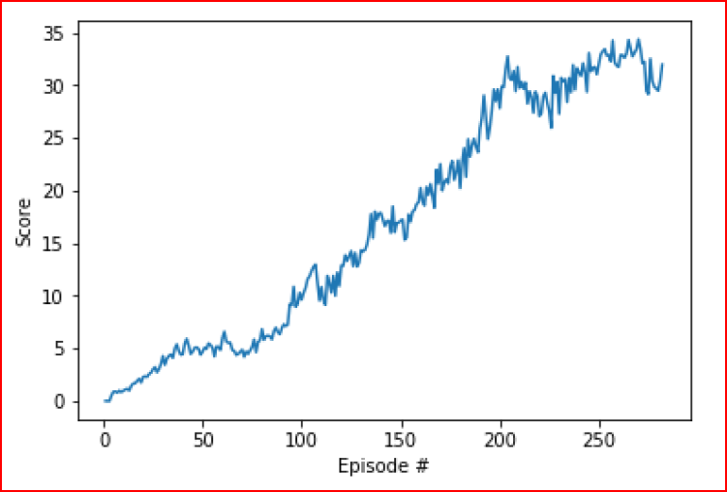

The task was completed in 282 episodes.

**Ideas for future work**

1. Project will be solved using other algorithms such as PPO or, Dueling DQN

**Acknowledgements:**

Model Visualization: <https://github.com/szagoruyko/pytorchviz>