**Project report**

**Collaboration and Competition**

**Learning Algorithm:**

For this project DDPG (**D**eep **D**eterministic **P**olicy **G**radients) is used which performs good in continuous action space. The network is being updated 10 times after 2-time steps.

**The Deep Neural Network has following layers:**

**Actor Network**

* A hidden layer with 128 units and RELU activation.
* Batch normalization.
* Second hidden layer with 64 units and RELU activation.
* Batch normalization.
* Fully connected Layer.
* Tanh.

**Critic Network**

* Batch normalization on input.
* A hidden layer with 128 units and RELU activation.
* Second hidden layer with 64 units and RELU activation.
* Fully connected Layer.

**Parameters used in DDPG Algorithm:**

*BUFFER_SIZE = int(1e6)* # replay buffer size

*BATCH_SIZE = 512*  # minibatch size

*GAMMA = 0.99*  # discount factor

*TAU = 1e-3* # for soft update of target parameters

*LR_ACTOR = 5e-4* # learning rate of the actor

*LR_CRITIC = 1e-3* # learning rate of the critic

*WEIGHT_DECAY = 0* # L2 weight decay

**Result:**

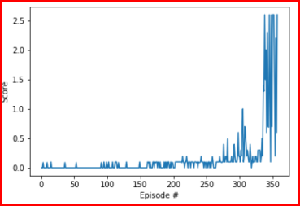

The task was completed in 357 episodes.

**Ideas for future work**

1. Will try to solve this project using other algorithms like PPO, A3C OR MADDPG.

**Acknowledgements:**

Model Visualization: <https://github.com/szagoruyko/pytorchviz>