**Final project of Coursera capstone Project**

In this project we will discuss about the Neighbourhoods of Newyork city in USA.

* let's take a look at the Newyork dataset.

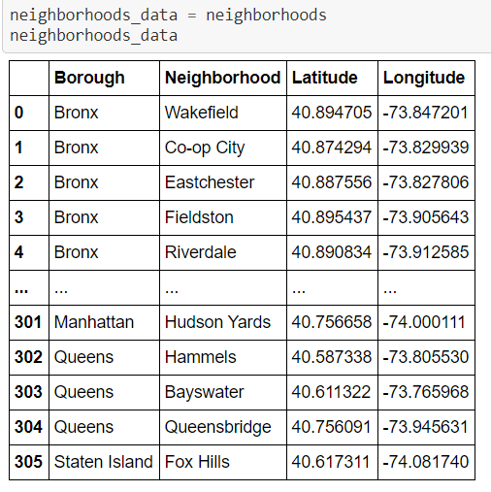

* Now, let's get the top 100 venues that are in Newyorkl within a radius of 10000 meters in JSON format

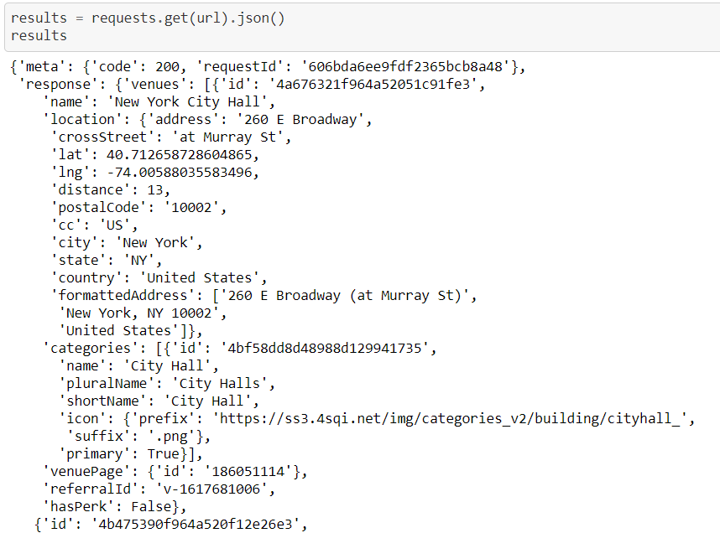

* Now we are ready to clean the json and structure it into a pandas dataframe

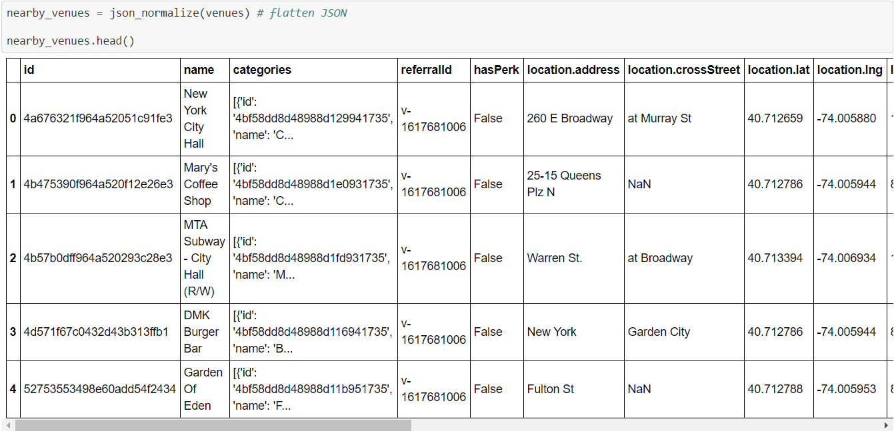

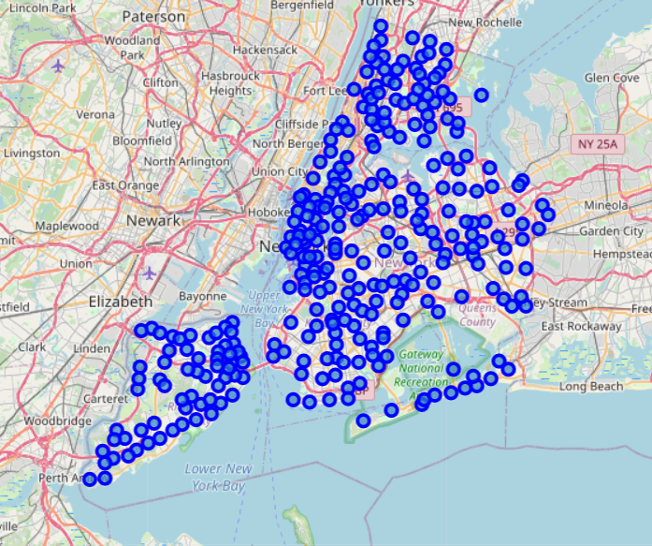

* Get the Catagories for each neighbourhood

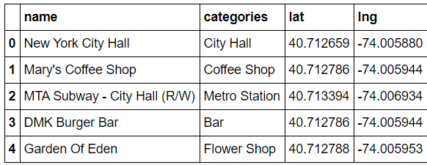

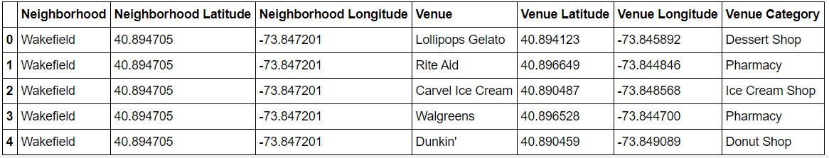

* find out how many unique categories can be curated from all the returned venues

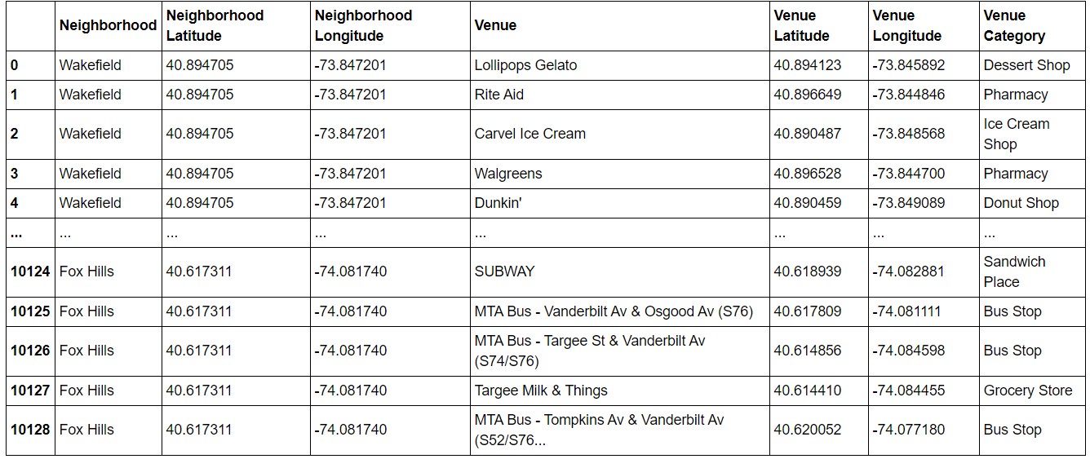

* let's group rows by neighborhood and by taking the mean of the frequency of occurrence of each category

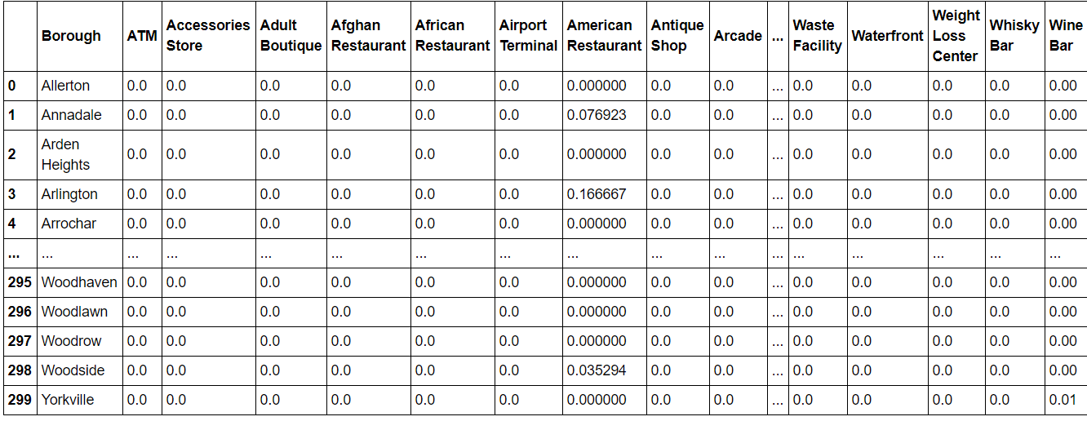

* let's create the new dataframe and display the top 5 venues for each neighborhood

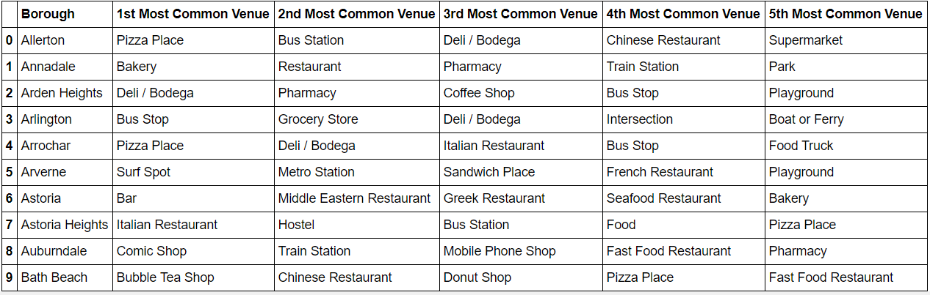

**Cluster Neighbourhoods**

Run k-means to cluster the neighbourhood into 7 clusters.

And we get the below pictorial view of Newyork

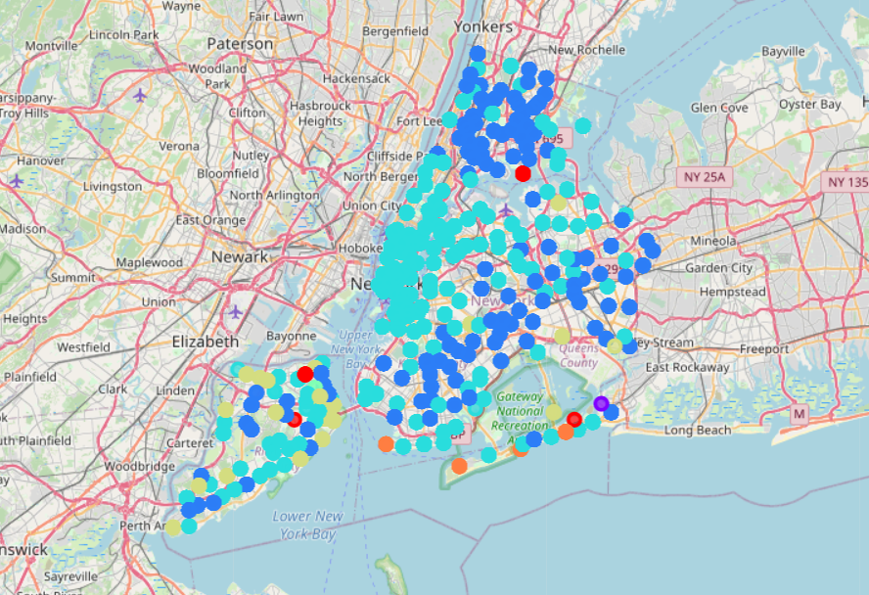

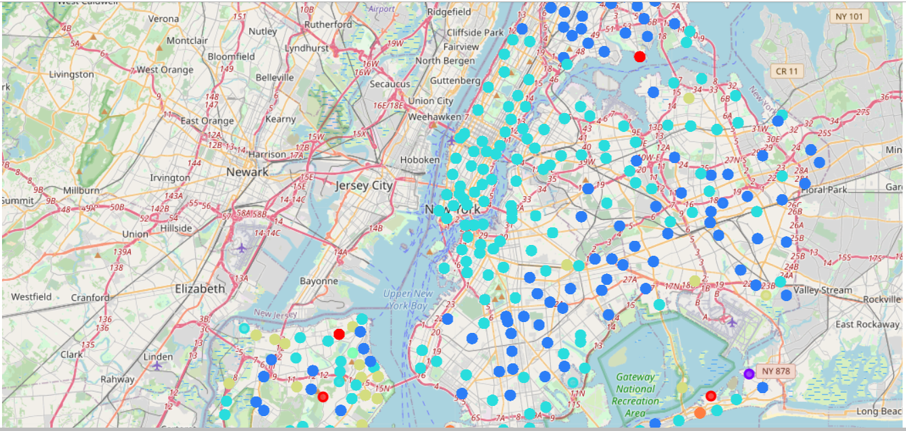

#### Cluster 1

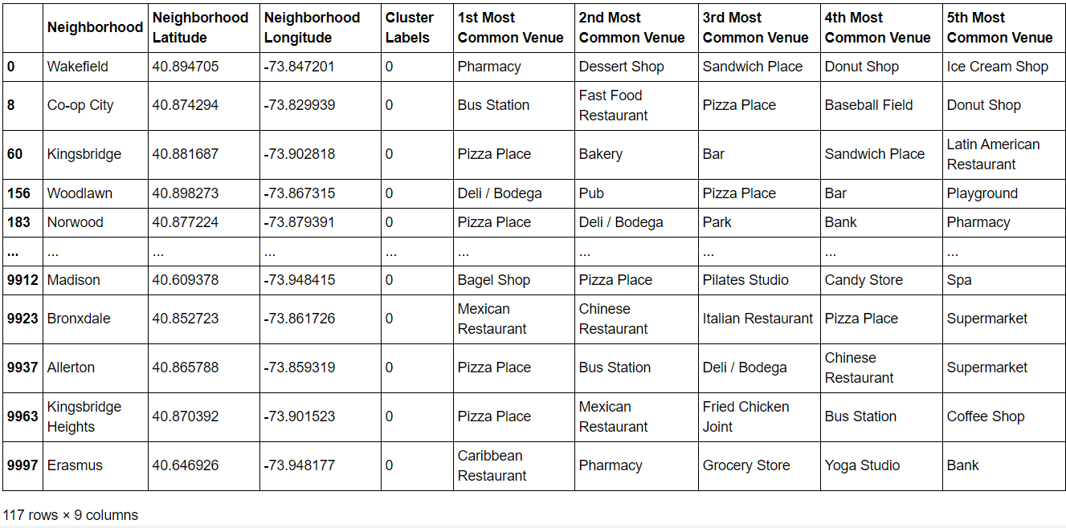

#### Cluster 2

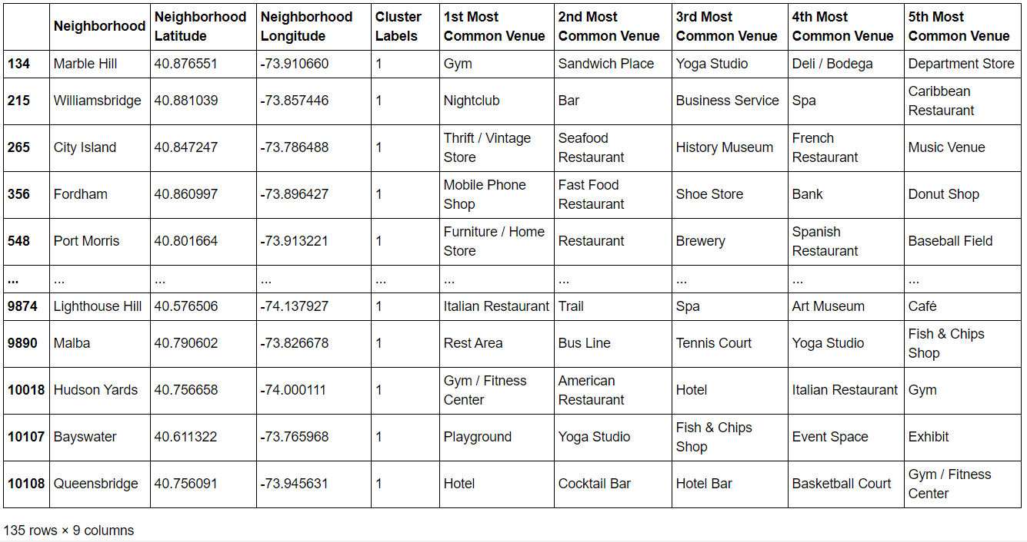

#### Cluster 4

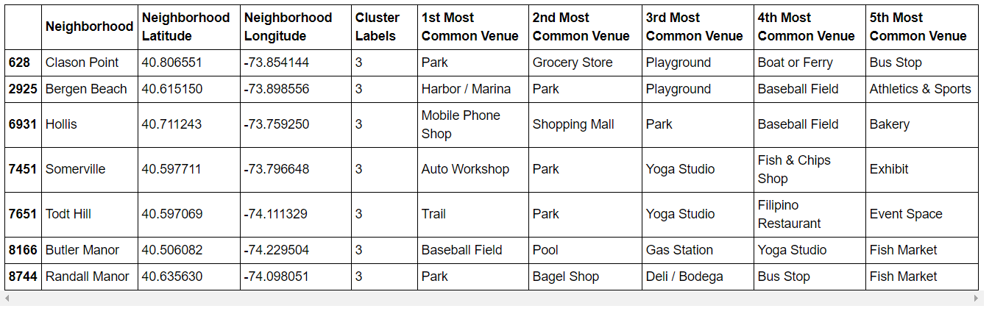

#### Cluster 5

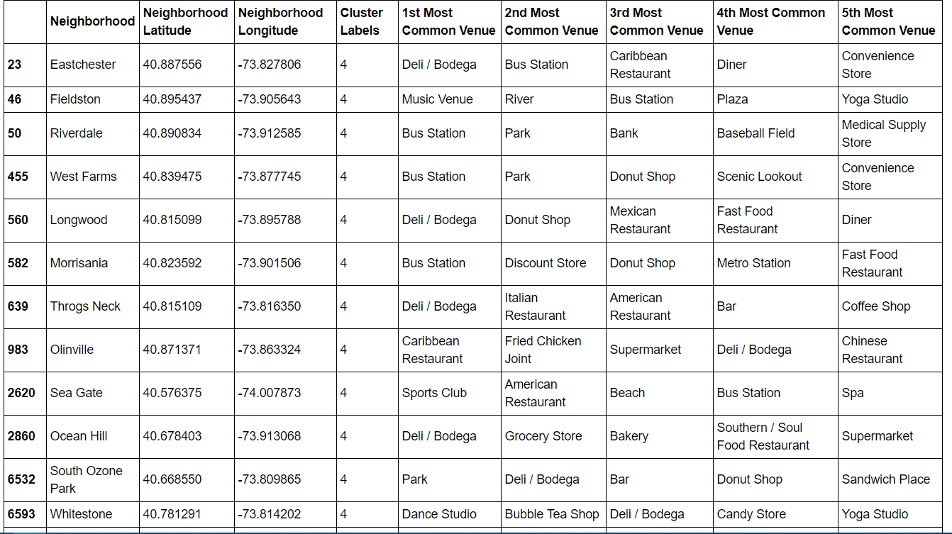

#### Cluster 6

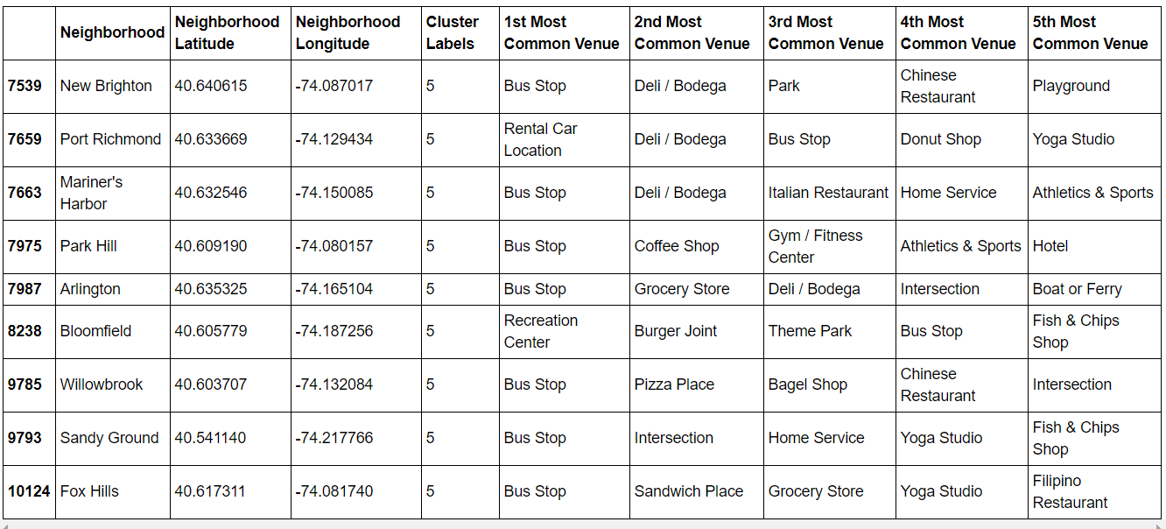

Conclutions:

We started this project to help to derive 2 important decision to make

1. Which area is more suitable for a person when someone come from a different location to pursue their corporate carrier
2. In which corner of area in Newyork city is more suitable for which business options like kind of cuisine restaurants, groceries shops, book store are a few example

Coming to the 1st point

We have highlighted the major similer cluster to identify the similer neighborhoods.

Someone needs to move from 1 place to other place he/she will get a very clear idea about the new place with the common and top venues of their likes.

And now 2nd point

The above prediction is also depicts in area which is the most populer venue. With respect to starting a business the above prediction will help which is the most populer business one can start or the missing one in that perticuler area.