**Introduction to Coursera capstone Project**

In this project we will discuss about the *Car Severity Accident Prediction* of a city in USA.

We will divide this into two parts.

1. Business Understanding.
2. Data Understanding.

**Business Understanding**: -

New York – The business hub in the world. People from around the world come here for job, Business and Entrepreneurship.

With the help of this analysis, we will help to derive 2 important decision to make.

1. Which area is more suitable for a person when someone come from a different location to persue their corporate carrier
2. In which corner of area in Newyork city is more suitable for which business options like kind of cuisine restaurants, groceries shops, book store are a few example

**Data Understanding** :-

First dataset contains the 'Borough' & 'Neighborhood' and the corresponding 'Latitude' & 'Longitude'.

With the help of Foursqaure API downloaded the top 100 venues and their categories that are in Newyork within a radius of 10000 meters

At 1st we prepare the dataframe which contains the

| **Borough** | **Neighborhood** | **Latitude** | **Longitude** |
| --- | --- | --- | --- |

Then we get the Lat & Long of Newyork

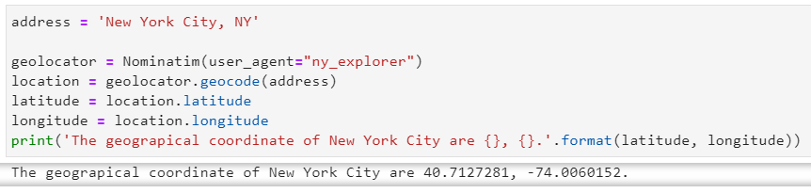

Create a map of New York with neighborhoods superimposed on top

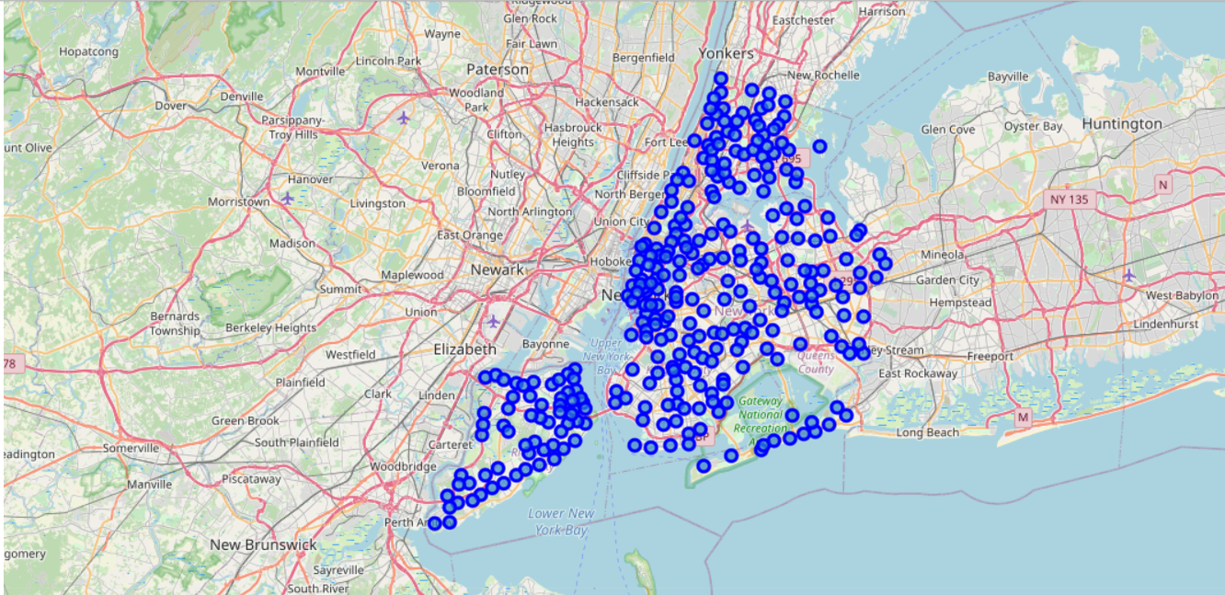

#### Now, let's get the top 100 venues that are in Newyork within a radius of 10000 meters.

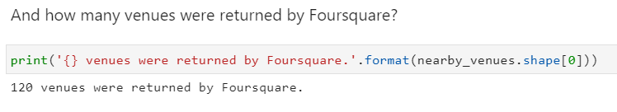

#### Find out how many unique categories can be curated from all the returned venues

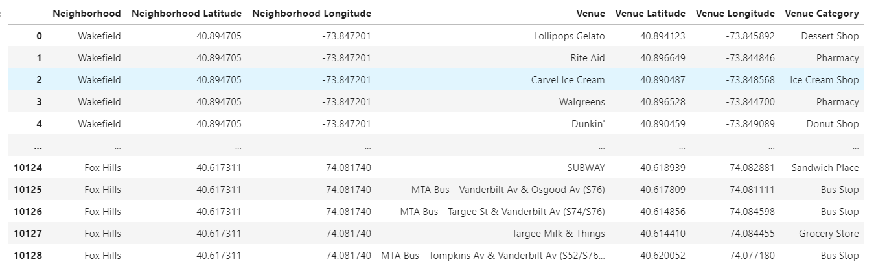

With this data we are going to find the top venues in each places.