1. List all students who have taken exactly 120 total credits.

select * from student
WHERE tot_cred = 120;

ID NAME DEPT_NAME TOT_CRED
----- -------------------- -------------------- ----------
22532 Silverman History 120
28299 Grange Languages 120
85904 Harass Cybernetics 120
7149 Xin Pol. Sci. 120
29645 Oller History 120
63582 Fischer Pol. Sci. 120
53118 Carvey Comp. Sci. 120
32385 Park Civil Eng. 120
77021 Bollen Psychology 120
10454 Ugarte Pol. Sci. 120
27094 Gur Geology 120

2. Find the names of all courses offered by the "Civil Engineering" department.
SELECT * FROM course
2 WHERE dept_name = 'Civil Eng.';

COURSE_I TITLE DEPT_NAME
-------- -------------------------------------------------- --------------------
CREDITS
----------
960 Tort Law Civil Eng.
3

680 Electricity and Magnetism Civil Eng.
3

998 Immunology Civil Eng.
4

3. Retrieve the names of all instructors who earn exactly ₹60,000.

SQL> SELECT * FROM instructor
2 WHERE salary = 60000;

no rows selected

4. List all classrooms located in the "Dunn" building.
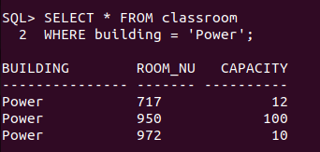

5. Find the total number of courses offered in the "Summer" semester of 2023.

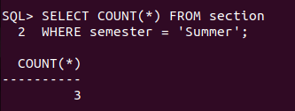

6. List all students who have taken exactly 150 total credits.
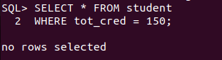

7. Find the names of all courses offered by the "Aerospace Engineering" department.

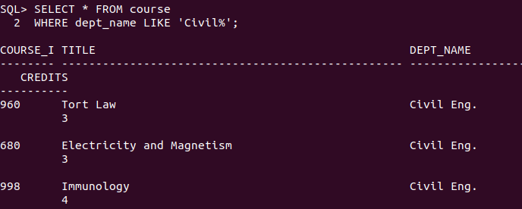

8. Retrieve the names of all instructors who earn exactly ₹80,000.
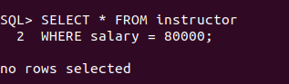

9. List all classrooms located in the "Smith" building.
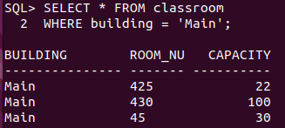

10. Find the total number of courses offered in the "Fall" semester of 2022.

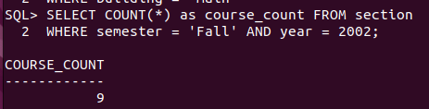

11. List all students who have taken courses with a grade of "A" in the "Spring" semester of
2022.

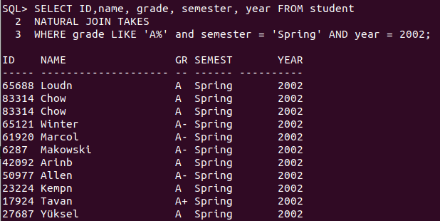

12. Retrieve the names of instructors who have taught in the "Winter" semester of 2022.
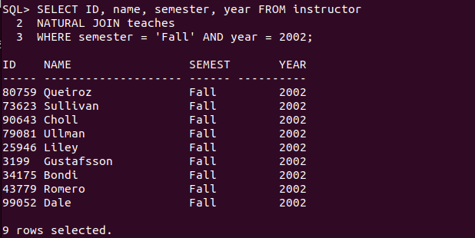

13. Find the average number of students per section in each course.

14. List all courses that have exactly 5 credits.

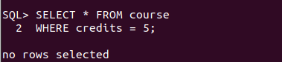

15. Retrieve the names of students who have taken courses in the "Main" building.

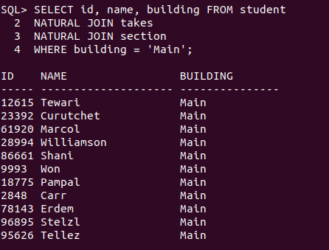

16. Find the total number of sections held in each building.

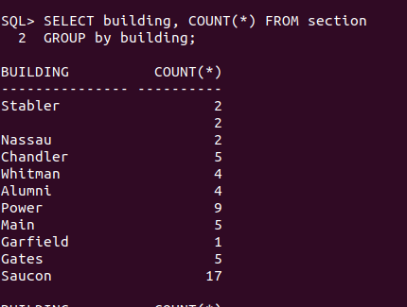

17. List all sections that are held in rooms with a capacity of exactly 50.

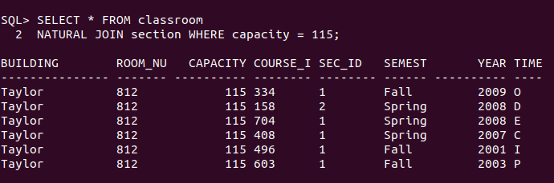

18. Retrieve the names of students who have taken courses with the highest number of
credits in the university.

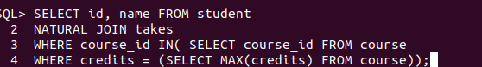

19. Find the departments with the highest number of courses.
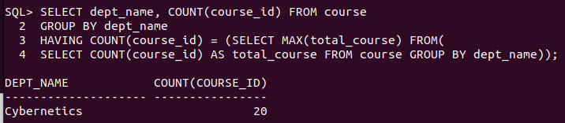

20. List all courses that have been taught by exactly 2 instructors.

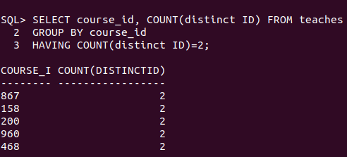

21. List all students who have taken courses with a grade of "B" in the "Summer" semester
of 2023.

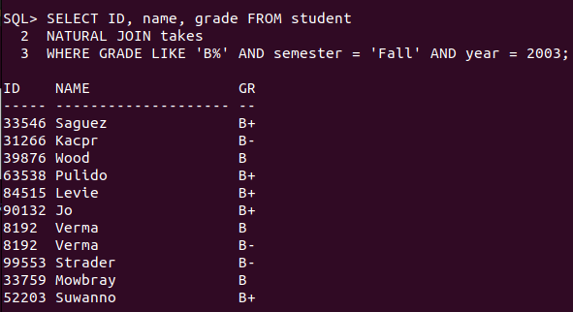

22. Retrieve the names of instructors who have taught in the "Spring" semester of 2021.

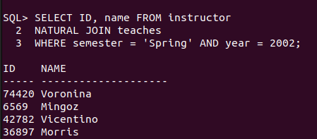

23. Find the average number of credits per student in each department.

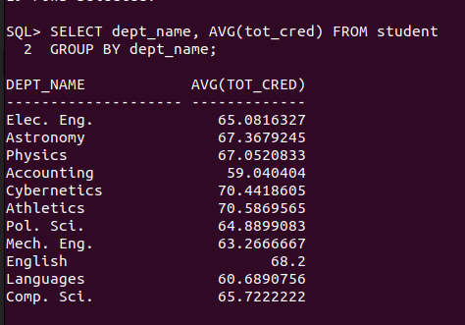

24. List all courses that have exactly 6 credits.

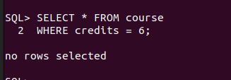

25. Retrieve the names of students who have taken courses in the "Lambert" building.

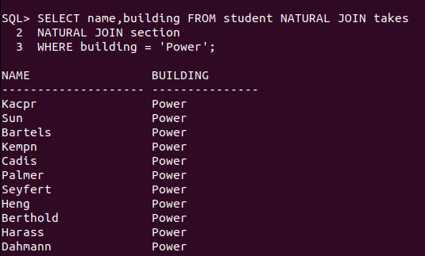

26. Find the total number of sections taught in each semester.
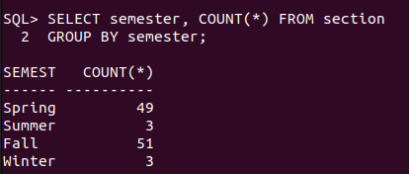

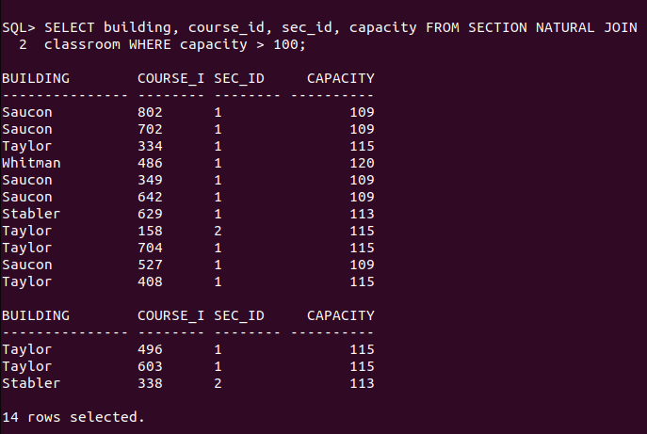
27. List all sections that are held in rooms with a capacity of exactly 200.
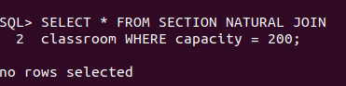

28. Retrieve the names of students who have taken courses with the lowest number of
credits in the university.
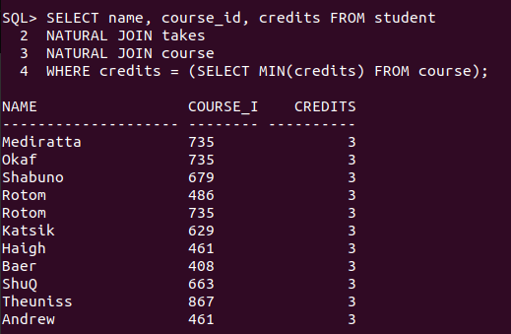

29. Find the departments with the lowest number of courses.
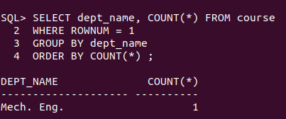

30. List all courses that have been taught by exactly 4 instructors.

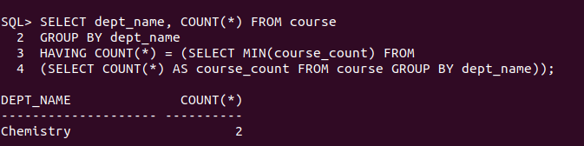

31. Find the students who have taken courses from at least 6 different departments.

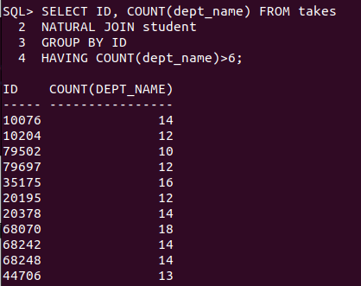

32. Retrieve the names of instructors who have taught the same course in multiple
semesters and years.

33. List all courses that are prerequisites for exactly 5 other courses.
34. Find the departments where the total student credits are greater than twice the
department budget.
35. Retrieve the names of students who have taken courses with every time slot in multiple
semesters and years.
36. List all courses that have been taught in every building except four.
37. Find the students who have taken the most number of courses in a single semester
across all departments.
38. Retrieve the names of instructors who have taught courses in all available semesters
and time slots.
39. List all students who have taken courses with overlapping time slots in the same
semester and year.
40. Find the courses that have the highest enrollment in a single year.
41. Find the students who have taken courses from at least 7 different departments.
42. Retrieve the names of instructors who have taught the same course in multiple
semesters and years.
43. List all courses that are prerequisites for exactly 6 other courses.
44. Find the departments where the total student credits are less than one-third of the
department budget.
45. Retrieve the names of students who have taken courses with every time slot in multiple
semesters and years.
46. List all courses that have been taught in every building except five.
47. Find the students who have taken the most number of courses in a single year across all
departments.
48. Retrieve the names of instructors who have taught courses in all available buildings and
time slots.
49. List all students who have taken courses with overlapping time slots in different
semesters and years.
50. Find the courses that have the lowest enrollment in a single year.
2. Find the names of all courses offered by the "Civil Engineering" department.
3. Retrieve the names of all instructors who earn exactly ₹60,000.
4. List all classrooms located in the "Dunn" building.
5. Find the total number of courses offered in the "Summer" semester of 2023.
6. List all students who have taken exactly 150 total credits.
7. Find the names of all courses offered by the "Aerospace Engineering" department.
8. Retrieve the names of all instructors who earn exactly ₹80,000.
9. List all classrooms located in the "Smith" building.
10. Find the total number of courses offered in the "Fall" semester of 2022.
11. List all students who have taken courses with a grade of "A" in the "Spring" semester of
2022.
12. Retrieve the names of instructors who have taught in the "Winter" semester of 2022.
13. Find the average number of students per section in each course.
14. List all courses that have exactly 5 credits.
15. Retrieve the names of students who have taken courses in the "Main" building.
16. Find the total number of sections held in each building.
17. List all sections that are held in rooms with a capacity of exactly 50.
18. Retrieve the names of students who have taken courses with the highest number of
credits in the university.
19. Find the departments with the highest number of courses.
20. List all courses that have been taught by exactly 2 instructors.
21. List all students who have taken courses with a grade of "B" in the "Summer" semester
of 2023.
22. Retrieve the names of instructors who have taught in the "Spring" semester of 2021.
23. Find the average number of credits per student in each department.
24. List all courses that have exactly 6 credits.
25. Retrieve the names of students who have taken courses in the "Lambert" building.
26. Find the total number of sections taught in each semester.
27. List all sections that are held in rooms with a capacity of exactly 200.
28. Retrieve the names of students who have taken courses with the lowest number of
credits in the university.
29. Find the departments with the lowest number of courses.
30. List all courses that have been taught by exactly 4 instructors.
31. Find the students who have taken courses from at least 6 different departments.
32. Retrieve the names of instructors who have taught the same course in multiple
semesters and years.
33. List all courses that are prerequisites for exactly 5 other courses.
34. Find the departments where the total student credits are greater than twice the
department budget.
35. Retrieve the names of students who have taken courses with every time slot in multiple
semesters and years.
36. List all courses that have been taught in every building except four.
37. Find the students who have taken the most number of courses in a single semester
across all departments.
38. Retrieve the names of instructors who have taught courses in all available semesters
and time slots.
39. List all students who have taken courses with overlapping time slots in the same
semester and year.
40. Find the courses that have the highest enrollment in a single year.
41. Find the students who have taken courses from at least 7 different departments.
42. Retrieve the names of instructors who have taught the same course in multiple
semesters and years.
43. List all courses that are prerequisites for exactly 6 other courses.
44. Find the departments where the total student credits are less than one-third of the
department budget.
45. Retrieve the names of students who have taken courses with every time slot in multiple
semesters and years.
46. List all courses that have been taught in every building except five.
47. Find the students who have taken the most number of courses in a single year across all
departments.
48. Retrieve the names of instructors who have taught courses in all available buildings and
time slots.
49. List all students who have taken courses with overlapping time slots in different
semesters and years.
50. Find the courses that have the lowest enrollment in a single year.

