1. Create the following tables with the following attributes and constraints on them.
a. Bank (bk_code, bk_name, bk_address)
b. Branch (br_id, br_name, br_address, bk_code)
c. Customer (cust_ID, cust_name, phone_no, address)
d. Account (acc_no, acc_type, balance, br_id)
e. Customer_Account (cust_ID, acc_no)
f. Loan (loan_ID, loan_type, amount, br_id)
g. Customer_Loan (cust_ID, loan_ID)

1. Create all the tables by defining primary key, foreign key and other appropriate constraints.
CREATE TABLE Bank (
bk_code VARCHAR2(10) PRIMARY KEY,
bk_name VARCHAR2(25) NOT NULL,
bk_address VARCHAR2(25) NOT NULL
);

CREATE TABLE Branch (
br_id VARCHAR2(10) PRIMARY KEY,
br_name VARCHAR2(25) NOT NULL,
br_address VARCHAR2(25) NOT NULL,
bk_code VARCHAR2(10),
CONSTRAINT fk_bank FOREIGN KEY (bk_code) REFERENCES Bank(bk_code) ON DELETE CASCADE
);

CREATE TABLE Customer (
cust_ID INT PRIMARY KEY,
cust_name VARCHAR2(25) NOT NULL,
phone_no VARCHAR2(15) UNIQUE NOT NULL,
address VARCHAR2(25) NOT NULL
);

CREATE TABLE Account (
acc_no INT PRIMARY KEY,
acc_type VARCHAR2(25) NOT NULL,
balance NUMBER(10,2) CHECK (balance >= 0),
br_id VARCHAR2(10),
CONSTRAINT fk_branch FOREIGN KEY (br_id) REFERENCES Branch(br_id) ON DELETE CASCADE
);

CREATE TABLE Customer_Account (
cust_ID INT,
acc_no INT,
PRIMARY KEY (cust_ID, acc_no),
CONSTRAINT fk_customer FOREIGN KEY (cust_ID) REFERENCES Customer(cust_ID) ON DELETE CASCADE,
CONSTRAINT fk_account FOREIGN KEY (acc_no) REFERENCES Account(acc_no) ON DELETE CASCADE
);

CREATE TABLE Loan (
loan_ID INT PRIMARY KEY,
loan_type VARCHAR2(50) NOT NULL,
amount NUMBER(10,2) CHECK (amount > 0),
br_id VARCHAR2(10),
CONSTRAINT fk_loan_branch FOREIGN KEY (br_id) REFERENCES Branch(br_id) ON DELETE CASCADE
);

CREATE TABLE Customer_Loan (
cust_ID INT,
loan_ID INT,
PRIMARY KEY (cust_ID, loan_ID),
CONSTRAINT fk_customer_loan FOREIGN KEY (cust_ID) REFERENCES Customer(cust_ID) ON DELETE CASCADE,
CONSTRAINT fk_loan FOREIGN KEY (loan_ID) REFERENCES Loan(loan_ID) ON DELETE CASCADE
);

INSERT INTO Bank VALUES ('B001', 'State Bank', 'MG Road, Bangalore');
INSERT INTO Bank VALUES ('B002', 'ICICI Bank', 'Koramangala, Bangalore');

INSERT INTO Branch VALUES ('BR01', 'MG Road Branch', 'MG Road, Bangalore', 'B001');
INSERT INTO Branch VALUES ('BR02', 'NITK Branch', 'Surathkal, Karnataka', 'B002');

INSERT INTO Customer VALUES (101, 'Amit', '9876543210', 'Bangalore');
INSERT INTO Customer VALUES (102, 'Ravi', '9823456789', 'Mangalore');
INSERT INTO Customer VALUES (103, 'Priya', '7890123456', 'Udupi');
INSERT INTO Customer VALUES (104, 'John', '9876501234', 'Surathkal');
INSERT INTO Customer VALUES (105, 'Anita', '9087654321', 'Bangalore');

INSERT INTO Account VALUES (201, 'Savings', 15000.00, 'BR01');
INSERT INTO Account VALUES (202, 'Current', 5000.00, 'BR02');
INSERT INTO Account VALUES (203, 'Savings', 2000.00, 'BR02');
INSERT INTO Account VALUES (204, 'Savings', 12000.00, 'BR01');
INSERT INTO Account VALUES (205, 'Current', 10000.00, 'BR01');

INSERT INTO Customer_Account VALUES (101, 201);
INSERT INTO Customer_Account VALUES (102, 202);
INSERT INTO Customer_Account VALUES (103, 203);
INSERT INTO Customer_Account VALUES (104, 204);
INSERT INTO Customer_Account VALUES (105, 205);

INSERT INTO Loan VALUES (301, 'Home Loan', 500000.00, 'BR01');
INSERT INTO Loan VALUES (302, 'Car Loan', 300000.00, 'BR02');
INSERT INTO Loan VALUES (303, 'Vehicle Loan', 200000.00, 'BR01');
INSERT INTO Loan VALUES (304, 'Education Loan', 100000.00, 'BR02');
INSERT INTO Loan VALUES (305, 'Home Loan', 600000.00, 'BR02');

INSERT INTO Customer_Loan VALUES (101, 301);
INSERT INTO Customer_Loan VALUES (102, 302);
INSERT INTO Customer_Loan VALUES (103, 303);
INSERT INTO Customer_Loan VALUES (104, 304);
INSERT INTO Customer_Loan VALUES (105, 305);

3. List the details of all customers.
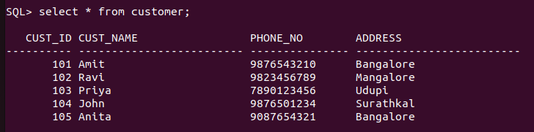

4. Find the cust_ID and phone number of customer ‘Ravi’.
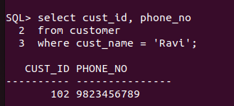

5. Find the Address of all branches of br_01.
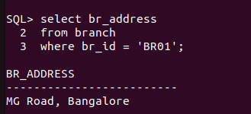

6. Find the details of Customer having ID 103.
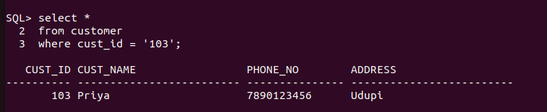

7. List the account details having balance more than 10000.


8. List the account details of branch br_02.
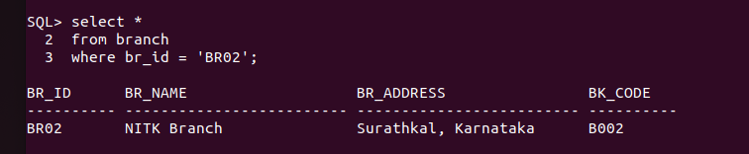

9. List the loan details of branch br_01.
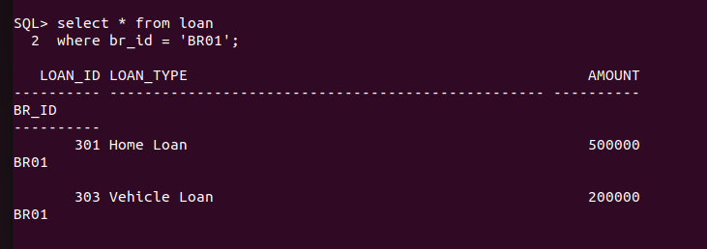

10. List the account details with their branch address.

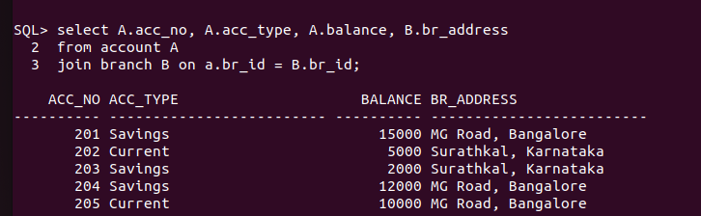

11. List the customer details with their account details.
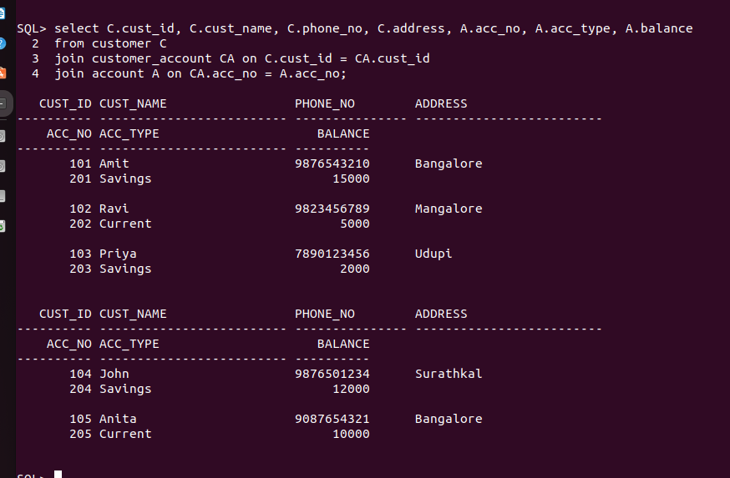

12. List the customer details having account type ‘savings’.
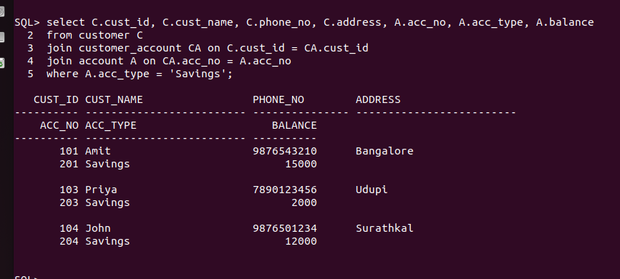

13. List the customer details having vehicle loan.
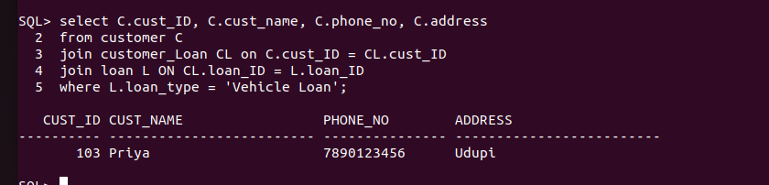

14. List the branch names of all accounts.
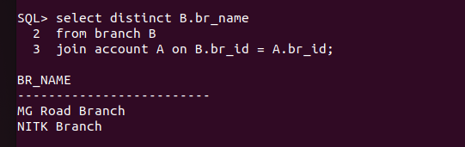
15. List the customer details going to ‘Surathkal’ branch.
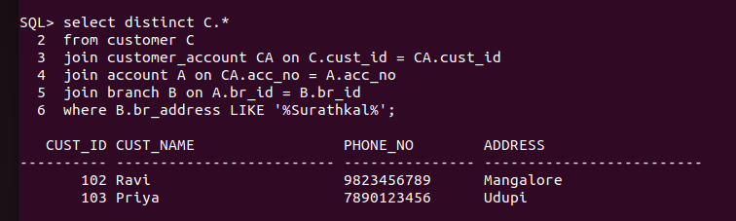

16. List the customers having loan account in ‘MG Road’ branch.
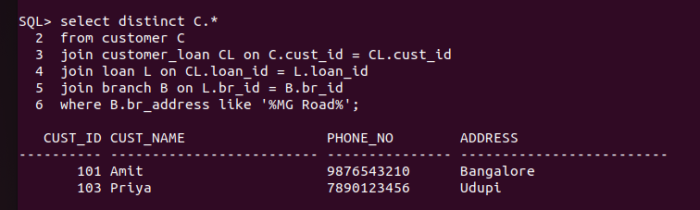

17. Find the customers having balance between 1000 to 10000.
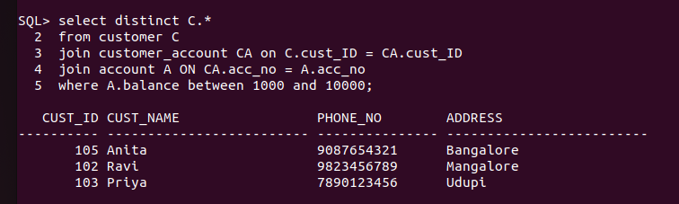

18. Give a bonus of rupees 100 to customers having more than 10000 balance.
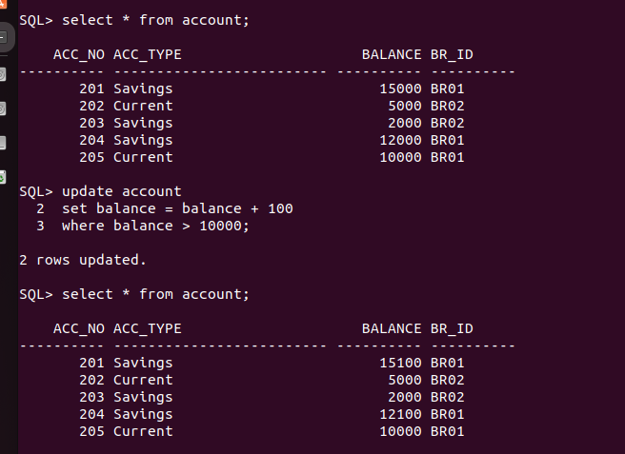

19. Deduct 50 rupees from customers having less than 500 rupees in balance.


20. Give the customer details having home loan.
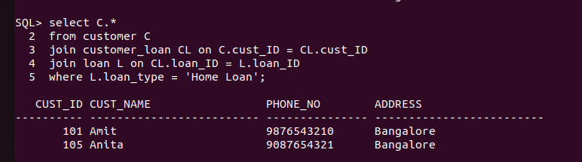

21. Give the customer details having home loan in ‘NITK’ branch
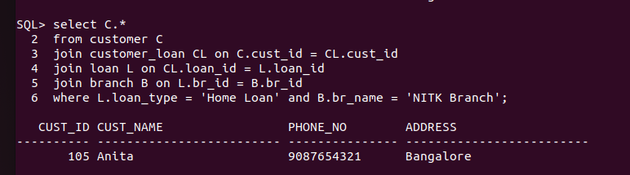

22. Add a column NOMINEE to the customer table with data type varchar (50).
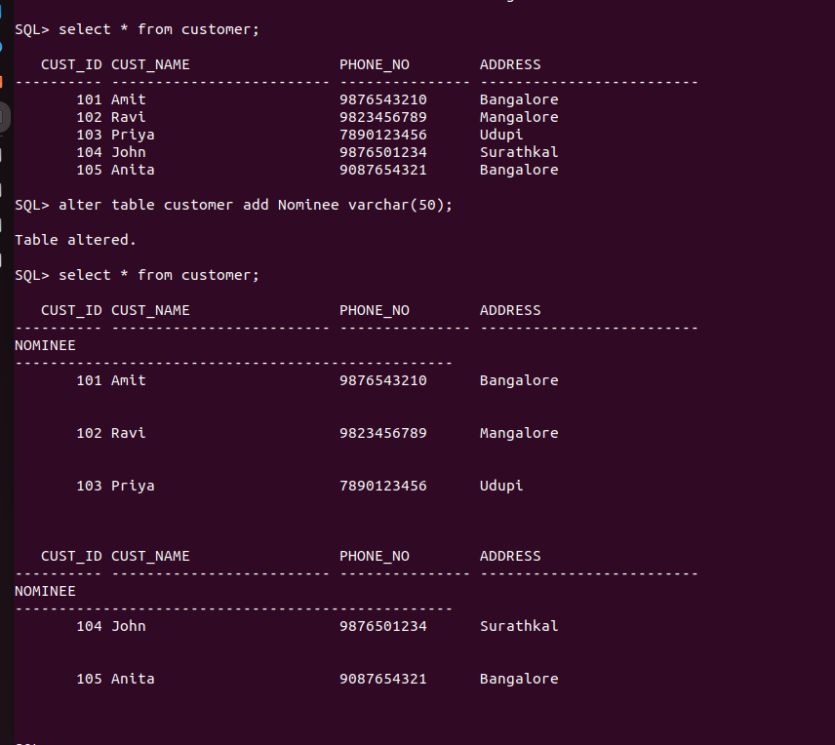

23. List all the account numbers in ascending order of their balance.
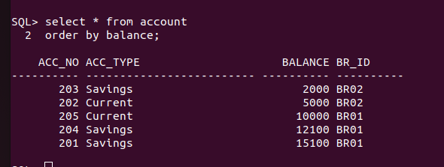

24. Count the number of customers having account type savings.
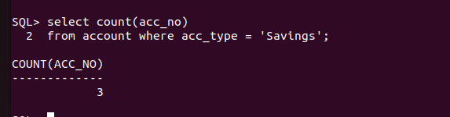

25. Count the number of customers for each account type.
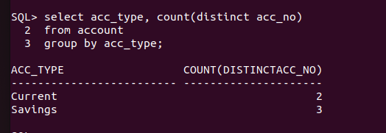

26. Find the total balance in Savings account.
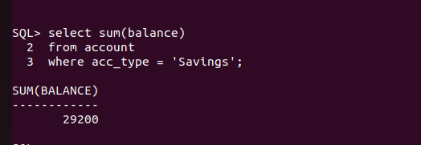

27. Find the average balance of Current account.
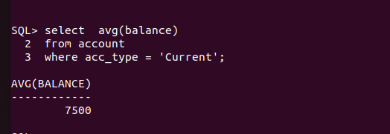

28. Find the average balance for each account type.

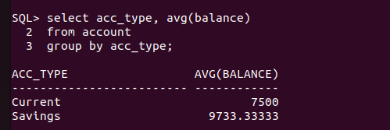
29. Find the customer details having maximum balance.
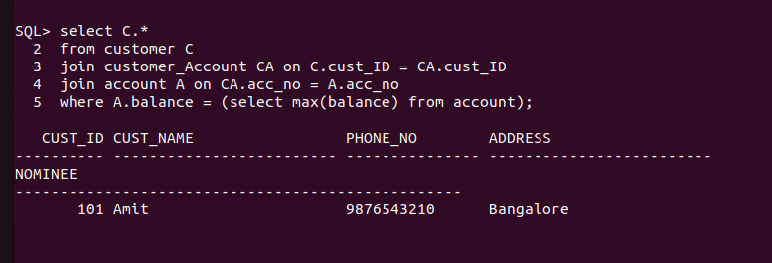
30. Find the average amount for vehicle loan.
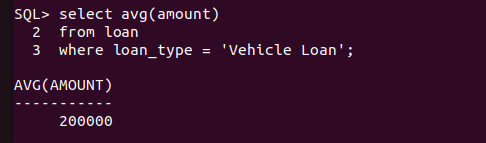

31. Find the average balance in each branch.

