Lab - 3
Date - 06.02.2026
1) DDA algorithm

#include <GL/glut.h>
#include <math.h>
#include <stdio.h>
#include <stdlib.h>

int xStart, yStart, xEnd, yEnd;

void ddaLine(int x1, int y1, int x2, int y2)
{
int dx = x2 - x1;
int dy = y2 - y1;

int steps = abs(dx) > abs(dy) ? abs(dx) : abs(dy);

float xInc = dx / (float)steps;
float yInc = dy / (float)steps;

float x = x1;
float y = y1;

glBegin(GL_POINTS);
for (int i = 0; i <= steps; i++)
{
glVertex2i((int)round(x), (int)round(y));
x += xInc;
y += yInc;
}
glEnd();
}

void display()
{
glClear(GL_COLOR_BUFFER_BIT);

glColor3f(1.0, 1.0, 1.0);
glPointSize(2.0);

ddaLine(xStart, yStart, xEnd, yEnd);

glFlush();
}

void init()
{
glClearColor(0.0, 0.0, 0.0, 1.0);
glMatrixMode(GL_PROJECTION);
glLoadIdentity();
gluOrtho2D(0, 640, 0, 480);
}

int main(int argc, char** argv)
{
printf("Enter x1 y1: ");
scanf("%d %d", &xStart, &yStart);

printf("Enter x2 y2: ");
scanf("%d %d", &xEnd, &yEnd);

glutInit(&argc, argv);
glutInitDisplayMode(GLUT_SINGLE | GLUT_RGB);
glutInitWindowSize(640, 480);
glutInitWindowPosition(100, 100);
glutCreateWindow("DDA Line Drawing - User Input");

init();
glutDisplayFunc(display);
glutMainLoop();

return 0;
}

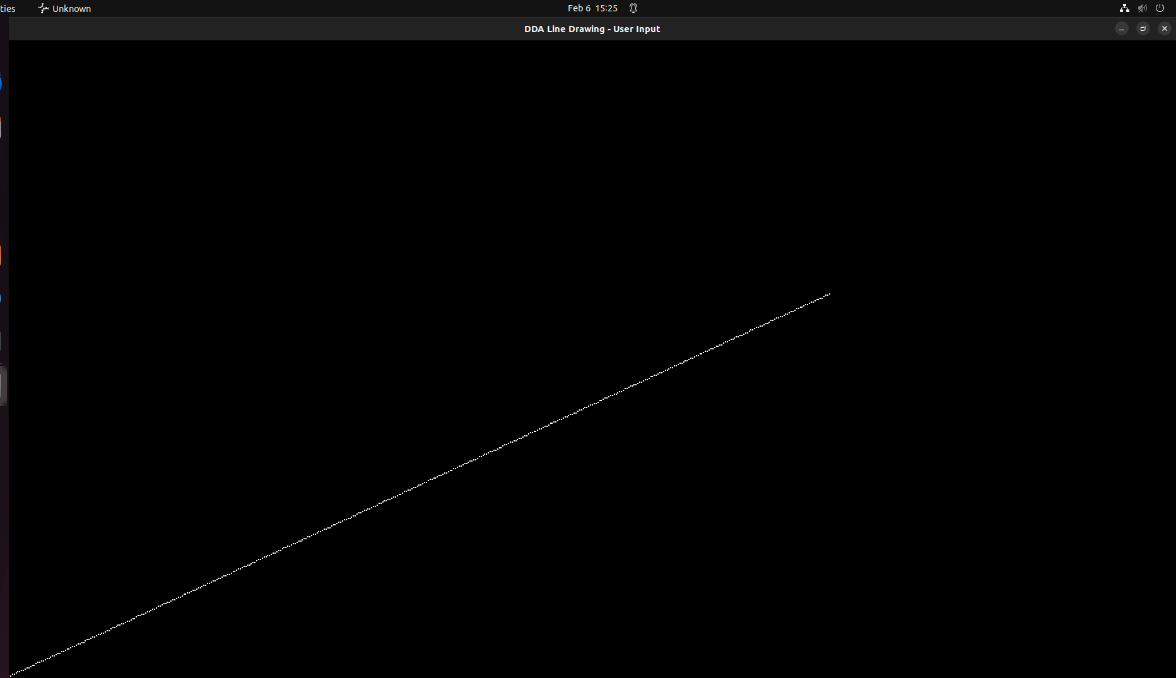

2) Bresenham's Line Generation Algorithm

#include <GL/glut.h>
#include <stdio.h>
#include <stdlib.h>

int xStart, yStart, xEnd, yEnd;

void bresenhamLine(int x1, int y1, int x2, int y2)
{
int dx = abs(x2 - x1);
int dy = abs(y2 - y1);

int sx = (x1 < x2) ? 1 : -1;
int sy = (y1 < y2) ? 1 : -1;

int err = dx - dy;

glBegin(GL_POINTS);
while (1)
{
glVertex2i(x1, y1);

if (x1 == x2 && y1 == y2)
break;

int e2 = 2 * err;

if (e2 > -dy)
{
err -= dy;
x1 += sx;
}

if (e2 < dx)
{
err += dx;
y1 += sy;
}
}
glEnd();
}

void display()
{
glClear(GL_COLOR_BUFFER_BIT);

glColor3f(1.0, 1.0, 1.0);
glPointSize(2.0);

bresenhamLine(xStart, yStart, xEnd, yEnd);

glFlush();
}

void init()
{
glClearColor(0.0, 0.0, 0.0, 1.0);
glMatrixMode(GL_PROJECTION);
glLoadIdentity();
gluOrtho2D(0, 640, 0, 480);
}

int main(int argc, char** argv)
{
printf("Enter x1 y1: ");
scanf("%d %d", &xStart, &yStart);

printf("Enter x2 y2: ");
scanf("%d %d", &xEnd, &yEnd);

glutInit(&argc, argv);
glutInitDisplayMode(GLUT_SINGLE | GLUT_RGB);
glutInitWindowSize(640, 480);
glutInitWindowPosition(100, 100);
glutCreateWindow("Bresenham Line Drawing - User Input");

init();
glutDisplayFunc(display);
glutMainLoop();

return 0;
}

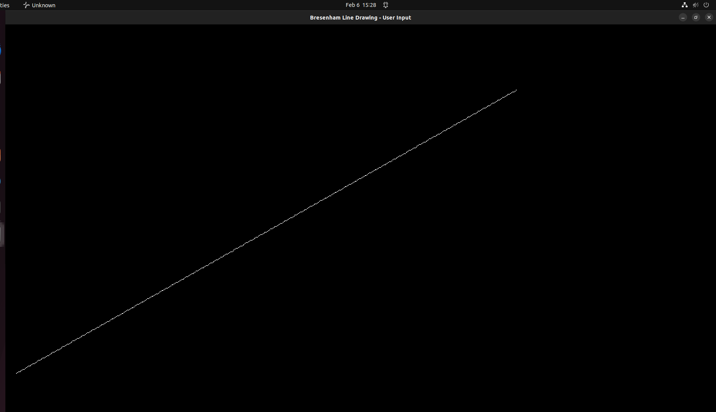

3) Implement line drawing algorithm to draw dotted line

#include <GL/glut.h>
#include <math.h>
#include <stdio.h>
#include <stdlib.h>

int xStart, yStart, xEnd, yEnd;

void ddaLineDotted(int x1, int y1, int x2, int y2)
{
int dx = x2 - x1;
int dy = y2 - y1;

int steps = abs(dx) > abs(dy) ? abs(dx) : abs(dy);

float xInc = dx / (float)steps;
float yInc = dy / (float)steps;

float x = x1, y = y1;

glBegin(GL_POINTS);
for (int i = 0; i <= steps; i++)
{
if (i % 3 == 0) // dotted pattern
glVertex2i(round(x), round(y));

x += xInc;
y += yInc;
}
glEnd();
}

void display()
{
glClear(GL_COLOR_BUFFER_BIT);
glPointSize(2.0);

glColor3f(1.0, 1.0, 1.0);
ddaLineDotted(xStart, yStart, xEnd, yEnd);

glFlush();
}

void init()
{
glClearColor(0.0, 0.0, 0.0, 1.0);
glMatrixMode(GL_PROJECTION);
glLoadIdentity();
gluOrtho2D(0, 640, 0, 480);
}

int main(int argc, char** argv)
{
printf("Enter x1 y1: ");
scanf("%d %d", &xStart, &yStart);

printf("Enter x2 y2: ");
scanf("%d %d", &xEnd, &yEnd);

glutInit(&argc, argv);
glutInitDisplayMode(GLUT_SINGLE | GLUT_RGB);
glutInitWindowSize(640, 480);
glutInitWindowPosition(100, 100);
glutCreateWindow("Dotted Line");

init();
glutDisplayFunc(display);
glutMainLoop();

return 0;
}

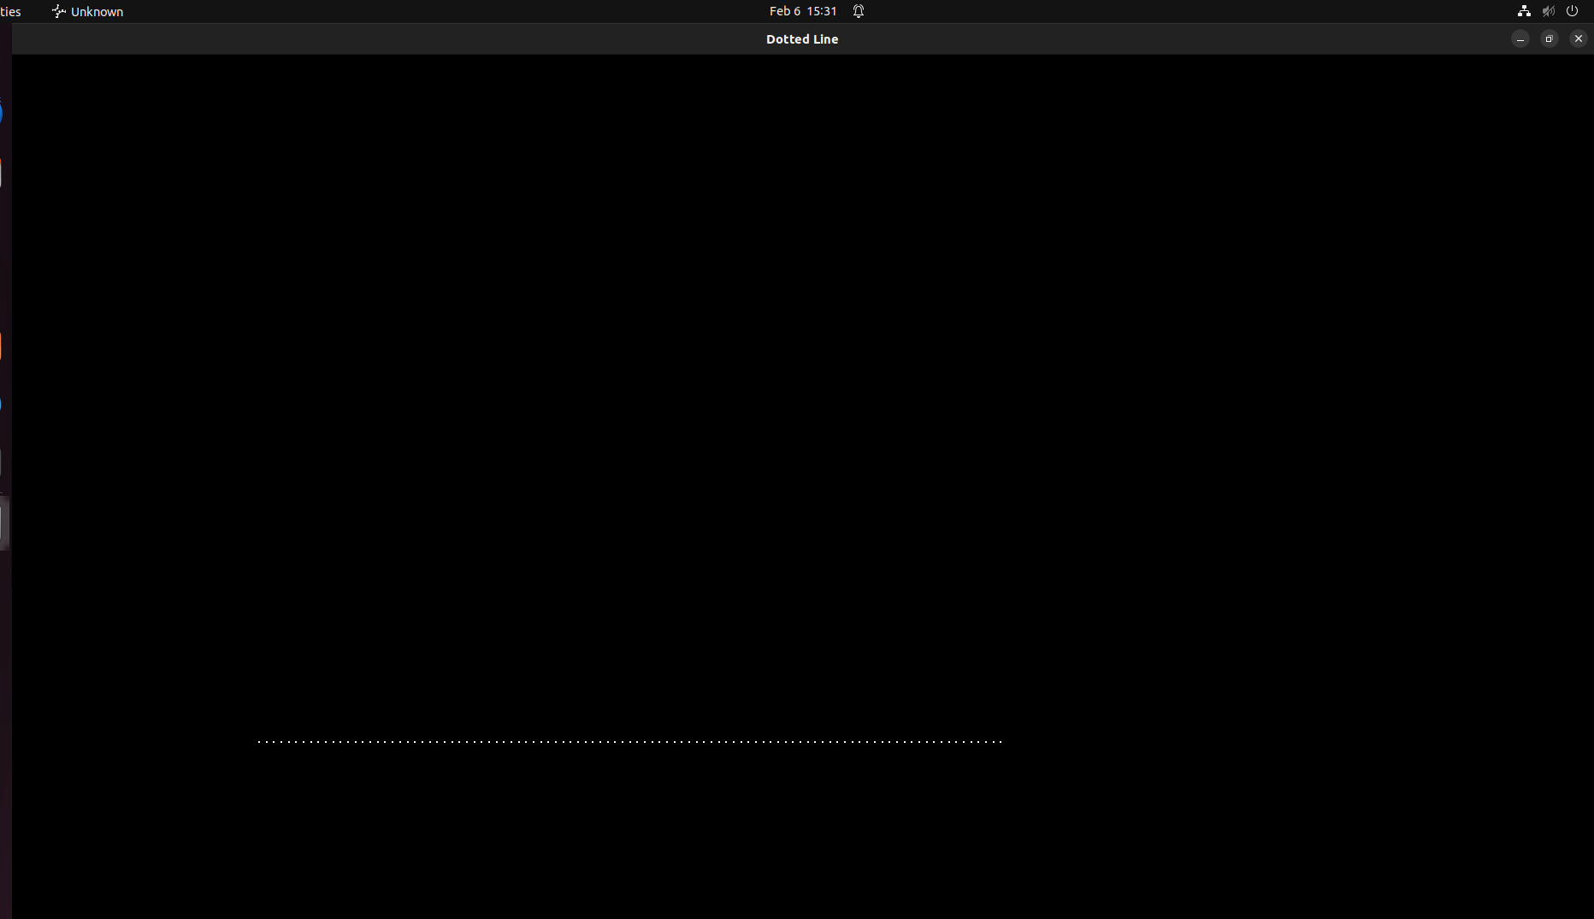

4) Implement line drawing algorithm to draw dashed-dotted line

#include <GL/glut.h>
#include <math.h>
#include <stdio.h>
#include <stdlib.h>

int xStart, yStart, xEnd, yEnd;

void ddaLineDashDot(int x1, int y1, int x2, int y2)
{
int dx = x2 - x1;
int dy = y2 - y1;

int steps = abs(dx) > abs(dy) ? abs(dx) : abs(dy);

float xInc = dx / (float)steps;
float yInc = dy / (float)steps;

float x = x1, y = y1;

glBegin(GL_POINTS);
for (int i = 0; i <= steps; i++)
{
int pattern = i % 10;

if (pattern < 4 || pattern == 6)
glVertex2i(round(x), round(y));

x += xInc;
y += yInc;
}
glEnd();
}

void display()
{
glClear(GL_COLOR_BUFFER_BIT);
glPointSize(2.0);

glColor3f(1.0, 0.0, 0.0);
ddaLineDashDot(xStart, yStart - 50, xEnd, yEnd - 50);

glFlush();
}

void init()
{
glClearColor(0.0, 0.0, 0.0, 1.0);
glMatrixMode(GL_PROJECTION);
glLoadIdentity();
gluOrtho2D(0, 640, 0, 480);
}

int main(int argc, char** argv)
{
printf("Enter x1 y1: ");
scanf("%d %d", &xStart, &yStart);

printf("Enter x2 y2: ");
scanf("%d %d", &xEnd, &yEnd);

glutInit(&argc, argv);
glutInitDisplayMode(GLUT_SINGLE | GLUT_RGB);
glutInitWindowSize(640, 480);
glutInitWindowPosition(100, 100);
glutCreateWindow("Dash-Dotted Line");

init();
glutDisplayFunc(display);
glutMainLoop();

return 0;
}

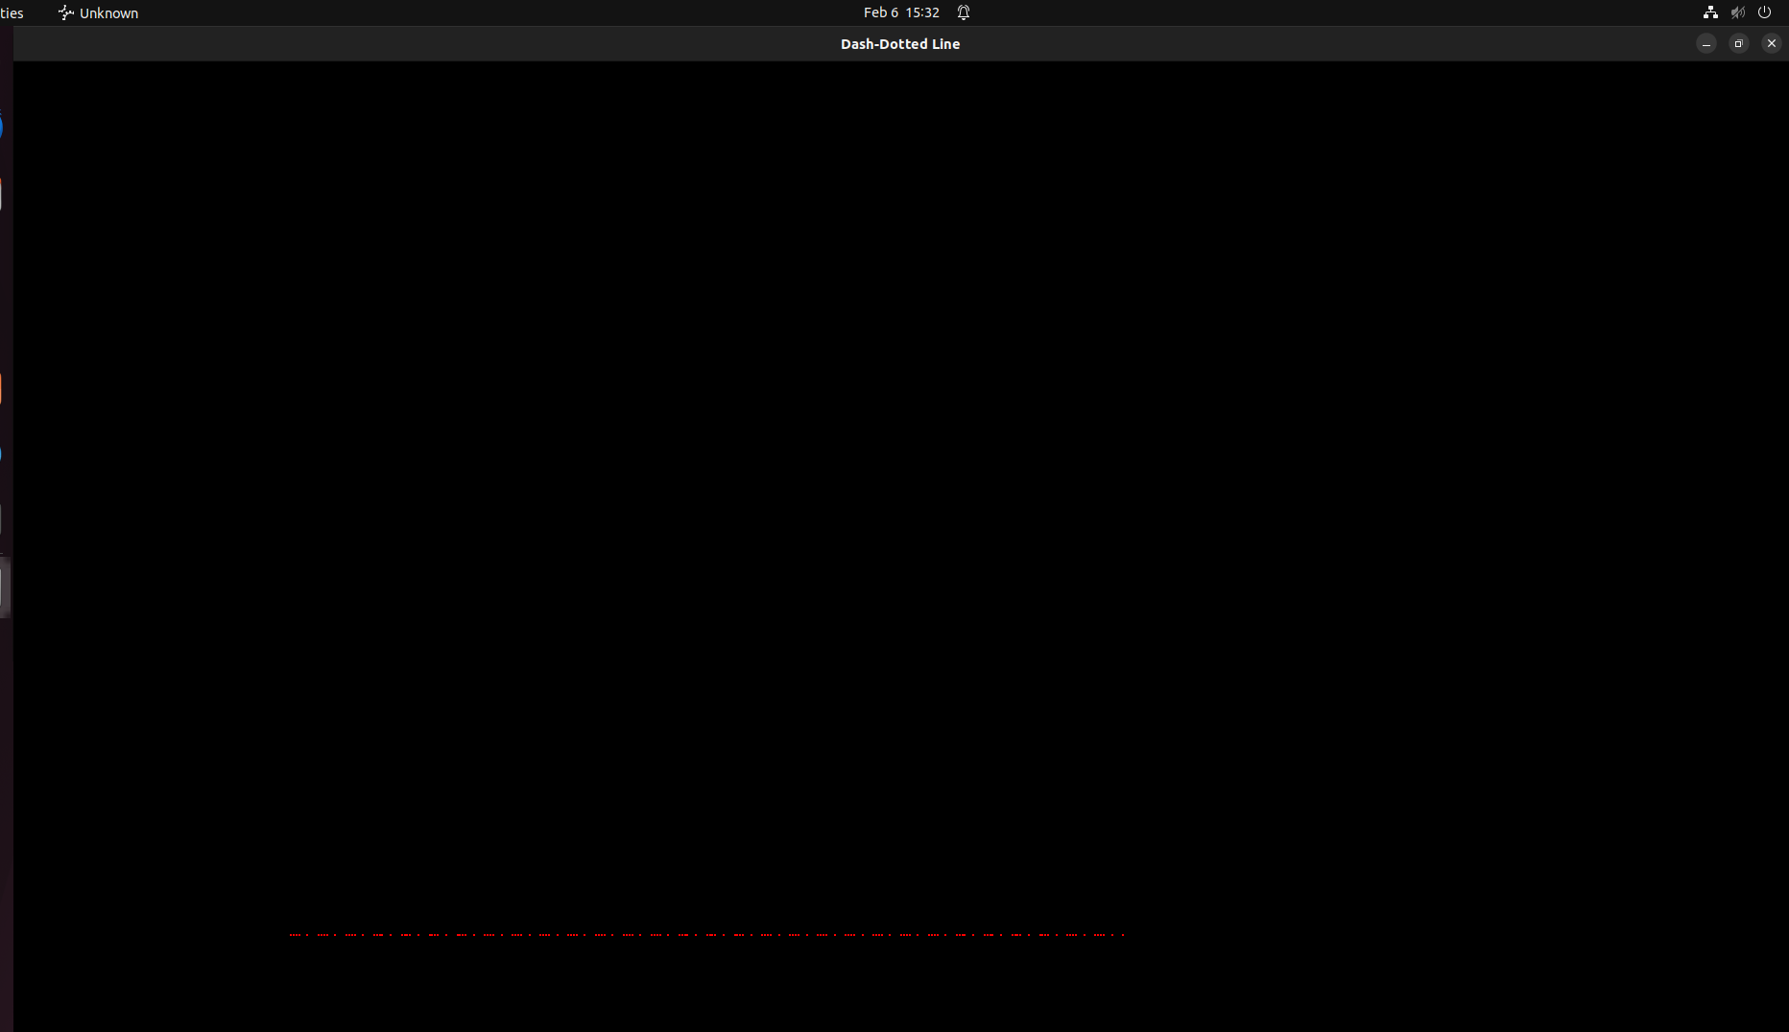

5) Use any Line Drawing algorithm, print HELLO.

#include <GL/glut.h>

void drawLine(float x1, float y1, float x2, float y2)
{
glBegin(GL_LINES);
glVertex2f(x1, y1);
glVertex2f(x2, y2);
glEnd();
}

void display()
{
glClear(GL_COLOR_BUFFER_BIT);
glColor3f(1.0, 1.0, 1.0); // white color

// H
drawLine(50, 50, 50, 150);
drawLine(100, 50, 100, 150);
drawLine(50, 100, 100, 100);

// E
drawLine(120, 50, 120, 150);
drawLine(120, 150, 170, 150);
drawLine(120, 100, 160, 100);
drawLine(120, 50, 170, 50);

// L
drawLine(190, 50, 190, 150);
drawLine(190, 50, 240, 50);

// L
drawLine(260, 50, 260, 150);
drawLine(260, 50, 310, 50);

// O
drawLine(330, 50, 380, 50);
drawLine(380, 50, 380, 150);
drawLine(380, 150, 330, 150);
drawLine(330, 150, 330, 50);

glFlush();
}

void init()
{
glClearColor(0.0, 0.0, 0.0, 0.0);
glMatrixMode(GL_PROJECTION);
glLoadIdentity();
gluOrtho2D(0, 500, 0, 200);
}

int main(int argc, char** argv)
{
glutInit(&argc, argv);
glutInitDisplayMode(GLUT_SINGLE | GLUT_RGB);
glutInitWindowSize(600, 300);
glutInitWindowPosition(100, 100);
glutCreateWindow("HELLO using OpenGL Line Drawing");

init();
glutDisplayFunc(display);
glutMainLoop();

return 0;
}

