#include <GL/glut.h>
#include<bits/stdc++.h>
using namespace std;

int xc = 250, yc = 250;

void init() {
glClearColor(0,0,0,1);
glColor3f(1,1,1);
glPointSize(1);
glMatrixMode(GL_PROJECTION);
glLoadIdentity();
gluOrtho2D(0,500,0,500);
}

void drawPoint(pair<int,int>pixel){
// add xc and yc to avoid negative co-ordinates
glVertex2i(xc + pixel.first, yc + pixel.second);
}

void circle(){
float r,p,x,y;
cout<<"Enter Radius : "; cin>>r;
p = 1 - r;
x = 0, y = r;

while(x<=y){
drawPoint({x,y});
drawPoint({y,x});

drawPoint({x,-y});
drawPoint({-y,x});

drawPoint({-x,-y});
drawPoint({-y,-x});

drawPoint({-x,y});
drawPoint({y,-x});

if(p<0)
p+=1+2*(x+1);
else {
p+=1+2*(x+1)-2*(y-1);

y--;
}
x++;
}
}

void display() {
glClear(GL_COLOR_BUFFER_BIT);
glBegin(GL_POINTS);

circle();

glEnd();
glFlush();
}

int main(int argc,char** argv) {
glutInit(&argc,argv);
glutInitDisplayMode(GLUT_SINGLE|GLUT_RGB);
glutInitWindowSize(500, 500);
glutInitWindowPosition(1100,600);
glutCreateWindow("Draw Circle");
init();
glutDisplayFunc(display);
glutMainLoop();
return 0;
}

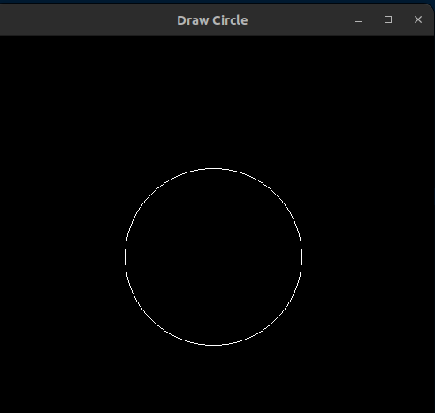

#include <GL/glut.h>
#include<bits/stdc++.h>
using namespace std;

void init() {
glClearColor(0,0,0,1);
glColor3f(1,1,1);
glPointSize(1);
glMatrixMode(GL_PROJECTION);
glLoadIdentity();
gluOrtho2D(0,500,0,500);
}

void drawPoint(pair<int,int>pixel){
glVertex2i(pixel.first,pixel.second);
}

void circle(int r,int xc,int yc){
float p,x,y;

p=1-r;
x=0,y=r;

while(x<=y){
drawPoint({xc+x,yc+y});
drawPoint({xc+y,yc+x});

drawPoint({xc+x,yc-y});
drawPoint({xc-y,yc+x});

drawPoint({xc-x,yc-y});
drawPoint({xc-y,yc-x});

drawPoint({xc-x,yc+y});
drawPoint({xc+y,yc-x});

if(p<0)
p+=1+2*(x+1);
else{
p+=1+2*(x+1)-2*(y-1);
y--;
}
x++;
}

}

void display() {
float x,y,r;
glClear(GL_COLOR_BUFFER_BIT);
glBegin(GL_POINTS);

cout<<"Enter radius : ";cin>>r;
cout<<"Enter center ";cin>>x>>y;

circle(r,x,y);

glEnd();
glFlush();
}

int main(int argc,char** argv) {

glutInit(&argc,argv);
glutInitDisplayMode(GLUT_SINGLE|GLUT_RGB);
glutInitWindowSize(500,500);
glutInitWindowPosition(1100,600);
glutCreateWindow("Draw Cicle");
init();
glutDisplayFunc(display);
glutMainLoop();
return 0;
}

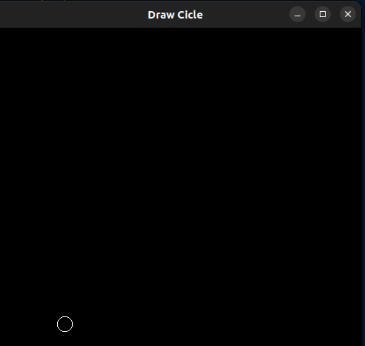

#include <GL/glut.h>
#include<bits/stdc++.h>
using namespace std;

void init() {
glClearColor(0,0,0,1);
glColor3f(1,1,1);
glPointSize(1);
glMatrixMode(GL_PROJECTION);
glLoadIdentity();
gluOrtho2D(0,500,0,500);
}

void drawPoint(pair<int,int>pixel){
glVertex2i(pixel.first,pixel.second);
}

void concentricCircle(int r1,int r2){
float p,x,y;

p=1-r1;
x=0,y=r1;

while(x<=y){
drawPoint({x+250,y+250});
drawPoint({y+250,x+250});

drawPoint({x+250,250-y});
drawPoint({250-y,x+250});

drawPoint({250-x,250-y});
drawPoint({250-y,250-x});

drawPoint({250-x,y+250});
drawPoint({y+250,250-x});

if(p<0)
p+=1+2*(x+1);
else{
p+=1+2*(x+1)-2*(y-1);
y--;
}
x++;
}

p=1-r2;
x=0,y=r2;

while(x<=y){
drawPoint({x+250,y+250});
drawPoint({y+250,x+250});

drawPoint({x+250,250-y});
drawPoint({250-y,x+250});

drawPoint({250-x,250-y});
drawPoint({250-y,250-x});

drawPoint({250-x,y+250});
drawPoint({y+250,250-x});

if(p<0)
p+=1+2*(x+1);
else{
p+=1+2*(x+1)-2*(y-1);
y--;
}
x++;
}

}

void display() {
float r1,r2;
glClear(GL_COLOR_BUFFER_BIT);
glBegin(GL_POINTS);

cout<<"Enter radius 1 : ";cin>>r1;
cout<<"Enter radius 2 : ";cin>>r2;

concentricCircle(r1,r2);

glEnd();
glFlush();
}

int main(int argc,char** argv) {

glutInit(&argc,argv);
glutInitDisplayMode(GLUT_SINGLE|GLUT_RGB);
glutInitWindowSize(500,500);
glutInitWindowPosition(1100,600);
glutCreateWindow("Draw star");
init();
glutDisplayFunc(display);
glutMainLoop();
return 0;
}

#include <GL/glut.h>
#include<bits/stdc++.h>
using namespace std;

void init() {
glClearColor(0,0,0,1);
glColor3f(1,1,1);
glPointSize(1);
glMatrixMode(GL_PROJECTION);
glLoadIdentity();
gluOrtho2D(0,500,0,500);
}

void drawPoint(pair<int,int>pixel){
glVertex2i(pixel.first,pixel.second);
}

void circle(int r,int xc,int yc){
float p,x,y;

p=1-r;
x=0,y=r;

while(x<=y){
drawPoint({xc+x,yc+y});
drawPoint({xc+y,yc+x});

drawPoint({xc+x,yc-y});
drawPoint({xc-y,yc+x});

drawPoint({xc-x,yc-y});
drawPoint({xc-y,yc-x});

drawPoint({xc-x,yc+y});
drawPoint({xc+y,yc-x});

if(p<0)
p+=1+2*(x+1);
else{
p+=1+2*(x+1)-2*(y-1);
y--;
}
x++;
}

}

void display() {
float x,y,r,c;

vector<int>radius;
vector<pair<int,int>>centre;

glClear(GL_COLOR_BUFFER_BIT);
glBegin(GL_POINTS);

cout<<"Enter number of circles : ";cin>>c;

cout<<"Enter radius : ";
for(int i=0;i<c;i++){
cin>>r;
radius.push_back(r);
}

cout<<"Enter centre : ";
for(int i=0;i<c;i++){
cin>>x>>y;
centre.push_back({x,y});
}

for(int i=0;i<c;i++)
circle(radius[i],centre[i].first,centre[i].second);

glEnd();
glFlush();
}

int main(int argc,char** argv) {

glutInit(&argc,argv);
glutInitDisplayMode(GLUT_SINGLE|GLUT_RGB);
glutInitWindowSize(500,500);
glutInitWindowPosition(1100,600);
glutCreateWindow("Draw star");
init();
glutDisplayFunc(display);
glutMainLoop();
return 0;
}

#include <GL/glut.h>
#include<bits/stdc++.h>
using namespace std;

void init() {
glClearColor(0,0,0,1);

glPointSize(2);
glMatrixMode(GL_PROJECTION);
glLoadIdentity();
gluOrtho2D(0,500,0,500);
}

void drawPoint(pair<int,int>pixel){
glVertex2i(pixel.first,pixel.second);
}

void circle(int r,int xc,int yc){
float p,x,y;

p=1-r;
x=0,y=r;

while(x<=y){
drawPoint({xc+x,yc+y});
drawPoint({xc+y,yc+x});

drawPoint({xc+x,yc-y});
drawPoint({xc-y,yc+x});

drawPoint({xc-x,yc-y});
drawPoint({xc-y,yc-x});

drawPoint({xc-x,yc+y});
drawPoint({xc+y,yc-x});

if(p<0)
p+=1+2*(x+1);
else{
p+=1+2*(x+1)-2*(y-1);
y--;
}
x++;
}

}

void display() {

glClear(GL_COLOR_BUFFER_BIT);
glBegin(GL_POINTS);

glColor3f(0,0,1);
circle(35,170,250);

glColor3f(1,1,1);
circle(35,250,250);

glColor3f(1,0,0);
circle(35,330,250);

glColor3f(1,1,0);
circle(35,210,220);

glColor3f(0,1,0);
circle(35,290,220);

glEnd();
glFlush();
}

int main(int argc,char** argv) {

glutInit(&argc,argv);
glutInitDisplayMode(GLUT_SINGLE|GLUT_RGB);
glutInitWindowSize(500,500);
glutInitWindowPosition(1100,600);
glutCreateWindow("Draw star");
init();
glutDisplayFunc(display);
glutMainLoop();
return 0;
}

