Assignment – 2
Date – 28.03.2026

1. Write an OpenGL program to perform 3D Translation of a Cube and display both the original and translated cube.

#include<GL/glut.h>

float cube[8][3] = {
{-0.5, -0.5, -0.5},
{ 0.5, -0.5, -0.5},
{ 0.5, 0.5, -0.5},
{-0.5, 0.5, -0.5},
{-0.5, -0.5, 0.5},
{ 0.5, -0.5, 0.5},
{ 0.5, 0.5, 0.5},
{-0.5, 0.5, 0.5}
};

float translated[8][3];
float tx = 2.0, ty = 1.5, tz = -1.0;
void translateCube(){
for(int i=0;i<8;i++){
translated[i][0] = cube[i][0] + tx;
translated[i][1] = cube[i][1] + ty;
translated[i][2] = cube[i][2] + tz;
}
}
void drawCube(float v[8][3]){
glBegin(GL_LINE_LOOP);
glVertex3fv(v[0]);
glVertex3fv(v[1]);
glVertex3fv(v[2]);
glVertex3fv(v[3]);
glEnd();
glBegin(GL_LINE_LOOP);
glVertex3fv(v[4]);
glVertex3fv(v[5]);
glVertex3fv(v[6]);
glVertex3fv(v[7]);
glEnd();
glBegin(GL_LINES);
for(int i=0;i<4;i++){
glVertex3fv(v[i]);
glVertex3fv(v[i+4]);
}
glEnd();
}
void display(){
glClear(GL_COLOR_BUFFER_BIT | GL_DEPTH_BUFFER_BIT);
glLoadIdentity();
gluLookAt(4, 4, 6, 0, 0, 0, 0, 1, 0);
glColor3f(1,1,1);
drawCube(cube);
glColor3f(1,0,0);
drawCube(translated);
glFlush();
glutSwapBuffers();
}

void init(){
glEnable(GL_DEPTH_TEST);
glClearColor(0,0,0,1);
translateCube();
}
void reshape(int w,int h){
glViewport(0,0,w,h);
glMatrixMode(GL_PROJECTION);
glLoadIdentity();
gluPerspective(60, (float)w / h, 1, 20);

glMatrixMode(GL_MODELVIEW);
}
int main(int argc,char** argv){
glutInit(&argc,argv);
glutInitDisplayMode(GLUT_DEPTH | GLUT_DOUBLE | GLUT_RGB);
glutInitWindowSize(800,600);
glutCreateWindow("3d Cube");
init();
glutDisplayFunc(display);
glutReshapeFunc(reshape);

glutMainLoop();
return 0;
}

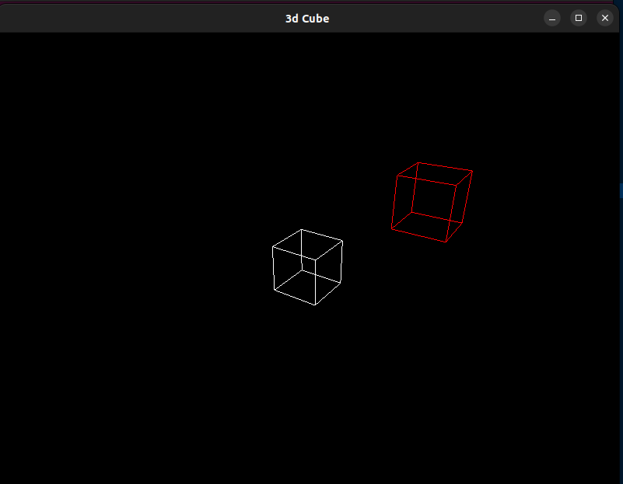

2. Program to perform 3D Scaling of a Pyramid and display both the original and scaled object.

#include<GL/glut.h>

float pyramid[5][3] = {
{-0.5, 0.0, -0.5},
{ 0.5, 0.0, -0.5},
{ 0.5, 0.0, 0.5},
{-0.5, 0.0, 0.5},
{ 0.0, 1.0, 0.0}
};

float scaled[5][3];

float sx = 2.0, sy = 1.5, sz = 1.0;
void scalePyramid(){
for(int i=0;i<5;i++){
scaled[i][0] = pyramid[i][0]*sx ;
scaled[i][1] = pyramid[i][1]*sy ;
scaled[i][2] = pyramid[i][2]*sz ;
}
}
void drawPyramid(float v[5][3]){
glBegin(GL_LINE_LOOP);
glVertex3fv(v[0]);
glVertex3fv(v[1]);
glVertex3fv(v[2]);
glVertex3fv(v[3]);
glEnd();

glBegin(GL_LINES);
for(int i=0;i<4;i++){
glVertex3fv(v[i]);
glVertex3fv(v[4]);
}
glEnd();
}
void display(){
glClear(GL_COLOR_BUFFER_BIT | GL_DEPTH_BUFFER_BIT);
glLoadIdentity();
gluLookAt(4, 4, 6, 0, 0, 0, 0, 1, 0);
glColor3f(1,1,1);
drawPyramid(pyramid);
glColor3f(1,0,0);
drawPyramid(scaled);
glFlush();
glutSwapBuffers();
}

void init(){
glEnable(GL_DEPTH_TEST);
glClearColor(0,0,0,1);
scalePyramid();
}
void reshape(int w,int h){
glViewport(0,0,w,h);
glMatrixMode(GL_PROJECTION);
glLoadIdentity();
gluPerspective(60, (float)w / h, 1, 20);

glMatrixMode(GL_MODELVIEW);
}
int main(int argc,char** argv){
glutInit(&argc,argv);
glutInitDisplayMode(GLUT_DEPTH | GLUT_DOUBLE | GLUT_RGB);
glutInitWindowSize(800,600);
glutCreateWindow("3d Pyramid");
init();
glutDisplayFunc(display);
glutReshapeFunc(reshape);

glutMainLoop();
return 0;
}

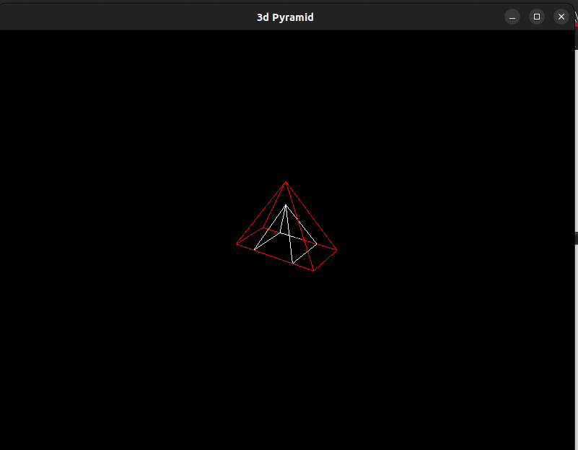

3. Program to perform 3D Rotation about the X-axis and display the rotated object along with the original.

#include<GL/glut.h>
#include<math.h>

float cube[8][3] = {
{-0.5, -0.5, -0.5},
{ 0.5, -0.5, -0.5},
{ 0.5, 0.5, -0.5},
{-0.5, 0.5, -0.5},
{-0.5, -0.5, 0.5},
{ 0.5, -0.5, 0.5},
{ 0.5, 0.5, 0.5},
{-0.5, 0.5, 0.5}
};

float rotated[8][3];

float angle = 45.0;

float rad;

void rotateX() {
rad = angle * 3.14159 / 180.0;

for(int i = 0; i < 8; i++) {
float x = cube[i][0];
float y = cube[i][1];
float z = cube[i][2];

rotated[i][0] = x;
rotated[i][1] = y * cos(rad) - z * sin(rad);
rotated[i][2] = y * sin(rad) + z * cos(rad);
}
}
void drawCube(float v[8][3]){
glBegin(GL_LINE_LOOP);
glVertex3fv(v[0]);
glVertex3fv(v[1]);
glVertex3fv(v[2]);
glVertex3fv(v[3]);
glEnd();
glBegin(GL_LINE_LOOP);
glVertex3fv(v[4]);
glVertex3fv(v[5]);
glVertex3fv(v[6]);
glVertex3fv(v[7]);
glEnd();
glBegin(GL_LINES);
for(int i=0;i<4;i++){
glVertex3fv(v[i]);
glVertex3fv(v[i+4]);
}
glEnd();
}
void display(){
glClear(GL_COLOR_BUFFER_BIT | GL_DEPTH_BUFFER_BIT);
glLoadIdentity();
gluLookAt(4, 4, 6, 0, 0, 0, 0, 1, 0);
glColor3f(1,1,1);
drawCube(cube);
glColor3f(1,0,0);
drawCube(rotated);
glFlush();
glutSwapBuffers();
}

void init(){
glEnable(GL_DEPTH_TEST);
glClearColor(0,0,0,1);
rotateX();
}
void reshape(int w,int h){
glViewport(0,0,w,h);
glMatrixMode(GL_PROJECTION);
glLoadIdentity();
gluPerspective(60, (float)w / h, 1, 20);

glMatrixMode(GL_MODELVIEW);
}
int main(int argc,char** argv){
glutInit(&argc,argv);
glutInitDisplayMode(GLUT_DEPTH | GLUT_DOUBLE | GLUT_RGB);
glutInitWindowSize(800,600);
glutCreateWindow("3d Cube");
init();
glutDisplayFunc(display);
glutReshapeFunc(reshape);

glutMainLoop();
return 0;
}

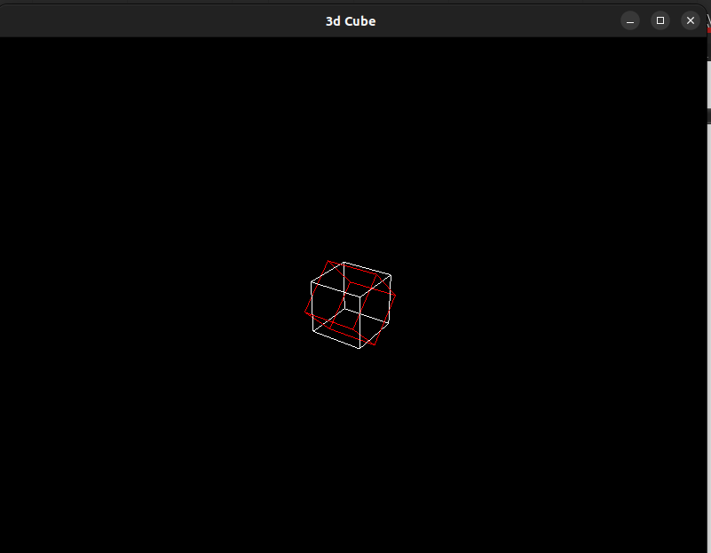

4. Program to implement the Cohen–Sutherland Line Clipping Algorithm to clip a line against a rectangular clipping window.

#include <GL/glut.h>
#include <stdio.h>

// Clipping window boundaries
float xmin = -1, ymin = -1, xmax = 1, ymax = 1;

// Line endpoints
float x1 = -2, Y = 0.5;
float x2 = 2, y2 = 1.5;

// Region codes
#define INSIDE 0
#define LEFT 1
#define RIGHT 2
#define BOTTOM 4
#define TOP 8

// Function to compute region code
int computeCode(float x, float y) {
int code = INSIDE;

if (x < xmin) code |= LEFT;
else if (x > xmax) code |= RIGHT;
if (y < ymin) code |= BOTTOM;
else if (y > ymax) code |= TOP;

return code;
}

// Cohen–Sutherland clipping
void cohenSutherland(float *x1, float *y1, float *x2, float *y2) {
int code1 = computeCode(*x1, *y1);
int code2 = computeCode(*x2, *y2);
int accept = 0;

while (1) {
if ((code1 == 0) && (code2 == 0)) {
accept = 1;
break;
}
else if (code1 & code2) {
break;
}
else {
float x, y;
int codeOut = code1 ? code1 : code2;

if (codeOut & TOP) {
x = *x1 + (*x2 - *x1) * (ymax - *y1) / (*y2 - *y1);
y = ymax;
}
else if (codeOut & BOTTOM) {
x = *x1 + (*x2 - *x1) * (ymin - *y1) / (*y2 - *y1);
y = ymin;
}
else if (codeOut & RIGHT) {
y = *y1 + (*y2 - *y1) * (xmax - *x1) / (*x2 - *x1);
x = xmax;
}
else if (codeOut & LEFT) {
y = *y1 + (*y2 - *y1) * (xmin - *x1) / (*x2 - *x1);
x = xmin;
}

if (codeOut == code1) {
*x1 = x;
*y1 = y;
code1 = computeCode(*x1, *y1);
} else {
*x2 = x;
*y2 = y;
code2 = computeCode(*x2, *y2);
}
}
}

if (!accept) {
*x1 = *y1 = *x2 = *y2 = 0;
}
}

// Display function
void display() {
glClear(GL_COLOR_BUFFER_BIT);

// Draw clipping window
glColor3f(1, 1, 1);
glBegin(GL_LINE_LOOP);
glVertex2f(xmin, ymin);
glVertex2f(xmax, ymin);
glVertex2f(xmax, ymax);
glVertex2f(xmin, ymax);
glEnd();

// Draw original line (red)
glColor3f(1, 0, 0);
glBegin(GL_LINES);
glVertex2f(-2, 0.5);
glVertex2f(2, 1.5);
glEnd();

// Perform clipping
float cx1 = x1, cy1 = Y, cx2 = x2, cy2 = y2;
cohenSutherland(&cx1, &cy1, &cx2, &cy2);

// Draw clipped line (green)
glColor3f(0, 1, 0);
glBegin(GL_LINES);
glVertex2f(cx1, cy1);
glVertex2f(cx2, cy2);
glEnd();

glFlush();
}

// Initialization
void init() {
glClearColor(0, 0, 0, 1);

glMatrixMode(GL_PROJECTION);
glLoadIdentity();
gluOrtho2D(-3, 3, -3, 3);
}

int main(int argc, char** argv) {
glutInit(&argc, argv);
glutInitDisplayMode(GLUT_SINGLE | GLUT_RGB);
glutInitWindowSize(600, 600);
glutCreateWindow("Cohen-Sutherland Line Clipping");

init();
glutDisplayFunc(display);

glutMainLoop();
return 0;
}

