**Lesson 02 Demo 01**

**Creating and Cloning a GitHub Repository**

**Objective:** To create and clone a GitHub repository for understanding the fundamentals of repository management and version control using Git and GitHub

**Tools required:** Git and GitHub

**Prerequisites:** You need to have Git installed and a GitHub account to proceed with this demo.

Steps to be followed:

1. Create a new GitHub repository
2. Clone the GitHub repository

**Step 1: Create a new GitHub repository**

1. Open the browser in your lab, go to **github.com**, and log in to your account

**Note**: If you do not have a GitHub account, visit the official website at <https://github.com/signup> and create a new account

1. Click on the **+** icon from the upper-right corner of the page and select **New repository** from the drop-down menu

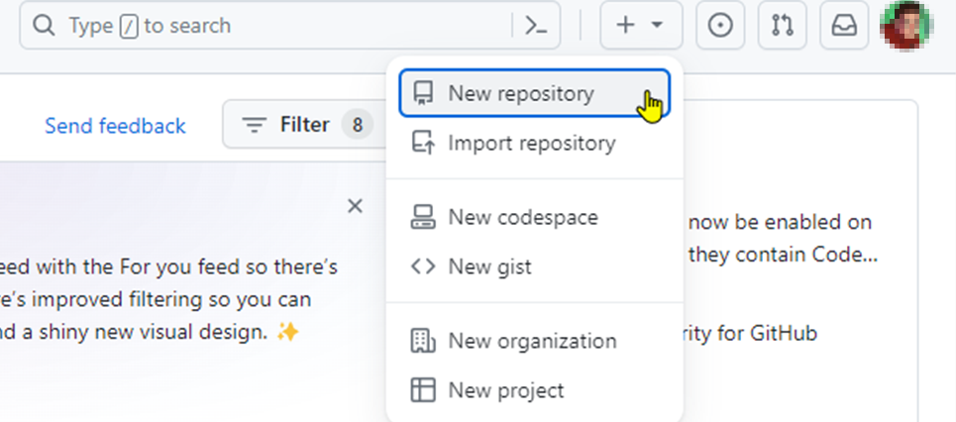

1. Enter the **Repository name** and **Description** as shown below:

**Note:** The repository name and description may differ from those shown in the screenshot.

1. Choose **Public** for the repository type

1. Select **Add a README** **file** option to include a README file for the repository

1. Click on the **Create repository** button

The remote GitHub repository is created.

**Step 2: Clone the GitHub repository**

1. Open the created repository and click on the **Code** button

1. Click on the copy icon to copy the **HTTPS URL** as shown below:

1. Open the terminal tab on your lab and use the following command to clone the repository:

**git clone <URL>**

**Note:** Replace the URL in the command with the copied **HTTPS URL** from the GitHub repository

By following these steps, you have successfully created and cloned a GitHub repository for understanding the fundamentals of repository management and version control using Git and GitHub.