**Lesson 02 Demo 02**

**Pushing a File to the GitHub Repository**

**Objective:** To demonstrate the process of pushing a file to a GitHub repository using Git commands for version control and collaboration

**Tools required:** Git and GitHub

**Prerequisites:** You need to have Git installed to proceed with this demo.

Steps to be followed:

1. Create a GitHub repository
2. Create a repository on the local machine
3. Push the changes in the local repository to GitHub
4. Check the status of the local and remote repository

**Step 1: Create a GitHub repository**

1. Open the browser in your lab, go to **github.com**, and log in to your account

**Note**: If you do not have a GitHub account, visit the official website at <https://github.com/signup> and create a new account

1. Click on the **New** button to create a new GitHub repository

1. Enter the repository name and description, then click the **Create repository** button

**Step 2: Create a repository on the local machine**

1. Open the terminal tab in your lab, and execute the following command to create a new project directory:

**mkdir createnewproject**

1. Run the following command to change the directory:

**cd createnewproject**

1. Create a README file using the following command:

**echo "# create new file for my project" >> README.md**



1. Initialize the Git repository using the following command:

**git init**

1. Add the README file using the command given below:

**git add .**



1. Use the following command to commit the changes:

**git commit -m "Added README file"**

**Step 3: Push the changes in the local repository to GitHub**

1. Open the **Terminal** and add a remote repository using the following command:

**git remote add origin <URL>**



**Note**: While creating the remote repository, copy the HTTPS URL

1. Push the changes to the remote repository using the following command:

**git push -u origin master**

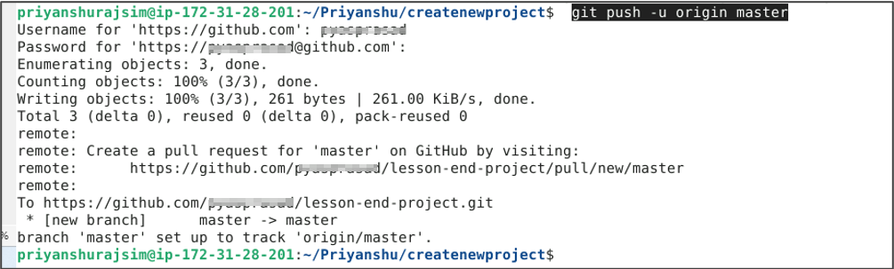

**Note**: After executing the Git push command, you will be asked to enter the username and password for your GitHub account.

**Step 4: Check the status of the local and remote repository**

1. Run the following command to check the status of the local repository:

**git status**

1. Visit **github.com** to inspect the remote repository

By following these steps, you have effectively demonstrated the process of pushing a file to a GitHub repository using Git commands for version control and collaboration.