**Lesson 02 Demo 04**

**Creating a Branch in Git**

**Objective:** To create a branch in a Git repository to facilitate a collaborative and organized approach to software development

**Tools required:** Git and GitHub

**Prerequisites:** You need to have Git installed to proceed with this demo.

Steps to be followed:

1. Create a new GitHub repository
2. Clone the GitHub repository
3. List all the branches in your repository
4. Create a new branch
5. Delete the branch

**Step 1: Create a new GitHub repository**

1. Click on the **New** button to create a new repository

1. Enter the repository name and description, then click on the **Create repository** button

**Step 2: Clone the GitHub repository**

1. Open the created GitHub repository and click on the **Code** button

1. Click on the copy icon to copy the **HTTPS** **URL** as shown below:

1. Open the terminal tab on your lab and use the following command to clone the repository:

**git clone <URL>**

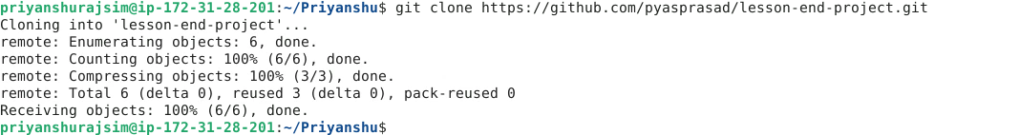

**Note**: Replace the URL with the copied HTTPS URL from the repository

**Step 3: List all the branches in your repository**

1. Navigate to the cloned repository using the following command:

**cd lesson-end-project**

1. Run the following command to display all repository branches:

**git branch**



**Step 4: Create a new branch**

1. Run the following command to create a new branch named **dev** in your repository:

**git branch dev**

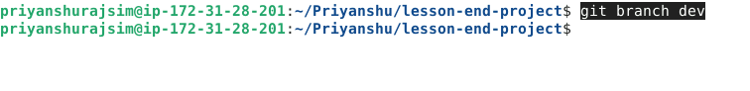

* 1. Execute the following command to verify the branch creation:

**git branch**



**Step 5: Delete the branch**

* 1. Run the given command to delete the recently created branch:

**git branch -d dev**

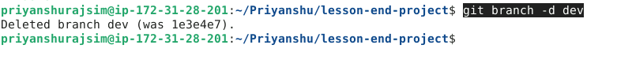

* 1. Execute the following command to verify the deletion of the branch:

**git branch**



By following these steps, you have successfully created a branch in a Git repository to facilitate a collaborative and organized approach to software development.