**Lesson 02 Demo 05**

**Switching Branches in Git**

**Objective:** To demonstrate how to switch branches in Git to understand the branch management and version control workflows in GitHub

**Tools required:** Git and GitHub

**Prerequisites:** You need to have Git installed to proceed with this demo.

Steps to be followed:

1. Create a new GitHub repository
2. Clone the GitHub repository
3. List all the branches in your repository
4. Create and switch to the new branch
5. Create a file and commit the changes
6. Switch back to the main branch

**Step 1: Create a new GitHub repository**

1. Click on the **New** button to create a new repository

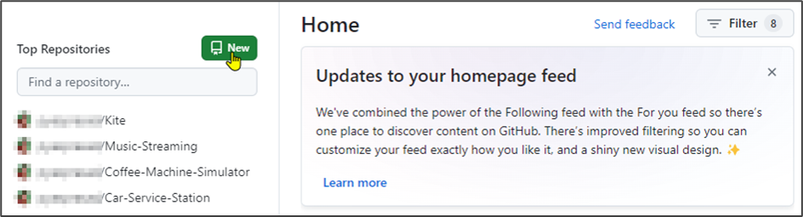

1. Enter the repository name and click on the **Create repository** button

**Step 2: Clone the GitHub repository**

1. Open the created repository in GitHub and click on the **Code** button

1. Click on the copy icon to copy the **HTTPS URL,** as shown below:

1. Open the terminal tab on your lab and use the following command to clone the repository:

**git clone <URL>**

**Note**: Replace the URL with the copied URL from the repository

**Step 3: List all the branches in your repository**

1. Navigate to the cloned repository using the following command:

**cd lesson-end-project**

1. Run the below command to display all repository branches:

**git branch**



**Step 4: Create and switch to the new branch**

1. Run the following command to create a new branch in your repository:

**git branch dev**

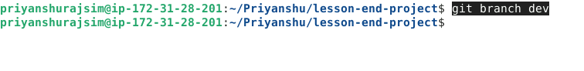

1. Use the following command to switch to the newly created branch:

**git checkout dev**



**Step 5: Create a file and commit the changes**

* 1. In the **dev** branch, execute the following command to create a file:

**vi index.html**



* 1. Add the given code snippet into the **index.html** file:

**<html>**

**<body>**

**<p> This is a Test HTML file. </p>**

**</body>**

**</html>**

**Note**: Press **i** to edit the files. Press the **Esc** button to exit insert mode and enter **:wq** to save the file

* 1. Use the following command to add the **index.html** file to the **dev** branch:

**git add .**

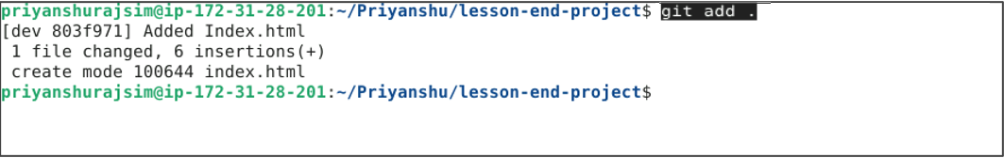

* 1. Use the following command to commit the changes:

**git commit -m "Added Index.html"**

* 1. Check the status of the new branch using the following command:

**git status**

**Step 6: Switch back to the main branch**

* 1. Use the following command to switch back to the main branch:

**git checkout main**

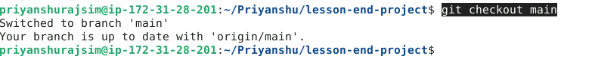

By following these steps, you have successfully demonstrated how to switch branches in Git, aiming to understand branch management and version control workflows in GitHub.