
SYMBIOVECTOR · CONCEPT NOTE
Regional Scale-Up of Microsporidia MB for Malaria Control

A $50M, five-year, three-country programme to take a self-spreading malaria blocking symbiont to regional deployment
SYMBIOVECTOR - a transformative solution for Malaria control
Malaria is a major problem. Malaria still kills roughly 610,000 people a year (accounting for 55 million DALYs), and progress has stalled: cases rose from 273 million to 282 million between 2023 and 2024, as insecticide and drug resistance erode the tools already in use¹. The core obstacle is economic as much as biological: every major intervention in use today, nets, spraying, chemoprevention, is a consumable that must be re-bought and re-delivered on a recurring basis, so cost scales with population covered, year after year, indefinitely.
The long-term sustainable solution is a self-sustaining control strategy. Absent a major and sustained increase in global malaria financing, the only realistic path to reversing this trajectory is a genuinely self-sustaining control strategy². Two approaches currently offer that possibility: gene-drive mosquitoes and symbiont-based control. Gene drive has drawn considerable attention, but significant technical hurdles remain unresolved, and its regulatory pathway and public acceptability have proven harder than anticipated.
Microsporidia MB is a potentially transformative solution. Symbiont-based mosquito control is the only self-regenerating strategy already proven to work in the field: the symbiont Wolbachia is now deployed across 15 countries, protecting 16 million people from dengue virus^{3,4}. We have already generated strong evidence that a symbiont-based approach can be equally transformative for malaria. Microsporidia MB (MB) is a naturally occurring Anopheles mosquito symbiont that blocks Plasmodium transmission, confirmed in the lab and, directly, in wild mosquito populations in the field (Ahero, western Kenya)^{5,18}. MB integrates into the germline of mosquitoes and is transmitted across mosquito generations^{6,7}, and it can also infect mosquitoes directly from the larval environment via spores, which removes the need to mass-rear and release mosquitoes, the single largest cost driver in comparable programmes (e.g. GM mosquitoes and even Wolbachia)^{8,9}. Beyond this, evidence from western Kenya suggests high public acceptance for symbiont-based mosquito control¹⁰. This combination of strong malaria transmission-blocking effect, self-propagation once released and scalable delivery and deployment is what a transformative malaria tool requires. MB is currently the only symbiont-based candidate to demonstrate all three together in a field setting.

Microsporidia MB could be sustainably deployed and reach scale. Initial deployment will use spore-based seeding of a defined subset of larval habitats, timed to precede the onset of the rains. Spores produced at regional facilities will be distributed to deployment sites for dissemination using a combination of traditional and drone-based approaches. Once seeded, infected mosquitoes do much of the remaining work, dispersing into additional habitats and propagating MB through the population and across generations. This is expected to establish high MB prevalence early in the transmission season, and to reduce transmission from both indoor- and outdoor-biting mosquitoes without requiring any action from the population being protected. The resulting model of centralized production, targeted seeding and self-propagating biological dissemination offers a fundamentally different and potentially far more scalable approach to malaria control. Based on field and laboratory experiments³⁸, we expect that maximum rate of MB spread and sustainability will occur within a specific range of climatic conditions which occur in areas sustaining more than half of Africa’s malaria burden (Figure 1). It is also worth noting that we expect additional MB strains exist with the potential to have different thermal preferences.
This would be highly cost-effective at scale. Although still illustrative, we believe it is reasonable to model a two-round well-timed spore-release campaign, achieving 90% MB prevalence, 75% transmission blocking, and six years of protection. Under these assumptions, the intervention would cost an estimated $24–188 per DALY averted ($47/DALY at 20% baseline malaria prevalence) and $720–5,760 per life saved. This estimate conservatively assumes MB spore production costs 10× more than Bacillus thuringiensis subsp. israelensis (Bti) larvicide. Despite this higher production cost, the intervention remains highly efficient because we estimate MB would require only two applications over six years rather than roughly 15 per year for Bti¹¹. Across most of the malaria prevalence range, this places MB within GiveWell’s ~$100/DALY benchmark for highly cost-effective interventions¹². The model also assumes MB blocks transmission across all primary malaria vectors at a given site, consistent with current evidence but not yet demonstrated. A more precise estimate will require field data on realized production and dissemination costs, as well as the duration of protection following a single elevation event.
Figure 1. Malaria cases against MB thermal suitability across Africa. Areas of moderate to high malaria burden that are also thermally suitable for Microsporidia MB (darker green) concentrate in East and Central Africa, West Africa and Madagascar.
Our scale-up vision
SYMBIOVECTOR is ready for large-scale investment: most of the evidence is in place, and so is the plan for what to do with it. Over five years and under $12M, we have moved MB from a lab discovery to field-validated malaria transmission blocking. We have about the same evidence base that Wolbachia had roughly 10–15 years ago. Our plan is to make that same transition to impact deliberately, across no less than three countries at once, while simultaneously building a scientific alliance for accelerated future expansion into up to 10 countries, rather than growing one country at a time. Figure 2 contrasts the scale-up with the pathway MB would otherwise follow. Under ‘business-as-usual’ funding, MB would proceed the way most academic discoveries do: continued research, a pilot trial, publication, and then a new round of fundraising before any scale-up could even be planned, a sequence that, based on comparable interventions, would likely take 2–5 years longer to reach the same point. The large-scale SYMBIOVECTOR investment instead runs research, regulatory engagement, manufacturing, and government partnerships in parallel across three countries from the outset, rather than starting each of those processes from scratch, one country at a time. This parallel structure creates value beyond speed alone: working across three different ecological, epidemiological, and regulatory contexts simultaneously generates a far broader evidence base, surfacing what works, and what needs adapting, much earlier than a single-country pathway would.

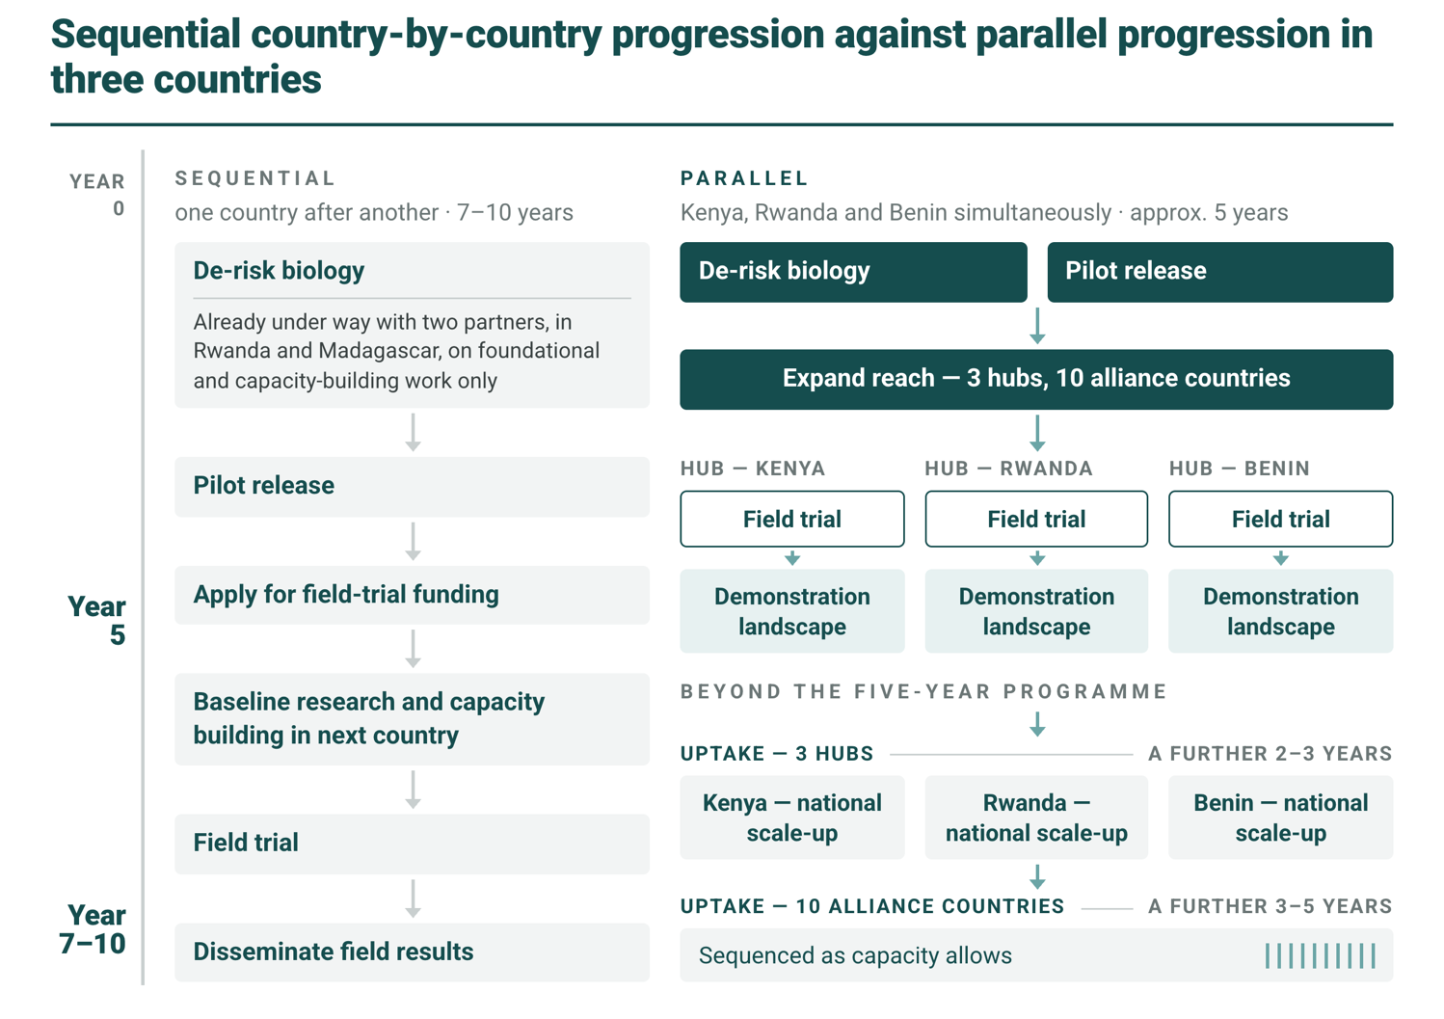
Figure 2. A hypothetical timeline for the SYMBIOVECTOR programme on current trajectory (sequential) and larger scale (parallel) approach.
The cost of delay. Experience from global health demonstrates that the greatest delays often occur after scientific proof of concept has been achieved. New vaccines and malaria interventions have historically taken many years, and in some cases more than a decade, to transition from successful development to routine implementation in low- and middle-income countries. These delays have been attributed not only to the science itself, but to insufficient early investment in manufacturing capacity, regulatory pathways, financing, and country readiness. Analyses of previous interventions conclude that planning for deployment must begin during product development, rather than after it, if public health impact is to be accelerated¹³. Accelerating the development and deployment of life-saving interventions therefore saves lives, alongside improvements in their efficacy¹⁴. Figure 3 conservatively quantifies hypothetical gains from the foreseen acceleration (and success of MB) in terms of DALYs and deaths averted.
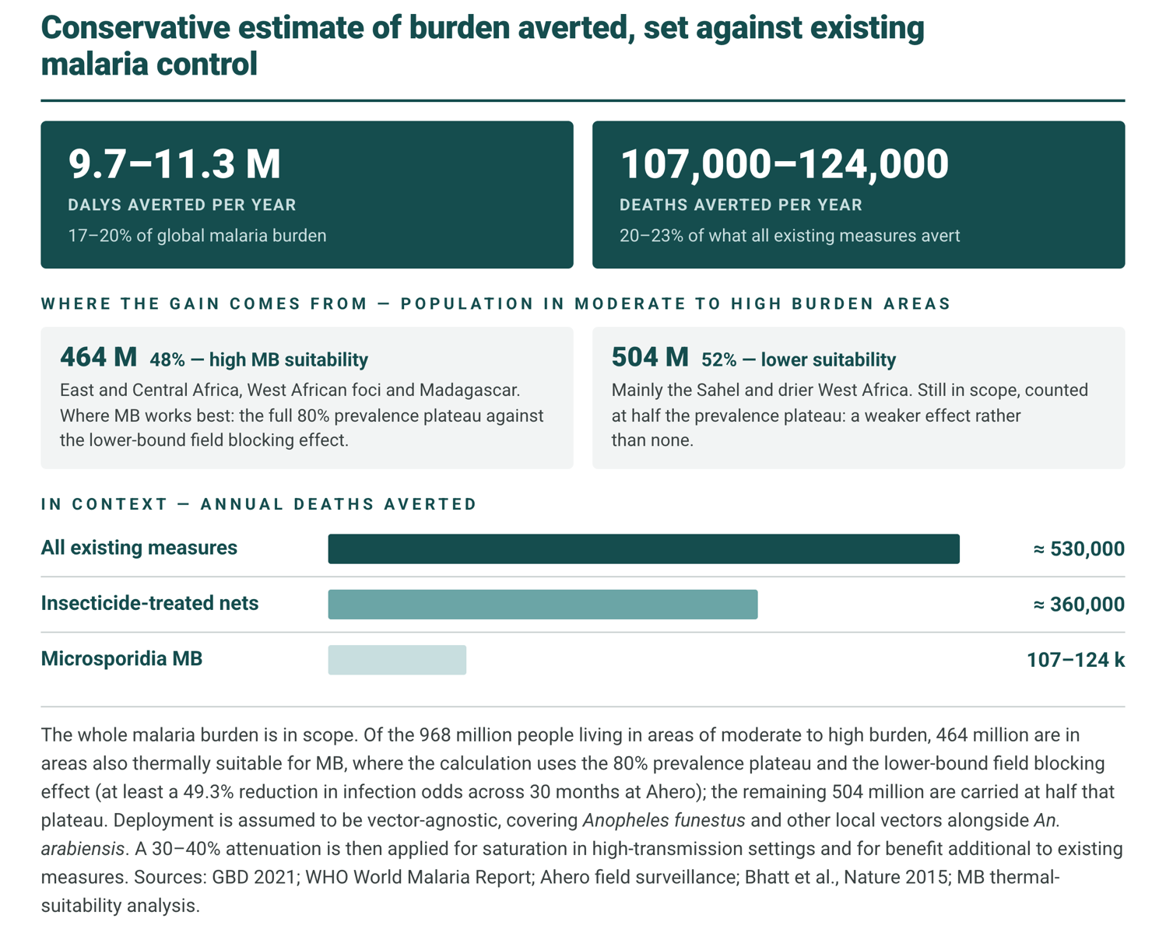
Figure 3. A hypothetical estimation for the potential impacts of implementing MB.
SYMBIOVECTOR is seeking $50M over five years in staged tranches tied to capability gates: evidence, then production and regulatory approval, then scaling. This funding will transition SYMBIOVECTOR from a research programme to an international malaria control platform with expertise in regulatory affairs, manufacturing, logistics, scientific partnership and alliance building, community engagement and government partnerships. This scale-up will build “demonstration landscapes” backstopped by research and MB production facilities. This is the basis for future work to integrate SYMBIOVECTOR’s work into mainstream malaria control programmes and financing.
Staged implementation: We propose a staged approach to building an MB malaria control implementation platform, where each phase builds the capabilities the next stage needs.
Stage 1 establishes the biology, production methods, and delivery technologies required for scalable deployment. Within stage 1, scientific partnerships to create an alliance for SYMBIOVECTOR-based control will be set up in up to 10 countries across Africa (Cameroon, Côte d’Ivoire, Ethiopia, Madagascar, Nigeria, Tanzania, Uganda), to strengthen capacity to research MB, data sharing and building the basis for accelerated scaling at a later stage.
Stage 2 develops the manufacturing, regulatory, safety, and field implementation platform needed for pilot releases in Kenya, Rwanda and Benin. Stage 2 will also lay the foundation for a multi-country field trial. Kenya, where Microsporidia MB was discovered and where the programme has made the greatest scientific progress, serves as the primary R&D hub and the site of the first pilot deployments. Rwanda provides a second, independent implementation pathway through a pro-innovation government and strong public-health institutions, while offering a gateway to the high-burden Great Lakes region. Benin establishes the West African hub, leveraging existing scientific partnerships and a stable base for expansion into Francophone West Africa, including several of the world’s highest-burden malaria countries¹⁵. Running three regulatory and implementation pathways in parallel reduces dependence on any single country’s approval timeline. Stage 3 initiates a field trial and establishes the organizational capacity for regional deployment through government partnerships, manufacturing, surveillance, and long-term programme management, creating an institution capable of taking MB from research to routine malaria control.
STAGE | BUDGET | FOCUS | KEY ACTIVITIES
Stage 1  YEARS 1–2 | ~$9M | De-risk the biology | Enhanced dissemination-pathway research; major expansion of semi-field capacity; focus on all major vector species; enhanced and geographically diverse efficacy studies. Alliance for SYMBIOVECTOR-based malaria control set up with partners in up to 10 African countries including strong data sharing and AI-enabled data platform integrating programme-wide data.
Stage 2  YEARS 2–4 | ~$24M | Pilot releases | Regulatory approval sought in Kenya, Rwanda and Benin. Establishment of large production facility in Nairobi rearing both hosts at scale; smaller-scale production set up in Benin and Rwanda in parallel; heavy community engagement throughout, preparation for field trial in stage 3. Pilot releases in western and northern Kenya (baseline data already collected) as well as sites in Rwanda and Benin.
Stage 3  YEARS 4–5 | ~$17M | Regional field trial and scale-up | Increased production across all three sites, sufficient to initiate field trial; spin-off of a dedicated not-for-profit entity partnering with in-country organizations to build large-scale production facilities in the most affected regions.

The end goal of this investment is not simply a successful pilot trial. It is to establish functioning demonstration landscapes - real-world sites where MB is established and operating in wild mosquito populations at operational scale, not just characterised under trial conditions. A trial produces evidence; a demonstration landscape produces evidence and a visible, working model of implementation that governments, funders, and national malaria programmes can evaluate directly and replicate in their own settings. Notably, the $50M is intended to demonstrate that MB works at meaningful operational scale in three countries, not to fund continent-wide malaria control indefinitely. Once that demonstration exists, we expect the pathway to full scale to run increasingly through redirected malaria-control financing rather than new philanthropic capital: nets, indoor spraying, and chemoprevention already consume large, recurring national and donor budgets, and a demonstrated, more durable, and potentially more cost-effective MB-based strategy creates the case for governments and global health funders to redirect a share of that existing spend toward it.
Leadership
SYMBIOVECTOR scientist Jeremy Herren discovered Microsporidia MB in 2018 (published in 2020)¹⁶ and his team have been leading its progression towards a field-validated malaria transmission blocking tool. SYMBIOVECTOR is hosted by the International Centre of Insect Physiology and Ecology (icipe), Africa’s leading insect science institute and the continent’s only international research centre dedicated primarily to insects and other arthropods. For more than five decades, icipe has combined world-class science with the development and deployment of practical technologies for agriculture and public health, working through long-term partnerships with African governments, research institutions, communities, and international organizations across more than 40 African countries. Its mission has always been not simply to generate knowledge, but to translate science into impact. Alongside biological research, SYMBIOVECTOR has invested in regulatory engagement, environmental risk assessment, community acceptance, production systems, mathematical modelling, and implementation science. These capabilities can now be extended into manufacturing, logistics, data infrastructure, and regional partnerships so that scientific progress is matched by implementation readiness. This combination of scientific leadership, African institutional ownership, existing government relationships, and implementation capability places SYMBIOVECTOR in a unique position to become not simply the developer of MB, but the organization that delivers the world’s first self-sustaining symbiont-based malaria control programme.
Additional detail
Funding and progress so far
Fundamental and applied research has been conducted across two phases: $2.2M from Open Philanthropy, $2.0M from the Gates Foundation and $1.0M from Children’s Investment Fund Foundation in Phase 1, followed by current Phase 2 commitments of $3.0M from Open Philanthropy (three-quarters expended) and $2.5M from Gates (half expended). This funding has de-risked most of the core biological and technical uncertainties that stand between discovery and impact. What follows summarises what that investment has established.
Strong Malaria Transmission-Blocking Effect
Controlled membrane feeding assays, using matched Plasmodium falciparum gametocyte donors, confirm that MB-infected mosquitoes establish lower parasite prevalence and density than their uninfected counterparts¹⁷, and see Figure 4. This effect has now been replicated in the wild: across 37,879 wild-caught An. arabiensis screened over 30 months at Ahero, MB-infected mosquitoes had roughly half the odds of carrying Plasmodium (OR = 0.51, ≥49.3% protection), with high-intensity, vertically transmitted infections conferring even stronger protection (≥59.7%), likely an underestimate since the analysis captured only the first four days of parasite development¹⁸. A second, independent field dataset corroborates this effect. Host genetic background showed no association with MB or Plasmodium status, ruling out genetic confounding as an explanation. Taken together, this is direct epidemiological evidence that MB reduces malaria transmission potential in a real transmission setting.
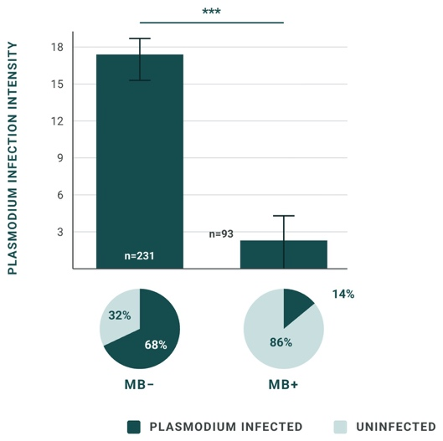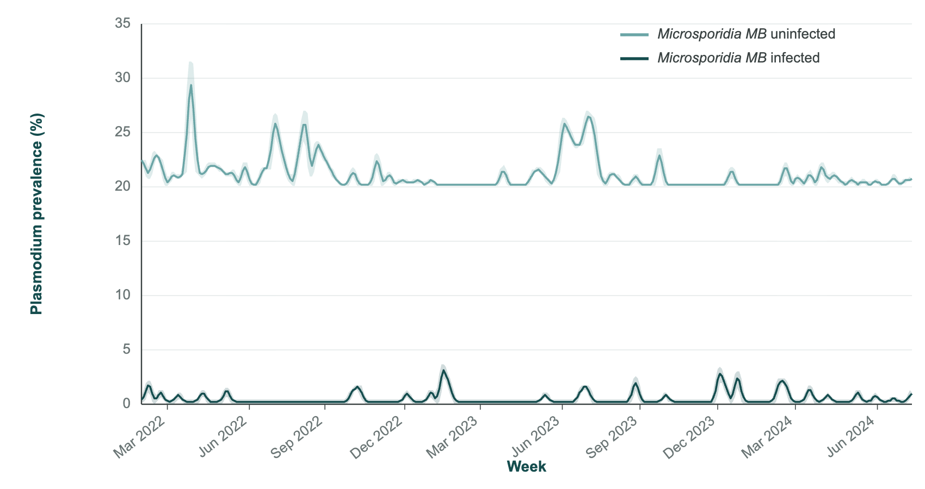
Figure 4. (Left) Membrane feeding assay results showing very strong malaria transmission blocking by MB. (Right) Malaria blocking effect of Microsporidia MB. Weekly Plasmodium prevalence in wild-caught mosquitoes, March 2022 to June 2024: MB-uninfected (light) against MB-infected (dark).
Self-propagation
The central premise of SYMBIOVECTOR, that a self-disseminating symbiont can sustain itself in Anopheles populations without repeated intervention, is no longer a hypothesis. Highly infected colonies reach and hold roughly 80% MB prevalence for over two years across different mosquito genetic backgrounds¹⁹, see Figure 5. This stability extends to semi-natural population cages, where MB levels held constant across generations except under high external temperature stress, and now to semi-field enclosures¹⁹. We have established the mechanistic basis for this persistence: maternal transmission occurs early in mosquito development when MB enters the germline stem cells of the Anopheles mosquito²⁰, see Figure 6. Intracellular vertical transmission shields MB from microbial competition, avoiding the competitive exclusion that limits many biological control agents. Maternal transmission is sustained between 63.5 to 99.5% (average of 74%) per gonotrophic cycle and is reinforced by a fitness advantage in infected offspring (faster pupation, higher mating competitiveness, and greater female longevity)^{20,22,23}. We have also resolved how horizontally acquired infections become heritable, mapping the process by which MB is transferred sexually into the female spermatheca and establishes systemic, germline infection within three days, at roughly 70% efficiency in our An. arabiensis colonies²⁴. A two-year longitudinal field study at the Ahero irrigation scheme, alongside a cross-zone survey spanning humid, semi-arid, and arid climates, has further defined how temperature, rainfall, and water coverage shape prevalence in the wild, giving us practical information on the environmental conditions that favour the spread of MB¹⁸.
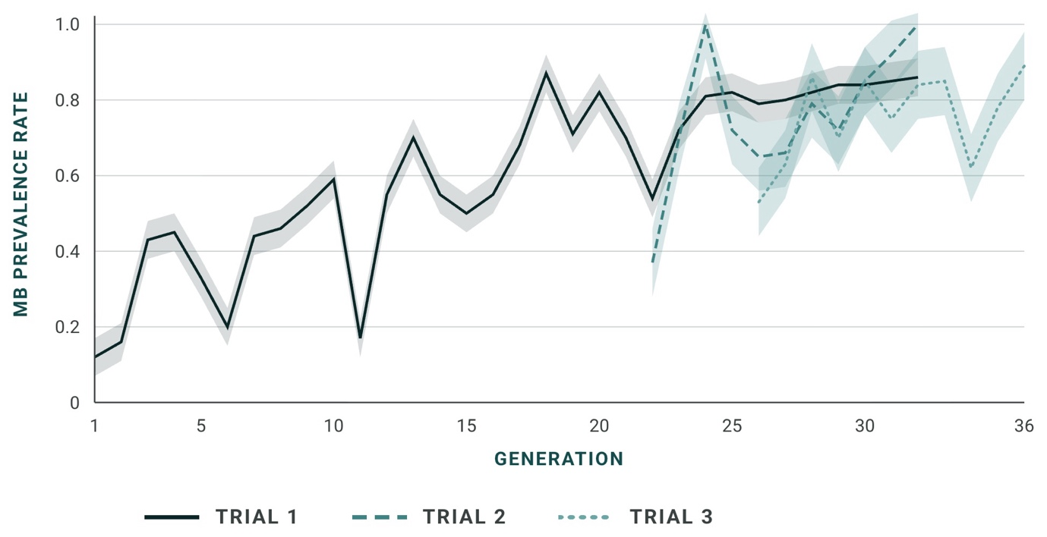
Figure 5. Transmission of Microsporidia MB across generations in cage trials demonstrating stable prevalence across three generations.
This dual transmission route structure is what allows a single or series of sequential seasonally timed releases to establish a high prevalence of MB that will largely maintain itself²⁶. We do not expect this to be a strictly one-off intervention. The same field data show that temperature and rainfall move MB prevalence up and down, so some degree of monitoring and periodic top-up is a reasonable planning assumption²⁷. Even so, the frequency of re-application should be substantially lower than for IRS spraying or larviciding (and possibly nets), each of which requires near-total re-delivery monthly, annually or multi-year cycle regardless of whether the previous round worked.
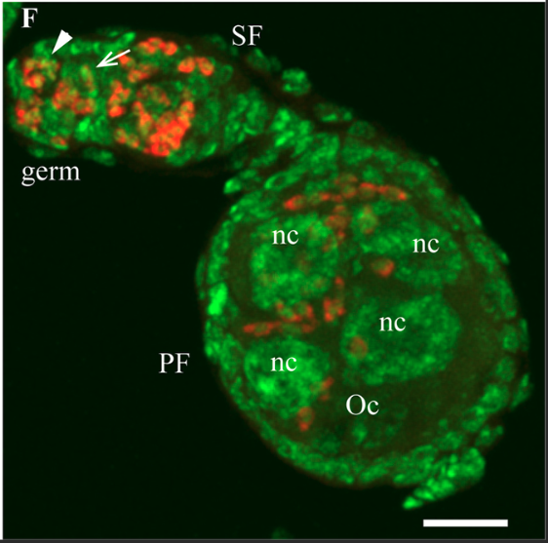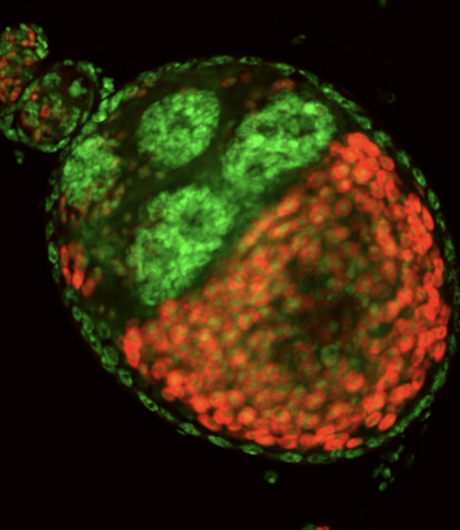
Figure 6. MB in the germline. (Left) Fluorescence micrograph showing MB (red) within germline and follicular tissue. SF, secondary follicle; PF, primary follicle; nc, nurse cells; Oc, oocyte. (Right) Fluorescence micrograph showing MB (red) within the developing egg cell.
Scalable Delivery and Deployment
MB is both horizontally and maternally transmitted; however, it can exploit two ‘paths’ of horizontal transmission. The first occurs between mosquitoes as they mate (sexual transmission)^{28,29} and the second is a potentially transformative route for MB deployment that avoids releasing infected mosquitoes. Instead, MB produces environmentally stable spores that infect Moina microcrustaceans, which amplify the infection and release a second spore form that is highly infectious to Anopheles larvae^{30,31}. Because Moina amplify rather than maintain the infection, scalable production is expected to combine centralised mosquito-derived spore production with distributed Moina-based amplification, offering a substantially lower-cost alternative to mass mosquito rearing, see Figure 7. Genome sequencing also shows that a single MB strain naturally infects most major African malaria vectors, including An. gambiae, An. coluzzii, An. funestus, An. coustani and An. pharoensis^{32–36}. Together with evidence that MB blocks transmission in multiple vector species, this raises the prospect of a single spore-based intervention suppressing malaria transmission across diverse vector communities, including An. funestus, the dominant vector across much of eastern and southern Africa. Beyond the technical advantages, our own work on community acceptance has also established that working without mosquito releases would increase already high community acceptance for SYMBIOVECTOR’s work in western Kenya³⁷.
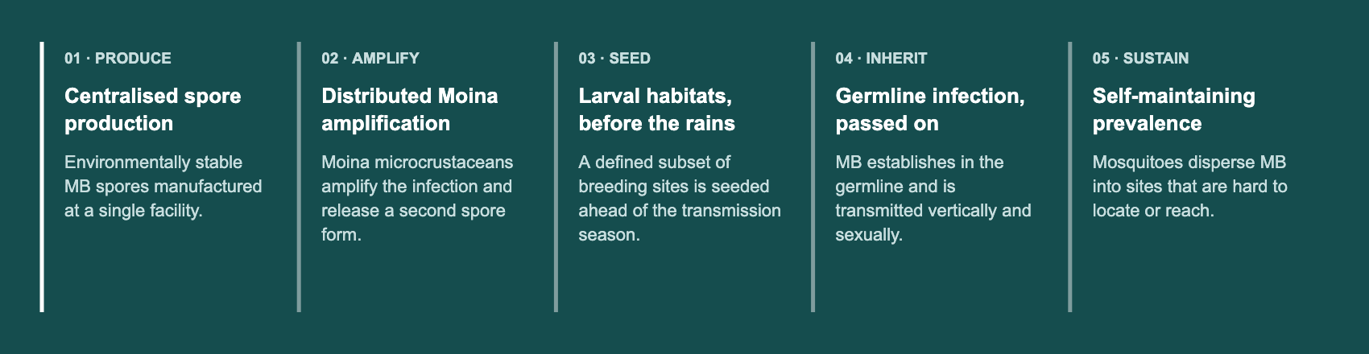
Figure 7. The MB production and dissemination pathway.

REFERENCES

1 | GLOBAL MALARIA BURDEN  Source for the annual malaria mortality figure and the 2023–2024 rise in cases, and for the statement that insecticide and drug resistance are eroding the tools in use.  World Health Organization. World malaria report 2025. Geneva: World Health Organization; 2025.

2 | CASE FOR MICROSPORIDIA IN VECTOR CONTROL  Standing review citation for the argument that microsporidia address residual malaria transmission not covered by bed nets and indoor spraying.  Bukhari T, Pevsner R, Herren JK. Microsporidia: a promising vector control tool for residual malaria transmission. Front Trop Dis. 2022;3:957109. doi:10.3389/fitd.2022.957109

3 | WOLBACHIA DEPLOYMENT SCALE  Source for the statement that Wolbachia is deployed across 15 countries, protecting 16 million people.  World Mosquito Program. Releasing hope: annual review 2025. Melbourne: World Mosquito Program; 2025.

4 | FIELD EFFICACY OF SYMBIONT DEPLOYMENT  Cluster-randomised trial underpinning the statement that symbiont-based mosquito control is proven in the field: wMel Wolbachia deployments reduced virologically confirmed dengue by 77.1% and dengue hospitalisation by 86.2% in Yogyakarta, Indonesia.  Utarini A, Indriani C, Ahmad RA, Tantowijoyo W, Arguni E, Ansari MR, et al. Efficacy of Wolbachia-infected mosquito deployments for the control of dengue. N Engl J Med. 2021;384(23):2177-2186. doi:10.1056/NEJMoa2030243

5 | DISCOVERY AND TRANSMISSION BLOCKING  Microsporidia MB is present at moderate prevalence in Anopheles arabiensis populations in Kenya, is localised to midgut and ovaries, is not associated with significant reductions in adult fecundity or survival, and blocks Plasmodium falciparum transmission: sporozoites are not detected in infected mosquitoes after experimental infection.  Herren JK, Mbaisi L, Mararo E, Makhulu EE, Mobegi VA, Butungi H, et al. A microsporidian impairs Plasmodium falciparum transmission in Anopheles arabiensis mosquitoes. Nat Commun. 2020;11:2187. doi:10.1038/s41467-020-16121-y

6 | 97% VERTICAL TRANSMISSION, VIA GERMLINE STEM CELLS  Vertical transmission occurs through acquisition of the symbiont by Anopheles cystocyte progenitors following germline stem cell division; the reported mother-to-offspring transmission rate is 97%.  Onchuru TO, Makhulu EE, Ronnie PC, Mandere S, Otieno FG, Gichuhi J, et al. The Plasmodium transmission-blocking symbiont, Microsporidia MB, is vertically transmitted through Anopheles arabiensis germline stem cells. PLoS Pathog. 2024;20(11):e1012340. doi:10.1371/journal.ppat.1012340

7 | TISSUE TROPISM  Microsporidia MB accumulates in male and female gonadal tissues; ovarian levels rise after blood feeding with the progression of oogenesis, and gonadal intensity tends to decrease as mosquitoes age. The localisation pattern is interpreted as adaptation that maximises transmission while remaining avirulent.  Makhulu EE, Onchuru TO, Gichuhi J, Otieno FG, Wairimu AW, Muthoni JN, et al. Localization and tissue tropism of the symbiont Microsporidia MB in the germ line and somatic tissues of Anopheles arabiensis. mBio. 2024;15(1):e02192-23. doi:10.1128/mbio.02192-23

8 | SPOROGENY AND A POSSIBLE ENVIRONMENTAL ROUTE  First detailed lifecycle description in a laboratory colony of An. coluzzii from western Burkina Faso. Microsporidia MB undergoes octosporogony in developing oocytes; the identification of spores in eggs suggests alternative horizontal routes, potentially allowing dissemination without adult mosquito releases. The symbiont was not generally present in the midgut, which points to a systemic basis for the transmission-blocking phenotype.  Parry ERS, Pevsner R, Poulton BC, Purusothaman DK, Adam AI, Issiaka S, et al. Imaging the lifecycle of Microsporidia sp. MB in Anopheles coluzzii from western Burkina Faso reveals octosporogony. mSphere. 2025;10(6):e00851-24. doi:10.1128/msphere.00851-24

9 | PROGRAMME COMMENTARY ON SPOROGENY  Invited commentary setting out what the sporogeny finding means for intervention design: vertical transmission gives intergenerational stability, while environmental spore dissemination could allow broader spread without costly mosquito releases. Useful as a short, citable statement of the programme's position.  Herren JK. Discovery of sporogeny in the malaria transmission-blocking symbiont of Anopheles mosquitoes. mSphere. 2025;10:e00325-25. doi:10.1128/msphere.00325-25

10 | SOCIAL ACCEPTANCE  Source for high social acceptance: The study surveyed 8,108 household heads in Ombeyi and Kakola, western Kenya, finding 81 percent willingness to accept and 96 percent willingness to participate in a Microsporidia MB based mosquito release strategy for malaria control  Bukhari T, Gichuhi J, Mbare O, Ochwal VA, Fillinger U, Herren JK. Willingness to accept and participate in a Microsporidia MB-based mosquito release strategy: a community-based rapid assessment in western Kenya. Malar J. 2024;23:113. doi:10.1186/s12936-024-04941-y

11 | BTI RETREATMENT FREQUENCY  Basis for the comparison of roughly 15 Bti applications a year against two MB applications over six years. WHO-prequalified Bti formulations reduced larval densities of Anopheles arabiensis and An. funestus by more than 98% within 72 hours, but residual efficacy lasted only one week in sun-exposed habitats and stayed above 50% for two weeks in shaded habitats, implying weekly retreatment through the transmission season.  Msugupakulya BJ, Ngajuma SK, Ngayambwa AN, Kidwanga BE, Mpasuka IR, Selvaraj P, et al. Influence of larval growth and habitat shading on retreatment frequencies of biolarvicides against malaria vectors. Sci Rep. 2024;14:1002. doi:10.1038/s41598-024-51152-1

12 | COST-EFFECTIVENESS BENCHMARK  Source for the benchmark used to place the estimated MB cost-effectiveness range in context. GiveWell states its cost-effectiveness in multiples of unconditional cash transfers rather than as a cost per DALY averted; the figure of roughly $100 per DALY is the approximate equivalent for its top-rated programmes.  GiveWell. GiveWell’s cost-effectiveness analyses. San Francisco: GiveWell; updated September 2026. Available from: https://www.givewell.org/how-we-work/our-criteria/cost-effectiveness/cost-effectiveness-models

13 | DELAY BETWEEN APPROVAL AND IMPLEMENTATION  Analysis of the time taken to begin implementation of four vaccines and three malaria interventions. A decade after regulatory approval, 33 per cent or fewer low and lower-middle-income countries had begun implementation; the authors conclude that planning for deployment must begin during product development rather than after it.  Brooks A, Smith TA, de Savigny D, Lengeler C. Implementing new health interventions in developing countries: why do we lose a decade or more? BMC Public Health. 2012;12:683. doi:10.1186/1471-2458-12-683

14 | COST OF DELAYED INTRODUCTION  Source for the statement that accelerating development and deployment saves lives alongside improvements in efficacy. The authors estimate that each year of delay in introducing a malaria vaccine would cost up to 234,000 lives in sub-Saharan Africa.  Black S, Bloom DE, Kaslow DC, Pecetta S, Rappuoli R. Transforming vaccine development. Semin Immunol. 2020;50:101413. doi:10.1016/j.smim.2020.101413

15 | BENIN  First report of natural microsporidia and Wolbachia infection in An. gambiae s.s. and An. coluzzii in Benin.  Ahouandjinou MJ, Sovi A, Sidick A, Sewadé W, Koukpo CZ, Chitou S, et al. First report of natural infection of Anopheles gambiae s.s. and Anopheles coluzzii by Wolbachia and Microsporidia in Benin: a cross-sectional study. Malar J. 2024;23(1):72. doi:10.1186/s12936-024-04906-1

16 | DISCOVERY OF MICROSPORIDIA MB  Source for the discovery: the first description of Microsporidia MB in Anopheles arabiensis in Kenya, published in 2020.  Herren JK, Mbaisi L, Mararo E, Makhulu EE, Mobegi VA, Butungi H, et al. A microsporidian impairs Plasmodium falciparum transmission in Anopheles arabiensis mosquitoes. Nat Commun. 2020;11:2187. doi:10.1038/s41467-020-16121-y

17 | MEMBRANE FEEDING ASSAYS  Source for the membrane feeding result: on experimental infection with Plasmodium falciparum, sporozoites were not detected in Microsporidia MB-infected mosquitoes, and field-collected infected An. arabiensis tested negative for P. falciparum gametocytes.  Herren JK, Mbaisi L, Mararo E, Makhulu EE, Mobegi VA, Butungi H, et al. A microsporidian impairs Plasmodium falciparum transmission in Anopheles arabiensis mosquitoes. Nat Commun. 2020;11:2187. doi:10.1038/s41467-020-16121-y

18 | AHERO FIELD COHORT  Source for the 30-month Ahero field dataset: 37,879 wild-caught An. arabiensis screened, roughly half the odds of carrying Plasmodium (OR = 0.51, at least 49.3% protection; at least 59.7% for high-intensity vertical infections).  Onchuru, T. O., Gichuhi, J., Bukhari, T., Wardle, J., Okello, I., Ronnie, C., Mbaisia, L., Barreaux, P., Churcher, T. & Herren, J. K. Suppression of Plasmodium falciparum infection by Microsporidia MB in wild Anopheles arabiensis populations. Nature communications, submitted. https://figshare.com/s/64913415013ef781198c?file=68437288

19 | TRANSGENERATIONAL SPREAD IN SEMI-FIELD CAGES  Semi-field monitoring of transgenerational spread; over four generations MB prevalence rose from 25% (F1) to 35% (F4), in. In cages MB prevalence rose from about 20% to 85-90% over 5 generations and has then been maintained at about 90% for 2 years (over 40 generations without intervention), this has been repeated in parallel 5 times.  Barreaux P, Bukhari, T, and Herren, JK. Microsporidia MB transgenerational spread in Anopheles arabiensis semi-field and colony cages. In preparation.

20 | MATERNAL TRANSMISSION THROUGH GERMLINE STEM CELLS  Source for the mechanism: Microsporidia MB is acquired by Anopheles arabiensis cystocyte progenitors following germline stem cell division, early in mosquito development. Mother-to-offspring transmission is reported at 97%.  Onchuru TO, Makhulu EE, Ronnie PC, Mandere S, Otieno FG, Gichuhi J, et al. The Plasmodium transmission-blocking symbiont, Microsporidia MB, is vertically transmitted through Anopheles arabiensis germline stem cells. PLoS Pathog. 2024;20(11):e1012340. doi:10.1371/journal.ppat.1012340

21 | HOST RESPONSE AND GUT MICROBIOTA  Cited for the statement that intracellular vertical transmission keeps Microsporidia MB out of competition with the mosquito microbial community. The paper reports changes in An. arabiensis gene expression and gut microbiota associated with infection.  Waweru JW, Mulder N, King'ori CN, Muiruri I, Alakonya MM, Makhulu EE, et al. Changes in the Anopheles arabiensis transcriptome and gut microbiota profiles associated with the endosymbiotic Microsporidia MB. BMC Genomics. 2026;27(1):91. doi:10.1186/s12864-025-12438-4

22 | FITNESS OF INFECTED OFFSPRING  Source for the fitness advantage in infected offspring, tested across larval diet regimes: no apparent fitness cost, with faster development and greater longevity.  Boanyah GY, Koekemoer LL, Herren JK, Bukhari T. Effect of Microsporidia MB infection on the development and fitness of Anopheles arabiensis under different diet regimes. Parasit Vectors. 2024;17:294. doi:10.1186/s13071-024-06365-8

23 | MATING FREQUENCY AND COMPETITIVENESS  Source for the mating competitiveness element: infected males show increased mating frequency and mating competitiveness.  Maina T, Shisia A, Gichuhi J, et al. Maximizing horizontal transmission through mating: increased mating frequency and mating competitiveness associated with Microsporidia MB-infected Anopheles arabiensis males. Malar J. 2025;24:114. doi:10.1186/s12936-025-05354-1

24 | SEXUAL TRANSMISSION AND SUBSEQUENT INHERITANCE  Source for horizontally acquired infections becoming heritable: Microsporidia MB is transmitted between mosquitoes during mating, and females infected this way transmit the symbiont to their offspring.  Nattoh G, Maina T, Makhulu EE, Mbaisi L, Mararo E, Otieno FG, et al. Horizontal transmission of the symbiont Microsporidia MB in Anopheles arabiensis. Front Microbiol. 2021;12:647183. doi:10.3389/fmicb.2021.647183

25 | KENYA, AGROECOSYSTEM SCALE  Source for the Ahero longitudinal study: prevalence was consistent across an irrigated rice scheme and an adjacent non-irrigated sugarcane zone, despite a seven-fold difference in host density, which the authors read as evidence that local landscape differences are unlikely to hinder symbiont deployment.  Gichuhi J, Bukhari T, Onchuru TO, Mbare O, Odoyo E, Herren JK. Different agroecosystems have similar Anopheles–Microsporidia MB infection dynamics in the Ahero region of Western Kenya: implications for symbiont control strategies. Front Malar. 2026;4:1794884. doi:10.3389/fmala.2026.1794884

26 | ECO-EPIDEMIOLOGICAL MODEL  Source for the expectation that one release, or a short sequence of releases, can establish a prevalence that largely maintains itself: a model of malaria transmission with Microsporidia MB as a biocontrol agent covering both vertical and horizontal transmission, which identifies low prevalence as the central constraint.  Mfangnia CNT, Tonnang HEZ, Tsanou B, et al. An eco-epidemiological model for malaria with Microsporidia MB as bio-control agent. Model Earth Syst Environ. 2025;11:221. doi:10.1007/s40808-025-02322-1

27 | PREVALENCE UNDER ENVIRONMENTAL VARIABILITY  Source for the monitoring and periodic top-up assumption: a system dynamics model driven by daily rainfall, humidity and temperature and calibrated on three years of Ahero data, in which climatic variation moves prevalence up and down.  Mfangnia CNT, Pedercini M, Tonnang HEZ, Herren JK. Modelling the temporal dynamics of Microsporidia MB prevalence in Anopheles mosquitoes under environmental variability. Sci Rep. 2026;16(1):16873. doi:10.1038/s41598-026-47368-y

28 | SEXUAL TRANSMISSION BETWEEN MOSQUITOES  Source for the first horizontal route: Microsporidia MB is transmitted between mosquitoes as they mate.  Nattoh G, Maina T, Makhulu EE, Mbaisi L, Mararo E, Otieno FG, et al. Horizontal transmission of the symbiont Microsporidia MB in Anopheles arabiensis. Front Microbiol. 2021;12:647183. doi:10.3389/fmicb.2021.647183

29 | MATING-RELATED CUES  Supporting detail on the mating route: male cuticular hydrocarbon profiles associated with mating behaviour, alongside host seeking and blood-meal source use..  Chepkemoi L, Cheseto X, Nyanjom SG, Herren JK, Tchouassi DP. Behaviour of the malaria vector Anopheles arabiensis infected with the endosymbiont Microsporidia MB: host seeking and cuticular hydrocarbons associated with mating. Acta Trop. 2026;278:108102. doi:10.1016/j.actatropica.2026.108102

30 | SPOROGENY AND AN ENVIRONMENTAL SPORE ROUTE  Source for environmentally stable spores: Microsporidia MB undergoes octosporogony in developing oocytes, and spores identified in eggs point to horizontal routes that would not require releasing adult mosquitoes.  Parry ERS, Pevsner R, Poulton BC, Purusothaman DK, Adam AI, Issiaka S, et al. Imaging the lifecycle of Microsporidia sp. MB in Anopheles coluzzii from western Burkina Faso reveals octosporogony. mSphere. 2025;10(6):e00851-24. doi:10.1128/msphere.00851-24

31 | SECONDARY HOST  We have conducted a series of experiments, demonstrating initially that octospores derived from Anopheles mosquito eggs could establish infections in mosquito larvae after being placed in water from natural mosquito breeding sites. The explanation for this is that a secondary host transmission cycle occurs in water from natural mosquito breeding sites (when secondary hosts are present). This is unpublished project data.

32 | DRAFT GENOME  Part of the basis for a single Microsporidia MB strain: draft whole-genome assembly from An. arabiensis in Kenya, 5,908,979 bp in 2,335 contigs.  Ang'ang'o LM, Waweru JW, Makhulu EE, Wairimu A, Otieno FG, Onchuru T, et al. Draft genome of Microsporidia sp. MB, a malaria-blocking microsporidian symbiont of the Anopheles arabiensis. Microbiol Resour Announc. 2024;13:e00903-23. doi:10.1128/MRA.00903-23

33 | GENOME ANNOTATION AND PHYLOGENY  Bioinformatic analysis of the assembled genome, placing Microsporidia MB within the Enterocytozoonidae and characterising its gene content.  Ang'ang'o LM, Herren JK, Tastan Bishop Ö. Bioinformatics analysis of the Microsporidia sp. MB genome: a malaria transmission-blocking symbiont of the Anopheles arabiensis mosquito. BMC Genomics. 2024;25:1132. doi:10.1186/s12864-024-11046-y

34 | NIGER  Natural infection of An. coluzzii in Zinder city, Niger, from a cross-sectional survey in the 2022 rainy season.  Moustapha LM, Sadou IM, Arzika II, Maman LI, Gomgnimbou MK, Konkobo M, et al. First identification of Microsporidia MB in Anopheles coluzzii from Zinder City, Niger. Parasit Vectors. 2024;17(1):39. doi:10.1186/s13071-023-06059-7

35 | NIGERIA AND NIGER  Distribution along a clinal gradient in An. gambiae s.l. across Nigeria and Niger, and its relationship to pyrethroid resistance.  Moustapha LM, Mukhtar MM, Sanda ANH, Adamu S, Aliyu YY, Einoi HK, et al. Spatial distribution of Microsporidia MB along clinal gradient and the impact of its infection on pyrethroid resistance in Anopheles gambiae s.l. mosquitoes from Nigeria and Niger Republic. Parasitologia. 2025;5(3):31. doi:10.3390/parasitologia5030031

36 | CAMEROON  Natural infection of An. coluzzii across four localities in Cameroon, with phylogenetic confirmation of the 18S sequence and maternal transmission in F1 progeny.  Sandeu MM, Tamko Mella GF, Maffo Tatsinkou CG, et al. Molecular detection and maternal transmission of Microsporidia MB in the field-caught Anopheles coluzzii in Cameroon. Sci Rep. 2026;16:20629. doi:10.1038/s41598-026-50804-8

37 | SOCIAL ACCEPTANCE  Source for high community acceptance in western Kenya: a survey of 8,108 household heads in Ombeyi and Kakola found 81% willing to accept and 96% willing to participate in a Microsporidia MB-based release strategy. The finding that acceptance would rise further without mosquito releases is programme work not reported in this paper.  Bukhari T, Gichuhi J, Mbare O, Ochwal VA, Fillinger U, Herren JK. Willingness to accept and participate in a Microsporidia MB-based mosquito release strategy: a community-based rapid assessment in western Kenya. Malar J. 2024;23:113. doi:10.1186/s12936-024-04941-y

38 | LINK BETWEEN TEMPERATURE AND MB  Source for effect of An. arabiensis larval habitat temperature on MB  Otieno, F.G., Barreaux, P., Belvinos, A.S. et al. The dissemination potential of Microsporidia MB in Anopheles arabiensis mosquitoes is modulated by temperature. Sci Rep 15, 28839 (2025). https://doi.org/10.1038/s41598-025-07414-7

