**Elevating Syscalls to privileged Actions to Prevent unauthorized Software Attacks**

**Parth P. Thakre**

*IT 5th Semester*

*Government Polytechnic Nagpur*

**Dr A R Mahajan**

*HOD, Information Technology*

*Government Polytechnic Nagpur*

**Atharva P. Bhajan**

*IT 5th Semester*

*Government Polytechnic Nagpur*

**Prof. L L Bhadekar**

*Lecturer, Information Technology*

*Government Polytechnic Nagpur*

***Abstract— NexPro is an advanced system call interception framework designed to address modern security threats by offering enhanced control and protection mechanisms. Building upon the foundational work of nexpoline, NexPro introduces fine-grained policies, behavioural learning, process lineage verification, enhanced cryptographic signatures, modular architecture, and user-space control. These improvements enable more secure and efficient system call management, making NexPro a viable solution for preventing unauthorized system access and detecting anomalies in real-time. By adopting these new features, NexPro ensures greater flexibility, scalability, and adaptability to dynamic computing environments, including cloud and container-based systems.***

**I. INTRODUCTION**

System call (syscall) interception has become crucial in modern cybersecurity due to the rise of increasingly sophisticated cyberattacks, including ransomware and advanced persistent threats (APTs). Attackers often exploit vulnerabilities at the system level by injecting malicious code or unauthorized software that executes dangerous syscalls, granting access to critical resources such as files, network operations, and system memory. Ransomware, for example, leverages system calls to encrypt files and disable system recovery mechanisms, holding valuable data hostage.

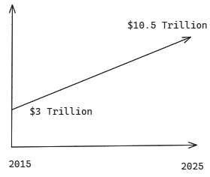

## Fig. 1: Growth of Damages Costs due to cybercrime

According to recent reports, ransomware attacks surged by over 150% globally in 2023, with damages exceeding $20 billion.[5] Moreover, APTs persistently target enterprise and governmental systems, executing syscalls to escalate privileges, steal sensitive data, and maintain long-term access. Traditional security measures often fail to detect or block these threats at the syscall level, leading to widespread system compromise. NexPro addresses these challenges by intercepting and controlling syscalls with fine-grained policies, behavioral learning, and cryptographic verification, effectively preventing unauthorized system access and mitigating ransomware and APT attacks before they cause damage. By implementing advanced syscall interception, NexPro serves as a crucial defense against modern cyber threats, providing real-time protection and reducing the success rate of malicious activities.

***2.* Background**:

System call interception frameworks have evolved significantly in response to growing security challenges and the need for fine-grained control over processes.

User

Kernel

app

mon

app

mon

BPF

app

SUD

mon

syscall ptrace seccomp-bpf nexpoline

Fig. 1: Secure Syscall Interception Mechanism[4]

Early frameworks primarily focused on monitoring system calls to detect unauthorized access or malware activity, using static rule-based approaches to allow or block specific system calls. However, as attacks grew more sophisticated, these frameworks struggled to adapt, leading to the development of more dynamic and context-aware solutions.

Frameworks like ptrace, seccomp, and SELinux introduced syscall interception mechanisms, adding the ability to enforce access control policies. Yet, despite their usefulness, they often lacked adaptability, especially in environments where dynamic workloads and rapidly evolving threats demand more robust solutions. Over time, the need for behavioural analysis, machine learning, and real-time anomaly detection emerged as critical factors in enhancing these frameworks' effectiveness.

**Nexpoline[4]**

Nexpoline, as a system call interception mechanism, offers a structured approach to controlling system calls, introducing elements of policy-based management to enhance system security. It was a significant step forward by focusing on the interception of system calls based on predefined policies, ensuring that unauthorized entities were blocked from making critical system calls. This approach helped reduce the attack surface by preventing malware and unauthorized applications from gaining access to privileged operations.

**Nexpoline** has several limitations:

1. Static Policy Management
2. No Behavioural Learning
3. Limited Process Verification
4. Cryptographic Weaknesses
5. Monolithic Architecture

# **NEXPRO**

# NexPro is an advanced syscall interception and monitoring framework designed to provide enhanced security by making system calls a **privilege**, not a right. Unlike traditional syscall interception mechanisms like **seccomp** or **ptrace**, which rely on static filtering or user-space debugging, NexPro introduces a **fine-grained, policy-driven** approach that enforces strict control over syscalls based on behavioral learning, process lineage, and cryptographic verification.

By using techniques like **Memory Protection Keys (MPK)** and **Supervisor User Data (SUD)**, NexPro ensures syscall validation occurs with minimal performance overhead while offering more robust protection against **unauthorized** and **anomalous** system calls. This makes it superior to existing solutions, providing both **security** and **efficiency** at a higher level than conventional syscall interception methods.

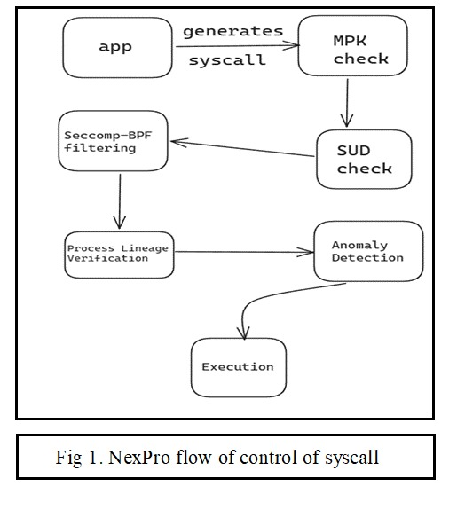

## *Flow*

**1. Application Generates a Syscall**

An application running in user space triggers a system call to access kernel services (e.g., file I/O, process creation).

**2. Memory Protection Keys (MPK) Check**

NexPro first checks the memory region from where the syscall is originating.

If the memory region is **trusted**, it has the correct **MPK**.

If the region is **untrusted**, the syscall is immediately blocked, and an alert is generated.

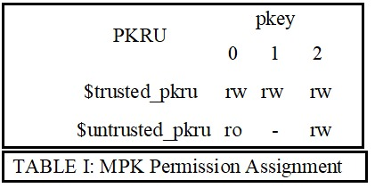

**3. Syscall User Dispatch (SUD) Check**

NexPro checks whether the syscall is being made from a valid user space that is authorized to interact with the kernel.[1]

If the syscall comes from an authorized **user space context**, proceed to the next step.

If the syscall comes from an unauthorized context, it is blocked.

**Trampoline Mechanism: Memory Permission Switch**

If the syscall passes the MPK and SUD checks but comes from an untrusted memory region, NexPro uses a **trampoline mechanism**.

**Trampoline** triggers the switching of memory permissions using the **WRPKRU instruction** to allow the syscall to originate from a trusted memory region.

If the switch is successful, proceed with the syscall.

If the switch fails, the syscall is blocked.

**5. Seccomp-BPF Filtering (Optional)**

NexPro applies **seccomp-bpf filters** to evaluate the syscall against predefined rules.[3]

If the syscall matches an allowed action based on the seccomp-bpf filters, it is allowed to proceed.

If the syscall does not match, it is blocked regardless of earlier checks.

**6. Process Lineage Verification**

NexPro checks the **process lineage** to verify that the process making the syscall has a trusted execution history.

If the process lineage matches an authorized profile, allow the syscall.

If the process lineage is suspicious or untrusted, the syscall is blocked.

**7. Behavioral Learning and Fine-Grained Policies (Future Enhancements)**

Over time, NexPro learns typical syscall patterns for trusted applications.[3]

If the syscall matches expected patterns, it is allowed.

If the syscall deviates from the learned behavior, NexPro flags it for further review or blocks it based on fine-grained policies.

**8. Syscall Execution and Response**

If the syscall successfully passes all the checks (MPK, SUD, trampoline, seccomp filters, process lineage, and behavior patterns), it is considered **legitimate**. The syscall is forwarded to the **kernel** for execution.

The kernel performs the requested operation and sends a response back to the application.

If any check fails, the syscall is **blocked**, and an appropriate response (such as an error code) is sent back to the application, informing it of the denied access.

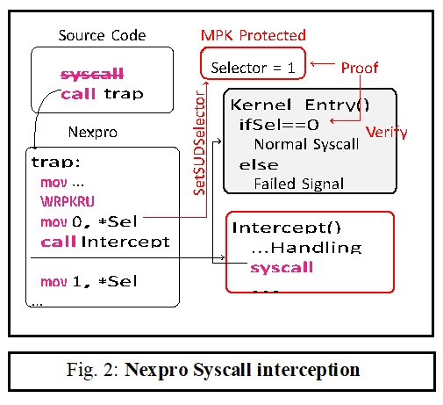

**NexPro incorporates a syscall logging mechanism designed for security auditing and policy creation. Every syscall that passes through NexPro is logged with details such as the application name, process ID, user context, syscall number, arguments, and target resources. Additionally, results from checks (MPK, SUD, Trampoline, seccomp filters) and the decision outcome—whether the syscall was allowed or blocked—are recorded. These logs are securely stored, protected by cryptographic signatures to prevent tampering, and periodically reviewed to identify any anomalies or potential security threats.**

**The logged data also supports behavioral analysis, enabling NexPro to identify legitimate syscall patterns over time. This data is leveraged for dynamic policy creation. NexPro can automatically suggest policies based on observed patterns, reducing manual administrative effort. For example, if an application consistently generates trusted syscalls, NexPro can propose adding them to an allowlist.**

**Administrators can create and modify policies manually, defining which syscalls are permitted or blocked based on criteria like user groups or execution contexts. NexPro’s policies are structured into allowlists for trusted syscalls and denylists for blocking risky or unknown syscalls, ensuring flexible and secure management of syscall behavior. This dynamic policy framework, informed by real-time logs and behavioral learning, ensures NexPro stays adaptable to evolving security needs while maintaining robust protections.**

**Policy Creation and Enforcement in NexPro**

NexPro provides a robust mechanism for managing syscall access through customizable policies tailored for each application. Applications can have their own specific syscall policies, structured into allowlists and denylists. The **allowlist** defines which syscalls are trusted and permitted based on predefined patterns, while the **denylist** blocks syscalls from applications, user contexts, or memory regions that are considered risky. NexPro’s automated policy creation is powered by its behavioral learning system, which monitors syscall logs to suggest policies. For instance, if an application consistently generates trusted syscalls, NexPro can propose an allowlist entry automatically. Alternatively, administrators can manually create or modify policies based on real-time security needs, blocking specific syscall types that are known for exploitation by malware.

When a syscall is initiated, NexPro consults its policy database to determine whether the syscall should be allowed or blocked. If a syscall matches an allowlist entry, it is immediately permitted, while any syscall on the denylist or violating specified conditions is promptly blocked. This dynamic yet controlled policy enforcement ensures that only legitimate syscalls are processed, maintaining system security without manual intervention in most cases.

**Performance and Impact of NexPro**

Despite its stringent security measures, NexPro is designed to operate without significantly affecting system performance. It uses highly optimized syscall filtering techniques, such as **Memory Protection Keys (MPK)**, **Supervisor User Data (SUD)**, and **seccomp filters**. These mechanisms function efficiently at the kernel level, reducing the need for frequent context switching and ensuring minimal latency during syscall interception and filtering. By leveraging memory protection mechanisms like MPK and SUD, NexPro minimizes the computational burden, ensuring syscalls are processed quickly without sacrificing security.

One of the key performance optimizations in NexPro is its reliance on **pre-compiled policies**, which are stored in fast-access structures like hash tables or trees. This setup allows NexPro to make decisions in real-time without requiring heavy computations. As soon as a syscall occurs, NexPro rapidly checks the pre-compiled policies to determine whether the syscall is allowed or blocked, ensuring instant access and minimal delay.

NexPro’s **behavioral learning system** operates in the background during periods of low CPU usage, processing syscall logs and suggesting policies without affecting active syscall performance. This ensures that learning-based tasks, such as pattern analysis and policy recommendations, occur without interrupting or slowing down critical system operations. Furthermore, NexPro's **modular architecture** allows for independent execution of different components, such as syscall filtering, logging, and policy enforcement, reducing the chances of performance bottlenecks. For instance, while policy enforcement occurs in real-time, it does not interfere with the syscall logging process, ensuring smooth system operations.

The use of a **trampoline mechanism** for syscall interception further enhances performance by quickly passing legitimate syscalls to the system kernel once they are verified. This low-latency approach ensures that normal operations are not hindered by NexPro's security checks. To prevent logging overhead from affecting syscall speed, NexPro employs an **asynchronous logging system**. Logs are buffered and written in batches by a separate thread, ensuring that syscall handling is not delayed by the logging process.

Overall, NexPro's performance optimizations ensure that it operates with minimal **CPU and memory overhead**. The lightweight security checks and efficient memory management keep resource utilization low, even when enforcing complex policies or logging a high volume of syscall data. NexPro’s design also allows it to scale effectively in **multi-core systems**, distributing workloads efficiently across cores and maintaining consistent performance, even under heavy syscall traffic. This scalability makes NexPro ideal for high-performance environments where both security and speed are critical.

# **IX. CONCLUSION**

This paper presents nexpro, a mechanism that utilizes MPK, Seccomp and SUD to make syscall a privilege.

It allows for exhaustive, safe, and low-overhead system call interception without requiring to modify the kernel. It can be used with other binary rewriting tools to enhance their security. Nexpro provides secure and reliable support for system call policies in tools such as sandboxes, in-process monitors, and operating system emulation.

# **REFERENCES**

1. Linux, Syscall user dispatch — the linux kernel docu mentation, https://docs.kernel.org/admin-guide/syscall user-dispatch.html, (Accessed on 12/21/2023), 2023.

[2] byValentin Rothberg, Improving linux container

security with seccomp — enable sysadmin,

https://www. redhat . com / sysadmin / container-

security- seccomp, (Accessed on 12/21/2023), 2020.

[3] W. Drewry, Dynamic seccomp policies (using bpf fil

ters) [lwn.net], https : / / lwn . net / Articles / 475019/,

(Accessed on 12/21/2023), 2012.

[4] Making 'syscall' a Privilege not a Right by Fangfei

Yang, Anjo Vahldiek-Oberwagner, Chia-Che Tsai,

Kelly Kaoudis, Nathan Dautenhahn

[2406.07429 (arxiv.org)](https://arxiv.org/pdf/2406.07429)

[5] [130 Cybersecurity Statistics: 2024 Trends and Data (terranovasecurity.com)](https://www.terranovasecurity.com/blog/cyber-security-statistics)

[6] T. Kim and N. Zeldovich, “Practical and effective sand

boxing for non-root users,” in 2013 USENIX Annual

Technical Conference (USENIX ATC 13), San Jose,

CA: USENIX Association, Jun. 2013, pp. 139–144.

[Online].Available:https://www.usenix.org/conference/

atc13/technical-sessions/presentation/kim.

[7] B. Brimhall, J. Garrard, C. De La Garza, and J.

Coffman, “A comparative analysis of linux mandatory

access control policy enforcement mechanisms,” in

Proceedings of the 16th European Workshop on System

Security, ser. EUROSEC ’23, Rome, Italy: Association

for Computing Machinery, 2023, pp. 1–7. [Online].

Available: <https://doi.org/10.1145/3578357.3589454>.

[8] B. McCarty, SELinux: NSA’s Open Source Security

Enhanced Linux. O’Reilly Media, Inc., 2004.

[9] Firejail, Firejail — security sandbox, https://firejail.

wordpress.com/, (Accessed on 01/10/2024), Oct. 2023.

[10] A. Vahldiek-Oberwagner, E. Elnikety, N. O. Duarte, M.

Sammler, P. Druschel, and D. Garg, “ERIM: Secure,

efficient in-process isolation with protection keys

(MPK),” in 28th USENIX Security Symposium (USENIX Security 19), Santa Clara, CA: USENIX Association, Aug. 2019, pp. 1221–1238. [Online]. Available: https : / / www. usenix.org/conference/usenixsecurity19/presentation/ vahldiek-oberwagner.

[11] K. Cook, Pku usage improvements for threads- kees cook, https : / / lore . kernel . org / lkml / 202208221331 . 71C50A6F @ keescook/, (Accessed on 12/30/2023), Aug. 2022.