* Docker wordpress container can be fetched from the following link, which contains apache and php.

<https://hub.docker.com/_/wordpress>

* All we need are MySQL (as database) and phpMyAdmin containers which can be fetched from the following links:

<https://hub.docker.com/_/mysql>

<https://hub.docker.com/r/phpmyadmin/phpmyadmin>

|  |
| --- |
| Copy the images 'mysql5.7_image.tar' and phpmyadmin_image.tar from GIT repo and embed it in Docker registry using the following command: |
| docker load --input mysql5.7_image.tar  docker load –input phpmyadmin_image.tar |

Upon executing the following command, three services will be created as described in the

docker-compose yml file for WordPress

docker-compose -f Wordpress.yml up -d

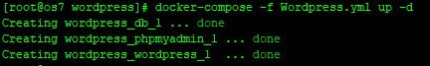

Hit the following link to access Wordpress and following on-screen instructions:

http://<Server-IP>:8005/

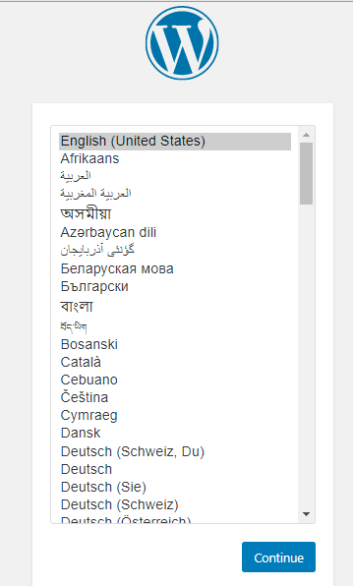

Refer link for accessing phpmyadmin:

http://<Server-IP>:8085/

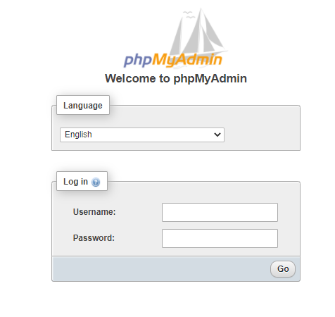

NOTE: Refer attached video for details.