**What is Cloud Computing?**

Cloud Computing often referred to as “the cloud”, in simple terms means storing or accessing your data and programs over the internet rather than your own hard drive.

Everything nowadays is moved to the cloud, running in the cloud, accessed from the cloud or may be stored in the cloud. Hence, the demand for ***Certified Cloud Architects*** is increasing across all sectors of the economy.

*Where exactly is this cloud?*

So to answer this question in this what is cloud computing blog, it is somewhere at the other end of your internet connection where you store your files and can be accessed from anywhere in the world. This could be a big deal for you, primarily because of three reasons:

* You do not have to maintain or administer any infrastructure for the same.
* It will never run out of capacity, since it is virtually infinite.
* You can access your cloud based applications from anywhere, you just need a device which can connect to the internet.

**AWS Architect Certificatio**

**How it all began?**

Though internet was born in 1960s, it was only in 1990s when the potential of internet to serve business was discovered, which then led to more innovation in this field. As the transfer speeds of the internet and connectivity got better it gave way to new type of companies called Application Service Providers (ASPs).

ASPs took the existing business applications and ran them for the business using their own machines. The customers would pay a monthly fee to run their business over the internet from ASP’s systems.

But it was only in the late 1990s that the cloud computing as we know it today emerged and led to this blog on what is cloud computing.

And since it has only grown, recently *businessinsider* reported,

*The cloud computing service has grown nearly 80% year-over-year in the last two quarters, and is on pace to hit $7.8 billion in revenue in 2015, four times the 2012 sales of $1.8 billion.*

Intriguing ain’t it?

Now that you have a fair idea, what cloud is, just think about all your daily activities online, and you will realize that a lot of your work that you do online is based on cloud. Like your social media interactions are all on the cloud, anything that you store online, is again cloud, you paying your electricity bills online, online shopping, everything!

Now **how does it all work,**let’s understand it through *an example*:

So, there is this application called the Customer Relation Manager (CRM) which is based on the cloud. This software is highly used in all the Sales organisations for better agility, enhanced productivity and low costs.

The way it is used is like this; a field sales representative would need an access to a mobile device which is connected to the internet and then he can retrieve the customer information irrespective of his location. Also, he can update the information on the go therefore no need of going back to the office to update the deal information.

The sales managers can also monitor everything on their internet enabled devices, and will know which deals to close or not. It all happens on the go!

The best part? You don’t have to buy any machines or administer any kind of software, it all will be handled by the cloud company which is running this application. Cool right?

**What is Cloud Computing? | AWS Training**

Let’s go ahead and take a deep dive into “*what is cloud computing*” and understand its architecture:

Now when you ask what is Cloud Computing the answer would be in a very broad sense therefore, the services it offers has been divided into three different models, let’s discuss each one of them:

* SaaS
* PaaS
* IaaS

1. **SaaS(Software As a Service)**

In this service the Cloud Provider leases applications or softwares which are owned by them to its client. The client can access these softwares on any device which is connected to the Internet using tools such as a web browser, an app etc.

**For Example:** salesforce.com provides the CRM(Customer Relation Manager) on a cloud infrastructure to its client and charges them for it, but the software is owned by the salesforce company only.

1. **PaaS(Platform as a Service)**

In this service the Cloud Provider gives the ability to the customer to deploy customer created application using programming languages, tools etc that are provided by the Cloud Provider. The customer cannot control the underlying architecture including operating  systems, storage, servers etc.

**For Example:**This service would make sense to you only if you are a developer, since this service provides you a platform for developing applications, like Google App Engine.

1. **IaaS(Infrastructure as a Service)**

In this service the Cloud Provider provides the customer with virtual machines and other resources as a service, they abstract the user from the physical machine, location, data partitioning etc. If the user wants a Linux machine, he gets a linux machine, he will not worry about the physical machine or the networking of the system on which the OS is installed, simple.

**For Example**AWS(Amazon Web Services) is IaaS, like ***AWS EC2***.

The diagram below, summarizes the differences b/w IaaS, PaaS and SaaS

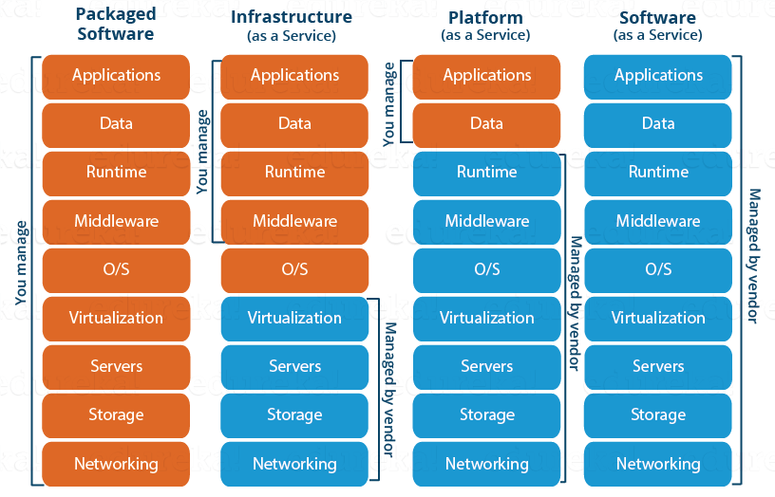

We now know about the service models, once you offer a service next comes deployment, let us now discuss the deployment models:

* Public Cloud
* Private Cloud
* Hybrid Cloud

1. **Public Cloud**

In a public cloud deployment mode, the services which are deployed are open for public use and generally public cloud services are free. Technically there may be no difference between a public cloud and a private cloud, but the security parameters are very different, since the public cloud is accessible by anyone there is a more risk factor involved with the same.

1. **Private Cloud**

A private cloud is operated solely for a single organization, it can be done by the same organization or a third-party organization. But usually the costs are high when you are using your own cloud since the hardware would be updated periodically, security also has to be kept in check since new threats come up every day.

1. **Hybrid Cloud**

A hybrid cloud consists the functionalities of both private and public cloud. How?

**Let’s understand it through an example:** Suppose there is a research company, so they would have some published data and also, data which would still be in research phase. Now anything which is still in research should be kept confidential right? Though your cloud provider may have state of the art security features but then it is still open to public, therefore prone to cyber-attacks.

So to address this risk, you can keep the data still being worked on, in your company’s servers whose access is controlled by the company, and your published data on the public platform, this type of arrangement would be a hybrid cloud.

I think by now you must have a fair idea about what is cloud computing. Let’s go ahead and know the target audience of the cloud, that is YOU, now you can either be looking at the cloud as an individual or a business, let’s take an insight into both the perspectives.

**Consumers v/s Business**

Let’s talk about consumers here, those of us who work in small to medium offices, use internet on a regular basis, for us cloud would be say Google Drive or maybe DropBox.

But, for organisations and businesses, it is an entirely different scene, for them cloud is SaaS where they might want to use a software on the cloud, or maybe PaaS where they might want to build an app on an environment which is provided by the cloud environment or maybe they want to avail the cloud service as an Infrastructure where in they will rent out entire VMs and configure it their own way, which will be IaaS.

Now you maybe wondering, do companies really use Cloud Computing? Of Course they do, according to a popular blogging site PCMag cloud computing generated 127 billion dollars in 2016, and by 2020 it could be 500 billion dollars.

Pretty impressive ain’t it? Now why are people or businesses moving to cloud? There should be some advantages right?

Let’s go ahead and see what advantages does Cloud Computing serve:

* **Fast Implementation**  
  If you’ve been there for a development or implementation of an application, it takes sometimes months or even years to make the application up and running, with cloud you can cut through the time and make things faster.
* **Instant Scalability**  
  With cloud resources you can always scale up or scale down the no. of resources and users according to your need, the cloud capacity never runs out!
* **Access Anywhere**  
  Applications built on cloud are designed to be accessed from anywhere, you just need an internet connection on a mobile device.
* **No Upfront Costs**Earlier to deploy an application you had to purchase the necessary hardware, build the architecture, purchase software licenses etc, but with cloud all those costs are dramatically reduced and in some cases eliminated.
* **Maintenance Free**  
  Traditionally you would have to patch your software with the latest releases, upgrade your hardware and also troubleshoot faults in your system at the hardware level, but with cloud you don’t have to worry about the maintenance of your hardware, it will all be managed by your cloud provider.
* **Better Security**An Independent study found that yearly a medium scale company loses around 260 laptops, this is a loss to the company not in monetary terms, but the data that was there on the laptop is valuable, with Cloud you don’t have to worry about that, all your data is stored in a centralized secure location.

**Now, how do you get started?**

There are tons of cloud providers out there to choose from. Let us take the most prominent ones.  

* **Azure:** It’s a cloud computing platform by Microsoft founded in 2010.
* **AWS:** Amazon Web Services is a cloud computing platform by Amazon in 2006.

**Which one will you choose?**

A question which would have crossed your mind, the moment you saw the two names.

Well let’s try to address this question for you.

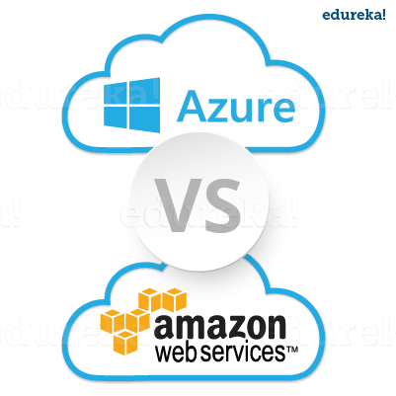

AWS and Microsoft Azure are two major players in the cloud computing industry, but still AWS is bigger than Azure. How much bigger?

Well, the server capacity of AWS is 6 times the size than all of its competitors server size combined.

Also AWS started its cloud journey way back in 2006 compared to Microsoft Azure which was launched in 2010, thus in terms of service, AWS’s service model is more mature. Amazon owns the largest data centers in the world, which are strategically placed all around the globe.

When we see Azure, it is nowhere near the capacity that Amazon has, but then Microsoft has been working hard to achieve the kind of services and flexibility that Amazon offers. For example in 2014, Microsoft launched redundant storage option called *Zone Redundant Storage* which is at par with the services that Amazon offers.

Let’s talk about a more important parameter like **Pricing**.

Amazon bills you for the hour, meaning the no. of hours you will be using your instances, the downside of this can be that if you stop your instance say after 2.5 hours, you will be billed for the whole 3 hours.

For this, Azure has a different scheme which may appeal customers, they bill you on minutes, that is the number of minutes you use your instance, but when you compare AWS and Azure prices in hours AWS is cheaper.

*For example:* an AWS m3.large instance is 0.133$ for an hour, and the equivalent instance in Azure (a Medium VM) costs 0.45$ for an hour.

Concluding here, Amazon emerges as a winner!

So now look at it this way, if you want to make a *career shift* in the cloud computing industry, which service is more likely to be in demand, AWS right?

Let’s see what Analytics has to say,

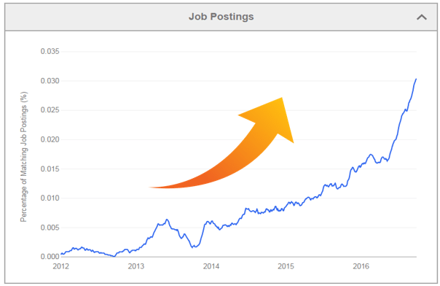

Fig. This graph shows job postings for a AWS Solution Architect from Indeed.com

**Want to be an AWS Solution Architect?**

To become a Solution Architect you will need extensive knowledge and hands-on exposure with AWS services. You can read about the AWS Services from this ***Amazon AWS Tutorial***.

What next, after you know all of these services and of-course what is cloud computing?

You get yourself certified! Here is a ***detailed guide*** on various certifications that you can do in AWS.

Don’t worry ***edureka!*** is here to help you with every step on your journey, for becoming a AWS Solution Architect you have to clear an exam, therefore besides this blog on what is cloud computing, we have come up with a curriculum which covers exactly what you would need to crack it! You can have a look here at the course details for ***AWS training***.

So this was about your career, now let’s come back to what is Cloud Computing, we discussed almost everything about Cloud Computing, but then let’s be honest, and understand that nothing in this world is all good. A lot has been said about Cloud Computing, good and bad. We covered almost all the good parts.

Let’s hear some **interesting arguments** about Cloud Computing.

Some people say moving your business completely to cloud may not be a good idea. Well, it kind of makes sense, because what if your Cloud Provider experiences a downtime, in that case your business will also suffer a loss.

This actually happened with our very own AWS in 2012 when there was a power outage due to an electrical storm in Northern Virginia due to which Amazon servers experienced a downtime, because of that big companies like Instagram, Pinterest and Instagram also experienced a downtime because they host their services on AWS.

# Cloud Computing Services: A Deeper Dive Into Cloud Computing

**“Cloud Computing is not only the future of computing but the present and the entire past of computing.** “says **Ellison,Co-founder and former CEO of Oracle**. ‘Cloud Computing’ has become quite a buzzword these days. It has evolved from personal cloud storage to organizations moving their entire data to the cloud. We can see acceleration in adoption of Cloud Computing Services every year, a trend that wont cease anytime soon.  

Through this blog, I will help you understand what **Cloud Computing** is and different types of Cloud Computing Services available to us.

Before that, let me give you quick insight as to what you will be learning in this blog. I will be covering the below mentioned topics in detail.

* What Is Cloud Computing?
* Cloud Computing Service Models
* Features Of Cloud Computing Services
* Deployment Models

Let’s get started!

## What Is Cloud Computing?

Cloud Computing in layman terms refers to computing over internet. In other words, it provides a means for you to store/access your data and applications over internet.

Cloud Computing can be defined as a model that delivers on-demand, self-sufficient Cloud Computing Services like:

* Virtualization
* Storage
* Network
* Operating System
* Middleware
* Databases
* Security
* Applications

through Wide Area Network(WAN) or dedicated network. Users can utilize these services with a little or no interaction with service providers.

We have some major companies delivering the Cloud Computing Services. Some notable examples include the following:

1. Amazon: Amazon Web Service(AWS) is one of the best Cloud Computing Service provider which offers a wide set of infrastructure services like database storage, computing power, networking etc.
2. Google: Google Cloud Platform allows clients to build, test, and deploy applications on Google’s highly-scalable and reliable infrastructure.
3. Microsoft: Microsoft Azure is used for deploying, designing and managing the applications through a worldwide network.

Want To Be A Certified AWS Architect?

Now the way these different Cloud Computing Services are delivered to users differ based on user’s requirements. Cloud Computing provides users with three distinctive types of Cloud Computing Services via the internet.

## Types Of Cloud Computing Services

First let us go through the definition of each Cloud Computing Service type:

### **SaaS(Software-as-a-Service):**

Saas provides clients with ability to use software applications over the internet via subscription basis. Clients can access applications from anywhere via web.

**Examples:** Google Applications and Salesforce.

### **PaaS(Platform-as-a-Service):**

PaaS provides a platform where the clients can deploy their own applications and host them. The client is free from hassles of setting up infrastructure, managing storage, servers, network etc.

**Examples:** Amazon Web Services and Rackspace.

### **IaaS(Infrastructure-as-a-Service):**

The IaaS provides just the hardware and network, the clients should install and develop software and applications.

**Examples:** IBM, Google and Amazon Web Services.

Now that we have gone through the definition, let us go ahead and understand each of these Cloud Computing Services in detail with the help of a **use case**. Consider a scenario where you have made travel plans. And you have decided **car as your mode of transport**. Now based on your requirements you have 4 options to choose from. Those are:

1. Take a taxi (SaaS)
2. Hire a car (PaaS)
3. Lease a car (IaaS)

### **SaaS(Software-as-a-Service)**

**Use case**: Suppose you choose to **take a taxi**, the car agency is responsible for car finance, servicing of the car. Besides that they take care of insurance and road tax. The driver, fuel requirements is taken care as well. You just need to pay for your ride.

Similarly Software-as-a-Service provider delivers software applications over the Internet, on demand and basically on a subscription basis. You just need to pay for the service you are utilizing. Entire software and hardware stack is hosted by the provider and made available to users over the Wide Area Network(WAN) like Internet or other dedicated networks.

SaaS eliminates the need for hardware acquisition, provisioning and maintenance, as well as software licensing,  installation and support. Provides scalability, flexible payments and auto updates.

### **Examples: Google Applications like Gmail, Google Docs.**

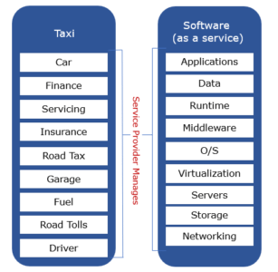

### **PaaS(Platform-as-a-Service)**

**Use case**: You plan to travel to a nearby place so decided to **rent a car**, then you might have to take care of fuel needs, road tolls and hire a driver as well. Rest of the work like finance of the car, car service, insurance, road tax, garage etc is responsibility of the car renting agency.

Likewise Platform-as-a-Service provider offers core computing services like storage, virtualization and network. In addition, hosts OS, middleware frameworks or other development services such as web services, database management system and SD’kits compatible with various programming languages. The service provider builds and renders a secure and optimized environment on which users can install applications and data sets.

The prime benefits of this type of service include its simplicity and convenience for users–the Platform-as-a-Service users can focus on creating and running applications rather than constructing and maintaining underlying infrastructural stack and services.

### **Examples: Google app Engine, Microsoft Azure, Salesforce.**

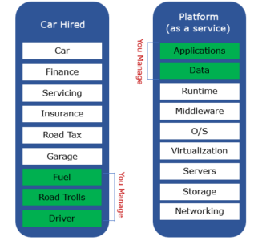

### **IaaS(Infrastructure-as-a-Service)**

**Use case:** You made long travel plans to a far away place so chose to **lease a car.**Here you have to worry about servicing a car, road tax, insurance and garage requirements, pay for the fuel, road tolls and hire a driver. Most of the work is done by you. The car agency takes care of just the finance related to leasing a car.

Similarly Infrastructure-as-a-Service provider offers end users with bare computing resources like storage capacity, virtualization, networking, security and maintenance on a pay-as-you-use basis. The users are no longer concerned with location and purchase costs. Furthermore IaaS provider supplies additional services that complement the above features like load balancing, billing details, data backup, recovery and storage.

IaaS model users handle most of the workload like installing, maintaining and managing software layers.

**Example:** Amazon AWS, Rackspace, Flexiscale and Google Cloud Platform are some well known IaaS providers.

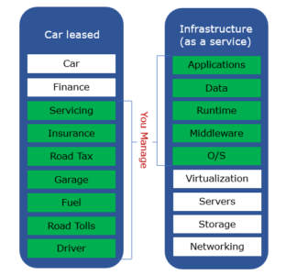

The below picture summarises what we have learnt about cloud computing services.

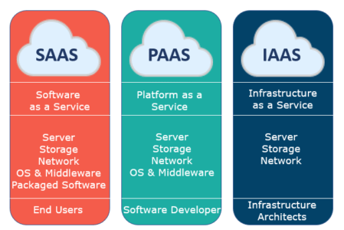

There are certain features that all these three Cloud Computing Service models have in common. Some of them are listed below.

## Cloud Computing Service Features And Benefits

### **Provider’s Responsibility**

The cloud service provider purchases, hosts and maintains either a part or complete infrastructure stack, necessary software and hardware in their own facility. As a result service users are spared from the complexity of dealing with the hardware and software on-premise.

### **Pay-for-Use**

Service users can just pay for the resources and services they use. By doing so they can maximise the cost savings unlike in traditional approach where the user has to pay complete cost irrespective of usage.

### **Limitless Scalability**

Cloud computing service providers usually provide the infrastructure in such a way so as to meet the increasing demands. The resources can be scaled up and scaled down according to enterprise requirements.

### **Migration Facility and Workload Resilience**

Cloud computing makes it possible to move data easily. Even more, the cloud computing service users need not worry about losing the data since cloud provides with multiple data backups.

### **Self Service Provisioning**

The end users can scale up and scale down resources depending on their business needs, update the services they are currently using, manage the billing details etc with little or no interaction with the cloud provider.

Want To Take Your 'Cloud' Knowledge To Next Level?

We have learnt about different Cloud Computing Services and their features. Usually these Cloud Computing Services are made available to users via various deployment models. Each deployment model is identified with specific features that support the user’s requirement of services. Let us learn about types of Cloud Deployment Models in detail.

## ****Cloud Deployment Models****

There are 3 fundamental Deployment Models of cloud computing: Public Cloud, Private Cloud and Hybrid Cloud.

### **Public cloud**

In **Public Cloud model**, services and infrastructure are hosted on premise of cloud provider and are provisioned for open use by general public. The end users can access the services via public network like internet. Public Cloud services are delivered mostly on demand. Popular for hosting everyday apps like email, CRM and other business support apps.

**Public Cloud model** offers high scalability, automated maintenance but more vulnerable to attacks due to high levels of accessibility.

Common Public Cloud providers include Amazon Web Services and Microsoft Azure.

### **Private Cloud**

**Private Cloud model** provides cloud services and infrastructure exclusively to a single tenant. The tenant can control and customize it to his need. The cloud infrastructure can be monitored either by cloud provider or the tenant. Many companies are migrating their data centers to Private Cloud to run core business fields like research, manufacturing human resource etc.

The **Private Cloud model** offers great levels of security and control, though cost benefits ought to be sacrificed to some extent.

Common Private Cloud providers include VMware and Openstack.

### **Hybrid Cloud**

As the name suggests Hybrid Cloud is composition of both Public Cloud and Private Cloud infrastructure. The company can use Private Cloud to run mission critical operations and Private Cloud to run non sensitive high demand operations.

The companies using **Hybrid Cloud model** benefit with the security and control aspect of Private Cloud and off-hand management and cost benefits of Public Cloud.

Want To Learn Azure From Industry Experts?

e And I hope you have enjoyed reading this blog. Now you know what Cloud Computing is and what are its different Services. To get in-depth knowledge on Cloud Computing and take your skills to the next level.