**Task 1:-To Explore supervised Machine learning**

**Problem Statement:-**

In this regression task we will predict the percentage of marks that a student is expected to score based upon the number of hours they studied. This is a simple linear regression task as it involves just two variables. Data can be found at <http://bit.ly/w-data>

Importing Needed package

In [127]:

**import** **matplotlib.pyplot** **as** **plt**

**import** **pandas** **as** **pd**

**import** **pylab** **as** **pl**

**import** **numpy** **as** **np**

**import** **seaborn** **as** **sns**

%matplotlib inline

**Reading the data in**

In [109]:

df = pd.read_csv("http://bit.ly/w-data")

*# take a look at the dataset*

df.head()

Out[109]:

|  | **Hours** | **Scores** |
| --- | --- | --- |
| **0** | 2.5 | 21 |
| **1** | 5.1 | 47 |
| **2** | 3.2 | 27 |
| **3** | 8.5 | 75 |
| **4** | 3.5 | 30 |

**Data Exploration**

Lets first have a descriptive exploration on our data.

In [110]:

*# summarize the data*

df.describe()

Out[110]:

|  | **Hours** | **Scores** |
| --- | --- | --- |
| **Count** | 25.000000 | 25.000000 |
| **Mean** | 5.012000 | 51.480000 |
| **Std** | 2.525094 | 25.286887 |
| **Min** | 1.100000 | 17.000000 |
| **25%** | 2.700000 | 30.000000 |
| **50%** | 4.800000 | 47.000000 |
| **75%** | 7.400000 | 75.000000 |
| **Max** | 9.200000 | 95.000000 |

In [111]:

df.isnull().any()

Out[111]:

Hours False

Scores False

dtype: bool

**Data Visualization**

In [112]:

df.plot(kind='scatter',x='Hours',y='Scores')

Out[112]:

<matplotlib.axes._subplots.AxesSubplot at 0x1f83ff6cda0>

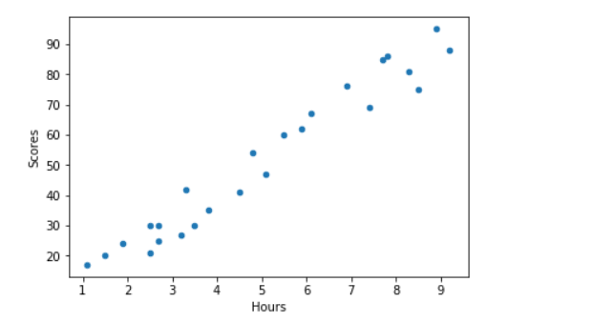

In [113]:

df.plot(kind='bar',x='Hours',y='Scores')

Out[113]:

<matplotlib.axes._subplots.AxesSubplot at 0x1f8400712e8>

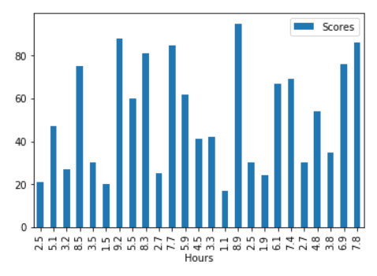

In [115]:

sns.heatmap(df.corr(),annot=**True**)

Out[115]:

<matplotlib.axes._subplots.AxesSubplot at 0x1f840136470>

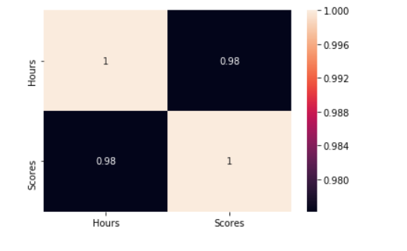

**Preparing Data**

In [114]:

*#Diving data into two variables x and y.*

x=df.iloc[:,:-1]

y=df.iloc[:,-1]

**Creating train and test dataset**

Train/Test Split involves splitting the dataset into training and testing sets respectively, which are mutually exclusive. After which, you train with the training set and test with the testing set. This will provide a more accurate evaluation on out-of-sample accuracy because the testing dataset is not part of the dataset that have been used to train the data. It is more realistic for real world problems.

This means that we know the outcome of each data point in this dataset, making it great to test with! And since this data has not been used to train the model, the model has no knowledge of the outcome of these data points. So, in essence, it is truly an out-of-sample testing.

In [117]:

**from** **sklearn.model_selection** **import** train_test_split

x_train,x_test,y_train,y_test=train_test_split(x,y,test_size=0.2,random_state=0)

print(x_train.shape)

print(x_test.shape)

print(y_train.shape)

print(y_test.shape)

(20, 1)

(5, 1)

(20,)

(5,)

**Simple Regression Model**

Linear Regression fits a linear model with coefficients  to minimize the 'residual sum of squares' between the independent x in the dataset, and the dependent y by the linear approximation.

In [131]:

**import** **time**

**from** **sklearn.linear_model** **import** LinearRegression

model=LinearRegression()

s=time.time()

model.fit(x_train,y_train)

print("Training complete")

print((time.time()-s)*1000,"ms")

Training complete

0.9968280792236328 ms

**Coefficient** and **Intercept** in the simple linear regression, are the parameters of the fit line. Given that it is a simple linear regression, with only 2 parameters, and knowing that the parameters are the intercept and slope of the line, sklearn can estimate them directly from our data. Notice that all of the data must be available to traverse and calculate the parameters.

In [132]:

print("coefficients:",model.coef_)

print("Intercept:",model.intercept_)

coefficients: [9.91065648]

Intercept: 2.018160041434683

In [133]:

plt.scatter(x,y)

plt.plot(x,model.predict(x),"-r")

plt.xlabel("No of Hours Studied")

plt.ylabel("Scores")

plt.legend()

plt.grid()

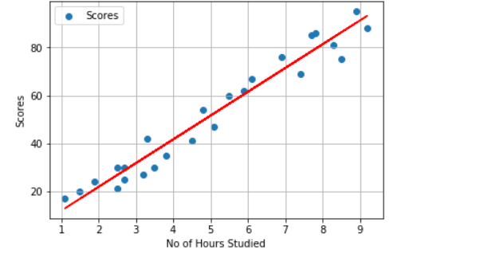

**Making Predictions**

In [134]:

y_pred=model.predict(x_test)

df = pd.DataFrame({'Actual': y_test, 'Predicted': y_pred})

print(df)

Actual Predicted

5 20 16.884145

2 27 33.732261

19 69 75.357018

16 30 26.794801

11 62 60.491033

**Query:- What will be predicted score if a student study for 9.25 hrs in a day?**

In [124]:

*# Solution*

print("No of Hours = ",9.25)

print("Predicted Score = ", model.predict([[9.25]])[0])

No of Hours = 9.25

Predicted Score = 93.69173248737538

**Evaluation**

we compare the actual values and predicted values to calculate the accuracy of a regression model. Evaluation metrics provide a key role in the development of a model, as it provides insight to areas that require improvement.

There are different model evaluation metrics, lets use MSE here to calculate the accuracy of our model based on the test set:

* Mean absolute error: It is the mean of the absolute value of the errors. This is the easiest of the metrics to understand since it’s just average error.
* Mean Squared Error (MSE): Mean Squared Error (MSE) is the mean of the squared error. It’s more popular than Mean absolute error because the focus is geared more towards large errors. This is due to the squared term exponentially increasing larger errors in comparison to smaller ones.
* Root Mean Squared Error (RMSE): This is the square root of the Mean Square Error.

In [125]:

**from** **sklearn** **import** metrics

print('Mean Absolute Error:', metrics.mean_absolute_error(y_test, y_pred))

print('Mean Squared Error:', metrics.mean_squared_error(y_test, y_pred))

print('Root Mean Squared Error:', np.sqrt(metrics.mean_squared_error(y_test, y_pred)))

Mean Absolute Error: 4.183859899002975

Mean Squared Error: 21.5987693072174

Root Mean Squared Error: 4.6474476121003665