Inventory Management System
Week 1 Task — Project Planning and Architecture Design
Prepared as a Junior Java Developer Architecture Submission
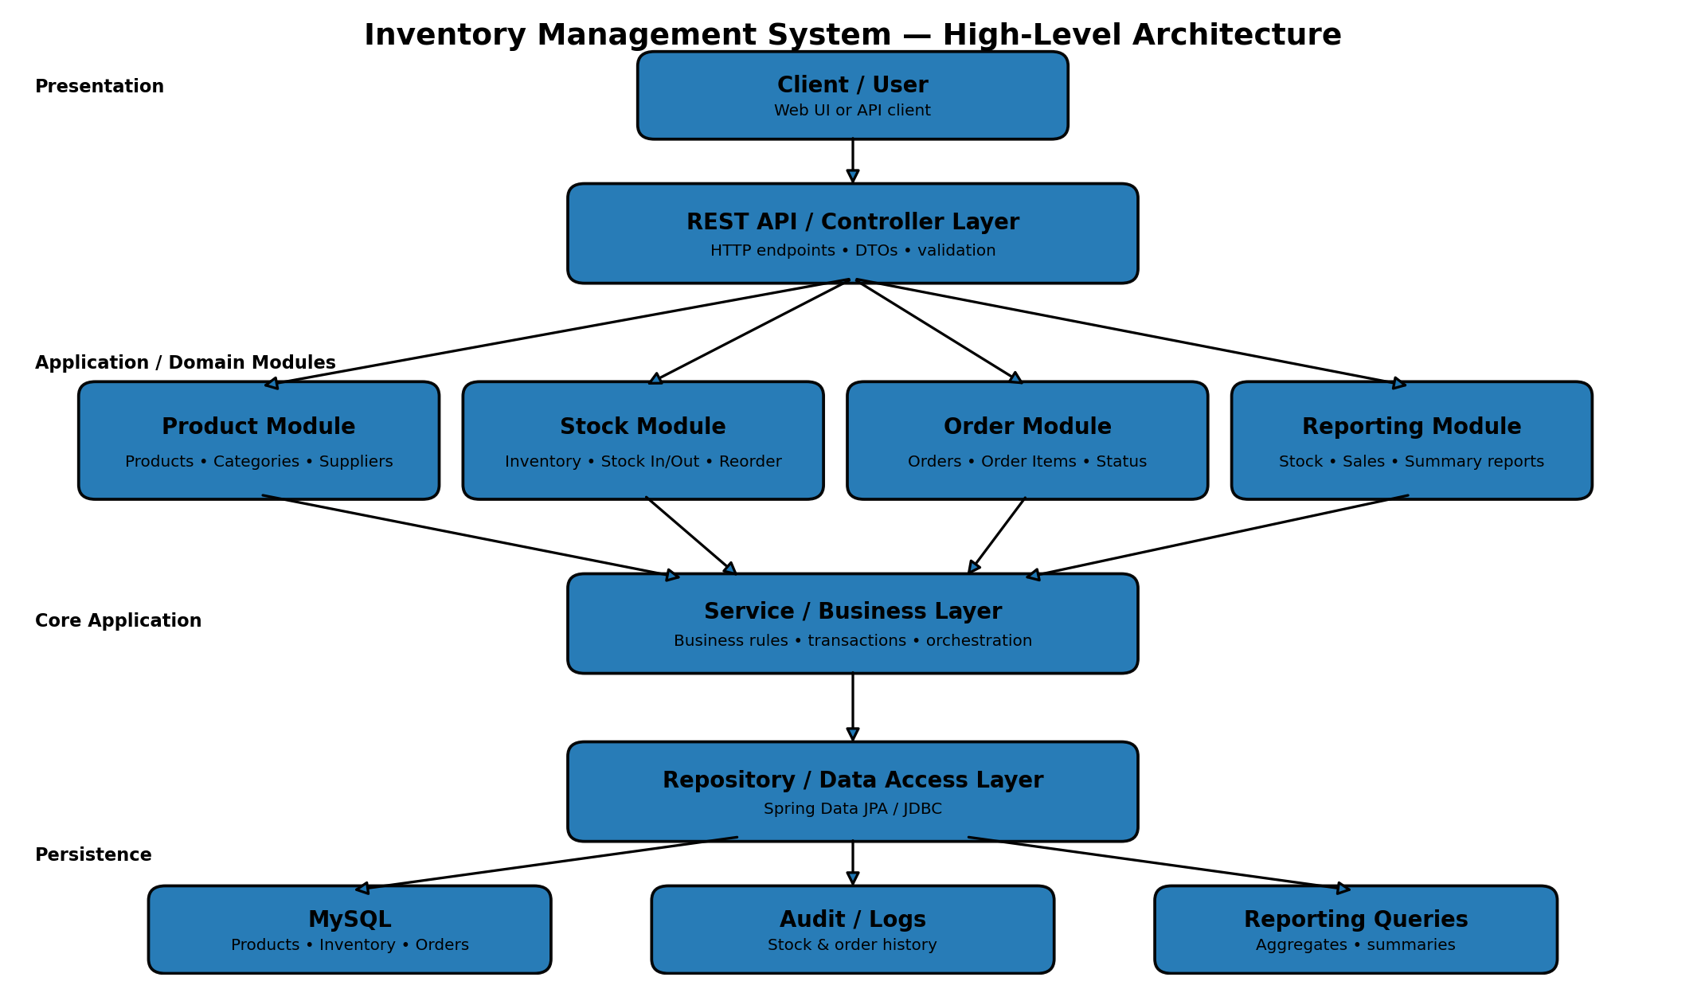
Figure 1: High-level architecture and module interaction.

Requirements at a Glance
Area | Planned Capability
Products | CRUD, SKU validation, category/supplier association
Inventory | Stock-in, stock-out, adjustment, low-stock detection, audit
Orders | Create, confirm, cancel, order totals and stock validation
Reports | Stock value, low-stock, category and order summaries
Technology | Java, Spring Boot, REST API, MySQL, JPA
Architecture | Layered modular monolith with dependency injection

1. Project Overview
The proposed Inventory Management System (IMS) is a small-business Java application intended for a retail store that needs a reliable way to manage products, stock levels, suppliers, customer orders, and operational reports. The purpose of this Week 1 design is not to implement the complete application, but to establish a practical architecture and a clear implementation plan that can be followed during development.
The system is designed around a layered architecture using Java and Spring Boot. A REST API will expose application capabilities to a web or mobile client, controller classes will handle HTTP requests, service classes will contain business rules, and repositories will manage persistence. MySQL is proposed as the relational database because inventory information is highly structured and requires consistency between products, stock transactions, and orders.
The design intentionally separates responsibilities. Product management should not directly manipulate database tables from a controller. Similarly, an order operation should not contain low-level SQL or HTTP concerns. This separation makes the application easier to test, maintain, debug, and extend.

2. Objectives
The main objectives are:
- Maintain accurate product and stock information.
Allow authorized users to create, update, view, and deactivate products.
Track stock additions, reductions, and adjustments.
Prevent an order from reducing inventory below the available quantity.
Maintain a history of important inventory transactions.
Support basic order processing and order-status tracking.
Provide useful reports such as current stock, low-stock products, stock value, and order summaries.
Provide a clean REST API that can later be consumed by a React or other frontend.
Keep the architecture modular enough to support future features such as authentication, notifications, barcode scanning, and cloud deployment.

3. Functional Requirements
3.1 Product Management
The system shall allow users to add products with fields such as product ID, name, SKU, category, supplier, selling price, cost price, and reorder level. Products can be updated and deactivated rather than physically deleted when historical records depend on them.
3.2 Category and Supplier Management
Products may belong to a category and may be associated with a supplier. The system should maintain these relationships so that users can filter products and generate supplier/category reports.
3.3 Stock Control
The system shall maintain the current quantity for every active product. Stock can increase through purchases or stock adjustments and decrease through completed orders or approved adjustments. Every change should create an inventory transaction record.
3.4 Order Processing
A user can create an order containing one or more order items. Before an order is confirmed, the system checks stock availability. On successful confirmation, the relevant quantities are reduced. Orders should have statuses such as CREATED, CONFIRMED, CANCELLED, and COMPLETED.
3.5 Reporting
The system should provide reports for current inventory, low-stock products, total inventory value, stock movement, order totals, and category-level summaries.
3.6 Validation and Error Handling
Required fields, positive quantities, valid prices, unique SKUs, and sufficient stock must be validated. The API should return meaningful HTTP status codes and structured error messages.

4. Non-Functional Requirements
The system should be maintainable, reliable, secure, testable, and reasonably scalable for a small retail business.
Maintainability: business logic must remain inside services rather than controllers or repositories.
Reliability: stock-changing operations must be transactional so that an order and its inventory updates do not leave the database in a partially updated state.
Performance: database queries should be indexed for fields such as SKU and product ID. Reporting queries should select only the required data.
Security: authentication and role-based authorization can be added as a separate security module. Passwords must never be stored in plain text.
Testability: services should depend on interfaces where appropriate, allowing unit tests to mock repositories.
Scalability: the initial system can be a modular monolith. If business growth later requires independent deployment, modules can be extracted into services with minimal changes to their internal responsibilities.

5. Proposed Architecture
The recommended architecture is a layered modular monolith.
Presentation Layer: REST controllers receive HTTP requests, validate input DTOs, call services, and return responses. Controllers should not contain business rules.
Service Layer: service classes coordinate application use cases. For example, OrderService validates an order, checks inventory, creates order records, and requests a stock reduction.
Repository Layer: repositories provide database access. Spring Data JPA can be used for normal CRUD and derived queries, while JPQL/native SQL can be used for specialized reporting.
Database Layer: MySQL stores normalized transactional data. Foreign keys maintain relationships between products, categories, suppliers, orders, order items, and inventory transactions.
The architecture is intentionally a modular monolith rather than microservices. For a small retail application, microservices would add operational complexity without providing enough immediate benefit. A well-structured monolith is easier to develop, deploy, monitor, and test while still allowing future extraction of modules.

6. Module Design
Product Module
Responsibilities include product CRUD operations, SKU validation, category association, supplier association, price validation, and product activation/deactivation.
Stock Module
Responsibilities include maintaining current quantity, processing stock-in and stock-out operations, checking reorder levels, and creating inventory transaction history. Stock modifications should occur through service methods rather than direct database updates from controllers.
Order Module
Responsibilities include creating orders, validating order items, calculating totals, checking stock, changing order status, and coordinating inventory changes. Order confirmation should be atomic.
Reporting Module
Responsibilities include read-only queries for inventory value, low-stock products, product movement, category summaries, and order summaries. Reports should not modify transactional data.
Supplier/Category Module
This module manages reusable reference data and prevents inconsistent product classifications.
Audit Module
Important operations such as stock adjustments and order status changes should be recorded with timestamp, operation type, product, quantity, and reference information. This improves traceability and debugging.

7. Proposed Database Design
The main tables are:
Product: id, sku, name, category_id, supplier_id, cost_price, selling_price, reorder_level, active, created_at.
Category: id, name, description.
Supplier: id, name, contact_name, email, phone.
Inventory: id, product_id, quantity, updated_at.
InventoryTransaction: id, product_id, transaction_type, quantity, reference_id, created_at.
CustomerOrder: id, order_number, status, total_amount, created_at.
OrderItem: id, order_id, product_id, quantity, unit_price, line_total.
Relationships are primarily one-to-many. A category can contain many products. A supplier can supply many products. An order has many order items. A product can have many inventory transactions. Inventory should have one current record per product.
The database should use primary keys, foreign keys, unique constraints on SKU and order number, and indexes on commonly searched columns. Monetary values should use DECIMAL rather than floating-point types.

8. Design Patterns and Principles
Layered Architecture Pattern
The application is divided into controller, service, and repository responsibilities. This is appropriate because each layer has a clear reason to change.
Repository Pattern
Repositories abstract persistence operations from business logic. The service layer can ask for a ProductRepository operation without knowing how the SQL is executed.
Service Layer Pattern
Business use cases are centralized in service classes. For example, confirmOrder() can coordinate validation, stock checking, order persistence, and inventory transactions.
Strategy Pattern
The system can use Strategy for report generation or stock adjustment rules. For example, different report strategies could generate low-stock, stock-value, or movement reports without placing every algorithm in one large class.
Factory Pattern
A small factory can create inventory transaction objects based on transaction type such as STOCK_IN, STOCK_OUT, RETURN, or ADJUSTMENT. This becomes useful when transaction creation rules grow.
DTO Pattern
Request and response DTOs prevent database entities from being exposed directly through the API. This also allows the API representation to evolve independently from the persistence model.
Dependency Injection
Spring's dependency injection supplies services with repository dependencies. This reduces tight coupling and makes unit testing easier.
SOLID principles will guide implementation. Single Responsibility keeps modules focused; Dependency Inversion allows services to depend on abstractions; Open/Closed supports adding new report or transaction strategies without rewriting existing logic.

9. Key Business Flows
Stock-In Flow:
1. Client sends a stock-in request.
2. StockController validates the request DTO.
3. StockService verifies the product.
4. Inventory quantity is increased.
5. InventoryTransaction records the movement.
6. The transaction commits as one database operation.
Order Confirmation Flow:
1. Client submits an order.
2. OrderService validates the order items.
3. The service checks that every requested quantity is available.
4. The order is created or updated to CONFIRMED.
5. Inventory quantities are reduced.
6. STOCK_OUT transactions are recorded.
7. The total amount is calculated.
8. The entire operation commits atomically.
If any required step fails, the transaction should roll back so that the database does not contain a confirmed order without the corresponding stock reduction.

10. REST API Plan
Representative endpoints include:
GET /api/products — list products
GET /api/products/{id} — get one product
POST /api/products — create a product
PUT /api/products/{id} — update a product
DELETE /api/products/{id} — deactivate a product
GET /api/inventory — view inventory
POST /api/inventory/stock-in — add stock
POST /api/inventory/adjust — adjust stock
GET /api/inventory/low-stock — find low-stock products
POST /api/orders — create order
GET /api/orders/{id} — get order
POST /api/orders/{id}/confirm — confirm order
POST /api/orders/{id}/cancel — cancel order
GET /api/reports/stock-value — inventory value
GET /api/reports/low-stock — low-stock report
GET /api/reports/category-summary — category summary
The API should use standard HTTP semantics. Successful creation can return 201 Created, successful retrieval 200 OK, invalid input 400 Bad Request, missing resources 404 Not Found, and conflicts such as duplicate SKU 409 Conflict.

11. Java Code Scaffolding
A possible package structure is:
com.example.inventory
├── controller
├── service
│ └── impl
├── repository
├── entity
├── dto
├── mapper
├── exception
├── strategy
└── config
Example service interaction:
public interface StockService {
InventoryResponse stockIn(Long productId, int quantity);
InventoryResponse adjust(Long productId, int quantity);
boolean hasSufficientStock(Long productId, int quantity);
}
@Service
public class StockServiceImpl implements StockService {
private final InventoryRepository inventoryRepository;
private final InventoryTransactionRepository transactionRepository;
public StockServiceImpl(
InventoryRepository inventoryRepository,
InventoryTransactionRepository transactionRepository) {
this.inventoryRepository = inventoryRepository;
this.transactionRepository = transactionRepository;
}
@Transactional
public InventoryResponse stockIn(Long productId, int quantity) {
// validate product and quantity
// increase inventory
// create STOCK_IN transaction
// return response
return null;
}
}
The order service would follow a similar structure:
@Transactional
public OrderResponse confirmOrder(Long orderId) {
// load order
// validate status
// check stock for every item
// reduce stock
// record STOCK_OUT transactions
// change order status
// return response
}
The actual implementation would replace the pseudocode with repository calls, validation, DTO mapping, and domain-specific exceptions.

12. Exception Handling and Validation
A centralized exception handler using @RestControllerAdvice is recommended. Custom exceptions such as ProductNotFoundException, InsufficientStockException, DuplicateSkuException, and InvalidOrderStateException make business failures explicit.
Validation annotations such as @NotBlank, @Positive, @PositiveOrZero, @Email, and @Size can be used on request DTOs. The API should return a consistent error structure containing timestamp, status, error code, message, and request path.
This approach prevents repetitive try/catch blocks in every controller and provides a predictable experience for frontend clients.

13. Testing Strategy
Unit tests should focus on service-level business rules. Examples include verifying that stock-in increases quantity, insufficient stock prevents order confirmation, duplicate SKUs are rejected, and cancelled orders cannot be confirmed.
Repository integration tests should verify database mappings and important queries.
Controller tests should verify HTTP status codes, validation errors, and response structures.
A complete testing plan should include normal cases, boundary values such as zero and negative quantities, missing products, duplicate SKUs, concurrent stock changes, and order cancellation scenarios.
For concurrency-sensitive inventory operations, the implementation should consider database locking or an appropriate optimistic/pessimistic concurrency strategy so that two simultaneous orders cannot incorrectly consume the same stock.

14. Security and Future Enhancements
Authentication and authorization should be introduced before production use. Roles such as ADMIN, INVENTORY_MANAGER, and SALES_USER can restrict operations. For example, only inventory managers may perform stock adjustments while sales users may create orders.
Future versions may include barcode scanning, supplier purchase orders, email alerts for low stock, dashboards, CSV/PDF reports, cloud deployment, caching, and audit dashboards.
If the business grows significantly, the reporting workload could eventually be separated from transactional operations. However, the first version should remain a modular monolith because it minimizes infrastructure complexity and is appropriate for the expected scale.

15. Architecture Decision Summary
The design chooses Java with Spring Boot, REST APIs, MySQL, and a layered modular-monolith architecture because these technologies are practical for a small retail application and align well with maintainable Java backend development.
The most important architectural decision is to keep business rules inside services and treat stock-changing operations as transactional use cases. Inventory is a consistency-sensitive part of the system: an order should never be confirmed while its stock reduction fails.
DTOs, repositories, dependency injection, centralized exception handling, and focused modules reduce coupling. Design patterns are used where they provide a real benefit rather than being added only for terminology. This makes the proposed solution feasible for a junior developer to implement while still demonstrating professional software engineering practices.

16. Conclusion
The proposed Inventory Management System provides a practical foundation for a small retail business. The architecture separates presentation, business logic, persistence, and reporting responsibilities while keeping the deployment model simple.
The design covers product management, stock control, order processing, reporting, validation, auditability, testing, and future security. The selected patterns—Layered Architecture, Repository, Service Layer, DTO, Strategy, Factory, and Dependency Injection—support maintainability and extensibility.
This Week 1 architecture can be directly converted into a Spring Boot implementation in later development phases. The next logical steps are database schema creation, Spring Boot project initialization, entity and repository implementation, service-level business rules, REST controllers, automated tests, and finally frontend integration.

Appendix A — Suggested Implementation Sequence
- 1. Initialize Spring Boot project and configure MySQL.
- 2. Create entities, relationships, constraints, and repositories.
- 3. Implement product, category, and supplier modules.
- 4. Implement inventory operations and inventory transaction history.
- 5. Implement order creation and transactional confirmation.
- 6. Add validation, custom exceptions, and global error handling.
- 7. Implement reporting queries.
- 8. Add unit, repository, and controller tests.
- 9. Add authentication and role-based authorization.
- 10. Integrate a frontend and prepare deployment.

Appendix B — Key Design Principle
The system should treat inventory quantity as business-critical state. Every operation that changes stock must be performed through a controlled service method and recorded as a transaction. This principle protects data consistency and provides an auditable history of stock movement.

