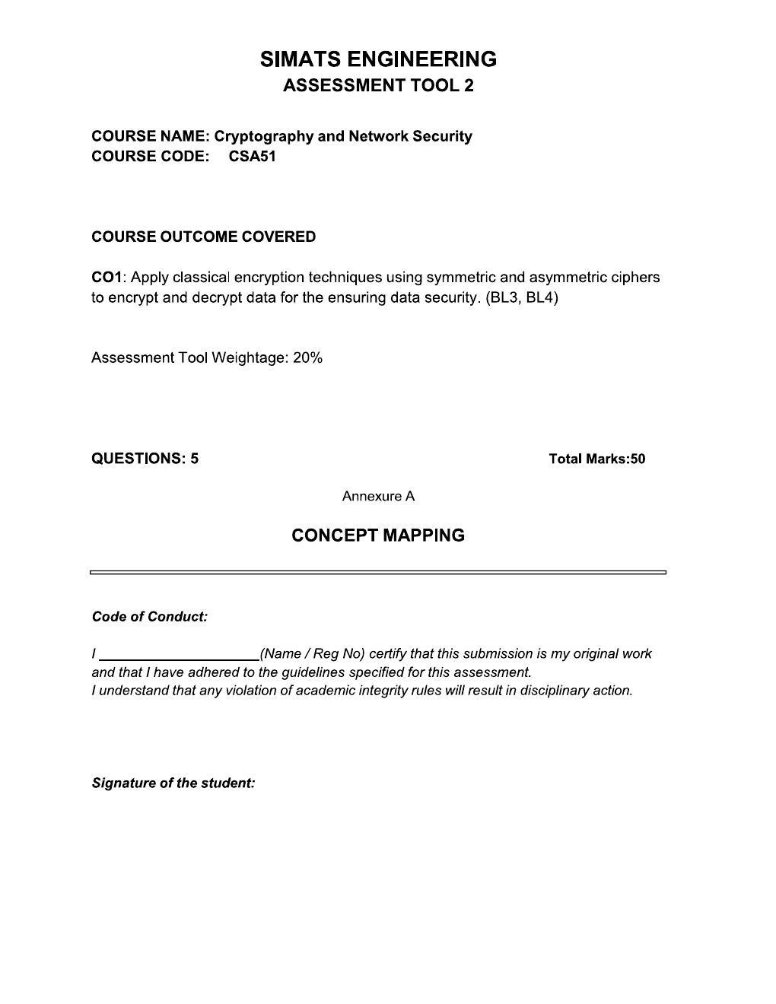

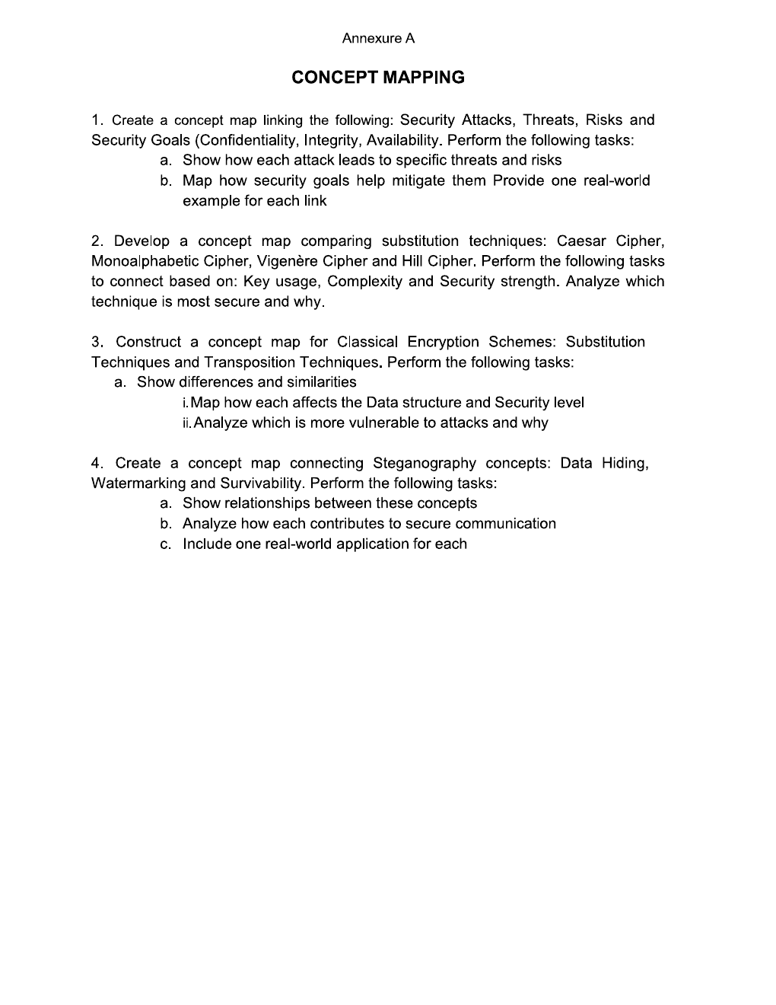

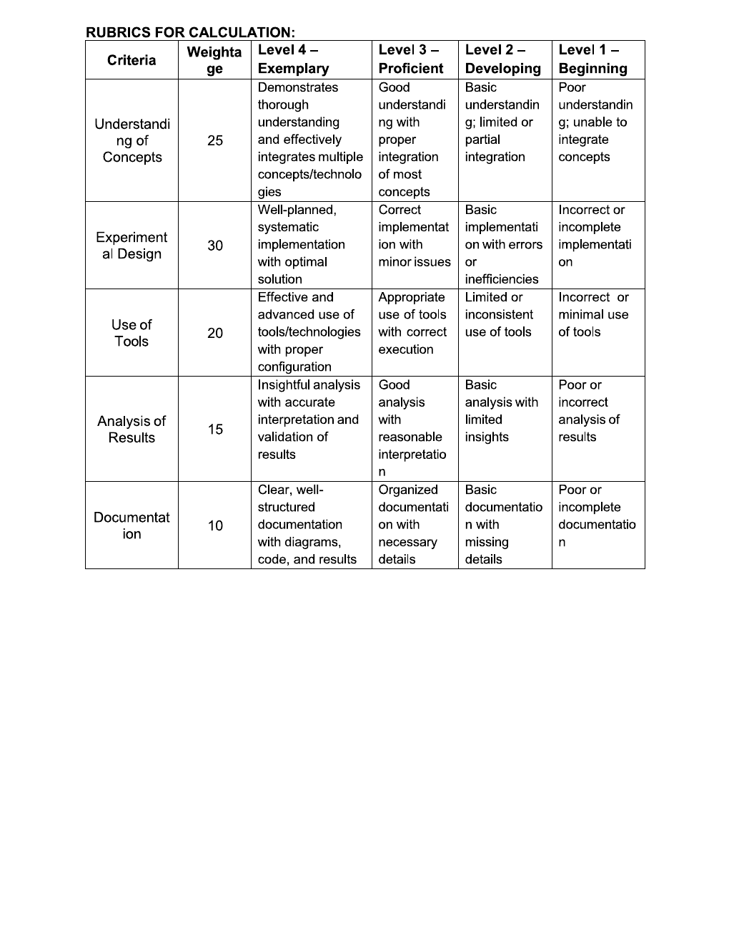

QUESTION 1: SECURITY ATTACKS, THREATS, RISKS AND SECURITY GOALS

1.1 Introduction
Information security protects information and computer systems from unauthorized access, disclosure, modification, destruction and disruption. Security attacks, threats and risks describe different aspects of possible harm, while security goals define what protection should achieve.

1.2 Key concepts
Concept | Meaning | Examples
Security attack | An action that attempts to compromise a system or information. | Eavesdropping, unauthorized modification, denial of service.
Threat | A potential cause of harm that may exploit a vulnerability. | Malware, an attacker, a malicious insider, a power failure.
Risk | The possibility and impact of loss when a threat exploits a vulnerability. | Financial loss, data exposure, service downtime.
Security goals | Properties that security controls aim to preserve. | Confidentiality, integrity and availability.

1.3 Concept map
INFORMATION SECURITY
Protect data, devices, networks and services
↓

Branch | Examples / relationships
Security attacks | Interception → information disclosure; modification → altered records; interruption → unavailable services; fabrication → false messages or transactions.
Threats | Hackers, malware, compromised credentials, malicious insiders and natural disasters.
Risks | Data theft, inaccurate information, financial loss, reputational damage and downtime.
Security goals | Confidentiality + Integrity + Availability (CIA triad).
Controls | Encryption, authentication, access control, integrity checks, backups, redundancy and monitoring.

1.4 How attacks affect security goals
Attack | Threat / weakness | Possible risk | Goal affected
Eavesdropping | Unprotected network traffic | Private data is exposed | Confidentiality
Data modification | Weak access controls or stolen credentials | Records or transactions become incorrect | Integrity
Denial of service | Flooding or exhausting system resources | Service becomes unavailable | Availability
Spoofing / fabrication | Weak identity verification | Fraud or false information | Authenticity and integrity

1.5 Security goals and mitigation
- Confidentiality: Information should be available only to authorized users. Encryption and access control help prevent disclosure. Example: HTTPS protects data sent to an online banking website.
- Integrity: Information should remain accurate and should not be changed without authorization. Hashes, message authentication codes and digital signatures can help detect unauthorized changes. Example: verifying a signed document.
- Availability: Authorized users should be able to access systems when needed. Backups, redundant servers, traffic filtering and disaster recovery reduce downtime. Example: a bank uses backup servers when a primary server fails.
Conclusion: Attacks exploit weaknesses, threats represent potential sources of harm, and risks describe possible consequences. Security controls reduce risks by protecting confidentiality, integrity and availability.

QUESTION 2: COMPARISON OF SUBSTITUTION CIPHERS

2.1 Introduction
A substitution cipher encrypts plaintext by replacing letters or groups of letters with other letters or symbols. Caesar, monoalphabetic, Vigenère and Hill ciphers use different key structures and encryption operations.

2.2 Caesar cipher
The Caesar cipher shifts every plaintext letter by a fixed number of alphabet positions. For a shift k, encryption is C = (P + k) mod 26 and decryption is P = (C − k) mod 26, with A = 0, B = 1, …, Z = 25.
CAESAR CIPHER EXAMPLE
Plaintext: HELLO
Shift each letter forward by 3
Ciphertext: KHOOR

Advantage: easy to understand and implement. Limitation: there are only 25 non-zero shifts, so a brute-force search is easy.

2.3 Monoalphabetic cipher
A monoalphabetic cipher uses a fixed substitution alphabet. Each plaintext letter maps to one ciphertext letter, and the same plaintext letter always maps to the same ciphertext letter. Although many substitution alphabets are possible, letter-frequency patterns are preserved, making the cipher vulnerable to frequency analysis.
Example mapping: Plain alphabet ABCDEFGHIJKLMNOPQRSTUVWXYZ; cipher alphabet QWERTYUIOPASDFGHJKLZXCVBNM.

2.4 Vigenère cipher
The Vigenère cipher uses a repeating keyword to choose different shifts for different positions. It is polyalphabetic because one plaintext letter can encrypt to different letters depending on the corresponding key letter.
Encryption formula: Cᵢ = (Pᵢ + Kᵢ) mod 26.
VIGENÈRE CIPHER EXAMPLE
Plaintext: ATTACKATDAWN
Key: LEMONLEMONLE
Ciphertext: LXFOPVEFRNHR

A repeating key makes it stronger than a simple Caesar shift against basic frequency analysis, but repeated patterns can reveal information about the key.

2.5 Hill cipher
The Hill cipher encrypts blocks of letters using matrix multiplication modulo 26. The key matrix must be invertible modulo 26 for decryption to work.
Formula: C = KP mod 26.
Example: K = [[3, 3], [2, 5]] and plaintext HI → P = [7, 8]ᵀ.
KP = [45, 54]ᵀ; reducing modulo 26 gives [19, 2]ᵀ, which corresponds to TC. Therefore, HI encrypts to TC. The determinant of K is 9, which is coprime to 26, so this key matrix is invertible modulo 26.

2.6 Concept map
Cipher | Key / operation | Strength and limitation
Caesar | One fixed shift | Very simple; vulnerable to brute force.
Monoalphabetic | Fixed substitution alphabet | Large theoretical key space; vulnerable to frequency analysis.
Vigenère | Repeating keyword and position-dependent shifts | Reduces simple single-letter frequency clues; repeated-key analysis is possible.
Hill | Invertible matrix operating on blocks | Obscures single-letter frequencies; vulnerable to known-plaintext attacks due to its linear structure.

2.7 Comparison and security analysis
Criterion | Caesar | Monoalphabetic | Vigenère | Hill
Key | Shift number | Substitution alphabet | Keyword | Invertible matrix
Complexity | Very low | Low | Moderate | Moderate
Typical weakness | Brute force | Frequency analysis | Repeating-key patterns | Known-plaintext / linear algebra
Relative classical security | Very weak | Weak | Often stronger than simple substitution | Hides simple letter frequencies but has structural weaknesses

Conclusion: These ciphers illustrate increasing complexity in key design and encryption. There is no universal winner without specifying the key and attack model. All four are classical techniques and should not be used to protect modern sensitive information; modern authenticated encryption is preferable.

QUESTION 3: CLASSICAL ENCRYPTION — SUBSTITUTION AND TRANSPOSITION

3.1 Introduction
Classical encryption transforms readable plaintext into ciphertext using a rule or key. Substitution changes the identity of characters, while transposition rearranges their positions.

3.2 Substitution techniques
Substitution replaces each plaintext letter or group of letters with another letter or symbol. The positions of characters are generally preserved in simple substitution, while block substitution methods such as Hill transform groups of letters.
- Examples: Caesar, monoalphabetic, Vigenère and Hill ciphers.
- A simple example is HELLO → KHOOR using a Caesar shift of 3.

3.3 Transposition techniques
Transposition rearranges the positions of plaintext characters according to a key or pattern. The characters themselves remain unchanged.
- Examples: Rail Fence cipher and columnar transposition cipher.
RAIL FENCE EXAMPLE — TWO RAILS
Plaintext: HELLOWORLD
Top rail: H L O O L
Bottom rail: E L W R D
Read top rail, then bottom rail
Ciphertext: HLOOLELWRD

3.4 Concept map
Feature | Substitution | Transposition
Main operation | Replaces characters or blocks | Rearranges character positions
Character identities | Usually changed | Preserved
Character order | Generally preserved in simple substitution | Changed
Examples | Caesar, Vigenère, Hill | Rail Fence, columnar transposition
Statistical weakness | Simple forms may preserve letter-frequency patterns | Character frequencies remain unchanged
Decryption | Reverse the substitution | Reverse the permutation

3.5 Similarities and differences
- Both convert plaintext into ciphertext using a rule or key.
- Both can be reversed by an authorized recipient with the correct key.
- Substitution changes symbols, while transposition changes their positions.
- Both classical forms can be vulnerable to cryptanalysis when used alone.
- Combining substitution and transposition can make analysis more difficult than using a simple technique alone, but it does not automatically provide modern security.

3.6 Vulnerability analysis
Neither category is universally more vulnerable; the result depends on the exact technique and key. Simple substitution ciphers can be attacked using letter-frequency analysis. Transposition ciphers preserve the original character frequencies, which also gives attackers useful statistical information.
Conclusion: Substitution and transposition are foundational classical encryption methods. Their main difference is whether they change character identities or character positions.

QUESTION 4: STEGANOGRAPHY — DATA HIDING, WATERMARKING AND SURVIVABILITY

4.1 Introduction
Steganography hides the existence of information by embedding it in an ordinary-looking cover medium such as an image, audio file, video or document. Encryption hides the meaning of a message; steganography aims to hide that a message is present.

4.2 Key concepts
Concept | Purpose and method | Example
Data hiding | Embeds secret information in a cover medium to make its presence difficult to detect. Methods include LSB image insertion and embedding data in audio or video. | A sender embeds an encrypted text message inside an image.
Digital watermarking | Embeds ownership or identifying information to help establish origin, support copyright protection or aid authentication. | A photographer embeds an invisible watermark in an image.
Survivability | The ability of embedded information to remain detectable or recoverable after expected transformations or processing. | A robust watermark remains detectable after image resizing or compression.

4.3 Concept map
Concept | Relationship | Goal
Data hiding | Steganography conceals a message in cover media. | Conceal the existence of information.
Watermarking | A specialized form of data embedding that adds identification or ownership information. | Copyright protection and origin identification.
Survivability | Robustness helps embedded data or watermarks survive expected changes. | Preserve detection or recovery after processing.

4.4 How the concepts contribute to secure communication
- Data hiding makes communication less conspicuous by concealing the presence of a message.
- Watermarking helps identify ownership or origin and can support content authentication.
- Survivability helps embedded information persist after media is transformed or processed.
- Steganography does not necessarily encrypt a message. For stronger protection, the sender can encrypt the message first and then embed the ciphertext in the cover medium.
- Not all steganographic methods are robust. Simple LSB data hidden in an image may be destroyed by lossy compression.

4.5 Real-world applications
Application | How it works | Benefit
Confidential communication | An encrypted message is embedded in an ordinary image before being sent. | Conceals the message's presence while encryption protects its contents.
Copyright protection | A photographer embeds identifying watermark data in an image. | Helps establish ownership if content is copied or redistributed.
Media processing | A robust watermark is designed to remain detectable after compression or resizing. | Supports continued identification after expected transformations.

Conclusion: Data hiding conceals information, watermarking embeds ownership or identification information, and survivability concerns the persistence of embedded information after changes. These concepts support confidential communication, copyright protection and digital content verification.

OVERALL CONCEPT MAP: ASSESSMENT SUMMARY
CRYPTOGRAPHY AND NETWORK SECURITY
Q1 — Security: Attacks → Threats → Risks → CIA security goals
↓
Q2 — Substitution ciphers: Caesar • Monoalphabetic • Vigenère • Hill
↓
Q3 — Classical schemes: Substitution (replace characters) vs Transposition (rearrange characters)
↓
Q4 — Steganography: Data hiding • Watermarking • Survivability
↓
Overall outcome: Understand security risks, compare classical ciphers, and explain methods for concealing and protecting digital information.

Final review checklist
- Fill in your name and registration number on the cover page.
- Check all four question headings and their diagrams.
- Ensure formulas and worked examples are readable.
- Review the content and rewrite any parts required by your instructor in your own words.
- Sign the academic integrity statement as required by the original assessment sheet.
Prepared as a structured draft based on the uploaded CSA51 Assessment Tool 2 instructions. Verify that the final submission follows your instructor's requirements.

