-INTRODUCTION:

Analyzing COVID-19 vaccines involves assessing various aspects related to their safety, efficacy, distribution, and impact on public health. Here's an introduction to the key areas of analysis:

1. Vaccine Development:

Types of Vaccines:Different COVID-19 vaccines use various technologies, such as mRNA, viral vector, protein subunit, or inactivated virus. Understanding the technology behind each vaccine is crucial for analysis.

Clinical Trials: Examining the results of phases I, II, and III clinical trials provides insights into the safety and efficacy of the vaccine. Key metrics include the vaccine's ability to generate an immune response, the duration of protection, and any adverse effects.

1. Efficacy and Effectiveness:

Vaccine Efficacy:This measures how well a vaccine performs under ideal conditions in a controlled clinical trial.

Real-world Effectiveness: Analyzing data from post-approval settings helps understand how the vaccine performs in diverse populations, considering factors like age, comorbidities, and different virus variants.

1. Safety Profile:

Adverse Events: Analyzing reported adverse events from clinical trials and real-world use is essential for evaluating the safety profile of a vaccine.

Long-Term Effects: Monitoring the potential for long-term effects is crucial, although it may require ongoing surveillance.

1. Distribution and Access:

Global Distribution: Assessing the equitable distribution of vaccines worldwide is essential for controlling the global pandemic.

Logistical Challenges: Examining the logistical aspects of vaccine distribution, including cold chain requirements, storage, and transportation, is crucial for successful implementation.

1. Herd Immunity and Transmission Control:
2. Population Coverage: Assessing the percentage of the population that needs to be vaccinated to achieve herd immunity is essential for controlling the spread of the virus.

Impact on Transmission: Understanding the vaccine's impact on reducing transmission is vital for evaluating its overall effectiveness in controlling the pandemic.

6. Public Perception and Vaccine Hesitancy:

Communication Strategies: Analyzing the effectiveness of communication strategies used to convey vaccine information to the public can help address vaccine hesitancy.

-Barriers to Vaccination: Identifying and addressing barriers, including misinformation, cultural factors, and accessibility issues, is crucial for successful vaccination campaigns.

7. Monitoring Variants:

Vaccine Resistance: Analyzing data on the vaccine's effectiveness against emerging variants helps determine if booster shots or updated vaccines are necessary.

8. Policy Implications:

Vaccination Policies: Evaluating the impact of government policies, including vaccine mandates, on vaccination rates and public health outcomes.

9. Long-Term Monitoring:

Surveillance Systems: Establishing and maintaining surveillance systems for monitoring vaccine effectiveness, safety, and any emerging issues over the long term.

Effective analysis of COVID-19 vaccines involves a multidisciplinary approach, incorporating data from clinical trials, real-world studies, public health initiatives, and ongoing research into the virus and its variants.

OUTLINE OF THE PROBLEM STATEMENT:

The problem statement for COVID-19 vaccine analysis encompasses several critical aspects that researchers and public health officials aim to address. Below is an outline highlighting key elements of the problem statement:

I. Introduction:

- Background:

- Brief overview of the COVID-19 pandemic and its global impact.

- Introduction to the urgent need for effective vaccines to mitigate the spread of the virus and reduce the severity of illness.

II. Vaccine Development and Approval

- Diverse Vaccine Technologies:

- Recognition of various COVID-19 vaccines developed using different technologies (mRNA, viral vector, protein subunit, inactivated virus).

- Accelerated Development:

- Acknowledgment of the unprecedented speed of vaccine development and the challenges associated with maintaining rigorous safety and efficacy standards.

III. Clinical Trials and Efficacy:

- Phases of Clinical Trials:

- Overview of the phases of vaccine clinical trials, emphasizing the importance of comprehensive data collection.

- Efficacy Measures:

- Discussion on the metrics used to evaluate vaccine efficacy under controlled conditions.

IV. Safety Concerns:

- Adverse Events:

- Recognition of reported adverse events associated with COVID-19 vaccines.

- Emphasis on the need for continuous monitoring and assessment of long-term safety.

V. Distribution Challenges:

- Global Disparities:

- Highlighting the challenges in ensuring equitable distribution of vaccines globally.

- Logistical Issues:

- Addressing logistical challenges related to transportation, storage, and supply chain management.

VI. Variants and Vaccine Effectiveness:

- Emerging Variants:

- Acknowledgment of the evolution of the virus and the potential impact of new variants on vaccine effectiveness.

- Booster Shots:

- Discussion on the need for booster shots to enhance and prolong immunity.

VII. Public Perception and Hesitancy:

- Communication Gaps:

- Identification of communication gaps that contribute to vaccine hesitancy.

- Barriers to Access:

- Exploration of factors hindering widespread vaccine uptake, including misinformation, cultural factors, and accessibility issues.

VIII. Policy Implications:

-Government Policies:

- Examination of the effectiveness and implications of government policies, including mandates and incentives.

- Evaluation of the role of public health strategies in promoting vaccine acceptance.

IX. Long-Term Monitoring and Surveillance:

Continuous Monitoring:

- Emphasis on the need for robust surveillance systems for ongoing monitoring of vaccine effectiveness and safety.

- Consideration of long-term implications and planning for sustained vaccination efforts.

X. Research Gaps and Future Directions:

-Unanswered Questions:

- Identification of gaps in current knowledge and areas where further research is needed.

- Suggested directions for future research to enhance our understanding of COVID-19 vaccines.

By addressing these elements in the problem statement, researchers and stakeholders can better focus their efforts on comprehensive COVID-19 vaccine analysis and contribute to the ongoing global response to the pandemic.

DESIGN THINKING PROCESS:

Design thinking is a problem-solving approach that emphasizes empathy, creativity, and iterative prototyping. Applying design thinking to COVID-19 vaccine analysis involves understanding the needs and challenges of various stakeholders in the vaccination process. Here's a simplified design thinking process for COVID-19 vaccine analysis:

1. Empathize:

- Understand Stakeholders:

- Identify and empathize with key stakeholders, including researchers, healthcare workers, policymakers, and the general public.

- User Journey Mapping:

- Map out the experiences and challenges faced by each stakeholder group in the vaccine analysis and distribution process.

- Collect User Feedback:

- Gather feedback through surveys, interviews, or focus groups to understand concerns, perceptions, and experiences related to COVID-19 vaccines.

2. Define:

- Problem Statement Refinement:

- Refine the problem statement based on insights gained during the empathize phase.

- Clearly articulate the specific challenges and opportunities in COVID-19 vaccine analysis.

3. Ideate:

- Brainstorming Sessions:

- Facilitate brainstorming sessions with multidisciplinary teams to generate creative ideas for addressing the identified challenges.

- Encourage a diverse range of perspectives to foster innovation.

- Prototyping Concepts:

- Develop rough prototypes or concepts for potential solutions to key problems in vaccine analysis.

- Explore both technological and non-technological solutions.

4. Prototype:

- Develop Prototypes:

- Create tangible prototypes of the most promising concepts, considering both analytical tools and communication strategies.

- Prototypes could include data visualization dashboards, communication materials, or software tools.

5. Test:

- User Testing:

- Collect feedback on prototypes through user testing with representatives from stakeholder groups.

- Iterate on the prototypes based on real-world feedback.

- Pilot Programs:

- Implement small-scale pilot programs to test the feasibility and effectiveness of proposed solutions.

- Gather data on the impact of the prototypes in real-world scenarios.

6. Implement:

- Scale-Up Strategies:

- Develop strategies for scaling up successful prototypes to larger populations or broader contexts.

- Consider the integration of solutions into existing healthcare systems and public health frameworks.

7. Iterate:

- Continuous Improvement:

- Establish feedback loops to continuously monitor and improve implemented solutions.

- Iterate on the design based on ongoing data and user feedback.

8. Communicate:

- Transparent Communication:

- Develop communication strategies to convey vaccine analysis findings and updates to the public, healthcare professionals, and policymakers.

- Use clear, accessible language to foster understanding and trust.

9. Collaborate:

- Multidisciplinary Collaboration:

- Foster collaboration between researchers, healthcare professionals, policymakers, and technology experts.

- Encourage open communication and knowledge-sharing to address challenges collectively.

10. Learn and Adapt:

- Reflect and Adapt:

- Reflect on the entire design thinking process to identify lessons learned.

- Use insights gained to adapt strategies and approaches for future challenges in COVID-19 vaccine analysis.

Applying design thinking to COVID-19 vaccine analysis ensures a holistic and user-centric approach, fostering innovation and adaptability in the face of evolving challenges.

PHASES DEVELOPMENT :

Phase 1 Development:

****Phase 1: Problem Definition and Design Thinking****

In this part we understand the problem statement and created a document on what we have understood and how will we proceed ahead with solving the problem. We think on a design and present in form of the document.

****Phase 2: Innovation:****

In this section we put our design into innovation to solve the problem. Created a document around it.

****Phase 3: Development Part 1:****

In this section we begin building our project by loading and preprocessing the dataset.

****Phase 4: Development Part 2****

In this section continue building the project by performing different activities like feature engineering, model training, evaluation etc as per the instructions in the project.

****Phase 5: Project Documentation & Submission****

In this section you will document the complete project and prepare it for submission.

DESCRIBING A DATASET:

The dataset for COVID-19 vaccine analysis is a comprehensive collection of structured information related to various aspects of COVID-19 vaccination. The dataset includes data points gathered from clinical trials, real-world vaccination campaigns, and post-vaccination surveillance. Here are key components and variables that might be present in a COVID-19 vaccine analysis dataset:

1. Vaccine Information:

Vaccine Type: Indication of the specific COVID-19 vaccine, including mRNA vaccines, viral vector vaccines, protein subunit vaccines, or inactivated virus vaccines.

Manufacturer: Details about the pharmaceutical company or organization producing the vaccine.

2.Demographic Information:

- Age Groups: Breakdown of vaccine efficacy and safety data across different age groups.

- Gender: Analysis of vaccine performance based on gender.

- Comorbidities: Data on vaccine effectiveness in individuals with underlying health conditions.

3. Geographical Data:

- Regional Distribution: Information on vaccine distribution across different regions and countries.

- Vaccine Uptake Rates: Percentage of the population vaccinated in specific geographic areas.

4. Time-Series Data:

- Vaccination Timeline:Dates of vaccine approvals, rollouts, and subsequent updates.

5. Variant Analysis:

- Effectiveness Against Variants:

Data on how well the vaccine performs against emerging COVID-19 variants.

This dataset would serve as a valuable resource for researchers, public health officials, policymakers, and data scientists to conduct in-depth analyses and draw evidence-based conclusions about the performance and impact of COVID-19 vaccines. It facilitates ongoing assessment and adaptation of vaccination strategies in the global effort to control the pandemic.

Dataset Used Link :(https://www.kaggle.com/datasets/gpreda/covid-world-vaccination-progress)

DATA PREPROCESSING STEPS:

Analyzing COVID-19 vaccine data involves several steps of data preprocessing to ensure that the data is clean, accurate, and suitable for analysis. Below are common data preprocessing steps for COVID-19 vaccine analysis:

1. Data Collection:

- Collect data from reliable sources such as health organizations, government databases, or research institutions.

2. Data Cleaning:

- Handle missing data by either imputing missing values or removing incomplete records.

- Identify and address duplicates in the dataset.

- Correct any inaccuracies or errors in the data.

3.Data Integration:

- Combine data from different sources if needed for a comprehensive analysis.

- Ensure consistency in data formats and units.

4. Data Transformation:

- Convert data types as needed (e.g., date formats, numerical values).

- Normalize or standardize numerical features to bring them to a similar scale.

- Encode categorical variables into numerical format using techniques like one-hot encoding.

5. Feature Engineering:

- Create new relevant features that might enhance the analysis.

- Extract relevant information from existing features (e.g., extracting month or year from a date).

6. Handling Outliers:

- Identify and address outliers that might adversely affect the analysis.

- Decide whether to remove, transform, or impute outliers based on the nature of the data.

7. Data Sampling:

- Depending on the size of the dataset, consider using techniques like random sampling to reduce computational load while preserving the representativeness of the data.

8. Handling Time Series Data:

- If the dataset involves time series data, ensure that the time-related features are handled appropriately.

- Consider creating additional time-related features (e.g., day of the week, month) for analysis.

9. Data Splitting:

- Divide the dataset into training and testing sets for model development and evaluation.

- Consider using cross-validation techniques to ensure robust model performance.

10. Dealing with Imbalanced Data:

- If the dataset is imbalanced (e.g., unequal distribution of vaccine uptake), consider techniques such as oversampling, undersampling, or using appropriate evaluation metrics.

11. Data Exploration and Visualization:

- Explore the data using statistical methods and visualization tools to gain insights.

- Identify patterns, trends, and correlations within the dataset.

12. Documentation:

- Document all steps taken during the preprocessing phase to ensure transparency and reproducibility.

13. Quality Control:

- Implement checks to ensure data quality at each step of the preprocessing pipeline.

These steps can vary based on the specific goals of the analysis and the characteristics of the dataset. Always tailor the preprocessing steps to the unique requirements of your COVID-19 vaccine analysis.

FEATURE EXTRACTION TECHNIQUES :

Feature extraction is a crucial step in analyzing data, including datasets related to COVID-19 vaccine research. Feature extraction involves selecting and transforming relevant information from raw data to create a set of features that can be used for analysis. Here are some feature extraction techniques that can be applied to COVID-19 vaccine analysis:

1. Sequence Analysis:

- If you are dealing with genetic data, such as the sequence of the virus or the genetic makeup of the vaccine, sequence analysis techniques can be employed. This involves identifying patterns, motifs, and variations within the genetic sequences.

2. Structural Analysis:

- For protein-based vaccines or when analyzing the structure of viral proteins, structural analysis techniques can be employed. This may involve extracting features related to protein folding, secondary structure, or specific functional domains.

3. Text Mining and Natural Language Processing (NLP):

- Analyzing scientific literature and textual data related to COVID-19 vaccines can provide valuable insights. NLP techniques can be used to extract key terms, relationships, and sentiment from research papers, articles, and other textual sources.

4. Time-Series Analysis:

- If your data includes temporal aspects, such as the progression of vaccine development or the spread of the virus, time-series analysis can be applied. This involves extracting features related to trends, seasonality, and anomalies over time.

5. Graph-based Methods:

- Representing relationships between different components in the data as a graph and applying graph-based algorithms can be useful. For instance, constructing a network of protein-protein interactions or vaccine-candidate interactions and extracting features from the graph structure.

6.Biological Pathway Analysis:

- Considering the biological pathways involved in the immune response or the virus life cycle can guide feature extraction. Features can be related to the activation of specific pathways, interactions between proteins, or the presence of key biomarkers.

7. Dimensionality Reduction Techniques:

- Methods like Principal Component Analysis (PCA) or t-Distributed Stochastic Neighbor Embedding (t-SNE) can be employed to reduce the dimensionality of the data while retaining important information. This is particularly useful when dealing with high-dimensional datasets.

8. Statistical and Mathematical Transformations:

- Applying statistical measures such as mean, standard deviation, or mathematical transformations like Fourier transforms can help capture important characteristics of the data.

9. Machine Learning-based Feature Selection:

- Utilizing machine learning algorithms for feature selection can automatically identify the most relevant features for a specific analysis. Techniques like Recursive Feature Elimination (RFE) or feature importance from tree-based models can be applied.

10. Vaccine-specific Features:

- Extracting features specific to vaccines, such as the type of vaccine (mRNA, viral vector, protein subunit), adjuvants used, or the formulation composition.

It's important to note that the choice of feature extraction techniques depends on the nature of the data available and the specific goals of the analysis. A combination of these techniques may be applied for a comprehensive understanding of COVID-19 vaccine-related data.

MACHINE LEARNING ALGORITHM :

Introduction :

Nowadays, Machine Learning (ML) algorithms are used in wide computational areas due to its effective performance. [1,2]. In December 2019, a new series of coronavirus known as SARS-Cov-2 has been detected and caused a huge number of mortality due to irregular respiratory illnesses [1,2]. Recently, this virus I known as COVID-19, it starts spreading from Wuhan, Hubie Province, China, and then became more quick spreading in all countries around the world. The virus itransmittableamongpeople and becomes a universal pandemic. COVID-19 has shown moderate symptoms and hits people of all age.

Methods and Tecniques:

The proposed Weka methods is basically consisting of four main steps: Dataset preparation, data preprocessing, Weka implementation and applying classification algorithms.

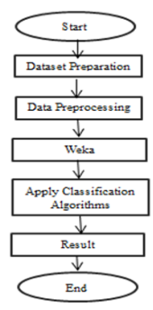

Dataset Preparation :

The “COVID-19 World Vaccination Progress Dataset’ is used from the Vaccine Adverse Event Reporting System (VAERS) Dataset (HHS.gov) in .CSV file format. The VAERS dataset is an open-source archive that contains the most detailed and relevant information on COVID-19 World Vaccination Progress and Events accessible everywhere in the world.

Data pre-Processing:

There are 6745 instances in the dataset we used for this study, with more than 14 attributes. Prior to implementing the technique, any processing of the dataset is usually done. Data transmission has to be improved in order to meet data consistency requirements. There are two main methods of data processing: data collection, convert nominal data to numeric data.

RESULT AND DISCUSSION:

The previous section involves the study of each of the four techniques (Decision Tree, Random Forest, Naive Bayes-Nearest Neighbor (KNN)) introduced previously and testing each one of them using Weka Classification Tool on a set of COVID-19 Vaccine data. There are 14 attributes and 6745 instances in the whole data collection. In this paper, this study did not use SVM algorithm because the standard SVM is not suitable for the classification of large datasets, despite its strong theoretical basis and high classification accuracy. This is because the training difficulty of SVM is heavily dependent on the size of the dataset. For a large dataset, it is better to select the Decision Tree algorithm or Random tree algorithm if the dataset is consisting of more noisy data; the most suitable algorithm is the classification algorithm.

CONCLUSION:

COVID-19 pandemic impacts millions of lives all around the world as a major public health concern. To win the fight against the COVID-19 pandemic, we'll need an efficient vaccine that can be distributed equally and broadly. Therefore, we retrieved datasets on covid-19 world vaccine progress and have processed this information using four algorithm.

Evalution metrics :

When evaluating the performance of a model in COVID-19 vaccine analysis, it's essential to use appropriate evaluation metrics based on the specific task at hand. The choice of metrics depends on whether you are dealing with a classification, regression, or another type of problem. Here are some common evaluation metrics for different types of analyses:

Classification Metrics:

1. Accuracy:

- Formula: (TP + TN) / (TP + TN + FP + FN)

- Measures the overall correctness of the model's predictions.

2. Precision (Positive Predictive Value):

- Formula:TP / (TP + FP)

- Indicates the proportion of true positives among all positive predictions. Relevant when false positives are costly.

3. Recall (Sensitivity, True Positive Rate):

- Formula:TP / (TP + FN)

- Measures the proportion of actual positives that were correctly identified. Important when false negatives are costly.

4. F1 Score:

- Formula: 2 * (Precision * Recall) / (Precision + Recall)

- Balances precision and recall, useful when there's an uneven class distribution.

5. Area Under the Receiver Operating Characteristic (ROC) Curve (AUC-ROC):

- Measures the trade-off between true positive rate and false positive rate across different probability thresholds.

6. Area Under the Precision-Recall (PR) Curve (AUC-PR):

- Evaluates the trade-off between precision and recall across different probability thresholds.

Regression Metrics:

1. Mean Absolute Error (MAE):

- Formula: (1/n) ∑ |actual - predicted|

- Represents the average absolute difference between actual and predicted values.

2. Mean Squared Error (MSE):

- Formula:(1/n) ∑ (actual - predicted)^2

- Puts more emphasis on large errors compared to MAE.

3. Root Mean Squared Error (RMSE):

- Formula: sqrt(MSE)

- Provides an interpretable metric in the same unit as the target variable.

4. R-squared (Coefficient of Determination):

- Formula: 1 - (SSR/SST)

- Measures the proportion of the variance in the dependent variable that is predictable from the independent variable.

PROGRAM :

import pandas as pd

import seaborn as sns

import numpy as np

import matplotlib.pyplot as plt

import plotly.express as px

import io

import requests

import warnings

warnings.filterwarnings('ignore')

read_data = requests.get(url).content

address = pd.read_csv(io.StringIO(read_data.decode('utf-8')))

address.head()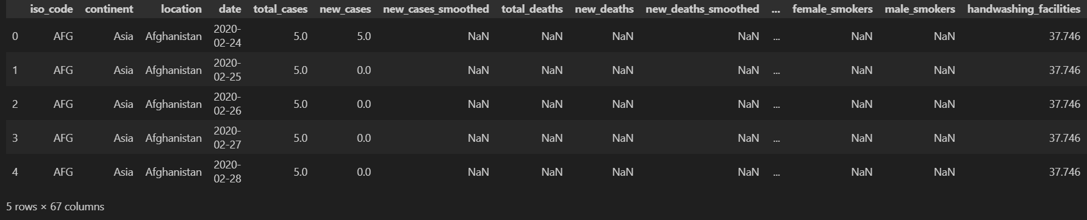

vaccine=pd.read_csv(io.StringIO(read_data.decode('utf-8')))

address=data

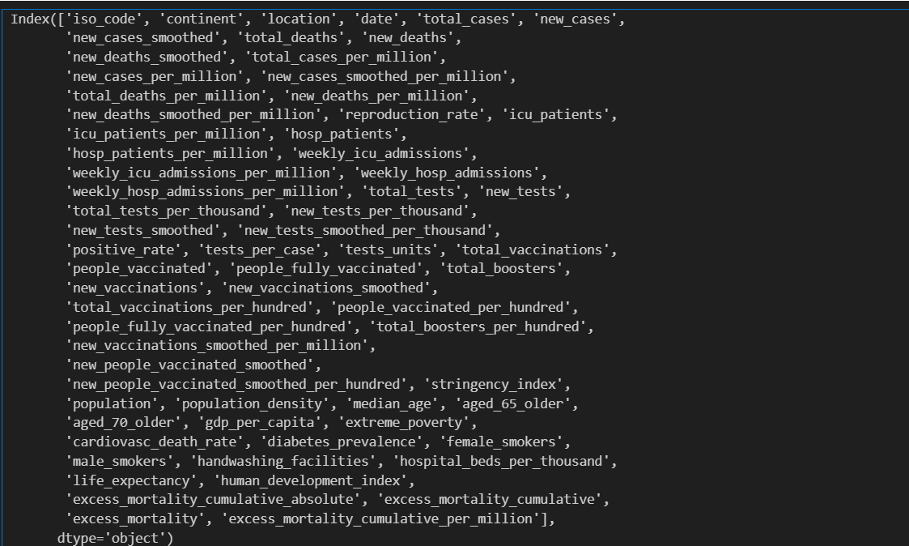

data.info()

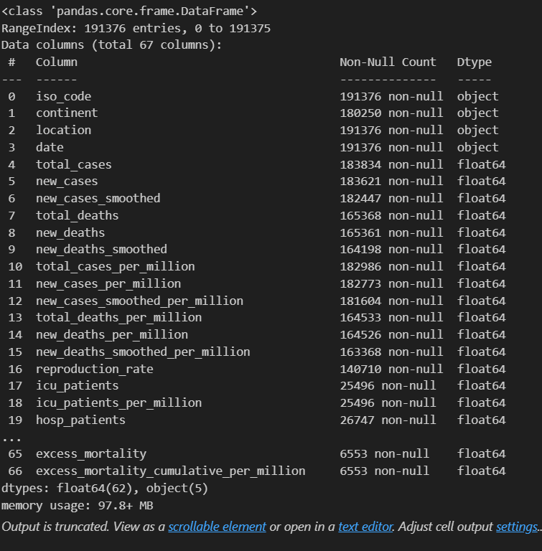

data.describe(include='all')

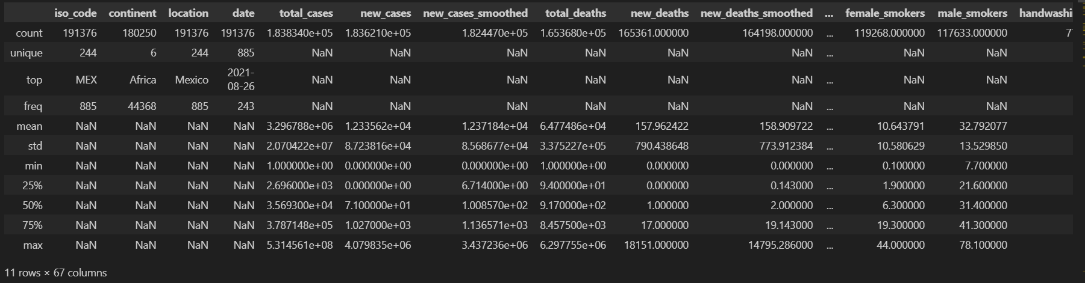

vaccine.info()

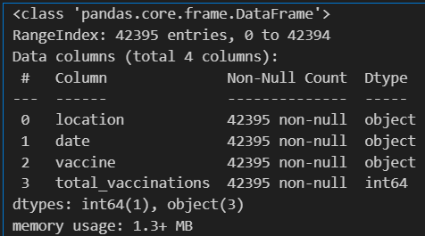

vaccine.describe()

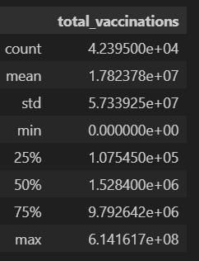

1. DATA PROCESSING:

data.isnull().sum()

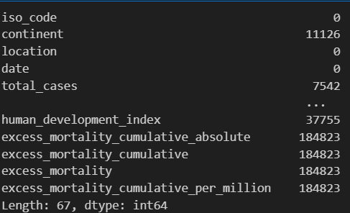

data['date']=pd.to_datetime(data['date'])

vaccine['date']=pd.to_datetime(data['date'])

data.drop([ 'new_cases_smoothed','new_deaths_smoothed', 'new_cases_smoothed_per_million',

'new_deaths_smoothed_per_million', 'reproduction_rate', 'icu_patients',

'new_tests_smoothed', 'new_tests_smoothed_per_thousand',

'new_vaccinations_smoothed',

'new_vaccinations_smoothed_per_million',

'new_people_vaccinated_smoothed',

'new_people_vaccinated_smoothed_per_hundred'], axis=1, inplace=True)

data.drop(['icu_patients_per_million','hosp_patients','hosp_patients_per_million','weekly_icu_admissions',

'weekly_icu_admissions_per_million','weekly_hosp_admissions','weekly_hosp_admissions_per_million',

'new_tests_per_thousand','excess_mortality_cumulative_absolute','excess_mortality_cumulative',

'excess_mortality','excess_mortality_cumulative_per_million','stringency_index','life_expectancy','human_development_index','extreme_poverty',

'cardiovasc_death_rate',

'diabetes_prevalence',

'female_smokers',

'male_smokers',

'handwashing_facilities',

'hospital_beds_per_thousand'],axis= 1,inplace=True)

Checking fpr the null values

x=data.isnull().sum()*100/len(data)

X

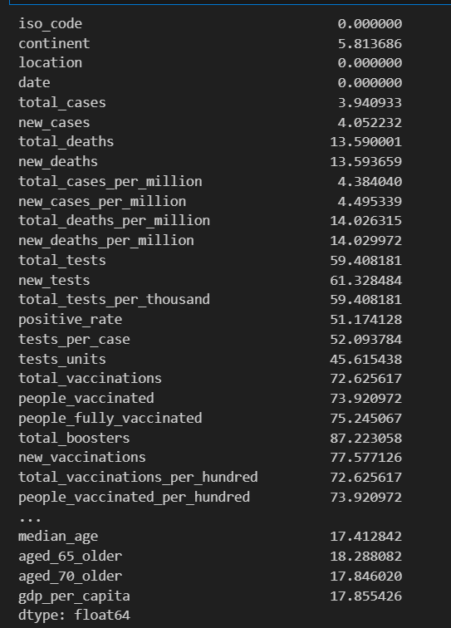

checking for duplicate values

duplicate = data[data.duplicated()]

duplicate

print(data.isnull().values.any())

data['total_deaths'].mean()

data['total_deaths'].median()

data['total_deaths'].replace(np.nan,data['total_deaths'].median()).head(10)

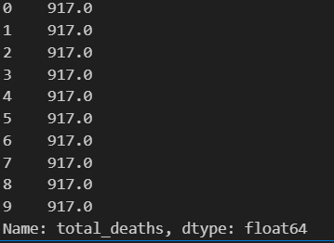

Method to fill nan cells

data.fillna(method="bfill")

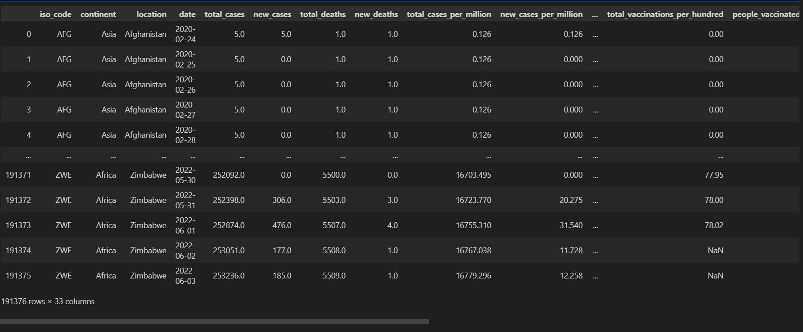

data.isnull().values.any() #Checking fo nan values in whole dataframe

data.head()

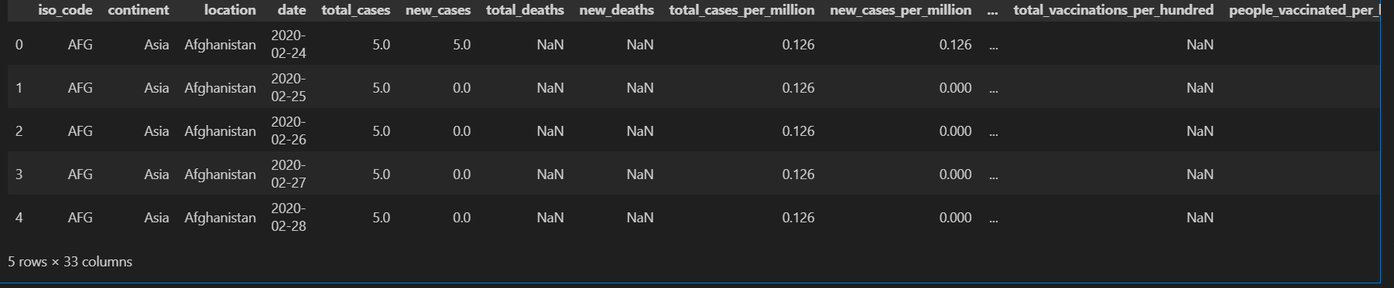

data.info()

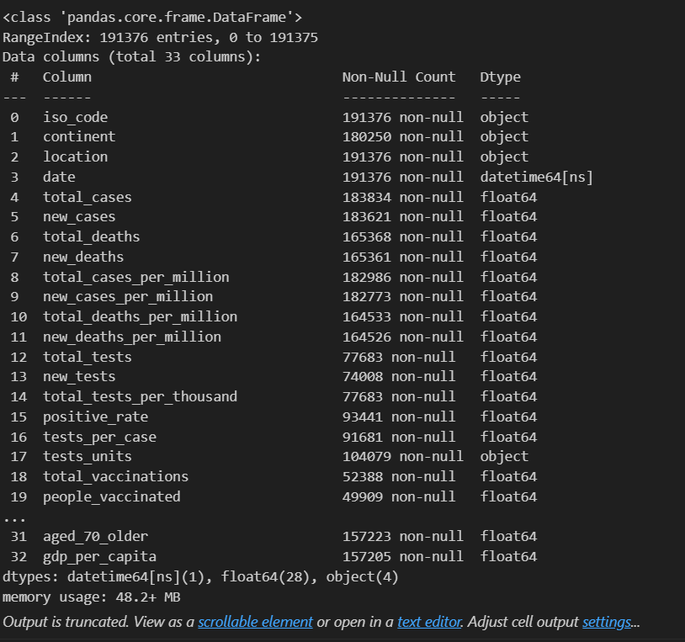

data.drop(['tests_units'],axis=1,inplace=True)

null_percentage=data.isna().sum()*100/len(data)

null_percentage.head(38)

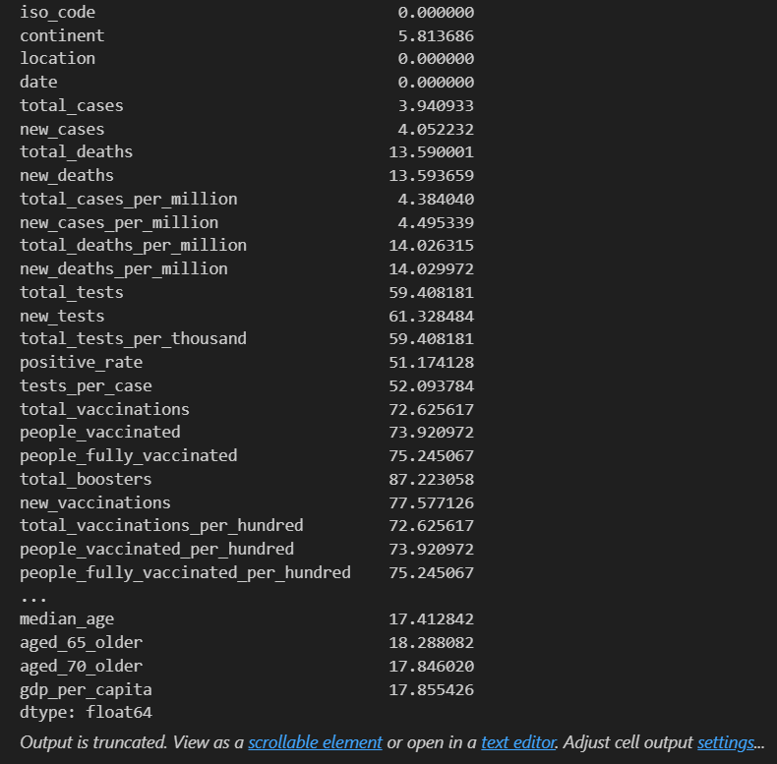

data=data.fillna(method="bfill")

null_percentage=data.isna().sum()*100/len(data)

null_percentage.head(38)

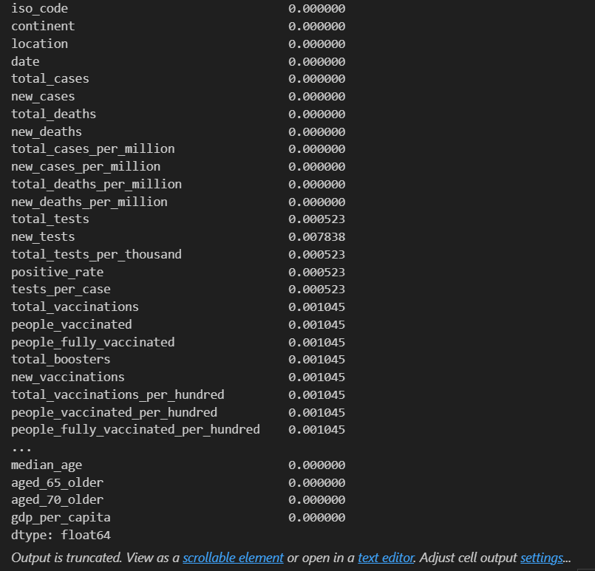

data.isnull().sum()

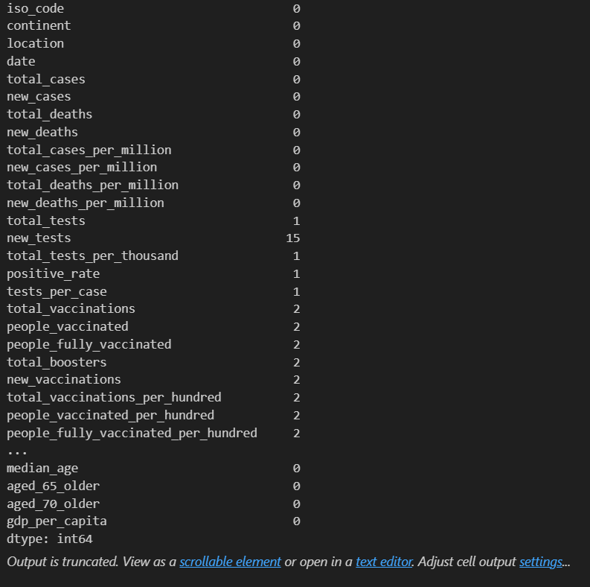

data['new_tests'].replace(np.nan,data['new_tests'].median(),inplace=True)

data['positive_rate'].replace(np.nan,data['positive_rate'].median(),inplace=True)

data['tests_per_case'].replace(np.nan,data['tests_per_case'].median(),inplace=True)

data['new_vaccinations'].replace(np.nan,data['new_vaccinations'].median(),inplace=True)

data.isnull().sum()

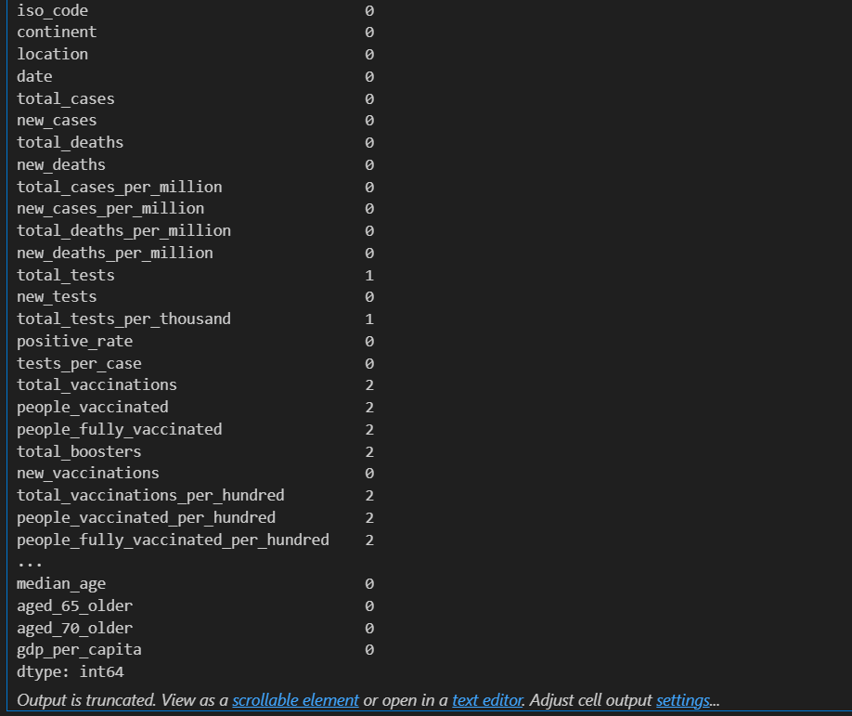

v=vaccine.drop(['total_vaccinations'], axis = 1)

V

