Autonomous Car Racing Resources

This is a list-in-progress of autonomous car resources, reference platforms and documentation.

**Contents:**

* Racing Leagues
* Meetup Groups
* Online Discussion Groups/Communities
* Software
* Online Courses
* Indoor reference platforms
* 1/10th-1/16th scale indoors/outdoors reference platforms
* Carl’s Gokart Build
* Full-size reference platforms

## 

## Racing Leagues

* [Self Racing Cars](http://selfracingcars.com/) (Silicon Valley: full-size cars, including go-karts)
* [Self Driving Track Days](http://selfdrivingtrackdays.com/) (Europe)
* [Formula Pi Racing](https://www.kickstarter.com/projects/frobotics/formula-pi-self-driving-robot-racing-with-the-rasp?ref=nav_search) (remote racing of RaspberryPi cars on an indoor track)
* [F1/10 Racing](http://f1tenth.org/car-assembly) (higher-end 1/10th scale cars with Lidar and Nvidia computer, started by U Penn. Starting cost around $3,000)
* [Sparkfun Autonomous Vehicle Competition](https://avc.sparkfun.com/) (Boulder CO)
* [Power Racing Series](http://www.powerracingseries.org/) (Sub $500 electric human-piloted karts and sub $2500 autonomous karts. 9 races across the US at Maker Faire )
* [RoboRace](http://www.theverge.com/2016/10/14/13290272/roborace-autonomous-racing-series-behind-the-scenes-first-look) (very expensive full-size autonomous cars for Formula E racing)

## Meetup Groups

Bay Area:

* [Self Racing Cars](https://www.meetup.com/Self-Racing-Cars/)
* [Autonomous Vehicle Enthusiasts](https://www.meetup.com/Autonomous/)
* [Silicon Valley Automotive Open Source](https://www.meetup.com/Silicon-Valley-Automotive-Open-Source/)
* [Connected Car SF](http://www.meetup.com/ConnectedCarSF/) and [Connected Car SV](http://www.meetup.com/Connected-Car-Silicon-Valley)
* [SAE International (innovations in mobility)](http://www.meetup.com/SAE-International-Innovations-in-Mobility/)

## Online Discussion Groups/Communities

* **Facebook**: [Self Racing Cars Group](https://www.facebook.com/groups/1168085296609595/), [DIY Robocars Group](https://www.facebook.com/groups/696607900513533/), [Silicon Valley AI Community](https://www.facebook.com/groups/SVAIResearch/)
* **Reddit**: [Self Racing Cars subreddit](https://www.reddit.com/r/SelfRacingCars/), [Self Driving Cars subreddit](https://www.reddit.com/r/SelfDrivingCars/)
* **LinkedIn**: [Self Racing Cars Group](https://www.linkedin.com/groups/13400805)

## Software

* [PX4:Rover](http://px4.io/technology/px4-software-stack/)
* [APM:Rover](http://ardupilot.org/rover/index.html)
* [Lane-tracking CV code](https://github.com/zlite/lanetracker) (Python). Works with APM:Rover, ROS, Raspberry Pi.
* [Automotive Grade Linux](https://www.automotivelinux.org/)
* [FormulaPi](https://sourceforge.net/u/zlite/formulapi/ci/master/tree/)
* [Autoware](https://github.com/CPFL/Autoware) (urban autonomous driving)
* [Dataspeed](https://bitbucket.org/DataspeedInc/) [(DBW, Speed Control, CAN interface)](https://sourceforge.net/u/zlite/formulapi/ci/master/tree/)

## Online Courses

* [Udacity](https://www.udacity.com/course/self-driving-car-engineer-nanodegree--nd013) (Self Driving Car)
* [Udacity](https://www.udacity.com/course/artificial-intelligence-for-robotics--cs373) (AI for robotics)
* [Coursera](https://www.coursera.org/learn/machine-learning/lecture/zYS8T/autonomous-driving) (Autonomous driving)

## Indoor reference platforms

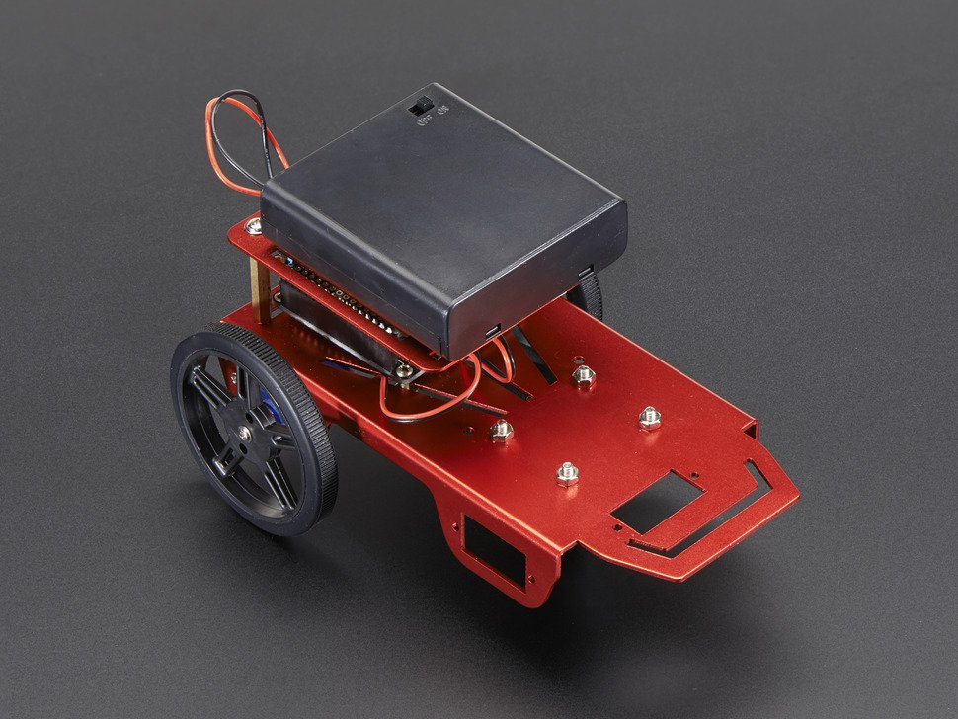

[Adafruit chassis](https://www.adafruit.com/products/2939)

[ZeroBorg motor controller](https://www.piborg.org/zeroborg)

[Raspberry Pi Zero + camera](https://www.adafruit.com/products/3170)

[FormulaPi code](https://sourceforge.net/u/zlite/formulapi/ci/master/tree/)

## 1/10th-1/16th scale indoors/outdoors reference platforms

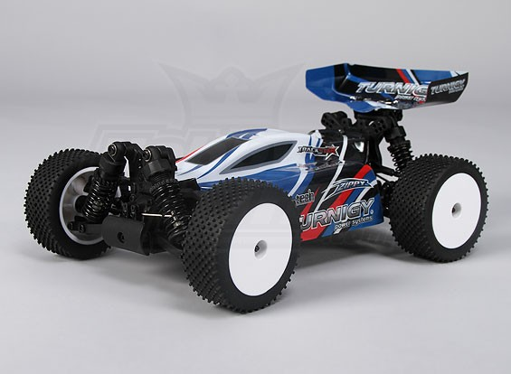

Current components:

* Existing hobby grade RC Car (requires ESC and standard hobby servo for steering, see below for two recommendations))
* Raspberry Pi 3
* [Raspberry Pi Camera](https://www.adafruit.com/products/3099)
* [Raspberry Pi Servo Hat](https://www.adafruit.com/product/2327) (for connecting RPI to existing RC car)
* Mobile battery charger

Hobby car platforms:

* [Hobby King 1/16 mini rally car](https://hobbyking.com/en_us/1-16-brushless-4wd-racing-buggy-w-25a-system.html)  - This car is small but handles very well and can soak up some bumps.
* [1/10 Trooper Pro](https://hobbyking.com/en_us/trooper-pro-4x4-1-10-brushless-sct-arr.html) - A fast offroad car, but might be a bit loose for high speed road driving - CAD files available for a mounting plate and roll bar. Currently Adam Conway is using this car.

Tips for choosing a car:

* No need to get the “RTR” versions, these come with a transmitter(remote control). It is unlikely you will need or be able to use the remote that comes with these models. Choose the “ARR” version which typically comes with everything but a battery and TX/RX.
* Choose an ESC with a “UBEC” this will power your servo board connected to the raspberry pi, however will not power the raspberry pi.
* 4WD is nearly free in most cars now. While it will take a while for us to get cars fast enough to take advantage of this for performance, it does improve braking performance, which is important immediately.

[More detail and link to github to be added by Adam Conway]

## Otavio’s Neural Network Carputer

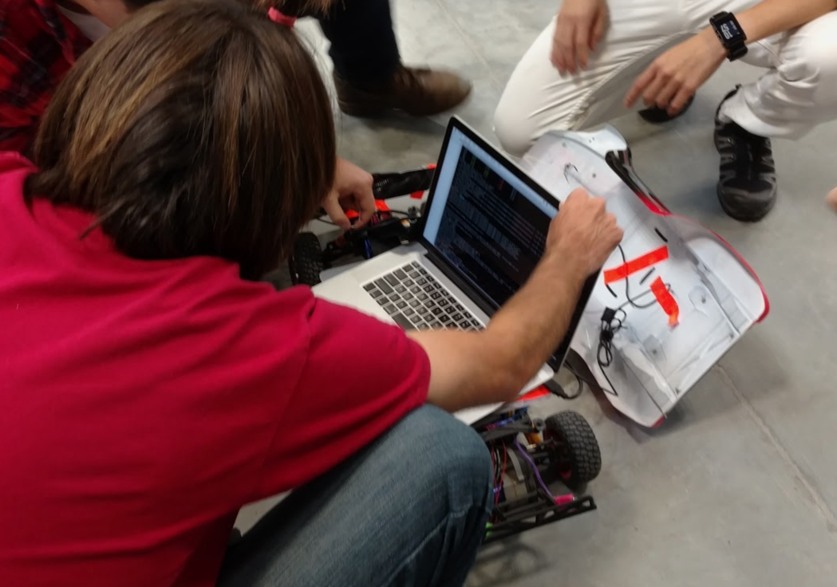

Github repo: <https://github.com/otaviogood/carputer>

## 

## 

## Carl’s Gokart Build

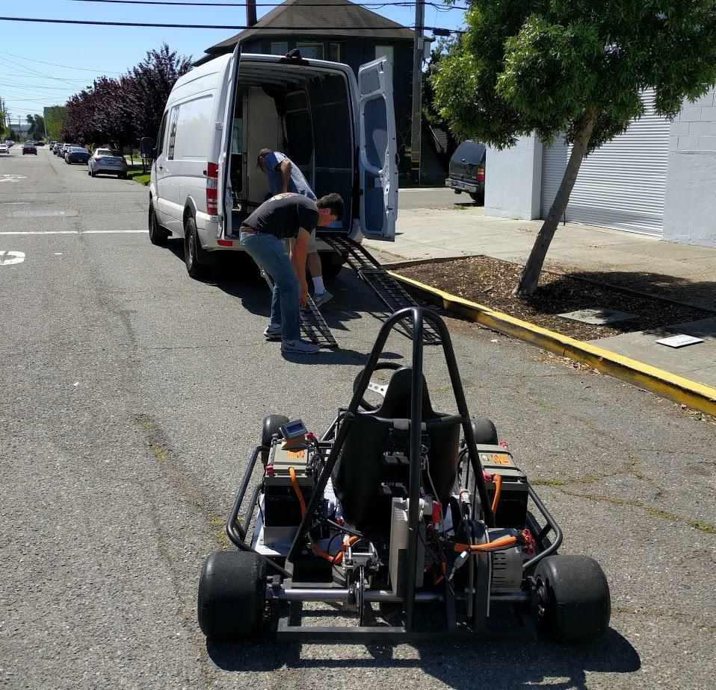

* Frame: Electric power, [custom build](http://autodesk.blogs.com/between_the_lines/2016/05/how-to-make-an-autonomous-go-kart-by-autodesk-ceo-carl-bass.html)
* Steering: [big-ass servo](https://www.pololu.com/product/1391)
* Motor control: [Arduino control](https://github.com/zlite/gokart-motor-controller) of [Sevcon Gen4](http://www.sevcon.com/ac-controllers/gen4%E2%84%A2.aspx) commercial motor controller
* On-board computer: RaspberryPi 3 with [Navio 2 autopilot shield](https://emlid.com/)
* Code:
  + Basic I/O: [APM:Rover](http://ardupilot.org/rover/index.html)
  + App framework: [Dronekit](http://python.dronekit.io/)
  + Navigation: [Custom Python script](https://github.com/djnugent/lanetracker)
  + Computer Vision: OpenCV
  + Simulation: [SITL](http://ardupilot.org/dev/docs/sitl-simulator-software-in-the-loop.html#sitl-simulator-software-in-the-loop), ROS/Gazebo
* Sensors:
  + Differential GPS
  + [RTK GPS](https://emlid.com/reach/)
  + [RaspberryPi Camera](https://www.raspberrypi.org/products/camera-module-v2/)
  + [Lidar Lite rangefinder](http://ardupilot.org/copter/docs/common-rangefinder-lidarlite.html)
* Communications:
  + [RFD 900+ long-range modem](http://store.rfdesign.com.au/rfd-900p-modem/)
  + Yagi antenna

## Full-size reference platforms

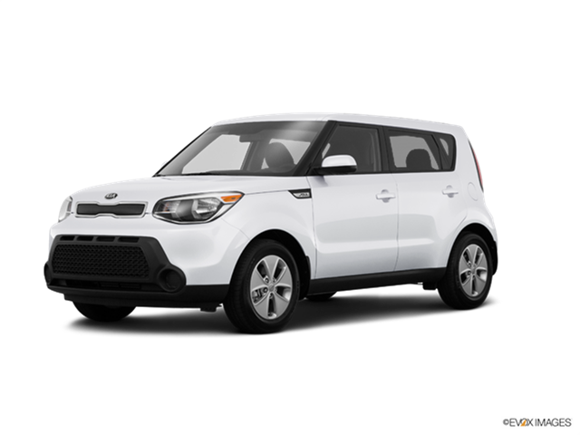

* 2014 or newer Kia Soul (mostly drive by wire and easily hacked)
* [Polysync/OSCC open source car control software+hardware](http://oscc.io/#) ($699)

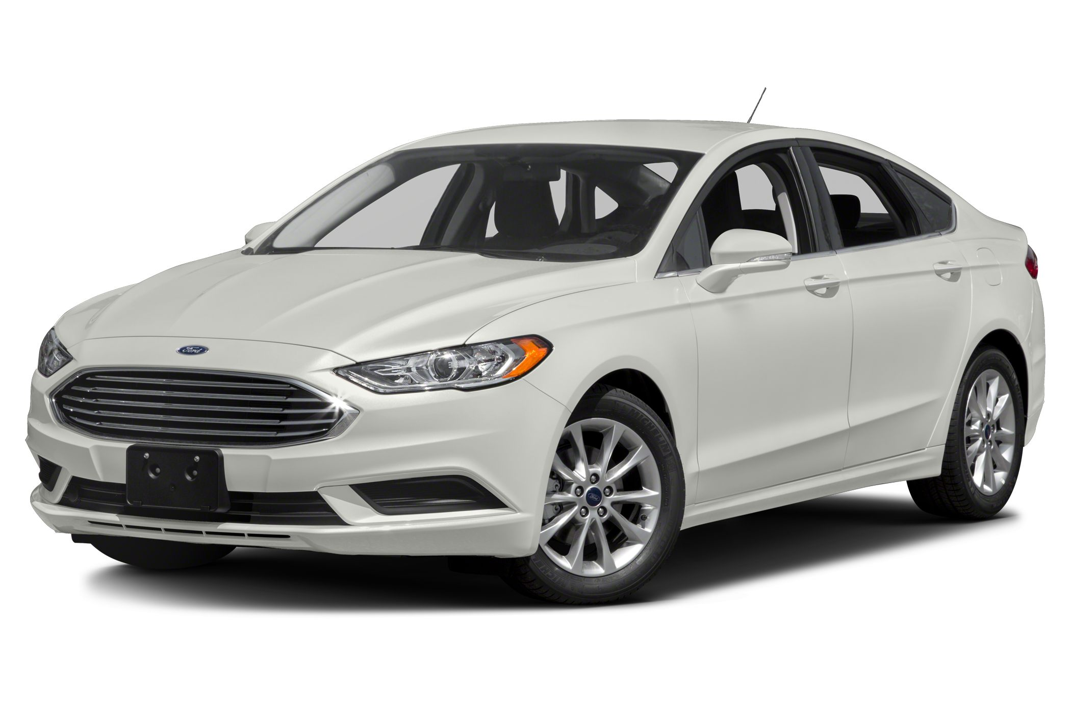

* Ford Fusion (fully drive-by-wire and can be hacked)
* [NVidia Drive AI board](http://www.nvidia.com/object/drive-px.html)