Day 08 – Cloud Server Setup:Nginx & Web Deployment

Part 1 – Launch Cloud Instance & SSH Access

Step 1: Login to AWS

Step 2: Launch EC2 Instance
Click:
Launch Instance

Configure:
Setting | Value
Name | day08-nginx-server
AMI | Ubuntu Server 22.04 LTS
Instance Type | t2.micro (Free Tier)
Key Pair | Create new key pair
Security Group | Allow SSH + HTTP

Step 3: Create Key Pair
Choose:
- Key Pair Name: day08-key
- Type: .pem
Download the .pem file carefully.
Example:
day08-key.pem
Store it safely in Downloads folder.

Step 4: Configure Security Group
Enable these:
Type | Port
SSH | 22
HTTP | 80
This allows:
- SSH access
- Website access from browser
Click:
Launch Instance

Step 5: Copy Public IP
After instance launches:
Copy:
Public IPv4 address
Example:
13.233.xx.xx


Step 6: Connect via SSH

Windows (Git Bash / PowerShell)
Move to Downloads folder:
cd ~/Downloads
Give key permission:
chmod 400 day08-key.pem
Connect to server:
ssh -i day08-key.pem ubuntu@YOUR_PUBLIC_IP
Example:
ssh -i day08-key.pem ubuntu@13.233.xx.xx


Expected Output
You should see something like:
Welcome to Ubuntu 22.04 LTS
ubuntu@ip-172-31-x-x:~$
📸 Take Screenshot:
- SSH terminal connected to EC2
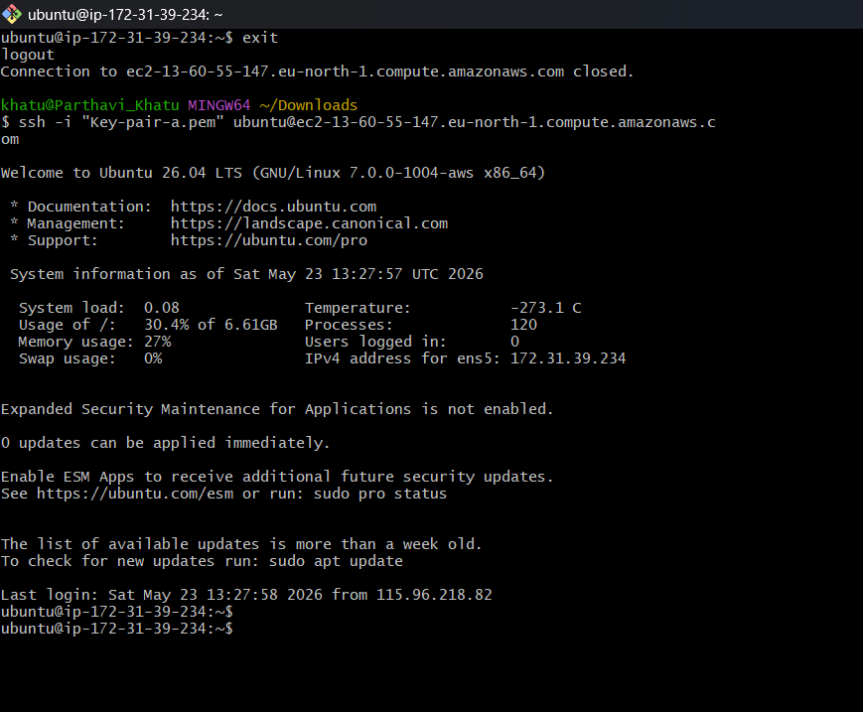

Part 2 – Install Docker & Nginx

Step 1: Update System
Run:
sudo apt update && sudo apt upgrade -y


Step 2: Install Docker
Install Docker:
sudo apt install docker.io -y
Start Docker:
sudo systemctl start docker
Enable Docker on boot:
sudo systemctl enable docker
Check status:
sudo systemctl status docker
Expected:
active (running)


Step 3: Install Nginx
Install Nginx:
sudo apt install nginx -y
Start Nginx:
sudo systemctl start nginx
Enable Nginx:
sudo systemctl enable nginx
Check status:
sudo systemctl status nginx
Expected:
active (running)

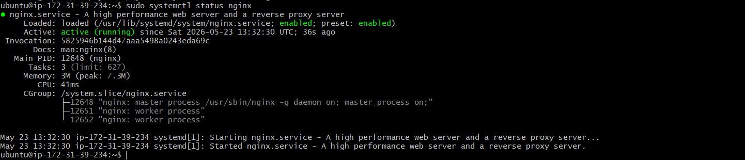

Part 3 – Verify Web Access
Open browser:
http://YOUR_PUBLIC_IP
Example:
http://13.233.xx.xx


Expected Result
You should see:
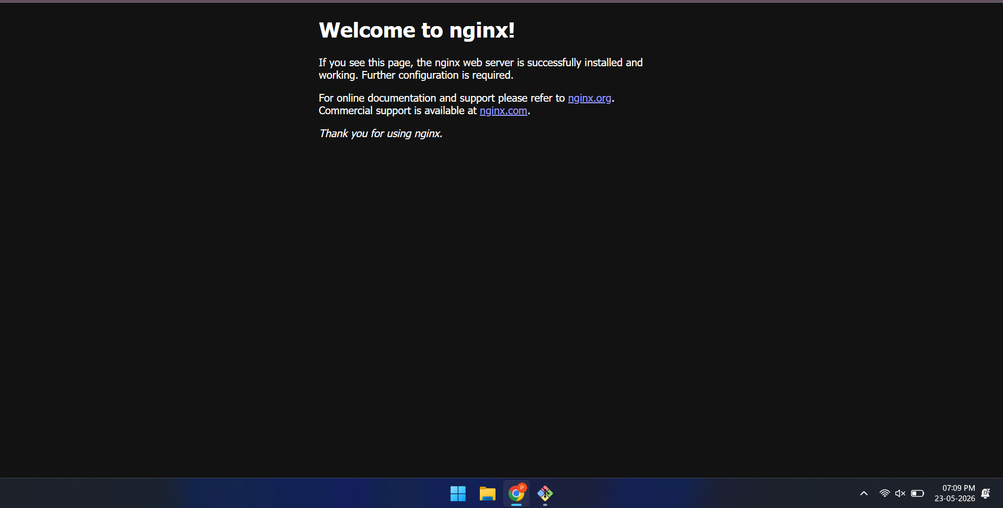

“Welcome to nginx!”
📸 Take Screenshot:
- Nginx welcome page in browser

Part 4 – Extract Nginx Logs

Step 1: View Nginx Logs
Access log:
sudo cat /var/log/nginx/access.log


Error log:
sudo cat /var/log/nginx/error.log
You will see browser request entries.

Step 2: Save Logs to File
Copy access logs:
sudo cp /var/log/nginx/access.log ~/nginx-logs.txt
Verify:
cat ~/nginx-logs.txt
📸 Take Screenshot:
- Terminal showing nginx-logs.txt contents

Step 3: Download Log File to Local Machine
Open NEW terminal on your local machine.
Move to Downloads:
cd ~/Downloads
Run:
scp -i day08-key.pem ubuntu@YOUR_PUBLIC_IP:~/nginx-logs.txt .
Example:
scp -i day08-key.pem ubuntu@13.233.xx.xx:~/nginx-logs.txt .
Check downloaded file:
ls
You should see:
nginx-logs.txt

Nginx-logs.txt—--------------
ubuntu@ip-172-31-39-234:~$ sudo cat nginx-logs.txt
27.102.121.17 - - [23/May/2026:13:38:09 +0000] "GET / HTTP/1.0" 200 615 "-" "ivre-masscan/1.3 https://github.com/robertdavidgraham/"
::1 - - [23/May/2026:13:38:11 +0000] "GET / HTTP/1.1" 200 615 "-" "curl/8.18.0"
115.96.218.82 - - [23/May/2026:13:39:05 +0000] "GET / HTTP/1.1" 200 409 "-" "Mozilla/5.0 (Windows NT 10.0; Win64; x64) AppleWebKit/537.36 (KHTML, like Gecko) Chrome/148.0.0.0 Safari/537.36"
115.96.218.82 - - [23/May/2026:13:39:09 +0000] "GET /favicon.ico HTTP/1.1" 404 197 "http://13.60.55.147/" "Mozilla/5.0 (Windows NT 10.0; Win64; x64) AppleWebKit/537.36 (KHTML, like Gecko) Chrome/148.0.0.0 Safari/537.36"

