task4-Step-by-Step Guide to Create linux-practice.md
You’ll perform a few Linux commands, observe the output, and write everything into a markdown document.

1. Process Checks Section
Add this heading:
## Process Checks
Now run these commands in terminal.

Command 1 — View Running Processes
ps aux | head
This shows currently running processes.
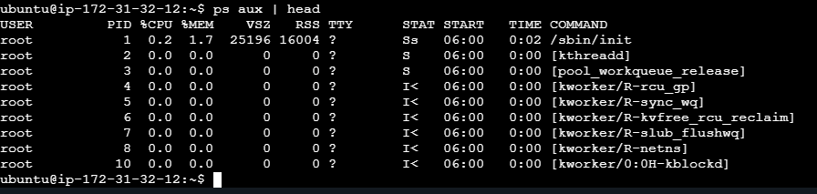

Command 2 — Search Specific Process
pgrep systemd
OR
top
If using top, press q to quit.
Record output similarly.
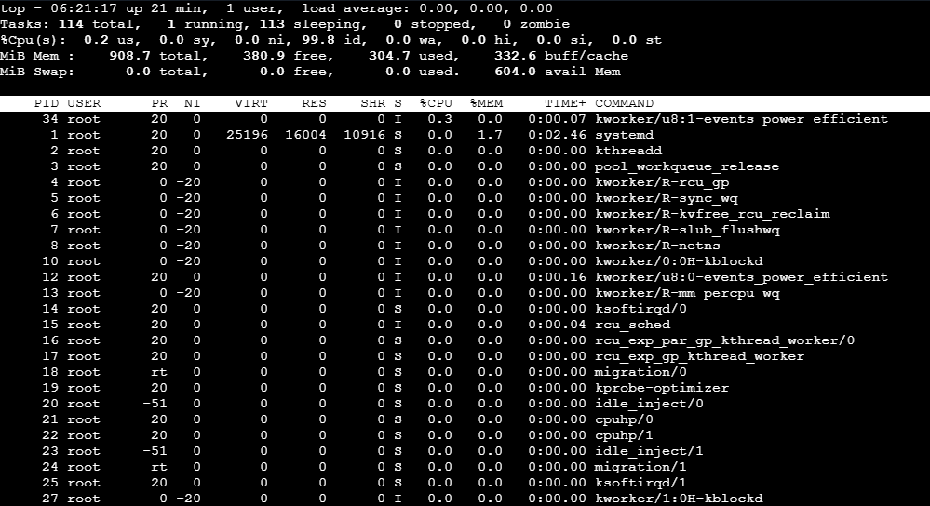

4. Service Checks Section
Add:
## Service Checks
Choose one service available on your system.
Common examples:
- ssh
- cron
- docker
- nginx

Command 3 — Check Service Status
Example using SSH:
systemctl status ssh
Copy important lines into markdown.
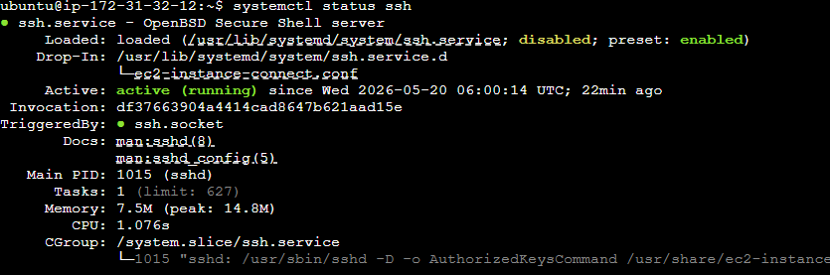

Command 4 — List Running Services
systemctl list-units --type=service --state=running
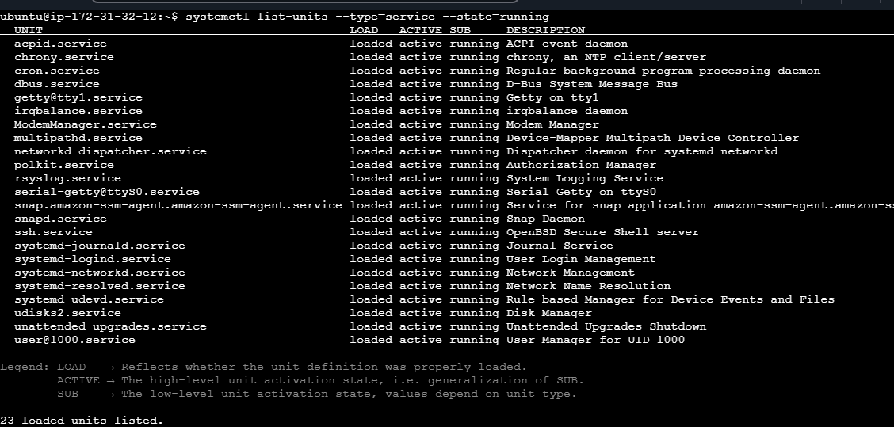

5. Log Checks Section
Add:
## Log Checks


Command 5 — View Logs for Service
Example:
journalctl -u ssh --no-pager | tail -n 20
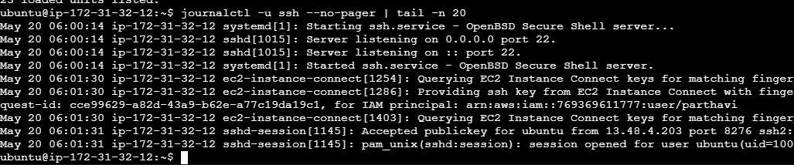

Command 6 — View System Logs
tail -n 50 /var/log/syslog
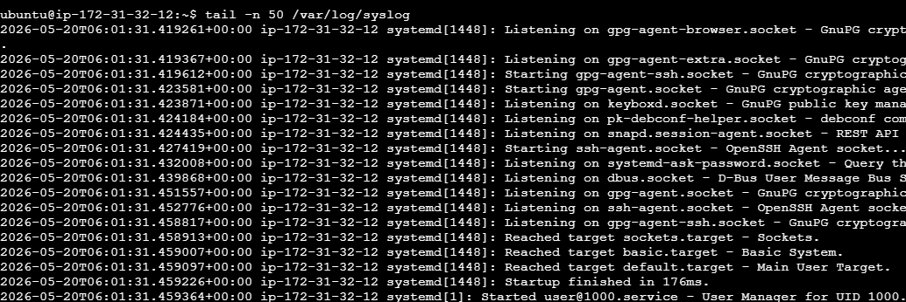

6. Mini Troubleshooting Section
Add:
## Mini Troubleshooting Steps

Example:
### Problem
SSH service was not running.

### Troubleshooting Steps

Checked service status:
```bash
systemctl status ssh
```

Started the service:
```bash
sudo systemctl start ssh
```

Verified again:
```bash
systemctl status ssh
```

### Result
Service became active and running.

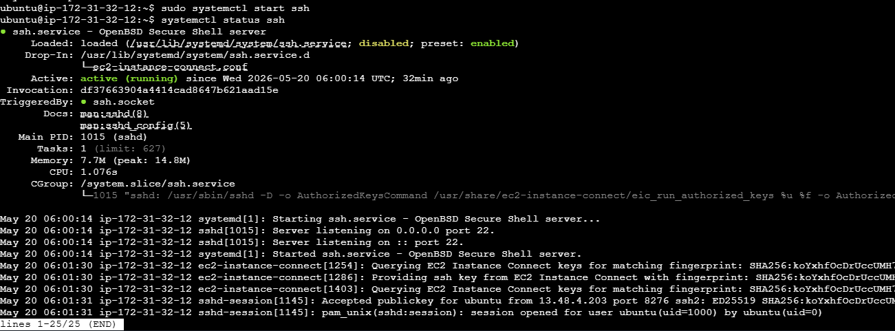

Commands Summary

Process Commands
- ps aux | head
- pgrep systemd
- top

Service Commands
- systemctl status ssh
- systemctl list-units --type=service --state=running

Log Commands
- journalctl -u ssh --no-pager | tail -n 20
- tail -n 50 /var/log/syslog

