Day 06 – Linux Fundamentals: Read and Write Text Files
file-io-practice.md

Step 1 — Create a Working Folder
Open your terminal and create a practice folder.
mkdir day06-file-io
cd day06-file-io

What this does
- mkdir → creates a new directory
- cd → moves into that directory
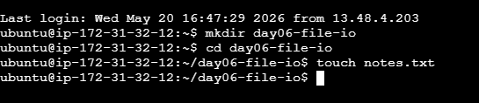

Step 2 — Create an Empty File
Create the practice file.
touch notes.txt

What this does
- touch creates an empty file named notes.txt
Check if the file exists:
ls
Expected output:
notes.txt


Step 3 — Write the First Line
Write text into the file using >.
echo "Line 1 - Linux file practice" > notes.txt

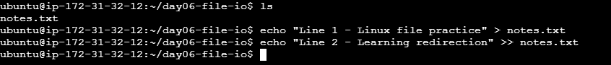

What this does
- echo prints text
- > writes text into the file
- If the file already has content, > replaces it

Step 4 — Append a Second Line
Add another line using >>.
echo "Line 2 - Learning redirection" >> notes.txt

What this does
- >> appends text to the existing file
- It does NOT delete previous content

Step 5 — Append a Third Line Using tee
Use tee to display and write at the same time.
echo "Line 3 - Using tee command" | tee -a notes.txt



What this does
- tee writes output into a file
- -a means append
- The line is shown on the terminal and saved to the file

Step 6 — Add More Practice Lines
Add a few more lines to make the file longer.
echo "Line 4 - Practicing cat command" >> notes.txt
echo "Line 5 - Practicing head command" >> notes.txt
echo "Line 6 - Practicing tail command" >> notes.txt
echo "Line 7 - DevOps uses text files daily" >> notes.txt
echo "Line 8 - File practice completed" >> notes.txt


Step 7 — Read the Full File
Display the entire file content.
cat notes.txt

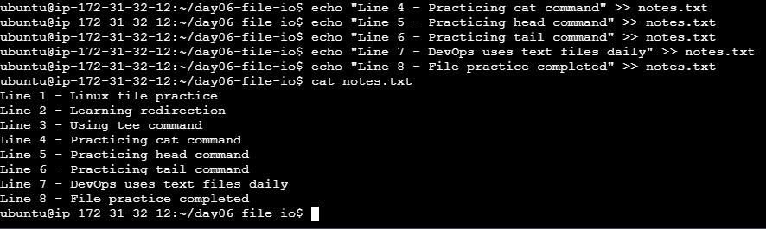

Expected Output
Line 1 - Linux file practice
Line 2 - Learning redirection
Line 3 - Using tee command
Line 4 - Practicing cat command
Line 5 - Practicing head command
Line 6 - Practicing tail command
Line 7 - DevOps uses text files daily
Line 8 - File practice completed


Step 8 — Read the First Few Lines
Use head command.
head -n 2 notes.txt

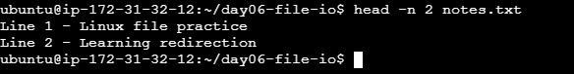

What this does
- Displays the first 2 lines of the file
Expected output:
Line 1 - Linux file practice
Line 2 - Learning redirection


Step 9 — Read the Last Few Lines
Use tail command.
tail -n 2 notes.txt

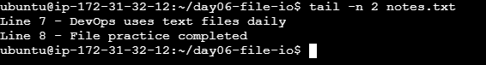

What this does
- Displays the last 2 lines of the file
Expected output:
Line 7 - DevOps uses text files daily
Line 8 - File practice completed


