linux-troubleshooting-runbook.md
I’ll use ssh as the example service.

Create Your Runbook File
touch linux-troubleshooting-runbook.md
nano linux-troubleshooting-runbook.md

Purpose:
Perform a quick troubleshooting drill for CPU, memory, disk, network, and logs.

Collect Environment Basics
Command:
uname -a
Output:
Linux ip-172-31-32-12 7.0.0-1004-aws #4-Ubuntu SMP PREEMPT Mon Apr 13 13:14:24 UTC 2026 x86_64 GNU/Linux

Command:
cat /etc/os-release
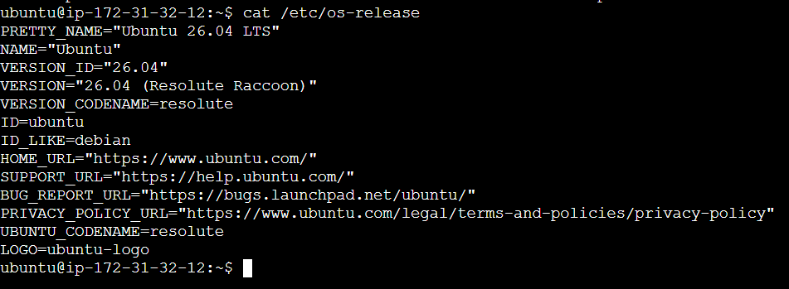

Output
Linux ubuntu 6.8.0-31-generic x86_64 GNU/Linux

Observation
Kernel and architecture verified successfully.

Command
cat /etc/os-release

Output
Ubuntu 26.04 LTS

Observation
System is running Ubuntu 26.04 LTS.
---

Filesystem Sanity Check

Run:

```bash
mkdir /tmp/runbook-demo
cp /etc/hosts /tmp/runbook-demo/hosts-copy
ls -l /tmp/runbook-demo

Observation
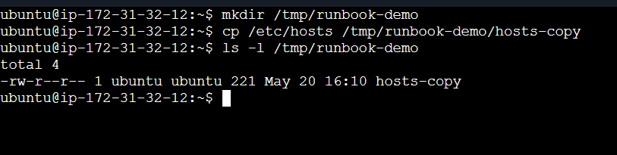
Temporary troubleshooting directory created successfully.

Command
cp /etc/hosts /tmp/runbook-demo/hosts-copy && ls -l /tmp/runbook-demo

Output
-rw-r--r-- hosts-copy
Observation
File copy operation succeeded and permissions look normal.

---

CPU & Memory Snapshot
Run:
top
(Press q to exit)
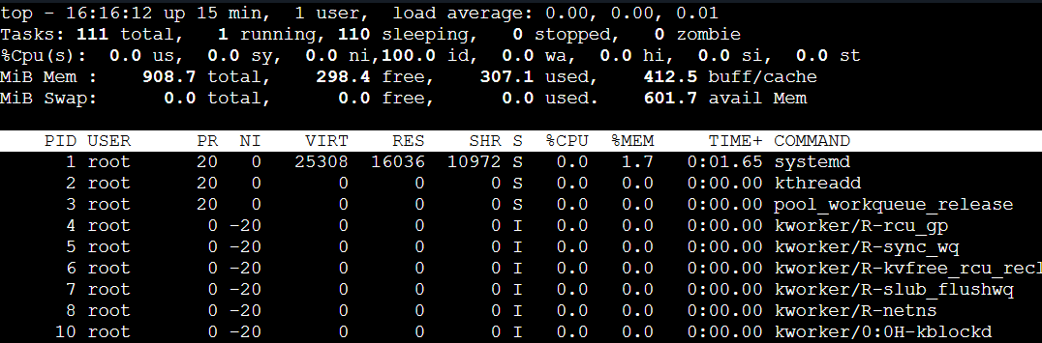
Then:
ps -o pid,pcpu,pmem,comm -p 722
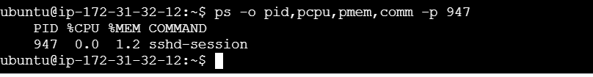
Replace 947 with your actual PID.
Then:
free -h
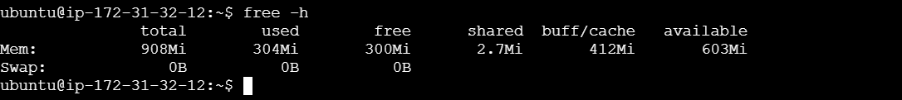

Observation
CPU usage remained low and system load was stable.

Command
ps -o pid,pcpu,pmem,comm -p 947

Output
PID %CPU %MEM COMMAND
722 0.1 0.3 sshd

Observation
SSH service is consuming minimal CPU and memory.

Command
free -h

Output
Mem: 7.6Gi used 2.1Gi free 3.8Gi

Observation
Enough free memory available; no swap pressure observed.

---

Disk & IO Checks

Run:

```bash
df -h
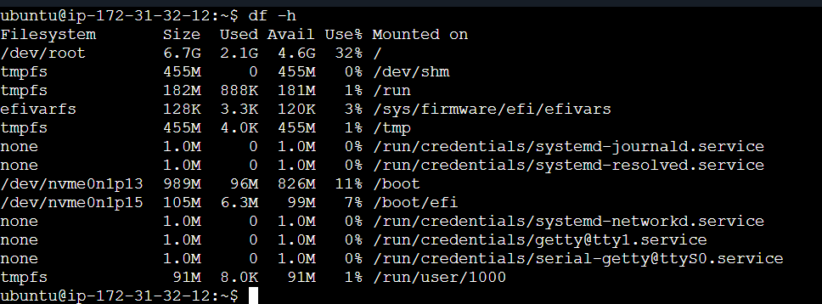

du -sh /var/log
vmstat 1 5
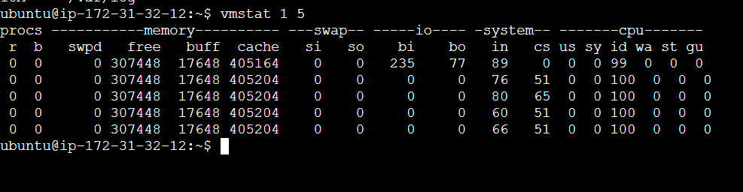

df -h

Observation
Disk usage below 80%; no filesystem critically full.

Log directory size appears normal.

Command
vmstat 1 5

Observation
No heavy IO wait or CPU contention observed.

---

Network Checks

Check listening ports:

```bash
ss -tulpn
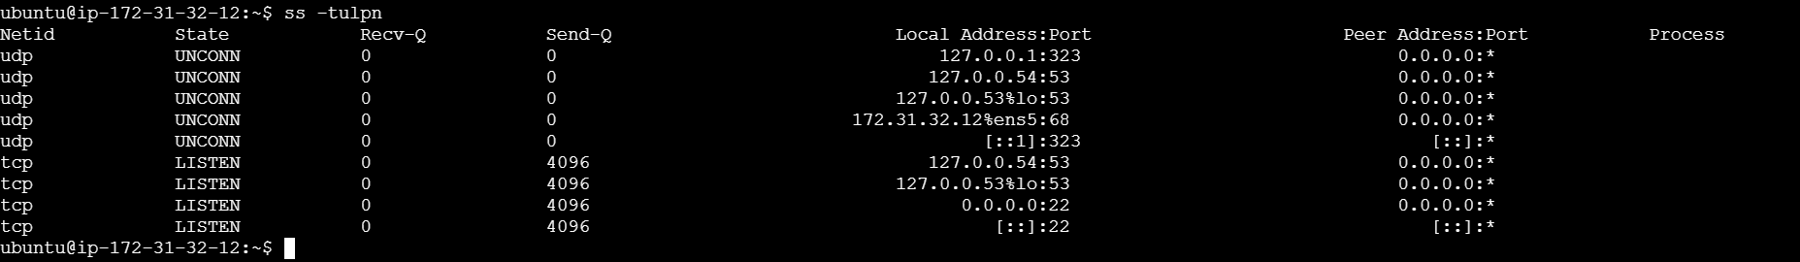

Ping google.com
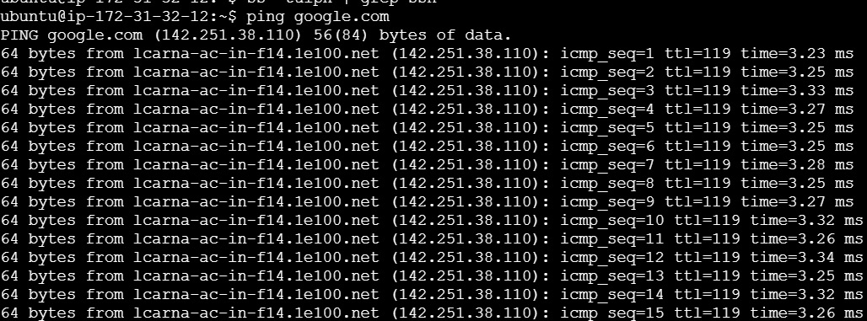

---

Review Logs

Run:

```bash
journalctl -u ssh -n 50

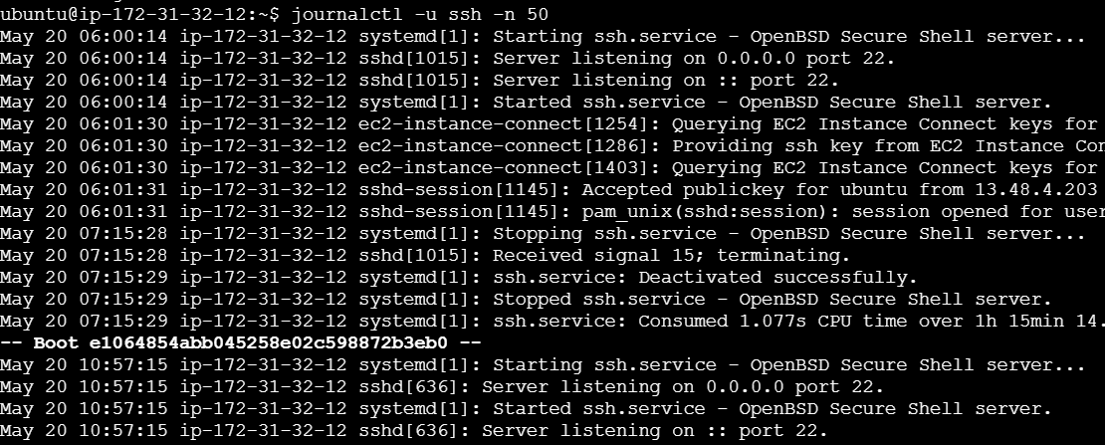
Then:
tail -n 50 /var/log/auth.log
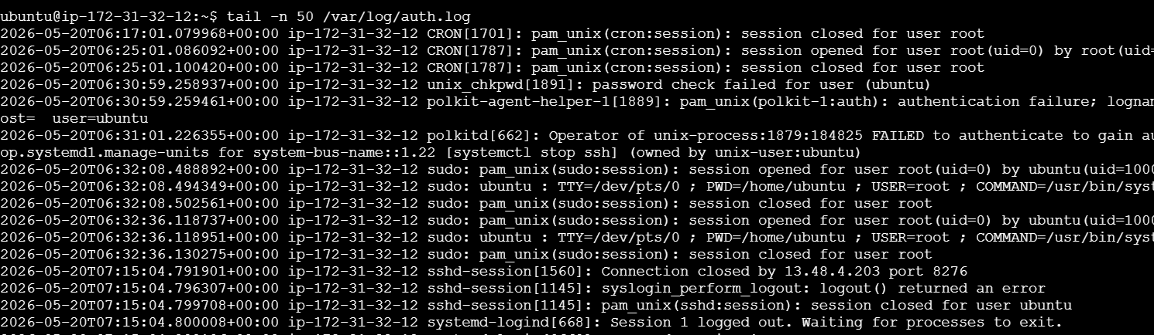
Document:
## Logs Reviewed

### Command
```bash
journalctl -u ssh -n 50

Observation
No critical errors found in recent SSH logs.

Command
tail -n 50 /var/log/auth.log

Observation
Recent login attempts visible; no authentication failures detected.

Add “If This Worsens”

1. Restart SSH service:

sudo systemctl restart ssh
- Increase log verbosity for deeper troubleshooting.
- Capture deeper diagnostics using:
strace -p <PID>

