Vision of the Department
To be a well-known centre for pursuing computer education through innovative pedagogy, value-based education and industry collaboration. Mission of the Department
To establish learning ambience for ushering in computer engineering professionals in core and multidisciplinary area by developing Problem- solving skills through emerging technologies.
Session | 2025-26 (ODD) | Course Name | PE1:MFDA(LAB)
Semester | 5 | Course Code | 23IOT1526
Roll No | 52 | Name of Student | Parth Bhedurkar

Practical Number | 9
Course Outcome | - Use the mathematical concepts, statistical formulae, visualization techniques and linear algebra concepts in the field of data analysis.  - Apply logical thinking to understand and solve the  problem using probability theory and  linear algebra in the given context  - Employ the sampling techniques and estimation  methods to predict the solution related to the area of data analysis in variety of applications 4. Write conclusion using hypothesis testing
Aim | To develop a multipleregression model .
Problem Definition | To develop a multipleregression model for predictinga dependent variable based on two or more independent variables, and to evaluate the significance and accuracy of the model. In the field of real estate analytics, predicting house prices based on property features is a common requirement. The aim is to build a statistical model that can estimate the house price (Price) using size in square feet (Area), number of bedrooms (Bedrooms), and distance from the city  center (Distance). This will help property investors and homebuyers make data-driven decisions.
Theory (100 words) | Multiple Linear Regression (MLR) is a statistical technique used to model the relationship between one dependent variable and two or more independent variables. In this practical, we aim to predict house prices based on key property features — specifically area (in square feet), number of bedrooms, and distance from the city center.  The general form of a multiple regression model is:  Price=β0+β1(Area)+β2(Bedrooms)+β3(Distance)+ϵPrice = \beta_0 +  \beta_1(Area) + \beta_2(Bedrooms) + \beta_3(Distance) +  \epsilonPrice=β0 +β1 (Area)+β2 (Bedrooms)+β3 (Distance)+ϵ where  - β0\beta_0β0 is the intercept,  - β1,β2,β3\beta_1, \beta_2, \beta_3β1 ,β2 ,β3 are regression coefficients that represent how each independent variable affects the price,  - ϵ\epsilonϵ is the random error term.  The model helps us understand how much each factor contributes to the overall house price. For example, a larger area or more bedrooms might increase the price, while a greater distance from the city center might decrease it.  In R, the model can be developed using the lm() function. The summary() function provides important statistical details such as p-values, R-squared value, and significance of predictors.  - A low p-value (< 0.05) means the variable significantly affects the house price.  - The R-squared value shows how well the model fits the data (closer to 1 indicates a better fit).  By building this model, property investors and buyers can make data-driven decisions and estimate fair market values for houses based on their characteristics.

Vision of the Department
To be a well-known centre for pursuing computer education through innovative pedagogy, value-based education and industry collaboration. Mission of the Department
To establish learning ambience for ushering in computer engineering professionals in core and multidisciplinary area by developing Problem- solving skills through emerging technologies.

Procedure and Execution  (100 Words) | - Collected data on house prices along with their area, number of bedrooms, and distance from the city center.  - Entered the data into R using a data frame.  - Built a multiple linear regression model using the lm() function.  - Checked the summary of the model to understand the importance of each variable.  - Used the model to predict prices for new houses based on their features.
Procedure and Execution  (100 Words) | Code:  data <- data.frame(  Price = c(250000, 320000, 180000, 540000,  450000, 390000, 210000, 610000, 300000,  470000),  Area = c(1500, 1800, 1200, 2500, 2300, 2000,  1300, 3000, 1600, 2200),  Bedrooms = c(3, 4, 2, 5, 4, 3, 2, 5, 3, 4),  Distance = c(5, 7, 15, 3, 4, 6, 14, 2, 8, 5)  )  model <- lm(Price ~ Area + Bedrooms + Distance, data = data)  summary(model)  new <- data.frame(Area = c(1800, 2500), Bedrooms = c(3, 4), Distance = c(6, 3))  predict(model, new)

Vision of the Department
To be a well-known centre for pursuing computer education through innovative pedagogy, value-based education and industry collaboration. Mission of the Department
To establish learning ambience for ushering in computer engineering professionals in core and multidisciplinary area by developing Problem- solving skills through emerging technologies.
Output:
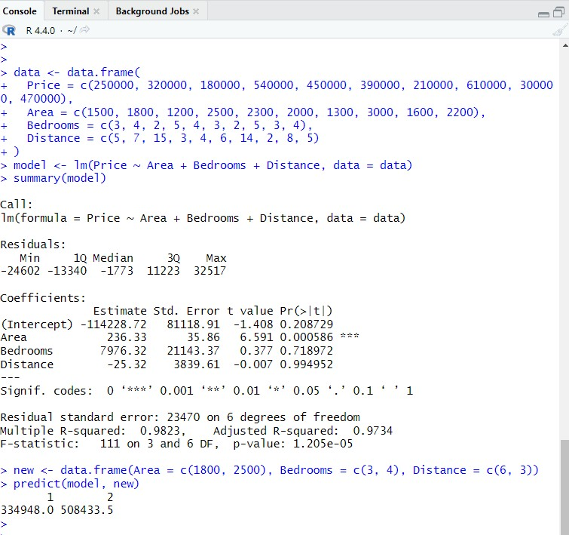
sOutput Analysis | The model shows that house price increases with area and number of bedrooms but decreases as distance from the city center grows. The R-squared value indicates a good fit, and most predictors are significant. Overall, the model gives a reliable estimate of house prices based on key features.
Link of student Github profile where lab assignment has been uploaded | https://github.com/parthbhedurkar

Vision of the Department
To be a well-known centre for pursuing computer education through innovative pedagogy, value-based education and industry collaboration. Mission of the Department
To establish learning ambience for ushering in computer engineering professionals in core and multidisciplinary area by developing Problem- solving skills through emerging technologies.
Conclusion | Hence draws a conclusion using a hypothesis
Plag Report  (Similarity index <  12%) | V  
Date | 28/10/25

