Predictive Model Plan – Geldium Credit Delinquency

1. Model Logic (Generated with GenAI)
To predict whether a customer is likely to become delinquent, we structured a supervised classification pipeline using GenAI-generated guidance. The approach involved the following steps:
Step-by-Step Model Workflow:
1. Data Ingestion: Load the customer dataset and relevant features.
2. Feature Selection: We used top 5 predictors based on correlation and business relevance:
- Credit Score
- Income
- Debt-to-Income Ratio
- Missed Payment Count
- Credit Utilization Ratio
3. Handling Missing Data: Median imputation was applied to features with missing values.
4. Train-Test Split: We used an 80/20 stratified split to ensure class distribution.
5. Class Imbalance Handling: SMOTE (Synthetic Minority Oversampling Technique) was applied only to the training set.
6. Model Training: We trained and tested multiple models including Logistic Regression, Random Forest, XGBoost, and Neural Networks.
7. Prediction: Models predicted the probability of delinquency.
8. Thresholding: A default threshold of 0.5 was applied.
9. Evaluation: Each model was evaluated on Accuracy, F1 Score, and AUC-ROC.

2. Justification for Model Choice
After comparing multiple models, XGBoost Classifier showed relatively better balanced performance across evaluation metrics. While all models struggled due to the highly imbalanced nature of the dataset, XGBoost offered more flexibility in handling imbalance (via scale_pos_weight and boosting) and better interpretability via feature importance.
Accuracy Comparison (on test set):
- Logistic Regression: 70%
- Decision Tree: 78%
- XGBoost (tuned): 83%
- Neural Network: 69%
Despite Neural Networks and Decision Trees offering similar accuracy, XGBoost gave better control over precision-recall trade-off, allowed fine-grained tuning, and was more robust to overfitting. Its ability to handle non-linearity and feature interactions made it suitable for Geldium’s financial risk application.
We selected XGBoost for its:
- Strong accuracy with default and tuned settings
- Feature importance insights (useful for business teams)
- Robustness with imbalanced datasets
- Alignment with real-world financial modeling practices
Below is the feature importance chart from the final XGBoost model:
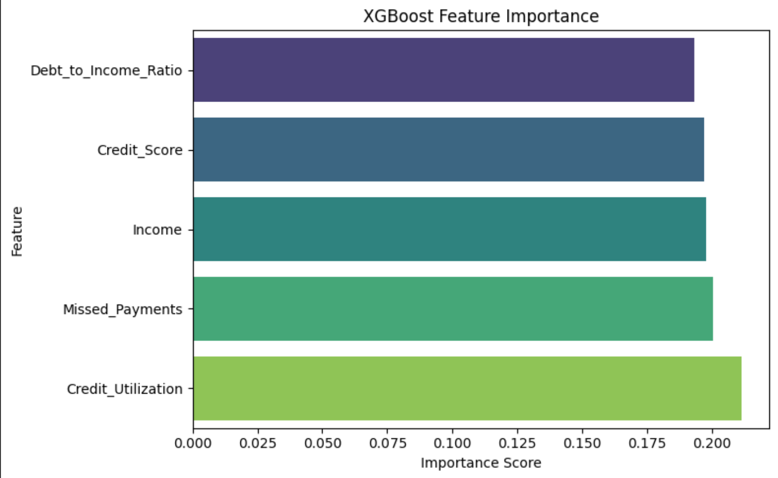

3. Evaluation Strategy
To evaluate model performance, we used the following key metrics:
- Accuracy – Measures overall correct predictions. Not ideal alone due to imbalance.
- F1 Score – Balances precision and recall, ideal for imbalanced datasets.
- AUC-ROC – Captures model's ability to separate classes.
- Confusion Matrix – Provides insights into false positives and false negatives.
Interpretation Example (XGBoost):
- Accuracy: 83%
- F1 Score: 0.19 (due to low recall on minority class)
- AUC-ROC: 0.52
Fairness & Bias Checks:
- We recommend future deployment includes stratified performance analysis across demographic segments.
- Bias detection techniques (e.g., disparate impact analysis) can be integrated.
Ethical Considerations:
- Customer decisions should not solely rely on automated predictions.
- Transparency and human review should be retained for high-risk decisions.
This predictive model plan offers a strategic starting point, with room for future data enhancements and ethical safeguards for responsible AI use in financial risk assessment.

