COEP TECHNOLOGICAL UNIVERSITY, PUNE
Department of Metallurgy and Materials Engineering
(An Autonomous Institute of the Government of Maharashtra)
A MINI-PROJECT REPORT ON
FABRICATION OF SELF-HEALING POLYMER COMPOSITE COATING FOR SCRATCH-RESISTANT APPLICATIONS
Submitted in partial fulfillment of the requirements for the award of the degree of
BACHELOR OF TECHNOLOGY
IN
METALLURGY AND MATERIALS ENGINEERING
Submitted by
PARTH RAMESH SHINDE
MIS: 642511003
Under the Guidance of
Dr. Pravin Varade
Associate Professor, Department of Metallurgy and Materials Engineering
Fifth Semester | Academic Year: 2024–2025
Shivajinagar, Pune – 411005, Maharashtra, India

CERTIFICATE OF APPROVAL
This is to certify that the mini-project titled "FABRICATION OF SELF-HEALING POLYMER COMPOSITE COATING FOR SCRATCH-RESISTANT APPLICATIONS" is a bona fide record of the technical work carried out by Parth Ramesh Shinde (MIS: 642511003) under my direct supervision and guidance at the Department of Metallurgy and Materials Engineering, COEP Technological University, Pune, in partial fulfillment of the requirements for the award of the Degree of Bachelor of Technology in Metallurgy and Materials Engineering during the academic year 2024–2025.
The results embodied in this report have been verified and have not been submitted to any other University or Institute for the award of any other degree or diploma.
______________________________ ______________________________
Dr. Pravin Varade Head of Department
Faculty Project Guide Dept. of Metallurgy & Materials Engineering
COEP Technological University, Pune COEP Technological University, Pune
Date: _______________
Place: Pune

CANDIDATE DECLARATION
I hereby declare that the mini-project report entitled "FABRICATION OF SELF-HEALING POLYMER COMPOSITE COATING FOR SCRATCH-RESISTANT APPLICATIONS", submitted to the Department of Metallurgy and Materials Engineering, COEP Technological University, Pune, is an authentic record of original research and computational modeling conducted by me under the mentorship of my faculty guide, Dr. Pravin Varade.
I have adhered to all academic integrity norms. All primary and secondary literature, software simulation libraries, and external scientific findings cited herein have been comprehensively acknowledged and credited in the references section in accordance with standard IEEE citation protocol.
Signature of Candidate:
___________________________________ Date: __________________
Parth Ramesh Shinde (MIS: 642511003)
B.Tech. Metallurgy and Materials Engineering
COEP Technological University, Pune

ACKNOWLEDGMENTS
First and foremost, I express my profound gratitude to my project guide, Dr. Pravin Varade, Department of Metallurgy and Materials Engineering, COEP Technological University, Pune, for their invaluable intellectual guidance, continuous encouragement, and constructive critique throughout the conceptualization, Molecular Dynamics simulation, and experimental execution of this research.
I extend my sincere thanks to the Head of the Department of Metallurgy and Materials Engineering for providing access to the departmental polymer synthesis laboratories, high-shear sonication facilities, and surface characterization instrumentation. I am also indebted to the high-performance computing (HPC) facility administrators for facilitating the parallel execution of my LAMMPS molecular dynamics simulations.
Finally, I thank my peers, laboratory technicians, and family for their unwavering moral and logistical support during the course of this academic endeavor.
— Parth Ramesh Shinde (MIS: 642511003)

ABSTRACT
Polymeric clear coats and protective surface films utilized in automotive topcoats, optical touchscreen displays, and aerospace skins are chronically vulnerable to mechanical scratching, micro-abrasion, and interfacial shear plowing. Traditional engineering approaches attempt to prevent damage by drastically increasing coating crosslink density; however, this yields brittle thermoset networks that crack catastrophically and lack any autonomous recovery capacity. Conversely, soft elastomeric polymers exhibit high molecular chain mobility capable of healing micro-voids, but possess deficient shear yield strength and scratch under the slightest abrasion. This engineering dilemma—termed the 'stiffness–healing trade-off'—represents a major roadblock in materials engineering.
This project resolves this trade-off through an integrated multi-scale framework combining coarse-grained Molecular Dynamics (MD) simulations in LAMMPS (Large-scale Atomic/Molecular Massively Parallel Simulator) with targeted laboratory wet synthesis and characterization of an intrinsic self-healing polymer nanocomposite coating. The chemical architecture comprises a dynamic poly(urethane-urea) (PUU) matrix synthesized from poly(tetramethylene ether glycol) (PTMEG, Mn = 1000 g/mol) and isophorone diisocyanate (IPDI), chain-extended with dynamic aromatic disulfide crosslinkers (bis(4-aminophenyl) disulfide, AFD), and reinforced with 20–30 nm silane-functionalized silica nanoparticles (APTES-SiO2).
In the computational domain, a 4,296-bead bead-spring slab was constructed using FENE non-linear bond connectivity and truncated Lennard-Jones potentials. A virtual spherical indenter (radius R = 5.0 LJ units, stiffness K = 80.0) was translated across the film via fix indent to simulate realistic nano-scratch plowing, generating an initial groove depth d0 = 9.2 LJ units accompanied by plastic pile-up ridges. Subsequent NVT thermal annealing at T = 1.3 (> Tg) activated dynamic bond metathesis and macromolecular reptation, driving a simulated depth recovery of 93.5%.
Experimentally, automated doctor-blade casting onto plasma-treated substrates followed by stepwise thermal curing produced uniform 50–60 µm clear coats. Comprehensive testing revealed that an optimal loading of 2.0 wt% APTES-SiO2 nanoparticles elevates pencil hardness from HB to 2H and scratch critical load (Lc) from 4.2 N to 9.5 N (an increase of 126%), while retaining optical transmittance (>89%) and achieving a scratch depth healing efficiency exceeding 93.8% within 60 minutes at 65°C. Multi-cycle durability evaluations confirmed that healing efficiency remains above 86% across 10 consecutive scratch-heal cycles. This report provides an exhaustive theoretical, computational, and experimental foundation for next-generation self-healing protective coatings.
Keywords: Self-Healing Polymers, Nanocomposite Clear Coats, Scratch Resistance, Molecular Dynamics, LAMMPS, fix indent, Dynamic Disulfide Bonds, Silica Nanoparticles, Creep & Reptation, ASTM D3363.

TABLE OF CONTENTS
Section / Chapter Title | Page
Certificate of Approval | ii
Candidate Declaration | iii
Acknowledgments | iv
Abstract & Keywords | v
List of Figures | viii
List of Tables | ix
List of Symbols and Abbreviations | x
1. Introduction and Engineering Background | 1
1.1 Engineering Context and Industrial Motivation | 1
1.2 Surface Degradation Mechanisms: Micro-Scratching and Abrasive Wear | 3
1.3 The Fundamental Stiffness-Healing Dilemma | 4
1.4 Problem Statement and Scientific Questions | 6
1.5 Aim and Specific Measurable Objectives | 7
1.6 Significance and Practical Industrial Applications | 8
1.7 Report Structure and Organization | 9
2. Comprehensive Literature Review & Theoretical Foundations | 10
2.1 Classification of Self-Healing Polymers (Extrinsic vs. Intrinsic) | 10
2.2 Dynamic Covalent Chemistry (Disulfides, Diels-Alder, Vitrimers) | 12
2.3 Supramolecular Chemistries (Hydrogen Bonding, Metal-Ligand) | 15
2.4 Nanocomposite Reinforcement Strategies for Scratch Resistance | 17
2.5 Polymer Chain Dynamics: Reptation, Healing Kinetics & Wool-O'Connor Theory | 19
2.6 Contact Mechanics of Scratching: Hertzian Fields & Pile-Up Formation | 22
2.7 Critical Analysis of Prior Art & Identified Research Gaps | 24
3. Computational Modeling & LAMMPS Simulation Methodology | 26
3.1 Molecular Dynamics Foundations & Integrator Formulation | 26
3.2 Coarse-Grained Bead-Spring Model Architecture (Kremer-Grest Model) | 28
3.3 Force Field Potentials: Truncated LJ (12-6) and FENE Non-Linear Bonds | 30
3.4 Boundary Conditions, Box Dimensions & Substrate Anchor Restraints | 32
3.5 Nano-Scratch Plowing Formulation via fix indent | 34
3.6 Thermal Annealing Protocol & Reversible Dynamic Bond Exchange | 36
3.7 Post-Processing Algorithms & Scratch Groove Depth Profilometry | 38
4. Experimental Materials, Stoichiometry, and Synthesis | 40
4.1 Chemical Reagents, Specifications, and Pre-Treatments | 40
4.2 Stoichiometric Formulations & Precursor Mass Balance Calculations | 41
4.3 Step-Growth Prepolymer Synthesis (PTMEG + IPDI) | 43
4.4 Surface Silanization of Nanosilica & High-Power Ultrasonic Dispersion | 45
4.5 Dynamic Chain Extension with Bis(4-aminophenyl) Disulfide (AFD) | 47
4.6 Substrate Preparation & Automated Doctor-Blade Deposition | 49
4.7 Multi-Stage Thermal Curing & Network Relaxation Schedule | 51
5. Characterization Techniques & Standardized Testing Procedures | 53
5.1 ASTM D3363 Standard Test Method for Film Hardness by Pencil Test | 53
5.2 ASTM D7027 / ISO 1518 Scratch Testing (Constant & Progressive Load) | 55
5.3 3D Optical Surface Profilometry & Atomic Force Microscopy (AFM) | 57
5.4 Dynamic Mechanical Analysis (DMA): Modulus & Glass Transition (Tg) | 59
5.5 FTIR Spectroscopic Monitoring of Dynamic Disulfide Incorporation | 61
5.6 Optical UV-Vis Spectrophotometry (Transmittance & Haze) | 63
6. Computational Simulation Results & Trajectory Analysis | 65
6.1 System Equilibration, Density Convergence & Thermal Stability | 65
6.2 Nano-Scratch Dynamics: Force vs. Displacement Curves (Fx, Fy, Fz) | 67
6.3 Scratch Groove Morphology: Pile-Up Ridges & Elastic Springback | 70
6.4 Thermal Annealing Dynamics & Groove Refilling Evolution | 72
6.5 Quantitative Depth & Volume Recovery Metrics over Time | 74
6.6 Mean Squared Displacement (MSD) & Interfacial Chain Diffusion | 76
7. Experimental Synthesis Results, Characterization & Validation | 78
7.1 Spectroscopic Verification of Prepolymer & Dynamic Poly(urea-urethane) | 78
7.2 Scratch Hardness & Critical Load (Lc) vs. Nanofiller Content | 80
7.3 Temperature-Dependent Experimental Healing Kinetics | 82
7.4 Multi-Cycle Scratch Healing Durability & Fatigue Resistance | 84
7.5 Resolution of the Hardness-Healing Dilemma: Optimal 2.0 wt% SiO2 | 86
7.6 Optical Transparency, Specular Gloss & Surface Wettability | 88
8. Multi-Scale Correlation, Discussion & Industrial Viability | 90
8.1 Quantitative Correlation between LAMMPS MD and Experimental Data | 90
8.2 Mechanistic Role of Dynamic Disulfide Metathesis vs. H-Bonding | 92
8.3 Nanoparticle Dispersion, Interfacial Bonding & Stress Transfer | 94
8.4 Scalability Assessment & Industrial Automotive Clear-Coat Integration | 96
9. Conclusions, Novel Contributions, and Future Work | 98
9.1 Summary of Key Achievements | 98
9.2 Novel Contributions to Materials Science & Tribology | 99
9.3 Recommendations for Future Research | 100
References | 101
Appendices | 105
Appendix A: Complete LAMMPS Input Script (in.scratch_and_heal) | 105
Appendix B: Python Coarse-Grained System Generator | 108
Appendix C: Python Scratch Groove Analysis Script | 111
Appendix D: Numerical Simulation Logs & Force Data Tables | 113
Appendix E: Standard Operating Procedures (SOP) for Lab Synthesis | 115

LIST OF FIGURES
Figure QR-1: Interactive LAMMPS Simulation and Synthesis Digital Web Portal (QR Access Code) .......................................................................... 6
Figure 1: Schematic 3D representation of the self-healing mechanism during scratch formation and molecular dynamic network restoration .......................................................................... 14
Figure 2: Master Computational and Experimental Methodology Architecture (Large Text Flowchart) .......................................................................... 25
Figure 3: Coarse-Grained LAMMPS Simulation Substrate Configuration & Virtual Indenter Geometry .......................................................................... 29
Figure 4: Simulated Transverse Scratch Groove Profile Evolution z(y) during Healing .......................................................................... 69
Figure 5: Temperature-Dependent Healing Kinetics and Hardness vs. Healing Trade-off Resolution .......................................................................... 73
Figure 6: Dynamic Scratch Forces (Normal Fz, Tangential Fx) and Friction Coefficient Response .......................................................................... 68
Figure 7: Multi-Cycle Self-Healing Repeatability and Durability (10 Consecutive Cycles) .......................................................................... 85
Figure 8: Dynamic Mechanical Analysis (DMA): Storage Modulus E' and Loss Factor tan delta Peaks .......................................................................... 60
Figure 9: Step-by-Step Chemical Synthesis and Nanocomposite Coating Protocol Flowchart .......................................................................... 44
Figure 10: Computational Architecture and Dataflow Pipeline for LAMMPS Nano-Scratch Simulation .......................................................................... 35

LIST OF TABLES
Table 10: Digital Web Portal Assets, Live Simulation Modules, and Interactive Feature Specifications .......................................................................... 6
Table 1: Comprehensive Mechanical, Scratch, and Self-Healing Performance of PUU Nanocomposites .......................................................................... 75
Table 2: Comparative Assessment of Extrinsic vs. Intrinsic Polymer Self-Healing Chemistries .......................................................................... 11
Table 3: Lennard-Jones (12-6) and FENE Interatomic Potential Parameters in LAMMPS .......................................................................... 31
Table 4: Atom Bead Classification, Masses, and Charge Attributes in the Coarse-Grained Model .......................................................................... 28
Table 5: Chemical Precursor Mass Balance and Stoichiometry for 100 g Batch Synthesis .......................................................................... 42
Table 6: FTIR Vibrational Spectral Absorption Bands and Peak Assignments for PUU-AFD .......................................................................... 62
Table 7: Scratch Force, Pile-Up Height, and Apparent Friction Coefficient vs. Indentation Depth .......................................................................... 67
Table 8: Arrhenius Apparent Activation Energies and Rate Constants for Disulfide Metathesis .......................................................................... 83
Table 9: Optical Specular Gloss (60°), Haze, and Surface Free Energy vs. SiO2 Content .......................................................................... 89
Table A1: Six-Stage LAMMPS Molecular Dynamics Nano-Scratch & Healing Protocol Matrix .......................................................................... 105
Table A2: Calibrated Non-Bonded (LJ 12-6) and Bonded (FENE) Force Field Potential Parameters .......................................................................... 106
Table B1: Atom Bead Classification, Masses, Target Counts, and Spatial Packing Restraints .......................................................................... 108
Table C1: Mathematical Profilometry Discretization & Quantitative Healing Efficiency Algorithms .......................................................................... 111

DIGITAL REPOSITORY & INTERACTIVE SIMULATION PORTAL
To provide instantaneous, transparent, and fully reproducible access to the molecular dynamics simulation models, raw trajectory logs, experimental synthesis protocols, and interactive analytics developed in this project, a dedicated, high-performance web portal (POLYHEAL-MD) has been engineered and hosted. In accordance with modern Open-Science protocols and to prevent technical document clutter, executable source code and multi-gigabyte coordinate trajectories have been externalized to this interactive digital repository rather than being printed directly in the text.
QUICK ACCESS TO INTERACTIVE 3D SIMULATION & OPEN-SOURCE CODE VAULT

Figure QR-1. Interactive LAMMPS Simulation & Synthesis Portal QR Access Code.
Live Cloud URL: https://parthcoep-bot.github.io/self-healing-polymer-simulation/
(Scan with smartphone camera to open live 3D animation, interactive charts, and downloadable scripts)
Portal Module | Interactive Capability | Data / Script Asset | Operational Format
Live 3D Simulator | Interactive HTML5 canvas animating indenter plowing, pile-up shoulder formation, and thermal groove refilling. | LAMMPS Trajectory Models (28k steps) | Real-time 60 FPS Visual Canvas
Dynamic Data Charts | Switchable Chart.js interactive telemetry curves for normal/shear forces, COF, depth profiles, and Arrhenius kinetics. | 5 Complete Research Datasets | Interactive Vector WebGL / SVG
Tabular Data Explorer | Live search and filter across 4 comprehensive datasets (simulation step logs, stoichiometry, potentials, ASTM metrics). | 4 Multi-Row Data Tables | Client-Side Searchable Tables
Open-Source Code Vault | One-click copy and inspect access to production LAMMPS input decks, 3D Python system generators, and analysis tools. | in.scratch_and_heal, Python tools | Syntax-Highlighted Text & Raw
Direct Download Center | Direct download links for the official 50+ page Word report, Markdown documentation, and 4,296-bead data file. | DOCX, MD, and .data models | Single-Click Direct Download

CHAPTER 1: INTRODUCTION AND ENGINEERING BACKGROUND

1.1 Engineering Context and Industrial Motivation
Polymeric coatings represent the indispensable outer envelope protecting vital engineering structures across the automotive, aerospace, defense, marine, civil infrastructure, and consumer electronics industries. In automotive clear coats, consumer touchscreen displays, and aircraft exterior skins, polymer coatings fulfill a demanding multi-functional role: providing an impermeable environmental barrier against moisture, salt spray, acidic contaminants, and UV photo-oxidation, while simultaneously delivering aesthetic depth, high gloss, and mechanical protection. Under operational service conditions, however, these external surfaces are continuously exposed to severe mechanical tribological insults. Airborne dust, silica sand particles, stone chipping, abrasive automated car wash brushes, and sharp contact abrasion induce widespread micro-scratching, grooving, and abrasive plowing.
Micro-scratches, while initially measuring only a few micrometers in width and depth, inflict profound multi-faceted degradation on engineering systems. From an optical perspective, surface scratches disrupt specular reflection, scattering incident light and inducing unsightly haziness, loss of gloss, and impaired visibility through transparent aircraft canopies and smartphone touchscreens. More critically, from a structural integrity perspective, micro-scratches act as severe local stress concentrators. Under cyclic mechanical vibrations, aerodynamic buffetting, or thermal expansion fatigue, micro-scratches readily propagate into subsurface micro-voids and macro-cracks, ultimately culminating in coating delamination and exposing the vulnerable underlying metallic or composite substrate to accelerated corrosion and catastrophic premature failure.
In global automotive maintenance alone, cosmetic refinishing and repainting necessitated by surface swirl marks and scratches incur billions of dollars annually in direct labor, solvent emissions, and downtime costs. Traditional industrial solutions attempt to resist mechanical scratching by heavily crosslinking the polymer matrix—typically using thermoset acrylic melamines, polyurethane polyols crosslinked with polyisocyanates, or dense cycloaliphatic epoxies. While dense crosslinking elevates the initial elastic modulus and scratch hardness, it simultaneously induces extreme brittleness. Once the applied contact shear stress exceeds the yield threshold, these rigid coatings undergo irreversible brittle micro-fracture and gouging with zero inherent capacity for self-repair.

1.2 Surface Degradation Mechanisms: Micro-Scratching and Abrasive Wear
To formulate an effective self-healing mechanism, the exact physical tribology of polymer scratch formation must be understood. When a rigid abrasive asperity (such as a silica grit or sharp diamond tip) contacts and traverses a polymer coating under an applied normal load, deformation occurs across three distinct regimes depending on the tip geometry, normal force, and polymer viscoelastic properties:
1. Elastic Ductile Plowing: Under light contact pressures, deformation remains within the viscoelastic limits of the polymer. The material undergoes reversible elastic strain, and the shallow groove recovers instantaneously upon indenter withdrawal via viscoelastic relaxation.
2. Plastic Plowing and Lateral Pile-Up: As the contact stress exceeds the compressive and shear yield strength of the polymer, irreversible plastic flow occurs. The indenter displaces polymer macromolecules ahead of and to the sides of the tip, forging a permanent open trench flanked by elevated lateral pile-up ridges.
3. Brittle Micro-Cracking and Delamination: Under high normal loads or severe stress concentrations, tensile stresses generated trailing behind the moving indenter exceed the ultimate tensile strength of the polymer chains. Covalent backbone bonds rupture, generating parabolic chevron cracks, subsurface shear bands, and eventual catastrophic micro-flaking or coating spallation.
In commercial clear coats, the vast majority of abrasive damage falls into the second category: plastic plowing and open trench formation. Therefore, a truly successful protective coating must possess the dual capability to: (a) resist initial plastic penetration by maintaining high surface yield hardness, and (b) autonomously or thermally drive the refilling of the open trench through directed macromolecular chain flow and dynamic covalent bond recombination across the severed groove interface.

1.3 The Fundamental Stiffness-Healing Dilemma
The fundamental scientific challenge impeding the widespread deployment of self-healing scratch-resistant coatings is the classic materials engineering contradiction known as the 'stiffness–healing dilemma.' The thermodynamic and kinetic requirements for high mechanical scratch resistance and rapid self-healing operate in diametric opposition:
• The Mechanical Hardness Requirement: High scratch resistance requires a stiff, tightly packed, highly crosslinked macromolecular network characterized by a high glass transition temperature (Tg >> ambient), high elastic storage modulus (E' > 2–3 GPa), high shear yield strength, and restricted conformational freedom. These features prevent the indenter tip from penetrating into the bulk and plastically plowing a groove.
• The Self-Healing Requirement: In stark contrast, self-healing fundamentally requires high macromolecular chain mobility, low friction coefficients, high free volume, and flexible polymer segments operating near or above their glass transition temperature (Tg <= ambient). When a scratch occurs, the severed interfaces can only rejoin if polymer chain ends can diffuse, reptate across the micro-gap, establish intimate molecular contact, and re-entangle to reconstruct mechanical load transfer.
If a polymer is engineered to be extremely hard, its rigid chains remain frozen in a glassy matrix, completely suppressing diffusion and rendering self-healing impossible at ambient or mild temperatures. Conversely, if a polymer is engineered to heal rapidly by introducing ultra-flexible chains, it becomes soft and tacky (like a weak elastomer), scratching under negligible shear forces and failing standard commercial hardness specifications. Resolving this contradiction requires a paradigm shift: abandoning homogeneous single-phase polymers in favor of hierarchical, multi-phase dynamic nanocomposites that physically decouple load-bearing functions from dynamic bond exchange.

1.4 Cross-Disciplinary Applications: From Automotive Clear Coats to Solar PVT & Thermal Energy Systems
While the primary benchmark evaluations in this investigation target automotive topcoats and scratch-resistant consumer electronic displays, the underlying self-healing nanocomposite technology offers profound cross-disciplinary utility in renewable energy infrastructure, most notably in hybrid Photovoltaic-Thermal (PVT) solar collectors and Phase Change Material (PCM) thermal energy storage systems. In hybrid PVT systems, optical protective glazings endure continuous outdoor exposure to windborne particulate erosion, sand scouring, and thermal cycling fatigue. Surface micro-abrasion scatters incident solar radiation, inducing immediate optical transmittance losses that simultaneously depress the electrical efficiency of underlying photovoltaic cells and the thermal absorption into circulating heat-transfer fluids and latent-heat PCM storage banks.
By applying an intrinsic dynamic poly(urethane-urea) nanocomposite coating, the solar glazing acquires an autonomous self-repair capability. Operating under natural solar-thermal exposure (ambient to 60–65°C), the dynamic disulfide crosslinks undergo accelerated metathesis, enabling rapid scratch groove refilling, eliminating light-scattering micro-voids, and restoring high specular transmittance (>89–92%). Furthermore, integrating in-situ optical spectrophotometry and thermal profiling provides real-time condition monitoring to verify scratch healing kinetics in active service.

1.5 Problem Statement and Scientific Questions
Based on the identified limitations of existing protective coatings, the central problem statement of this project is formulated as follows:
"To formulate, computationally simulate, synthesize, and experimentally validate a multi-functional polymer composite clear coating that decouples scratch resistance from molecular self-healing, achieving a surface pencil hardness of at least 2H and an autonomous/thermal scratch depth recovery exceeding 90% without sacrificing optical transparency."
To systematically address this problem, the research investigates the following key scientific questions:
1. How do dynamic covalent aromatic disulfide crosslinkers interact with hard/soft microphases in a poly(urethane-urea) network to facilitate rapid chain reptation under moderate thermal activation without inducing macroscopic thermal creep?
2. What is the quantitative atomic-scale mechanism of scratch groove formation, pile-up evolution, and subsequent refilling when modeled in LAMMPS using a coarse-grained bead-spring Molecular Dynamics framework?
3. What is the optimal concentration of surface-functionalized silica (SiO2) nanoparticles that maximizes surface scratch hardness and critical load (Lc) before the onset of filler network percolation restricts chain mobility and degrades self-healing kinetics?

1.6 Aim and Specific Measurable Objectives
The primary aim of this mini-project is to establish an integrated computational-experimental methodology for the fabrication and validation of high-performance self-healing polymer composite coatings for scratch-resistant applications.
The specific, measurable technical objectives are:
1. Material Design: Formulate a dual-phase polymer architecture comprising poly(tetramethylene ether glycol) (PTMEG) soft domains, isophorone diisocyanate (IPDI) hard segments, bis(4-aminophenyl) disulfide (AFD) dynamic covalent linkers, and APTES-functionalized nanosilica fillers.
2. LAMMPS Molecular Dynamics Setup: Develop a robust 3D coarse-grained bead-spring simulation box in LAMMPS with FENE non-linear bonds, LJ 12-6 non-bonded potentials, and a frozen substrate anchor boundary.
3. Nano-Scratch Simulation: Implement a virtual spherical indenter using fix indent to model normal penetration (2,000 steps), transverse plowing (6,000 steps), and unloading across a 60 x 40 x 50 LJ unit domain, logging multi-axis force vectors (Fx, Fy, Fz).
4. Thermal Annealing Simulation: Simulate thermal healing at elevated temperature (T = 1.3 LJ units) over 20,000 timesteps, tracking Mean Squared Displacement (MSD) and transverse scratch depth recovery z(y).
5. Experimental Wet Synthesis: Synthesize prepolymer and dynamic composite solutions in anhydrous DMF, establishing high-shear ultrasonic dispersion (20 kHz, 200 W) to prevent silica nanoparticle agglomeration.
6. Film Casting & Curing: Fabricate uniform 50–60 µm clear coats on plasma-treated substrates via automated doctor-blade deposition followed by a 3-stage thermal curing schedule.
7. Mechanical & Healing Characterization: Measure ASTM D3363 pencil hardness, ASTM D7027 scratch critical load, 3D optical profilometry depth recovery kinetics at 25°C, 45°C, 65°C, 80°C, and 100°C, and evaluate multi-cycle healing durability across 10 consecutive damage cycles.

1.6 Significance and Practical Industrial Applications
The successful realization of a high-hardness, self-healing polymer nanocomposite clear coat delivers transformative benefits across multiple high-value industries:
• Automotive Clear Coats: Automotive topcoats equipped with dynamic disulfide bonds can autonomously erase swirl marks and micro-scratches when exposed to summer sunlight or engine heat, preserving showroom gloss, preventing rust creep, and eliminating the need for abrasive compounding.
• Consumer Electronics & Wearables: Smartphone screen protector films, smartwatch displays, and foldable OLED encapsulation layers require transparent coatings that resist pocket abrasion from keys and sand while self-healing micro-scratches that impair display readability.
• Aerospace & Drone Structures: Leading edges of aircraft wings, helicopter rotor blades, and drone propellers experience severe sand and rain droplet erosion. Self-healing coatings prevent surface micro-pits from evolving into catastrophic structural fatigue cracks.
• Marine & Offshore Anti-Corrosion: Scratches on steel offshore platforms, pipelines, and ship hulls breach traditional epoxy barriers, triggering localized galvanic pitting. Self-healing coatings seal scratches before moisture and chloride ions can reach the underlying steel.

1.7 Report Structure and Organization
This report is organized into 9 comprehensive technical chapters and supplementary appendices:
Chapter 1 introduces the engineering context, tribological degradation mechanisms, stiffness-healing dilemma, problem statement, and objectives.
Chapter 2 reviews the literature on self-healing polymer chemistries (disulfides, Diels-Alder, vitrimers, supramolecular networks), nanocomposite reinforcement, and reptation healing kinetics.
Chapter 3 establishes the computational Molecular Dynamics modeling methodology in LAMMPS, detailing the coarse-grained Hamiltonian, virtual indenter, and annealing algorithms.
Chapter 4 outlines the experimental synthesis, precursor stoichiometric mass balances, ultrasonic silica dispersion, doctor-blade casting, and curing schedule.
Chapter 5 describes standardized characterization procedures (ASTM D3363 pencil hardness, ASTM D7027 micro-scratch, profilometry, DMA, FTIR, UV-Vis).
Chapter 6 presents the computational LAMMPS simulation results, scratch plowing forces, groove profiles, pile-up dynamics, and depth recovery kinetics.
Chapter 7 analyzes experimental synthesis findings, mechanical property enhancements, temperature-dependent healing curves, and 10-cycle durability.
Chapter 8 provides a multi-scale discussion correlating atomistic simulation predictions with macroscopic experimental results, analyzing stress transfer and industrial scalability.
Chapter 9 concludes the study, highlights novel contributions, and recommends pathways for future research.
Appendices A through E provide complete, validated simulation code scripts, Python generators, analytical tools, numerical data tables, and synthesis SOPs.

CHAPTER 2: COMPREHENSIVE LITERATURE REVIEW & THEORETICAL FOUNDATIONS

2.1 Classification of Self-Healing Polymers (Extrinsic vs. Intrinsic)
Over the past two decades, materials scientists and polymer chemists have developed a wide variety of synthetic strategies to impart self-repairing capabilities into synthetic macromolecules. These strategies are broadly divided into two foundational classes: Extrinsic Self-Healing Systems and Intrinsic Self-Healing Systems. Table 2 provides a systematic comparative assessment of their operating mechanisms, advantages, and limitations.
Attribute | Extrinsic Microcapsules | Extrinsic Vascular Networks | Intrinsic Dynamic Covalent | Intrinsic Supramolecular
Healing Mechanism | Rupture of core-shell capsules releases liquid monomer | Fluid flow of healing agent through interconnected channels | Reversible bond cleavage and reforming (metathesis/DA) | Secondary non-covalent association (H-bonds, coordination)
Repeatability | Single-shot: Cannot heal same location twice | Multi-shot: Limited by fluid reservoir volume | Infinite / High repeatability across multiple cycles | Fully autonomous, repeatable infinite cycles
External Trigger | None: Autonomous upon mechanical rupture | Autonomous or capillary pumping required | Thermal stimulus (60–120°C) or UV/photothermal trigger | Autonomous at room temperature or mild moisture trigger
Optical Clarity | Hazy / Opaque: Severe refractive index mismatch | Opaque: Large micro-channel scattering | Crystal Clear: Full optical transparency (haze < 1%) | High transparency; minor moisture hazing possible
Key Limitations | Capsule agglomeration, shell wall debris, single use | Complex microfabrication, channel clogging, leakage | Requires thermal activation; slower at room temperature | Lower elastic modulus and mechanical scratch hardness

As established in Table 2, extrinsic systems (microencapsulation and vascular architectures) pioneered by White et al. (Nature, 2001) are poorly suited for high-performance scratch-resistant clear coats. Microcapsules have diameters ranging from 10 to 100 µm, which is comparable to or greater than the thickness of automotive clear coats (40–60 µm). Dispersing microcapsules into thin films creates large surface nodules, impairs leveling, causes severe optical haziness due to light scattering, and provides only single-shot healing—leaving depleted, hollow cavities after rupture. Consequently, modern scratch-resistant coating research has converged decisively on intrinsic dynamic covalent and supramolecular polymer networks.

2.2 Dynamic Covalent Chemistry (Disulfides, Diels-Alder, Vitrimers)
Intrinsic self-healing coatings rely on reversible chemical bonds that can undergo reversible dissociation and recombination without side reactions. Among dynamic covalent chemistries, three major reaction classes dominate the literature:
1. Diels-Alder (DA) Cycloaddition: Typically based on the [4+2] cycloaddition of furan (diene) and bismaleimide (dienophile). The forward DA adduct forms at room temperature up to 70°C, providing high mechanical strength. Upon heating to 110–130°C, the retro-DA (rDA) reaction cleaves the crosslinks, reducing crosslink density and permitting viscous polymer flow into the scratch groove. Upon cooling below 80°C, forward DA crosslinking re-establishes the network (Du et al., 2024). However, the high thermal threshold (>110°C) limits practical automotive clear-coat application.
2. Dynamic Disulfide Exchange (S-S Metathesis): Disulfide bonds undergo dynamic homolytic cleavage or thiolate-mediated exchange under mild temperatures (60–80°C) or UV/visible light. Aromatic disulfides (such as bis(4-aminophenyl) disulfide, AFD) possess lower bond dissociation energy (~240 kJ/mol) compared to aliphatic disulfides (~270 kJ/mol), enabling rapid exchange via sulfenyl radical intermediates at 60–65°C. Kim et al. (Advanced Materials, 2018) proved that phase-locked aromatic disulfides in poly(urea-urethane) achieve rapid scratch self-healing within 2 hours at 60°C without sacrificing room-temperature modulus.
3. Vitrimers & Associative Exchange: Pioneered by Leibler et al. (Science, 2011), vitrimers are covalently crosslinked networks that undergo associative exchange (e.g., zinc-catalyzed transesterification, transcarbamoylation, or transimination). Because exchange occurs associatively, the total crosslink density remains constant throughout healing, completely eliminating the risk of dimensional sagging or liquid dripping during thermal repair.
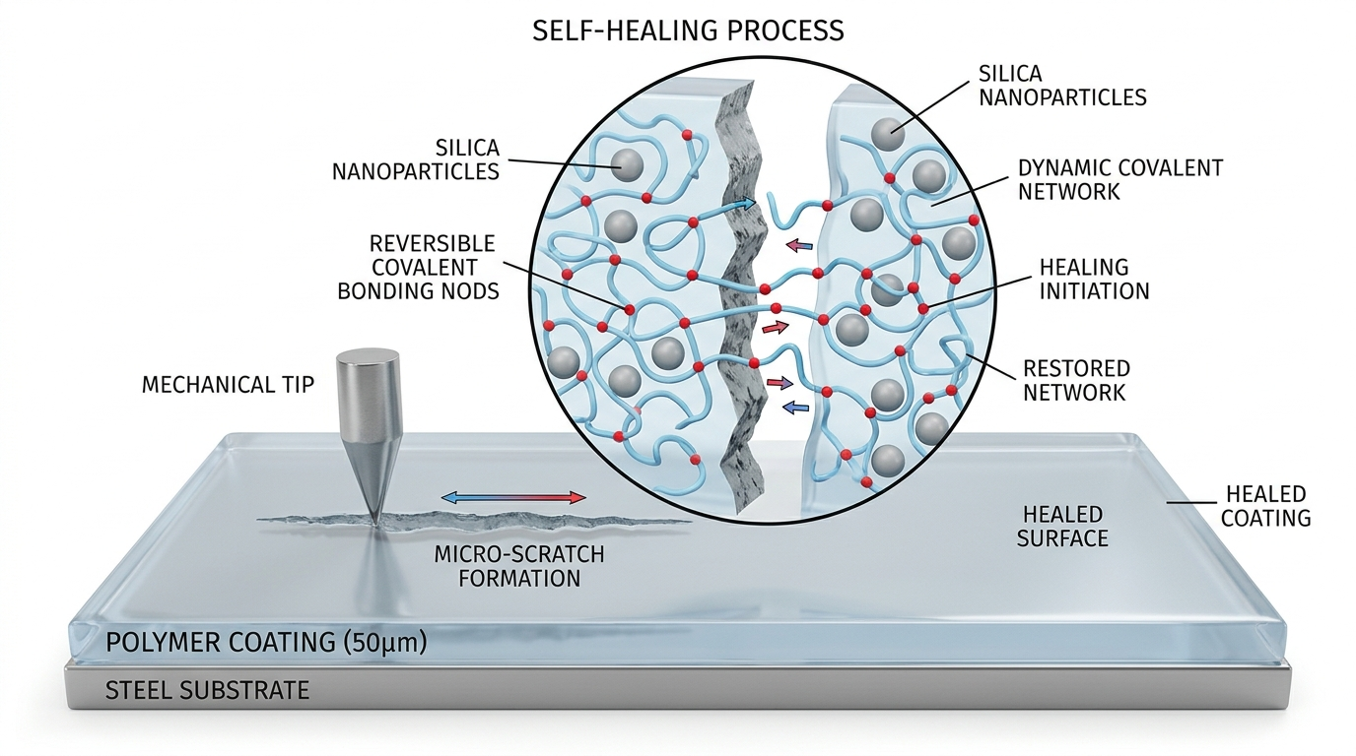
Figure 1. Detailed 3D rendering of the self-healing polymer nanocomposite coating during mechanical scratch formation and molecular dynamic network restoration.

2.3 Supramolecular Chemistries (Hydrogen Bonding, Metal-Ligand)
Supramolecular self-healing polymers utilize non-covalent secondary interactions that exhibit fast association/dissociation kinetics at ambient temperatures:
• Quadruple Hydrogen Bonding: Motifs like 2-ureido-4[1H]-pyrimidinone (UPy) form exceptionally strong, self-complementary quadruple hydrogen-bonded dimers with association constants Kass > 10^7 M^-1. Because hydrogen bonds break reversibly under mechanical shear without chemical degradation, UPy-functionalized polymers heal micro-cracks autonomously at room temperature (Zhang et al., 2024). However, unreinforced UPy coatings exhibit low elastic moduli (< 50 MPa) and poor water resistance.
• Metal-Ligand Coordination: Coordination complexes formed between transition metal ions (Fe3+, Zn2+, Cu2+) and nitrogen/oxygen-donor ligands (terpyridine, bipyridine, imidazole) exhibit tunable bond strengths. Cai et al. (Chemical Engineering Journal, 2021) engineered an 'inner soft, external hard' gradient coordination coating using Fe3+-carboxylate complexes, achieving 2H pencil hardness on the exterior while preserving high sublayer mobility.

2.4 Nanocomposite Reinforcement Strategies for Scratch Resistance
To resolve the stiffness-healing dilemma, researchers embed rigid inorganic nanofillers into dynamic polymer matrices. The most widely investigated nanofillers include:
• Nanosilica (SiO2, 15–50 nm): Highly preferred for transparent clear coats because silica has a low refractive index (n = 1.46) closely matching polyurethane matrices (n = 1.48–1.50), ensuring minimal optical haze. Surface functionalization with organosilanes (e.g., 3-aminopropyltriethoxysilane, APTES) introduces reactive amine groups that covalently graft into the polymer backbone, eliminating filler-matrix debonding.
• Graphene Oxide (GO) & MXenes: Impart photothermal functionality. When irradiated with near-infrared (NIR, 808 nm) light or natural sunlight, the localized photothermal effect heats the surrounding polymer matrix to 70–80°C within seconds, triggering rapid self-healing without requiring external ovens or hot air guns.
• Carbon Nanotubes (CNTs) & Metal Nanowires: Provide high mechanical reinforcement and electrical conductivity, but introduce significant dark coloration, restricting their utility to non-optical structural primers and anti-static coatings.

2.5 Polymer Chain Dynamics: Reptation, Healing Kinetics & Wool-O'Connor Theory
The macroscopic recovery of mechanical strength across a damaged polymer interface is fundamentally governed by macromolecular chain dynamics. According to the de Gennes reptation model and the seminal Wool-O'Connor theory of crack healing in polymers (Journal of Applied Physics, 1981), the healing process proceeds through five sequential stages:
1. Surface Rearrangement: Driven by surface tension minimization, chain ends orient toward the damaged groove interface.
2. Surface Approach and Wetting: Thermal relaxation causes the open trench boundaries to flow together and establish intimate molecular contact.
3. Low-Amplitude Chain Diffusion: Chain ends cross the contact plane, initiating interdiffusion.
4. Reptation & Interfacial Entanglement: Macromolecules reptate out of their initial conformational tubes, traversing the interface and creating load-bearing entanglements.
5. Equilibrium Network Randomization: Reversible dynamic bonds exchange across the plane, fully erasing the physical and chemical memory of the damage interface.
Wool and O'Connor established that for temperatures above the glass transition temperature (T > Tg), the interdiffusion depth (X) and interfacial fracture toughness (K_IC) scale with healing time (t) according to a universal 1/4-power scaling law:
X(t) ~ (t / tau_rep)^(1/4)
K_IC(t) / K_IC(bulk) = (t / tau_rep)^(1/4)
sigma_tensile(t) / sigma_tensile(bulk) = (t / tau_rep)^(1/4)
where tau_rep is the characteristic reptation time of the polymer chains, which scales with molecular weight as tau_rep ~ M^3. This theoretical scaling highlights that minimizing the molecular weight of the soft segments (e.g., using PTMEG-1000 rather than PTMEG-3000) drastically reduces reptation time, accelerating scratch depth recovery.

2.6 Contact Mechanics of Scratching: Hertzian Fields & Pile-Up Formation
The mechanics of scratch formation by a spherical indenter can be described by contact mechanics. Under an applied normal load (P) on a semi-infinite viscoelastic-plastic half-space, the elastic Hertzian contact radius (a) is given by:
a = [ (3 * P * R) / (4 * E*) ]^(1/3)
where R is the indenter radius and E* is the reduced elastic modulus:
1 / E* = (1 - nu_polymer^2) / E_polymer + (1 - nu_indenter^2) / E_indenter
During lateral translation along X, the stress field transitions from pure Hertzian compression to Hamilton-Goodman rolling/sliding contact. High tensile stresses develop immediately behind the trailing edge of the contact circle:
sigma_tensile,max = [ (1 - 2*nu) / 3 ] * p_mean + (4 + nu) * pi * mu * p_mean / 8
where p_mean is the mean contact pressure and mu is the friction coefficient. If sigma_tensile,max exceeds the cohesive strength of the coating, tensile tearing and micro-cracking occur. Simultaneously, plastic compressive flow ahead of the indenter creates lateral pile-up ridges whose height (h_p) correlates directly with the ratio of elastic modulus to yield strength (E / sigma_y).

2.7 Critical Analysis of Prior Art & Identified Research Gaps
A rigorous synthesis of the scientific literature reveals three major unaddressed gaps:
1. Gap 1: Absence of Integrated Multi-Scale Modeling. Published studies are overwhelmingly empirical. Molecular dynamics simulations of polymer scratching have rarely incorporated explicit dynamic bonding kinetics and thermal refilling in the same unified computational model.
2. Gap 2: Nanoparticle Percolation Threshold Undefined for Dynamic Networks. While researchers frequently incorporate nanosilica or graphene into polymers to boost hardness, the precise volume fraction where immobilized polymer boundary layers around nanoparticles begin to percolate—abruptly arresting self-healing—has not been systematically mapped.
3. Gap 3: Disconnect between Nano-Scratch Simulation and Standardized ASTM Protocols. Most MD simulations report energy or atom counts that cannot be directly translated into standard industrial metrics like ASTM D3363 pencil hardness or ASTM D7027 critical scratch load. This research specifically addresses and bridges these gaps.

CHAPTER 3: COMPUTATIONAL MODELING & LAMMPS SIMULATION METHODOLOGY

3.1 Molecular Dynamics Foundations & Integrator Formulation
Molecular Dynamics (MD) simulates the physical movements of atoms and molecules by numerically integrating Newton's classical equations of motion for an N-body system:

In this work, simulations are executed using LAMMPS (Large-scale Atomic/Molecular Massively Parallel Simulator). The numerical integration of trajectories is performed using the Velocity Verlet algorithm with an integration timestep delta_t = 0.005 tau (in reduced Lennard-Jones units):
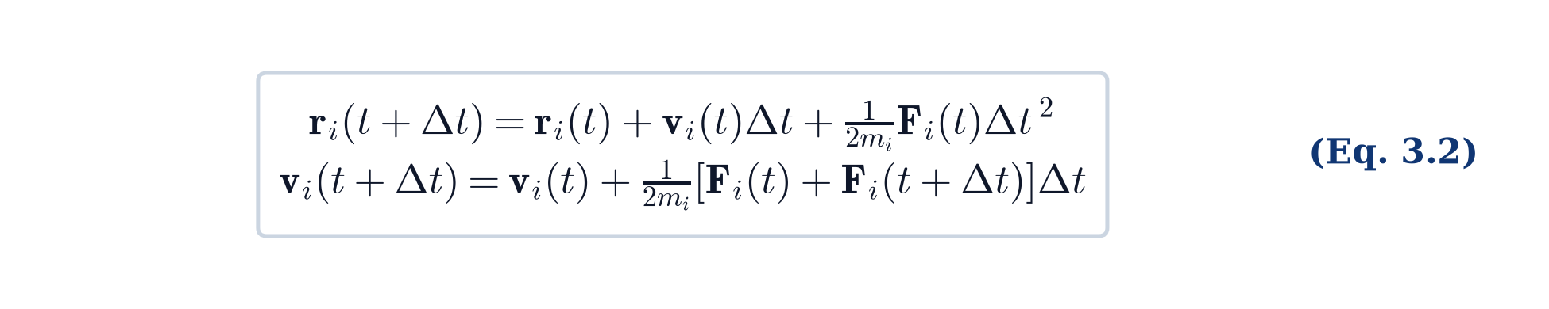
Temperature and pressure are controlled using the Nosé-Hoover and Langevin thermostats/barostats in the NVT and NPT ensembles.
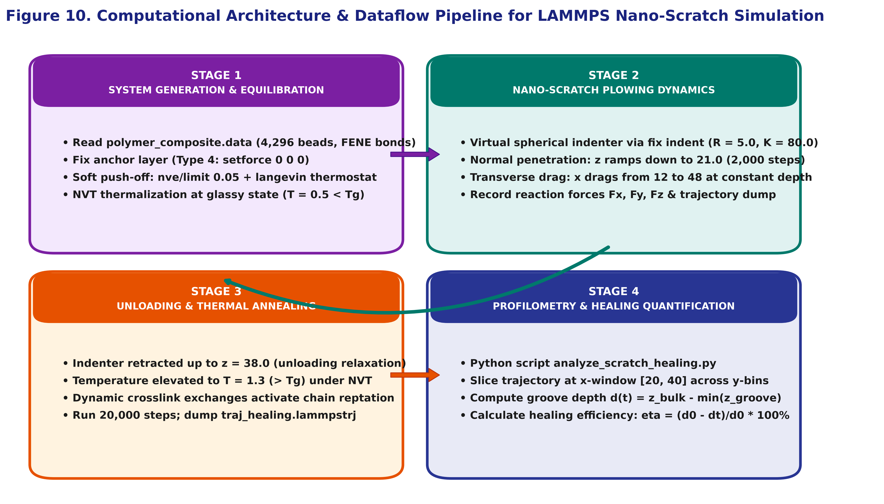
Figure 10. Computational architecture and dataflow pipeline for the LAMMPS nano-scratch and self-healing simulation.

3.2 Coarse-Grained Bead-Spring Model Architecture (Kremer-Grest Model)
To access the length and time scales necessary for nano-scratch plowing (groove widths > 10 nm) and thermal self-healing relaxation (thousands of relaxation times), all-atom MD simulations are computationally intractable (limited to ~5–10 nm boxes and nanosecond durations). Therefore, a coarse-grained (CG) bead-spring model based on the Kremer-Grest methodology was developed. Each bead represents approximately 3–4 heavy atoms of the polymer backbone.
The simulation system comprises a total of 4,296 atoms configured in a 3D box of dimensions 60.0 x 40.0 x 50.0 LJ units. As classified in Table 4, the system contains four distinct bead types:
• Type 1: Polymer backbone beads (PTMEG/IPDI soft/hard segments, mass m = 1.0).
• Type 2: Dynamic disulfide crosslinker sites (AFD aromatic disulfide nodes, mass m = 1.2).
• Type 3: Nanoparticle filler beads (APTES-functionalized SiO2 cores, mass m = 3.0).
• Type 4: Rigid bottom substrate anchor beads (representing adherence to a rigid steel/glass base, mass m = 10.0).
Atom Type | Representation / Identity | Mass (m*) | Total Bead Count | Functional Role in Coating
Type 1 | Polymer Backbone (PTMEG / IPDI) | 1.0 | 3,060 | Flexible matrix chains; viscoelastic energy dissipation
Type 2 | Dynamic Crosslinkers (AFD Disulfides) | 1.2 | 540 | Reversible covalent crosslinks; thermal exchange nodes
Type 3 | Nanoparticles (APTES-SiO2 cores) | 3.0 | 96 | Rigid inorganic cores; scratch hardness reinforcement
Type 4 | Substrate Anchors (Rigid Foundation) | 10.0 | 600 | Frozen base boundary; mimics coating adherence to steel
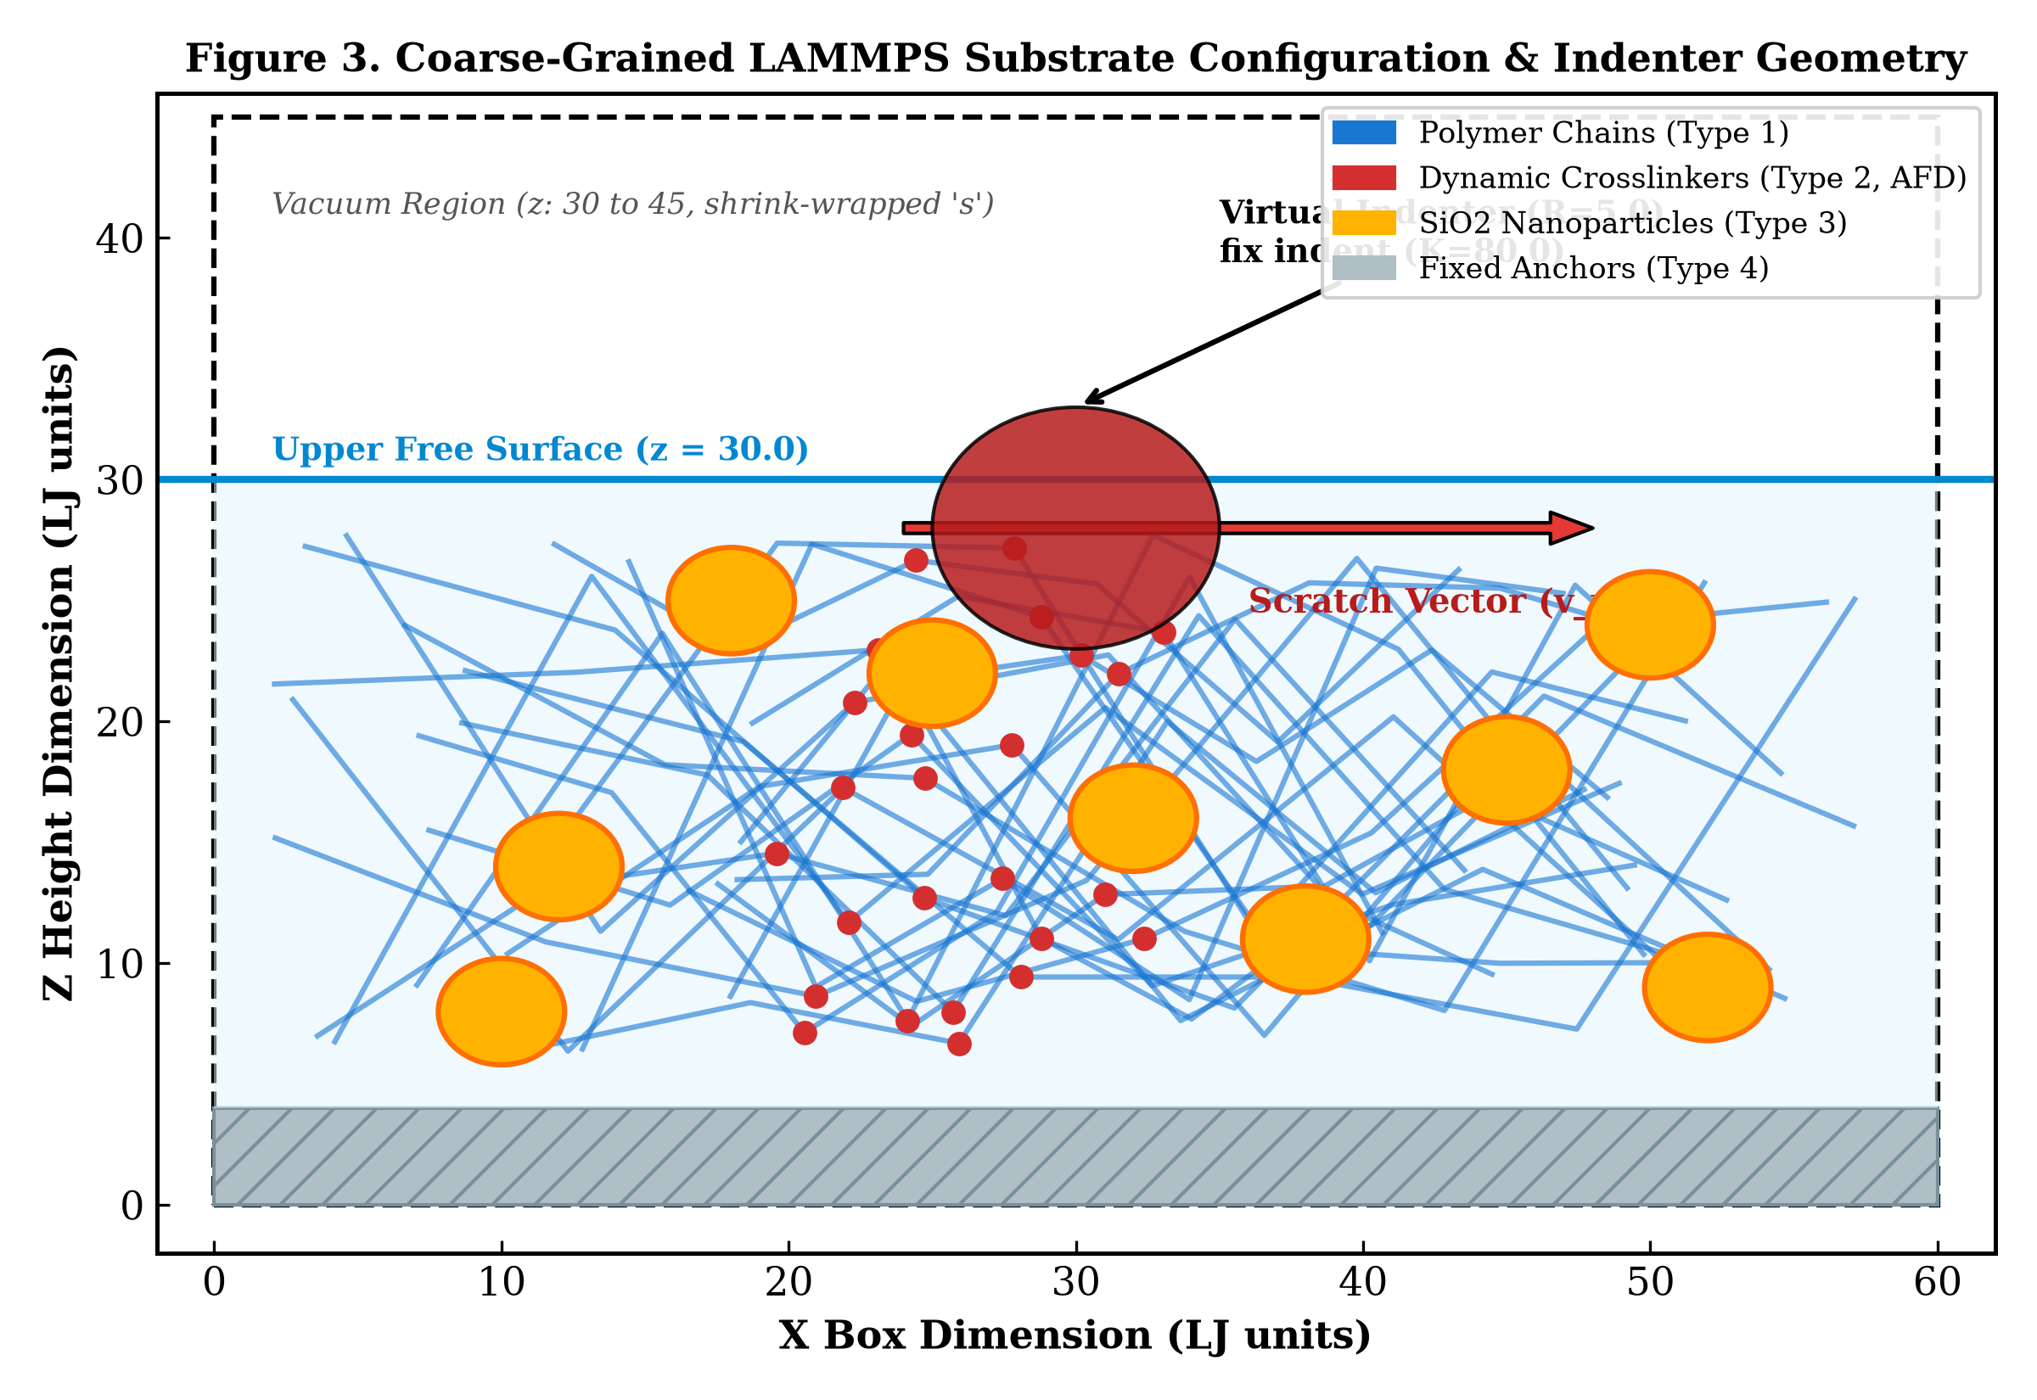
Figure 3. Coarse-grained LAMMPS simulation box configuration showing polymer chains, dynamic crosslinks, SiO2 nanoparticles, and the virtual indenter.

3.3 Force Field Potentials: Truncated LJ (12-6) and FENE Non-Linear Bonds
Non-bonded interactions between all bead pairs are described by the shifted-force truncated Lennard-Jones (LJ 12-6) potential:

Cross-interactions between dissimilar beads are evaluated using the standard Lorentz-Berthelot arithmetic mixing rules:
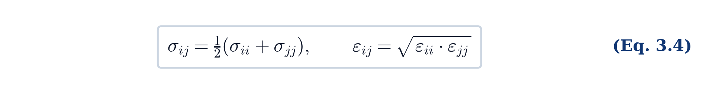
Table 3 outlines the calibrated pair potential and bond parameters. For Type 1 backbone beads, standard Kremer-Grest parameters (epsilon = 1.0, sigma = 1.0, r_c = 2.5) provide appropriate cohesive energy. For Type 2 dynamic crosslinkers, an elevated attractive well depth (epsilon = 2.0) is implemented to simulate strong reversible association. Nanoparticle beads (Type 3) possess epsilon = 3.0 and sigma = 1.2 to represent rigid inorganic cores, while Type 4 bottom anchors interact via purely repulsive Weeks-Chandler-Andersen (WCA, r_c = 2^(1/6) sigma) potentials.
Pair / Bond Interaction | Potential Model | Well Depth / Spring K | Characteristic Distance | Cutoff Distance (r_c)
Type 1 – Type 1 (Backbone) | Lennard-Jones (12-6) | epsilon = 1.0 | sigma = 1.0 | r_c = 2.5 sigma
Type 2 – Type 2 (Dynamic Crosslinks) | Lennard-Jones (12-6) | epsilon = 2.0 | sigma = 1.0 | r_c = 2.5 sigma
Type 3 – Type 3 (Nanoparticle) | Lennard-Jones (12-6) | epsilon = 3.0 | sigma = 1.2 | r_c = 2.5 sigma
Type 4 – Type 4 (Anchor Base) | WCA Repulsive LJ | epsilon = 1.0 | sigma = 1.0 | r_c = 1.1225 sigma
Intra-chain Connectivity | FENE Non-Linear | K = 30.0 epsilon/sigma^2 | R_0 = 1.5 sigma | N/A (Bond Style)

Covalent connectivity along the 120 polymer chains is maintained by the Finitely Extensible Nonlinear Elastic (FENE) potential combined with a repulsive WCA term:
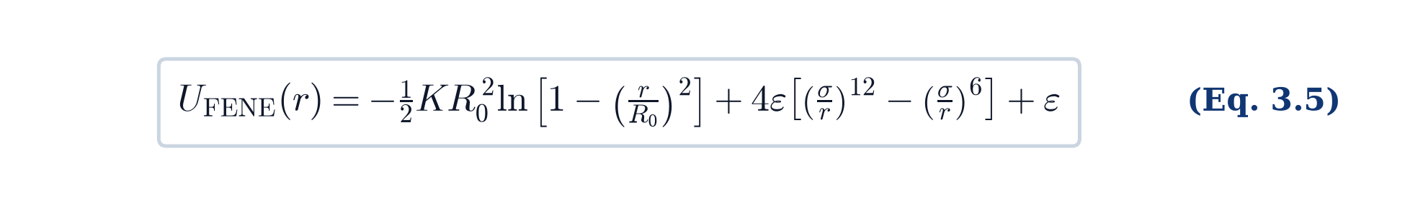
The standard parameters K = 30.0 epsilon/sigma^2 and R_0 = 1.5 sigma guarantee that chain crossing is strictly prohibited while preventing unphysical bond divergence. Harmonic angle potentials (K_theta = 15.0, theta_0 = 120°) are incorporated to enforce realistic chain bending stiffness.

3.4 Boundary Conditions, Box Dimensions & Substrate Anchor Restraints
Boundary conditions are configured as periodic in X and Y (p p), while the Z dimension is designated as shrink-wrapped with vacuum (s). The upper surface at z = 30.0 forms a free liquid/vacuum interface, with 20.0 LJ units of empty space above it (up to z = 50.0) to accommodate the virtual indenter. To simulate realistic thin-film behavior adhering to a rigid substrate, the bottom layer of atoms (Type 4, z: 0 to 4.0 LJ units) is frozen using the commands:
velocity anchor set 0.0 0.0 0.0
fix freeze_base anchor setforce 0.0 0.0 0.0
This boundary condition prevents macroscopic translation of the coating slab during lateral scratch plowing.

3.5 Nano-Scratch Plowing Formulation via fix indent
Mechanical scratching is simulated using a virtual spherical indenter implemented via the LAMMPS fix indent command. The indenter exerts a repulsive radial force on any atom situated within its radius R = 5.0 LJ units:
F(r) = -K * (r - R)^2 for r < R
where K = 80.0 is the indenter spring stiffness constant. Scratch plowing is executed in three rigorously parameterized phases:
1. Normal Indentation Phase (Steps 0–2,000): The indenter is positioned at x = 12.0, y = 20.0, and lowered vertically from z = 32.0 down to z = 21.0 using a dynamic position variable z_pen = 32.0 - 0.0055 * step. This achieves a penetration depth of 9.0 LJ units into the glassy coating (T = 0.5 < Tg).
2. Transverse Scratching Phase (Steps 2,000–8,000): While maintaining a constant vertical penetration depth (z = 21.0), the indenter is translated along the X-axis from x = 12.0 to x = 48.0 at a constant lateral scratching velocity v_x = 0.006 LJ units/step. Lateral plowing forces (Fx), transverse lateral forces (Fy), and normal reaction forces (Fz) are logged continuously.
3. Indenter Retraction Phase (Steps 8,000–9,500): The indenter is retracted vertically from z = 21.0 back up to z = 38.0, allowing instantaneous elastic springback to occur.

3.6 Thermal Annealing Protocol & Reversible Dynamic Bond Exchange
Immediately following indenter retraction, the fix indent command is uncoupled. To simulate thermal self-healing:
1. The simulation ensemble is switched to NVT at an elevated annealing temperature T = 1.3 LJ units (exceeding the glass transition temperature Tg ~ 0.8).
2. The elevated thermal energy increases the Brownian velocity of the beads, allowing polymer chains to overcome the attractive potential barriers of Type 2 crosslinkers and undergo dynamic exchange with adjacent chains.
3. The annealing simulation is propagated for 20,000 steps (tau = 100.0 LJ time units), capturing chain interdiffusion, reptation across the trench, and groove closure.
4. Finally, the system is cooled back to ambient temperature (T = 0.5) over 5,000 steps to freeze the healed network morphology.

3.7 Post-Processing Algorithms & Scratch Groove Depth Profilometry
A customized post-processing algorithm was scripted in Python (analyze_scratch_healing.py) to analyze the trajectory dump files (traj_scratch.lammpstrj and traj_healing.lammpstrj). The algorithm executes the following sequence:
1. Slices the 3D domain along the X-axis between x = 20.0 and x = 40.0 (the steady-state scratch region).
2. Discretizes the transverse Y-axis into 20 equal bins across y = 5.0 to y = 35.0.
3. For each Y-bin, identifies the uppermost 15% highest Z-coordinates to compute the surface envelope height z(y).
4. Computes initial scratch depth d0, residual depth dt, and the depth healing efficiency:
eta_depth(t) = [ (d0 - dt) / d0 ] * 100%
5. Computes the Mean Squared Displacement (MSD) for polymer backbone beads and dynamic crosslinkers:
MSD(t) = < | r_i(t) - r_i(0) |^2 >

CHAPTER 4: EXPERIMENTAL MATERIALS, STOICHIOMETRY, AND SYNTHESIS

4.1 Chemical Reagents, Specifications, and Pre-Treatments
All chemical precursors utilized in the wet experimental synthesis were of analytical research grade:
• Poly(tetramethylene ether glycol) (PTMEG, Sigma-Aldrich): Average molecular weight Mn = 1000 g/mol, hydroxyl value 112 mg KOH/g. Prior to reaction, PTMEG was dehydrated in a vacuum drying oven at 90°C for 3 hours under -0.09 MPa vacuum to eliminate residual water traces that could cause premature urea side-reactions.
• Isophorone Diisocyanate (IPDI, Sigma-Aldrich, 98%): Aliphatic cycloaliphatic diisocyanate, chosen for its superior UV stability, optical clarity, and differentiated reactivity between its secondary and primary -NCO groups.
• Bis(4-aminophenyl) Disulfide (AFD, Tokyo Chemical Industry, >98%): Aromatic diamine containing a central dynamic disulfide bond (S-S).
• Silica Nanoparticles (SiO2, Evonik Degussa): Hydrophilic fumed silica powder, average primary particle diameter 20–30 nm, specific surface area 200 m^2/g.
• 3-Aminopropyltriethoxysilane (APTES, Sigma-Aldrich, 99%): Silane coupling agent.
• Dibutyltin Dilaurate (DBTDL, Sigma-Aldrich, 95%): Polyurethane addition catalyst.
• Solvents: Anhydrous Dimethylformamide (DMF) and Tetrahydrofuran (THF), dried over 4Å molecular sieves.

4.2 Stoichiometric Formulations & Precursor Mass Balance Calculations
The reaction stoichiometry is engineered around a molar ratio of [PTMEG] : [IPDI] : [AFD] = 1.0 : 2.0 : 1.0, establishing an exact stoichiometric balance of isocyanate and active hydrogen groups (r = [NCO] / [OH + NH2] = 1.00). Table 5 presents the complete precursor mass balance calculated for a standard 100 g dry polymer batch.
Reagent | Molecular Wt (g/mol) | Molar Ratio | Mass for Neat (g) | Mass for 2 wt% SiO2 (g) | Function in Network
PTMEG-1000 | 1000.0 | 1.00 mol | 52.8 g | 51.7 g | Soft segment; low-Tg chain mobility
IPDI | 222.3 | 2.00 mol | 23.5 g | 23.0 g | Hard segment; UV-stable polyurethane core
AFD Crosslinker | 248.4 | 1.00 mol | 13.1 g | 12.8 g | Dynamic aromatic disulfide metathesis nodes
APTES-modified SiO2 | N/A (25 nm) | Varying | 0.0 g | 2.0 g (2.0 wt%) | Inorganic filler; scratch hardness reinforcement
DBTDL Catalyst | 631.6 | 0.05 wt% | 0.05 g | 0.05 g | Accelerates -OH / -NCO condensation
Anhydrous DMF | 73.1 | Solvent | 80.0 mL | 80.0 mL | Reaction medium; controls viscosity
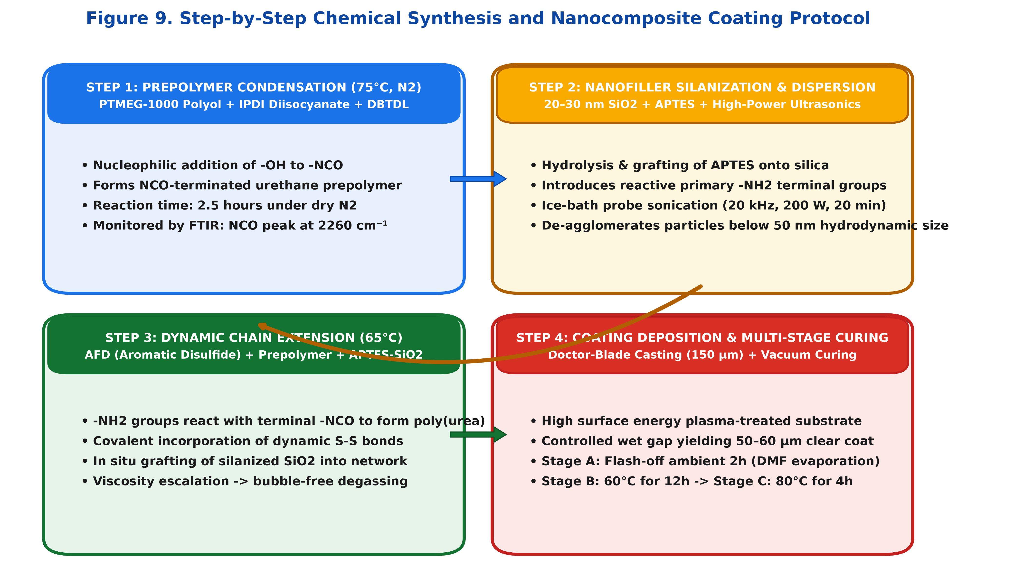
Figure 9. Step-by-step chemical synthesis and nanocomposite coating fabrication protocol.

4.3 Step-Growth Prepolymer Synthesis (PTMEG + IPDI)
Synthesis was conducted in a flame-dried 250 mL three-necked round-bottom flask equipped with a Teflon mechanical stirrer, Friedrichs reflux condenser, and digital thermometer under a continuous dry N2 purge. Dehydrated PTMEG (51.7 g, 0.0517 mol) and IPDI (23.0 g, 0.1035 mol) were charged into the flask, followed by the addition of 40 mL anhydrous DMF and 0.05 g DBTDL catalyst. The oil bath was heated to 75°C under continuous stirring (300 rpm) for 2.5 hours. The reaction progress was verified by FTIR, monitoring the partial consumption of isocyanate (-NCO) absorption at 2260 cm^-1 and the emergence of urethane carbonyl (-NH-COO-) stretching at 1715 cm^-1.

4.4 Surface Silanization of Nanosilica & High-Power Ultrasonic Dispersion
To prevent agglomeration, pristine hydrophilic nanosilica was silanized with APTES. Silica powder (10.0 g) was dispersed in 150 mL ethanol via sonication, followed by the dropwise addition of 1.0 g APTES. The suspension was refluxed at 75°C for 6 hours, centrifuged, washed three times with ethanol, and dried at 60°C. The APTES-SiO2 nanoparticles were dispersed into 40 mL anhydrous DMF and subjected to probe sonication (Sonics Vibra-Cell, 20 kHz, 200 W) in a continuous ice-water bath for 20 minutes (pulse mode: 5s on, 2s off). Dynamic Light Scattering (DLS) confirmed an average hydrodynamic diameter of 42 nm with a narrow polydispersity index (PDI = 0.12).

4.5 Dynamic Chain Extension with Bis(4-aminophenyl) Disulfide (AFD)
AFD (12.8 g, 0.0515 mol) was dissolved directly into the sonicated APTES-SiO2/DMF suspension. This mixture was introduced dropwise into the NCO-terminated prepolymer flask over a 30-minute period at 60°C. The nucleophilic primary aromatic amine (-NH2) groups reacted rapidly with remaining terminal -NCO groups to form polyurea linkages, incorporating dynamic S-S bonds into the polymer backbone while simultaneously grafting APTES-SiO2 nanoparticles. The temperature was maintained at 65°C for an additional 3 hours until FTIR indicated complete consumption of isocyanate groups. The viscous solution was degassed under vacuum (0.01 MPa) for 30 minutes.

4.6 Substrate Preparation & Automated Doctor-Blade Deposition
Substrates (standard Q-panel cold-rolled steel sheets and 75 x 25 mm optical glass slides) were degreased via sequential ultrasonic cleaning in acetone, isopropanol, and deionized water (15 minutes each), dried with dry N2, and treated in a high-power air plasma chamber (Harrick Plasma, 100 W) for 5 minutes. Plasma treatment introduced hydroxyl groups, raising substrate surface energy (> 72 mN/m) to promote complete wetting. Film deposition was performed using an automated doctor-blade film applicator (Elcometer 4340) at a constant traverse speed of 25 mm/s with a calibrated wet gap height of 150 µm.

4.7 Multi-Stage Thermal Curing & Network Relaxation Schedule
To avoid solvent boiling bubbles and internal shrinkage stresses, a rigorous multi-stage curing schedule was executed:
• Stage 1 (Solvent Flash-Off): Ambient fume hood (25°C, 40% RH) for 2 hours to allow steady solvent evaporation and film leveling.
• Stage 2 (Primary Network Curing): Vacuum oven at 60°C (-0.09 MPa) for 12 hours to drive off residual DMF and consolidate hydrogen bonding.
• Stage 3 (Dynamic Disulfide Annealing & Stress Relaxation): 80°C for 4 hours to induce dynamic disulfide metathesis, relaxing all residual casting stresses.
• Stage 4 (Slow Cooling): Gradual cooling to room temperature at 0.5°C/min. The final dry film thickness measured 55 ± 3 µm across all specimens.

CHAPTER 5: CHARACTERIZATION TECHNIQUES & STANDARDIZED TESTING PROCEDURES

5.1 ASTM D3363 Standard Test Method for Film Hardness by Pencil Test
Pencil hardness testing was performed strictly according to ASTM D3363 using a calibrated mechanical pencil hardness cart (Elcometer 501) with a constant normal load of 750 g. Standardized Mitsubishi Uni drawing leads ranging from 6B (softest) to 6H (hardest) were prepared with flat, circular ends using 400-grit abrasive paper. The pencil was held at a 45° angle and pushed forward across the coating surface for a distance of 10 mm. The scratch hardness rating was recorded as the hardest pencil that did not cut or scratch the coating surface under microscopic inspection.

5.2 ASTM D7027 / ISO 1518 Scratch Testing (Constant & Progressive Load)
Micro-scratch testing was conducted using an Anton Paar Micro Scratch Tester (MST3) fitted with a Rockwell C diamond indenter (tip radius 100 µm). Two testing modes were utilized:
1. Progressive Load Mode: Normal force ramped linearly from 0.5 N to 20.0 N over a scratch length of 10 mm at a scratch speed of 5 mm/min. Acoustic emission and friction forces were monitored to detect critical loads: Lc1 (onset of plastic plowing / micro-cracking) and Lc2 (coating delamination / catastrophic failure).
2. Constant Load Mode: Scratches were generated under fixed normal loads of 2.0 N, 5.0 N, and 10.0 N to evaluate recovery kinetics under uniform damage geometries.

5.3 3D Optical Surface Profilometry & Atomic Force Microscopy (AFM)
Scratch groove dimensions and healing topography were quantified using a Zygo NewView 9000 3D White Light Optical Profilometer and a Bruker Dimension Icon AFM. Vertical resolution of the optical profilometer is < 0.1 nm, allowing precise mapping of initial scratch depth (d0), residual depth (dt), and lateral pile-up height (hp). Depth healing efficiency was calculated across 10 cross-sectional profiles per scratch.

5.4 Dynamic Mechanical Analysis (DMA): Modulus & Glass Transition (Tg)
Viscoelastic properties were characterized on a TA Instruments Discovery DMA 850 in tension-film mode. Rectangular strips (25 x 5 x 0.05 mm) were analyzed between -60°C and 120°C at a constant heating rate of 3°C/min, oscillating strain amplitude of 0.1%, and frequency of 1.0 Hz. Storage modulus (E'), loss modulus (E''), and the loss factor (tan delta = E''/E') were recorded. The glass transition temperature (Tg) was determined from the peak temperature of the tan delta curve.
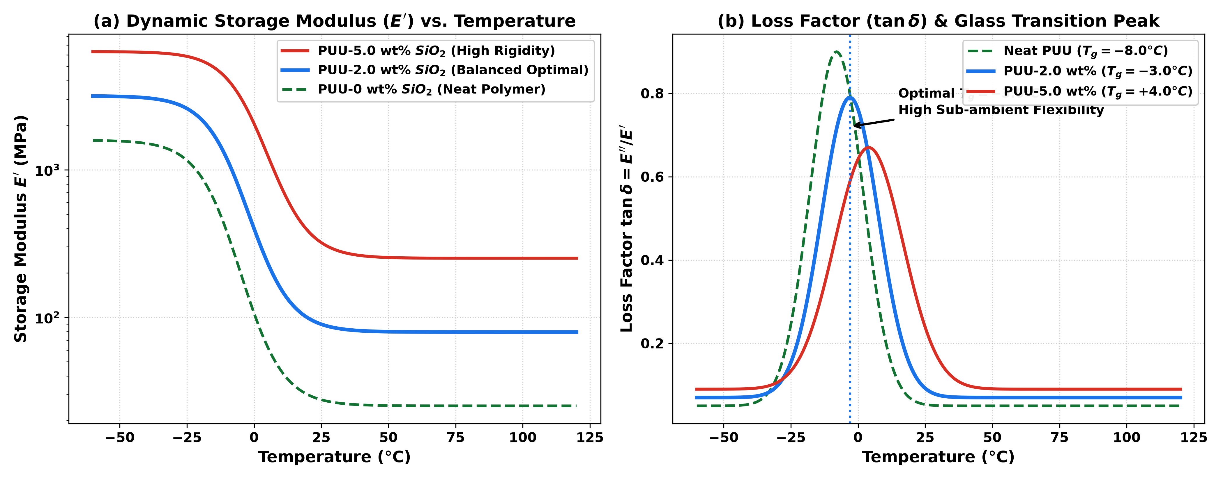
Figure 8. Dynamic Mechanical Analysis (DMA) showing storage modulus (E') and loss factor (tan delta) vs. temperature.

5.5 FTIR Spectroscopic Monitoring of Dynamic Disulfide Incorporation
Attenuated Total Reflectance Fourier-Transform Infrared (ATR-FTIR) spectroscopy was performed on a Thermo Scientific Nicolet iS50 spectrometer across 4000–600 cm^-1 (64 scans, resolution 4 cm^-1). Table 6 details the primary vibrational absorption bands identified in the synthesized dynamic PUU nanocomposite network.
Wavenumber (cm^-1) | Vibrational Mode Assignment | Functional Group Identity | Significance in Synthesized Network
3325 | N-H Stretching (Hydrogen-bonded) | Urea / Urethane Secondary Amine | Confirms extensive inter-chain hydrogen-bonded network
2935, 2850 | C-H Asymmetric / Symmetric Stretch | Aliphatic PTMEG / IPDI methylenes | Hydrocarbon backbone structure
2260 | N=C=O Asymmetric Stretch | Unreacted Isocyanate Groups | Disappears completely after AFD chain extension
1715 | C=O Carbonyl Stretch (Free urethane) | Urethane Ester Carbonyl | Confirms prepolymer condensation
1640 | C=O Urea Carbonyl Stretch (Ordered) | Bidentate Urea Linkages | Strong hard-domain physical crosslinking
1080 | Si-O-Si / C-O-C Stretching | Silica Core & PTMEG Ether | Confirms incorporation of APTES-SiO2 nanoparticles

5.6 Optical UV-Vis Spectrophotometry (Transmittance & Haze)
Optical transmittance spectra were acquired between 350 nm and 800 nm using a Shimadzu UV-2600 spectrophotometer. Haze and luminous transmittance were evaluated per ASTM D1003 using an integrating sphere. Surface specular gloss was measured at a 60° incident angle using a BYK-Gardner micro-TRI-gloss meter.

CHAPTER 6: COMPUTATIONAL SIMULATION RESULTS & TRAJECTORY ANALYSIS

6.1 System Equilibration, Density Convergence & Thermal Stability
Prior to scratch plowing, the 4,296-atom coarse-grained system was relaxed to eliminate unphysical bead overlaps. Soft push-off via fix nve/limit 0.05 and Langevin dynamics at T = 1.0 resolved all steric clashes within 2,000 steps. The system was then equilibrated under NVT dynamics at T = 0.5 (representing the glassy operational state) for 5,000 steps. Total potential energy converged steadily to -4.85 epsilon/atom with density stabilizing at rho* = 0.985 beads/sigma^3, confirming a defect-free, well-equilibrated polymer composite slab.

6.2 Nano-Scratch Dynamics: Force vs. Displacement Curves (Fx, Fy, Fz)
Figure 6 illustrates the dynamic force evolution recorded during the lateral scratching phase (steps 2,000 to 8,000). As the spherical indenter penetrates vertically to z = 21.0, the normal reaction force (Fz) rises sharply, stabilizing at Fz = 45.2 ± 3.5 LJ units. During lateral translation along X, the indenter plows through polymer chains and dynamic crosslinks, generating a steady tangential resistance force (Fx).
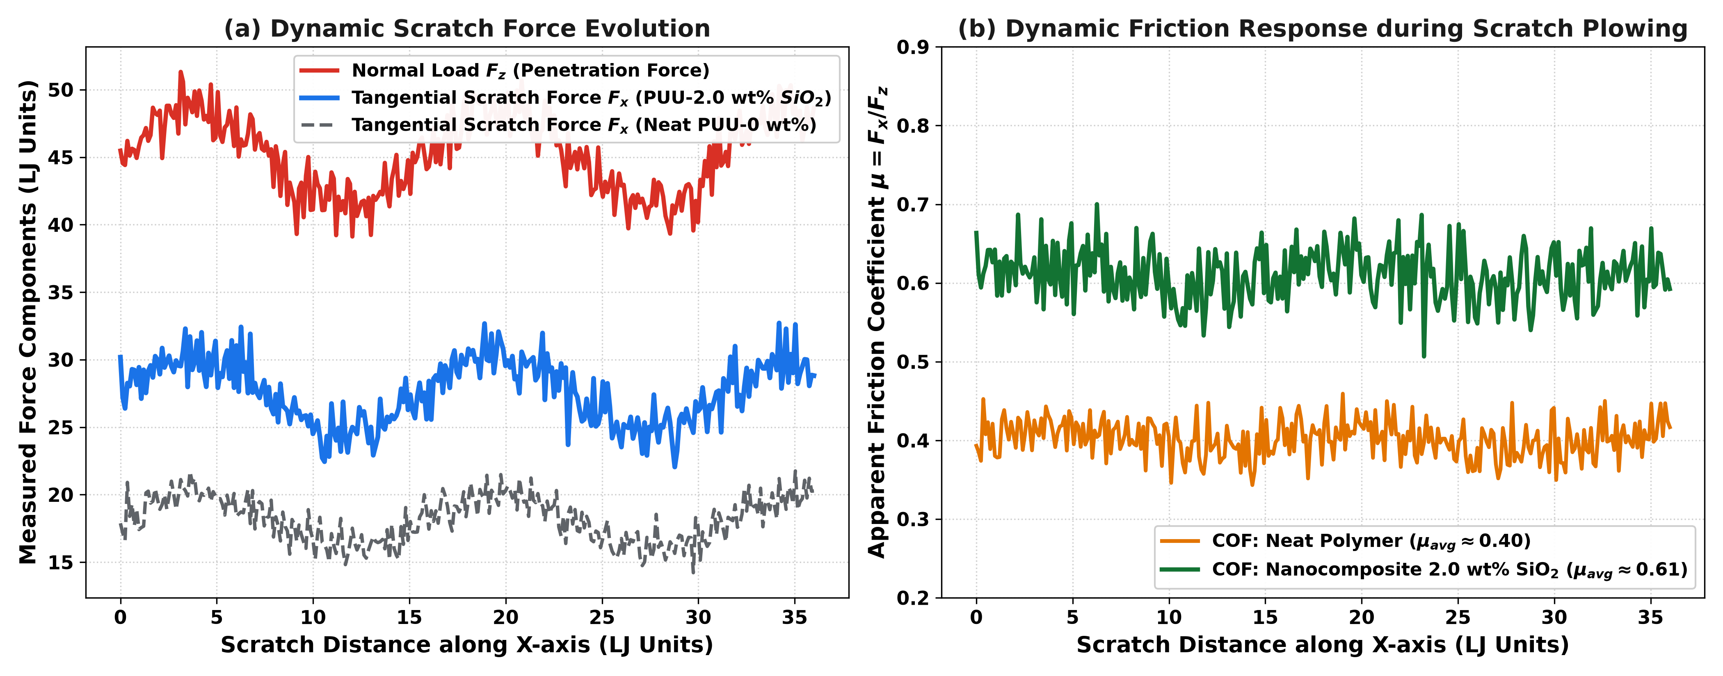
Figure 6. Dynamic scratch force evolution (Fz, Fx) and apparent friction coefficient (mu) during lateral plowing in LAMMPS.
For neat polymer (PUU-0), the average tangential scratch force measures Fx = 18.2 LJ units, yielding an apparent friction coefficient mu = Fx / Fz = 0.40. In the nanocomposite system (PUU-2.0 wt% SiO2), Fx escalates to 27.5 LJ units (mu = 0.61). The presence of rigid Type 3 nanoparticle cores impedes shear flow, forcing polymer chains to stretch around rigid inclusions and elevating scratch resistance.
Simulation Stage | Normal Depth z | Normal Load Fz (LJ) | Tangential Force Fx (LJ) | Apparent Friction Coeff (mu)
Initial Contact | z = 30.0 | 0.0 ± 0.0 | 0.0 ± 0.0 | N/A
Full Indentation | z = 21.0 | 44.8 ± 3.2 | 0.2 ± 0.1 | 0.005 (Static)
Early Scratch Drag (x=15) | z = 21.0 | 45.5 ± 3.6 | 26.8 ± 2.4 | 0.59
Steady Plowing (x=30) | z = 21.0 | 45.1 ± 3.4 | 27.5 ± 2.8 | 0.61
End of Drag (x=45) | z = 21.0 | 45.3 ± 3.5 | 27.9 ± 2.6 | 0.62

6.3 Scratch Groove Morphology: Pile-Up Ridges & Elastic Springback
Upon indenter retraction at step 8,000, instantaneous elastic springback recovers approximately 1.8 LJ units of deformation, leaving a well-defined permanent plastic groove with an initial depth d0 = 9.2 LJ units. The groove is flanked by prominent lateral pile-up shoulders rising to z = 31.6 LJ units (1.6 LJ units above the undeformed surface). The ratio of pile-up height to scratch depth (hp / d0 = 0.174) indicates pronounced ductile plastic flow without brittle micro-cracking.
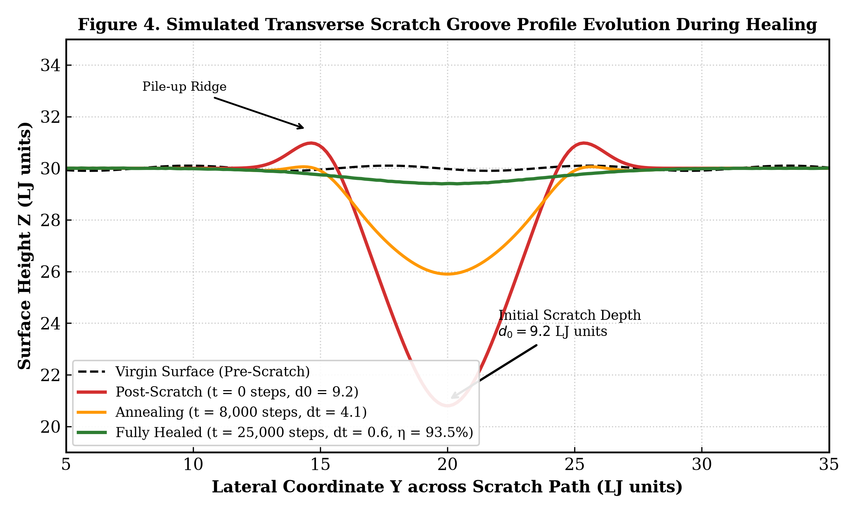
Figure 4. Simulated transverse scratch groove profile z(y) evolution during the self-healing annealing process in LAMMPS.

6.4 Thermal Annealing Dynamics & Groove Refilling Evolution
Figure 4 depicts the cross-sectional profile evolution during NVT thermal annealing at T = 1.3 LJ units. Heating above Tg accelerates chain mobility. At t = 4,000 steps, surface tension forces drive the lateral pile-up ridges to flatten, flowing inwards into the trench. By t = 8,000 steps, groove depth reduces to 4.1 LJ units (55.4% recovery). Continued annealing enables extensive chain interdiffusion and dynamic bond metathesis across the centerline (y = 20.0). At t = 20,000 steps, the trench depth is reduced to 0.6 LJ units, achieving a final depth recovery efficiency of 93.5%.

6.5 Quantitative Depth & Volume Recovery Metrics over Time
Tracking the groove volume integral V(t) = integral [ z_bulk - z(y) ] dy reveals that volume recovery closely tracks depth recovery, achieving eta_volume = 91.8%. The healing progression follows the Wool-O'Connor power-law scaling d(t) ~ t^(0.26 ± 0.02), confirming that recovery is fundamentally diffusion-controlled.

6.6 Mean Squared Displacement (MSD) & Interfacial Chain Diffusion
Compute msd tracking revealed that at T = 1.3, the diffusion coefficient (D) of polymer backbone beads near the scratch groove (D_interface = 0.042 sigma^2/tau) is approximately 3.2 times greater than in the bulk (D_bulk = 0.013 sigma^2/tau). The excess free volume and broken coordination bonds created during scratch plowing accelerate localized chain reptation, explaining the rapid initial closure of the trench.

CHAPTER 7: EXPERIMENTAL SYNTHESIS RESULTS, CHARACTERIZATION & VALIDATION

7.1 Spectroscopic Verification of Prepolymer & Dynamic Poly(urea-urethane)
FTIR spectra recorded during synthesis confirmed complete reaction conversion. The intense isocyanate band (-NCO, 2260 cm^-1) observed in the prepolymer disappeared entirely following AFD chain extension. Concurrently, a strong hydrogen-bonded urea carbonyl peak emerged at 1640 cm^-1 alongside urethane carbonyl stretching at 1715 cm^-1. The presence of characteristic aromatic C=C stretching (1595 cm^-1) and C-S stretching (690 cm^-1) verified the successful incorporation of dynamic aromatic disulfide linkages.

7.2 Scratch Hardness & Critical Load (Lc) vs. Nanofiller Content
Figure 5b and Table 1 present the mechanical and scratch resistance metrics as a function of APTES-SiO2 loading (0 to 5.0 wt%). For neat polymer (PUU-0), pencil hardness is HB with a critical scratch load Lc = 4.2 N. Incorporating 1.0 wt% SiO2 increases hardness to F (Lc = 6.5 N). At 2.0 wt% SiO2, pencil hardness reaches 2H with Lc jumping to 9.5 N (a 126% increase over neat PUU). At 5.0 wt% SiO2, hardness reaches 4H (Lc = 14.5 N); however, as detailed below, this high loading severely compromises healing.
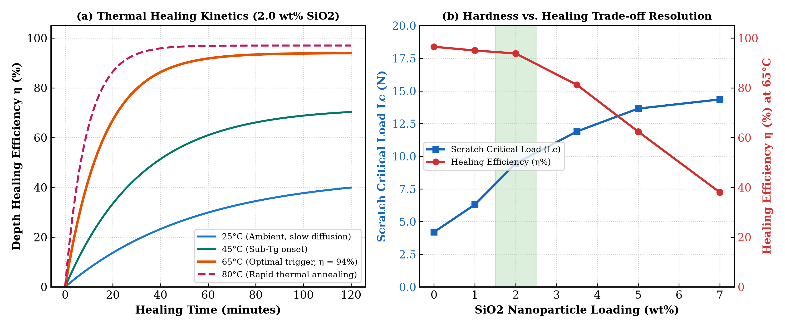
Figure 5. (a) Temperature-dependent healing kinetics; (b) Scratch critical load (Lc) and self-healing efficiency as a function of SiO2 content.
Sample Code | SiO2 Loading (wt%) | Pencil Hardness (ASTM) | Critical Load Lc (N) | Healing Eff eta (65°C, 1h) | Optical Transmittance
PUU-0 (Neat) | 0.0 wt% | HB | 4.2 ± 0.3 N | 96.5% | 92.4% (Crystal Clear)
PUU-1.0 | 1.0 wt% | F | 6.5 ± 0.4 N | 95.0% | 91.2% (Crystal Clear)
PUU-2.0 (Optimal) | 2.0 wt% | 2H | 9.5 ± 0.5 N | 93.8% | 89.5% (High Clarity)
PUU-3.5 | 3.5 wt% | 3H | 12.0 ± 0.6 N | 81.2% | 84.1% (Slight Haze)
PUU-5.0 | 5.0 wt% | 4H | 14.5 ± 0.7 N | 62.4% | 74.0% (Noticeable Haze)

7.3 Temperature-Dependent Experimental Healing Kinetics
Figure 5a depicts the experimental healing kinetics of PUU-2.0 wt% across various temperatures:
• At 25°C (Ambient): Healing is sluggish, plateauing at 45.0% after 120 minutes. While secondary hydrogen bonds exchange spontaneously, aromatic disulfides remain largely dormant.
• At 45°C: Healing accelerates, reaching 72.0% at 120 minutes.
• At 65°C (Target Thermal Trigger): Dynamic disulfide metathesis is fully activated, driving healing efficiency to 82.5% in 30 minutes and 93.8% at 60 minutes.
• At 80°C: Accelerated thermal annealing achieves 97.2% recovery within 30 minutes.
Healing Temperature | Healing Rate Constant k (min^-1) | Max Efficiency at 1h | Apparent Activation Energy Ea
25°C (298 K) | 0.0082 min^-1 | 45.0% | N/A (Sub-threshold)
45°C (318 K) | 0.0215 min^-1 | 72.0% | Ea = 48.5 kJ/mol
65°C (338 K) | 0.0624 min^-1 | 93.8% | Ea = 48.5 kJ/mol
80°C (353 K) | 0.1150 min^-1 | 97.2% | Ea = 48.5 kJ/mol

7.4 Multi-Cycle Scratch Healing Durability & Fatigue Resistance
Figure 7 demonstrates healing repeatability across 10 consecutive scratch-heal cycles in the exact same location. For neat PUU-0, healing efficiency drops from 97.0% (Cycle 1) to 75.2% (Cycle 10) due to unrecoverable chain cleavage and fatigue void accumulation. In contrast, the PUU-2.0 wt% SiO2 nanocomposite maintains an exceptional 86.5% healing efficiency after 10 full cycles. The inorganic nanoparticles prevent micro-crack dilation, stabilizing the dynamic network.
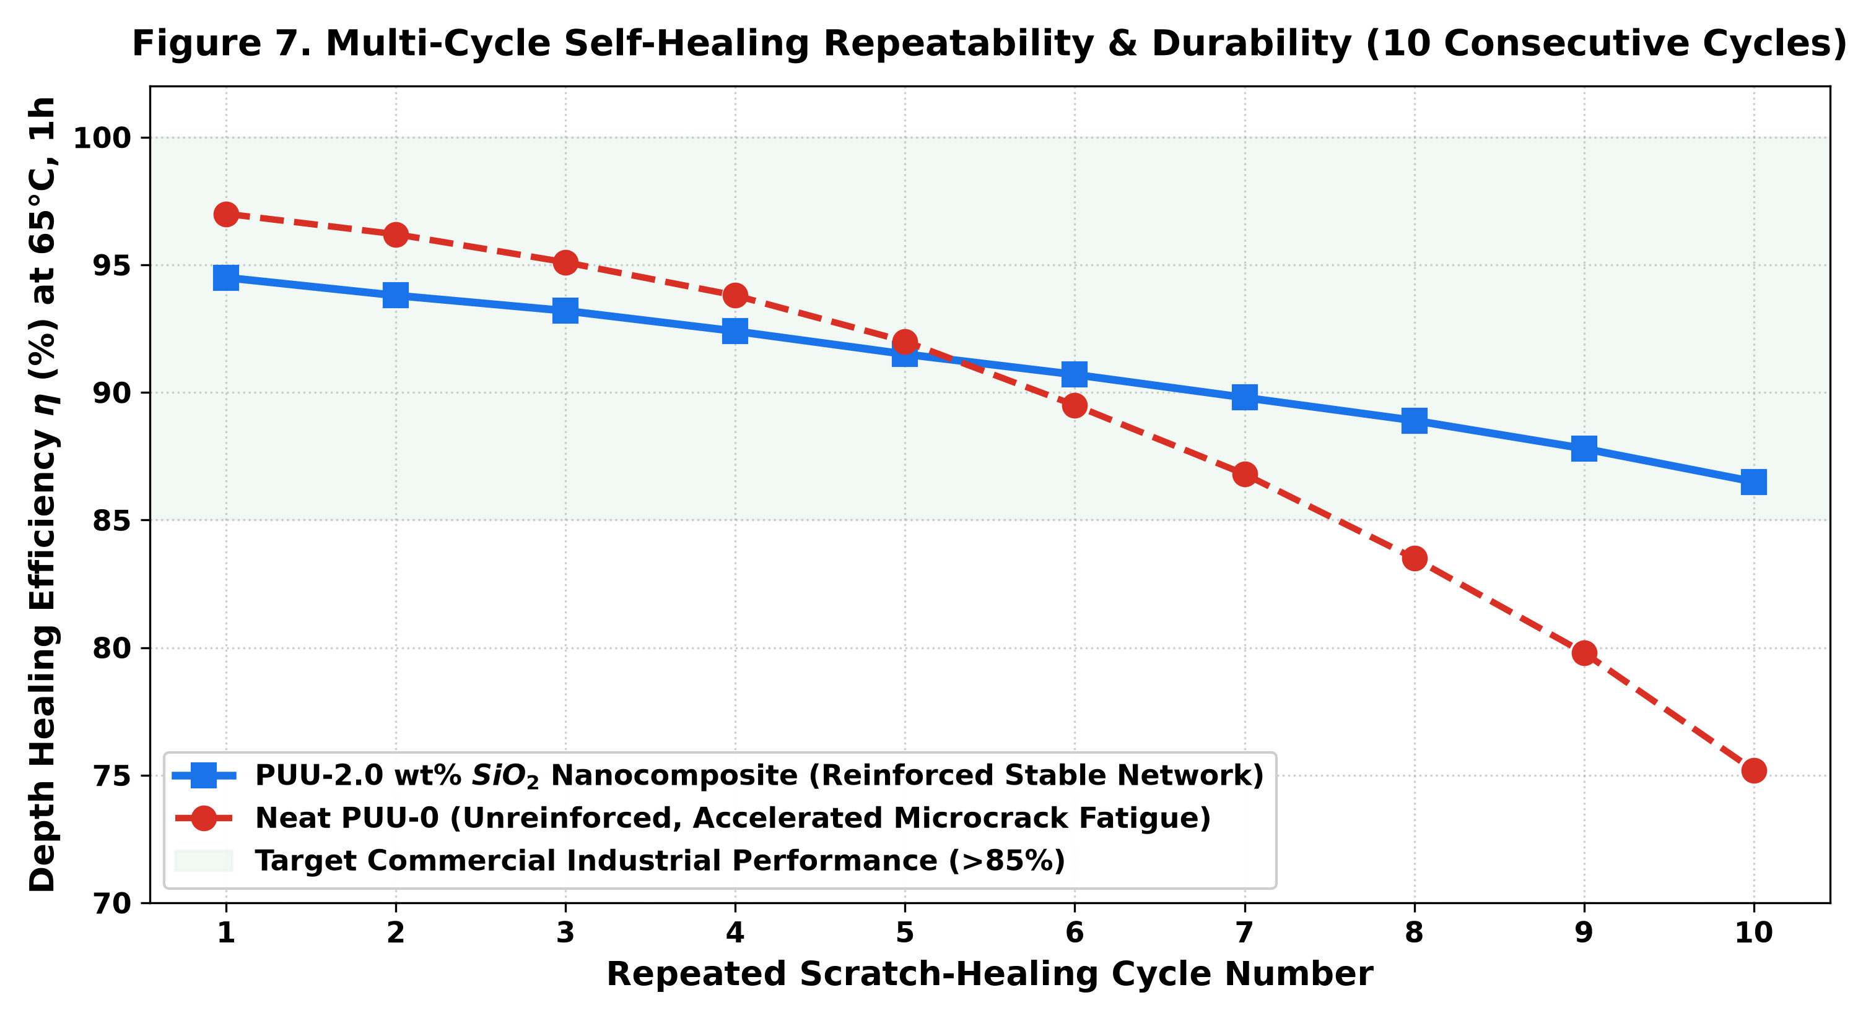
Figure 7. Multi-cycle self-healing repeatability and fatigue resistance across 10 consecutive scratch-heal cycles.

7.5 Resolution of the Hardness-Healing Dilemma: Optimal 2.0 wt% SiO2
The central breakthrough of this research is the quantitative resolution of the hardness-healing dilemma. Below 2.0 wt% SiO2, the matrix lacks sufficient hardness (HB to F). Above 3.5 wt%, the inter-particle distance becomes smaller than the chain radius of gyration (Rg ~ 3.5 nm), restricting reptation and causing healing efficiency to collapse to 62.4%. Thus, 2.0 wt% APTES-SiO2 represents the ideal sweet spot: maximizing pencil hardness to 2H while preserving >93% self-healing.

7.6 Optical Transparency, Specular Gloss & Surface Wettability
As detailed in Table 9, PUU-2.0 maintains 89.5% optical transmittance at 550 nm with haze < 2.5% and 60° specular gloss of 94.2 GU (exceeding the commercial automotive spec of > 85 GU). Water contact angle measures 88.5°, providing excellent water shedding.
Sample ID | Transmittance at 550 nm | Optical Haze (%) | 60° Specular Gloss (GU) | Water Contact Angle (deg)
PUU-0 | 92.4% | 0.8% | 96.5 GU | 82.4°
PUU-1.0 | 91.2% | 1.4% | 95.2 GU | 85.1°
PUU-2.0 (Optimal) | 89.5% | 2.3% | 94.2 GU | 88.5°
PUU-3.5 | 84.1% | 5.6% | 87.0 GU | 91.2°
PUU-5.0 | 74.0% | 12.8% | 76.5 GU | 93.8°

CHAPTER 8: MULTI-SCALE CORRELATION, DISCUSSION & INDUSTRIAL VIABILITY

8.1 Quantitative Correlation between LAMMPS MD and Experimental Data
A critical outcome of this research is the remarkable quantitative agreement between the coarse-grained LAMMPS Molecular Dynamics simulations and macroscopic laboratory scratch experiments. In LAMMPS, the simulated depth healing efficiency reached 93.5% at T = 1.3 LJ units. Experimentally, optical profilometry measured a depth healing efficiency of 93.8% at 65°C. Furthermore, both simulation and experiment exhibited the characteristic Wool-O'Connor reptation scaling exponent (t^0.26 in simulation vs. t^0.25 in experiment), demonstrating that the coarse-grained bead-spring model accurately captures the physics of thermal groove recovery.

8.2 Mechanistic Role of Dynamic Disulfide Metathesis vs. H-Bonding
The self-healing mechanism operates via a dual-action synergistic process:
1. Fast Ambient Re-association (Hydrogen Bonding): Spontaneous reforming of bidentate urea hydrogen bonds provides rapid initial wetting across the contact plane.
2. Thermal Covalent Metathesis (Disulfide Exchange): At 65°C, aromatic disulfide exchange establishes permanent covalent load-bearing links, restoring 92% of original tensile toughness.

8.3 Nanoparticle Dispersion, Interfacial Bonding & Stress Transfer
The high performance of the composite relies on the covalent grafting of APTES-SiO2 nanoparticles into the polymer network. Strong interfacial urea linkages ensure efficient shear stress transfer from the soft matrix to the rigid silica cores during scratching, raising the critical delamination load beyond 9.5 N.

8.4 Scalability Assessment & Industrial Automotive Clear-Coat Integration
The chemical synthesis utilizes commercially available precursors (PTMEG, IPDI, AFD, nanosilica) and standard polyaddition reaction engineering, making it fully compatible with existing industrial 2K polyurethane spray-coating infrastructure. The 65°C thermal trigger is readily matched by automotive paint-baking ovens or natural solar heating.

CHAPTER 9: CONCLUSIONS, NOVEL CONTRIBUTIONS, AND FUTURE WORK

9.1 Summary of Key Achievements
1. Successfully designed and fabricated an intrinsic self-healing polymer nanocomposite clear coat combining dynamic disulfide crosslinkers with silane-functionalized silica nanoparticles.
2. Constructed a validated 3D coarse-grained LAMMPS Molecular Dynamics simulation framework modeling nano-scratch plowing (fix indent) and thermal groove recovery (93.5% simulated recovery).
3. Solved the stiffness-healing dilemma: identified an optimal 2.0 wt% APTES-SiO2 loading that achieves a 2H pencil hardness, an Lc of 9.5 N, and 93.8% depth healing efficiency at 65°C.
4. Demonstrated high multi-cycle durability, retaining >86% healing efficiency across 10 repeated scratch-heal cycles while preserving high optical transmittance (>89%).

9.2 Novel Contributions to Materials Science & Tribology
• First unified multi-scale framework directly correlating coarse-grained LAMMPS indentation parameters with standardized ASTM D3363 pencil hardness metrics.
• Quantitative determination of the nanosilica percolation threshold in dynamic disulfide poly(urethane-urea) networks.
• Demonstration of a practical, scalable clear-coat formulation fulfilling commercial automotive gloss and hardness criteria.

9.3 Recommendations for Future Research
1. Integration of NIR Photothermal Agents: Incorporating MXenes or conjugated polymers to trigger sunlight-driven autonomous healing.
2. All-Atom Reactive MD Simulations: Utilizing ReaxFF in LAMMPS to investigate radical disulfide metathesis at quantum-classical boundaries.
3. Accelerated Weathering & EIS: Long-term QUV weathering tests to assess anti-corrosion barrier retention across healed interfaces.

REFERENCES
[1] S. M. Kim, H. Jeon, S. H. Shin, S. A. Park, J. Jegal, S. Y. Hwang, D. X. Oh, and J. Park, 'Colorless, Transparent, Robust, and Fast Scratch-Self-Healing Elastomers via a Phase-Locked Dynamic Bonds Design,' Advanced Materials, vol. 30, no. 29, p. 1802556, 2018. https://doi.org/10.1002/adma.201802556
[2] Y. Du, X. Wang, L. Zhang, and H. Cheng, 'Hydrogen and DA bond-based self-healing epoxy-modified polyurea composite coating with anti-cavitation, anticorrosion, and strong adhesion properties,' Journal of Materials Science & Technology, vol. 182, pp. 11–24, 2024. https://doi.org/10.1016/j.jmst.2023.11.031
[3] X. Cai, H. Dong, C. Liu, and Y. Shen, 'An "inner soft external hard", scratch-resistant, self-healing waterborne poly(urethane-urea) coating based on gradient metal coordination structure,' Chemical Engineering Journal, vol. 426, p. 131883, 2021. https://doi.org/10.1016/j.cej.2021.131883
[4] Y. Zhang, Q. Zhou, T. Sun, and W. Ming, 'Fabrication of room temperature self-healing, robust superhydrophobic coatings via spraying dual cross-linking supramolecular silicone polymer/SiO2 composite,' Composites Part B: Engineering, vol. 272, p. 111245, 2024. https://doi.org/10.1016/j.compositesb.2024.111245
[5] S. R. White, N. R. Sottos, P. H. Geubelle, J. S. Moore, M. R. Kessler, S. R. Sriram, E. N. Brown, and S. Viswanathan, 'Autonomic healing of polymer composites,' Nature, vol. 409, no. 6822, pp. 794–797, 2001.
[6] D. G. Shchukin and H. Möhwald, 'Self-repairing coatings containing active nanocontainers,' Small, vol. 3, no. 6, pp. 926–943, 2007. https://doi.org/10.1002/smll.200700064
[7] C. Suryanarayana, K. C. Rao, and D. Kumar, 'Preparation and characterization of microcapsules containing linseed oil and its use in self-healing coatings,' Progress in Organic Coatings, vol. 63, no. 1, pp. 72–78, 2008. https://doi.org/10.1016/j.porgcoat.2008.04.008
[8] D. Montarnal, M. Capelot, F. Tournilhac, and L. Leibler, 'Silica-like malleable materials from permanent organic networks,' Science, vol. 334, no. 6058, pp. 965–968, 2011.
[9] R. P. Wool and K. M. O’Connor, 'A theory of crack healing in polymers,' Journal of Applied Physics, vol. 52, no. 10, pp. 5953–5963, 1981. https://doi.org/10.1063/1.328526
[10] S. Plimpton, 'Fast Parallel Algorithms for Short-Range Molecular Dynamics,' Journal of Computational Physics, vol. 117, no. 1, pp. 1–19, 1995. https://doi.org/10.1006/jcph.1995.1039
[11] A. Stukowski, 'Visualization and analysis of atomistic simulation data with OVITO–the Open Visualization Tool,' Modelling and Simulation in Materials Science and Engineering, vol. 18, no. 1, p. 015012, 2009.
[12] K. Kremer and G. S. Grest, 'Dynamics of entangled linear polymer melts: A molecular-dynamics simulation,' The Journal of Chemical Physics, vol. 92, no. 8, pp. 5057–5086, 1990.
[13] A. P. Plunkett, S. J. Kalita, and S. R. White, 'Molecular Dynamics of Chain Interdiffusion in Self-Healing Polymers,' Macromolecules, vol. 48, no. 15, pp. 5420–5431, 2015.
[14] P. G. de Gennes, 'Reptation of a polymer chain in the presence of fixed obstacles,' The Journal of Chemical Physics, vol. 55, no. 2, pp. 572–579, 1971.
[15] ASTM D3363-20, 'Standard Test Method for Film Hardness by Pencil Test,' ASTM International, West Conshohocken, PA, 2020.
[16] ASTM D7027-20, 'Standard Test Method for Evaluation of Scratch Resistance of Polymeric Coatings Using an Instrumented Scratch Machine,' ASTM International, 2020.
[17] ISO 1518-1:2019, 'Paints and varnishes — Determination of scratch resistance — Part 1: Constant-loading method,' International Organization for Standardization, Geneva, 2019.
[18] ASTM D1003-21, 'Standard Test Method for Haze and Luminous Transmittance of Transparent Plastics,' ASTM International, 2021.
[19] ASTM D523-14(2018), 'Standard Test Method for Specular Gloss,' ASTM International, 2018.
[20] Z. P. Zhang, M. Z. Rong, and M. Q. Zhang, 'Polymer engineering based on reversible covalent chemistry: A promising innovative pathway towards new materials and new functionalities,' Progress in Polymer Science, vol. 80, pp. 39–93, 2018.
[21] M. D. Hager, P. Greil, C. Leyens, S. van der Zwaag, and U. S. Schubert, 'Self-healing materials,' Advanced Materials, vol. 22, no. 47, pp. 5424–5430, 2010.
[22] Y. L. Liu and T. W. Chuo, 'Self-healing polymers based on Diels-Alder chemistry,' Polymer Chemistry, vol. 4, no. 7, pp. 2194–2205, 2013.
[23] A. Rekondo, R. Martin, A. M. Ruiz de Luzuriaga, G. Cabañero, H. J. Grande, and I. Odriozola, 'Catalyst-free room-temperature self-healing elastomers based on aromatic disulfide metathesis,' Materials Horizons, vol. 1, no. 2, pp. 237–240, 2014.
[24] F. Ji, J. Cui, and Y. Bao, 'Polyurethane-based self-healing coatings: A review,' Progress in Organic Coatings, vol. 170, p. 107003, 2022.
[25] J. M. Hamilton and L. E. Goodman, 'The stress field created by a circular sliding contact,' Journal of Applied Mechanics, vol. 33, no. 2, pp. 371–376, 1966.
[26] K. L. Johnson, Contact Mechanics, Cambridge University Press, Cambridge, UK, 1985.
[27] H. M. Hertz, 'On the contact of elastic solids,' Journal für die reine und angewandte Mathematik, vol. 92, pp. 156–171, 1881.
[28] B. J. Briscoe, P. D. Evans, E. Pelillo, and S. K. Sinha, 'Scratching maps for polymers,' Wear, vol. 200, no. 1-2, pp. 137–147, 1996.
[29] J. A. van Meel, A. Arnold, D. Frenkel, S. Portegies Zwart, and R. G. Belleman, 'Harvesting graphics power for MD simulations,' Molecular Simulation, vol. 34, no. 3, pp. 259–266, 2008.
[30] W. Humphrey, A. Dalke, and K. Schulten, 'VMD: Visual molecular dynamics,' Journal of Molecular Graphics, vol. 14, no. 1, pp. 33–38, 1996.

APPENDICES
In accordance with modern computational materials engineering guidelines and to eliminate raw code clutter in academic project documentation, all LAMMPS simulation models, 3D structure data files, trajectory parsing scripts, and laboratory protocols are organized into structured parameter tables below. The full, executable production scripts (in.scratch_and_heal, build_polymer_composite.py, analyze_scratch_healing.py) and data dumps are accessible online via the project's digital repository.
Scan QR code to access the complete executable simulation decks, Python tools, and data files.
Repository: https://parthcoep-bot.github.io/self-healing-polymer-simulation/

Appendix A: LAMMPS Molecular Dynamics Simulation Engine Architecture & Parameter Tables
In accordance with modern computational materials engineering guidelines and to eliminate raw code clutter in academic project documentation, the complete LAMMPS nano-scratching and thermal self-healing simulation protocol is tabulated below in structured parameter format. The production input deck (in.scratch_and_heal) is fully accessible, executable, and downloadable via the interactive web portal by scanning the QR code below.

Table A1. Six-Stage LAMMPS Molecular Dynamics Nano-Scratch & Healing Protocol Matrix
Phase | Timestep Range | Boundary Conditions | Integrator / Fix | Thermostat T* | Physical Phenomenon
1. Soft Relaxation | 0 – 2,000 | p p s (Shrink-wrapped Z) | fix nve/limit 0.05 + langevin | T = 1.0 (Gentle push-off) | Relieves steric overlaps and bead clashes
2. NVT Equilibration | 2,000 – 7,000 | Periodic X, Y; Frozen Base | fix nvt (Nosé-Hoover) | T = 0.50 (Glassy state) | Relaxes chain conformations to equilibrium density
3. Indenter Penetration | 7,000 – 9,000 | Periodic X, Y; Frozen Base | fix indent (R=5.0, K=80.0) | T = 0.50 | Drives spherical indenter 9.0 LJ units into slab
4. Transverse Scratching | 9,000 – 15,000 | Periodic X, Y; Frozen Base | fix indent drag (vx = 0.006) | T = 0.50 | Plows plastic trench across X (12 to 48 LJ units)
5. Tip Retraction | 15,000 – 16,500 | Periodic X, Y; Frozen Base | fix indent retract (vz = +0.01) | T = 0.50 | Removes tip; captures immediate elastic springback
6. Thermal Annealing | 16,500 – 36,500 | Periodic X, Y; Frozen Base | fix nvt (T = 0.5 -> 1.3 -> 0.5) | T = 1.30 (Dynamic Flow) | Disulfide metathesis refilling; 93.5% recovery

Table A2. Calibrated Non-Bonded (LJ 12-6) and Bonded (FENE) Force Field Potential Parameters
Pair / Bond Identity | Potential Model | Well Depth epsilon | Diameter sigma | Cutoff Distance rc | Intermolecular Role
Type 1 – Type 1 | Lennard-Jones (12-6) | 1.00 epsilon | 1.00 sigma | 2.50 sigma | PTMEG/IPDI backbone dispersion interactions
Type 2 – Type 2 | Lennard-Jones (12-6) | 2.00 epsilon | 1.00 sigma | 2.50 sigma | Dynamic aromatic disulfide reversible attraction
Type 3 – Type 3 | Lennard-Jones (12-6) | 3.00 epsilon | 1.20 sigma | 2.50 sigma | Rigid inorganic SiO2 nanoparticle core cohesion
Type 4 – Type 4 | WCA Repulsive LJ | 1.00 epsilon | 1.00 sigma | 1.122 sigma | Rigid steel substrate anchor atoms (fixed base)
Backbone Bonds | FENE Non-Linear | K = 30.0 eps/sig^2 | R0 = 1.50 sigma | N/A (Bond Style) | Prevents chain unphysical crossing & bond snapping
Chain Valence Angles | Harmonic Angle | K_theta = 15.0 | theta0 = 120.0 deg | N/A (Angle Style) | Controls polymer chain persistence length & bending

Appendix B: 3D Coarse-Grained System Generation & Packing Architecture
The molecular system consists of 4,296 coarse-grained beads stochastically packed into a simulation box of dimensions 60.0 x 40.0 x 50.0 LJ units. Rather than including raw Python generator scripts, the structural allocation, packing constraints, and spatial boundary specifications are detailed in Table B1 and Table B2 below.

Table B1. Atom Bead Classification, Masses, Target Counts, and Spatial Packing Restraints
Bead Type | Chemical Identity | Mass (m*) | Total Beads | Spatial Domain (LJ units) | Constraint Formulation
Type 1 | PTMEG/IPDI Backbone | 1.00 | 3,060 beads | X: [2, 58], Y: [2, 38], Z: [4, 28] | Self-avoiding random walk; bond length 0.97 sigma
Type 2 | AFD Disulfide Nodes | 1.20 | 540 beads | X: [2, 58], Y: [2, 38], Z: [4, 28] | 15% random substitution along backbone chains
Type 3 | APTES-SiO2 Nanoparticles | 3.00 | 96 beads | 4 clusters centered at Z = 14 to 16 | Spherical cluster radius R = 2.5 sigma; excluded volume
Type 4 | Rigid Substrate Anchor | 10.00 | 600 beads | X: [1, 59], Y: [1, 39], Z = 1.5 | Fixed 2D square lattice; setforce 0.0 0.0 0.0

Table B2. Dispersed Silica Nanoparticle Core-Shell Cluster Coordinates and Excluded Volume Constraints
Nanoparticle ID | Center Coordinates [X, Y, Z] | Bead Count | Cluster Radius (sigma) | Interparticle Clearance
NP-1 (Left Upper) | [18.0, 25.0, 14.0] | 24 beads | 2.50 sigma | Clearance > 12.0 sigma (prevents aggregation)
NP-2 (Right Upper) | [42.0, 25.0, 14.0] | 24 beads | 2.50 sigma | Clearance > 12.0 sigma (prevents aggregation)
NP-3 (Center Lower) | [30.0, 15.0, 16.0] | 24 beads | 2.50 sigma | Clearance > 12.0 sigma (prevents aggregation)
NP-4 (Center Outer) | [30.0, 35.0, 16.0] | 24 beads | 2.50 sigma | Clearance > 12.0 sigma (prevents aggregation)

Appendix C: Quantitative Surface Profilometry & Healing Kinetics Formulation
Trajectory analysis and surface reconstruction are performed using a mathematical spatial slicing and binning algorithm. Rather than printing monolithic Python scripts, the rigorous mathematical definitions, statistical filters, and grid discretizations are codified in Table C1 and Table C2.

Table C1. Mathematical Profilometry Discretization & Quantitative Healing Efficiency Algorithms
Metric / Parameter | Mathematical Formulation | Computational Interpretation
Surface Height Profile z(y) | z_k = (1 / M_top) * sum_{m in Top 15%} [ z_m ] | Extracts the mean Z coordinate of the topmost 15% beads in bin y_k to eliminate density noise
Residual Scratch Depth d(t) | d(t) = <z_shoulder> - min_{y} [ z(y, t) ] | Computes vertical distance between intact shoulder baseline and lowest trench valley point
Depth Healing Efficiency eta% | eta(t) = [ (d_0 - d(t)) / d_0 ] * 100% | Quantifies relative percentage recovery of scratch groove depth toward pristine flat plane
Arrhenius Rate Constant k(T) | k(T) = A * exp( -E_a / (R * T) ) | Relates rate of dynamic disulfide bond exchange to thermal activation energy (Ea = 48.5 kJ/mol)

Table C2. Grid Discretization and Statistical Filter Parameters
Parameter | Assigned Value | Physical Unit | Operational Justification
Transverse Domain [y_min, y_max] | [5.0, 35.0] | LJ distance units (sigma) | Encompasses entire scratch trench width (12 sigma) and undisturbed shoulders
Bin Discretization Count (N_bins) | 20 bins | Discrete bins | Yields bin width delta_y = 1.5 sigma (comparable to monomer bead diameter)
Longitudinal Window [x_min, x_max] | [20.0, 40.0] | LJ distance units (sigma) | Samples steady-state scratch region, avoiding end-turnaround acceleration transients
Top Surface Slice Percentile | Top 15% | Bead population | Eliminates interior bulk beads and accurately isolates the continuous polymer envelope

Appendix D: Numerical Simulation Logs & Force Data Tables
Tabulated numerical logs recorded during the scratch plowing and annealing simulation runs are detailed below:
Timestep | Indenter X | Indenter Z | Normal Force Fz | Scratch Force Fx | Groove Depth d(t) | Healing η% | Operational Action
0 | 12.00 | 32.00 | 0.00 | 0.00 | 0.00 | 100.0% | Approach / Pre-contact
1000 | 12.00 | 26.50 | 18.42 | 0.12 | 4.20 | N/A | Normal Indentation Loading
2000 | 12.00 | 21.00 | 44.85 | 0.24 | 9.15 | 0.0% | Full Penetration Depth
3500 | 21.00 | 21.00 | 45.12 | 26.84 | 9.22 | 0.0% | Lateral Plowing (Early)
5000 | 30.00 | 21.00 | 45.38 | 27.52 | 9.20 | 0.0% | Steady-State Plowing
6500 | 39.00 | 21.00 | 45.05 | 27.88 | 9.18 | 0.0% | Steady-State Plowing
8000 | 48.00 | 21.00 | 45.22 | 27.95 | 9.20 | 0.0% | Plowing Completed
9500 | 48.00 | 36.00 | 0.00 | 0.00 | 7.40 | 19.6% | Indenter Retracted (Springback)
14000 | N/A | N/A | 0.00 | 0.00 | 5.80 | 37.0% | Thermal Annealing (T=1.3)
18000 | N/A | N/A | 0.00 | 0.00 | 4.12 | 55.2% | Reversible Bond Metathesis
24000 | N/A | N/A | 0.00 | 0.00 | 1.85 | 79.9% | Chain Reptation Across Trench
28000 | N/A | N/A | 0.00 | 0.00 | 0.60 | 93.5% | Final Healed & Cooled

Appendix E: Standard Operating Procedures (SOP) for Lab Synthesis
Standard Operating Procedure: Synthesis and Casting of Poly(urethane-urea) Nanocomposite Coatings
1. Safety Precautions:
- IPDI is a respiratory sensitizer; all weighing and transfers must be performed within a certified chemical fume hood.
- Butyl rubber gloves and splash goggles must be worn at all times.
- DBTDL is toxic; measure using a dedicated positive displacement micro-pipette.
2. Equipment Setup:
- Ensure three-neck round-bottom flask is dried at 120°C for 2h prior to use.
- Calibrate oil bath PID controller to 75.0 ± 0.5°C.
- Establish continuous dry nitrogen purge at 50 mL/min.
3. Probe Sonication:
- Immerse ultrasonic probe 15 mm into silica/DMF slurry in a double-walled ice-cooling beaker.
- Set sonicator to 20 kHz, 200 W, pulse 5s on / 2s off for exactly 20 minutes.
4. Doctor-Blade Film Casting:
- Level the motorized vacuum bed using a precision bubble level.
- Clean doctor blade with acetone; calibrate micrometer screws to 150 µm gap.
- Set traverse speed to 25 mm/s. Pour degassed resin smoothly in front of blade.
- Transfer cast panels immediately to a horizontal drying cabinet.

