**Lab Practical #01:**

Study of basic networking commands and IP configuration.

**Practical Assignment #01:**

1. Perform and explain various networking commands listed below:
   1. ipconfig
   2. ping
   3. getmac
   4. systeminfo
   5. traceroute / tracert
   6. netstat
   7. nslookup
   8. hostname
   9. pathping
   10. arp

## ipconfig

### Description:

**The ipconfig command shows current TCP/IP settings and can refresh DHCP and DNS configurations.**

|  |  |  |
| --- | --- | --- |
| No. | Option | Description |
| 1 | ipconfig | Displays basic IP information. |
| 2 | Ipconfig/all | Shows detailed network configuration. |
| 3 | Ipconfig/release | Releases the IP address for the adapter. |
| 4 | Ipconfig/renew | Renews the IP address for the adapter. |
| 5 | Ipconfig/flushdns | Clears the DNS cache. |

### Implementation:

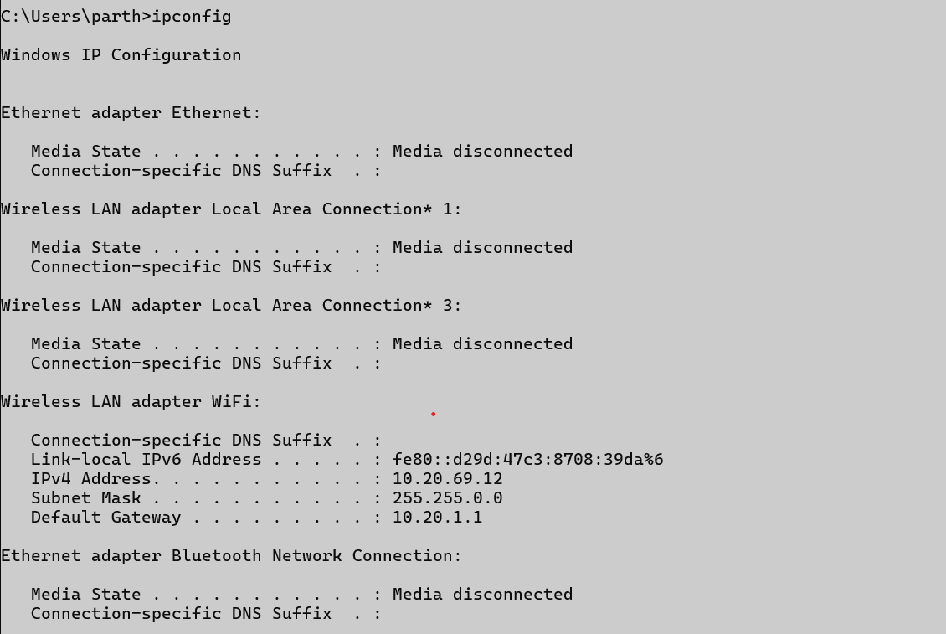

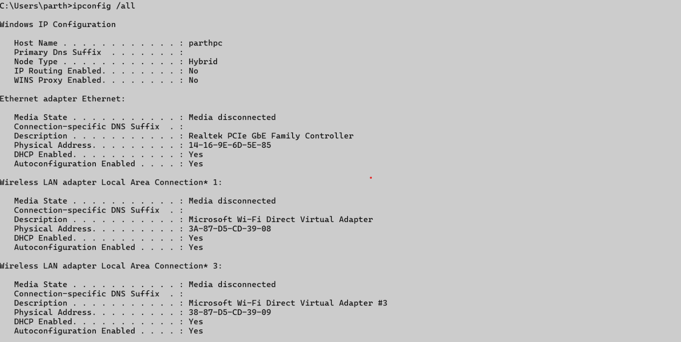

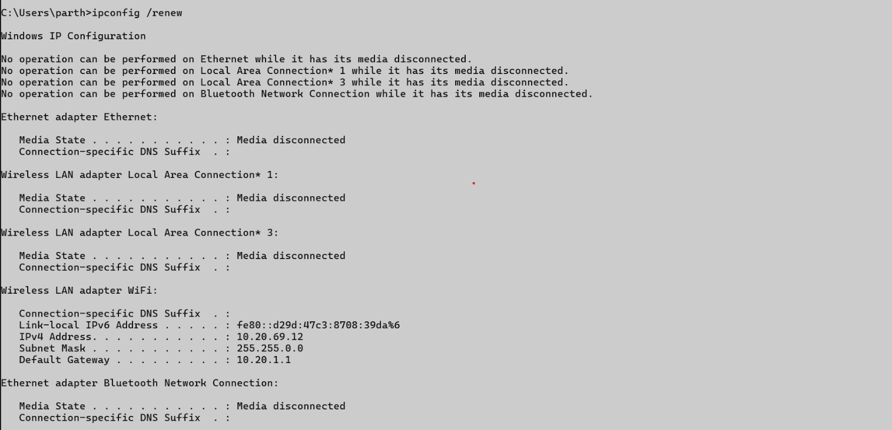

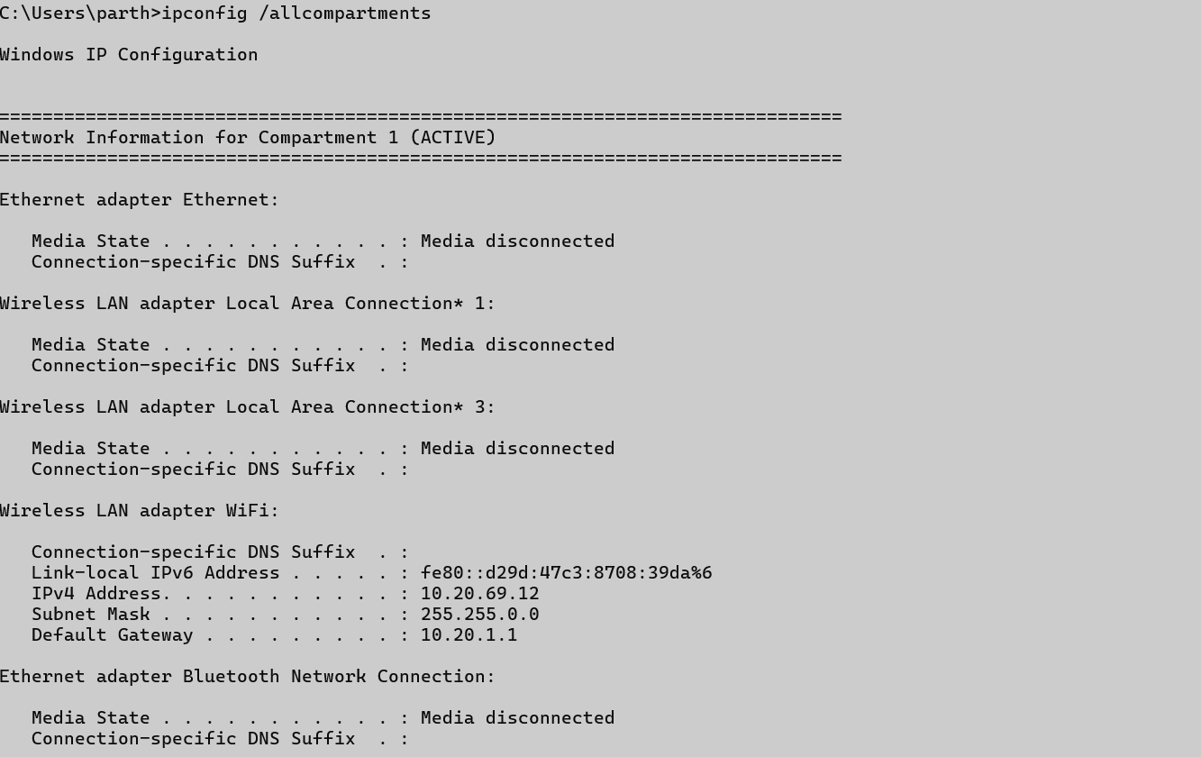

## ping

### Description:

**The ping command checks the network connectivity between the source and destination.**

|  |  |  |
| --- | --- | --- |
| No. | Option | Description |
| 1 | ping hostname | Pings a remote server or website. |
| 2 | ping -t | Continues to ping until stopped manually. |
| 3 | ping -n count | Sends a specific number of ping request. |
| 4 | ping -l size | Specifies the size of the packet to send. |
| 5 | ping -4 / -6 | Forces IPv4 or IPv5 address usage. |

### Implementation:

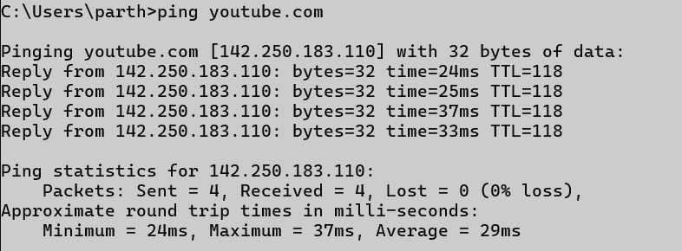

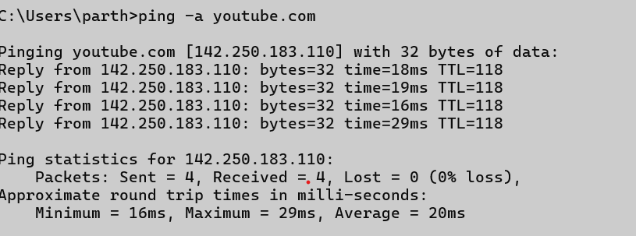

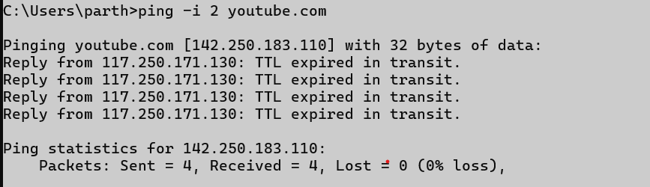

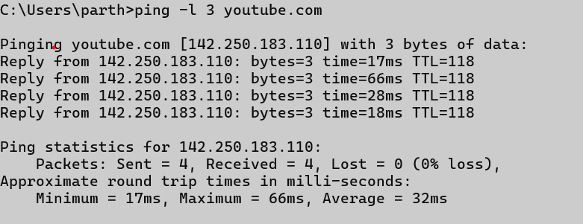

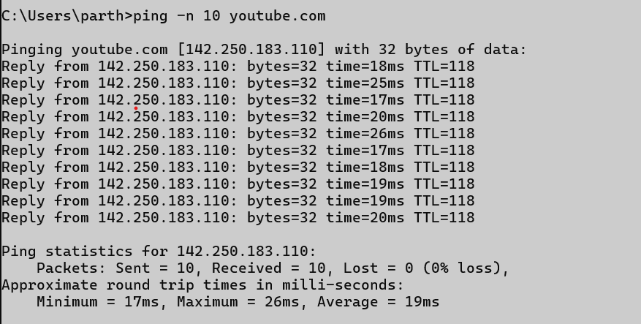

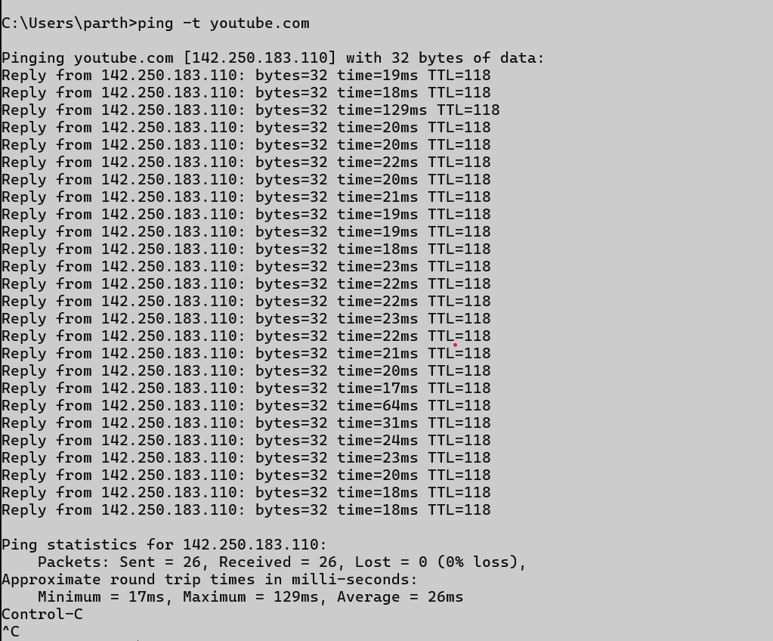

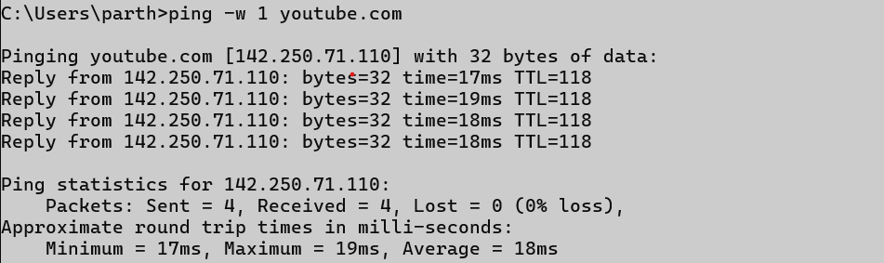

## getmac

### Description:

**The getmac command displays the MAC addresses of the system’s network interfaces.**

|  |  |  |
| --- | --- | --- |
| No. | Option | Description |
| 1 | getmac | Displays MAC addresses of all network cards. |
| 2 | getmac /v | Shows detailed information. |
| 3 | getmac /fo list | Outputs the information in a list format. |
| 4 | getmac /fo csv | Outputs the information in a CSV format. |
| 5 | getmac /nh | Omits headers in the output. |

### Implementation:

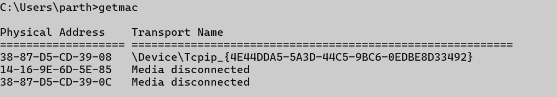

## systeminfo

### Description:

**The systeminfo command shows detailed system and OS configuration info.**

|  |  |  |
| --- | --- | --- |
| No. | Option | Description |
| 1 | systeminfo | Displays all system information. |
| 2 | systeminfo /s | Retrieves info from a remote system. |
| 3 | systeminfo /fo csv | Outputs the information in a CSV format. |
| 4 | systeminfo /fo list | Outputs the information in a list format. |

### Implementation:

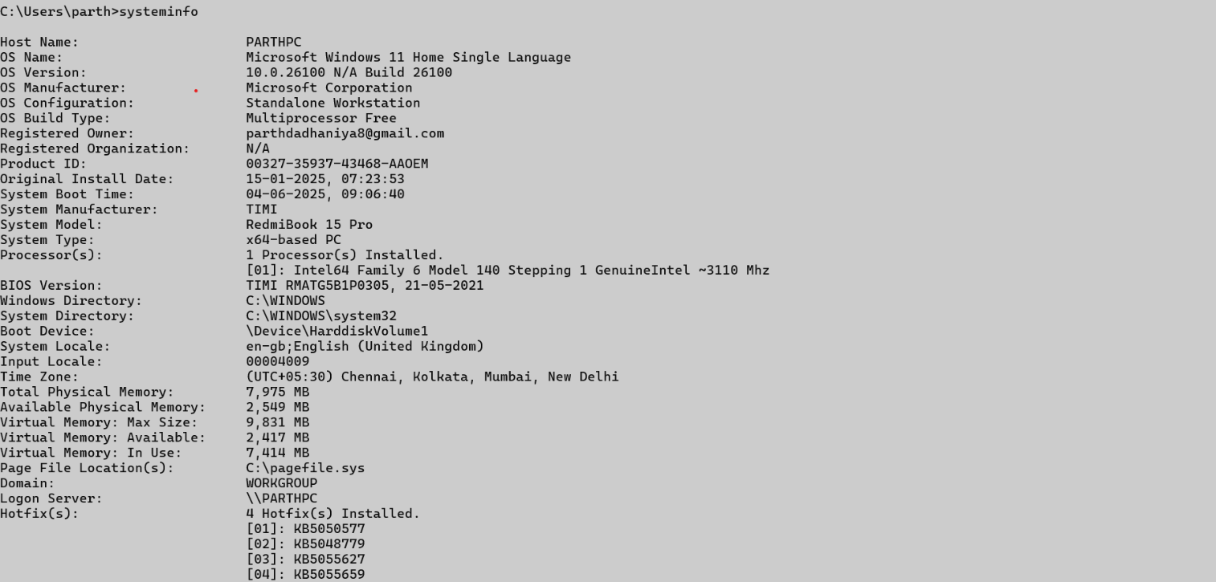

## traceroute / tracert

### Description:

**The tracert command traces the route packets take to a network host.**

|  |  |  |
| --- | --- | --- |
| No. | Option | Description |
| 1 | tracert hostname | Traces the route to a specific host. |
| 2 | tracert -d | Does not resolve addresses to hostnames. |
| 3 | tracert -h hops | Specifies the maximum number of hops. |
| 4 | tracert -w timeout | Waits for timeout milliseconds for each reply. |

### Implementation:

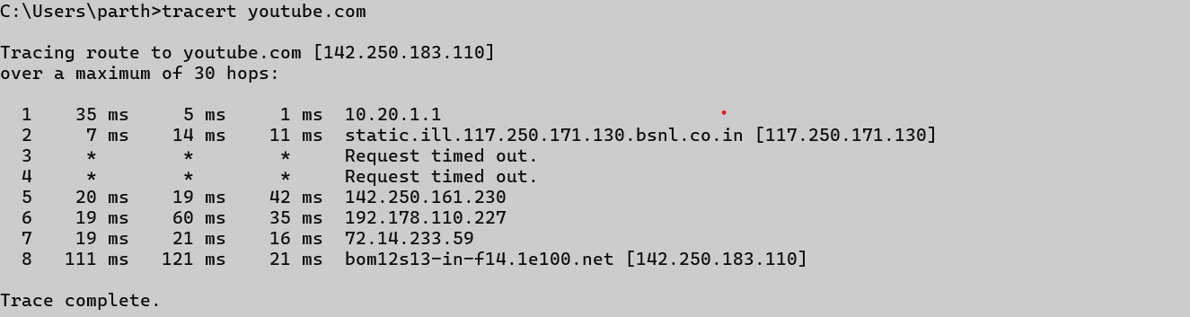

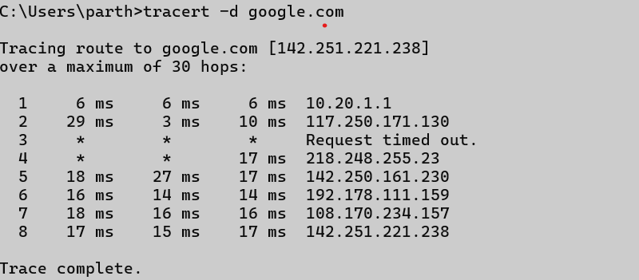

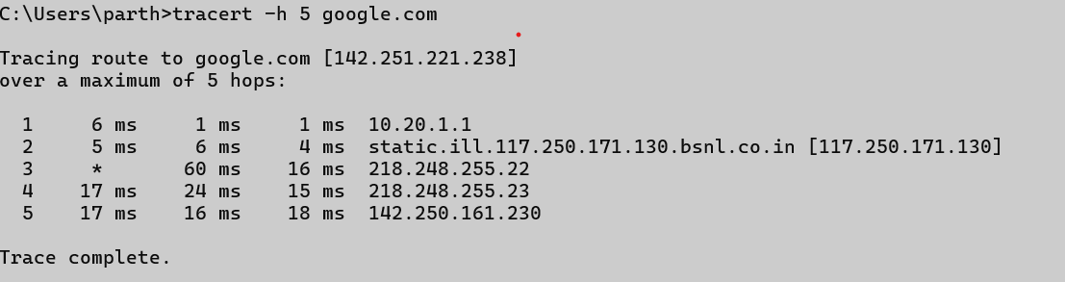

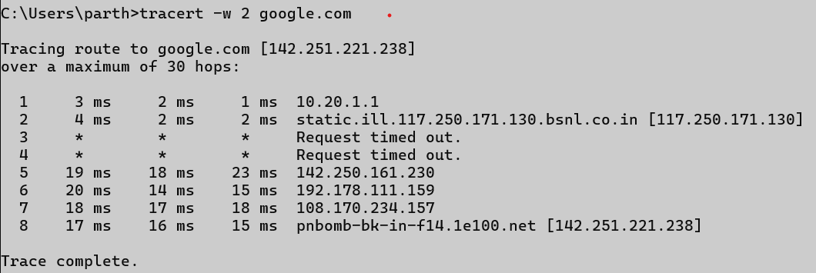

## netstat

### Description:

**The netstat command shows active TCP connections, ports, and network statistics.**

|  |  |  |
| --- | --- | --- |
| No. | Option | Description |
| 1 | netstat | Displays all active connections. |
| 2 | netstat -a | Shows all listening ports and connections. |
| 3 | netstat -n | Shows addresses and port numbers numerically. |
| 4 | netstat -o | Shows connections with their process IDs. |
| 5 | netstat -e | Displays Ethernet statistics. |

### Implementation:

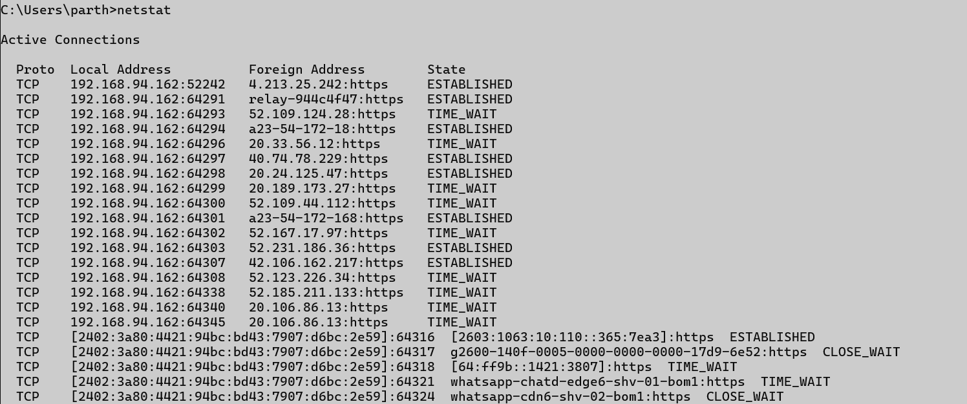

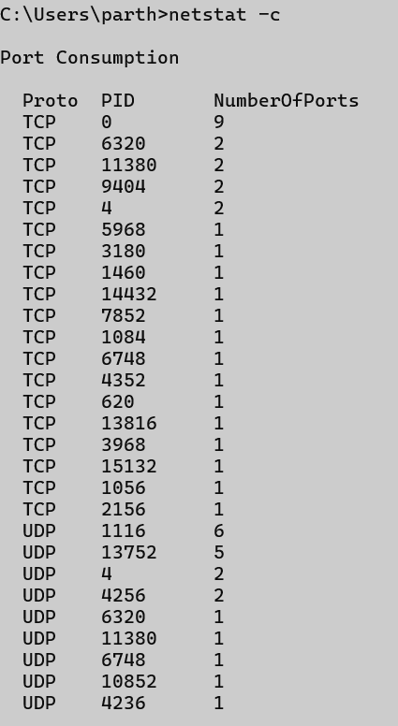

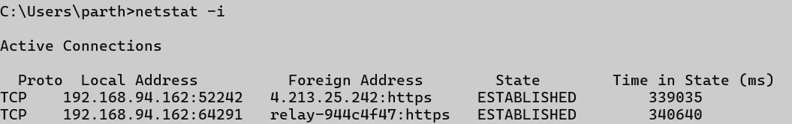

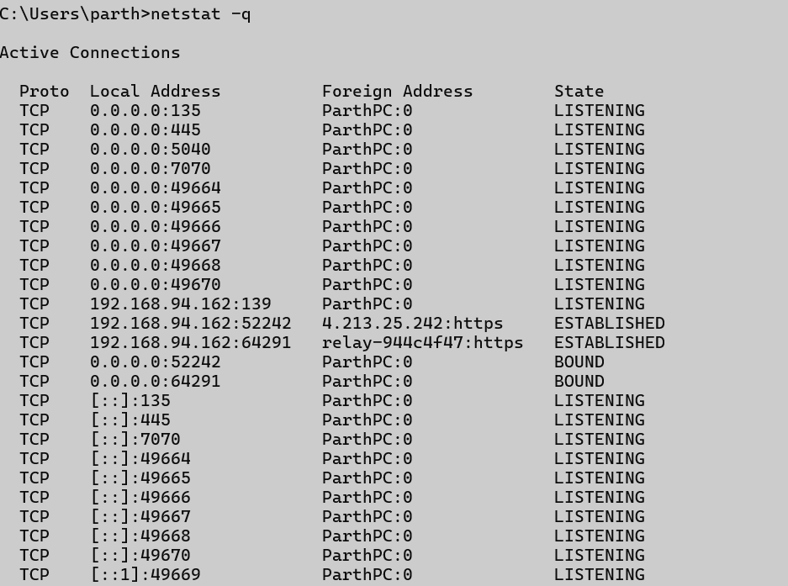

## nslookup

### Description:

**The nslookup command queries the DNS to obtain domain name or IP address mapping.**

|  |  |  |
| --- | --- | --- |
| No. | Option | Description |
| 1 | nslookup hostname | Gets the IP address of the hostname. |
| 2 | nslookup -type=A | Finds IPv4 addresses for a domain. |
| 3 | nslookup -type=MX | Displays mail servers for a domain. |
| 4 | nslookup -type=NS | Shows name servers for a domain. |

### Implementation:



## hostname

### Description:

**The hostname command displays the system’s network name.**

### Implementation:

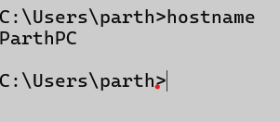

## pathping

### Description:

**The pathping command provides information about latency and packet loss along a route.**

|  |  |  |
| --- | --- | --- |
| No. | Option | Description |
| 1 | pathping hostname | Traces route and checks latency and packet loss. |
| 2 | pathping -n | Does not resolve addresses to hostnames. |
| 3 | pathping -h hops | Sets the maximum number of hops to search. |
| 4 | pathping -w timeout | Waits timeout milliseconds for each reply. |

### Implementation:

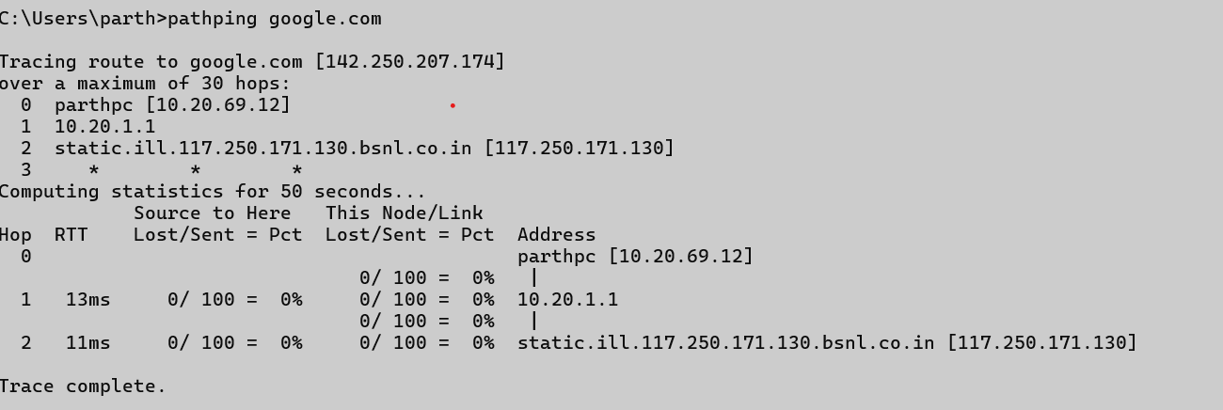

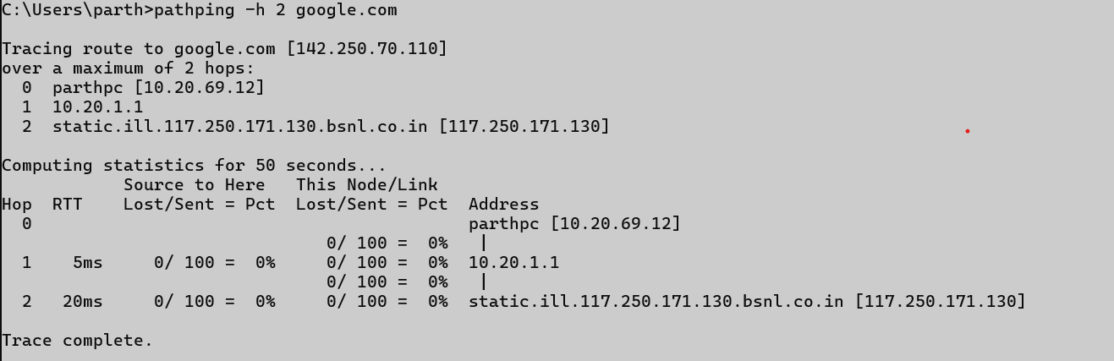

## arp

### Description:

**The arp command displays and modifies the ARP (Address Resolution Protocol) cache.**

|  |  |  |
| --- | --- | --- |
| No. | Option | Description |
| 1 | arp -a | Displays the ARP table. |
| 2 | arp -d | Deletes an entry from the ARP cache. |
| 3 | arp -s ip mac | Adds a static entry to the ARP cache. |
| 4 | arp -g | Same as arp -a, displays the ARP table. |

### Implementation:

